Online Supplemental Material B – Imputation
We used the R package mixgb (Deng, 2023; Deng & Lumley, 2024) to multiply impute missing data. Mixgb, in turn, is based on XGBoost (Chen et al., 2024) a highly efficient gradient boosting (Friedman, 2002) machine learning library, to predict missing values. With this approach, non-linear relationships as well as complex interactions between variables are captured and used in the imputation model. The model can deal with continuous as well as categorical data. Instead of using the predicted values directly, mixgb uses predictive mean matching (Little, 1988) to randomly select from the observed values close to the predicted one. In this way, imputed data cannot take on values outside the range of observed data. This method is widely used in multiple imputation; for example, it is the default method in the popular R package mice (van Buuren & Groothuis-Oudshoorn, 2011). The implementation is fast, memory efficient, and can run on multiple processors (or GPUs, or clusters) in parallel, making it suitable for large datasets such as the one used in the present study. This document contains the missingness rates of all variables in the dataset as well as selected imputation diagnostics graphs for all grades.

Missingness Rates
The two variables gender and migration background that were not specific to any grade had missingness rates of 0% and 4.32%, respectively. The corresponding information for all other variables is given in the table below by grade. A dash (–) indicates that the variable in question was not available for a particular grade and was not imputed. Some variables were not used in the analyses reported in the paper but were included in the imputation model to improve performance.

Item/Variable | Grade
Item/Variable | 3 | 5 | 7 | 9
Need for cognition
Item 1 | 40.3 | 40.3 | 65.9 | 23.9
Item 2 | 40.6 | 40.5 | 66.0 | 24.3
Item 3 | 40.5 | 40.5 | 66.5 | 24.7
Item 4 | 40.6 | 40.6 | 66.4 | 24.4
Item 5 | 40.5 | 40.4 | 67.2 | 24.7
Academic interest
Item 1 | 40.5 | 40.3 | 65.2 | 23.6
Item 2 | 40.7 | 40.4 | 65.1 | 23.2
Self-concept
Item 1 | 40.6 | 40.2 | 64.9 | 22.7
Item 2 | 40.2 | 39.9 | 64.8 | 23.5
Achievement
German Listening Comprehension | 40.4 | – | – | –
German Reading Comprehension | 40.3 | 40.3 | 65.8 | 35.5
French Reading Comprehension | – | 39.6 | 64.0 | 27.4
Mathematics | 39.0 | 38.9 | 63.8 | 20.9
Sociodemographic
Parental education level | 46.8 | 49.5 | – | –
Highest ISEI | 49.2 | 48.0 | 77.4 | 40.7
Family wealth index | – | – | 64.2 | 21.8
Language spoken at home
French | 39.8 | 39.8 | 64.7 | 23.1
Luxembourgish/German | 39.5 | 39.8 | 64.5 | 22.8
Other Romance language | 39.4 | 39.8 | 64.6 | 22.9

Imputation Diagnostics Graphs
Mixgb provides graphs comparing the distribution of observed values to imputed ones. Since there are 70 variables in the dataset we only show variables used in the substantive analyses, not those included to improve performance of the imputation model.

Need for Cognition – Grade 3
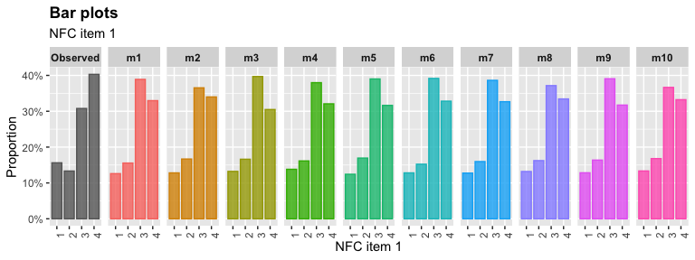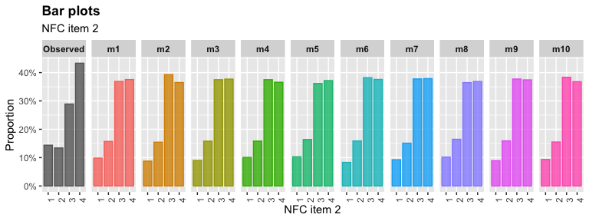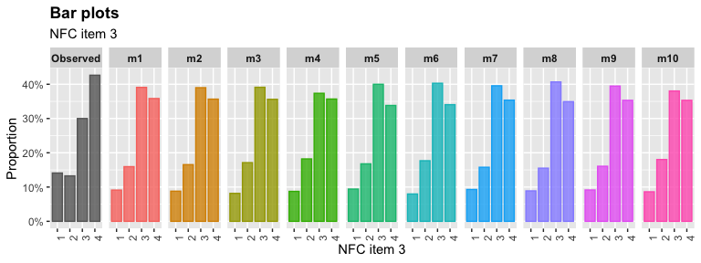
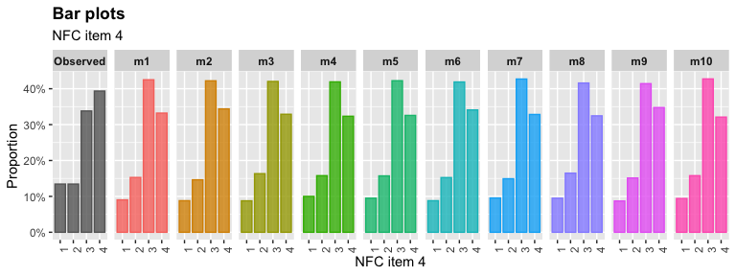
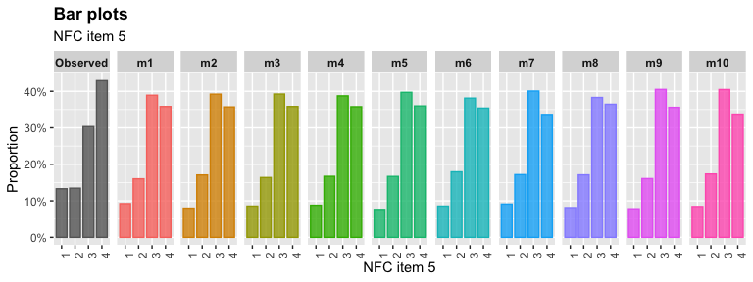

Need for Cognition – Grade 5
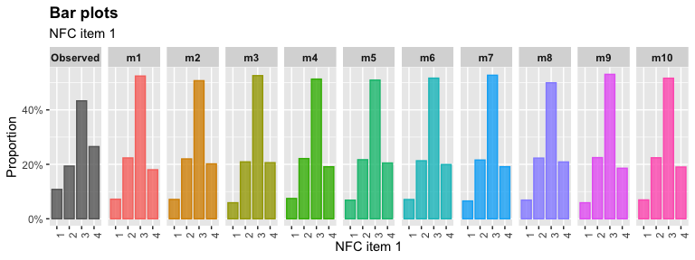
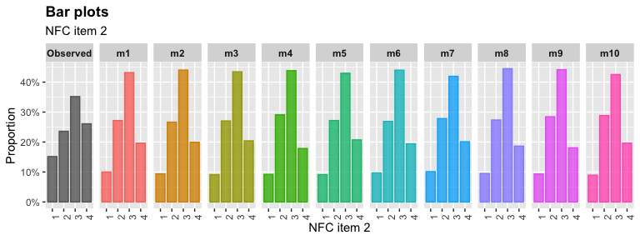
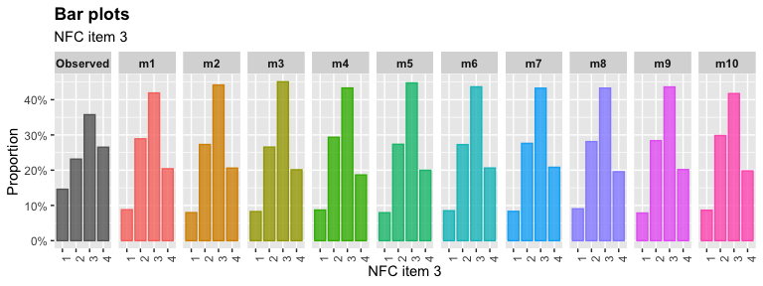
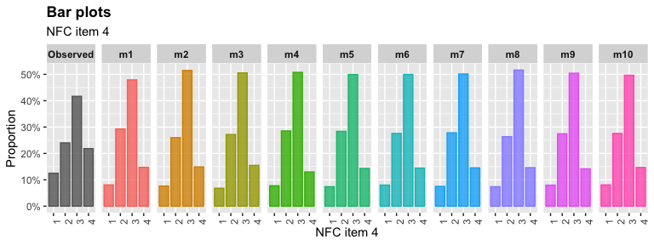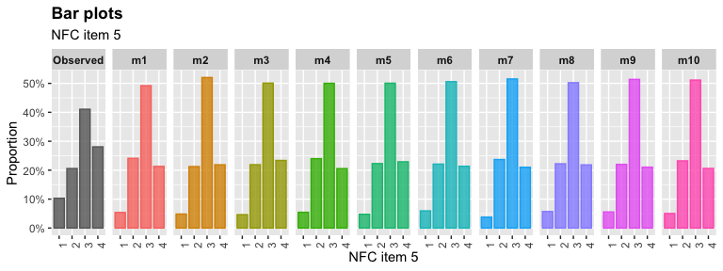
Need for Cognition – Grade 7
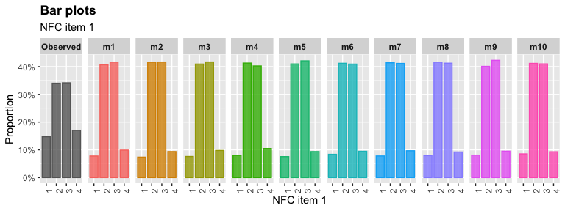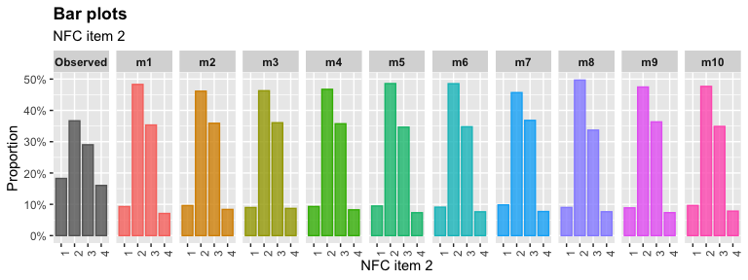
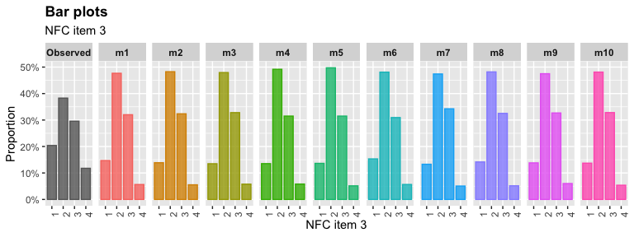

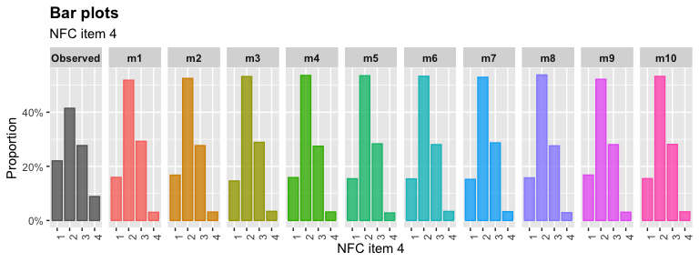
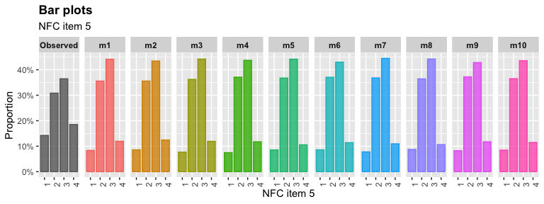

Need for Cognition – Grade 9
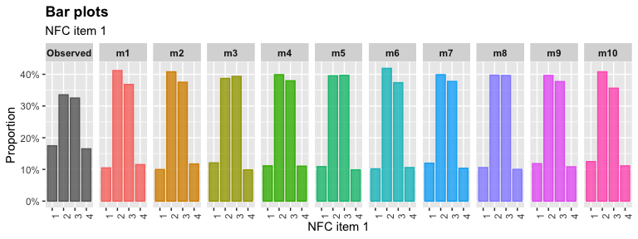
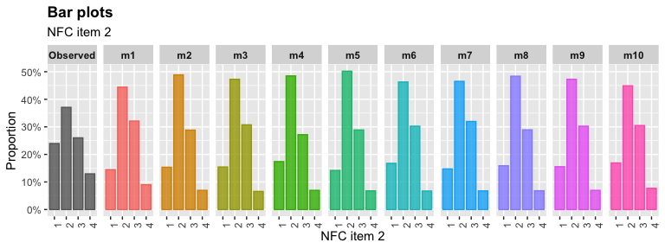
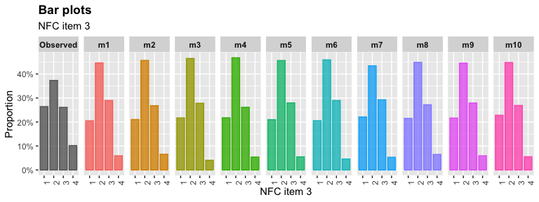
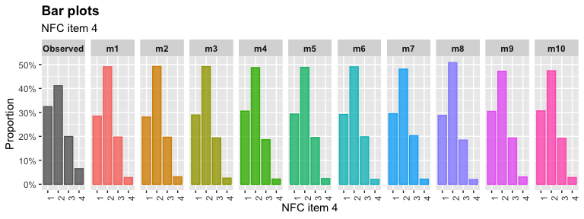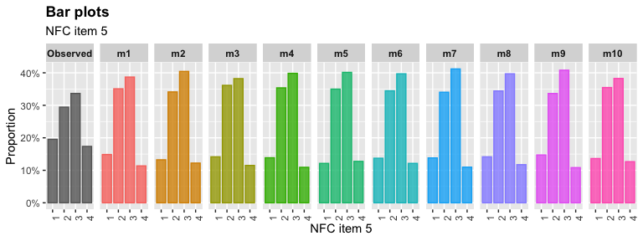
Motivational Variables
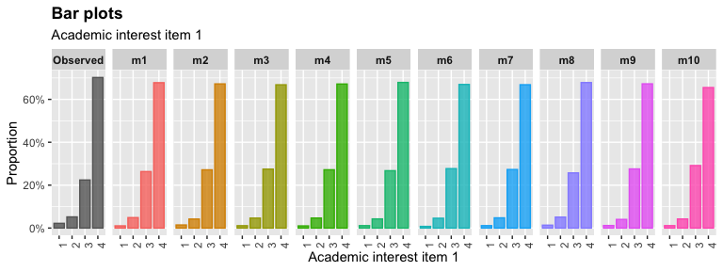
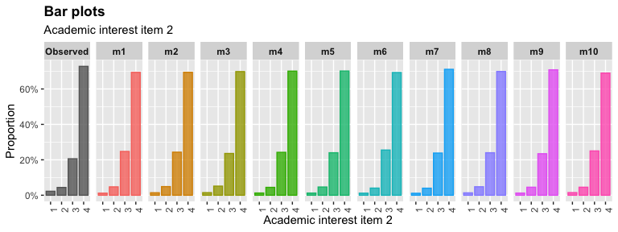
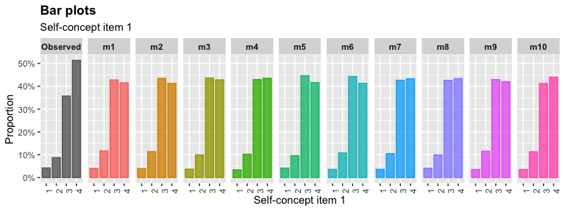
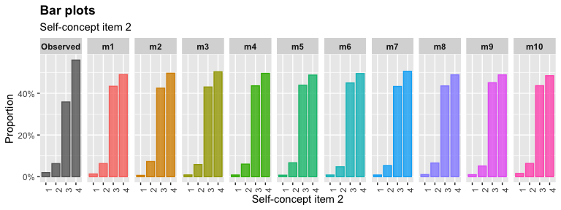

Academic Achievement
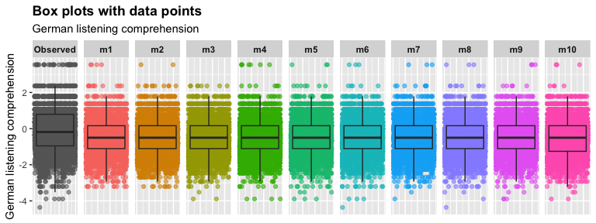
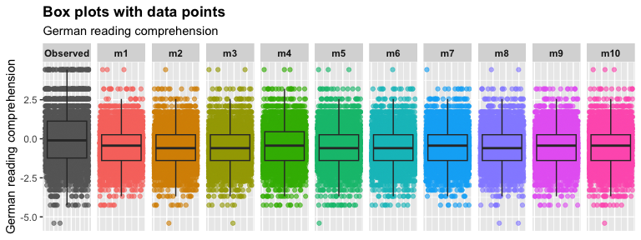
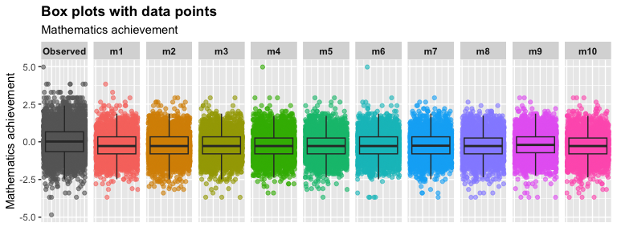

Sociodemographic Variables
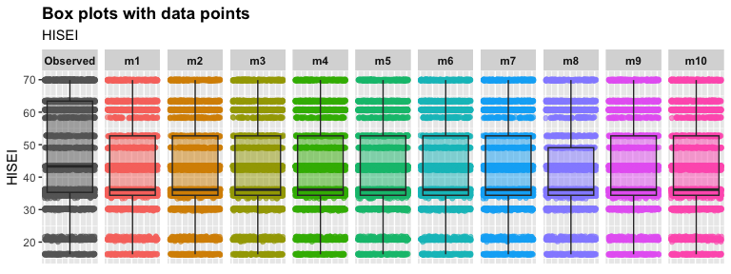
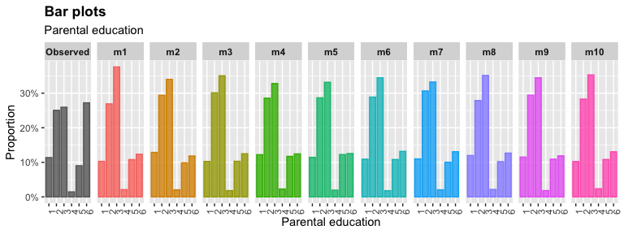
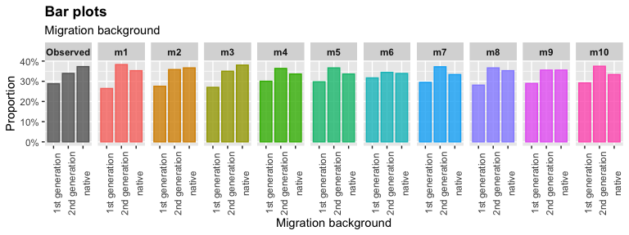

References
Chen, T., He, T., Benesty, M., Khotilovich, V., Tang, Y., Cho, H., Chen, K., Mitchell, R., Cano, I., Zhou, T., Li, M., Xie, J., Lin, M., Geng, Y., Li, Y., & Yuan, J. (2024). xgboost (Version 1.7.8.1) [Manual]. https://CRAN.R-project.org/package=xgboost
Deng, Y. (2023). mixgb: Multiple imputation through ‘xgboost’ (Version 1.5.2) [Computer software]. https://CRAN.R-project.org/package=mixgb
Deng, Y., & Lumley, T. (2024). Multiple imputation through xgboost. Journal of Computational and Graphical Statistics, 33(2), 352–363. https://doi.org/10.1080/10618600.2023.2252501
Friedman, J. H. (2002). Stochastic gradient boosting. Computational Statistics & Data Analysis, 38(4), 367–378. https://doi.org/10.1016/S0167-9473(01)00065-2
Little, R. J. A. (1988). Missing-data adjustments in large surveys. Journal of Business & Economic Statistics, 6(3), 287. https://doi.org/10.2307/1391878
van Buuren, S., & Groothuis-Oudshoorn, K. (2011). mice: Multivariate imputation by chained equations in R. Journal of Statistical Software, 45(3). https://doi.org/10.18637/jss.v045.i03

