SUPPORTING INFORMATION

Foraging flight strategy varies with species identity of co-occurring individuals in bats
Montaine Delmotte^{1,2,3}, Alice Baudouin⁴, Anaïs Pessato^{1,2}, Andréas Ravache^{1,2}, Martin Thibault^{1,2,5}, Fabien Verniest^{1,2}, Kévin Barré^{1,2,6}
¹ Centre d'Ecologie et des Sciences de la Conservation (CESCO), Muséum national d'Histoire naturelle, Centre National de la Recherche Scientifique, Sorbonne Université, CP 135, 57 rue Cuvier, 75005 Paris, France
² Centre d'Ecologie et des Sciences de la Conservation (CESCO), Muséum national d'Histoire naturelle, Station de Biologie Marine, 1 place de la Croix, 29900 Concarneau, France
³ INRAE, UR1115, Plantes et Systèmes de culture Horticoles, 84000, Avignon, France
⁴ Ligue pour la Protection des Oiseaux Auvergne-Rhône-Alpes, 18 place génissieu, 26120, Chabeuil, France
⁵ UMR ENTROPIE (UR-IRD-IFREMER-CNRS-UNC), Labex-CORAIL, 98800 Nouméa, New Caledonia.
⁶ Faculty of Science, Technology and Medicine, University of Luxembourg, Esch-sur-Alzette, Luxembourg

Figure S1. Map of the study area and localization of the 16 study sites along the Rhône Valley.
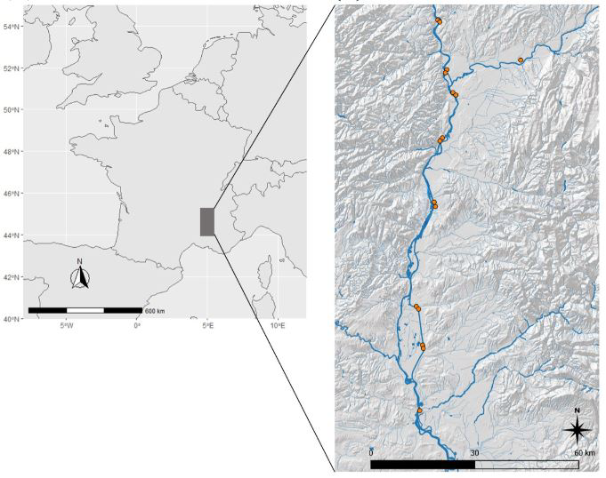

Table S1. Summary table of sampling dates, weather during field sessions and
information about herbaceous vegetation and landscape features for each sampled site.

Site identifier | Date of sampling | Mean temperature (°C) | Mean wind speed (m/s) | Vegetation covering (%) | Maximum height of vegetation (cm) | Mean height of prevailing plant stratum (cm) | Distance to nearest water body (m) | Distance to nearest woodland edge (m) | Proportion of woodland within a 1000 m radius
StPaul1 | 21/09/2022 | 20.0 | 1.8 | 50 | 30 | 20 | 325 | 27 | 0.27
Blv1 | 22/09/2022 | 18.9 | 1.0 | 80 | 90 | 70 | 122 | 35 | 0.12
Blv2 | 22/09/2022 | 18.9 | 1.0 | 90 | 100 | 70 | 120 | 31 | 0.12
Don1 | 23/09/2022 | 19.6 | 1.0 | 15 | 60 | 25 | 85 | 41 | 0.15
Don2 | 23/09/2022 | 19.6 | 1.0 | 15 | 60 | 25 | 73 | 63 | 0.16
Roc1 | 25/09/2022 | 16.7 | 1.0 | 70 | 30 | 10 | 142 | 14 | 0.20
Roc2 | 25/09/2022 | 16.7 | 1.0 | 70 | 30 | 10 | 147 | 26 | 0.24
Bol1 | 26/09/2022 | 16.3 | 1.2 | 80 | 100 | 70 | 111 | 30 | 0.12
Bol2 | 26/09/2022 | 16.3 | 1.2 | 80 | 100 | 70 | 98 | 42 | 0.11
Stge1 | 27/09/2022 | 18.2 | 0.0 | 95 | 50 | 30 | 67 | 32 | 0.51
Stge2 | 27/09/2022 | 18.2 | 0.0 | 70 | 50 | 20 | 255 | 16 | 0.43
Sau1 | 28/09/2022 | 15.8 | 1.0 | 70 | 30 | 15 | 118 | 38 | 0.22
Sau2 | 28/09/2022 | 15.8 | 1.0 | 70 | 30 | 15 | 76 | 60 | 0.23
Cad2 | 29/09/2022 | 15.4 | 4.4 | 95 | 110 | 50 | 61 | 61 | 0.10
Ozon1 | 30/09/2022 | 11.4 | 5.3 | 95 | 90 | 40 | 231 | 50 | 0.19
Ozon2 | 30/09/2022 | 11.4 | 5.3 | 80 | 60 | 10 | 270 | 53 | 0.19
Mean | - | 16.8 | 1.7 | 70.3 | 63.7 | 34.4 | 143.8 | 38.7 | 0.2

Taxa | Number of positions | Number  of trajectories
Mid-range echolocators  Pipistrellus nathusii  Pipistrellus pygmaeus  Pipistrellus kuhlii  Pipistrellus pipistrellus  Hypsugo savii | 6.477  2.689  1.719  1.290  727  53 | 710  291  214  122  77  6
Long-range echolocators | 301 | 86
Eptesicus serotinus | 44 | 8
Nyctalus leisleri | 253 | 75
Nyctalus noctula | 4 | 3
Short-range echolocators | 490 | 77
Barbastella barbastellus | 10 | 2
Myotis daubentonii | 88 | 14
Myotis natereri | 193 | 27
Plecotus austriacus | 155 | 24
Rhinolophus ferrumequinum | 44 | 10
Table S2. Summary table of the number of positions and flight trajectories for the Mid-range echolocators guild and species that it contains.

Figure S2. Histograms of the number of bat trajectories per number of co-occurring conspecifics (A), intra-guild heterospecifics (B) and inter-guild heterospecifics (C) individuals.

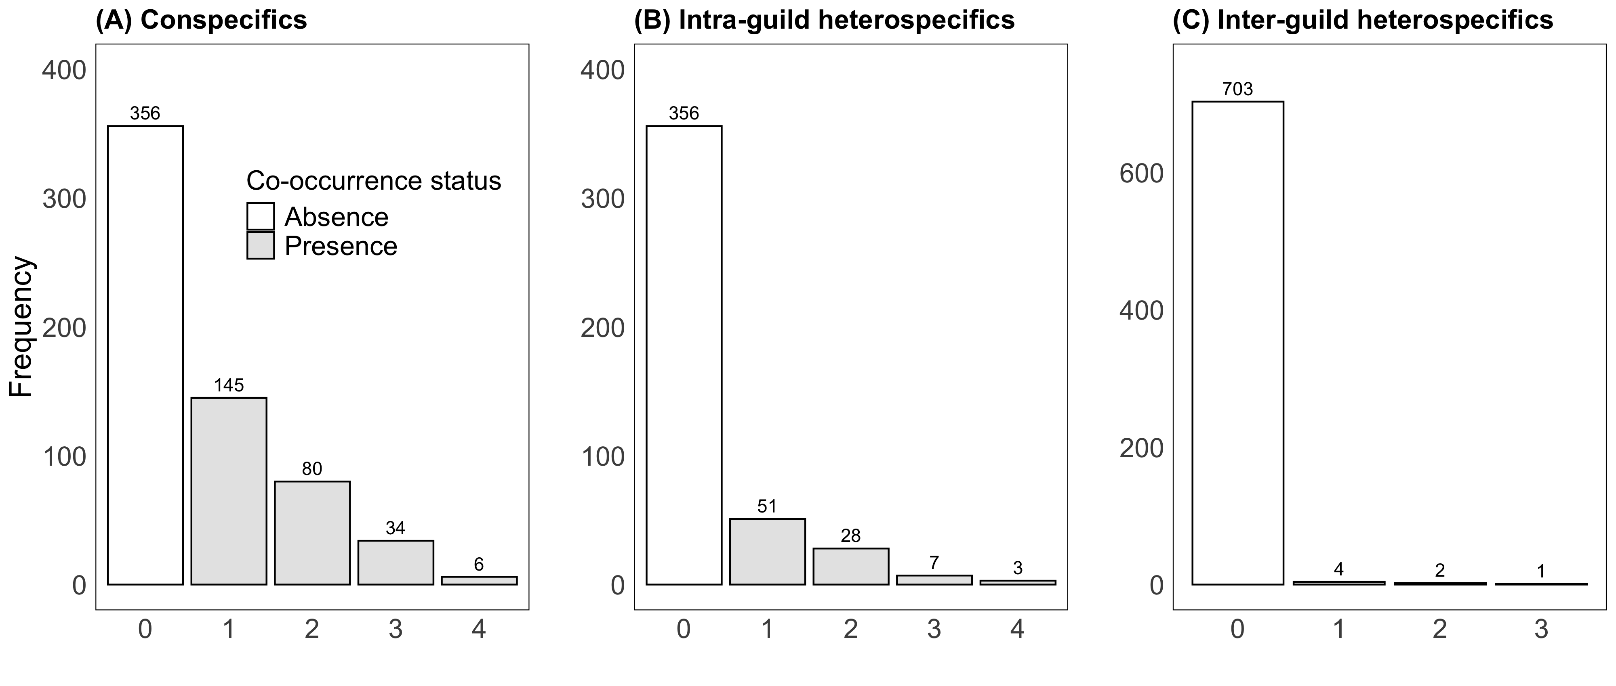

Figure S3. Residual plots of both conspecifics (A) and heterospecifics (B) models drawn from the R package DHARMa.

(A) Conspecifics
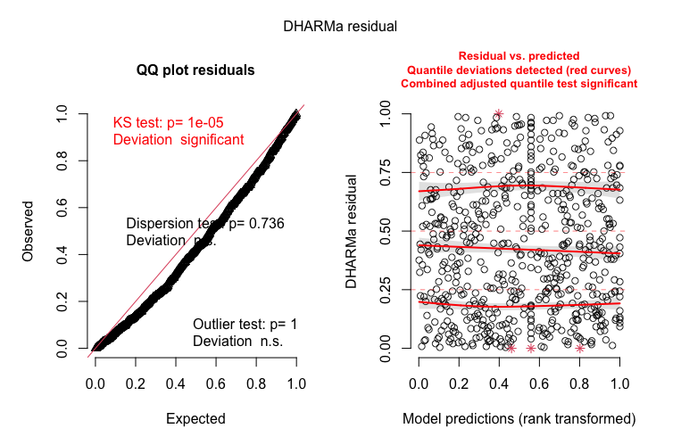
(B) Intra-guild heterospecifics
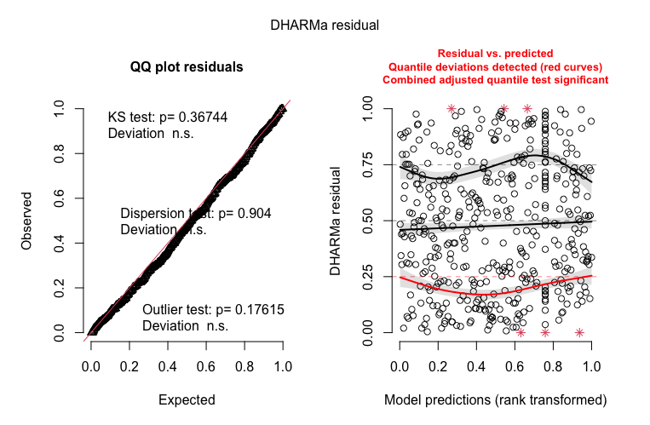

Figure S4. Histogram of the feeding buzz score variable.
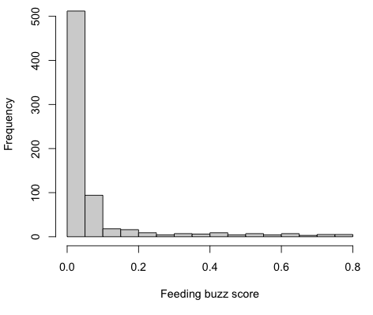
Figure S5. Residuals of models fitting the unnormalized response variable using a binomial distribution. Since residuals are of very poor quality, we retained the model that modelled the normalized response variable using a Gaussian distribution.
(A) Conspecifics
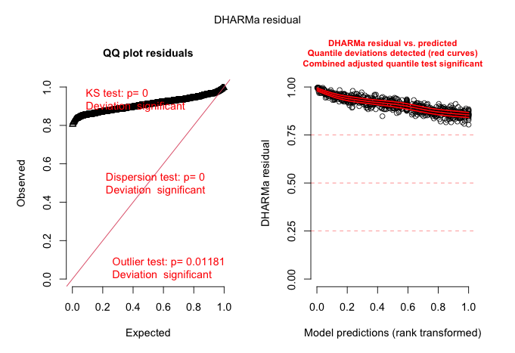

(B) Intra-guild heterospecifics
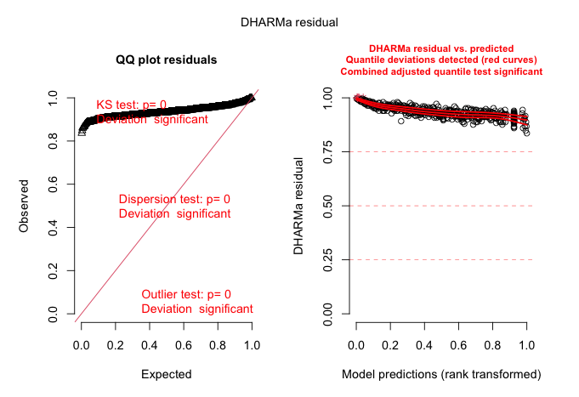
Post-hoc test | Estimate | SE | df | t.ratio | p-value
Conspecifics
Absence vs. Presence | -0.528 | 0.079 | 614 | -6.665 | < 0.001***
Flight speed : Absence | -0.108 | 0.030 | 614 | -3.599 | 0.003**
Flight speed : Presence | -0.066 | 0.034 | 614 | -1.956 | 0.051*
Intra-guild heterospecifics
Absence vs. Presence | -0.427 | 0.122 | 438 | -3.509 | < 0.001***
Flight speed : Absence | -0.108 | 0.031 | 438 | -3.459 | < 0.001***
Flight speed : Presence | 0.057 | 0.061 | 438 | 0.940 | 0.348
Table S3. Summary table of the estimated marginal means from post-hoc tests on
fitted models with emmeans R package.

Table S4. Estimates, standard errors, z values and P-values from GLMMs comparing the minimum flight speed of trajectories between the presence and the absence of conspecifics and intra-guild heterospecifics. The delta AIC (Akaike Information Criterion) exhibits the difference in AIC value of the models with the null model, when positive models are considered as better than the null model.
Variable | Estimate | SE | z value | P-value | delta AIC
Conspecifics model
Intercept | -0.094 | 0.073 | -1.292 | 0.196 | 0.96
Conspecific presence | 0.146 | 0.085 | 1.724 | 0.085 | 0.96
Intra-guild heterospecifics model
Intercept | -0.028 | 0.080 | -0.354 | 0.724 | -0.90
Heterospecific presence | 0.129 | 0.123 | 1.046 | 0.295 | -0.90

