Paper published in:
Hélot, Christine; Barni, Monica; Janssens, Rudi; Bagna, Carla (Eds.)
Linguistic Landscapes, Multilingualism and Social Change,
pp.233-248. Frankfurt-am-Main: Peter Lang (2012)

Kasper Juffermans & Jannet Coppoolse

How literate, low-literate and non-literate readers

read the linguistic landscape in a Gambian village

Summary
In this chapter we explore how visual messages in the public space of a Gambian village community are received and interpreted by people with various levels of literacy competency. We photographed all landmark linguistic landscape items (a total of 23 multimodal signs) on the main road that runs through the village and conducted ‘photo-stimulated’ interviews with twenty literate, low-literate and non-literate villagers. The participants’ responses were ordered on a continuum of ways of interpretation, from ‘perfect alphabetic reading’ to ‘no interpretation at all’, with intermediate categories of ‘reading images’ and ‘recognition through the background on the photo’. Our research suggests that personal literacy competence is a matter of degree and that there is a range of interpretive practices that people with various competencies draw on in order to make sense of the linguistic landscape surrounding them.

Résumé
Dans ce chapitre nous explorons comment les messages visuels dans l'espace public sont reçus et interprétés par des personnes ayant divers niveaux d'alphabétisation. Tous les éléments importants du paysage linguistique repérés sur la route qui traverse le village ont été photographiés (un total de 23 signes multimodaux). Puis, des entretiens « stimulés par les photos » ont été menés avec vingt villageois lettrés, peu lettrés et non lettrés. Les réponses des participants ont été classées selon la façon dont les signes sont interprétés, de « lire parfaitement » à « aucune interprétation », avec des catégories intermédiaires de « lecture des images » et de « reconnaissance grâce à l’arrière-plan sur la photo ». En conclusion, nous observons que la dichotomie analphabètes/alphabètes ne permet pas de saisir la complexité de la répartition des stratégies de lecture que les personnes ayant divers niveaux d’alphabétisation se servent pour saisir le sens du paysage linguistique les entourant.

1 Introduction

In their seminal work Reading Images, Kress & Van Leeuwen (1996) observe that under the influence of new technological affordances, literacy is becoming increasingly visual in its uses of multiple semiotic modes in a range of genres including advertisements, websites, school textbooks, instruction manuals, newspapers as well as the linguistic landscape (see also Iedema 2003; Kress 2003). This creates new demands as well as opportunities for consumers or ‘readers’ of such texts. It is, for instance, no longer sufficient to be able to ‘read’ in a narrow sense (i.e., to be able to decode the scripted symbols of written language) to be literate. One equally has to be able to ‘read images’ to be literate in a visual world. By the same token, those who have not learned to decode the scripted symbols of written language can draw on the less exclusive interpretive practices of reading images to understand and to participate in a world that is saturated with literacy. Although Kress & Van Leeuwen confine their discussion and conclusions to the Western world, only to suggest comparisons with non-Western cultural environments for future research, we propose to take some of their ideas to a small West African village and explore how visual messages in the public space are being read by literate, low-literate and non-literate villagers alike.

2 Sociolinguistic context

2.1 The Gambia

The West African country The Gambia (with definite article and capital ‘T’ according to common usage) has an estimated population of 1.7 million and a land surface of 10,380 square kilometers, which makes it the smallest but also one of the most densely populated countries of mainland Africa. The Gambia, surrounded by Senegal, has an elongated shape that follows the river by the same name some 470 kilometers from the continental savanna to the Atlantic Ocean. Socio-economically, it is ranked as 168th country (of 182) in the Human Development Index (UNDP 2009), which means that it is considered to be among the poorest countries in the world.
In common with many sub-Saharan African countries there is a strong urban-rural divide that dominates the geography and economy of the country. The most urbanised area is located in the Kombo districts in the west on the south bank, comprising of the capital city of Banjul and towns such as of Serrekunda, Kanifing, Bakau and Brikama. Urban Kombo accommodates the largest proportion of the Gambian population, the largest number of schools per head, most of the industry and the best access to modern life facilities such as tap water and electricity. Most of the country’s tourism activity, embassies and international organisations are also concentrated here. Country-wide the rural areas are dominated by agricultural land which is predominantly used for cultivating groundnuts for export, and rice, fruit and vegetables for domestic consumption.
As a former British colony, English occupies a prominent position in Gambian public life. It is the language of parliament, higher courts of law, the written media, tourism industry, and of the eight o’clock news on TV. It is also the de facto medium of instruction in schools from nursery to university level. It is not, however, the language most heard in minibuses, on markets, on school playgrounds, in people’s compounds, or in the rice fields. These more informal domains are occupied by The Gambia’s nine or so local languages: the Atlantic languages Wolof, Fula, Serer, Jola and Manjago, the Mande languages Mandinka, Bambara and Serahule, and the English-based creole Aku. While no statistics are available for language use, the decennial census provides the following figures for ethnic groups: Mandinka 36%, Fula 22%, Wolof 15%, Jola 11%, Serahule 3%, Serer 2%, Manjago 2%, Bambara 1%, Aku <1% (figures of 2003, GBoS 2007).
Within this ethnolinguistic diversity, there are two local languages that stand out as lingua franca: Mandinka and Wolof. In somewhat oversimplified terms, Mandinka is most widely spoken as a first and second language in the rural areas up-country, and Wolof assumes the role of vehicular language in the greater Banjul and Serrekunda area in the west of the country. Arabic occupies an important position in public life as well, in particular for conversational greeting and praying, as well as for religious education. For a more elaborate discussion of the language situation in Gambian society, see Juffermans & McGlynn (2009).
It should be obvious that multilingualism is the rule here as almost every Gambian typically makes use of multiple languages on a daily basis, however orally. In contrast to the linguistic diversity in the range of spoken media of communication, the linguistic landscape is surprisingly monolingual, with English as default language for literacy in the public space, in urban and rural areas alike.

2.2 A modern, multiethnic village

The site where we conducted our research is a modern, multiethnic village in southwest Gambia that is situated at approximately sixty kilometres or two hours travelling by public transport from urban Kombo.
The village is referred to here as a modern village because people have lived there for only three to four generations and because it was built around the structures of the modern (colonial and postcolonial) state. That is to say that it was built on both sides of the main road, connecting towns and villages on the south bank of The Gambia. The village stretches out along this road as well as a secondary road going to a riverine village further north. To the south there is only farmland and bush before the border with the Casamance region of southern Senegal. The east-west axis is important as well: people orient to the east when they pray and head west when they travel to the city.
The village is referred to as a multiethnic village because no ethnic group formed an absolute majority, even though the village is located in the Foni area that is historically dominated by Jolas, which means that the alkaloship (local political leadership) of the village remains in the lineage of its Jola founders. In a survey of multilingualism carried out by the first author and a colleague in July-August 2005 among 248 villagers of all ages, 33 percent responded by saying that they were Jola, 31.5 percent Mandinka, 17.5 percent Fula, nine percent Manjago and 6.5 percent Wolof. Further, 10.5 percent of interviewees declared that they had been born into an ethnically mixed marriage, and 8.5 percent reported that they were married to someone from a different ethnic group.
With regard to the linguistic resources available to this rural population, there are the local languages of the above and other ethnic groups, but also world languages such as English, French and Arabic, as well as Portuguese Creole. There was a clear lingua franca in the village, as revealed in the high number (95 percent) of respondents who declared to be speakers of Mandinka. As is the case for The Gambia as a whole, multilingualism is also the rule in this village, as Jola and Wolof were said to be spoken by more than half of the questioned population (59 and 57 percent respectively), and Fula by over a third (35 percent). English was claimed to be understood by 43 percent, Arabic by 14 percent and French by 9 percent.
For written communication English is the default language of literacy, although only a small number of villagers can read. English is the medium of instruction at all levels in the district school, even though informal spoken use of local languages in the classroom is widely practiced and de facto tolerated (cf. McGlynn & Martin 2009). As an alternative for the mainstream public school system, there is also an Arabic-medium Islamic madrassa boarding school at some distance where some children of the village are being sent to. A small number of children is not sent to school but kept at home to assist their parents with farming and other domestic chores. Elderly people in the village typically have not had any formal education and are illiterate and unable to speak English.

3 Investigating sociolinguistic village life and the public space

3.1 Fieldwork

As part of a larger ethnographic study investigating into language and literacy practices in Gambian society (Juffermans 2010), we embarked on a joint fieldwork trip in June-July 2008, which was a first visit for the second author and one in a series for the first author. We stayed in separate host families to participate in and observe village life. This experience was contrasted with simultaneous fieldwork in the urban area where we also stayed in different host families.
Guided by members of our host families, we made a tour around the village visiting shops, the clinic, two NGOs and the nursery school and were introduced to various families across the village. As strangers or guests (luntangolu), we spent many hours sitting under a mango tree along the road chatting and drinking attaya (strong Chinese green tea). We both made efforts to learn Mandinka in order to enable us to communicate with the non-English speaking members of our host families. Our primary behaviour as fieldworkers can basically be described as (deep) ‘hanging out’ (Geertz 1998) – talking, drinking, eating and sleeping in the village in order to experience and understand local life as much as possible. As we were interested in sociolinguistic life and as our companions or informants were equally interested in our lives and habits, much time was spend on discussing issues of language, literacy, culture, education, religion, but also travel, migration and globalisation. By and large, villagers were very collaborative in talking to us and helping us with our research, e.g., in the form of providing translation and interpretation when and where needed.

3.2 A corpus of linguistic landscape items

It was decided that we would focus our research on the linguistic landscape of the village. Linguistic landscape research had so far focused mainly on cities and urban places across the industrialised world (see Gorter 2006; Shohamy & Gorter 2009; and Shohamy, Ben-Rafael & Barni 2010; -- Coulmas 2009:14 is most outspoken in claiming that ‘linguistic landscape is really cityscape’) and so we were interested in exploring the linguistic landscape in a rural African setting. Linguistic landscape research had thus far also mainly focused on the landscape as a container of literacy products and not on the events and practices of people as users of these spaces (for critique, see e.g., Pennycook 2009; Garvin 2010 is an exception). In our study, we were therefore interested in involving the reading practices and experiences of people living in the landscape.
As a first step we compiled a corpus of linguistic landscape items. We photographed all landmark items on the highway running through the village. Mainly roadside billboards were photographed because they were most salient in the village and were visible for everyone. Moreover, the village’s billboards could be photographed comprehensively as there were only a very small number of them. The photographed signs included wooden and steel painted billboards put up by non-local actors, but also charcoal and painted graffiti on houses (e.g., telephone numbers and welcome messages). Also a flag and the printed clothes of the village’s alkalo were included in our small, but comprehensive corpus of linguistic landscape items. In all, over a distance of six kilometres along the main road, 23 signs were photographed. The photographs were printed on A5-format in black-white in urban Kombo and brought back to the village to be used in interviews with local users of the linguistic landscape. Only nineteen of these signs were selected to be used in the interviews, as some billboards were very similar to each other.
When looking for multilingualism in the corpus, we find that the local Gambian languages spoken in the village are not (or only very marginally) represented in the linguistic landscape. English is by far the dominant visible language in the public space of the village. Besides English, however, also the local language Mandinka and the global languages Arabic and Chinese are represented in our corpus.
Figures 1, 2 and 3 give examples of billboards we photographed. Figure 1 is a billboard of the national mobile telephone company Gamcel. This is an example of a billboard that is in English only, but makes productive use of visual resources to construct its meaning. The letter ‘l’ in Gamcel, for instance, depicts an antenna which visually suggests mobile telecommunication. The brand name is further recognisable by its use of a typical typeface and colour scheme. We hypothesised that even if one is not able to read the word Gamcel (i.e., to decode the graphic symbols of the roman alphabet) one would still be able to recognise and understand the sign as a whole as a Gamcel sign.
Figure 2 is the billboard of SMILE Irrigation Technologies. It is placed at the entrance of a community garden where an association of women does farm work. In the centre of the board a short written text in a large font gives the name, function and address of the garden. The images to the left and right of the text show what technologies are used in the garden, subtitled in English language in angular comic book balloons.
Figure 3 shows the billboard of Taiwan Technical Mission, an organisation that provides technical support for the irrigation garden. It’s a multilingual sign consisting of parallel English and Chinese text in traditional characters. Besides the text, the Gambian and Taiwanese flags are comradely depicted on top of the billboard.

3.3 Participant villagers

As a second step we started selecting participants for ‘photo-stimulated’ interviews. Twenty participants with various levels of literacy competency were invited to participate in the interviews. As a first question, they were asked if they were literate. On the basis of their answers (and further consultation with our research assistant and casual observation) they were divided in three groups: a group of four (high-) literates (who responded that they could read ‘very well’ – group HL), a group of seven low-literates (who responded that they could read only a little – group LL), and a group of nine non-literates (who responded negatively to the question if they could read – group NL).
We have followed Skar (1994: 261) in the use of the term non-literate as opposed to illiterate since the latter has a negative connotation (‘failed communication in a medium not mastered’) whereas the former emphasises orality as an alternative means of communication.
The classic sociolinguistic variables of sex, age and level of education of participants were noted and taken along in our analysis. Our twenty participants consisted of fourteen men and six women ranging in age between 14 and 85, including thirteen under the age of 30. Eight of our participants were high-educated (HE), six low-educated (LE) and also six formally non-educated (NE). Some of the high-educated participants were not permanent residents of the village but lived a part of the year or a part of the week in urban Kombo where their work or school was located. Most participants who are low or non-educated were described as farmer under occupation on their ID cards and were permanent village residents.
‘High-educated’ for our purposes here means that the participant has graduated from or is still attending mainstream English senior secondary school (grade 10-12) or a similar level of education at the madrassa school system. Low-educated means that the participant had only had a few years of education, until upper basic school (grade 6-9) as a maximum. ‘Non-educated’ means that the participant has had (practically) no formal education. To distinguish between mainstream English medium education and the Arabic medium Islamic alternative, the level of education has been specified with the abbreviations ‘Eng’ and ‘Ar’ in Table 2 below, where the other variables can also be found for every individual participant.

3.4 Photo-stimulated interviews

The main part of our research project consisted of ‘photo-stimulated interviews’. Each participant was asked individually for every sign: ‘What does it tell you?’ and ‘How do you know/see that?’ Interviews were done in English or, with an interpreter, in Mandinka. The various answers were tape-recorded and/or written down as literally as possible. Besides the answers, other relevant observations were also noted.
As an example, Table 1 gives the responses of all twenty participants for one sign, the billboard of Taiwan Technical Mission as reproduced in Figure 3. The first column gives the first names of the participants as well as the group they were divided into (literate, low-literate, non-literate). The second column gives the (summarised) responses for every participant. The third column gives the ‘ways of interpretation’ (WOI), i.e., the strategies used to read the signs, as explained in paragraph 4.1.

Table 1: Responses for the Taiwan Technical Mission sign (Figure 3)
Respondent | Response | WOI
Almameh (HL) | He reads the English text aloud. Audio recording: ‘This also is a joint project between the republic of The Gambia and Taiwan. Cooperation between these two countries to venture in agriculture. In Ndemban.’ | (1)
Abdoulie (HL) | He reads the English text aloud. Audio recording: ‘Taiwan Embassy is a co-funder in this project. A collaboration of Taiwan and The Gambia.’ | (1)
Sarjo (HL) | He reads the English text on the billboard aloud. Audio recording: ‘It is two countries, it is Taiwan and Gambia. Taiwan, they are helping Gambia, agriculture, particularly in this gardening. Found in rural areas here. This is Taiwanese writing, maybe this has the same meaning as this.’ | (1)
Abubacar (HL) | He says it is about cooperation between Taiwan and The Gambia. He also reads the English text aloud. | (1)
Manyima (LL) | She recognises the flags. She cannot read the Chinese script. | (6)
Baba (LL) | It takes time to read the English text. He reads: ‘Occupation: department of state for agriculture’. | (3)
Lamin (LL) | He recognises the flags of The Gambia and China. He hesitates about the Chinese flag. | (6)
Fatou (LL) | ‘Gambian flag, garden.’ | (6/8)
Fanta (LL) | ‘Flag of The Gambia.’ | (6)
Sainey (LL) | He only reads the word ‘Gambia’. | (5)
Yahya (LL) | ‘Taiwanese and Gambian flag.’ He reads: ‘Taiwan and Gambia’, this takes some time. | (3/6)
Mero (NL) | She doesn’t know what the billboard is about. | (12)
Lamin (NL) | ‘They work there from Besse. Banana farm, limono, mandarine, fruits and plants. Also plants.’ | (8/9)
Sirah (NL) | She doesn’t know what the billboard is about. | (12)
Malang (NL) | ‘Gambian and Chinese flag.’ | (6)
Ismaela (NL) | ‘Gambian flag.’ | (6)
Famara (NL) | ‘Flag of The Gambia and Senegal.’ | (6/10)
Abdoulie (NL) | ‘Flag here’ and she points at the flag of The Gambia. | (6)
Wuyeh (NL) | ‘Flag of The Gambia.’ | (6)
Isatou (NL) | She doesn’t know what the billboard is about. | (12)
Numbers in third column correspond to different ways of interpretation (WOI) on multimodal continuum: (1) perfect reading; (2) minor hesitations; (3) spelling words; (4) reading numbers only; (5) recognising ‘word pictures’; (6) reading images or logos; (7) recognition through text’s design; (8) recognition of sign as a whole; (9) recognition through background; (10) guessing; (11) prompted response; (12) no interpretation at all. Participants are divided in three categories of literacy: high-, low- and non-literate.

4 Ways of interpretation

4.1 A multimodal continuum

When the individual responses for every billboard are analysed and presented in a structured way, twelve different strategies of interpretation can be distinguished. Thus, an overview appears of the way public signs are being read, namely: (1) perfect alphabetic reading (i.e., reading in its narrow sense of decoding the scripted symbols of written language); (2) reading with minor hesitations; (3) spelling words; (4) reading numbers only; (5) recognising ‘word pictures’; (6) reading images (or pictograms, logos, etc.); (7) recognising a text’s design; (8) recognising the sign as a whole; (9) recognising the sign through the background of the photo; (10) guessing; (11) no interpretation (prompted response); (12) no interpretation at all.
Table 2 shows the different ways of interpretation used by our twenty participants. The vertical axis gives the names of the participants together with their estimated level of literacy (as defined in groups of HL, LL and NL) and the social variables of sex, age and their determined level of education, as described in paragraph 3.3. The horizontal axis plots the twelve above-described ways of interpretation. The numbers in the table indicate how often each subject makes use of a particular way of interpretation. The most frequent ways of interpretation per participant have been marked in bold and form a diagonal line from the top-left to the bottom-right corner.
There is a small group (scattered in the top-left of Table 2) of fairly confident readers that encounter no significant problems in decoding alphabetically scripted language. A relatively large group (scattered in the centre of Table 2) interprets on the basis of images, logos and design and the sign as a whole without being confident readers in the narrow sense of the word. There is an equally large group (scattered in the bottom-right corner of the table) that generally did not come at any significant interpretation. Another small group can be distinguished that only read numbers and/or frequently used words such as local place names.
From the data in Table 2 it becomes clear that other elements than written texts should be taken into account when studying reading practices. Other semiotic modalities play an important role in interpretation as well. The table shows a multimodal continuum of actual reading practices or ways of interpretation. It thus becomes clear that a dichotomy between being literate and illiterate is not descriptively adequate for the distribution of reading skills in the village.

Table 2: Ways of interpretation and social variables for each participant
WOI | (1) | (2) | (3) | (4) | (5) | (6) | (7) | (8) | (9) | (10) | (11) | (12)
Almameh (HL)  m, 26, HE-Eng | 17 |  |  |  |  | 2
Abdoulie (HL)  m, 28, HE-Eng | 16 | 1 |  |  |  | 2 |  | 1
Sarjo (HL)  m, 21, HE-Eng | 17 |  |  |  |  | 2
Abubacar (HL)  m, 17, HE-Eng | 14 |  |  |  |  | 3 |  | 1
Manyima (LL)  f, 17, HE-Eng | 5 | 6 | 2 |  |  | 2
Baba (LL)  m, 23, HE-Ar | 5 | 7 | 5 |  | 1 | 4
Yahya (LL)  m, 15, LE-Eng |  |  | 4 | 1 | 2 | 7 | 4 | 1 |  |  |  | 2
Fatou (LL)  f, 25, LE-Eng |  |  | 1 | 1 |  | 8 | 5 | 2 |  | 1 |  | 3
Lamin (LL)  m, 29, LE-Ar |  |  |  | 1 |  | 7 | 5 | 3 |  |  |  | 5
Fanta (LL)  f, 14, LE-Eng |  |  | 2 | 1 | 3 | 7 | 7 |  | 1 |  |  | 4
Sainey (LL)  m, 15, LE-Eng |  |  |  |  | 7 | 3 | 3 | 1 |  | 1 |  | 5
Malang (NL)  m, 42, HE-Ar |  |  |  | 1 |  | 7 | 3 | 4 | 1 | 4 | 1 | 2
Famara (NL)  m, 27, LE-Eng |  |  |  | 1 |  | 8 | 6 | 1 |  | 4 |  | 2
Lamin (NL)  m, 34, HE-Ar |  |  |  | 1 |  | 6 | 3 | 4 | 1 | 1 |  | 8
Abdoulie (NL)  m, 20, NE |  |  |  | 1 |  | 5 | 3 | 1 |  |  |  | 10
Wuyeh (NL)  m, 47, NE |  |  |  | 1 |  | 5 | 3 |  |  |  |  | 10
Ismaela (NL)  m, 85, NE |  |  |  |  |  | 4 | 1 | 1 | 1 |  |  | 12
Mero (NL)  f, 70s, NE |  |  |  |  |  | 3 |  | 1 |  |  |  | 15
Isatou (NL)  f, 40s, NE |  |  |  |  |  | 3 |  | 1 |  |  |  | 15
Sirah (NL)  f, 60s, NE |  |  |  |  |  | 3 |  | 1 |  |  |  | 16
Ways of interpretation horizontally: from (1) perfect reading to (12) no interpretation, as in Table 1. Names and social variables vertically: male/female; age; level and medium of education (high/low/non-educated; English/Arabic). Frequency of used WOIs indicated per participant in absolute numbers.

4.2 Reading across generations

Looking for the relationships between the ways of interpretation and the social variables sex, level of education and age in Table 2, roughly three groups can be distinguished. The first group is the group of confident readers and consists especially of high-educated young men (below the age of thirty). The second group used predominantly the various ways of interpretation in the middle of our continuum and consists of low-educated men and women of various ages. They interpreted on the basis of images, logos and design. Although they acquired basic reading skills in school, they do not greatly draw on these school-acquired skills in their ways of interpretation. The third group consists mainly of elderly men and women who received no formal education at all. They often could not give any interpretation, despite the availability of images or symbols on billboards.
Age and the level of education are important factors in the way the multi-semiotic signs are being interpreted. This factor appears to determine largely if alphabetic decoding and/or more creative visual reading strategies are involved in their interpretative practices. As the level of education correlates with the variables of sex and age, a relationship is thus established between these three variables and their reading practices or ways of interpretation.

4.3 Symbolic and functional literacy

The data in Table 2 can be supplemented with some observations. First, there was virtually no comprehension by any of our participants of written text in a language other than English, neither in the local language Mandinka, nor in the global languages Arabic and Chinese. These languages seem to have a largely symbolic function, as they are connected to identity – the national or cultural identity of the Chinese (Taiwanese) NGO sponsoring the vegetable garden (Figure 3) and the religious identity of the Islamic association of West Africa supporting Islamic education (not reproduced here). Although none of our participants could read the Arabic text in the signboard of an Islamic school, almost all of them recognised the script as being Arabic and acknowledged its association with Islam. An illustration of this symbolic value of the Arabic script can be given by the answer of a low-literate participant interpreting the billboard: ‘Islamic school and Islamic writing’.
A second observation concerns the local valuation of literacy and illiteracy. Some participants expressed no shame at not being able to read. One of them said during the interview that he did not consider it a problem that he could not read. There appeared not to be any social stigma regarding illiteracy. Another participant advanced that he had ‘no time to read’ and that others helped him with writing when needed. This way, non-literates still have access to literacy and can function nonetheless in a world that is saturated with literacy. It appears that collaborative literacy is an important part of the informal economy of the village community (cf. Juffermans 2011).

5 Conclusion

This small experimental ethnographic study aimed to shed light on the way literate, low-literate and non-literate people read the linguistic landscape. In the village, literacy is very unevenly distributed among men and women, younger and elderly persons, and by and large corresponds with education. In our introduction, we raised the possibility that visual literacy creates new demands as well as opportunities for readers of such public texts. As Kress & Van Leeuwen (2001) argued, reading involves much more than interpreting written text only. All semiotic modalities, like images, size, colour, layout, emplacement, materiality, etc. are involved in reading in a wider sense.
We wondered to what extent non- and low-literates could draw on visual ways of interpretation (e.g., reading images, recognising a text’s design) to understand multimodal texts in their environment. It turned out that there are a number of persons unable to make much sense of the signs presented to them (or of the task we presented them). These were, however, predominantly elderly persons. Our research also indicated that there is a very large grey zone between them and the perfect readers. This large category of low-literate readers as we have termed them in the title of this chapter draws on a variety of visual interpretative strategies to read the signs in their local linguistic landscape. They extract information mainly from extra-textual elements that are widely available in the public texts in their environment. Thus, a dichotomy between literates and non-literates, as often posited in population statistics, is descriptively inadequate to address the complexity of literacy as a local, situated practice. Rather, there seems to be a multi-semiotic continuum of reading practices and ways to interpret public texts that is variously available to readers. Low-literate readers who have difficulties decoding the scripted symbols of written language can and do indeed draw on more holistic semiotic interpretive practices (including ‘reading images’) to make sense of the literate world they live in.

Acknowledgement

We would like to thank Dorina Veldhuis and Jeanne Kurvers for comments and feedback on an earlier draft of this paper. We also wish to acknowledge the support of a student travel grant of the International Office and a departmental travel grant (both at Tilburg University) to carry out our field research.

Figures

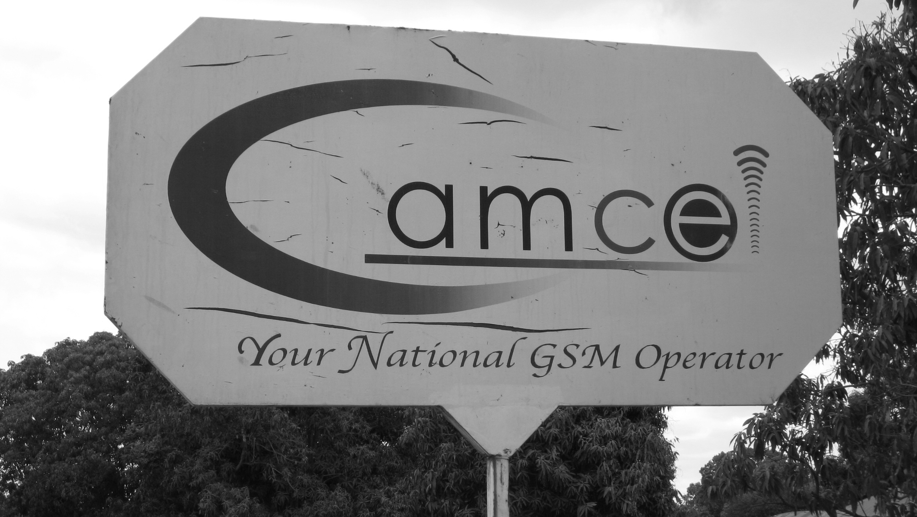
Figure 1: Gamcel billboard

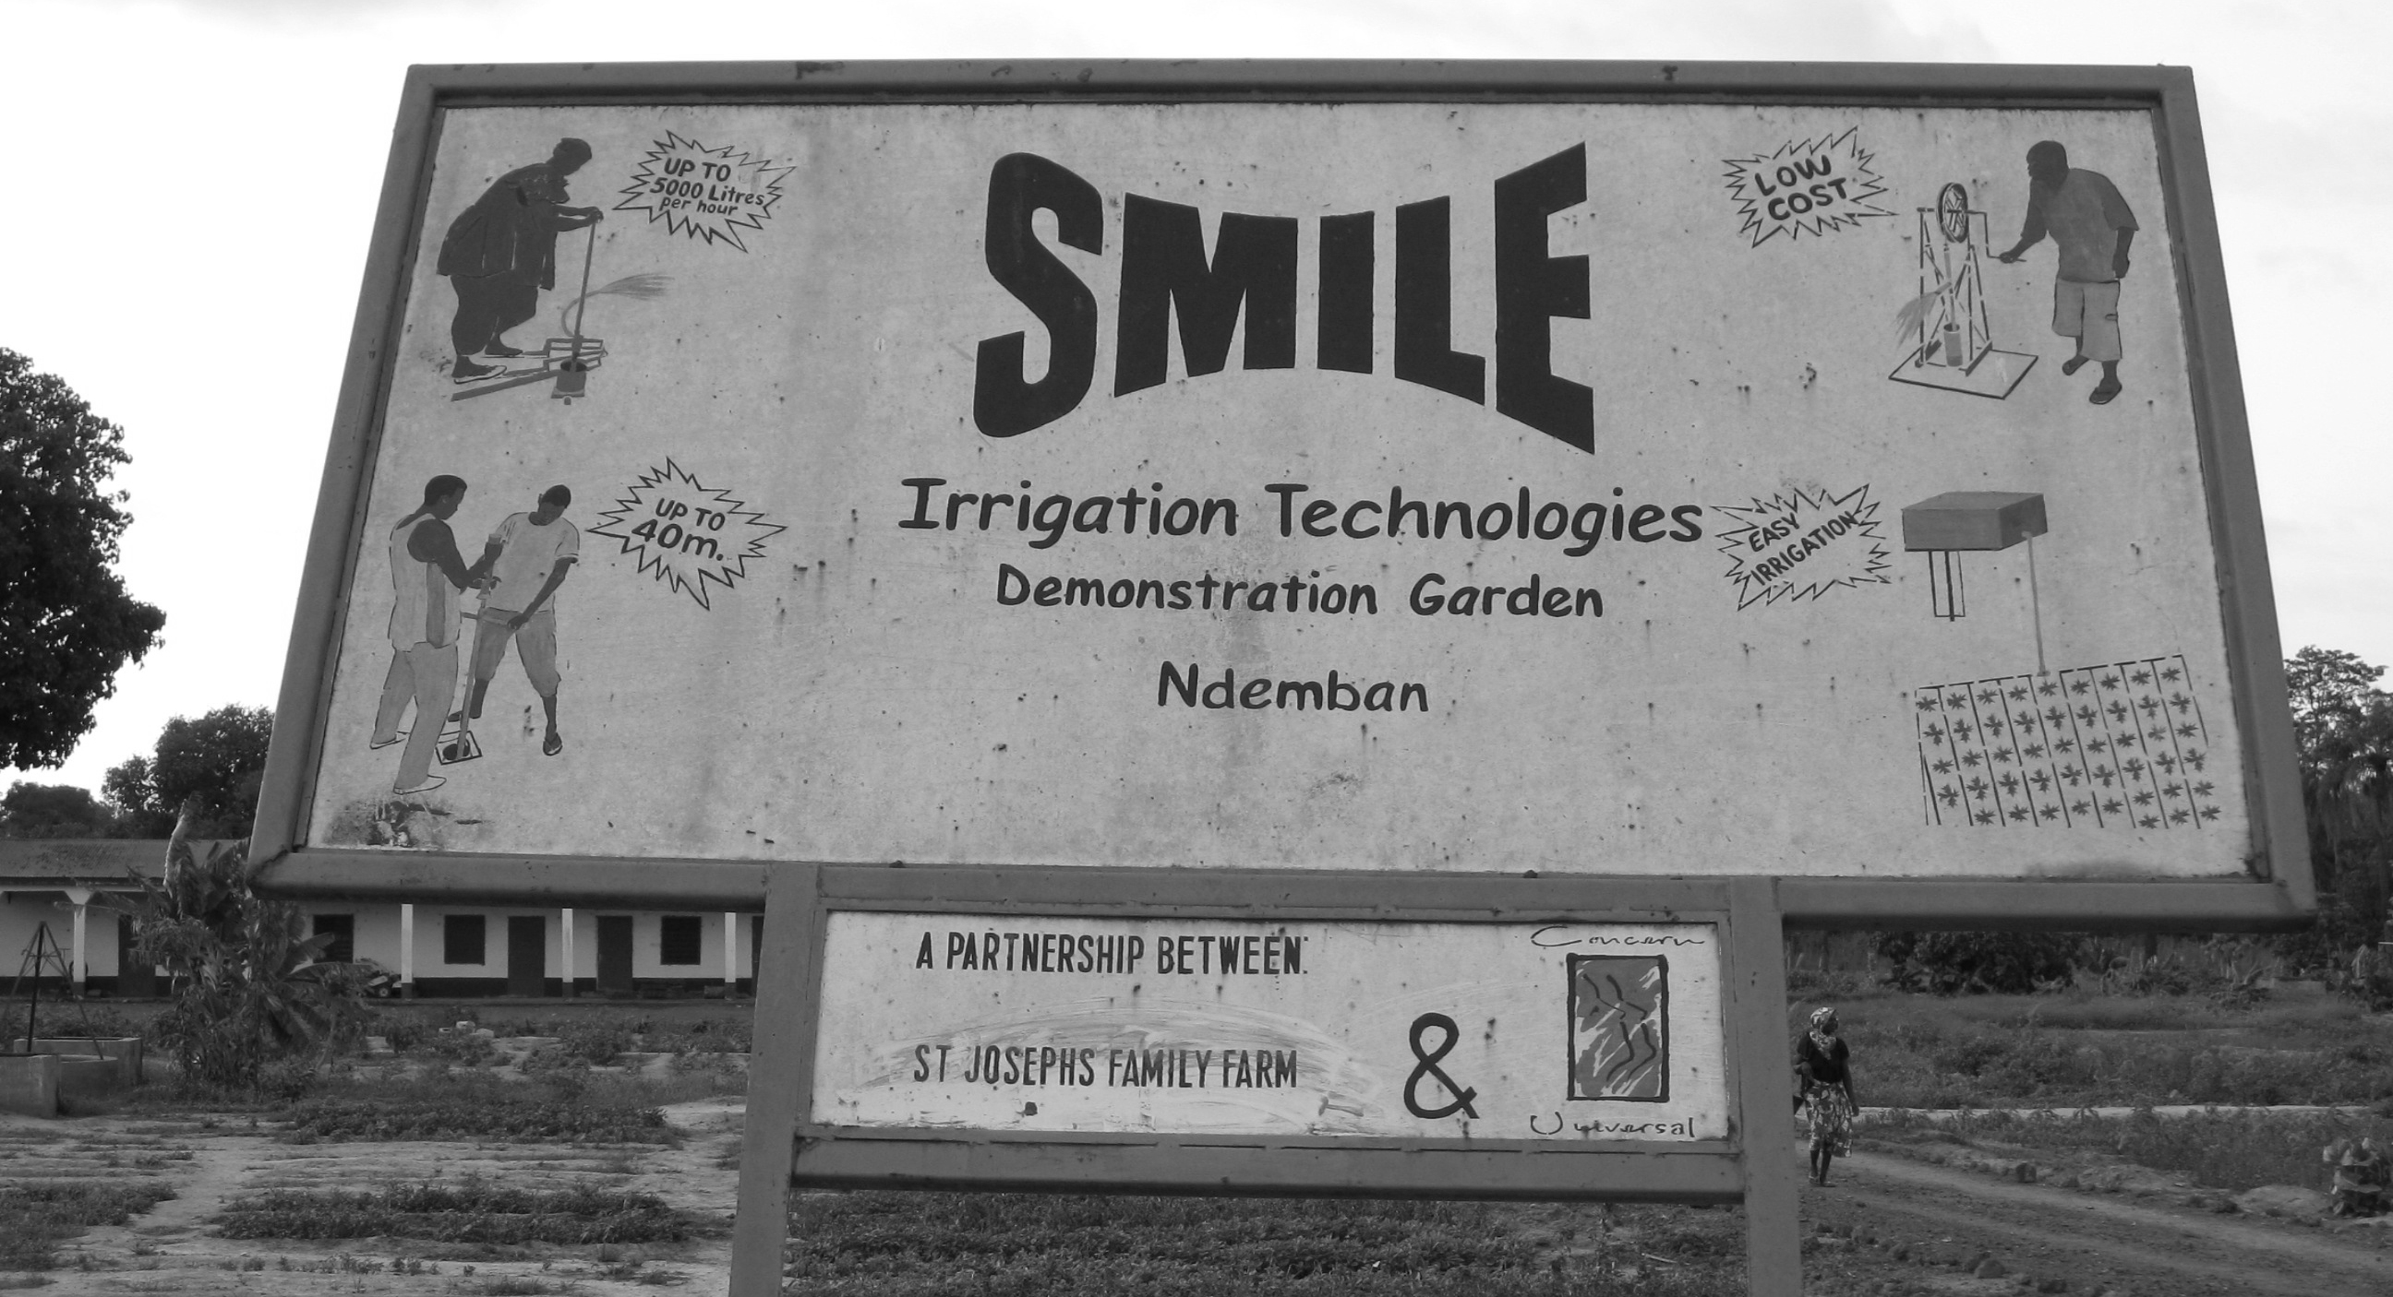
Figure 2: SMILE Irrigation technologies billboard

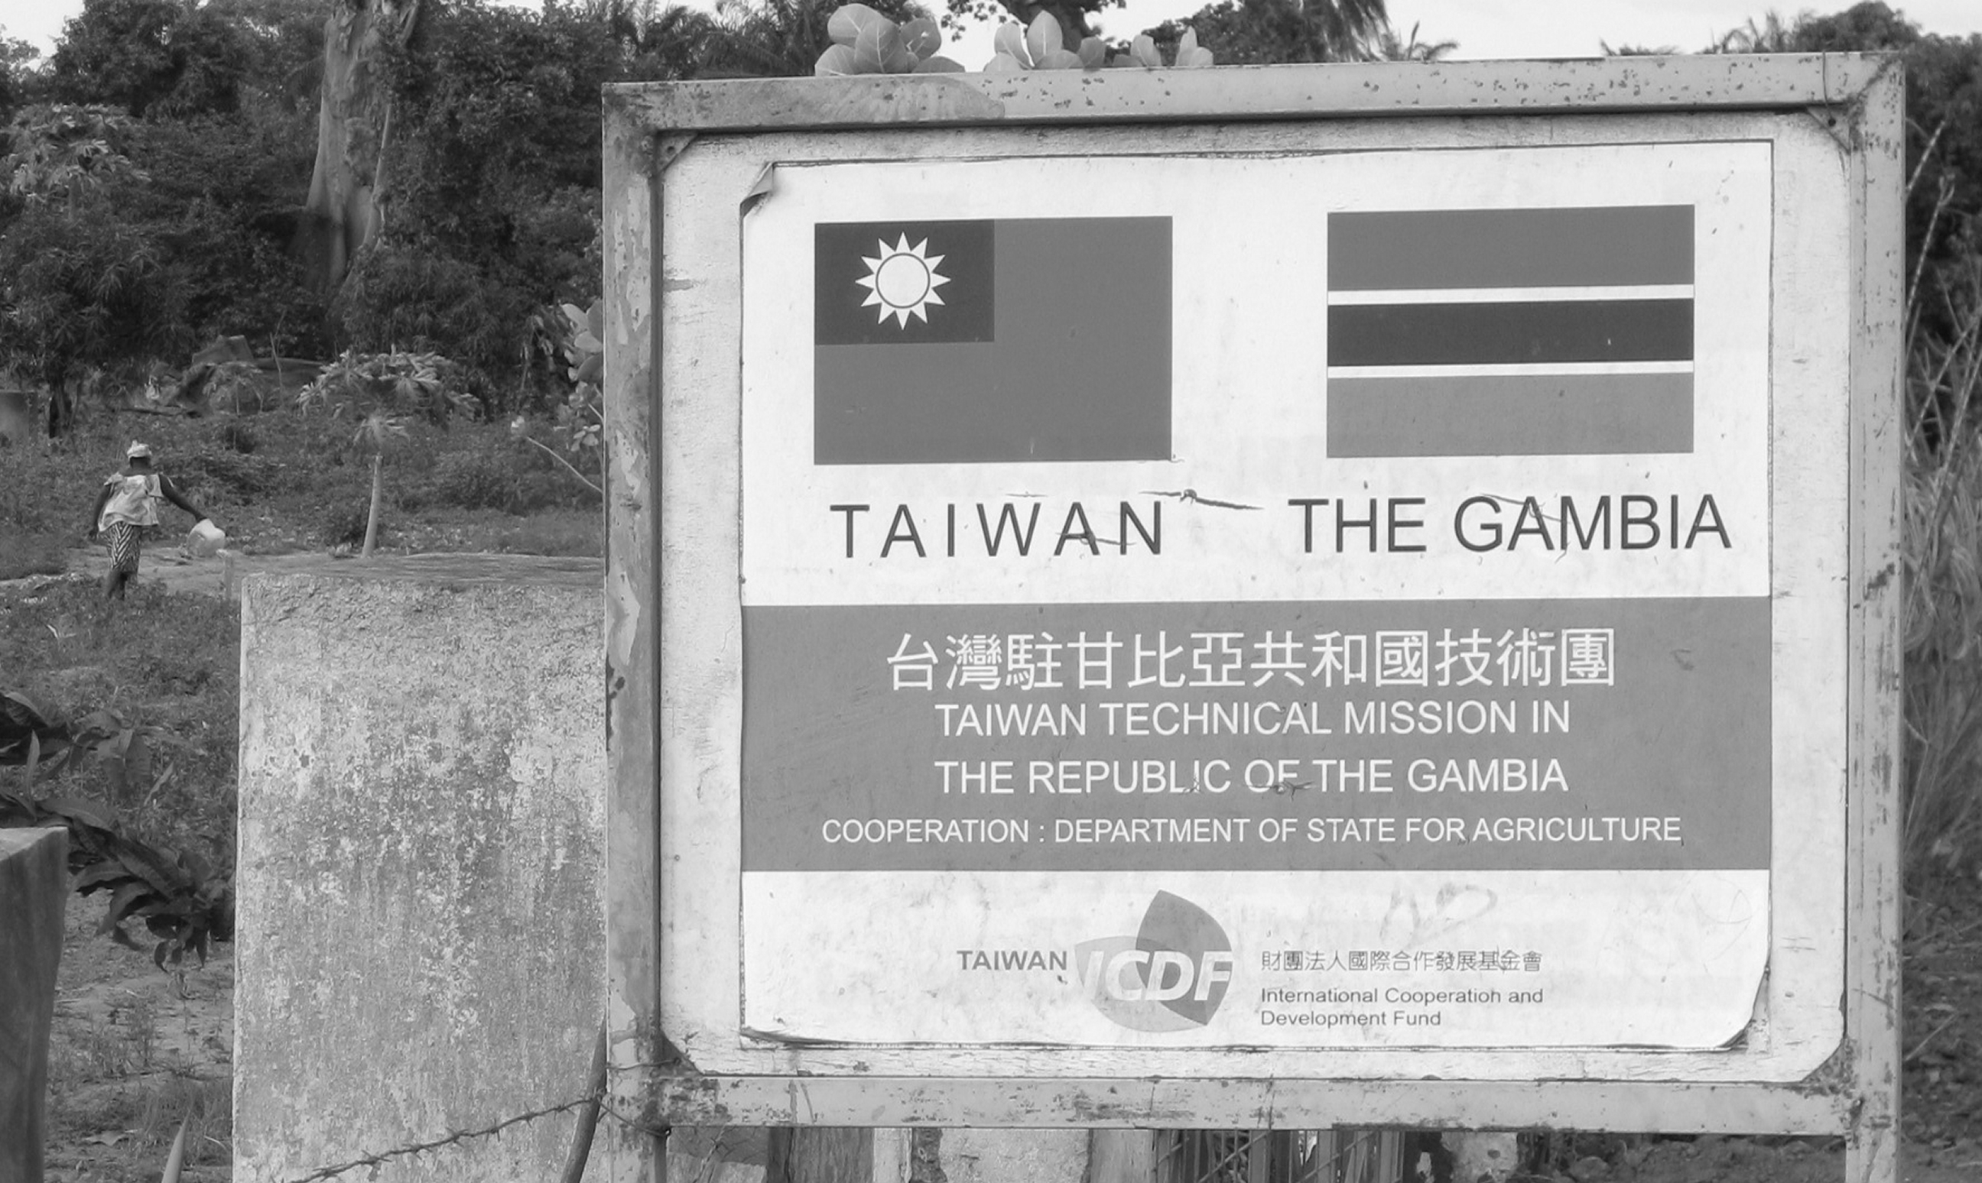
Figure 3: Taiwan Technical mission billboard

Bibliography

Coulmas, Florian (2009): Linguistic landscaping and the seed of the public sphere. In: Elana Shohamy / Durk Gorter (eds.) Linguistic Landscape: Expanding the Scenery. London: Routledge, 13-24.
Garvin, Rebecca (2010): Responses to the linguistic landscape in Memphis, Tennessee: An urban space in transition. In: Elana Shohamy / Eliezer Ben-Rafael / Monica Barni (eds.) Linguistic Landscape in the City. Bristol: Multilingual Matters, 252-71.
GBoS (2007): Population and Housing Census 2003. Personal communication with Mr Alieu Sarr: Specific enquiries into ethnicity, literacy, migration and religion. In. Kanifing: Gambia Bureau of Statistics, website: www.gbos.gm.
Geertz, Clifford (1998): Deep hanging out. The New York Review of Books 45: 22 October.
Gorter, Durk (ed.) (2006): Linguistic Landscape: A New Approach to Multilingualism. Clevedon: Multilingual Matters.
Iedema, Rick (2003): Multimodality, resemiotization: Extending the analysis of discourse as multi-semiotic practice. Visual Communication 2: 29-57.
Juffermans, Kasper (2010): Local Languaging: Literacy Products and Practices in Gambian Society. Tilburg University.
Juffermans, Kasper (2011): The old man and the letter: Repertoires of languaging and literacy in a Gambian village. Compare: A Journal of International and Comparative Education 41: 165-80.
Juffermans, Kasper / Caroline McGlynn (2009): A sociolinguistic profile of The Gambia. Sociolinguistic Studies 3: 129-55.
Kress, Gunther (2003): Literacy in the New Media Age. London: Routledge.
Kress, Gunther / Theo van Leeuwen (1996): Reading Images: The Grammar of Visual Design. London: Routledge.
Kress, Gunther / Theo van Leeuwen (2001): Multimodal Discourse: The Modes and Media of Contemporary Communication. London: Arnold.
McGlynn, Caroline / Peter Martin (2009): ‘No vernacular’: Tensions in language choice in a sexual health lesson in The Gambia. International Journal of Bilingual Education and Bilingualism 12: 137-55.
Pennycook, Alastair (2009): Linguistic landscapes and the transgressive semiotics of graffiti. In: Elana Shohamy / Durk Gorter (eds.) Linguistic Landscape: Expanding the Scenery. London: Routledge, 302-12.
Shohamy, Elana / Eliezer Ben-Rafael / Monica Barni (eds.) (2010): Linguistic Landscape in the City. Bristol: Multilingual Matters.
Shohamy, Elana / Durk Gorter (eds.) (2009): Linguistic Landscape: Expanding the Scenery. London: Routledge.
Skar, Sarah Lund (1994): On the margin: Letter exchange among Andean non-literates. In: Eduardo P. Archetti (ed.) Exploring the Written: Anthropology and the Multiplicity of Writing. Oslo: Scandinavian University Press, 261-76.
UNDP (2009): Human Development Report 2009. New York: United Nations Development Programme, online version http://hdr.undp.org.

Kasper Juffermans, MA (Ghent), PhD (Tilburg) is a sociolinguist in the School of Humanities and the Babylon Center at Tilburg University and since October 2011 also in the Linguistic Diversity Management in Urban Areas (LiMA) research cluster at the University of Hamburg. He wrote his dissertation on literacy and multilingualism (‘local languaging’) in The Gambia and is currently involved in two projects, one investigating Chinese-Dutch youth identity discourses in and beyond complementary schooling (with colleagues in Tilburg), the other investigating superdiversity and digital media (in Hamburg). His work appeared in journals such as Language Matters, Sociolinguistic Studies, International Journal of Educational Development and Compare: A Journal of Comparative and International Education.

Jannet Coppoolse, BHS (Eindhoven), MA (Tilburg) is a professional occupational therapist in geriatric care and an intercultural communication specialist. She has done volunteer work in development projects in Ethiopia and Ghana and conducted ethnographic fieldwork in rural Gambia, for which she was awarded the second prize in the Tilburg University Master’s Thesis Prize 2010. She has co-authored a Dutch language handbook of clinical occupational therapy for paramedics. She is currently travelling in Europe and Asia.

