Supporting Information

Water-templated growth of interfacial superglue polymers for tunable thin films and in-situ fluid encapsulation

Venkata S.R. Jampani^{1,2}, Miha Škarabot², Urban Mur³, Damien Baigl⁴, Ulrich Jonas⁵, Jan P. F. Lagerwall¹, Miha Ravnik³, Manos Anyfantakis¹*
¹Department of Physics and Materials Science, University of Luxembourg; L-1511, Luxembourg
²Condensed Matter Physics Department, Jožef Stefan Institute; 1000 Ljubljana, Slovenia
³Faculty of Mathematics and Physics, University of Ljubljana; 1000 Ljubljana, Slovenia
⁴PASTEUR, Department of Chemistry, École Normale Supérieure, PSL University, Sorbonne Université, CNRS, 75005 Paris, France.
⁵Department of Chemistry and Biology, University of Siegen; D-57076, Siegen, Germany
*Corresponding author. Email: anyfas.com@gmail.com

Materials
Key ingredients. At its core, the WRAPPINGS (Water-based, Room temperature, Atmospheric Pressure Polymerization of Instant Glues controlled by Surfactants) concept involves the exposure of the surface of an aqueous solution containing cationic species, which act as stabilizing accelerators for the polymerization of cyanoacrylate monomer. The three essential ingredients are: water, a cationic substance, and a monomer. We tested whether the following materials, both laboratory-grade and commercial products used in everyday life, can be successful key ingredients for WRAPPINGS:

Laboratory grade chemicals. Concerning laboratory-grade materials, the following were used:
- Water. Ultrapure water, conductivity 0.055 µS/cm, produced in the lab by an ultra-purification system; ACS reagent grade water, conductivity <10⁻⁶ MΩ∙cm
- Surfactants. Dodecyltrimethylammonium bromide, DTAB, purity ~99%; hexadecyltrimethylammonium bromide, CTAB, purity ≥99.0%; sodium dodecyl sulfate, SDS, purity ≥99.0%; the photosensitive surfactant azobenzene trimethylammonium bromide (AzoTAB) was synthesized as described in references^{[1]} and^{[2]}.
- Monomers. Ethyl cyanoacrylate, ECA, n-butyl cyanoacrylate, BCA, isopropyl cyanoacrylate, ICA; these monomers were purchased by Afinitica, Spain.

Commercial materials. Regarding commercial materials used in everyday life, we utilized the following (purchased online and from local shops):
- Water. Bottled drinking water, Spa
- Surfactants. Cloth softener (contains both cationic and non-ionic surfactants), Vernel
- Monomers. Instant adhesive (superglue), Pattex liquid and Uhu liquid, main ingredient: ethyl cyanoacrylate; tissue adhesive, 3M™ Vetbond™, main ingredient: n-butyl cyanoacrylate

Other materials. Apart from surfactants, we tested whether other substances containing cations act as STACCs; these were the following: poly (L-lysine), purchased in the form of aqueous solution (0.1% w/v); triethylamine C₆H₁₅N, purity ≥99%; sodium bicarbonate NaHCO₃, BioReagent, for molecular biology; sodium bromide NaBr, purity ≥99.99%. Furthermore, the following chemicals were also used: methylene blue, with dye content ≥ 82.0 %, used to show that a thick PBCA film coating a sessile drop withstands partial immersion in water and prevents dye leaching (Fig. 3f). Rhodamine B was used for studying the kinetics of dye release from a PBCA-encapsulated drop into a Phosphate Buffer Saline (PBS) buffer solution (produced from 20X concentrate, purchased by Thermo Scientific), see Fig. 3g, Fig. S30 and Movie S10; alanine (Carl Roth), purity ≥98.5%, and ninhydrin, ACS Reag. Ph Eur GR was used to analyze an aminoacid-indicator reaction using either liquid dumplings shown in Figs. 3, k-n and Movie S12, or sessile drops enclosed in a PECA chamber shown in Fig. S34 and Movies S15. Congo Red (TCI Chemicals), purity: >98.0%, used as a pH-sensitive indicator for detecting the release of gaseous acetic acid from a polymerized bubble, see Fig. 4, l-o and Movie S16; anhydrous glycerol (AppliChem GmbH), was used in the formulation of the aqueous CTAB solution employed for making gas bubbles.
Most soap bubbles were filled with ambient laboratory air. Some bubbles were filled with air saturated with acid vapor (Fig. 4, l-o, and Fig. S35, f and Movies S16) or base (Fig. S35, d-e). To collect such saturated vapors, a syringe was used immediately after opening a bottle containing either acetic acid (purity ≥99%) or triethylamine (purity ≥99%). Additionally, compressed CO₂ was utilized to make bubbles that contained either pure CO₂ or air-CO₂ mixtures, as shown in Fig. S35, a-c. Finally, commercially available Daphnia, a planktonic crustacean, was used to demonstrate the possibility of packaging living media with PBCA films, thanks to their biocompatibility, see Fig. 3, h-j and Movies S11.
All materials, except stated otherwise, were purchased by Merck; all materials were used as received.

Sample cells and polymerization chambers. For growing planar films on the free surface of an aqueous surfactant solution, the solution is typically kept within a black poly (propylene) screw cap (ROTILABO®, ND 18, purchased from Roth). Polymerization of surfactant solutions, either held within the lids or in the form of sessile drops placed on flat substrates, is then conducted by placing the samples inside poly(styrene) cell culture dishes, typically 100 mm diameter (purchased by VWR). Note that these culture dishes serve as polymerization chambers because their lids carry sessile drops of monomers (see TPF generation section below); the contact angle of the monomer drops was θ= 16 ± 2°. On the other hand, solidification of quasi-spherical and sessile soap bubbles was achieved by polymerizing them within Nalgene™ straight-sided wide-mouth polycarbonate jars, height 74 or 118 mm, inner neck diameter 64 mm (respective volumes 125 and 250 mL, ThermoFisher Scientific). The same procedure is used for sealing surfactant solutions held within smaller poly(styrene) culture dishes. For example, Fig. 3e shows a large volume of surfactant solution sealed with a PBCA film, and Fig. 3f shows a PBCA-coated sessile drop immersed in water. Culture dishes with diameters ranging from 35 to 100 mm (VWR) are used during this process. Additionally, this method is used for aqueous drops containing Daphnia (Fig. 3, h-j), and for carrying out the gas release experiments using solid bubbles (Fig. 4, j-o).

Substrates. In early experiments (see, for example, Fig. 2), PCA films were deposited on poly (styrene) culture dishes (VWR). However, these substrates are quite reflective; as a result, reflected light from the substrate (comprising all wavelengths of the illumination source) gets mixed with light of specific wavelengths that is selectively reflected by the PCA film due to thin-film interference. To minimize the contribution of the former and be able to study the interference colors solely, we deposited PCA films on poorly reflecting matte black substrates (see, for instance, Fig. 1c and Fig. S1). These were fabricated by depositing a black polymer layer on ordinary glass microscope slides. This was achieved by spraying the glass slides with a silicone resin-based spray (Maston heat resistant spray 600 ºC) purchased by a local hardware shop. This coating procedure was done three times, with 5 min waiting time between layers. After application of the spray, the glass slides were dried at the ambient temperature (~22 °C) for 30 minutes. Finally, the glass slides were baked at 200 ºC for 60 min for the coating to harden. Additionally, welding protection glasses (DIN 14 0196), purchased by Aulektro, were also used (see, for example, Movies S5-S6) because of their increased optical absorption, however, their reflectivity was still higher than the coated glass slides. Lids of culture dishes (also made of poly (styrene), VWR) were used as substrates for the AzoTAB solution sessile drops for photopatterning experiments (see Fig. S27).
AFM experiments for measuring the thickness (Fig. 1m, Fig. S11) and topography (Fig. S12) of PCA films required the use of very smooth substrates. For these experiments, PECA films, synthesized on the surface of aqueous DTAB solutions held within plastic lids, were transferred onto 10 mm x 10 mm Si wafer diced chips, purchased by Alpha Nanotech Inc. (thickness 650 µm, orientation <100>, P-type, Boron-doped, roughness< 0.5 nm). These samples were also used for optical microscopy imaging (Fig. 1, f-k, Figs. S8-S9) and reflection spectroscopy experiments (Fig. 1l, Fig. S10).
Quasi-spherical soap bubbles (Fig. 4b-e, Figs. S31-S32) were placed on a black, synthetic fabric (bought from a local store). This fabric was used because the bubble exhibited minimum spreading on it. Sessile bubbles were deposited either on pieces of PTFE sheet (Bola, thickness 1 mm, purchased by Bohlender, Germany; Fig. 4f-o, Figs. S34-S35), polymer-coated glass slides (Fig. S33), or PS culture dishes (Fig. S35).

TPF characterization
Optical microscopy and spectroscopy. We systematically analyzed TPFs grown on black lids using t_{pol} values from 5 to 60 minutes (Figs. S8 and S9). To ensure that the atmosphere inside the reaction chamber was always saturated with ECA vapor even for prolonged t_{pol}, we exchanged the monomer-laden lid with another lid carrying fresh ECA drops for the samples prepared for t_{pol} ≥ 35 min. The same set of TPFs was then transferred to Si substrates for further examination, as demonstrated in Movies S4 and S5. To perform spectroscopy and microscopic imaging of TPFs, we utilized a spectrometer (Ocean Optics, USB2000) and a Nikon microscope (LV100 Pol) equipped with a Pixelink camera (PL-A742). We employed reflection microscopy with a 20X magnification objective, which covered 428 μm X 343 μm area, to gather the TPF reflection color and corresponding reflection spectra of the same region. It is worth noting that we did not use polarizers or waveplates in the light path.
In order to evaluate the reflectivity and color variation of TPFs grown under different t_{pol} values, we utilized specific microscope settings. The microscope lamp power was set to the maximum while the exposure time was adjusted to 5 ms. We also adjusted the RGB color settings to 1 (red), 1.23 (green), and 1.9 (blue) in the Pixelink capture OEM software to match the macroscopic color of the film seen by the naked eye under ambient lighting conditions. We captured microscopic images of TPF reflections at various locations on the film, using a continuous set of TPFs grown with 5-minute polymerization steps (t_{pol}), as shown in Figs. S8 and S9. We observed that TPFs grown with t_{pol} values ranging from 1 to 30 minutes exhibited uniform, wrinkle-free films. However, for t_{pol} values ranging from 35 to 60 minutes, wrinkles appeared progressively, although the films remained uniformly colored, suggesting that the wrinkles were due to folding.
For the spectroscopy of the exact location where we have captured the images, we have used a few additional steps. We obtained the reference spectrum of the microscope lamp using a BB1-E02 broadband mirror (Thorlabs) and subtracted it with reflection spectra taken from the bare Si substrate used to deposit the TPFs. This baseline spectrum setting allowed us to determine the absolute percentage of the reflection intensity from TPFs grown at different time windows (t_{pol} = 1min to 60 min) at fixed DTAB concentration C_{s} = 2 mM (see Fig. S10). Note that the gradual increase of the interference peaks within the measurement window (400 nm to 780 nm) is the indication of gradual thickness increase of the TPFs with 5-minute polymerization steps (t_{pol}). To further confirm the TPFs thickness experimentally, we have conducted atomic force microscopy (AFM) analysis on the same films.

Scanning electron microscopy (SEM). To examine the TPF surface and thickness, we utilized SEM (JEOL, JSM 6010LA). The first step was to obtain a free-standing TPF, either with the procedures described above or by growing the film (and drying it) using a ring-shaped substrate (O-ring). We adhered the TPF to the surface of the specimen stub to be examined with SEM using tape. Before loading the sample into the SEM vacuum chamber, a 3 nm gold conductive layer was deposited on the TPF using a sputter (Quoram). Due to the softness of the films, a relatively low acceleration voltage (5 - 10 kV) was utilized at different magnifications (as seen in Figs. S4-S5). The surface topography of PECA and PBCA films revealed no structural features. Additionally, the TPF film had a uniform thickness of 70 μm throughout its length, as shown in Fig. S5. Besides employing O-rings to inspect the TPF surface features and thickness, we have also used flat SiO₂ substrates where TPF is grown and directly attached to SEM specimen stubs using double-sided adhesive tape. A featureless TPF surface is observed in all cases.

Film thickness measurement and film morphology analysis with Atomic force microscopy (AFM). The same series of films used for spectral analysis were scratched with a scalpel, and the TPF height and topography were analyzed. To measure the thickness of the film, we imaged its edge with the help of a Nanoscope III Multimode scanning probe microscope (Digital Instruments) in contact mode (Fig. S11). We used Nanoscope Analysis software to determine the height difference between the film and the Si substrate. Subsequently, we employed tapping mode AFM to inspect the surface of each film (Fig. S12). Our observations suggested that the topography of the film is mostly even and does not undergo significant changes during the polymerization time. Moreover, the image RMS roughness is R_{q}≈ 4 nm, slightly increasing as the polymerization time (t_{pol} = 1 min to 60 min) increases.

Measurement of mechanical properties of PCA films with AFM. We have used the same AFM instrument to measure the elastic modulus of both PECA and PCBA films. The AFM was operated in force mode using special cantilevers (Nanosensors, SD-Sphere-NCH-S) with a spherical tip (diameter 2R = 0.8 µm). We have used the Hertz model^{[3]} for the parabolic tip to determine the Young’s modulus E of the film, which is related to the compressing force F through
$$F=\frac{4\sqrt{R}}{3} \frac{E}{1-v^{2}} δ^{3/2}$$

Where δ is the deformation of the film, R is the radius of the tip curvature, and ν is the Poisson's ratio of the film. Many force-deformation curves for each polymer were obtained (using different films). The average values of Young’s modulus obtained are E_{PECA} = 1.6 ± 0.5 GPa and E_{PBCA} = 0.5 ± 0.2 GPa by considering ν = 0.4 (see Fig. S6).

Fourier transform infrared-attenuated total reflection (FTIR-ATR) spectroscopy. We used a Perkin Elmer Spectrum 400 to carry out FTIR-ATR measurements and study the presence of DTAB molecules within PECA TPFs. To see the vibrational modes of C-H stretching^{[4]}, we used pure DTAB powder. To systematically investigate the presence of DTAB in PECA, we grew TPFs starting from 0 mM DTAB (pure water) and gradually increased the DTAB concentration in the TPFs using 2 mM, 5 mM, 10 mM, and 20 mM solutions. The TPFs were grown for a fixed time t_{pol}= 20 minutes and then transferred to clean glass slides. Fig. S24 displays detailed spectra that indicate the presence of specific ester vibrations characteristic of PECA and not present in DTAB alone^{[5]}. These vibrations can be observed in TPFs grown with varying concentrations of DTAB solution. Additionally, the TPFs exhibit symmetric CH₃ and N-CH₃ vibrations of DTAB, with the band intensities gradually increasing from lower to higher DTAB concentrations in the aqueous subphase onto which the PECA TPFs are grown.

Daphnia observation through a PBCA-coated water drop. A single Daphnia was placed in a 200 μL water puddle containing a small amount of DTAB
(C_{s}= 100 µM). As mentioned in the main text, this low surfactant concentration was found to be low enough not to harm Daphnia, however, it is adequate to yield a robust TPF on the free surface of the puddle upon exposure to BCA vapor. The biocompatible PBCA film was grown on the water surface for t_{pol}= 30 min, and the swimming Daphnia was observed during the polymerization time, as well as for 60 min after the end of the polymerization (see Fig. 3h-j and Movies S11). Only one animal is used for the experiment shown. Note that, after experiments with Daphnia, we have returned the crustaceans to their native aqueous solution. We did not perform any post-release observations. Commercially available Daphnia were chosen for the experiments due to their ready availability and the suitability of these organisms for demonstrating the packaging capability of WRAPPINGS.

Preliminary polymer characterization. Two series of films, each one produced under the exact same conditions, were prepared by applying WRAPPINGS on the surface of sessile drops (volume 100 µL) of aqueous DTAB solution (C_{s}= 1 mM) sitting on polymer-coated glass slides. The first series comprised six light blue PECA films produced for t_{pol}= 20 min (total mass ~ 0.5 mg), whereas the second series consisted of six purple films prepared for t_{pol}= 80 min (total mass ~ 2.1 mg). All films were deposited on substrates (using the procedures described above) and were then collected as free-standing films. Subsequently, they were dissolved in acetone to perform characterization experiments. Gel permeation chromatography experiments indicated that the number-averaged molecular mass (M_{n}) and the dispersity (Đ) of the films produced for t_{pol}= 20 min ranged from about 86 to 141 kg/mol and 1.3 to 1.8, respectively; for the films prepared for t_{pol}= 80 min, M_{n}≈132 kg/mol and Đ≈ 2.3. These preliminary results, however, must be considered with caution because the amount of material (i.e., PECA) available for characterization was minimal. Due to their nanometric thickness, the sample mass available for each TPF is tiny (on the order of 0.05 mg); therefore, producing a large amount (on the order of a few mg, at least) requires a massive number of identical experiments and for accurate data possible with a total of 100 mg material we need to have 2000 identical experiments. Although we here show that this task is indeed possible, it extends well beyond the scope of the current manuscript and will be the subject of future work.

Additional experiments to understand the role of surfactant in TPF growth. We performed additional experiments with different cationic surfactants, such as CTAB and DTAB, and anionic surfactants, such as SDS, to fully understand the role of the surfactant (Figs. S17, S20). A schematic of the interfacial system is shown in Fig. S18. We compared these experiments with ultrapure water that did not contain surfactants. As shown in Fig. S19, the growth of PECA films formed on ultrapure water is slower than films grown on the DTAB-containing water phase. In addition, the PECA films grown on ultrapure water were transparent and fragile, as shown by the broken pieces of the film. AFM experiments confirm this comparatively slow growth: for a given polymerization time (t_{pol}= 20 min), the film thickness is d_{f}≈ 40 nm and
d_{f}≈ 180 nm, for C_{s}= 0 mM and C_{s}= 2 mM, respectively.
We attribute the results of slower TPF growth on ultrapure water to the contribution of two main factors. First, the surface of ultrapure water, which is rich in H₃O⁺ and OH⁻ from the dissociation equilibrium of water, acts as a giant initiation site for anionic polymerization^{[6]}. This leads to a high number of carbanions at the water surface due to fast anionic reaction rates, yet the polymerization rate is limited due to a diffusion-controlled monomer supply from the gas phase (Fig. S18). Secondly, it is known that water molecules also act as a termination agent due to the binding of protons (from H₃O⁺) to the carbanion^{[7]}. As a result, the growing macromolecules are often terminated by the abundant H₃O⁺. Note that these two effects mentioned above should not be significantly affected by the presence of added salt. This is supported by the fact that the addition of NaBr to the subphase did not facilitate colored TPF growth. In fact, a PECA film grown on a NaBr solution is transparent and fragile (Fig. S17), similar to films grown on ultrapure water. This result rules out the possibility that the Br anion alone is responsible for the generation of colored TPFs.
The difference in the fragility (which is due to the difference in film thickness) of the PECA films formed when using NaBr as opposed to a robust one when using NaHCO₃ at the same concentration (Fig. S23), can be attributed to the differing roles these substances play in the polymerization process. NaHCO₃ acts as a weak base when dissolved in water. It captures excessive free protons (H⁺) resulting from the self-dissociation of water, reducing the reversible termination rate of the polymerization reaction (Fig. S18). This leads to a higher concentration of anionic chain ends and, thus, more active sites, effectively increasing the polymerization rate and leading to the formation of a more robust PECA film. In contrast, NaBr acts only as a neutral electrolyte, not significantly influencing the pH or the concentration of the active sites. Consequently, the polymerization rate is comparatively lower, resulting in a thinner and, hence, more fragile PECA film.
However, surfactants have a direct influence on TPF growth. A report by Limouzin et al. shows how BCA polymerization in miniemulsion droplets with dodecylbenzenesulfonic acid is slowed down by introducing protons from the sulfonic acid head group to cause efficient (reversible) termination at the monomer-water interface^{[8]}. However, our experiments show that anionic surfactants (SDS) do not accelerate TPF growth at the air-water interface (Fig. S20). This is in stark contrast to cationic surfactants, which led us to hypothesize that the cation at the interface accelerates TPF growth, and water, as a highly polar solvent, promotes ion dissociation. To test this hypothesis further, we performed interfacial polymerization experiments with water containing a positively charged and surface-active polyelectrolyte, namely poly(L-lysine). We obtained colored TPFs that are qualitatively similar to those obtained with DTAB and CTAB solutions (Fig. S21). This confirms that cations near the liquid interface accelerate the growth of TPFs.
As shown schematically in Fig. S18, the positively charged head group of the surfactant, located at the interface between air and water, creates a two-dimensional nano-environment that serves as a template for the growth of the polymer chains. This 2D interface allows efficient access to the supply of monomers from the gas phase, which are delivered directly to the active sites of the growing chains. Furthermore, the cationic interface suggests that the dissociation equilibrium between the positive counterion from the surfactants and the active anionic ECA chain end controls the rate of polymerization. This strong ion dissociation of the negative active chain end and the large tetra-alkyl ammonium group is probably not present in salts, polyelectrolytes, or surfactant-free pure water, resulting in a slower and disordered polymerization process leading to transparent non-colored TPFs.
Furthermore, we suspect that this behavior may be even more complex and resemble the differences in reaction pathways based on the differences in alkyl substitution observed in the reaction between CAs and various substances used to promote adhesion between polyolefin surfaces bonded with instant adhesives. For example, tertiary amines with long alkyl chains are effective promoters in contrast to primary and secondary amines^{[9]}. The higher adhesive bond strength achieved with tertiary amines is attributed to the rapid initiation of high molecular weight polymer formation. In contrast, the reaction of primary and secondary amines initially leads to aminocyanopropionate esters and, thus, to lower molecular weight adhesive polymers^{[10]}. Indeed, our experiments have shown that colored TPFs form on the surface of aqueous triethylamine solutions (Fig. S22), which have already been reported to lead to high molecular weight poly(cyanoacrylates), with an appearance similar to those formed with DTAB solutions^{[10]}. As shown in Fig. S23, the colored TPFs were prepared with aqueous solutions of sodium bicarbonate (baking soda), which is used in numerous household and laboratory applications due to its ability to generate high molecular weight PCAs^{[11]}. Therefore, the complex interplay of the stabilizing effect of the surfactant head on the growing chain is akin to the effects of ions bound to bulky groups on anionic polymerization in solution.
It is worth noting that much higher concentrations of poly (L-lysine) (ca. ≥ 0.05 wt.%) than DTAB (C_{s}≥ 1 µM= 3x10⁻⁵ wt.%) are required to see the formation of qualitatively similar TPFs (Fig. S21). Analogously, higher concentrations of triethylamine (≥ 0.5 mM= 3x10⁻³ wt.%, Fig. S22) and sodium bicarbonate (≥ 0.5 mM= 4x10⁻³ wt.%, Fig. S23) are necessary for TPF formation indicating surfactant high surface activity promoting TPF growth confined to the interface. We attribute this to the amphiphilicity and, thus, the inherent high surface activity of the surfactant. This is in contrast to the hydrophilic poly(L-lysine) (polycation), triethylamine (amine), and NaBr (electrolyte), which are not classified as strong amphiphilic molecules. Hence, given that a higher concentration of cations is required at the interface, a lower total (i.e., bulk) concentration of surfactants than polyelectrolytes or bases is necessary to observe the same effect. This is reminiscent of the minute (~µM) surfactant concentrations (as opposed to much higher electrolyte concentrations) required for driving the formation of 2D colloid crystals at the air-water interface^{[12]}. These findings have dual importance. First, they indicate that a µM amount of cationic surfactant can accelerate the growth of TPFs at a fluid interface by electrostatically stabilizing the growing anionic CA chains. Second, the capability of naturally occurring species, such as polyelectrolytes, to act as stabilizing accelerators allows TPF preparation using only biocompatible chemicals. This might be a unique advantage when employing WRAPPINGS in applications of biochemical relevance like liquid encapsulation, as discussed in the main text.

Packaging of Daphnia within a PBCA-coated water puddle. This exploratory experiment aimed to showcase the feasibility of encapsulating, in-situ, a living organism within its native liquid environment using the WRAPPINGS concept. To demonstrate this, we used a commercial veterinarian BCA-based product for the packaging of a large (≈ 2 mm), transparent-bodied water flea, Daphnia. Our focus was solely on observing the crustacean for a short duration (via microscopic observation, 30 minutes during polymerization, and 60 minutes post-polymerization; see Movies S11). The Daphnia exhibited normal swimming behavior throughout the experiment, as no significant changes in swimming behavior were observed.
It must be noted that we did not aim at toxicological testing. A primary toxicological study would require a minimum of 2 days of exposure to PBCA polymers and a larger number of Daphnia. Given the short duration and limited scope of our experiment, toxicological analysis was not deemed necessary; however, this is undoubtedly an exciting topic for future research.

Influence of monomer evaporation rate on the WRAPPINGS process. We expect that any factor influencing the rate of evaporation of the monomer from the liquid phase (monomer drop) to the gas phase (air) can affect the rate of the polymerization reaction, especially in the early stages of it. However, the effect of the monomer evaporation rate on the polymerization kinetics may be diminished once the monomer concentration in the gas phase reaches saturation. Note that there can be a steady state with monomer saturation, provided that the mass of monomer provided by the evaporating monomer drop exceeds the mass of monomer consumed at the air-water interface.
Regardless of whether they will impact only the polymer growth rate at the early stages of the whole polymerization process, such factors include experimental conditions like the ambient temperature (T) and pressure (P) or even geometrical factors, such as the surface area of the monomer drop (A_{mon}, directly linked to the wettability of the monomer drop on the substrate, that is the lid of the Petri dish). Also, note that the monomer evaporation rate decreases with time due to the polymerization (e.g., initiated by moisture) at the surface of the monomer drops. One would expect that when the monomer evaporation rate increases (this will happen with increasing T, P, or A_{mon}), the polymer growth rate increases as well due to the availability of more monomer to the reaction sites. However, one also must consider the effect of T and P on the polymerization process itself. Algaier et al. studied the dependence of the rate of polymerization and molecular weight on T of poly(ethyl cyanoacrylate) (PECA) produced by the superglue fuming of latent fingerprints. They found that the amount of PECA produced increased with decreasing T, while the molecular weight of the polymer did not vary much with T. This was attributed to an increase in the extent of the dissociation of the ion pair that initiates the polymer chain growth and resides on the end of the growing macromolecular chain at lower T; this loosening improved the rate of initiation and propagation.^{[13]} This example highlights the complexity of the film formation process, in which key phenomena (e.g., monomer evaporation rate and polymer growth rate) have drastically different dependencies on T. Therefore, dedicated research must be designed and executed to establish a solid picture of the influence of T (and other ambient conditions, e.g., P) on the WRAPPINGS process.
Supplementary Figures S1 to S37
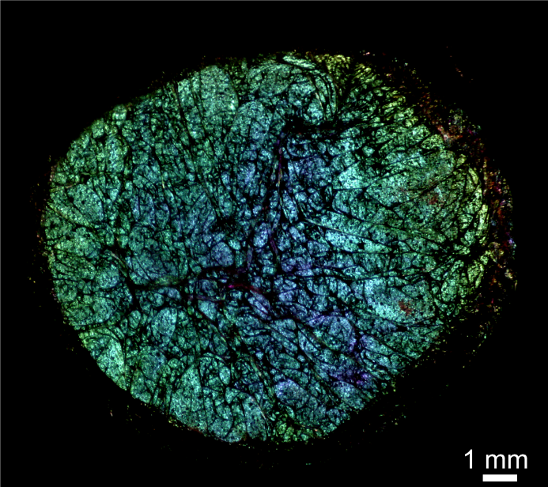
Fig. S1. A dry PECA film was deposited onto a polymer-coated glass substrate. The reflection micrograph of a dry PECA film was grown on the free surface of a sessile drop of an aqueous DTAB solution (C_{s}= 2 mM, volume 100 µL). The surfactant solution drop was placed on a black polymeric substrate (kept inside a culture dish, diameter 100 mm, volume≈ 173 cm²) and exposed to ethyl cyanoacrylate vapors of a commercial superglue (4 drops x 4 µL each) for t_{pol}= 3645 s (see Movie S1). The dry film was obtained by draining the water via the capillary action of a lint-free paper tissue put in contact with the edge of the polymer-coated drop and letting the remaining water evaporate (see Movie S2).

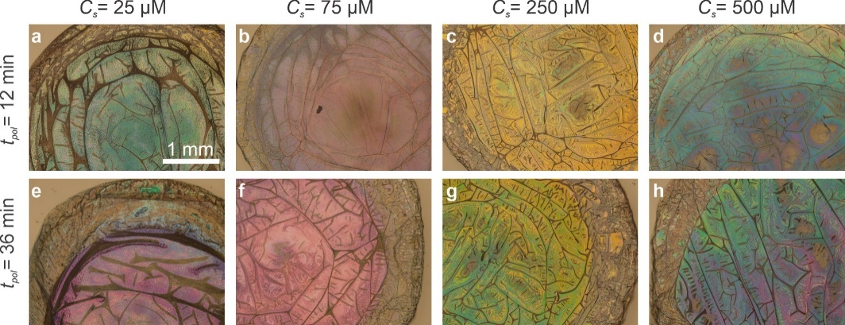
Fig. S2. Dry PECA films obtained using pure ECA, with varying polymerization times and DTAB concentrations, deposited on poly (styrene) substrates. (a-h) Reflection micrograph of dry PECA films, which were grown on the free surface of sessile drops of aqueous DTAB solutions with varying C_{s}, for two different polymerization times, t_{pol}= 12 min and 36 min, respectively. The solution drops were placed on the inner bottom surface of poly (styrene) culture dishes (diameter 100 mm, volume≈ 173 cm²). The dishes were covered with their lids, onto which a few drops (~ few µL each) of pure ethyl cyanoacrylate monomer were dispensed. The dry films were obtained by letting the water evaporate under ambient lab conditions (see Movie S2). Despite the significant reflectance of the poly (styrene) substrate, the interference colors of the PECA thin films are clearly visible. All micrographs were captured using the same magnification; thus, the scale bar shown in a, applies to all panels.

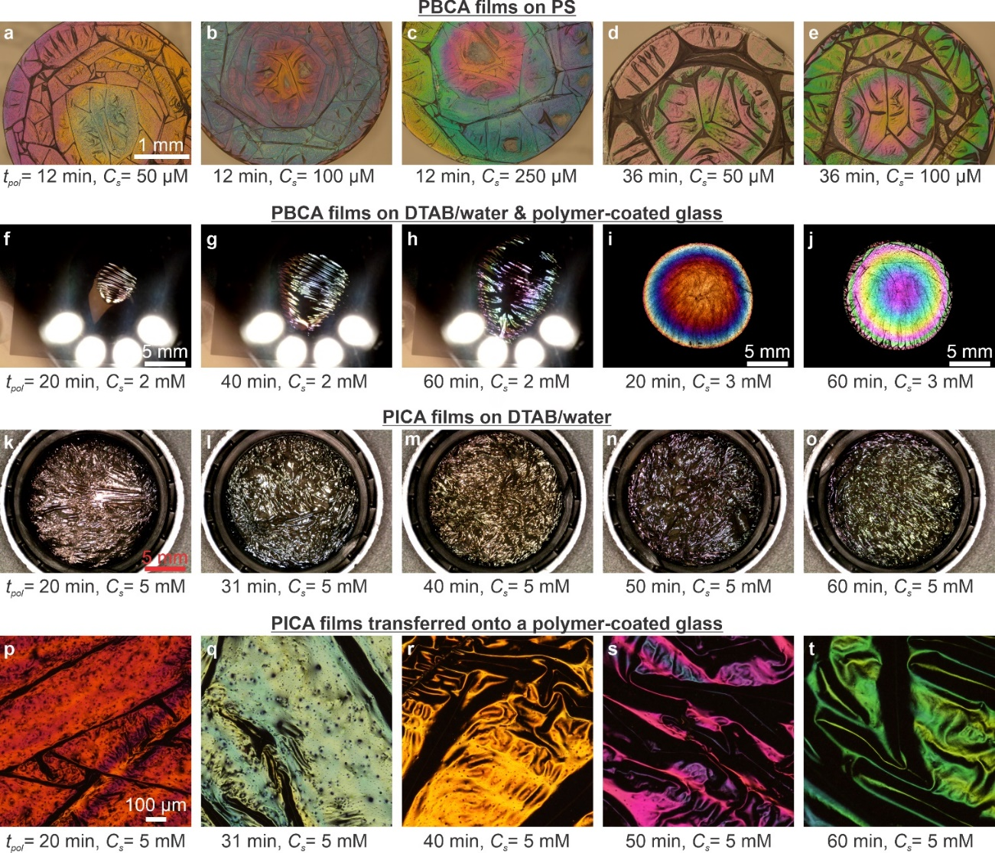
Fig. S3. Thin films of PBCA and poly (isopropyl cyanoacrylate) films (PICA) on various surfaces. (a-e) Reflection micrographs of PBCA films, which were grown on the free surface of sessile drops of aqueous DTAB solutions with varying C_{s}, for two different polymerization times, t_{pol}= 12 min and 36 min, respectively. The solution drops were placed on the inner bottom surface of poly (styrene) culture dishes (diameter 100 mm, volume≈ 173 cm²). The dishes were covered with their lids, onto which a few drops (~ few µL each) of pure butyl cyanoacrylate monomer were dispensed. The dry films were obtained by letting the water evaporate under ambient lab conditions. In spite of the substantial reflectance of the poly (styrene) substrate, the interference colors of the PBCA thin films are clearly visible. (f-h) Reflection micrographs of a PBCA film that was grown onto the free surface of a DTAB/water sessile drop (C_{s}= 2 mM, volume 100 µL) sitting on a polymer-coated glass slide at different stages of the polymerization time. The sample is inside a culture dish (diameter 100 mm, volume≈ 173 cm²) that is covered with its lid, onto which 4 drops (4 µL each) of pure butyl cyanoacrylate monomer are dispensed. As polymerization proceeds at the free interface, a thin PBCA film starts forming at the center of the drop surface and then expands radially to cover the whole free surface of the drop. (i-j) Reflection micrographs of dry PBCA films produced by a very similar procedure (4 drops of pure BCA, 4 µL each) and deposited on the polymer-coated substrates. The interference colors of PBCA films are generally more vivid than those of PECA films, presumably due to the higher refractive index of PBCA. (k-o) Reflection micrographs of PICA films that were grown on the surface of DTAB/water solutions (C_{s}= 5 mM, volume 1 mL) held within poly (propylene) lids for different polymerization times. The sample is inside a culture dish (diameter 100 mm, volume≈ 173 cm²) that is covered with its lid, onto which 8 drops (4 µL each) of pure butyl cyanoacrylate monomer were dispensed. The color variation with increasing t_{pol} indicates the increasing thickness of the TPFs. (p-t) Reflection micrographs of the same PICA films shown in k-o, after being transferred onto polymer-coated glass slides and having let the water evaporate. The scale bars shown in a, f, k, and p also apply to b-e, g-h, l-o, and q-t, respectively.

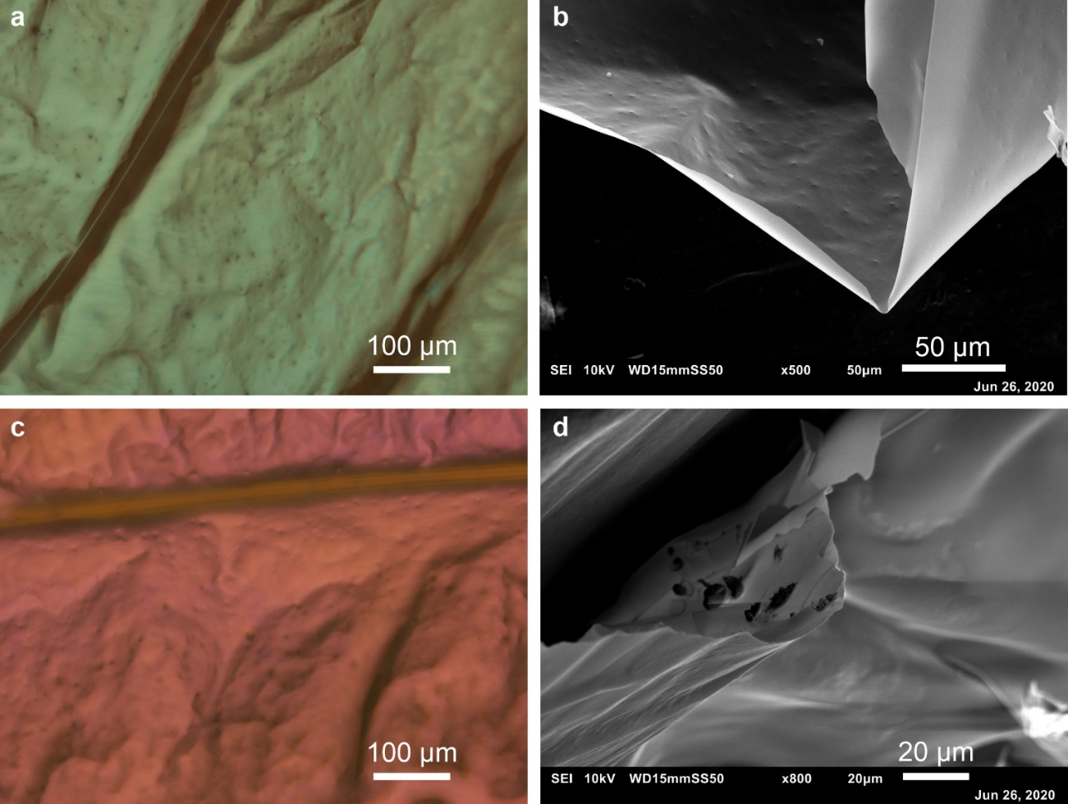
Fig. S4. Reflection micrographs and SEM images of PECA films. (a, c) Reflection micrographs of a green and a pink PECA film that were formed on the surface of a sessile drop of aqueous DTAB solution deposited on polymer-coated glass, with C_{s}= 500 µM (a) and C_{s}= 200 µM (c), respectively. Despite showing macroscopic and microscopic folds, both films have a smooth surface overall, with no periodic nanostructural features (on the order of visible wavelengths) observed in the corresponding SEM images b, d. The SEM experiments were performed after these films were detached from the substrate and kept in a self-standing configuration.

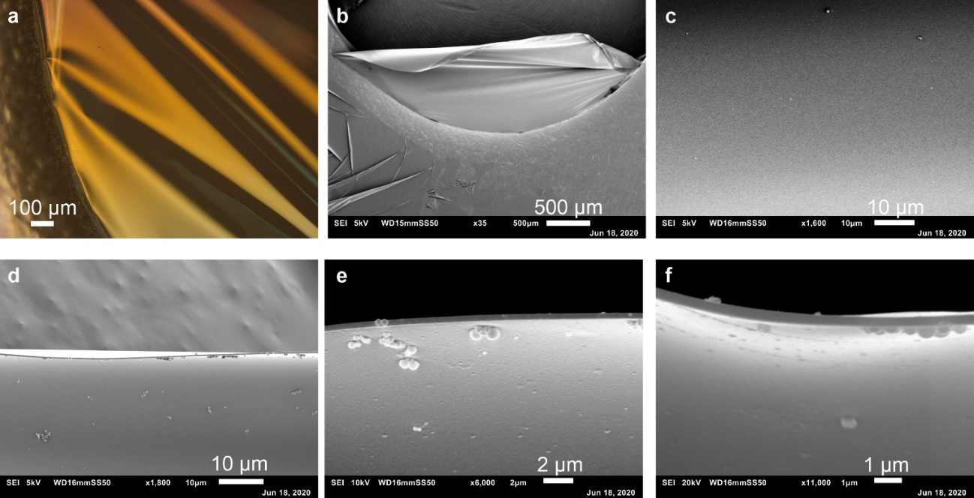
Fig. S5. Additional SEM images of free-standing PBCA films. (a) Optical reflection micrograph of a free PBCA film supported by a stainless-steel O-ring (seen on the left part of the image). This film was grown (t_{pol}= 60 min) on the free surface of aqueous DTAB solution (volume 3.5 mL, C_{s}= 0.5 mM) held within a poly (styrene) culture dish (diameter 35 mm). This dish was placed inside a larger poly (styrene) culture dish (diameter 60 mm) that was covered with a lid, onto which five drops (4 µL each) of pure butyl cyanoacrylate monomer were dispensed. The O-ring was immersed in the surfactant solution before the beginning of the polymerization; after the reaction was completed, the film was captured by the O-ring by lowering the level of the liquid relative to the O-ring. The folding of the film is also evident in a low-magnification SEM image (b). Similar to the PECA films (Fig. 4), no periodic nanostructure is observed on the surface of the film, which is very smooth (c). Images of the cross-section of this film at different magnifications uncover the sub-µm thickness of the film, which is very uniform across the entire field of view (d-f). The TPF thickness was manually measured at 23 different locations of the cross-section, shown with red vertical lines in (d). The mean thickness value is d_{f}= 308±19 nm (the error is the standard deviation).
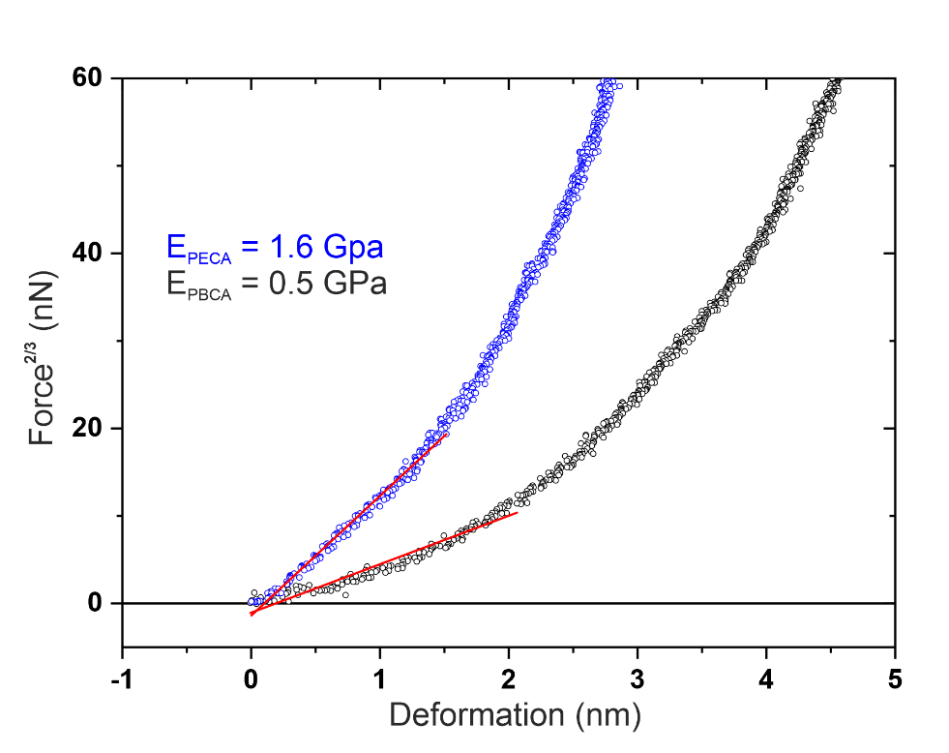

Fig. S6. Representative force-deformation curves of PECA and PBCA films measured by AFM. Following the Hertz model (see SI text for details), we used the linear part of the F^{2/3} versus δ curve to determine the Young’s modulus E of the film.

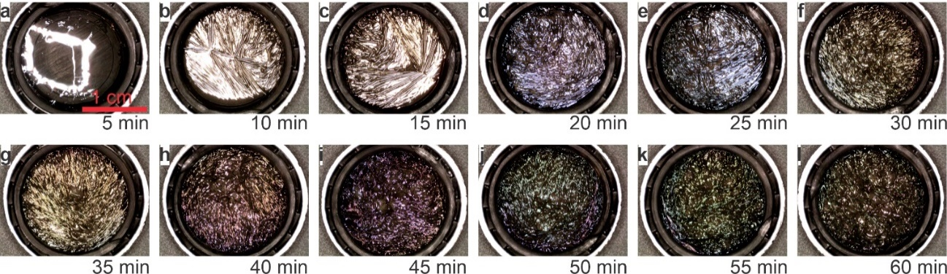
Fig. S7. A series of PECA films were grown onto the surface of aqueous DTAB solutions for varying polymerization time. (a-f) Reflection micrographs of films grown onto DTAB solutions (volume 1 mL) with fixed C_{s} = 2 mM, before their transfer onto silicon substrates; t_{pol} is indicated. The surfactant solutions are held within poly (propylene) lids. The samples were inside a culture dish (diameter 100 mm, volume≈ 173 cm²) that was covered with its lid, onto which 8 drops (4 µL each) of ethyl cyanoacrylate (commercial superglue) were dispensed. To ensure an ECA-saturated atmosphere inside the reaction chamber even for prolonged t_{pol}, we exchanged the monomer-laden lid with another lid carrying fresh ECA drops for the samples prepared for t_{pol} ≥ 35 min (g-l). The color of the TPFs varies with the t_{pol}, indicating a gradual increase in film thickness. The main file shows the same series of dried films in Fig. 1f-k. All images were captured using the same magnification; thus, the scale bar
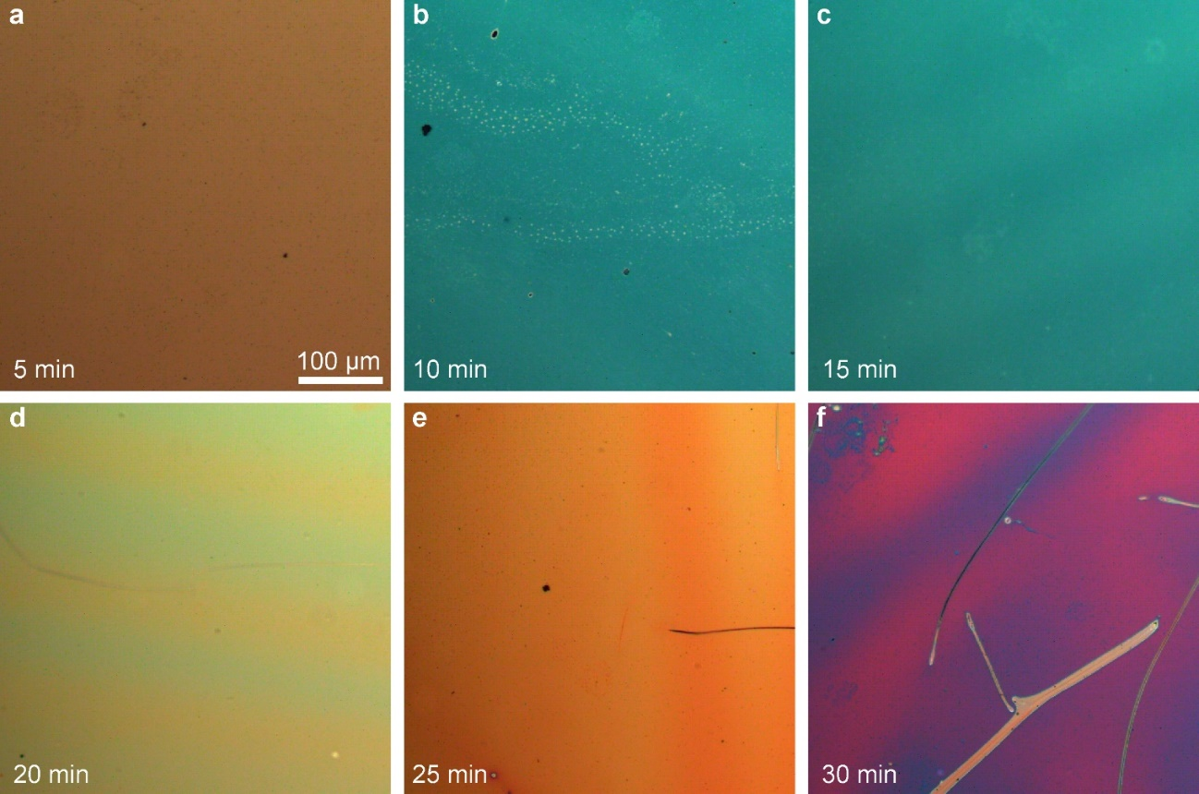
Fig. S8. The series of PECA films grown onto DTAB solutions for various t_{pol}, shown in Fig. S7, after being transferred onto Si substrates. (a-f) Reflection micrographs of films grown onto DTAB solutions (volume 1 mL) with fixed C_{s} = 2 mM for varying t_{pol}, transferred onto Si wafers (see Movie S4). The color of the TPFs is uniform, and the films are wrinkle-free for t_{pol}= 5-30 min. The main file shows the same series of films in Fig. 1f-h. All micrographs were captured using the same magnification; thus, the scale bar shown in a applies to all panels.

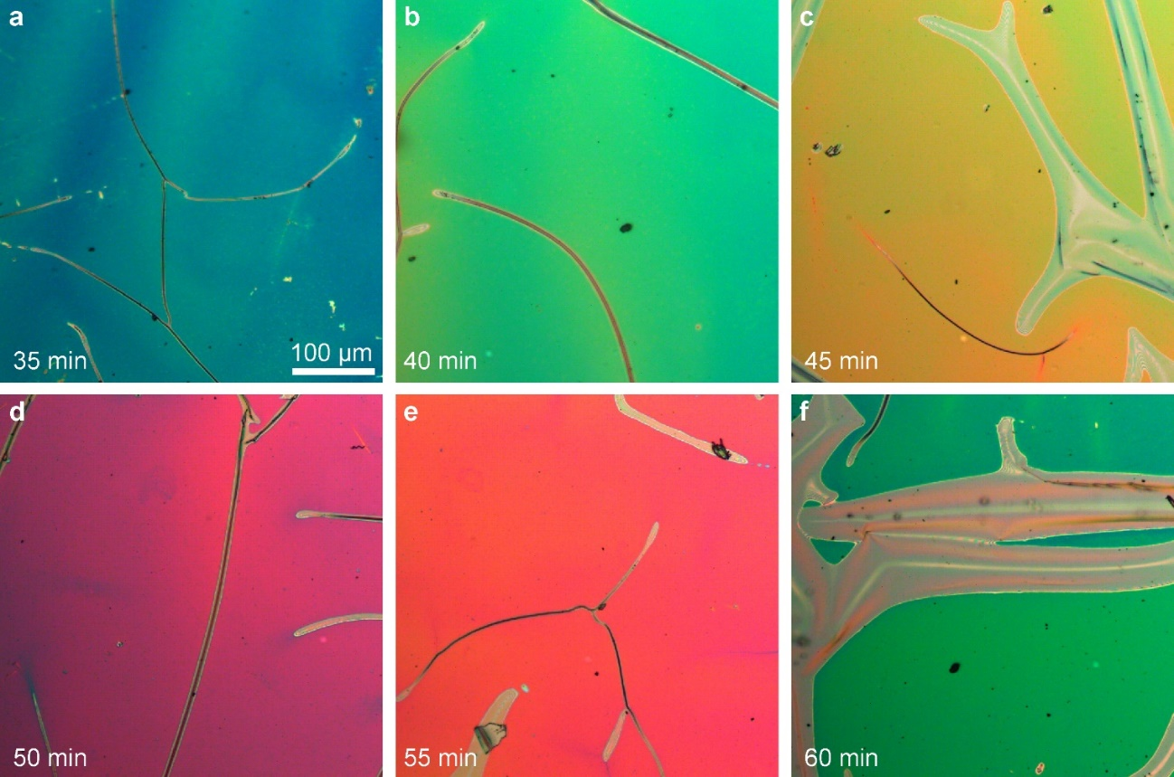
Fig. S9. The series of PECA films grown onto DTAB solutions for prolonged t_{pol}, shown in Fig. S7, after being transferred onto Si substrates. (a-f) Reflection micrographs of films grown onto DTAB solutions (volume 1 mL) with fixed C_{s} = 2 mM for varying t_{pol}, transferred onto Si wafers (see Movie S4). Note that the monomer-laden lid was exchanged with another lid carrying fresh ECA (commercial superglue) droplets to ensure a monomer-saturated atmosphere inside the polymerization chamber. The color of each TPF is uniform. Wrinkles are more evident compared to shorter t_{pol} (Fig. S8), and the wrinkling density increases with increasing t_{pol}, indicating an increased Young's modulus (see main text), this is consistent with the documented increase in film thickness. The main file shows the same series of films in Fig. 1i-k. All micrographs were captured using the same magnification; thus, the scale bar shown in a applies to all panels.

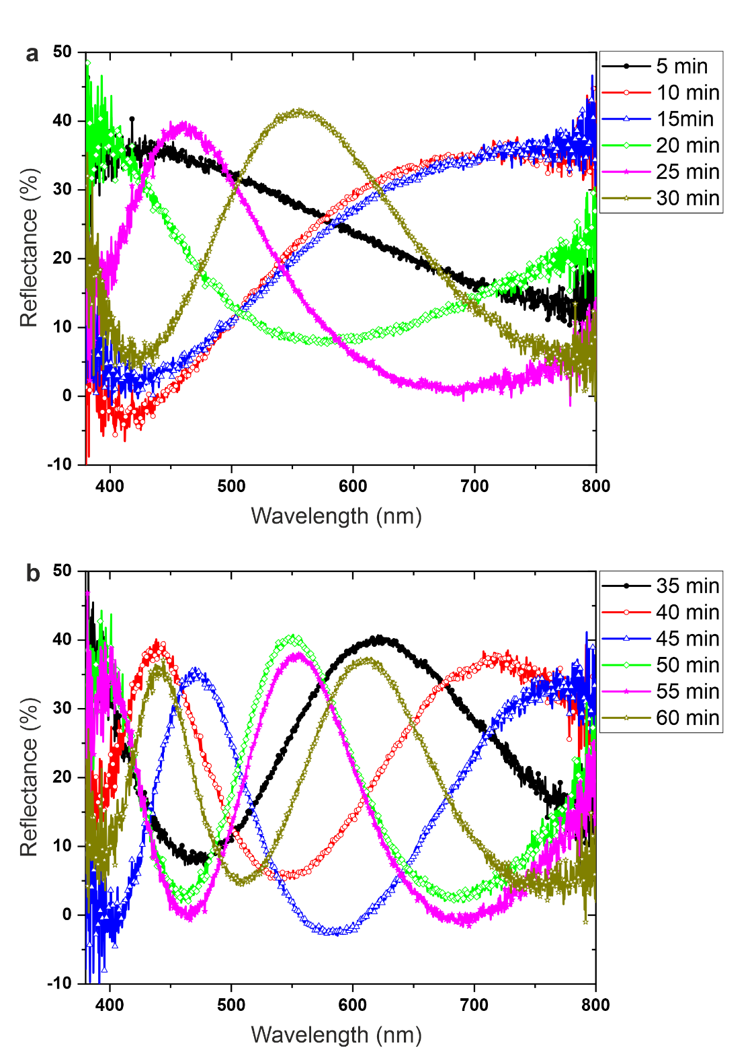
Fig. S10. Spectroscopic response of a series of dry PECA films grown onto DTAB solutions for various t_{pol} and transferred onto Si wafers. Reflection microspectroscopy measurements on the PECA films shown in Figs. S8, a and S9, b, respectively. (a) Films grown for short t_{pol}, display a single, broad reflection peak within the investigated wavelength window; the position of the peak is shifted toward shorter wavelengths with varying t_{pol}. (b) Contrarily, films synthesized for comparatively longer t_{pol}, show multiple reflection peaks; this is because constructive interference condition is fulfilled for more wavelengths in relatively thicker film. We have used the same colors for the spectra corresponding to sets (a) and (b) to aid the eye.
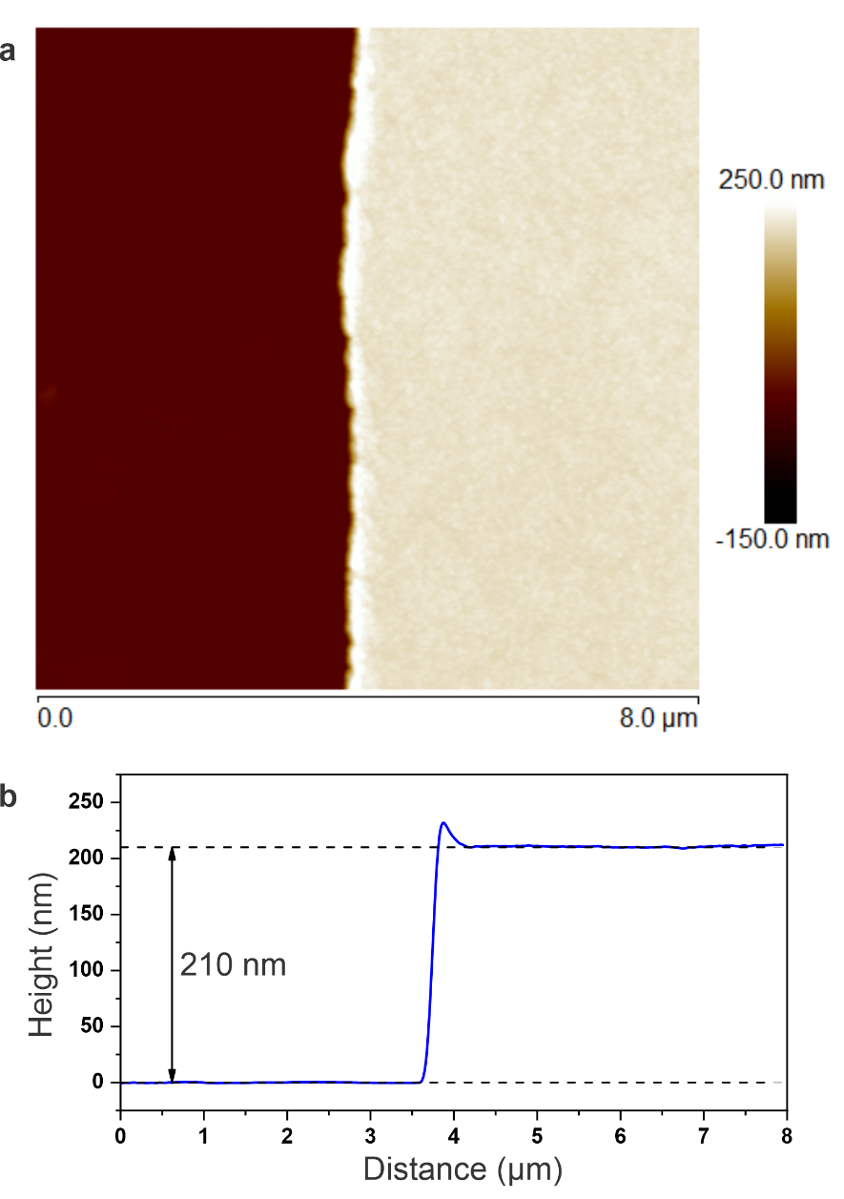
Fig. S11. Measurement of the thickness of PECA films using AFM. An example of a thickness profile measured with AFM of a PECA film grown for t_{pol} = 20 min and deposited onto a Si wafer (see Figs. S7-S9). (a) and (b) show the scratch and the average height profile along the line perpendicular to the edge of the film, respectively. Note that the shoulder visible at the scratch position is due to film deposition along the cut while making the scratch using a scalpel.

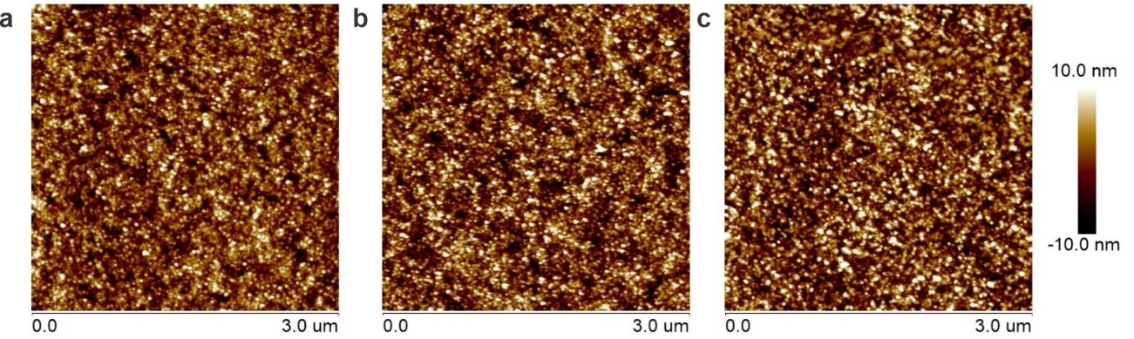
Fig. S12. AFM topography images of three dry PECA films grown for various t_{pol} and deposited onto Si wafers. These films were grown onto the surface of aqueous DTAB solutions (volume 1 mL, C_{s}= 2 mM, see Figs. S7-S9) for t_{pol}= 10 min (a), 25 min (b), and 50 min (c), respectively. The films remain smooth regardless of their thickness, with the RMS roughness R_{q} only slightly increasing with increasing t_{pol}, assuming values of R_{q}=3.55 nm (a), R_{q}= 4.0 nm (b), and R_{q}= 4.1 nm (c).

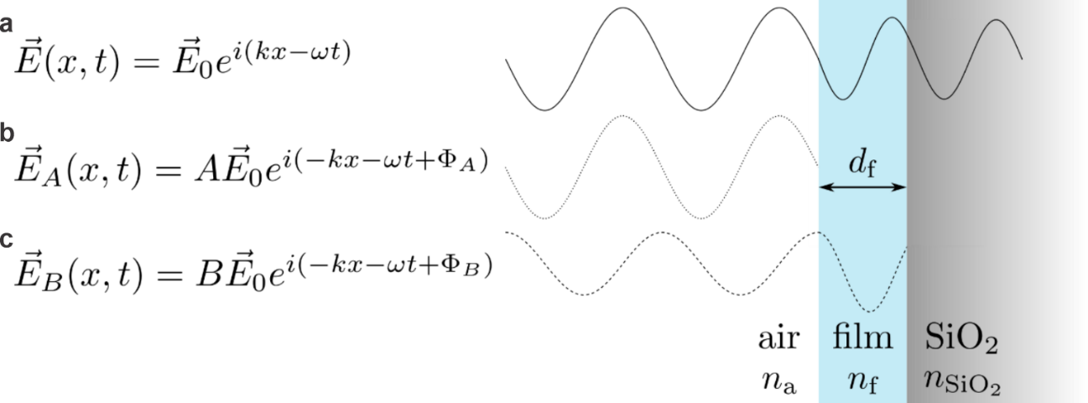
Fig. S13. Model of thin film interference. (a) The incoming linearly polarized plane wave impinges on the interface formed between the air and the polymer film and is partially reflected. The reflected wave (b) gains a phase shift of Φ_{A} upon reflection, and a factor of A decreases its amplitude compared to the amplitude of the incoming wave. (c) The transmitted wave is partially reflected from the interface formed between the polymer film and the supporting SiO₂. During propagation through the film, the wave gains a phase shift of Φ_{B,} and a factor of B decreases its amplitude compared to the amplitude of the incoming wave. The total reflected wave is represented by the sum ${\vec{E}}_{A}+{\vec{E}}_{B}$. The amplitudes of the waves in the schematic are not-to-scale.

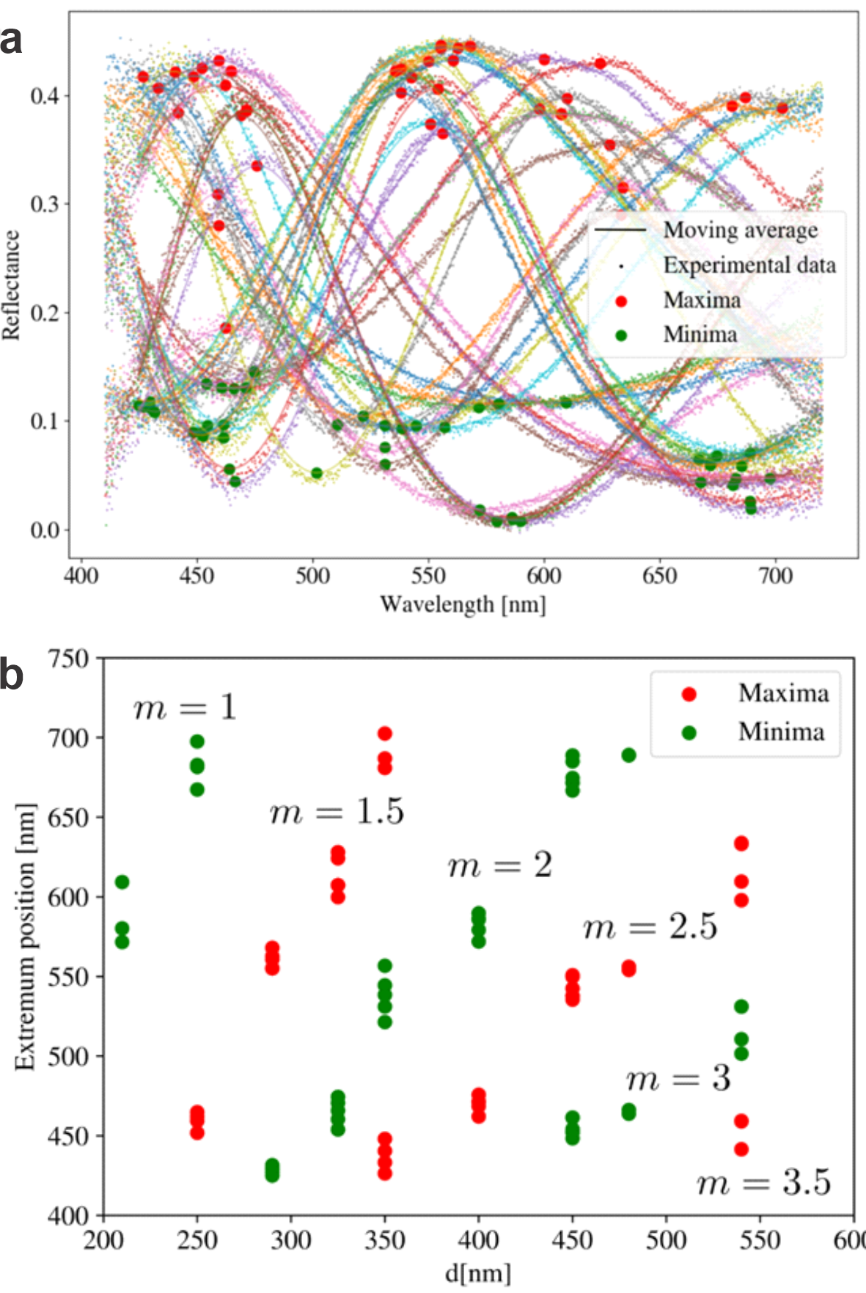
Fig. S14. Determination of the interference order from the experimental reflectance data. (a) Reflectance spectra (small dots) and their corresponding moving average plots (lines) were obtained from 39 samples with nine different film thicknesses. Each color represents a different measurement. The red and green dots mark the maxima and the minima of the spectra, respectively. (b) A plot of the wavelength extrema in the transmittance spectra versus the film thickness is used to identify the interference order m.

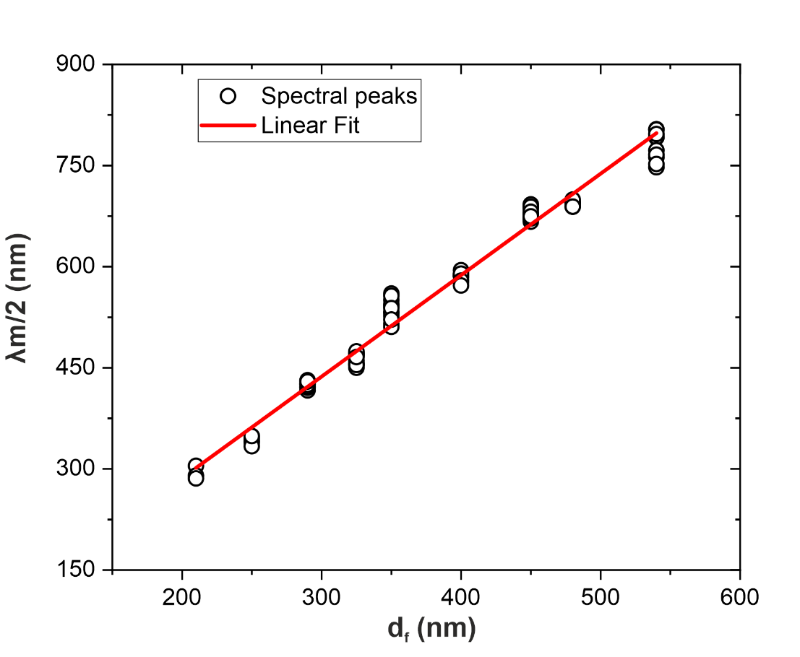
Fig. S15. Determination of the refractive index of the polymer film. A plot of λm/2 versus thickness (d_{f}) is utilized to determine the refractive index of the film, n_{f}, using linear regression (see Eq. 5). The slope, which corresponds to n_{f}, assumes a value of 1.505 ± 0.022. The R-squared value of the fit is larger than 0.98. Note that the refractive index of PECA films ranges from 1.5 to 1.55 depending on the purity^{[14]}. The pure solvent-free ECA available under the brand name Cyanolit has a refractive index of 1.5.

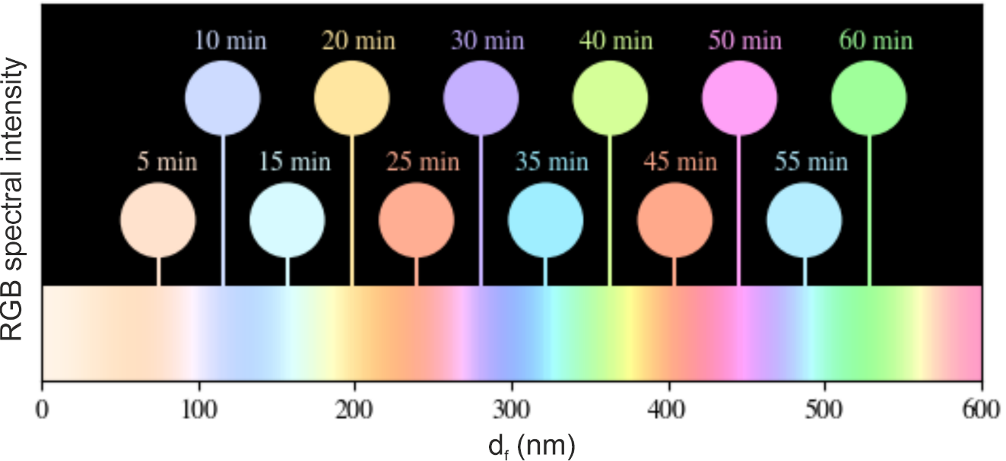
Fig. S16. Modelling of interference colors from thin PECA films. To determine the colors of the thin films, we utilized Eq. 3 along with reflection intensities measured experimentally, using refractive index values of n_{a}= 1, n_{f}= 1.505, and n_{SiO2}= 1.46 for air, PECA film, and SiO₂, respectively. RGB color chart shows expected film colors for different film thicknesses. Circles show expected colors for a few selected polymerization times, determined by using the linear relationship between polymerization time and film thickness, measured by AFM (Fig. 1).

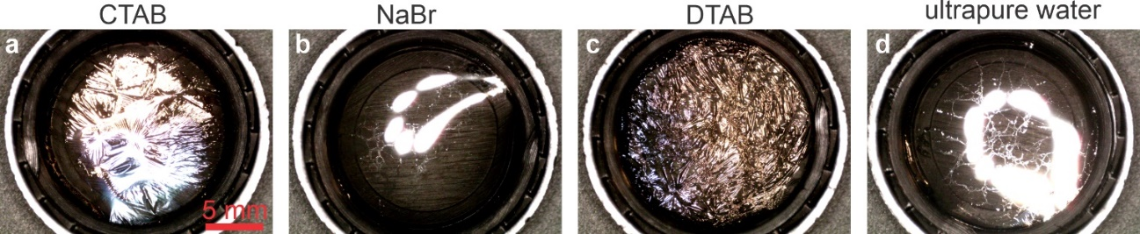
Fig. S17. PECA film growth on the free surface of aqueous solutions of surfactants, electrolyte, and ultrapure water. Reflection micrographs of PECA films synthesized on the surface of (a) a solution of cationic surfactant CTAB (C_{s}= 0.5 mM), (b) a NaBr salt solution (concentration 0.5 mM), (c) a solution of cationic surfactant DTAB (C_{s}= 0.5 mM), and (d) ultrapure water (ACS reagent grade). All experiments are carried out under identical experimental conditions: the liquids (volume 1 mL) are contained within poly (propylene) lids, which are kept inside culture dishes (diameter 100 mm, volume≈ 173 cm²) that are covered with their lids. On the lids, we dispense 8 drops (4 µL each) of ethyl cyanoacrylate (commercial superglue); the reaction time is kept constant at t_{pol}= 20 min. A highly reflective, vividly colored film forms on the surface of the CTAB solution (a), which is qualitatively similar to the film formed on the DTAB solution, albeit the latter is more wrinkled (c). On the contrary, a fragile, transparent PECA film forms on the surface of the NaBr solution (b), similar to the film formed on ultrapure water (d). The result of this control experiment indicates that the Br⁺ cation alone cannot lead to the acceleration of the polymerization kinetics observed when cationic surfactants are used. All images were captured using the same magnification; thus, the scale bar shown in (a) applies to all panels.

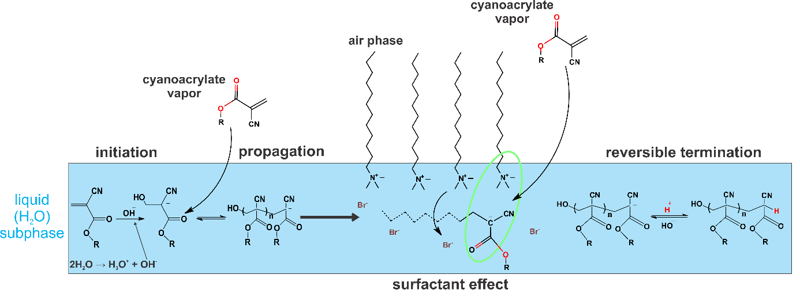
Fig. S18. Schematic representation of the anionic polymerization of ECA and the PECA film formation at the air-water interface. The anionic polymerization reaction of ECA monomers (coming from the air phase above the aqueous phase) is initiated by OH⁻, which are produced by the self-dissociation of water. The chain propagation occurs as more incoming monomers are attached to the growing anionic chain. The cationic surfactant molecules located at the air-water interface create a structured nano-environment that promotes the association between polymer chains and positively charged surfactant head groups. The aqueous subphase aids in dissociating and diffusing bromide anions, supporting the formation of structured PECA films. Cyanoacrylate monomer vapors participate in controlled polymerization at the interface, contributing to the growth of a uniform TPF. Finally, the reversible termination by H⁺ (also produced by the self-dissociation of water molecules) is shown on the right-hand side of the schematic.

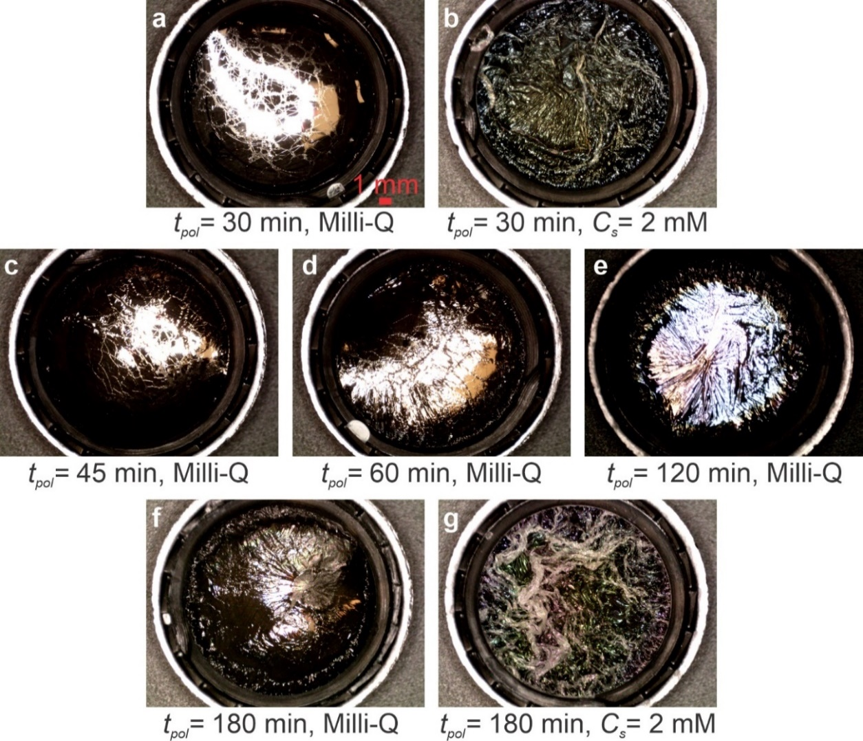
Fig. S19. PECA films grown on the surface of ultrapure water. (a, c-f) Reflection micrographs of PECA films that were grown on the surface of ultrapure water (milli-Q, volume 1.5 mL) held within poly (propylene) lids for different polymerization times t_{pol}. For the polymerization reaction, each sample was kept inside a culture dish (diameter 100 mm, volume≈ 173 cm²) that was covered with its lid, onto which 16 drops (4 µL each) of ethyl cyanoacrylate (commercial superglue) were dispensed. (b, g) PECA films were grown under identical conditions (and with identical experimental parameters), onto the surface of aqueous DTAB solutions (C_{s}= 2 mM). Polymerization times, e.g., t_{pol}= 30 min, are long enough for DTAB solutions to result in colorful, highly reflective films (b) but are not adequate to produce similar films on ultrapure water (a). Only thin, fragile PECA films are observed on ultrapure water for t_{pol}≤ 60 min (c-d), whereas for t_{pol}≥ 120 min, PECA films with qualitatively similar features as the ones formed on DTAB solutions are produced (e-f). For comparison, we also show a PECA film made on an aqueous DTAB solution for t_{pol}= 180 min (g). The interference color and the extensive wrinkling and folding of the film indicate a much greater film thickness due to the action of DTAB drastically accelerating the polymerization kinetics (see also main text). All images were captured using the same magnification; thus, the scale bar shown in a applies to all panels.
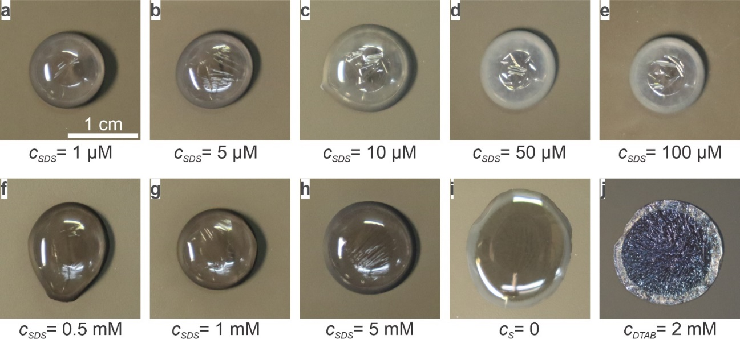
Fig. S20. PECA films grown on aqueous SDS solutions and comparison with a PECA film grown on an aqueous DTAB solution. (a-h) Reflection micrographs of PECA films synthesized on the surface of sodium dodecyl sulfate solutions of varying polymer concentrations, C_{SDS}. (i) A reflection micrograph of a PECA film is synthesized on the surface of pure water. (j) Reflection micrograph of a PECA film grown on the surface of a DTAB solution (C_{DTAB}= 2 mM). All experiments are carried out under identical experimental conditions: each drop (volume 100 µL) is placed in a culture dish (diameter 100 mm, volume≈ 173 cm²), which is closed with a lid containing 8 drops (4 µL each) of ethyl cyanoacrylate (commercial superglue). The reaction time is kept constant at t_{pol}= 20 min. The colored film is visible only in panel j, consistent with Fig. S7. In all other panels, colorless films are observed.

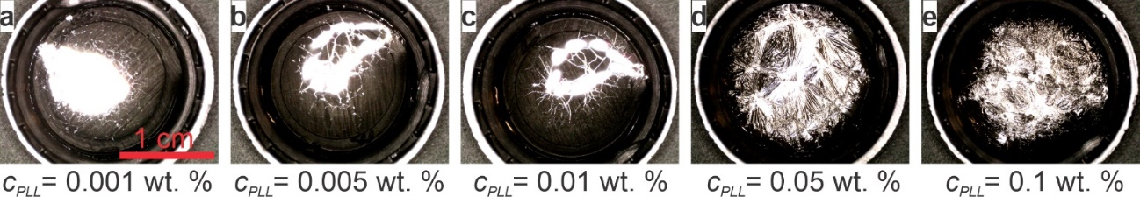
Fig. S21. PECA film growth onto the surface of aqueous solutions of a cationic polyelectrolyte, poly (L-lysine). Reflection micrographs of PECA films synthesized on poly (L-lysine) solutions of varying polymer concentration, C_{PLL}. All experiments are carried out under identical experimental conditions: the solutions (volume 1 mL) are contained within poly (propylene) lids kept inside culture dishes (diameter 100 mm, volume≈ 173 cm²) that are covered with their lids. On the lids, we dispense 8 drops (4 µL each) of ethyl cyanoacrylate (commercial superglue); the reaction time is kept constant at t_{pol}= 20 min. For C_{PLL}≤ 0.01 wt.%, fragile, transparent PECA films form, qualitatively similar to the case of ultrapure water (a-c). Contrarily, exposure of solutions with higher poly (L-lysine) concentrations (C_{PLL}≥ 0.05 wt.%) to monomer vapor leads to highly reflective, silver-colored PECA films that have similar qualitative features as the ones obtained when using surfactant solutions (d-e). All images were captured using the same magnification; thus, the scale bar shown in the first image applies to all panels.

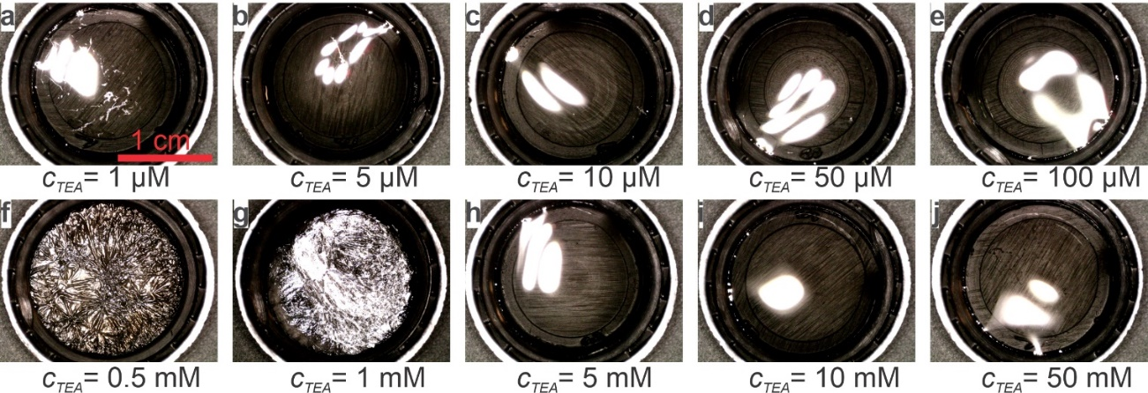
Fig. S22. PECA film growth onto the surface of aqueous solutions of triethylamine, TEA. (a-j) Reflection micrographs of PECA films were synthesized on solutions of varying TEA concentrations, such as C_{TEA}. All experiments are conducted under identical conditions: the TEA solutions (volume 1 mL) are contained within poly (propylene) lids, which are kept inside culture dishes (diameter 100 mm, volume≈ 173 cm²) that are covered with their lids. On the lids, we dispense 8 drops (4 µL each) of ethyl cyanoacrylate (commercial superglue); the reaction time is kept fixed at t_{pol}= 20 min. For C_{TEA}≤ 100 µM, fragile, transparent PECA films form; the same behavior is observed for C_{TEA}≥ 5 mM. These excessively thin films are reminiscent of the PECA films formed on the surface of ultrapure water. On the contrary, exposure of the surface of solutions within a comparatively narrower, intermediate TEA concentration window (C_{TEA}= 0.5-1 mM) results in PECA films similar to those obtained utilizing cationic surfactants. We attribute the lower C_{TEA} limit for obtaining films similar to the ones obtained with cationic surfactants to a critical surface concentration of TEA molecules that can accelerate the polymer film growth. The upper C_{TEA} limit is linked to the fact that at high C_{TEA}, an increased number of TEA molecules escape from the solution, leading to an increased concentration of TEA molecules in the vapor phase above the solution. When the latter concentration is large enough, the monomer drops on the lid of the reaction chamber undergo polymerization, the rate of which is highly accelerated. As a result, the surface of the ECA drops becomes solid quickly, and the monomer supply is reduced. The consequence of this is a very slow growth of the PECA film at the solution surface. All images were captured using the same magnification; hence, the scale bar shown in the first image applies to all micrographs.

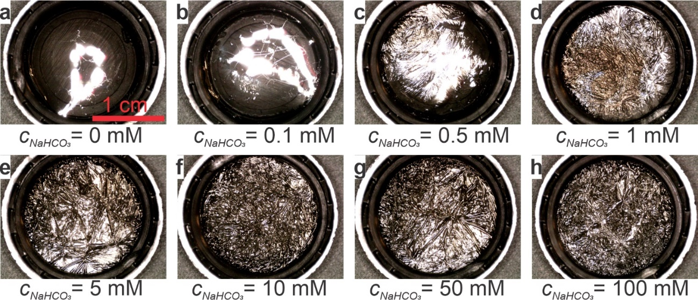
Fig. S23. PECA film growth onto the surface of aqueous solutions of sodium bicarbonate, a substance frequently used as a superglue accelerator. (a-h) Reflection micrographs of PECA films formed on solutions of varying NaHCO₃ concentration, C_{NaHCO3}. All experiments are carried out under identical conditions: the solutions (volume 1 mL) are contained within poly (propylene) lids, which are kept inside culture dishes (diameter 100 mm, volume≈ 173 cm²) that are covered with their lids. On the lids, we dispense 8 drops (4 µL each) of ethyl cyanoacrylate (commercial superglue); the reaction time is kept constant at t_{pol}= 20 min. Panel (a) shows a film formed on the surface of ultrapure water (ACS reagent grade). For C_{NaHCO3}≤ 0.1 mM, fragile, transparent PECA films form, qualitatively similar to the case of ultrapure water (a-b). Contrarily, exposure of solutions with higher NaHCO₃ concentrations
(C_{NaHCO3}≥ 0.5 mM) to monomer vapor leads to the formation of highly reflective PECA films with vivid interference colors (silver, golden, and slightly purple). Qualitatively, these PECA films have similar characteristics to those obtained using cationic surfactant solutions. All images were captured using the same magnification; thus, the scale bar shown in a applies to all images.

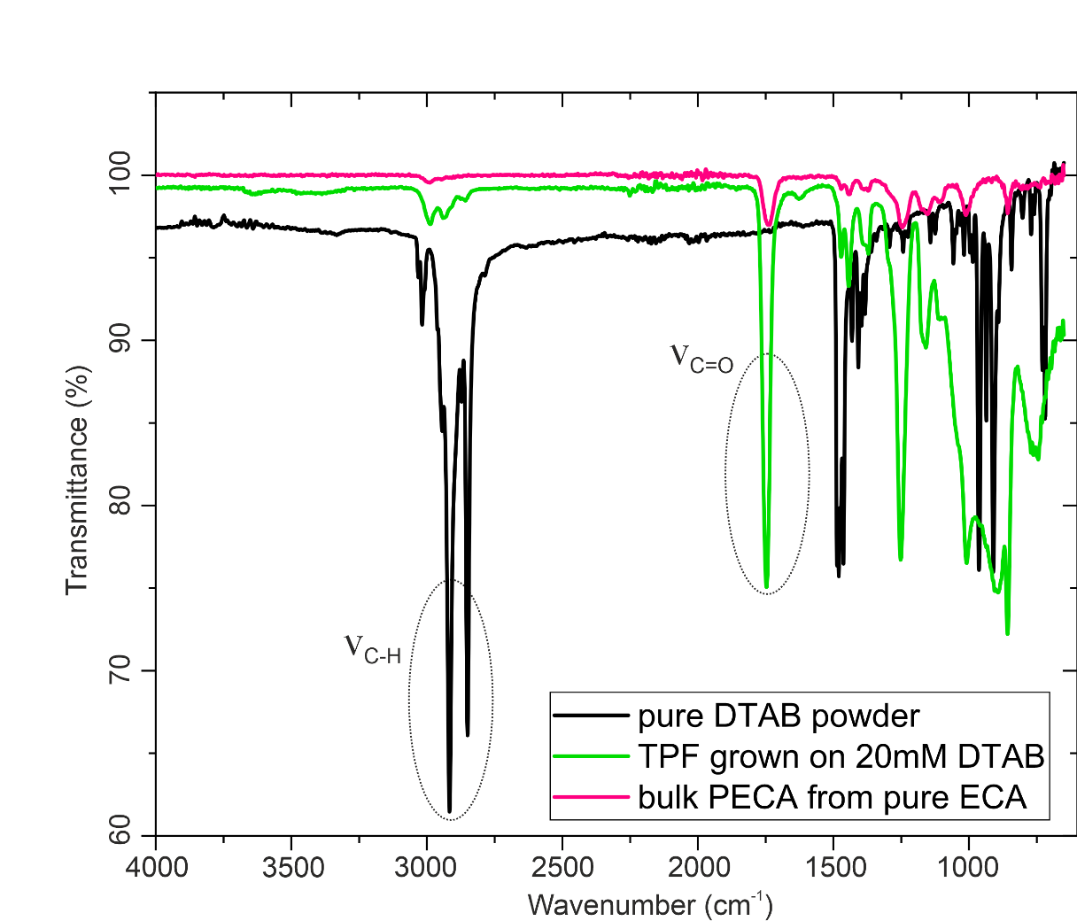
Fig. S24. FTIR-ATR characterization of PECA films. A set of spectra over a broad range of wavenumbers for pure DTAB powder, a PECA TPF grown on the surface of a 20 mM aqueous DTAB solution and transferred onto a clean glass, and a bulk PECA formed using pure ECA on a clean glass. Distinct characteristic ester (1740 cm⁻¹), and C-H vibrational modes at 2949 cm⁻¹ and 2990 cm⁻¹ (marked with dotted ellipses) are observed. Note that the ester vibrations that are characteristic of PECA only are not present in pure DTAB. Additionally, symmetric and asymmetric CH₃, as well as symmetric N-CH₃ vibrations, which are present only in DTAB^{[4]}, can be seen via the gradual increase in transmittance signal in TPFs grown on aqueous solutions with increasing concentrations of DTAB. All samples are prepared on identical clean glass plates.

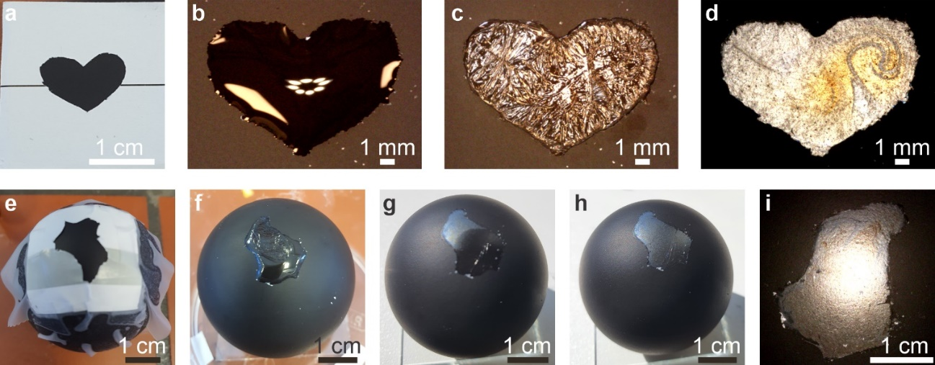
Fig. S25. Preparation of PECA films with complex shapes using wettability patterns on flat and curved substrates. (a) A heart-shaped paper mask is attached to a flat substrate (glass slide coated with hydrophobic polymer), and the uncovered area is corona-treated to generate a heart-shaped hydrophilic region surrounded by a hydrophobic area. (b) Aqueous DTAB solution (C_{s}= 2 mM, volume 40 µL) is dispensed on the patterned substrate, and a heart-shaped air-water interface is formed. (c) Polymerization of ECA (commercial superglue) for t_{pol}= 10 min results in a heart-shaped PECA film with gold-like color on the surface of the shaped drop. (d) The resulting dry PECA film is deposited onto the substrate after the solution below the film is removed and the remaining water is evaporated. (e-i) The sequence of steps of a similar procedure, as shown in (a-d), followed to create a silver-colored PECA film with the silhouette of Luxembourg on a ping-pong ball. In this case, aqueous DTAB solution (C_{s}= 2 mM, volume 40 µL) is dispensed on the Luxembourg-shaped hydrophilic area of the curved hydrophobic substrate, and it is exposed to ECA vapors (commercial superglue) for t_{pol}= 5 min.

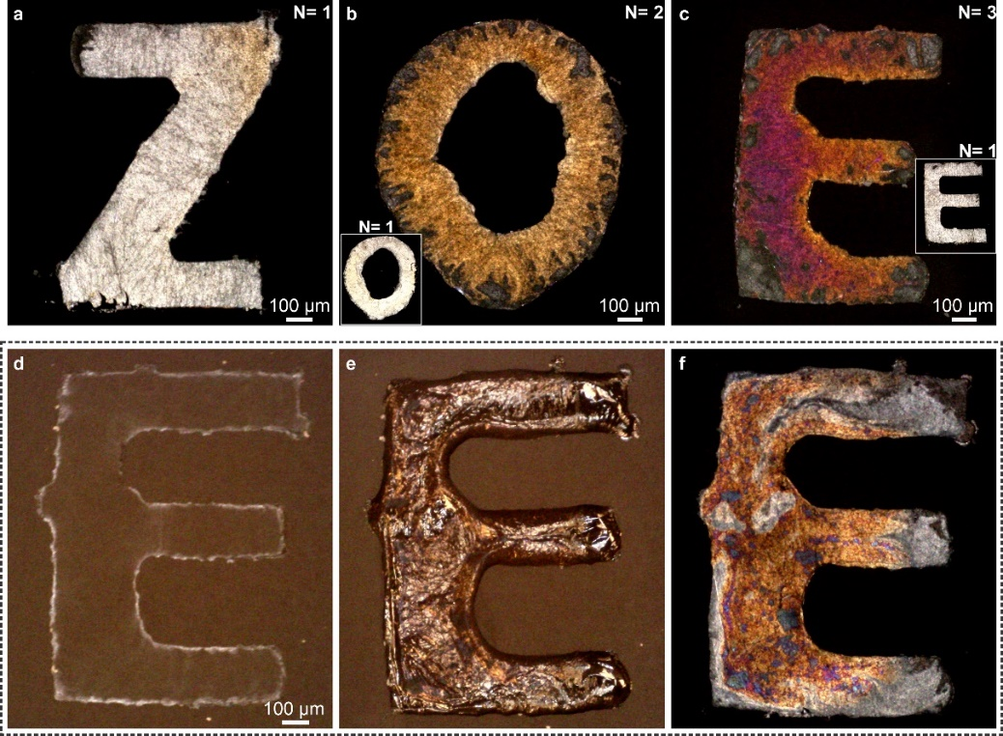
Fig. S26. Examples of complex-shaped PECA films further highlight the versatility of WRAPPINGS. (a) A simple approach for generating a PECA TPF with a tailored shape is to use a hydrophilic area enclosed within a hydrophobic surface, as described in Fig. S25. Here, a more complex, Z-shaped film is prepared by exposing an aqueous DTAB solution to ECA vapor. The film color was set to silver by choosing the appropriate polymerization time (t_{pol}= 10 min), which resulted in the film thickness (≈110 nm, Fig. S16) corresponding to this interference color. (b) The film thickness can be further modified after the end of polymerization by implementing a second polymerization reaction. This example shows an O-shaped PECA film, which results from the exposure of a DTAB solution to the ECA monomer in two steps (N= 2). Each polymerization step lasted for t_{pol}= 10 min; the two steps were separated by 5 min. The first step results in a silver-colored film (as the film shown in the inset, prepared from the same DTAB solution with N=1 and t_{pol}= 10 min). After the second polymerization step and removal of the solution, an orange, O-shaped PECA film is produced. (c) An E-shaped film obtained by three polymerization steps (N= 3, each step for t_{pol}= 10 min). The inset shows a film produced by conducting an identical experiment but with only one polymerization step
(N=1, t_{pol}= 10 min). The same aqueous DTAB solution (C_{s}= 2 mM, volume 20 µL) was used in each case. (d-f) Facile preparation of a complex-shaped PECA film employing a ''just add water'' procedure. Surfactant molecules are deposited along an E-shaped pattern by dispensing an aqueous DTAB solution (C_{s}= 2 mM, volume 22 µL) on the corresponding hydrophilic area of a hydrophobic substrate and letting the water evaporate (drying time≈ 43 min) (d). Then, ultrapure water (volume 22 µL) is dispensed on the DTAB pattern, and the resulting solution is exposed to ECA vapor for t_{pol}= 10 min. The resulting E-shaped PECA film (e) is deposited on the substrate by removing the surfactant solution underneath (f). The non-uniform color may be attributed to inhomogeneities in DTAB distribution in the E-shaped drop, arising because the solution was not mixed after water addition onto the deposited surfactant. Commercial superglue was used for all these experiments. The scale bar in (d) applies to images showing in (e, f) as well.

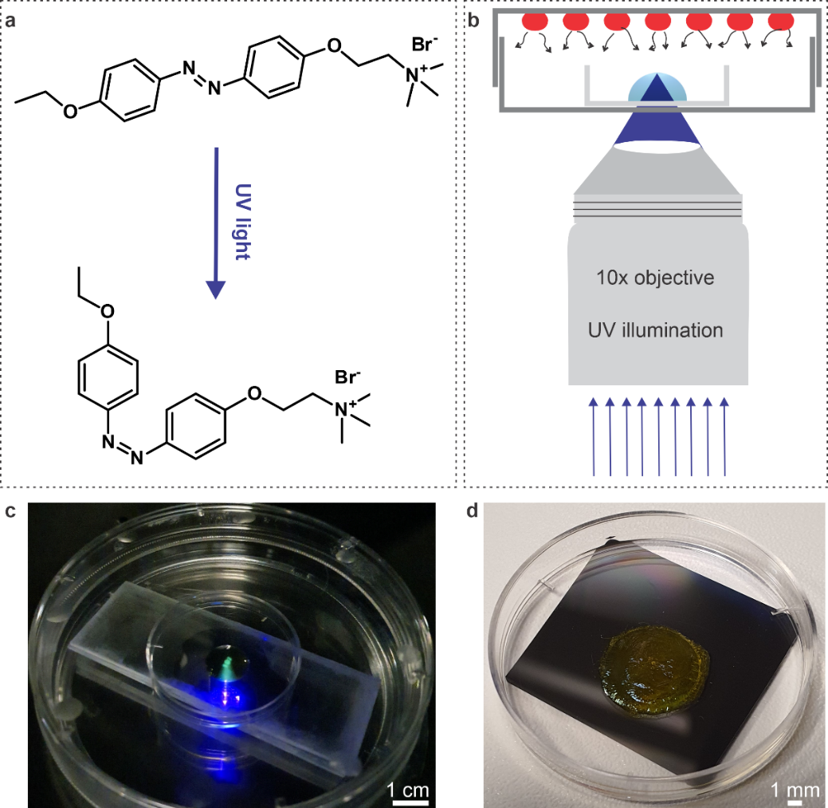
Fig. S27. Photopatterning thin PECA films through simultaneous exposure of aqueous AzoTAB solutions to structured UV light and ECA vapor. (a) The AzoTAB photosurfactant undergoes trans-cis isomerization under UV illumination. The shape change of the molecule results in a change in polarity: the cis isomer is comparatively more polar and more hydrophilic compared to the trans isomer. Hence, when irradiating the free surface of an AzoTAB solution rich in trans isomers (i.e., a solution that is kept under dark conditions), the surface concentration of cis and trans surfactants is modified. (b) The photopatterning setup we use for UV irradiating a drop of aqueous AzoTAB solution while it is exposed to vapors of ECA. UV light (wavelength 365 nm) passes through a photomask, and it is then focused on the free surface of the drop using a microscope objective. (c) Photograph of an example of the actual experimental configuration. An AzoTAB solution drop (C_{s}= 5 mM, volume 100 µL) is sitting on a poly (styrene) substrate (a culture dish lid), itself placed inside a culture dish; the monomer (commercial superglue) droplets can be seen on the covering lid. A set of glass slides is used to elevate the sample and place it at the right distance from the microscope objective (10x) used to focus the UV light pattern (in the form of the name ''ZOE'') on the free surface of the drop. (d) An example of a photopatterned film is after the completion of polymerization and before the underlying AzoTAB solution is removed so that the film is deposited on a smooth substrate.
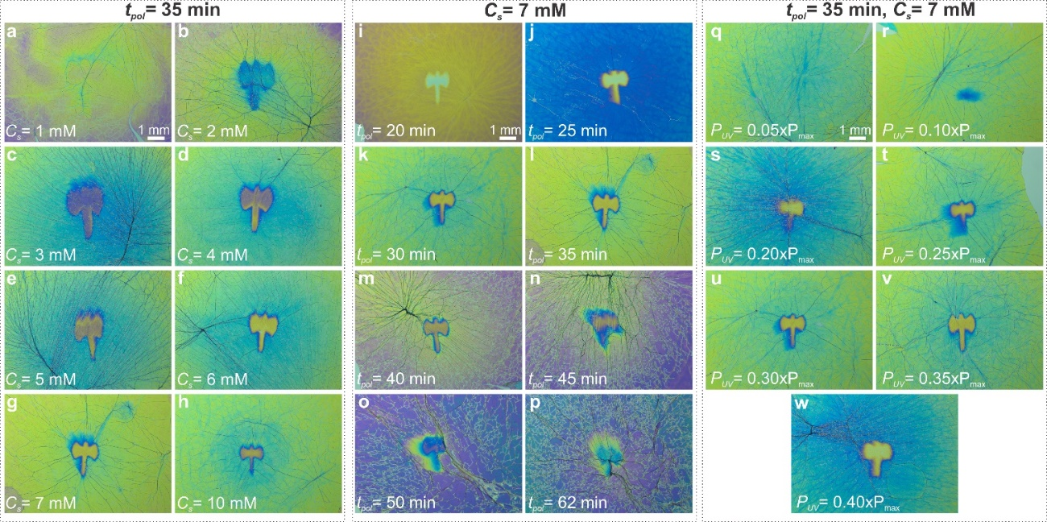
Fig. S28. Exploration of the influence of various material and process parameters on the quality of light-directed patterns on PECA films. For each of these experiments, a drop of aqueous AzoTAB solution (volume 100 µL), sitting on a poly (styrene) substrate, was irradiated by a UV light pattern (Minoan double axis) and simultaneously exposed to vapors of ECA (commercial superglue 8 drops, 4vµL each). After the polymerization was completed, the films were transferred onto Si substrates (see Movie S5). (a-h) Influence of AzoTAB concentration (C_{s}). For this series of experiments, the polymerization time and UV power were fixed at t_{pol}= 35 min and P_{UV}= 0.30·P_{max}, respectively. Film patterning is observed only for C_{s}≥ 2 mM. Beyond this critical AzoTAB concentration, the clarity of the final pattern increases with increasing C_{s}. Additionally, the size of the final pattern decreases with increasing C_{s}. Considering these results, we decided to keep C_{s}= 7 mM as the working concentration for most of our photopatterning experiments because it is the minimum C_{s} that gives very well-defined patterns. (i-p) Influence of polymerization time (t_{pol}). For this series of experiments, C_{s} and P_{UV} were fixed at C_{s}= 7 mM and P_{UV}= 0.30·P_{max}, respectively. Both the color of the non-irradiated and the irradiated parts of the PECA film change with increasing t_{pol}, which is attributed to the increasing film thickness. In addition, increasing t_{pol} leads to films with a higher wrinkling density; especially for t_{pol}≥ 40 min, the wrinkle density is so high that it significantly affects the overall film quality. For this reason, we decided to use t_{pol}< 40 min for most of our experiments. (q-w) Influence of P_{UV}. For these experiments, the polymerization time and the AzoTAB concentration were fixed at t_{pol}= 35 min and C_{s}= 7 mM, respectively. Film patterning is observed only for P_{UV}≥ 0.10·P_{max}. Beyond this critical UV power, the clarity of the final pattern increases with increasing P_{UV} up to P_{UV}=0.35·P_{max}; a further increase in power to P_{UV}=0.40·P_{max}; leads to a decrease in pattern clarity. This interesting result merits further investigation in the future; it is, however, outside the scope of this work. Despite the lack of knowledge about the underlying mechanism, we decided to use P_{UV}=0.30·P_{max} for the majority of our experiments.

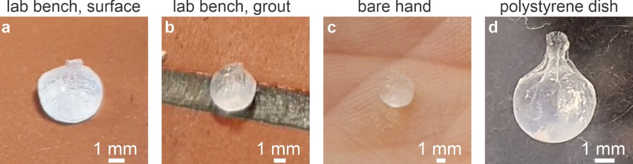
Fig. S29. A PECA-coated liquid dumpling can sit on different solid surfaces with varying chemical properties and topographies without wetting them. (a-d) Photographs demonstrating the non-wetting nature of liquid dumplings (containing aqueous DTAB solution). Due to this non-sticking property, it is easy to manipulate the liquid dumplings, even with bare hands (c). See also Movie S7.

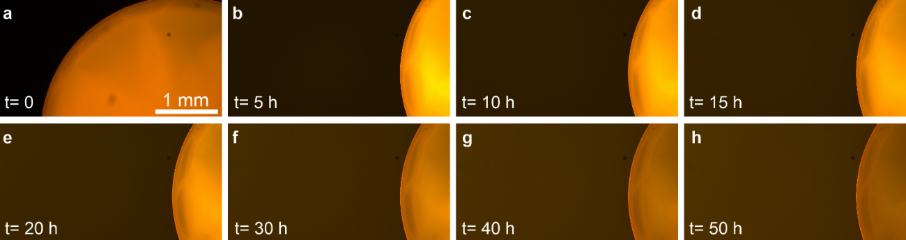
Fig. S30. A thin PBCA film formed on the free surface of a sessile drop of aqueous Rhodamine B solution allows for the slow release of the dye into a surrounding buffer solution. (a-h) Fluorescence microscopy images showing the release of dye from a PBCA-coated sessile drop (volume 10 μL) of an aqueous solution of DTAB (C_{s}= 0.5 mM) and Rhodamine B (0.001 wt.%) into the surrounding bath (phosphate-buffered saline solution, 1x, 600 μL). The thin PBCA film was grown on the drop by exposing it (t_{pol}= 2 min) to the vapors of a commercial tissue adhesive used in veterinarian applications. The release kinetics is followed in real-time by monitoring the fluorescent intensity of the drop and the bath, respectively, thanks to the transparency of the encapsulating film. The instant t=0 indicates the start of the recording, that is, immediately after the BCA polymerization is finished and the PBCA-coated drop is surrounded by the buffer solution. The time-lapse Movie S10, from which these snapshots are extracted, was analyzed to obtain the data shown in Fig. 3g.

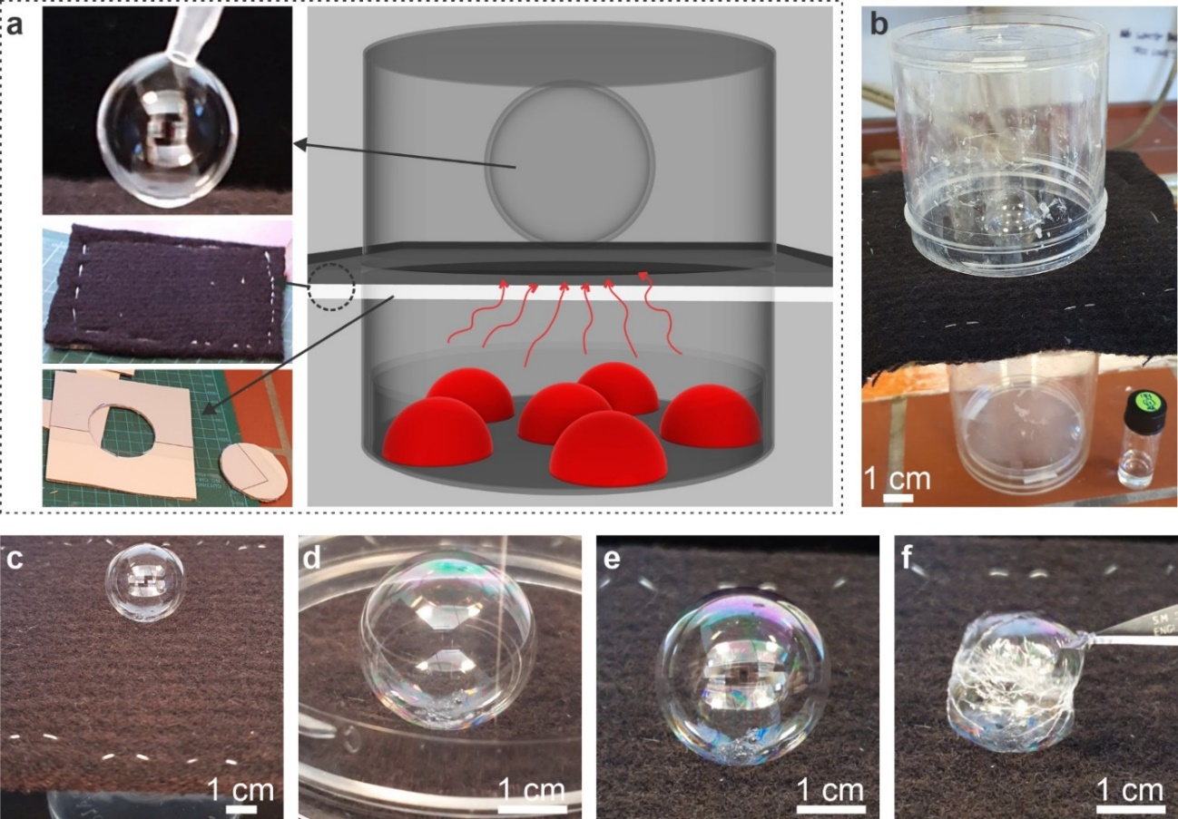
Fig. S31. The experimental setup and procedure for polymerizing quasi-spherical gas bubbles, along with some representative examples of solidified bubbles. (a) Schematic of the setup (right panel) and photographs of the components (left panel). A freshly created bubble (top) is placed on a cloth that sits on a cardboard that is cut open (bottom). The cardboard is sandwiched between two poly (carbonate) jars (volume 250 mL each); ECA (commercial superglue) drops are placed on the base of the bottom jar. The monomer vapor passes through the opening in the cardboard and the porous cloth and reaches the surface of the bubble to initiate polymerization. (b) Photograph showing a typical bubble solidification experiment with a setup such as the one described in (a). (c-e) The steps of the bubble solidification procedure. A quasi-spherical bubble (volume 5 mL, aqueous solution of CTAB, C_{s}= 6 mM and glycerol, 20 wt.%), just after deposition on the cloth sitting on the bottom jar (on which 8 drops of commercial superglue, 4 µL each, are placed) (c). Immediately afterward, the second (empty) jar is placed on top of the bubble; we consider this to be the onset of polymerization. Photograph of the bubble after t_{pol}= 10 min (d), and after the polymerization is completed (t_{pol}= 20 min, e). (f) The solidified bubble collapses (instead of bursting) when pierced with a scalpel, which indicates its elastic nature. See also Movies S13 and S14 for a similar sequence of generation and solidification and breaking of an air bubble, respectively.

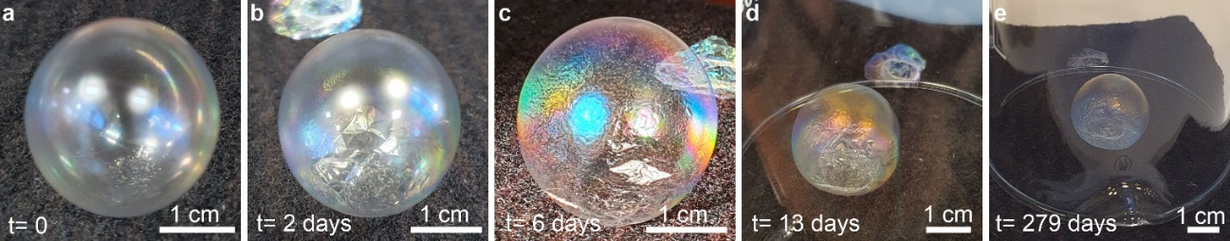
Fig. S32. A quasi-spherical, solidified air bubble remaining intact longer than ~279 days after it was created. (a) A soap bubble, comprising a thin film of an aqueous mixture of CTAB and glycerol that encloses air, was exposed to vapors of ECA (commercial superglue). The PECA film formed on the bubble surface led to its solidification; the instant t=0 indicates the day this was done. (b-e) Photographs of the same bubble as in a, were taken over the course of 279 days. Despite a decrease in air pressure inside the bubble, suggested by the wrinkles on its surface, the bubble remains intact. A jar is used to enclose the bubble and protect it from air currents in the lab that could take it away or even break it. Vivid interference colors, which suggest that the PECA film thickness is on the order of ~ 1 µm, are pronounced in c due to direct sunlight illuminating the bubble.

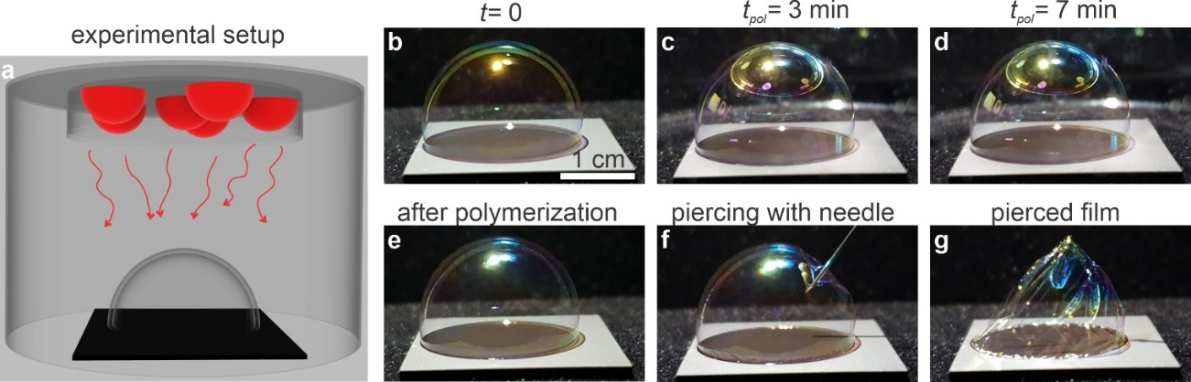
Fig. S33. Creation of a sessile soap bubble on a partially wetting solid substrate and polymerization upon its exposure to ECA vapor. (a) Schematic of the setup used for solidifying sessile soap bubbles. A spherical soap bubble is deposited on a polymer-coated glass substrate, assuming a hemispherical, dome-like shape. The sessile bubble is covered with a poly (carbonate) jar (volume 125 mL), on the top surface of which, sessile drops of ECA (commercial superglue) are dispensed. The monomer vapor reaches the bubble surface, and polymerization is initiated. (b) Photograph of a sessile bubble (volume 3 mL, aqueous solution of CTAB, C_{s}= 6 mM and glycerol, 20 wt.%), just after it is deposited on the substrate. The monomer-laden jar is placed above the bubble, marking the onset of the polymerization
(t_{pol}= 0). (c, d) Photographs of the same bubble at different instants during polymerization. After the polymerization is completed (t_{pol}= 10 min), the solidified sessile bubble (e) is pierced with a needle (f), which results in an elastic film that slowly collapses onto the surface (g).

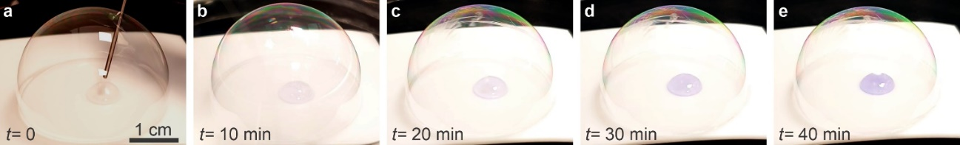
Fig. S34. Monitoring the progress of the alanine-ninhydrin reaction by simple visual observation through a transparent PECA reaction chamber. A PECA reaction chamber is formed by first preparing a sessile bubble (6 mL) on a PTFE substrate using an aqueous solution of CTAB (C_{s}= 5.95 mM) and glycerol (30 wt. %). Using a metallic needle prewetted with the above bubble juice, we place two sessile drops containing alanine (1.05 wt. %) and ninhydrin (1.04 wt. %) aqueous solutions in the interior of the bubble (a). The bubble is then solidified by exposing it (t_{pol}= 10.5 min) to commercial superglue (ECA) vapors. The resulting PECA film is highly transparent, allowing real-time monitoring of the progress of the aminoacid-indicator reaction through the color change in the drop (b-e). Note that t=0 indicates the instant at which the two drops are mixed, that is, the beginning of the acid-indicator reaction. All images were captured using the same magnification; thus, the scale bar shown in (a) applies to all images. See Fig. 4 f-i and Movies S15 for further details.

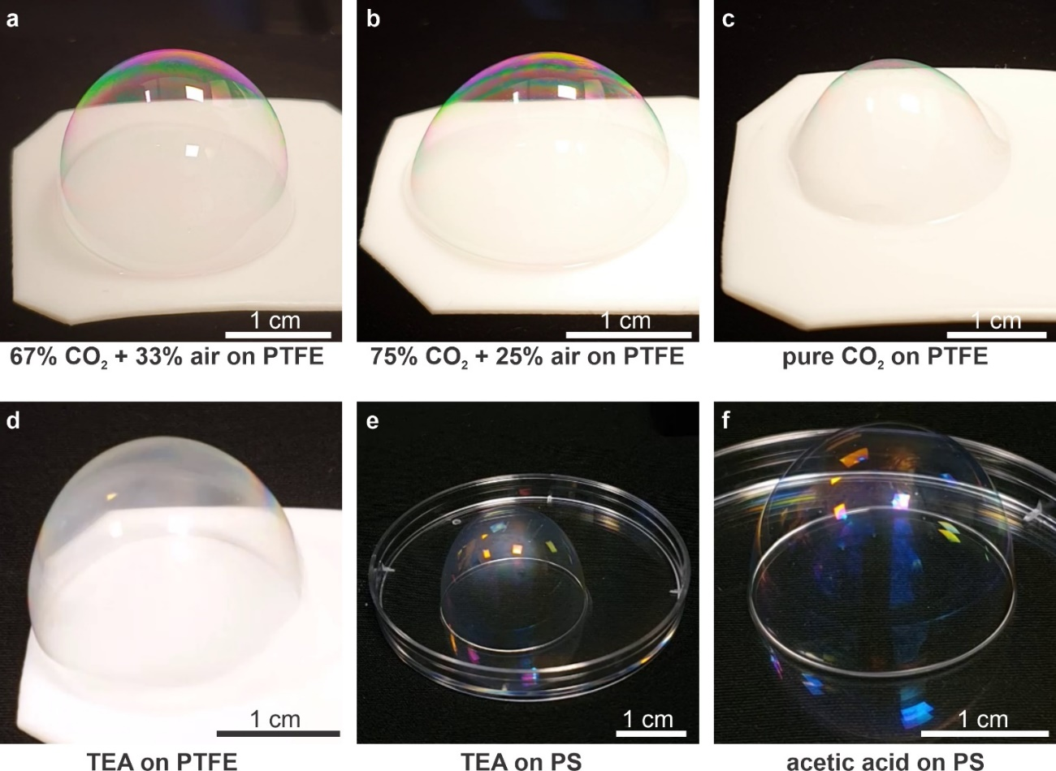
Fig. S35. Photos of polymerized sessile bubbles containing inert and reactive gases. All experiments are carried out in the same manner: a spherical soap bubble is deposited on a substrate (indicated in each panel), and it assumes a hemispherical, dome-like shape. The sessile bubble is covered with a poly (carbonate) jar (volume 125 mL), on the top surface of which, sessile drops of ECA (commercial superglue) are dispensed. The monomer vapor reaches the bubble surface, and polymerization is initiated. Inert mixtures of CO₂ and air at different proportions (a, b) and even pure CO₂ (c), can be enclosed within the PECA bubble. Furthermore, air saturated with amine (triethylamine, (d, e) or acid (acetic acid, f) can also be encapsulated by the PECA film grown on the bubble surface. The bubble juice used for all these experiments was an aqueous solution of CTAB (C_{s}= 5.69 mM) and glycerol (20.1 wt. %). The bubble volumes at the beginning of the experiments are typically between 7 and 15 mL. Typically, 4-8 drops of commercial superglue are used for monomer supply (volume 4 µL each), apart from the experiment shown in (e), where 30 monomer drops were utilized. Note that bubbles encapsulating various gases can be placed on various surfaces.

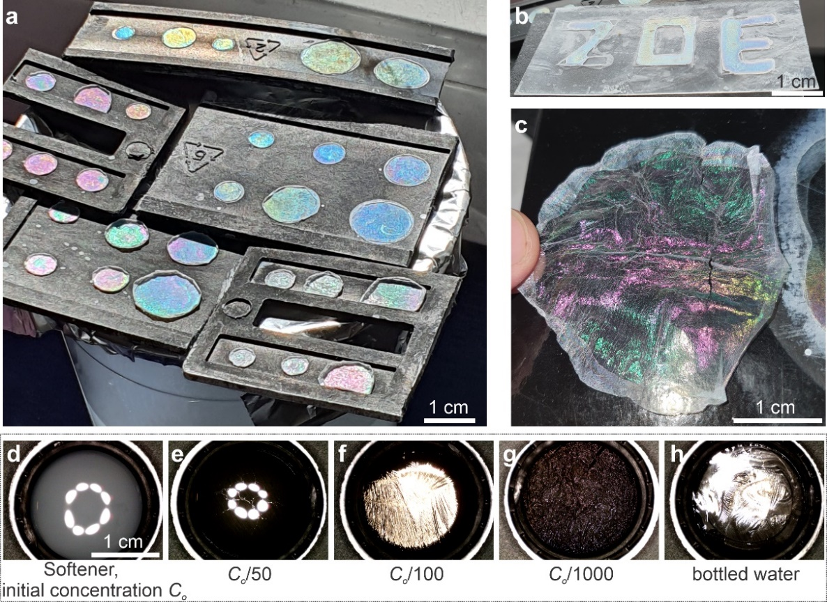
Fig. S36. The robustness of WRAPPINGS for preparing coloured PECA films of various forms using common household materials without the need for any elaborate equipment. (a) Photograph of PECA films made by exposing drops of cloth softener (diluted with potable water) to vapors of commercial superglue inside a glass jar. After water evaporation under ambient conditions, the films are deposited on the black plastic substrate. (b) Photograph of three shaped PECA films forming the name ''ZOE''. The softener solution, on which polymerization occurs, is shaped by using a plastic foil (patterned with a knife) as the substrate. (c) A large, self-standing PECA film formed on the surface of a large puddle of softener solution sitting on laminated paper after the water evaporated and the dry film peeled off the surface (Movie S17). Experiments (b-c) were conducted in a similar reaction chamber to the one used in a. (d-e) Reflection micrographs of PECA films formed on the surface of commercial cloth softeners with varying concentrations. The (unknown) concentration of the commercial product is C_{o}; no PECA film formation is observed on its free surface. Dilution (with bottled drinking water) to C_{o}/50 leads to very thin, transparent, and fragile PECA films (reminiscent of those formed on ultrapure water). Samples diluted further (C_{o}/100 and C_{o}/1000), lead to highly reflective PECA films, qualitatively similar to the ones observed with cationic surfactant solutions (f, g). For comparison, a silver-colored film formed on the surface of the same drinking water used for the dilutions is shown in (h). This last film is different from the very thin films formed on the surface of ultrapure water under identical conditions; this suggests that the metal ions present in drinking water may be responsible for the comparatively accelerated polymerization. All experiments are carried out under identical conditions: the solutions (volume 1 mL) are contained within poly (propylene) lids, which are kept inside culture dishes (diameter 100 mm, volume≈ 173 cm²) that are covered with their lids. On the lids, we dispense 8 drops (4 µL each) of ethyl cyanoacrylate (commercial superglue); the reaction time is t_{pol}= 20 min. The scale bar in (a) applies to all panels.

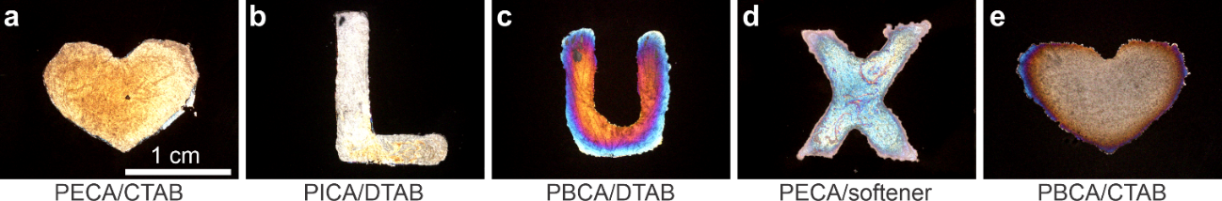
Fig. S37. The diverse potential of WRAPPINGS for creating complex-shaped PCA films with varying structural colors, utilizing various monomers and surfactants. Various materials can be used, in conjunction with the wet patterning approach (see Fig. S25), to prepare complex TPFs on the surface of liquid drops that, after liquid removal, are deposited on polymer-coated glass substrates. Reflection micrographs of: (a) a heart-shaped, gold-colored PECA film formed on an aqueous CTAB solution (C_{s}= 0.2 mM, volume 40 µL, monomer: ECA, commercial superglue, t_{pol}= 15 min). (b) an L-shaped, silver-coloured PICA film formed on an aqueous DTAB solution (C_{s}= 2 mM, volume 30 µL, monomer: pure ICA, t_{pol}= 10 min). (c) a U-shaped, multi-colored PBCA film formed on an aqueous DTAB solution (C_{s}= 2 mM, volume 30 µL, monomer: pure BCA, t_{pol}= 20 min). (d) an X-shaped, cyan-colored PECA film formed on a commercial softener (C_{s}= C₀/100, where C₀ is the initial, unknown concentration of cationic surfactant in the product, volume 30 µL, monomer: ECA, commercial superglue, t_{pol}= 30 min). (e) a heart-shaped, silver-brownish colored PBCA film formed on aqueous CTAB solution (C_{s}= 0.2 mM, volume 40 µL, monomer: pure BCA, t_{pol}= 15 min). All images were captured using the same magnification; thus, the scale bar shown in (a) applies to all panels.
Legends for Supplementary Movies

Supplementary Movie S1.
Formation of a PECA film on the surface of a surfactant solution drop. A sessile drop of DTAB/water solution (C_{s}= 2 mM, volume 100 µL) is dispensed on a polymer-coated glass substrate and placed inside a plastic Petri dish. The dish is covered with a lid, on which we dispense four drops of a commercial superglue (ECA), marking the onset of the polymerization reaction. The recording starts at t_{pol}= 127 s, and the total polymerization time is t_{pol}= 1h 45 s. As polymerization proceeds at the air-water interface, a thin PECA forms at the center of the drop surface and then quickly expands to cover the whole free surface of the drop. The surface of the film continues expanding with time, occupying an area larger than the drop surface, as indicated by the translucent band forming near the drop contact line, the thickness of which increases with time; this band is presumably due to film folding near the drop edge. The color progressively changes, starting with gold, purple, green, purple, and green again, indicating a gradual thickness increase. The wrinkle density also increases with time, in accordance with the expected Young's modulus increase of the film. The Movie is accelerated 1200x. The drop diameter is about 25.2 mm.

Supplementary Movie S2.
Removal of surfactant solution under a PECA film with a tissue. A lint-free paper tissue is used to remove most of the DTAB/water solution (C_{s}= 2 mM) under the PECA film grown on its surface (Movie S1). The aqueous solution is gradually replaced by air pockets under the film, which makes the film color (green) more vivid with time. To obtain a thoroughly dried film on the supporting substrate (see, for example, Fig. 1 b-c), the remaining water is removed by letting the sample dry under ambient laboratory conditions. The Movie is accelerated 10x. The thin film diameter is about 25.2 mm, and this scale does not include the extra rim formation upon drying.

Supplementary Movie S3.
Self-standing PECA film after detaching it from the supporting substrate. A PECA film is first grown on a solid supporting substrate (polymer-coated glass) by exposing a sessile drop (DTAB/water solution) to vapors of a commercial superglue (ECA). The film is then deposited on the substrate by removing the water under it (see Movies S1-S2). We then use a scalpel to detach the film from the substrate and a pair of tweezers to lift it off and hold it in a self-standing configuration. The Movie is accelerated 5x. The film diameter is about 23 mm.

Supplementary Movie S4.
Transfer of a PECA film from the surfactant solution on which it was grown onto a Si wafer. A PECA film is initially prepared by exposing a DTAB/water solution (C_{s}= 1 mM) in a plastic lid to a commercial superglue (ECA) for t_{pol}= 20 min. We inject additional water under the film using a syringe and a needle to stretch the film and facilitate cutting. A scalpel is then used to cut a large part of the film, and more ultrapure water is added to create a dome-shaped liquid extending over the rim of the lid. Subsequently, the lid is placed in a large beaker containing ultrapure water, and the film floats on the water surface. This step also removes surfactant molecules from the bottom surface of the film. Finally, the latter is deposited on the wafer by placing a Si wafer under the floating film. To obtain dry PECA films onto Si wafers (see, for example, Fig. 1f-k), the remaining water is removed by letting the samples dry under ambient laboratory conditions. This Movie is accelerated 5x. The plastic lid diameter is about 19 mm.

Supplementary Movie S5.
Transfer of a photopatterned PECA film from a solution of photosurfactant onto a solid substrate. A photopatterned thin film is first formed on the free surface of an AzoTAB solution drop (C_{s}= 4 mM) by exposing it to monomer vapor of a commercial superglue (ECA) for
t_{pol}= 45 min while being irradiated with structured UV light (wavelength 365 nm). After the polymerization ends, a scalpel is first used to detach the PECA film from the supporting substrate, a polystyrene culture dish lid. We then add ultrapure water into the lid, and the film floats on its surface. We next place the lid in a beaker with ultrapure water; the film, free of photosurfactant (dissolved in water), floats on the water surface. Finally, the latter is deposited on glass by placing a black welding glass under the floating film. The same procedure is followed to obtain photopatterned films deposited onto Si wafers. To obtain dry PECA films (see, for example, Fig. 2, f-h), we remove the remaining water by letting the samples dry under ambient laboratory conditions. The Movie is accelerated 6x. The outer diameter of the culture dish lid is 37.8 mm.

Supplementary Movie S6
Evaporation of water under a photopatterned PECA film transferred onto a solid substrate. A photo mask is used to generate a structured light pattern (four circles) that impinges onto an aqueous AzoTAB solution (C_{s}= 7 mM), while the solution is being exposed to the monomer vapor of a commercial superglue (ECA). The resultant PECA at t_{pol}= 40 min shows four UV patterned areas with reduced thickness, which appear as four blue dots in the yellow-colored TPF after water is evaporated. The substrate utilized in this experiment was welding glass. The Movie is accelerated 70x. The horizontal width of the image is 9.9 mm.

Supplementary Movie S7
Manipulation of a liquid dumpling using a pair of tweezers. A liquid dumpling is first made by exposing the surface of a pendant DTAB/water drop (C_{s}= 0.2 mM) to the monomer vapor of a commercial superglue (ECA). Initially sitting on a black fabric, the PECA-coated liquid dumpling is manipulated utilizing tweezers. For instance, it may be held by its upper part, transported, and placed on various surfaces like the lab bench shown here or even on one's hands (not shown in the Movie; see Fig. S29). The Movie is accelerated 3x. The diameter of the liquid dumpling is about 4.25 mm.

Supplementary Movie S8
Immobilizing an aqueous puddle on a solid substrate by coating the puddle-free surface with a PBCA film. A ~200 µL puddle of DTAB/water solution (C_{s}= 50 µM) is fixed on the supporting solid substrate (polymer-coated glass) by creating a thin PBCA film on its surface. This is achieved by exposing the puddle to vapors of BCA for t_{pol}= 10 min. The polymer film is robust enough to hold the liquid in place, even when the substrate is moved around or tilted at large angles. The Movie is accelerated 3x. The diameter of the aqueous puddle is about 11.4 mm.

Supplementary Movie S9
Sealing of a large volume of surfactant solution within a culture dish by coating its free surface with a PBCA film. A large volume (7.5 mL) of DTAB/water solution (C_{s}= 0.2 mM), held inside a plastic culture dish, is sealed with a PBCA film synthesized on its free surface. This is achieved by exposing the surface of the liquid to BCA vapor for t_{pol}= 3 h. The polymer film conforms to the shape of the liquid surface, providing a tailored sealing to the liquid without any observable distortions when the sample is vibrated (by tapping onto the surface on which it is sitting). Furthermore, the film is robust enough to prevent the liquid (mass ~7.5 g) from flowing out of the dish, even when placed in an upside-down position. This is a real-time Movie. The outer diameter of the culture dish is 34.8 mm.

Supplementary Movie S10
Slow release of dye from a liquid droplet, packaged with PBCA, into the surrounding buffer solution. Real-time imaging captures the release of dye from a PBCA-coated, 10 µL droplet of an aqueous solution containing DTAB (C_{s}= 0.5 mM) and Rhodamine B (0.001 wt.%) into the surrounding phosphate-buffered saline solution (1x, volume 600 µL). The PBCA film is created by exposing the droplet to commercial tissue adhesive (BCA) vapors for t_{pol}= 2 min. The resulting thin polymer film allows the diffusion of Rhodamine B from the interior of the droplet to the surrounding buffer solution, as evidenced by the decrease in brightness of the droplet and the increased intensity of the initially dark surrounding (for a quantitative evaluation of the fluorescence intensity change, see Fig. 3g). The Movie is accelerated 12000x. The size of the imaging window is 742 µm x 556 µm.

Supplementary Movie S11
In-situ encapsulation of a swimming Daphnia. A sequence shows a Daphnia swimming within a water puddle containing a small amount of DTAB. It continues swimming within the PBCA-coated water puddle, unharmed by the polymerization reaction and remains alive for an extended period of time. A Daphnia sits on a polystyrene culture dish in a 200 µL puddle of a dilute DTAB/water solution (C_{s}= 100 µM). The first part of the movie is recorded before exposing the puddle to monomer vapor, i.e., before the polymerization reaction starts. The Daphnia is not harmed by the presence of surfactant, presumably due to its very low concentration; this C_{s}, however, is enough to allow the quick polymerization of BCA and, in turn, the formation of a PBCA film.
The second part of the movie is recorded after the aqueous puddle has been exposed to commercial tissue adhesive (BCA) vapors for t_{pol}= 30 min. The polymerization reaction, leading to the formation of a thin PBCA film on the free surface of the puddle, does not harm Daphnia. This brightfield transmission mode imaging was carried out on an inverted microscope. The high transparency of the PBCA film allows the white light (used for illumination) to be transmitted through the sample, despite the wrinkles on the film surface causing minor light scattering.

The last part of the movie was recorded 60 minutes after the end of the polymerization reaction (t_{pol}= 30 min), with Daphnia spending a total of 90 min inside the aqueous puddle. The increased wrinkling density of the PBCA film is likely due to water evaporation from the puddle. However, the film still allows most of the illumination light to pass through the sample, as evidenced by the excellent image quality. The size of the Daphnia is approximately 0.24 mm without considering the limbs.

Supplementary Movie S12
Real-time monitoring of a chemical reaction that starts upon squeezing a liquid package containing an aminoacid solution against another liquid package containing an indicator solution. Squeezing the two liquid packages against each other leads to the mixing of the enclosed aqueous solutions, marking the onset of the reaction of alanine with ninhydrin. The color of the initially transparent liquid mixture changes progressively to purple, owing to the formation of Ruhemann's purple. This gradual color change is readily observable by the naked eye (i.e., no special imaging equipment is required), thanks to the high transparency of the PECA polymer films enclosing the liquids. This is a time-lapse Movie comprising snapshots taken at 30-second time intervals and accelerated 240x. The size of each liquid package is approximately 3 mm in diameter.

Supplementary Movie S13
Formation of a quasi-spherical soap bubble containing air and solidification by exposing it to monomer vapor. Initially, a bubble is created by injecting air in a micropipette containing an aqueous bubble solution (CTAB, C_{s}= 6 mM + glycerol, 20 wt.%). The bubble is then placed on a black fabric that shows minimal wetting of the bubble solution, leading to a self-standing, quasi-spherical air bubble. The fabric is placed on a plastic container, on the bottom of which a few drops of commercial superglue (ECA) have been pre-dispensed. An empty plastic container is immediately placed on the cloth to ensure that polymerization occurs in a closed environment; we define this as the onset of polymerization (t_{pol}= 0 min). The vaporized monomer passes through the pores of the fabric and reaches the outer surface of the bubble, where polymerization takes place. After t_{pol}= 10 min, a solid air bubble is formed. The interference color of the bubble changes during the course of the reaction due to i) a decrease in film thickness because of water evaporation and ii) an increase in thickness due to polymerization, indicating that the film thickness is on the order of a few hundred nanometers. The Movie is accelerated 35x. The size of the bubble is 2.5 cm.

Supplementary Movie S14
Piercing of a solidified, quasi-spherical soap bubble containing air with a needle. A quasi-spherical bubble, made from an aqueous solution of CTAB and glycerol and solidified by exposing it to commercial superglue (ECA) vapors, is pierced with a sharp needle. The elastic nature of the PECA film, with a thickness on the order of a few hundred nanometers, as evidenced by the vivid interference colours, is confirmed by the collapsing of the film on the supporting fabric. The Movie is accelerated 2x. The diameter of the solid bubble is about 2.3 cm.

Supplementary Movie S15
Generating and transforming a hemispherical air bubble into a chemical reaction chamber. A hemispherical air bubble is a chemical reaction chamber, conducting a chemical reaction between two drops enclosed within it by transforming the bubble into a solid reaction chamber via exposure to monomer vapor. The reaction product is then collected with a micropipette after puncturing the polymeric reaction chamber.
First, a sessile soap bubble (volume≈ 6 mL) is generated on a PTFE substrate by injecting air through a micropipette containing an aqueous bubble solution (CTAB, C_{s}= 5.95 mM + glycerol, 30 wt.%). Then, a drop of alanine/water solution (1.05 wt.%) and a drop of ninhydrin/water solution (1.04 wt.%) are placed inside the bubble using a prewetted needle with the bubble solution, taking advantage of the self-healing nature of soap film. The aminoacid-indicator reaction starts when the two solutions mix.
The second part of the Movie shows a process similar to the one in Movie S13, where the sessile soap bubble is covered with a plastic container with pre-dispensed drops of commercial superglue (ECA). This initiates polymerization, which lasts for t_{pol}= 10.5 min (the polymerization ends when the monomer-laden container is removed). The resulting solid polymeric reaction chamber has high optical quality, allowing observation of the ongoing alanine-ninhydrin reaction. The reaction progress is evidenced by the color of the liquid turning purple due to Ruhemann's purple formation (see Fig. S34). The base radius of the sessile bubble is about 3 mm.
The last part of the movie shows that thirty minutes after initiating the alanine-ninhydrin reaction, a pair of tweezers with a sharp tip is used to puncture the PECA reaction chamber. Subsequently, a micropipette is used to collect the liquid reaction product (Ruhemann's purple). The dimensions of the PTFE plate are about 4.9 mm x 4.4 mm.

Supplementary Movie S16
Polymerizing and puncturing a hemispherical bubble to release acetic acid and react with indicator dye. First, a hemispherical bubble containing acetic acid is polymerized by exposing it to monomer vapor. A bubble is created by injecting air (volume≈ 8 mL) saturated with acetic acid in a micropipette containing aqueous bubble solution (CTAB, C_{s}= 5.94 mM + glycerol, 20.1 wt.%). The bubble is placed on a PTFE substrate, forming a sessile bubble due to partial wetting. A plastic container with pre-dispensed drops of commercial superglue (ECA) is placed over the bubble, initiating polymerization, which lasts for t_{pol}= 10 min (the polymerization ends when the monomer-laden container is removed). The interference color of the sessile bubble changes during the reaction due to i) a decrease in film thickness because of water evaporation and ii) an increase in thickness due to polymerization. The color suggests that the film thickness is on the order of a few hundred nm. The result is a solid hemispherical membrane that encapsulates the mixture of gases. The diameter of the bubble is 2.51 cm.
In the second part of the movie, the PTFE plate with the solid sessile bubble containing acetic acid is placed in a plastic culture dish. Next to it, a sessile drop of a solution of a pH-sensitive dye (Congo Red/water, 0.04 wt. %) is placed, which is initially red. The PECA bubble breaks upon covering the dish with a lid, releasing acetic acid inside the dish. The diffusion of acetic acid into the dye solution lowers its pH, leading to a gradual color change in the drop from red to black. The diameter of the indicator dye drop is 0.52 cm.

Supplementary Movie S17
Fabrication and detachment of self-standing PECA film made with everyday materials. A commercial cloth softener (containing, among other ingredients, cationic surfactants) is diluted with tap water. A large puddle (on the order of a few tens of mL) is deposited onto a black, laminated paper (that serves as the substrate), and it is exposed to vapors of commercial superglue inside a glass jar (that serves as the reaction chamber). Note that both the softener and tap water are common household materials used for washing clothes. After removing the aqueous liquid under the formed PECA film, the latter is picked up using a pair of tweezers. The film has a width of approximately 29 mm. This is a real-time Movie.

experiment type | surfactant | concentration (C_{s,} mM) | polymerization time (t_{pol,} min) | additives | key observations
PECA film formation | DTAB | 0.025 -2 | 5-60 | none | PECA films with uniform thickness & interference colors
PBCA film formation | DTAB | 0.05-3 | 12-60 | none | robust PBCA films with varying thickness & interference colors
PICA film formation | DTAB | 5 | 20-60 | none | PICA films with uniform thickness & interference colors
control experiment 1 | CTAB | 0.5 | 20 | none | films with uniform thickness, similar to DTAB case
control experiment 2 | none  (ultrapure water, ACS reagent grade) | 0 | 20 | none | broken, transparent, colorless films with lower thickness
control experiment 3 | none | 0.5 | 20 | NaBr (0.5 M) | colorless, fragile films similar to pure water case
control experiment 4 | SDS | 0.001-5 | 20 | none | colorless films
control experiment 5 | none  (milliQ water) | N/A | 30-180 | none | colorless, fragile films similar to ultrapure water up to 60 min; films with multiple colors above 120 min
control experiment 6 | none | variable | 20 | poly (L-lysine) | colored films only at high concentrations (C_{PLL}≥ 0.05 wt.%)
control experiment 7 | none | 0.001-50 | 20 | triethylamine | colored films only for C_{TEA}= 0.5-1 mM
control experiment 8 | none | 0.001-100 | 20 | NaHCO₃ | colored films only at C_{NaHCO3}≥ 0.5 mM.
control experiment 9 | AzoTAB | 1-7 | 20-62 | none | colored & UV patternable films
control experiment 10 | CTAB | 6 | 10-30 | glycerol (20-30 wt. %) | bubble creation & stabilization with colored films

Table S1: Summary of the most important findings of this study. Information about the type of experiment conducted, the surfactant utilized and its concentration (C_{s}), the polymerization time (t_{pol}), the type of additives used (any substance other than water or surfactant), if any, as well as the key observations made, are provided.
Supplementary References
[1] A. Diguet, N. K. Mani, M. Geoffroy, M. Sollogoub, D. Baigl, Chem. - A Eur. J. 2010, 16, 11890.
[2] A. Venancio-Marques, F. Barbaud, D. Baigl, J. Am. Chem. Soc. 2013, 135, 3218.
[3] I. N. Sneddon, Int. J. Eng. Sci. 1965, 3, 47.
[4] R. B. Viana, A. B. F. da Silva, A. S. Pimentel, Adv. Phys. Chem. 2012, 2012, 1.
[5] Y. Cui, J. Chai, H. Du, Y. Duan, G. Xie, Z. Liu, G. Cui, ACS Appl. Mater. Interfaces 2017, 9, 8737.
[6] D. C. Pepper, Makromol. Chemie. Macromol. Symp. 1992, 60, 267.
[7] I. Eromosele, D. Pepper, B. Ryan, Die Makromol. Chemie 1989, 190, 1613.
[8] C. Limouzin, A. Caviggia, F. Ganachaud, P. Hémery, Macromolecules 2003, 36, 667.
[9] Y. Okamoto, P. T. Klemarczyk, J. Adhes. 1993, 40, 81.
[10] P. Klemarczyk, Polymer (Guildf). 2001, 42, 2837.
[11] D. H. Park, S. B. Kim, K. D. Ahn, E. Y. Kim, Y. J. Kim, D. K. Han, J. Appl. Polym. Sci. 2003, 89, 3272.
[12] M. Anyfantakis, J. Vialetto, A. Best, G. K. Auernhammer, H.-J. Butt, B. P. Binks, D. Baigl, Langmuir 2018, 34, 15526.
[13] D. Algaier, D. Baskaran, M. Dadmun, React. Funct. Polym. 2011, 71, 809.
[14] C. Jansen, S. Wietzke, H. Wang, M. Koch, G. Zhao, Polym. Test. 2011, 30, 150.

