UNIVERSITY OF LUXEMBOURG
LUXEMBOURG CENTRE FOR SYSTEMS BIOMEDICINE

Dissertation

EMULATING THE GUT-LIVER AXIS: DISSECTING THE MICROBIOME’S EFFECT ON DRUG METABOLISM USING MULTI-ORGAN-ON-CHIP MODELS

by
Mara Lucchetti

Dissertation defense committee
Dr Elisabeth Letellier, Chair
Assistant Professor, Université du Luxembourg

Dr Paul Wilmes, Dissertation supervisor
Professor, Université du Luxembourg

Dr Jens Schwamborn, Vice-chair
Professor, Université du Luxembourg

Dr Peter Loskill
Professor, University of Tübingen

Dr Tamas Korcsmaros
Imperial College London

AFFIDAVIT

I hereby declare that this dissertation entitled “Emulating the gut–liver axis: Dissecting the microbiome's effect on drug metabolism using multi-organ-on-chip models” has been written only by the undersigned and without any assistance from third parties. Furthermore, I confirm that no sources have been used in the preparation of this thesis other than these indicated herein.

Esch-sur-Alzette, Luxembourg, July 2023

Mara Lucchetti

ABSTRACT

The gastrointestinal microbiome plays a key role in processes such as digestion and immunity. Imbalances in the gut microbial composition lead to the disruption of the intestinal barrier which results in inflammation and may trigger disease processes. Moreover, the gut microbiome is involved in the metabolic transformation of drugs. These transformations happen along the gut-liver axis and lead to the inactivation or reactivation of drugs. Modeling the highly variable luminal gut environment to understand how gut microbes can modulate drugs remains a challenge. This is mainly due to the lack of representative models of the human gut ecosystem. Microfluidics-based technologies such as organ-on-chips (OoC) can overcome current challenges in drug toxicity assessments as these technologies are designed to be more physiologically relevant than conventional in vitro and in vivo models.

This work describes a novel multi-organ-on-chip (MOoC) platform to predict the effect of the gut microbiome on drug metabolism. This MOoC platform interfaces the human microbial-crosstalk (HuMiX) model with the Dynamic42 liver-on-chip to recreate the bi-directional interconnection between the gut and the liver. My results demonstrate that the established gut-liver platform recapitulates characteristics of intestinal and liver cells. As a proof-of-concept, I used a well-known colorectal cancer drug, irinotecan, to follow its metabolization in the gut-liver platform. My findings demonstrate the ability to simulate irinotecan metabolism by tracking its metabolites in the gut-liver platform. Moreover, the gut-liver platform further validates the effect of a colorectal cancer-associated gut bacterium, Escherichia coli, to induce reactivation of one of irinotecan’s metabolites. The established platform thus represents an effective tool to better elucidate the interactions between the gut microbiota and pharmaceutical products and may contribute to the improvement of drug development strategies. Furthermore, this work includes the integration of TEER sensors in the HuMiX system for the characterization of the intestinal barrier. My findings demonstrate that the integrated TEER electrodes allow real-time assessment of barrier formation and disruption at four different positions of the cell culture area. Thus, these advancements open avenues to study intestinal barrier function in the context of drug metabolism.

In conclusion, the utilization of the organ-on-chip technology expanded our understanding on the interplay between the gut microbiome and drug metabolism that further pave the way for improving drug development strategies.

SCIENTIFIC OUTPUT

Publications
Some work shown in this dissertation has been published or submitted for publishing and can be found in chapter 4 and in the appendices together with my contributions to the individual publications. The following outcomes have been generated during my doctoral research:

Publication(s) in a peer-reviewed journal

- Lucchetti M., Kaminska M., Oluwasegun A. K., Mosig A. S., & Wilmes P. (2021). “Emulating the gut–liver axis: Dissecting the microbiome's effect on drug metabolism using multi-organ-on-chip models.” Current Opinion in Endocrine and Metabolic Research, Volume 18, Pages 94-101

Manuscripts in review in a peer-reviewed journal or in preparation

- Lucchetti M., Werr G., Johansson S., Barbe L., Grandmougin L., Wilmes P. and Tenje M. “Integration of multiple flexible electrodes for real-time detection of barrier formation with spatial resolution in a gut-on-chip system.” In revision with minor revisions. Microsystems and Nanoengineering

- Lucchetti M., Oluwasegun A. K., Jäger C., Perez-Escriva P., Letellier E., Mosig A. S., & Wilmes P. (2023) “An organ-on-chip platform for simulating drug metabolism along the gut-liver axis.” To be submitted to Biofabrication

- Meyers M., Ternes D., Koncina E., Schorr L., Schmoetten M., Lucchetti M., Perez-Escriva P., Pozdeev V. I., Tsenkova M., Gilson C., Gaigneaux A., Ginolhac A., Haan S., Wilmes P., Puschhof J. and Letellier E. “The often-overlooked colorectal cancer associated bacterium: Gemella morbillorum.” To be submitted to Nature Microbiology

- Greenhalgh K., Baginska J., Martin-Gallausiaux C., De Rudder C., Atarashi K., Ternes D., Ramiro-Garcia J., Malabirade A., Lucchetti M., Sedrani C., Tanoue T., Mac Giolla Eain M., Grandmougin L., Letellier E., Barrett M., Zenhausern F., Guérin C., Ollert M., Seguin-Devaux C., Honda K., Wilmes P. “iHuMiX: A personalised in vitro model for unravelling the role of human microbiome-immune interactions.” To be submitted to NPJ Biofilms and Microbiomes

Accepted or filed patent(s)

- LU503075: Microphysiological system (HuMiX 3.0)
- LU505023: Electrical measurements in a multilayered cell culture device (TEER-HuMiX)

Oral presentations at scientific conferences

- Emulating the gut–liver axis: Dissecting the microbiome's effect on drug metabolism using multiorgan-on-chip models. International Symposium for Microbial Ecology (ISME), Lausanne (Switzerland) (2022).
- Emulating the gut–liver axis: Dissecting the microbiome's effect on drug metabolism using multiorgan-on-chip models. Life Sciences PhD Days, Belval (Luxembourg) (2021).

Poster presentations at scientific conferences (first author only)

- Lucchetti M. et al. European Organ on Chip (EUROoC), virtual (2020)
- Lucchetti M. et al. International Human Microbiome Consortium (IHMC), virtual (2021)
- Lucchetti M. et al. European Organ on Chip (EUROoC), virtual (2021)
- Lucchetti M. et al. European Organ on Chip (EUROoC), Grenoble (France) (2022)

Cara Nonna,
Mi hai insegnato ad essere forte, anche nei momenti più difficili della vita. Ed è proprio per questa ragione che dedico questa tesi a te.

ACKNOWLEDGEMENTS

I would like to extend my appreciation to Professor Paul Wilmes, my supervisor, for providing me with the opportunity to explore the world of "organ-on-chips" within the context of the intestinal microbiome and cancer. His guidance, expertise, support, and patience were instrumental in helping me successfully complete my dissertation.

I would also like to express my gratitude to the external jury members, Professor Peter Loskill and Dr. Tamas Korcsmaros, as well as the internal jury members, Assist. Professor Elisabeth Letellier and Professor Jens Schwamborn, for their participation in my defense committee and for reviewing my dissertation. Furthermore, I would like to thank Assist. Professor Elisabeth Letellier for accepting the role of chairperson for my defense at the University of Luxembourg. Additionally, I want to acknowledge the valuable advice and comments provided by my CET committee members, Assist. Professor Elisabeth Letellier and Professor Jens Schwamborn, during our annual CET meetings.

I express my warm thanks to Dr. Christian Jäger as well as all former and current members of the Metabolomics platform, Floriane Gavotto and Lucia Gallucci, for helping me with the metabolite analysis and for valuable discussions. I would also like to thank Rashi Halder and Janine Habier from the Sequencing platform for performing the 16S analyses. Special thanks go to the entire HuMiX family: Léa Gandmougin, Audrey Frachet-Bour, Catherine Sedrani, Charlotte De Rudder and Amelie Teferle. This project would not have been possible without their constant help and support during my PhD. Thank you to Nicolas Tournier for his support and expertise in solving engineering problems and developing solutions. I thank my scientific mentors Dr. Susheel Busi, Dr. Camille Martin-Gallausiaux, Dr. Cedric Laczny, Dr. Dominik Ternes and Dr. Pau Perez-Escriva for their scientific guidance in the experimental planning of my work. Thank you to Marianne Meyers for her help in the lab and great discussions. A particular thank you to my work bestie Polina Novikova for her mental support. Special thank you to my current and former colleagues from the Systems Ecology group: Velma Aho, Júlia Ortis Sunyer, Sofija Andric, Emna Bouhajja, Tuesday Lowndes, Milena Despotovic, Lea Delacour, Paula Lupu, Jordan Caussin, Ben Kunath, Francesco Delogu and Zainab Zafar for their support, advice and awesome lunch breaks. I would also like to thank Tim Kaden and Martin Raasch from the Dynamic42 team as well as Professor Alexander Mosig and Kenny Oluwasegan for their support on the Dynamic42 chips. Thank you to Professor Maria Tenje and her group from Uppsala University: Gabriel Werr, Sofia, Johansson, Laurent Barbe, Ana Maria Porras and Sarah Carter, for kindly welcoming me in Uppsala. I gratefully acknowledge the entire EUROoCs team for the interesting and amazing meetings we had. Finally, I acknowledge the European Union’s Horizon 2020 research and innovation program (grant agreement No.812954) for funding this work.

I would like to extend my heartfelt gratitude to my friends who have been a solid source of mental support throughout my PhD journey. Thank you for being there through the highs and lows and for cheering me on.

Alla mia cara famiglia, vi ringrazio per tutto il vostro sostegno e la vostra pazienza in questi anni impegnativi del mio dottorato. Avete sopportato il peso del mio stress e delle mie oscillazioni d'umore con grazia, offrendo sempre una presenza confortante e un orecchio attento. I vostri sacrifici e la vostra comprensione mi hanno sostenuto, e sono profondamente grato per i sacrifici che avete fatto per aiutarmi a raggiungere i miei obiettivi. Grazie per aver creduto in me anche quando dubitavo di me stesso.

I want to dedicate a special note of appreciation to my incredible boyfriend, Pupponetto. You have been my engineer and my emotional support. Your problem-solving skills have often come to my rescue when I faced research challenges. But beyond that, your support and belief in me have been a great resource. You stood by me during the sleepless nights and the moments of self-doubt. Grazie di essere il migliore Pupponetto del mondo e di condividere questo percorso con me. Non vedo l'ora del tempo che passeremo insieme, sapendo che il nostro futuro ci riserva ancora momenti più belli.

ABBREVIATIONS

5-FU | 5-Fluorouracil
AC | Alternating Current
ADME | Absorption, Distribution, Metabolism and Excretion
AgCl | Silver Chloride
APC | 7-ethyl-10-[4-N-(5-aminopentanoicacid)-1-piperidino] carbonyloxycamptothecin
BSA | Bovine Serum Albumin
CD | Cluster of Differentiation
CES | Carboxylesterases
CIF | Cycle Inhibiting Factor
CNF-1 | Cytotoxic Necrotizing Factor
CRC | Colorectal Cancer
CYP | Cytochrome
DAPI | 4′,6-Diamidino-2-Phenylindole
dsDNA | double strand DNA
E. coli | Escherichia coli
EHR | Enterohepatic Recycling
ELISA | Enzyme-Linked Immunosorbent Assay
FEM | Finite Element Method
GCF | Geometrical Correction Factor
GIT | Gastrointestinal Tract
HRP | Horseradish Peroxidase
HuMiX | Human-Microbial Crosstalk
IEC | Intestinal Epithelial Cells
iGLC | integrated Gut-Liver chip
iPSC | induced Pluripotent Stem Cell
L-Dopa | Levodopa
LC-MS/MS | Liquid Chromatography coupled to tandem Mass Spectrometry
LDH | Lactate Dehydrogenase
MAMP | Microorganism-Associated Molecular Pattern
MDC1 | Mediator of DNA damage Checkpoint protein 1
MOoC | Multi-organ-on-Chip
MUX | Multiplexer
N₂ | Dinitrogen
NAFLD | Nonalcoholic Fatty Liver Disease
NF-κB | Nuclear Factor-Kappa B
NPC | 7-ethyl-10-(4-amino-1-piperidino) carbonyloxycamptothecin
OD | Optical Density
OoC | Organ-on-Chip
OTUs | Operational Taxonomic Units
PBT | Polybutylenterephthalat
PC | Polycarbonate
PCB | Printed Circuit Board
PDMS | Polydimethylsiloxane
PEDOT:PSS | Polystyrene Sulfonate
PET | Polyethylene Terephthalate
PI | Propidium Iodide
PMA | Phorbol Myristate Acetate
PNPG | p-Nitrophenyl-β-D-Glucopyranoside
Pt | Platinum
ROS | Reactive Oxygen Species
rRNA | ribosomal RNA
RT | Room Temperature
SCFA | Short Chain Fatty Acid
sIgA | secretory Immunoglobulin A
SQL-SAL | Single-Chamber Self-Assembly Liver model
Ta | Tantalum
TEER | Transepithelial/Endothelial Electrical Resistance
TMAO | Trimethylamine N-Oxide
TMB | Tetramethylbenzidine
UDP | Uridine Diphosphate
UGT | UDP-Glucoronosyltransferases
USB | Universal Serial Bus
vLAMPS | vascularized Liver Acinus Microphysiological System
VLDL | Very Low-Density Lipoprotein
ZO | Zonula Occludens

CONTENTS

ABSTRACT i
SCIENTIFIC OUTPUT ii
ACKNOWLEDGEMENTS v
ABBREVIATIONS viii
CONTENTS xii
LIST OF FIGURES xvi
LIST OF TABLES xvii
1. INTRODUCTION 1
1.1. The gut microbiome in health and disease 2
1.1.1. The gut microbiome 2
1.1.2. The intestinal barrier 3
1.1.3. Colorectal cancer 5
1.2. The gut-liver axis 9
1.2.1. Characteristics of liver cells 11
1.2.2. Liver functions and physiology 13
1.2.3. Liver and drug metabolism 13
1.2.4. Enterohepatic recirculation of drugs 14
1.2.5. Bacteria involved in drug metabolism 15
1.3. Experimental models for studying the gut-liver axis 22
1.3.1. Animal models 22
1.3.2. Human studies 23
1.3.3. In vitro models 23
1.3.4. Microfluidics-based in vitro models 24
2. AIMS AND OUTLINE OF THE THESIS 35
3. COMMON METHODOLOGY 37
3.1. INTRODUCTION 38
3.2. Human cell culture 39
3.2.1. Assessment of cell viability and functionality 40
3.2.2. Assessment of DNA damage 41
3.3. Bacterial cell culture 42
3.3.1. Assessment of bacterial growth and viability 43
3.4. Metabolomics 43
3.5. In vitro assessment of barrier integrity 44
3.5.1. Transepithelial electrical resistance measurements 44
3.5.2. Tight junction staining 45
3.6. HuMiX engineering 46
3.6.1. Z-shaped HuMiX 48
3.6.2. Introduction of transepithelial electrical resistance electrodes 49
3.6.3. Introduction of bubble traps 49
3.6.4. New seeding method 50
3.7. CONCLUSION 52
4. RESULTS 53
4.1. Manuscript I: An organ-on-chip platform for simulating drug metabolism along the gut-liver axis. 53
4.1.1. Contribution 53
4.1.2. Background and introduction 54
4.1.3. Manuscript 57
4.1.4. Conclusion 93
4.2. Manuscript II: Integration of multiple flexible electrodes for real-time detection of barrier formation with spatial resolution in a gut-on-chip system 97
4.2.1. Contribution 97
4.2.2. Background and introduction 98
4.2.3. Manuscript 99
4.2.4. Conclusion 130
5. GENERAL CONCLUSIONS AND PERSPECTIVES 131
5.1. General conclusions 132
5.2. Future perspectives 135
Bibliography 141
Appendices 159
Peer-reviewed publications 161
Appendix A 163
Appendix B 173
Appendix C 181

LIST OF FIGURES

Figure 1: Drug metabolism under healthy and unhealthy conditions. 3
Figure 2: Typical arrangement of cellular junctions. 5
Figure 3: The link between the gut microbiome and CRC initiation and progression. 8
Figure 4: Schematic of the gut-liver axis. 10
Figure 5: Organization of the liver. 12
Figure 6: Phases of drug metabolism. 14
Figure 7: The gut microbiome in drug metabolism. 16
Figure 8: Metabolic pathway of irinotecan. 19
Figure 9: Irinotecan metabolism in the human body. 21
Figure 10: Gut-on-chip models recapitulating human intestinal physiology. 27
Figure 11: Liver-on-chip models simulating liver physiology. 29
Figure 12: MOoCs simulating the interconnection between the gut and the liver. 31
Figure 13: OoCs with integrated electrodes. 33
Figure 14: ELISA assay for albumin detection. 41
Figure 15: DNA damage and repair pathway. 42
Figure 16: In vitro TEER measurements using chopstick electrodes. 45
Figure 17: Evolution of the HuMiX system. 47
Figure 18: Spiral and Z-shaped HuMiX design. 48
Figure 19: TEER measurements in HuMiX. 49
Figure 20: Seeding strategies for HuMiX. 51
Figure 21: Schematic of a personalized gut-liver platform with integrated TEER electrodes. 139

LIST OF TABLES

Table 1: Examples of drugs undergoing bacterial metabolization 17
Table 2: Human cells used in this study 39

INTRODUCTION

Parts of this chapter cover the following publication which can be found in the respective manuscript in the Appendices.

- Lucchetti M., Kaminska M., Oluwasegun A. K., Mosig A. S., & Wilmes P. (2021). “Emulating the gut–liver axis: Dissecting the microbiome's effect on drug metabolism using multiorgan-on-chip models.” Current Opinion in Endocrine and Metabolic Research, Volume 18, Pages 94-101

The gut microbiome in health and disease

The gut microbiome

The human body is populated by trillions of microorganisms, comprising bacteria, archaea, eukaryotes and viruses (Lloyd-Price et al., 2016). The gastrointestinal tract (GIT) is known to be the organ with the highest bacterial density (Thursby & Juge, 2017). The collection of the microorganisms in the GIT is termed gut microbiota. The microbes residing in the GIT contribute to diverse metabolic activities including vitamin synthesis, energy production, glucose and lipid metabolism (Brown et al., 2023; Rowland et al., 2018; Schoeler & Caesar, 2019). Additionally, gut microbes shape host immunity (Allaire et al., 2018; Wastyk et al., 2021) and contribute to drug metabolism (Nichols et al., 2019). A significant difference in the gut microbial composition is detected between individuals (Bäckhed et al., 2005; Fassarella et al., 2021). A plausible explanation for this interindividual variability is that the gut microbiome, which refers to the collective genomes of the microbes, is modulated by various factors. These include genetics, environment, lifestyle, nutrition and the use of antibiotics (Iebba et al., 2016; Wolter et al., 2021).

A healthy gut microbiome is characterized by a balanced microbiota i.e., a high presence of beneficial species including Firmicutes and Bacteroides (Bäckhed et al., 2012). This balanced status is also referred to as eubiosis (Figure 1 A). In contrast, an unhealthy gut microbiome is defined by an outgrowth of pathogenic species (Proteobacteria) (Petersen & Round, 2014). This unbalanced status, also termed dysbiosis (Figure 1 B), has been linked to the development of numerous diseases such as cancer, inflammatory bowel disease, neurological diseases and diabetes (types 1 and 2) (Cryan et al., 2020; Garrett, 2015). Dysbiosis is for instance caused by changes in environmental factors, high caloric intake or alcohol consumption (Petersen & Round, 2014). Several interventions are known to preserve a balanced gut microbiome to maintain health. These involve the use of antibiotics, probiotics, prebiotics and faecal transplantation (Bäckhed et al., 2012).
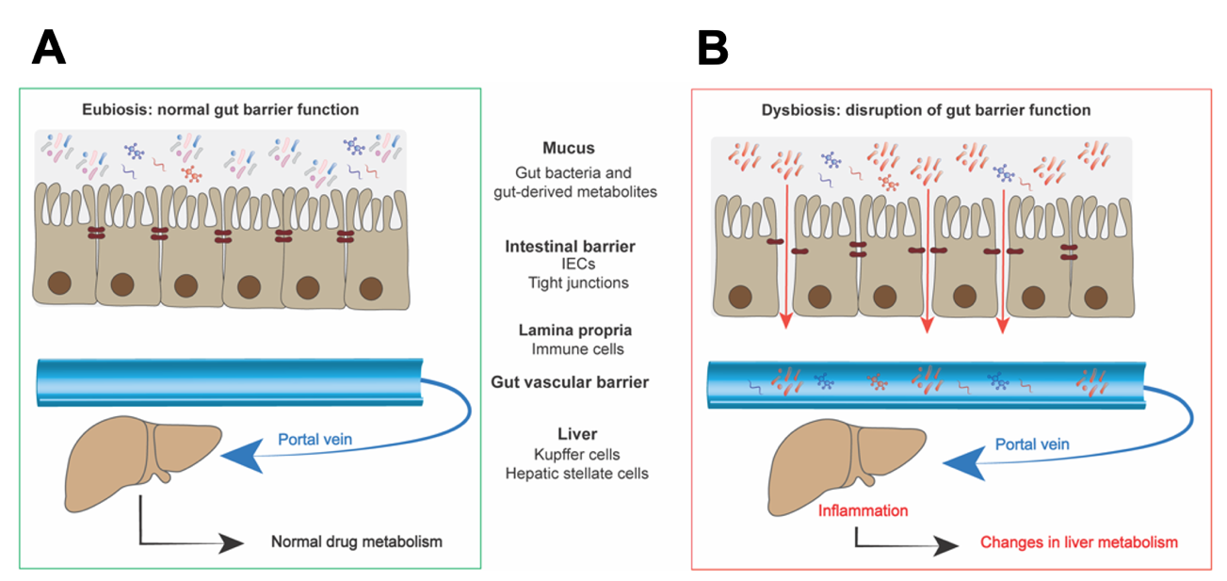
Figure 1: Drug metabolism under healthy and unhealthy conditions.
A) Under eubiotic (healthy) conditions, the intestinal barrier and mucus layer tightly regulate the passage of pathogens and metabolites. B) Under dysbiotic (unhealthy) conditions, the barrier is disrupted and cannot retain bacteria and bacterial-derived metabolites from reaching the portal vein. Ultimately, this results in changes in liver metabolism. IEC, intestinal epithelial cells. Figure reproduced from Lucchetti et al. 2021.

The intestinal barrier

The intestinal barrier is composed of an outer mucus layer including the gut microbiota, antimicrobial proteins, secretory Immunoglobulin A (sIgA), the epithelial cells and the lamina propria where immune cells reside (Vancamelbeke & Vermeire, 2017). The intestinal epithelium constitutes an important barrier against external factors such as bacteria, toxins and antigens (Groschwitz & Hogan, 2009) but is permeable to dietary nutrients, sugar, electrolytes and water. The permeability of the intestinal epithelium is regulated by the transepithelial/transcellular and paracellular routes. Paracellular transport is regulated by selective transporters on the cell membrane while transcellular passage is controlled by specific complexes localized at the apico-lateral side of the cells (Guttman & Finlay, 2009). These protein complexes can be grouped into desmosomes, adherens and tight junctions (Figure 2). They form intracellular seals consisting of transmembrane proteins that are connected to cytoplasmic adaptors and the actin cytoskeleton. Additionally, a homeostasis between intra- and extracellular calcium (Ca²⁺) levels is critical for maintaining tight junction assembly (Ma et al., 2000; Pongkorpsakol et al., 2021; Zihni et al., 2016). Given that these protein complexes are responsible for maintaining the mechanical junction between adjacent cells, they are crucial for regulating the tightness of the intestinal wall. When the intestinal barrier is compromised by dysbiosis (Figure 1B), gut bacteria and gut-derived metabolites can breach the intestinal barrier, enter the blood circulation and ultimately cause inflammation. The link between the intestine and the liver and the effect of intestinal dysbiosis on drug metabolism will be discussed in section 1.2.
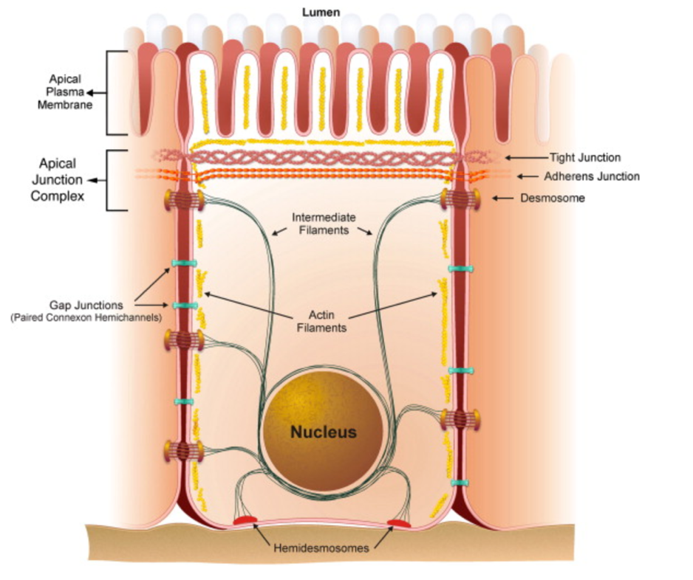
Figure 2: Typical arrangement of cellular junctions.
Intestinal epithelial cells are polarized cells. Their apical plasma membrane is presenting microvilli facing the intestinal lumen. Adjacent cells form anchors at their lateral side. The apical junction complex is typically composed of tight junctions, adherens junctions and desmosomes. They interact with the actin cytoskeleton through cytoplasmic adaptors to strengthen their structure. Other junction complexes include gap junctions and hemidesmosomes and interact with the lateral and basal side of the cells, respectively. Figure reproduced from (Guttman & Finlay, 2009).

Colorectal cancer

Colorectal cancer (CRC) is the third most common cancer worldwide (Rawla et al., 2019). Despite the efforts that are being made to improve its outcome through screening and therapy, CRC mortality remains high. The causes for the development of CRC pathogenesis are numerous. These can be a combination of genetic, epigenetic and environmental factors i.e., diet, lifestyle, alcohol consumption and smoking (Schmitt & Greten, 2021). The gut environment has emerged as an important factor in CRC development. Most colon cancers develop via a multistep process (Jass, 2007). This process is characterized by the presence of a benign polyp, developing to a pre-cancerous polyp, further advancing to an adenocarcinoma and finally a metastatic adenocarcinoma. Given that the progression from a benign polyp to a malign adenocarcinoma takes years, early screening of CRC can help detecting precancerous polyps and substantially reduce the risk of CRC progression.

Therapies

Current treatment strategies for CRC include chemotherapy, radiotherapy and surgery (Stintzing, 2014). Once a tumor has reached the metastatic phase, CRC surgery is not always sufficient to remove the cancerous lesions. In these cases, surgery is combined with chemotherapy to achieve shrinkage of the tumor and avoid further growth and progression. Chemotherapy is often a combination of several drugs. CRC chemotherapeutic treatments currently include a combination of 5-fluorouracil (5-FU), leucovorin and oxaliplatin (FOLFOX) or 5-FU, leucovorin and irinotecan (FOLFIRI). Given that these drugs are non-specific to cancer cells and thus also target healthy cells, they cause severe side effect in patients. These side effects include diarrhea and neutropenia and are limiting drug dosage. Novel treatment strategies for CRC are being explored because of drug resistance and the lack of specificity. Immunotherapy relies on utilizing the host’s own immune system to target cancer cells and could thus be a more effective way of treating CRC and avoiding unwanted side effects (Johdi & Sukor, 2020).

Colorectal cancer-associated bacteria

Perturbations in the gut microbial composition have been linked to the development and the progression of CRC (Silva et al., 2021; Figure 3). Several CRC-enriched bacteria were reported (Okumura et al., 2021; Rebersek, 2021). Recent advances in our understanding of the gut microbiome’s role in CRC have been obtained with the use of 16S ribosomal RNA (rRNA) sequencing and furthermore enabled the discovery of new CRC-associated bacteria (Schloss, 2018). Additionally, metabolomics allowed to link different gut microbial metabolites such as short chain fatty acids (SCFAs), vitamins, polyphenols and polyamines to CRC progression and metastases (X. Zhang et al., 2019). Interestingly, it was shown that CRC patients present a reduced variety in gut microbes with a decrease in specific strains. According to these studies, 11 operational taxonomic units (OTUs) belonging to the genera Enterococcus, Escherichia/Shigella, Klebsiella, Streptococcus, and Peptostreptococcus were more abundant in CRC patients (J. Kim & Lee, 2022). Other OTUs belonging to Roseburia and Lachnospiracae were less abundant.

Given that it is becoming clear that the gut microbiome is associated to an increased risk of developing CRC, more research is being conducted to better understand the underlying molecular mechanisms. Throughout the last years, several mechanisms have been described whereby the gut microbes can lead to cancer initiation and progression (J. Kim & Lee, 2022; Ternes et al., 2020). These mechanisms include the secretion of bacterial metabolites, bacterial adhesion and invasion of host cells and modulation of the host’s immune response. Hence, strategies to modulate the gut microbiome could be used to improve CRC therapy.

Escherichia coli and colorectal cancer tumor growth

Escherichia coli (E. coli) is a normal habitant of the GIT and helps to maintain homeostasis. However, some E. coli strains can become pathogenic. Pathogenic E. coli strains of the phylogenetic group B2 possess a genomic island called “pks” encoding a polyketide-peptide genotoxin termed colibactin (Cuevas-Ramos et al., 2010). Colibactin was shown to produce DNA double strand breaks. This pathogenic E. coli ^{pks+} strain was found to be highly abundant in CRC patients. Additionally, E. coli ^{pks+} strain was associated with inflammation and reactive oxygen species (ROS) production and closely related to the development of CRC (Veziant et al., 2016). Other genotoxins were shown to be expressed by E. coli ^{pks+} i.e., cyclomodulin cycle inhibiting factor (CIF) and cytotoxic necrotizing factor (CNF-1). Genotoxins can modulate differentiation, apoptosis and cell proliferation, subsequently leading to cell senescence and tumor growth. More specifically, CIF can block cell mitosis and CNF-1 can induce changes in the actin cytoskeleton and cause cellular senescence.

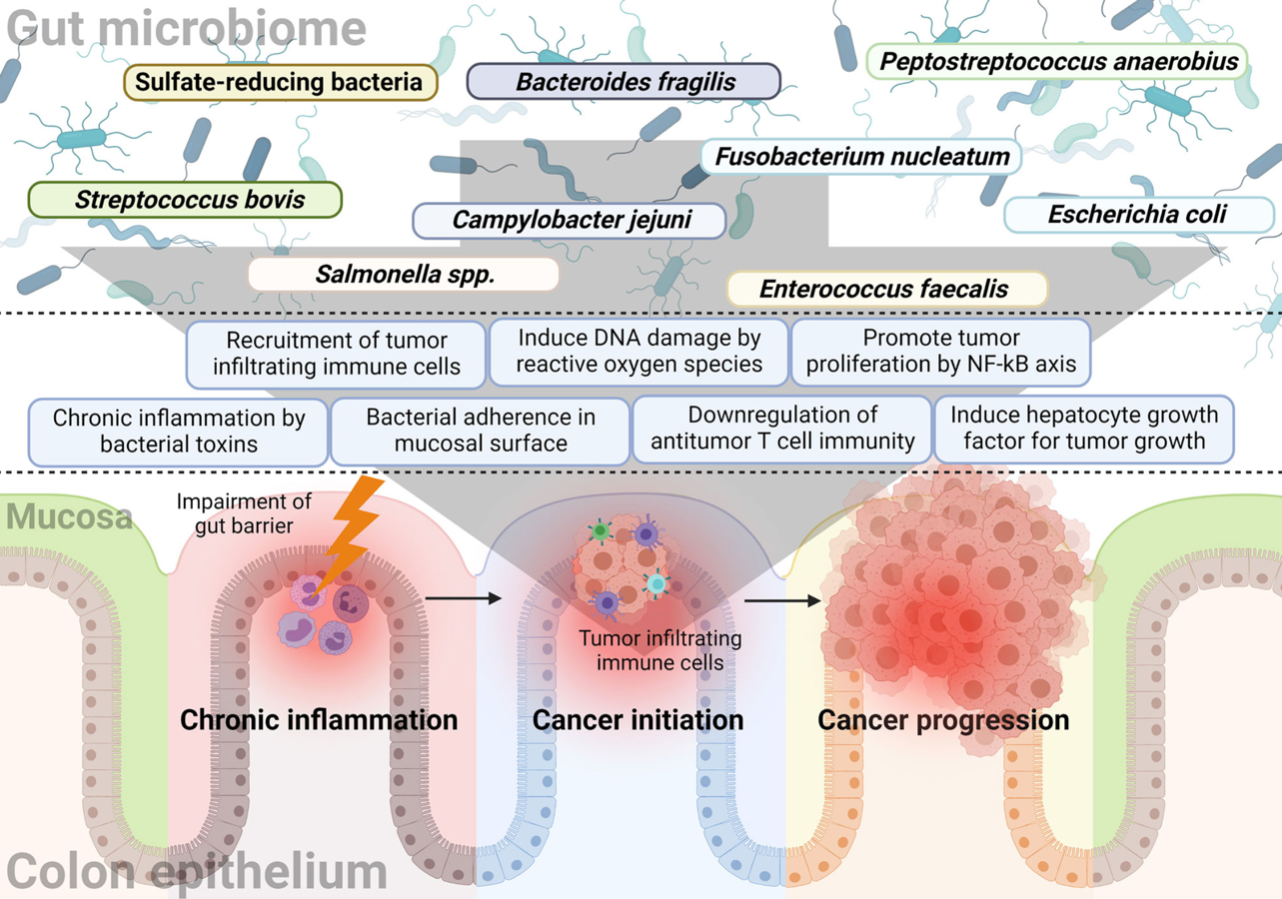
Figure 3: The link between the gut microbiome and CRC initiation and progression.
The mechanisms by which the gut microbes lead to cancer formation are diverse. Specific gut microbes were shown to induce chronic inflammation in the intestinal epithelium by secreting bacterial toxins. The induction of DNA damage via ROS is another possible mechanism. Then, some microorganisms recruit tumor infiltrating cells or promote tumor proliferation via the NF-κB pathway. ROS, Reactive Oxygen Species; NF-κB, Nuclear Factor-Kappa B. Figure reproduced from Kim & Lee, 2022.

The gut-liver axis

The term gut-liver axis designates the bidirectional interconnection between the gut and the liver (C. L. Hsu & Schnabl, 2023). As explained in 1.1.2 a tight intestinal barrier retains bacterial metabolites from spreading to the liver. Intestinal dysbiosis is therefore linked to liver inflammation which causes metabolic liver diseases such as alcohol-associated liver disease and nonalcoholic fatty liver disease (NAFLD) (Powell et al., 2021). Interestingly, modest improvements of liver diseases could be shown after faecal microbiota transplantation (Gu et al., 2021). These findings show the important interplay between the liver and the gut.

From an anatomical point of view, the gut-liver interconnection is done via the venous blood that is draining from the intestine into the liver through the portal vein (C. L. Hsu & Schnabl, 2023). Portal vein blood contains nutrients and microbial-derived metabolites that are absorbed by the intestinal cells and then taken up by the hepatic cells (Figure 4). These microbial-derived metabolites are important for the metabolic functions of the liver. The liver also communicates with the intestine through the biliary tract. Bile, which is a solution rich in bicarbonate, phospholipids, bile acids and IgA, is responsible for a number of functions. Bile represents a major excretion route for lipophilic substances, it emulsifies dietary fats to facilitate their intestinal absorption, eliminates cholesterol and it protects the body from enteric infections by secreting IgA.

The term enterohepatic recycling (EHR) refers to the circulation of substances from the liver into the bile, which are then reabsorbed in the small intestine and return to the liver via the portal vein (Tu et al., 2021). EHR is necessary for some endogenous compounds like bile acids. Recirculation of bile acids avoids faecal excretion and daily biosynthesis. EHR also plays an important role in the context of non-endogenous substances such as xenobiotics. The influence of EHR on xenobiotic metabolism will be further discussed in section 1.2.4.

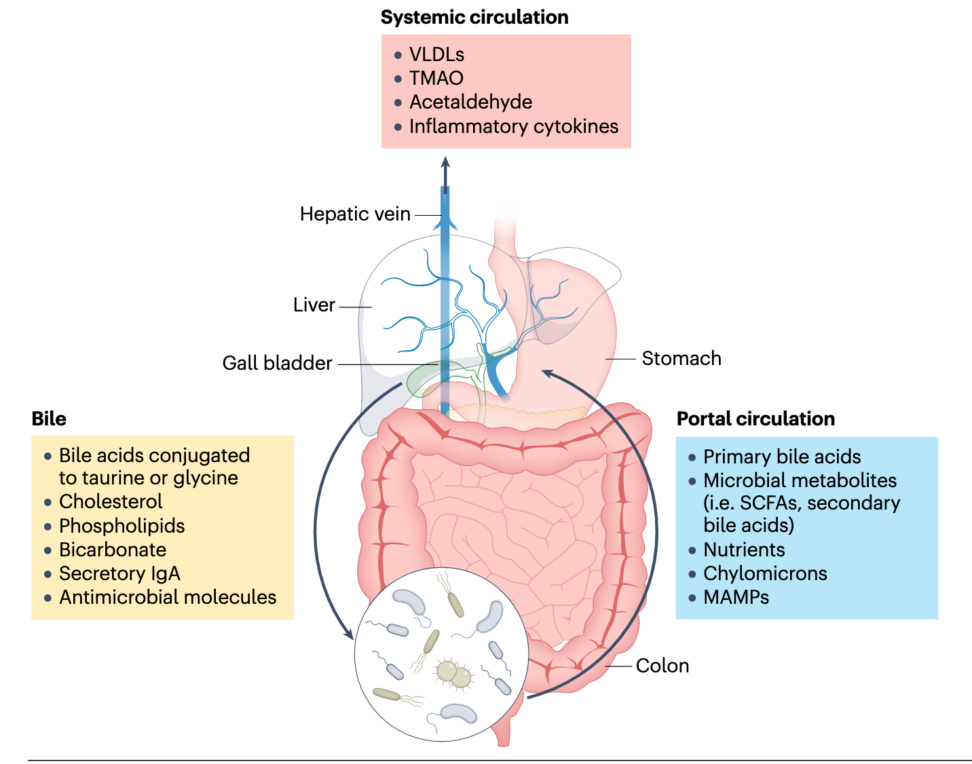
Figure 4: Schematic of the gut-liver axis.
The liver produces bile which is composed of different proteins (yellow box). Bile is transported to the small intestine via the biliary tract, aiding in lipid digestion and absorption. Gut bacteria convert bile acids into secondary bile acids in the colon. These are then transported to the liver via the portal circulation (blue box). Toxic metabolites that are produced by the liver continue their path to the systemic circulation (red box). MAMP, microorganism-associated molecular pattern; TMAO, trimethylamine N-oxide; VLDL, very low-density lipoprotein. Figure reproduced from Hsu & Schnabl, 2023.

Characteristics of liver cells

The liver is composed of different cell types i.e., hepatocytes, biliary epithelial cells (cholangiocytes), stellate cells, Kupffer cells and liver sinusoidal endothelial cells (Trefts et al., 2017). Hepatocytes being the most abundant cells in the liver and are implicated in most of the liver functions. Cholangiocytes are known as the cells lining the lumen of the biliary tract, stellate cells are responsible for vitamin A storage and Kupffer cells are macrophages residing in the liver. Finally, the liver sinusoidal endothelial cells are specialized endothelial cells forming the wall of the hepatic sinusoids. They make the vascular endothelium discontinuous by forming fenestrae (transcellular pores) to exchange proteins between plasma and the liver cells (Gracia-Sancho et al., 2021).

The hepatocytes are organized in a hexagonal nature (Figure 5 A) around the central vein to form the lobule. Branches of the hepatic artery, portal vein and bile ducts are surrounding the hepatic hexagonal structure and represent the portal triad area. Oxygen-rich blood from the hepatic artery mixes with nutrient-rich blood from the portal vein in the sinusoid to then drain into the central vein (Figure 5 B). This specific organization causes the presence of different zones with less or more oxygen and less or more nutrients and waste. This gradient results in a different partitioning of functions along the sinusoid, termed metabolic zonation, separated into three different zones.

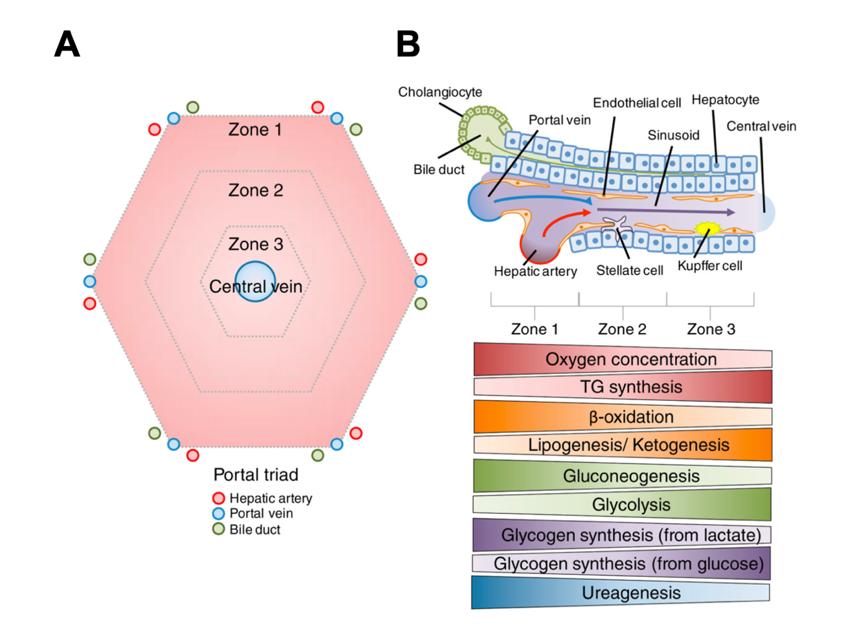
Figure 5: Organization of the liver.
A: Geometric representation of the liver. The hepatic artery, portal vein and biliary duct are organized in triads. B: Schematic representation of a liver sinusoid, the corresponding zones and metabolic processes. Different cell types coexist in the liver sinusoid: stellate cells, hepatocytes, endothelial cells, choliangocytes and Kupffer cells. The specific organization of the liver cells leads to several different gradients of oxygen, hormones, nutrients and waste products. These gradients create different zones in the liver which are characterized by different functions. Figure reproduced from Trefts et al., 2017.

Liver functions and physiology

The liver is responsible for a variety of functions in the human body. These comprise xenobiotic detoxification, lipid and cholesterol homeostasis, blood volume regulation, macronutrient metabolism, storage and redistribution of carbohydrates, lipids and vitamins (Bechmann et al., 2012). The liver produces and secretes bile which offers a route for the excretion of bile acids, drugs, metabolites, bilirubin and cholesterol.

Liver and drug metabolism

Drug metabolism is one of the main functions of the liver (Trefts et al., 2017). Drug metabolism involves drug-metabolizing enzymes that transform lipophilic drugs into more polar drugs to be excreted (Lucchetti et al., 2021; Omiecinski et al., 2011; Figure 6). Through this process, a drug is detoxified and its effect is terminated. Drug-metabolizing enzymes are abundantly found in the liver and to a lesser extend in other organs.

A drug can be administered through the oral or intravenous route. An orally administered drug has a drug bioavailability lower than 100% because it must first pass through the GIT to be absorbed. This process is termed first-pass metabolism. In comparison, a drug administered intravenously bypasses the first-pass effect and directly reaches the systemic circulation. Thus, drugs administered via the intravenous route have a bioavailability of 100%.

Figure 6: Phases of drug metabolism.
Several metabolic pathways are occurring to a chemical compound after oral intake. These pathways can be divided into three phases. The liver and GIT are responsible for the two first phases. Phase I is responsible for the oxidation of the compound via CYP450 to render it more soluble. Phase II also termed detoxification phase implicates the conjugation of the soluble metabolite to form a highly soluble metabolite. This occurs via UGTs. Highly soluble metabolites are eliminated by the body during phase III. GIT, gastrointestinal tract; CYP450, cytochrome 450; UGT, UDP-glucoronosyltransferases. Figure reproduced from Lucchetti et al. 2021.

Enterohepatic recirculation of drugs

As described in section 1.2 , EHR describes the process whereby a compound is recycled from liver to the intestine via biliary excretion and transported back to the liver. Drugs undergoing EHR show a longer half-life thus prolonging the effect of certain drugs and drug metabolites (M. S. Roberts et al., 2002). Consequently, the appearance of multiple peaks in drug plasma concentration can be observed. In addition, it was shown that EHR results in the reactivation of drugs through bacteria residing in the GIT. Factors influencing EHR are diverse and include the drugs molecular weight, chemical structure and polarity, biotransformation and metabolism (Malik et al., 2016). Understanding EHR is thus crucial to understand pharmacokinetics and drug dosage.

Bacteria involved in drug metabolism

Gut bacteria were shown to modify drug metabolism through the expression of different drug-metabolizing enzymes (Nichols et al., 2019; Wilson & Nicholson, 2017). Drugs that are delivered orally, undergo metabolization via host and bacterial enzymes residing in the small and large intestine (Zimmermann et al., 2019; Figure 7). Furthermore, drugs undergoing EHR are subjected to metabolization in the intestine. A series of drugs were reported to be chemically modified by gut bacteria (Dhurjad et al., 2022) and are summarized in Table 1. Moreover, bacteria from different clades were shown to be responsible for these modifications (Enright et al., 2016). These modifications include the: i) activation, ii) inactivation, iii) conversion into a toxic metabolite and iv) reactivation of a drug.

For instance, digoxin, a cardiotonic medication, can be rendered ineffective by Egghertella lenta. This bacterium converts digoxin into dihydrodigoxin and dihydrodigoxigenin (Haiser et al., 2014). Another example involves levodopa (L-Dopa), a treatment for Parkinson's disease. To become active dopamine, L-Dopa must first undergo intestinal absorption, cross the blood-brain barrier, and become decarboxylated within the central nervous system. However, research has revealed that Enterococcus faecalis-mediated decarboxylation transforms L-Dopa into dopamine, contributing to gastrointestinal side effects (Hashim et al., 2014; Jameson & Hsiao, 2019). Subsequently, Eggerthella lenta further dehydroxylates dopamine into m-Tyramine, influencing gut-related dopamine side effects. As a solution, L-Dopa is frequently administered in combination with carbidopa, a drug that prevents peripheral metabolism. Similarly, sulfasalazine, an anti-inflammatory drug, relies on microbial enzymes to cleave an azo-bond and activate its therapeutic effects. Lastly, brivudine, an oral antiviral treatment, is metabolized both by host enzymes and microbial enzymes (H Nakayama et al., 1997). This metabolism produces bromovinyluracil, which, when activated in the gut, can lead to hepatoxicity.

Importantly, xenobiotic metabolism is influenced by the microbial composition in the gut. Given that the microbial composition is different between individuals this results in a high variability of drug-metabolizing enzymes and differences in drug responses (Zimmermann et al., 2019). A better understanding of drug metabolism in the context of gut bacteria is crucial to customize treatments to render them more efficient.

Figure 7: The gut microbiome in drug metabolism.
After oral drug administration (1), the drug is absorbed in the small intestine and metabolized by host and bacterial enzymes. In the intestine (2), a drug can either be activated, inactivated or generate toxic compounds. These toxic compounds can cause liver toxicity (3). Figure reproduced from Lucchetti et al. 2021.

Table 1: Examples of drugs undergoing bacterial metabolization

Drug | Bacteria or enzyme | Modification | Reference
Brivudine | Bacteroides | Activation | (H Nakayama et al., 1997)
Diclofenac | β-glucuronidase enzymes | Reactivation | (Saitta et al., 2014)
Digoxin | Eggerthella lenta | Inactivation | (Haiser et al., 2014)
Indomethacin | β-glucuronidase enzymes | Reactivation | (Saitta et al., 2014)
Insulin | Protease enzymes | Inactivation | (Tozaki et al., 1997)
Irinotecan | Escherichia coli, Clostridium ramosum, Bacteroides vulgatus | Reactivation | (Takasuna et al., 2006)
Levodopa | Enterococcus faecalis, Eggerthella lenta,  Helicobacter pylori | Inactivation | (Hashim et al., 2014; Jameson & Hsiao, 2019)
Nitrazepam | Clostridium leptum | Conversion into a toxic compound | (Rafii et al., 1997)
Sulfasalazine | Azoreductase enzymes | Activation | (Peppercorn & Goldman, 1973)
Thioguanine | Escherichia coli | Activation | (Movva et al., 2016)

Irinotecan

As described in 1.1.3.1, irinotecan is used as one of the first-line chemotherapeutic treatments in CRC. Given that irinotecan was shown to be metabolized by the presence of gut bacteria (Table 1), its metabolism will be further discussed in this section.

Irinotecan is an analog of camptothecin derived from a Chinese tree called Camptotheca acuminata (Wall & Wani, 1996). In the mid-1980’s, the anticancer activity of irinotecan was elucidated. Irinotecan binds to the DNA topoisomerase I enzyme which is responsible for introducing single strand DNA breaks during DNA replication to allow supercoiled DNA to relax (Kciuk et al., 2020). Through inhibition of the DNA topoisomerase enzyme I, the relegation of the DNA strand is inhibited. This results in double strand DNA (dsDNA) breaks and further activation of damage checkpoint signaling and cell death. Given that cancer cells express more topoisomerase I enzyme they are more sensitive to irinotecan.

The prodrug irinotecan needs to be hydrolyzed into its active form SN-38 to exert its anti-cancerous activity (Smith et al., 2006; Figure 8). This transformation is done via two isoforms of carboxylesterases (CES1 and 2) localized in the blood, liver and kidneys. CES2 has a higher affinity for irinotecan than CES1 and thus mainly contributes to the activation of irinotecan. SN-38 is inactivated into SN-38G via UDP-glucoronosyltransferases (UGT) and excreted into the bile. UGT1A1, UGT1A7 and UGT1A9 are the major isozymes responsible for the detoxification of SN-38. Cytochrome (CYP) 3A4 enzymes contribute to the intrahepatic transformation of irinotecan into the inactive metabolites 7-ethyl-10-[4-N-(5-aminopentanoicacid)-1-piperidino] carbonyloxycamptothecin (APC) and 7-ethyl-10-(4-amino-1-piperidino) carbonyloxycamptothecin (NPC). NPC was shown to be converted into SN-38 but to a lesser extent than irinotecan. SN-38G can be deconjugated into SN-38 by β-glucuronidases produced by host (encoded by the GUSB gene) and bacterial cells (encoded by the uidA gene). Bacterial β-glucuronidase enzyme can cleave the glucuronic moiety to glucuronic acid and aglycone. The excretion route of all the metabolites of irinotecan is mainly done via the feces except for SN-38G which is only found in urine (Parvez et al., 2021). Elimination half-lives (t1/2) of irinotecan are between 5 and 18 hours.

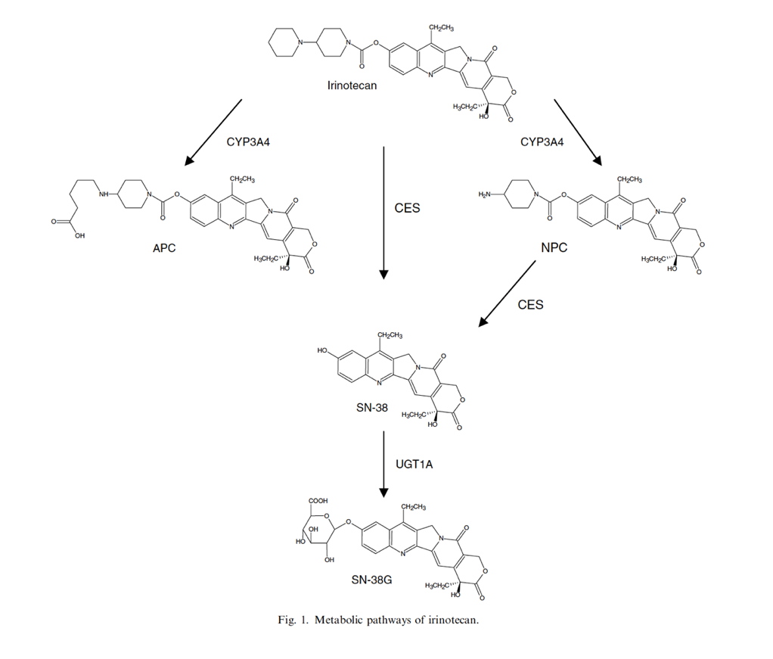
Figure 8: Metabolic pathway of irinotecan.
The prodrug irinotecan is either activated by CES enzymes into SN-38 or transformed into APC or NPC by CYP3A4. To a lesser extent, NPC can be further activated to SN-38 by CES enzymes. The active metabolite SN-38 is inactivated by UGT1A into SN-38G. CES1/2, carboxylesterase 1 and 2; APC, 7-ethyl-10-[4-N-(5-aminopentanoicacid)-1-piperidino] carbonyloxycamptothecin; NPC, 7-ethyl-10-(4-amino-1-piperidino) carbonyloxycamptothecin; CYP450, cytochrome 450; UGTs, uridine diphosphate glucoronyltransferase. Figure reproduced from Smith et al., 2006.

Irinotecan was first introduced in clinics in 1998 for the treatment of solid tumors, amongst which CRC, pancreatic and lung cancer are counted. The cellular metabolism of irinotecan is complex due to the involvement of many transporters and enzymes (Smith et al., 2006). Three different administration regimes for irinotecan currently exist in clinics. These can be weekly, bi-weekly or three-weekly (de Man et al., 2018). However, irinotecan is preferably administered intravenously every week for 90 minutes. Dosage of irinotecan range from 100 to 150 mg/m² of given weekly and from 150 to 350 mg/m² if given three-weekly. Primary side effects, neutropenia and diarrhea are often dose-limiting. Many studies were conducted to select the regimen and dosage causing the least side effects. Additionally, it was shown that even if reducing irinotecan dosage through combined therapy with 5-FU, the side effects were not improved and that these were highly dependent on the patient’s status.

Following intravenous injection of irinotecan, the prodrug is activated in the blood circulation into SN-38 (Figure 9). From there, SN-38 reaches the liver to be inactivated into SN-38G. Given that irinotecan metabolism is following EHR, SN-38G is recirculated back to the gut lumen via the bile duct. Interestingly, it was shown that SN-38G is reactivated via bacterial β-glucuronidases into SN-38, therefore prolonging the presence of the toxic metabolite in the body. Increasing number of research has shown that β-glucuronidase-expressing bacteria can enhance the reactivation of SN-38G (Parvez et al., 2021; Yue et al., 2021). Studies could show that inhibition of β-glucuronidase could reduce intestinal toxicity without interfering with irinotecan metabolism (A. B. Roberts et al., 2013). Moreover, the use of antibiotics to eliminate gut bacteria showed lower intestinal destruction in mice (Wallace et al., 2015). Many synthetic inhibitors i.e., E. coli and Clostridium perfringens β-glucuronidase-specific inhibitors and natural inhibitors i.e., flavonoids and cinnamic-acid derivates have been shown to successfully alleviate intestinal diarrhea. Given these findings, gut microbial manipulation will most probably become a part of CRC treatment.

Figure 9: Irinotecan metabolism in the human body.
The prodrug irinotecan is given intravenously (IV) to patients and is hydrolyzed in majority by blood CES 1/2 enzymes into the active metabolite SN-38. SN-38 travels through the blood circulation and is distributed through the body’s tissues e.g. the intestine, consequently also reaching the tumor target site. From the tissues, SN-38 is transported into the liver to be detoxified by UGT enzymes into the inactive form SN-38G. Instead of being excreted by the kidneys, SN-38G can reach the intestine via the biliary tract. Intestinal beta-glucuronidases, originating in majority from intestinal bacteria, are responsible for SN-38G deconjugation into SN-38. This causes SN-38 to persist longer in the intestine and triggers intestinal toxicity. CES1/2, carboxylesterase 1 and 2; UGT, uridine diphosphate glucoronyltransferase. Figure created with Adobe Illustrator.

Experimental models for studying the gut-liver axis

Given that the effect of the human microbiome on the liver and drug metabolism has increased in interest, there is a need to find ideal models to study the interaction between the gut and the liver (Pabst et al., 2023). However, it remains challenging to find an appropriate system to faithfully represent the GIT microbiome. Studies involving xenobiotics rely on studying absorption, distribution, metabolism and excretion (ADME) of the drug. Before starting human clinical trials ADME studies involve the use of different study models ranging from in vitro test tubes and cell culture systems to animal models and in silico modelling (D. Zhang et al., 2012). Each model aims to mimic as closely as possible human physiology to accurately predict the effect and toxicity of a drug. In the following sections, I will further describe the use of in vivo and in vitro models and their drawbacks in the context of the gut-liver axis and drug metabolism.

Animal models

Animal models are essential for improving our understanding of human disease and identifying new therapeutic strategies (Domínguez-Oliva et al., 2023). The use of living organisms, typically animals, is necessary to gain a comprehensive understanding of complex host-drug interactions (Douglas, 2019). Because animals consider the entire physiological context, compared to in vitro models, they provide a valuable tool for gaining insight into the entire physiological context. Therefore, animal models are often used in preclinical studies to investigate drug efficacy and toxicity. However, animal models are limited in their ability to represent human physiology. In addition, they cannot mimic the complex human responses to a drug and cannot show all its side effects.

For the study of the gut microbiome, animal models provide the means to manipulate host-microbiome interactions at the microbial and genetic level, which is not possible in humans (Kostic et al., 2013). Animals allow direct access to the contents of the colon, which is crucial for the study of metabolites and much more useful than feces. Animal models, especially germ-free or gnotobiotic animals (animals with a known and controlled gut microbiota composition), provide a valuable platform to study the role of gut microbes in drug metabolism in a living organism (Turner, 2018). By comparing drug metabolism in gnotobiotic and conventional animals, researchers can attribute specific metabolic changes to the gut microbiota.

Animal models have contributed to a large body of knowledge and remain essential for validating results from in vitro assays. Studying the influence of GIT microbes on drug metabolism requires an approach that combines in vitro, in vivo animal and human studies. However, animal studies raise many ethical and cost concerns, and translating their findings to humans remains challenging. Therefore, alternative models are needed to better simulate organ physiology in an animal-free manner.

Human studies

Human studies also play a crucial role in understanding the microbial influence on drug metabolism (Zimmermann et al., 2019). Human studies, such as clinical trials and observational studies, can provide insights into how individual variations in gut microbiota composition affect drug response (Javdan et al., 2020). These studies may involve analyzing the gut microbiota composition of individuals and correlating it with their drug metabolism profiles.

Advances in high-throughput sequencing technologies have enabled researchers to profile the composition and function of the gut microbiota with high accuracy (Turnbaugh et al., 2007). By analyzing the genetic material of gut microbes, researchers can identify specific microbial enzymes and pathways involved in drug metabolism. This information can guide the development of personalized medicine approaches that tailor drug regimens based on an individual's gut microbiota profile.

In vitro models

In vitro assays play a critical role in advancing our understanding of the gut-liver axis and drug metabolism by providing a controlled environment to study complex processes. In vitro models are used to screen large numbers of compounds at the discovery stage (D. Zhang et al., 2012). These models allow specific questions to be answered and do not require the use of large quantities of test compounds or cells. Furthermore, they allow researchers to individually study intestinal drug absorption and liver metabolism without the complexity of in vivo studies (Fedi et al., 2021; Ooka et al., 2020). One approach is to use cultured cells derived from gut and liver tissue. Enterocytes, the cells that line the intestinal wall, can be cultured to mimic the intestinal environment. These cells can be exposed to drugs and their responses analyzed to understand drug absorption. Similarly, hepatocytes can be cultured to study drug metabolism, including phase I and II responses.

In vitro assays also allow the use of patient-derived cells to better simulate human cell properties (Ramzy et al., 2020). The use of gels or scaffolds leads to the three-dimensional organization of these cells (Langhans, 2018). Nonetheless, in vitro models are not exposed to the dynamic environment of the human body and are often used to investigate a specific question at the single-organ level. Even though, in vitro models offer the opportunity to study the GIT microbiome and liver drug metabolism in a cost-effective and animal-free way, there is a need to find more complex in vitro systems.

Microfluidics-based in vitro models

Microfluidics-based in vitro systems, also known as organs-on-chips (OoCs) take classical in vitro assays to the next level because they are designed to better recapitulate human physiology. OoCs are fabricated using microfabrication techniques and allow for specific designs i.e., multiple channels, specific shapes and materials. These systems incorporate multiple cell types and allow the simulation of fluid flow and cell interactions, closely mimicking the in vivo environment. Furthermore, OoCs offer the possibility of sensor integration for monitoring the cell environment. By studying drug metabolism in these highly controlled systems, researchers can gain insight into how drugs are transformed in the gut and liver, as well as study potential interactions between the two organs.
In this section, I will first illustrate examples of single organ chips and will then describe platforms interconnecting single OoCs to form multi-organ chips (MOoCs).

Organ-on-chips

OoCs aim to closely mimic a tissue or an organ (Leung et al., 2022). To represent the intestine, it is necessary to reproduce the intestinal barrier with its villi-like structures and the gut environment characterized by shear stress, peristalsis and hypoxia (Thomas et al., 2023). Most OoCs recapitulating the intestine are based on at least two compartments to enable access the apical and basal pole of the cells (Marrero et al., 2021). This is important for cell differentiation and intestinal absorption. OoC compartments are often separated by a microporous polycarbonate (PC) or polyethylene terephthalate (PET) membrane enabling the passage of metabolites and preventing cell migration. The integration of hydrogel scaffolds simulates the physiological environment of the cells and enhances their in vivo-like differentiation (Costello et al., 2017; Figure 10 A). It was shown that shear stress is crucial for proper cell differentiation, mucus formation and drug absorption (Delon et al., 2019). By adjusting the flow rate and channel dimensions of the chip, shear stress can be tailored to the needs of the cells. To enable the co-culture of strict anaerobes and human cells in OoCs, oxygen levels must be lower than 0,5% (Zheng et al., 2015). Our in-house intestine chip named the human-microbial crosstalk model (HuMiX), has been validated to effectively simulate intestinal physiology and structure (Shah et al., 2016; Figure 10 B). The nitrogen flow in the top channel of HuMiX, creates an anoxic bacterial chamber, enabling the introduction of anaerobic bacterial cultures. Peristalsis is characterized by a series of muscle contractions occurring in the intestine. Peristalsis was simulated on-chip by applying vacuum suction to the lateral hollow chambers which caused stretching of the Polydimethylsiloxane (PDMS) chip (H. J. Kim et al., 2012; Figure 10 C). Primary epithelial cells isolated from an intestinal biopsy were, expanded as 3D organoids and cultured in a microfluidic device (Kasendra et al., 2018a). In this intestine-chip, the epithelium faithfully recapitulated in vivo structure of an epithelium.

Gut-on-chip systems provide the means to investigate microbiome-host interactions by introducing representative communities of the human GIT. The HuMiX system was used to model the intestinal barrier in relation to the GIT microbiome in a representative manner. Using the HuMiX system, an understanding of the importance of using synbiotics in the therapeutic treatment of CRC (Greenhalgh et al., 2019) and of the effect of microbiome-derived metabolites in driving CRC development (Ternes et al., 2022) has been obtained. Recent findings by Jalili-Firoozinezhad et al. (2019) showed that by placing their chips into an engineered anaerobic chamber they could ensure an oxygen gradient (Jalili-Firoozinezhad et al., 2019). Hence, they could culture highly complex communities of strict anaerobes and aerobes of human commensal gut bacteria. The Dynamic42 gut-on-chip was used to investigate microbial interactions in an immunocompetent environment (Maurer et al., 2019; Figure 10 D). They could successfully validate L. rhamnosus’ antagonistic interactions on the opportunistic pathogenic fungus Candida albicans.
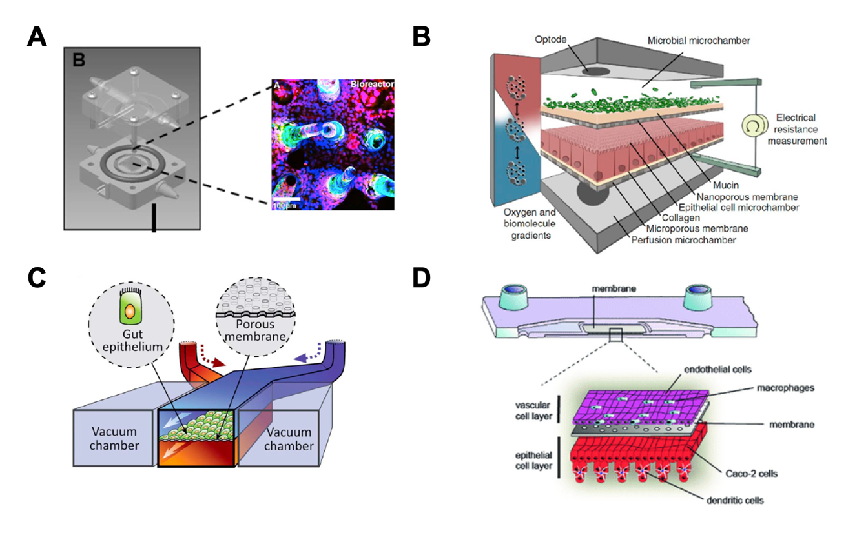
Figure 10: Gut-on-chip models recapitulating human intestinal physiology.
A) Gut-on-chip mimicking the 3D villi-like structures of the intestine via a hydrogel-scaffold. B) The HuMiX model comprises three channels and recreates an anoxic environment in the bacterial chamber. C) Gut-on-chip model comprising 2 channels, separated by a porous membrane and allowing the culture of an intestinal barrier. D) Dynamic42 gut-on-chip comprising dendritic cells, macrophages, endothelial cells and epithelial cells. 3D, three-dimensional; HuMiX, human-microbial crosstalk. Figure adapted from Costello et al., 2017, Shah et al., 2016, H. J. Kim et al., 2012 and Maurer et al., 2019.

To maintain human liver physiology several criteria need to be considered. These are hepatic polarization, oxygen zonation, shear stress to enhance metabolic activity, co-culture with other cells and hepatic cell origin (Dalsbecker et al., 2022; Deguchi & Takayama, 2022). The vascularized human liver acinus microphysiological system (vLAMPS) is a glass microfluidic chip recapitulating the 3D structure of the liver acinus (Li et al., 2018; Figure 11 A). Additionally, oxygen zonation was achieved by controlling the medium flow rate through the platform to create different zones of oxygen. The single-chamber self-assembly liver model (SQL-SAL) was designed to co-culture liver cells, immune, endothelial and stellate cells that would organize in physiologically relevant way (Vernetti et al., 2016; Figure 11 B). The chip was used to assess lactate dehydrogenase (LDH), albumin, drug and drug metabolites in the efflux media and to study hepatotoxicity. The Dynamic42 liver-on-chip system captures fundamental elements of liver metabolism and the human liver sinusoid structure (Rennert et al., 2015; Figure 11 C). The Dynamic42 system hence offers an effective tool for drug metabolism studies and acute and chronic liver inflammation disease modeling.

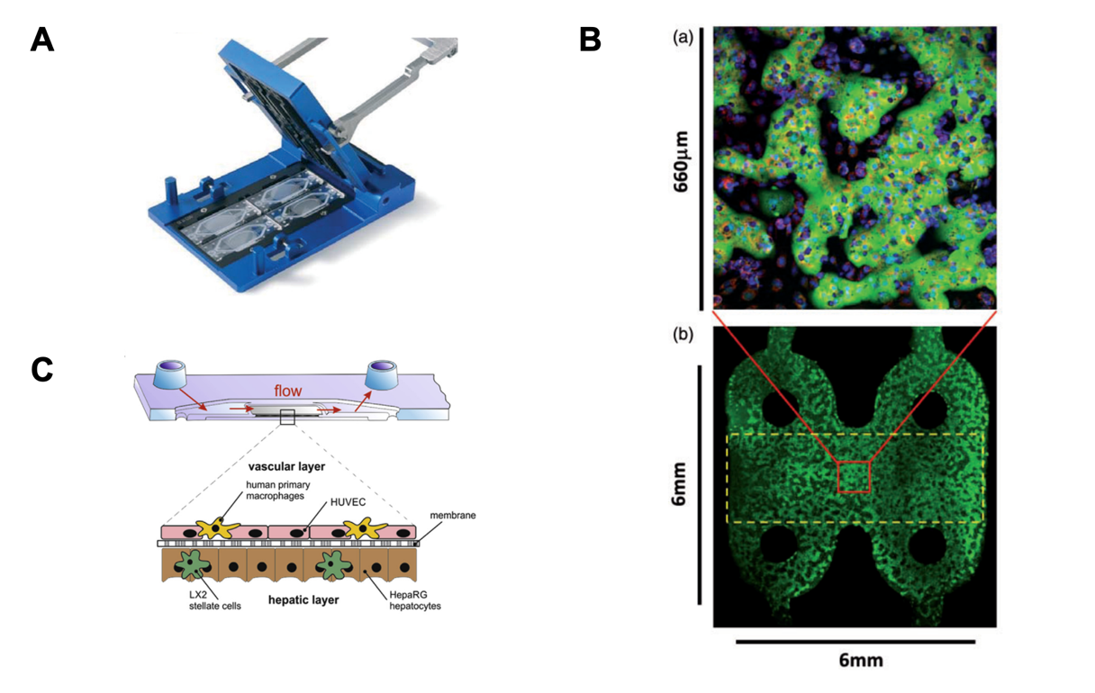
Figure 11: Liver-on-chip models simulating liver physiology.
A) vLAMPS glass-based liver chip recapitulating liver oxygen zonation. B) Cellular organization in the SQL-SAL liver-chip. C) Dynamic42 liver-on-chip containing endothelial cells, hepatocytes, stellate cells and macrophages. vLAMPS, vascularized human liver acinus microphysiological system; SQL-SAL, single-chamber self-assembly liver model. Figure adapted from Li et al., 2018, Vernetti et al., 2016 and Rennert et al., 2015.

Multi-organ-on-chip platforms

Modelling a single organ is not sufficient to understand more complex processes of drug metabolism. Multi-organ-chips aim to replicate interactions between two or more organs to provide a comprehensive understanding about organ function and interaction, disease mechanisms and drug metabolism. However, linking multiple OoCs comes with challenges. Scaling of the organs and the flow for each tissue, using specific cell medium for each tissue and the chip design need to be considered (Low et al., 2021).

Chen et al. (2017) demonstrated human gut-liver interactions under normal and inflammatory conditions using a MOoC platform (Chen et al., 2017; Figure 12 A). They could show that inflammatory gut-liver communication was associated with modifications in hepatic biotransformation and detoxification pathways implicating CYP450. Yang et al. (2023) designed an integrated gut-liver chip (iGLC) by co-culturing human gut and liver cells in a closed circulation loop (Yang et al., 2023;Figure 12 B). The iGLC platform was used to simulate initiation and progression of NAFLD by treatment with free fatty acids. The design of a four-organ chip offers the means to assess in vitro ADME effects and drug safety (Maschmeyer et al., 2015; Figure 12 C). Through the coupling of two-chamber OoCs of different organs a first pass model of drug absorption, metabolism and excretion was generated (Herland et al., 2020; Figure 12 D). This platform may be used for drug discovery and drug toxicity assessment.

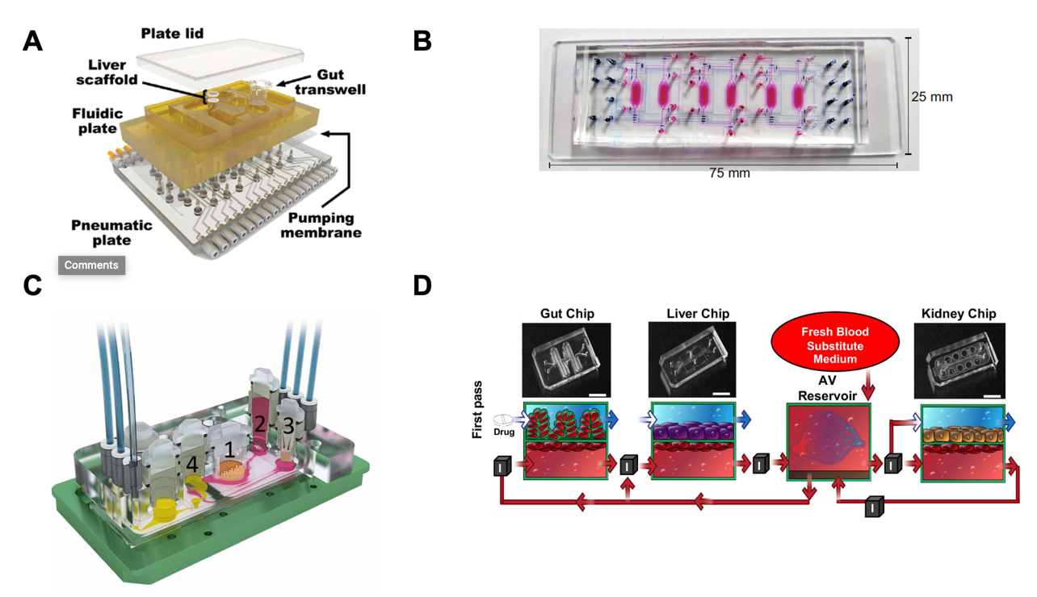

Figure 12: MOoCs simulating the interconnection between the gut and the liver.
A) Exploded view of gut-liver platform. B) iGLC platform used to simulate NAFLD. C) MOoC interconnecting the gut (1), the liver (2), the skin (3) and the kidney (4). D) Representations of the gut, liver and kidney chips containing a vascular compartment (AV) are shown on the bottom. Photos of the OoCs are shown on top. Medium flow is indicated by red arrows. Regions where an automated liquid handling system transfers fluid between the AV reservoirs are marked with ‘I’. iGLC, integrated gut-liver chip; NAFLD, non-alcoholic fatty liver disease; MOoC, multi-organ-on-chip. Figure adapted from Chen et al., 2017, Yang et al., 2023, Maschmeyer et al., 2015 and Herland et al., 2020.

Sensors

Sensors play a critical role in monitoring and controlling different parameters of the cell environment (Fuchs et al., 2021). This allows the researchers to gather more information on various parameters such as glucose levels, oxygen, pH and barrier permeability. Monitoring these parameters in real-time and in a non-invasive way, helps understanding cell behaviour in general and in response to external stimuli. The nature of integrated sensors to assess these parameters are electrical, optical and electrochemical sensors. The integration of electrical sensors in OoCs will be further disclosed in this section.

The integration of electrical sensors in OoCs can be used to obtain a transepithelial/endothelial electrical resistance (TEER) read-out. TEER measurements are widely used in vitro to assess the permeability of a barrier (Srinivasan et al., 2015). As discussed previously in 1.1.2, maintaining a tight intestinal barrier is crucial for preserving gut homeostasis. Previously, TEER sensors were introduced in OoCs using thin-film electrodes (van der Helm et al., 2019; Figure 13 A) or metal wires (van der Helm et al., 2016; Figure 13 B). Impedance spectroscopy was combined with electrical simulation to determine TEER and villi-formation of an intestinal epithelium grown in an OoC (van der Helm et al., 2019). A fabrication process for inserting Ag/AgCl electrodes in a two-channel PDMS chip was described (Douville et al., 2010). With this technology, confluency of different epithelial and endothelial cells was confirmed. TEER electrodes to measure confluency of renal epithelial cells under normal and barrier-disrupting conditions were integrated in a microfluidic device (Ferrell et al., 2010;Figure 13 C). Data normalization was addressed by integrating polystyrene sulfonate (PEDOT:PSS) electrodes in a microfluidic chip (Marrero et al., 2023; Figure 13 D). These electrodes cover the entire cell culture area and thus provide a homogenous electrical field across the entire membrane.

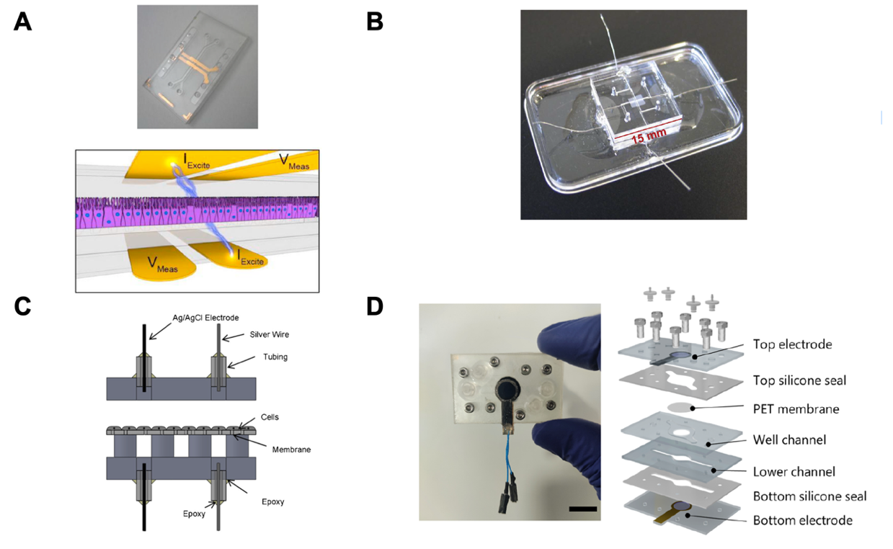
Figure 13: OoCs with integrated electrodes.
A) Microfluidic PDMS gut-on-chip device with two channels and integrated semi-transparent gold electrodes. B) Chip with integrated platinum wire electrodes. C) Schematic of TEER electrodes consisting of an Ag/AgCl and an Ag electrode on each side of the membrane. D) Microfluidic device with integrated PEDOT:PSS electrodes (scale bar = 1cm). PDMS, Polydimethylsiloxane; TEER, transepithelial/endothelial electrical resistance; AgCl, silver chloride; Ag, silver; PEDOT:PSS, polystyrene sulfonate. Figure adapted from van der Helm et al., 2019, van der Helm et al., 2016, Ferrell et al., 2010 and Marrero et al., 2023.

To conclude OoCs offer a promising approach to advance our understanding of human physiology, disease and drug responses in a more ethical way. In addition, the introduction of sensors facilitates the monitoring of cell parameters and provides a richer understanding of organ dynamics and interactions. Further advancements in this field are needed to improve the physiological resemblance of OoCs and accelerate their introduction in pre-clinical trials.

AIMS AND OUTLINE OF THE THESIS

The aim of this thesis was to establish an OoC-based study model to better recapitulate the gut-liver axis. For this purpose, I interfaced the HuMiX gut-on-chip and the Dynamic42 liver-on-chip from Jena University Hospital to create a multi-organ-chip system mimicking the gut-liver axis. To prove the functionality of the established platform, I simulated the metabolism of the well-known anticancer drug irinotecan. I then also used the platform, to study the impact of Escherichia coli on irinotecan metabolism. I selected a non-pathogenic E. coli strain for this work, as my primary interest was to investigate E. coli’s potential to affect irinotecan metabolism through its β-glucuronidase activity.

Given the importance of sensor integration in OoC systems to control the cell environment, I also worked on the introduction of TEER electrodes in the HuMiX system. This work led to the successful integration of thin-film platinum electrodes in HuMiX. These electrodes enabled to study intestinal barrier formation and disruption in HuMiX in real-time.

The presented work followed these main objectives:

- Interconnection of the HuMiX gut-on-chip with the Dynamic42 liver-on-chip for the establishment of a gut-liver platform
- Simulation of the metabolism of an anticancer drug, irinotecan, as a proof-of-concept of the established gut-liver platform
- Resolving the effect of a colorectal cancer-associated bacteria, Escherichia coli, on irinotecan metabolism using the gut-liver platform
- Integration of TEER electrodes in the HuMiX gut-on-chip to monitor real-time gut barrier permeability

COMMON METHODOLOGY

This chapter describes common methods that were used in this work. More details on these methodologies will be described in chapter 4 and refer to the following manuscripts:

- Lucchetti M., Oluwasegun A. K., Jäger C., Perez-Escriva P., Letellier E., Mosig A. S., & Wilmes P. (2023) “An organ-on-chip platform for simulating drug metabolism along the gut-liver axis.” To be submitted to Biofabrication

- Lucchetti M., Werr G., Johansson S., Barbe L., Grandmougin L., Wilmes P. and Tenje M. “Integration of multiple flexible electrodes for real-time detection of barrier formation with spatial resolution in a gut-on-chip system.” In revision with minor revisions. Microsystems and Nanoengineering

INTRODUCTION

The significant involvement of the gut-liver axis in drug metabolism processes as well as the influence of gut bacteria in the transformation of xenobiotics were described in section 1.2.4 and 1.2.5, respectively. Nonetheless, the full scope of the bacteria’s identity and the molecular mechanisms underlying xenobiotic metabolism remain incomplete. Given that the use of animal-free OoC systems is emerging to conduct research on the multi-organ level (section 1.3.4.2), this chapter focuses on the common methodologies that I employed to develop a platform simulating the gut-liver interplay. Within this chapter, I also address the strategies implemented to validate the functionality and metabolic activity of the cells within the platform. Furthermore, I tackle the methodologies used to conduct bacterial culture and to assess irinotecan metabolism.

The importance of barrier permeability in the context of the gut microbiome and drug metabolism was described in section 1.1.2 and 1.2. This section covers the methods utilized to assess in vitro barrier permeability. Furthermore, this chapter encompasses the method used to intentionally disrupt the epithelial barrier as well as the approach used to evaluate the disruption of tight junction proteins.

Finally, this chapter also outlines the improvements in engineering made in the HuMiX system, which were essential for mitigating bubble formation, integrating TEER electrodes in the HuMiX system and creating a functional gut-liver platform.

Human cell culture

Human cells used in this study are listed in Table 2. The cells were cultured in a humidified cell incubator at 5% CO₂ and 37°C. All the cells were verified monthly for mycoplasma using the MycoAlert® Mycoplasma detection kit (#LT07-318, Lonza). For subculture, the cells were detached from the culture flasks using TrypLE (TrypLE Express Enzyme (1X), phenol red, #12605010, Thermo Fisher Scientific). For the creation of stock vials, cells were resuspended in freezing solution (90% FBS HI, #10500-064, Life Technologies, 10% DMSO, #D841, Merck Milipore), transferred into a cryotube, placed at -80°C for 24 hours and then stored at -150°C until use. For cell recovery, cells were placed in a water bath at 37°C, resuspended in fresh cell culture media and centrifuged. The pellet was then resuspended in fresh culture media and the cell suspension transferred into a small flask for cell expansion.

Table 2: Human cells used in this study

Cell line | Cell-specific proteins
Caco-2 | Occludin, ZO-1
HepaRG | Albumin, CYP3A4
HUVEC | Cadherin-5
THP-1 | CD68

Assessment of cell viability and functionality

Cell viability

CASY cell count technology is used to assess cell viability. CASY measures the conductivity between two electrodes separated by a defined pore. The intensity of the signal directly correlates with the volume of the cells. Living cells have an intact membrane in comparison to dead cells. When a living cell is exposed to a low voltage field, it acts like an electric insulator and the electric current cannot go through. Thus, its full volume is detected. In contrast, in the case of a dead cell, which has pores in the membrane, the electrical field passes through and only its nucleus is detected.

Microscopy

Cells were stained for their specific proteins to assess barrier permeability, cell differentiation or metabolic functionality. Cell-specific proteins are listed in Table 2. Protein staining was performed using specific primary antibodies, further detailed in section 4.1.3.

ELISA

Albumin is the most abundant serum protein and is responsible for the transport of hydrophobic molecules and maintaining the oncotic pressure in the body (Spinella et al., 2016). Albumin is often used as a marker for hepatic viability in vitro because it reflects the functional integrity of hepatocytes. Albumin levels in the cell supernatants were quantified using Enzyme-Linked Immunosorbent Assay (ELISA) against albumin (Albumin Human ELISA kit, #EHALB, Thermo Fisher Scientific). The experimental principle of the ELISA assay for albumin detection is depicted in Figure 14 and further details on the method are found in section 4.1.3.

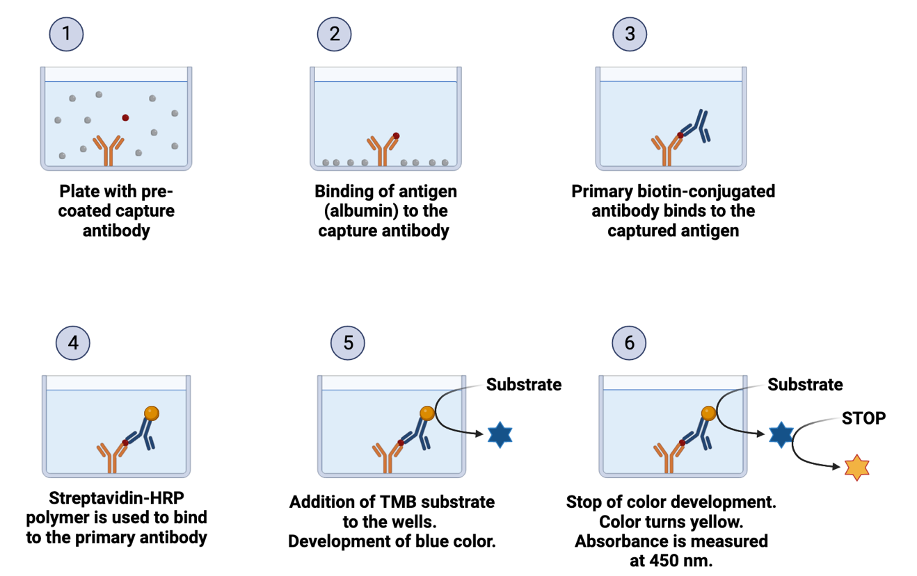
Figure 14: ELISA assay for albumin detection.
HRP, Horseradish Peroxidase; TMB, Tetramethylbenzidine. Figure created with BioRender.

Assessment of DNA damage

The γ-H2AX assay is a technique used to visualize and quantify DNA double strand (ds) breaks in cells (Noubissi et al., 2021). When DNA ds breaks occur, specific residues on histones are phosphorylated to form γ-H2AX histones. These can be detected with a specific antibody and visualized through fluorescence microscopy. The principle of this assay is depicted in Figure 15 and further details on the method are found in section 4.1.3.

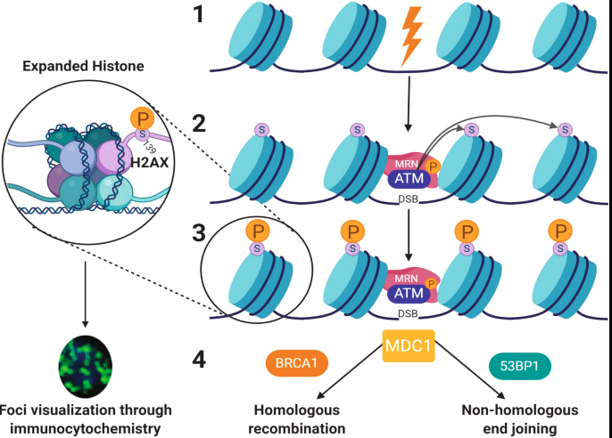
Figure 15: DNA damage and repair pathway.
(1) External factors can induce double breaks in DNA-wrapped histones. (2) This recruits the MRN protein complex and ATM kinases. (3) ATM kinases phosphorylate serine 139 residues on the H2AX histone protein. This creates phosphorylated foci that can be visualized through the γ-H2AX assay. (4) DNA checkpoint protein 1 (MDC1) is recruited to the double strand DNA breaks. DNA repair is then directed to homologous recombination or non-homologous end joining. MDC1, Mediator of DNA damage checkpoint protein 1. Figure reproduced from Noubissi et al., 2021.

Bacterial cell culture

Escherichia coli (MG1655, DSM 18039, DSMZ) strains were revived from glycerol stocks in 5 ml of anoxic brain heart infusion broth (BHI, #53286, Merck Milipore). Bacterial inoculums were cultured in an anaerobic chamber (GP-concept-T2, Jacomex) at 37°C, 95% N₂ and 5% CO₂. More details on bacterial cell culture can be found in section 4.1.3.

Assessment of bacterial growth and viability

Bacterial growth was assessed by measuring optical density (OD) at 600 nanometers (nm). OD measures the degree of light scattering caused by the bacteria in the suspension. The more bacteria are in the medium, the more turbid it is, the more light is scattered, the more bacteria have grown and the higher OD values are. Hence, OD values are directly proportional to the number of bacteria in the suspension (Beal et al., 2020).

Metabolomics

Metabolome analysis was the standard method used in this work to detect and quantify irinotecan and its metabolites (SN-38 and SN-38G). Metabolites were analyzed at the metabolomics platform at the Luxembourg Centre for Systems Biomedicine (LCSB). The collected samples were first extracted by Floriane Gavotto and Xiangyi Dong and analyzed with liquid chromatography and mass spectrometry. Data analysis was performed by Dr. Christian Jäger. Methods on metabolite extraction, Liquid Chromatography and Mass Spectrometry are further detailed in section 4.1.3..

In vitro assessment of barrier integrity

Transepithelial electrical resistance measurements

TEER measurements are commonly used to measure barrier permeability of an epithelial cell layer (Raut et al., 2021). To measure TEER, one of the chopstick electrodes is placed in the top compartment of a Transwell and the other one in the bottom compartment (Figure 16 A). The ohmmeter, which is connected to the chopstick electrodes, applies a small electrical current and measures the resulting voltage drop (Figure 16 B). TEER is calculated using Ohm's law (TEER = Voltage / Current). An increase in TEER over time signals the formation of tight junctions between cells. The higher the TEER, the more robust the barrier of the cell layer. A decrease in TEER thus indicates a damaged cell barrier. When growing Caco-2 cells on a semipermeable membrane and exposing them to apical and basal medium exchange for 21 days, they are differentiating into enterocyte-like cells (Meunier et al., 1995). More details on the application of this method are found in section 4.2.3.
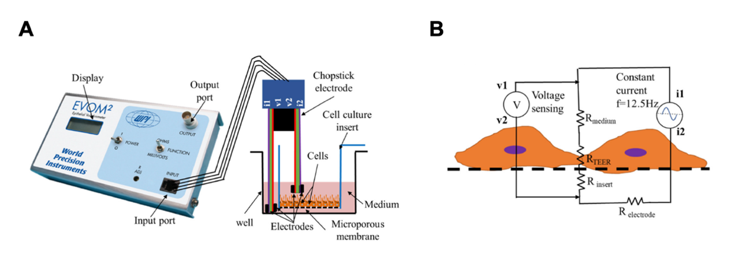
Figure 16: In vitro TEER measurements using chopstick electrodes.
A) Typical experimental setup for measuring TEER of an epithelial barrier growing on a Transwell insert. B) A simplified circuit diagram to model TEER measurement. The ohmmeter supplies a constant alternating current (AC) through i1 and i2 electrodes. The resulting drop is measured through v1 and v2 electrodes. The total electrical resistance, which is composed of the cell layer R_{TEER}, the membrane R_{insert} and the culture medium R_{medium} is estimated by subtracting the resistance of the electrode medium interface R_{electrode}. Figure reproduced from Raut et al., 2021.

Tight junction staining

Immunofluorescence staining of the tight junction proteins (i.e., occludin and ZO-1) was performed to visually confirm Caco-2 barrier formation. Details on the experimental procedure are described in section 4.2.3.

HuMiX engineering

The HuMiX system has undergone several developments since its first disclosure by (Shah et al., 2016). The HuMiX 1.0 version (Figure 17 A) was composed of a modular stacked assembly of silicone gaskets sandwiched between two PC lids (Shah et al., 2016). HuMiX 1.0 comprised three chambers separated by micro- or nanoporous membranes which enabled the co-culture of human and microbial cells (Figure 17 B). Furthermore, the insertion of chopstick electrodes in the system allowed for TEER measurements. HuMiX 2.0 was still composed of three chambers, but the silicone gaskets were sandwiched using a PC clamping system (Figure 17 C and D). This system was used for the co-culture of enteric neurons and epithelial cells by (Sedrani et al., 2023). HuMiX 2.1 (Ternes et al., 2022; Figure 17 C) and HuMiX 3.0 (Figure 17 E) were designed with an additional fourth chamber for the perfusion of Nitrogen (N₂) gas (Figure 17 F). This feature creates an anoxic chamber in the HuMiX system for the cultivation of strictly anaerobic bacteria. In this work, I mainly focus on the HuMiX 3.0 system which is, compared to HuMiX 2.0 and 2.1, composed of a metallic clamping system. This metallic clamp accelerates assembly and disassembly of the system. Despite all the advances HuMiX had already undergone, I encountered several challenges. These comprised: i) the big surface area and the complex structure of the spiral-shaped membrane, ii) the need of a flat surface area for the integration of TEER electrodes, iii) the presence of air bubbles in the channels and iv) the seeding strategy. The methodologies that I developed to address these difficulties will be further described.

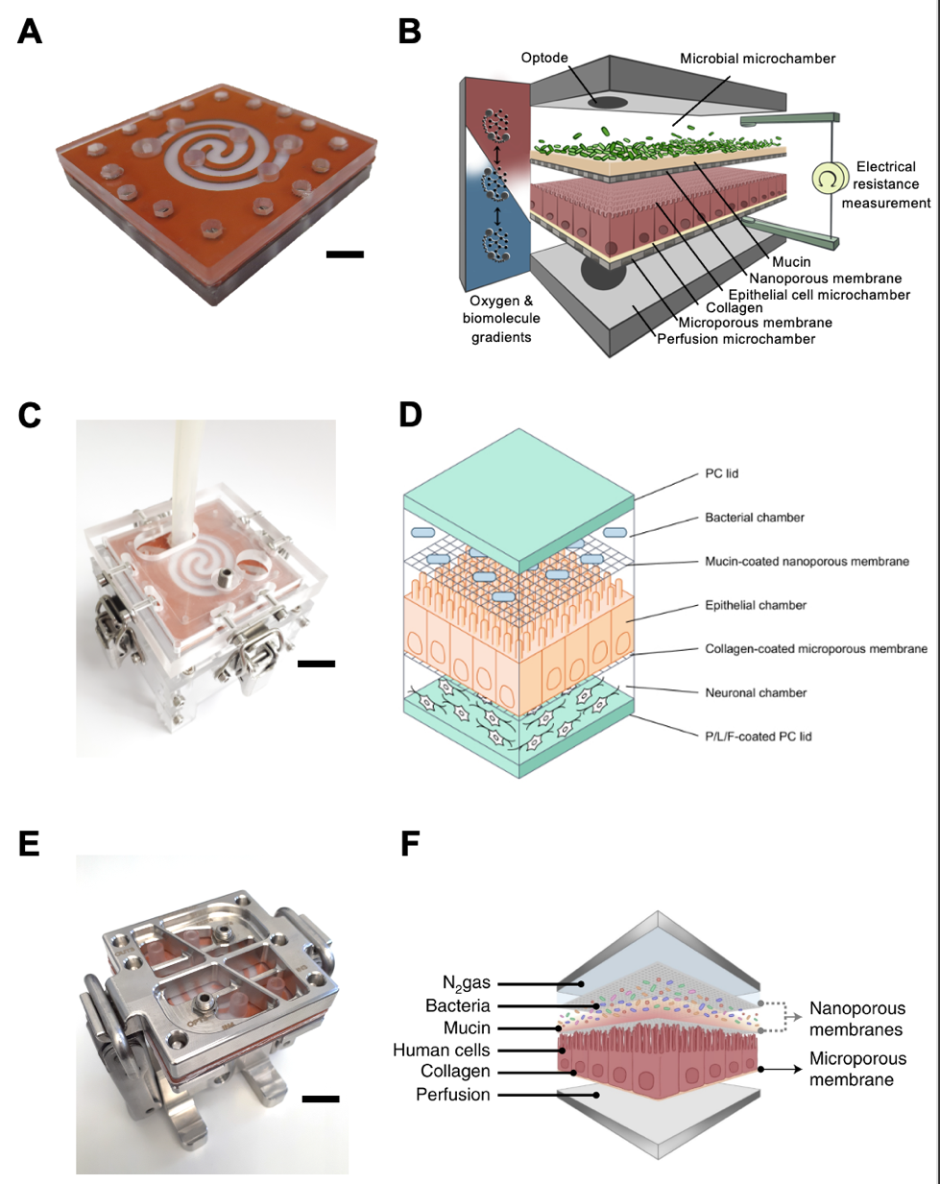
Figure 17: Evolution of the HuMiX system.
A) Picture of HuMiX 1.0. B) HuMiX 1.0 configuration with three chambers and inserted chopstick electrodes. C) Picture of HuMiX 2.1 with a plastic clamping system. D) Schematic of HuMiX 2.0 with three chambers. E) Picture of HuMiX 3.0 with metallic clamping system. F) HuMiX 2.1 and 3.0 configuration with four chambers. Scale bars = 1cm. Figures adapted from Shah et al., 2016, Sedrani et al., 2023 and Ternes et al., 2022.

Z-shaped HuMiX

The culture surface of the previous HuMiX versions was designed in a double spiral shape (Greenhalgh et al., 2019; Sedrani et al., 2023; Shah et al., 2016; Ternes et al., 2022) (Figure 18 A). For the introduction of TEER electrodes in particular, the spiral was changed to a Z-shape (Figure 18 B). The purpose of designing a Z-shaped membrane was to achieve the following objectives: i) reduce cell surface area and thus cell seeding number, ii) create a straight channel and thus reduce bubble formation and, iii) facilitate electrode insertion. The transition from the spiral to the Z shape also implied the need of changing the PC lids enclosing the silicon gaskets (Figure 18 C). To apply the right pressure around the membrane edges of the Z, there was a need to develop Z-shaped PC lids (Figure 18 D).

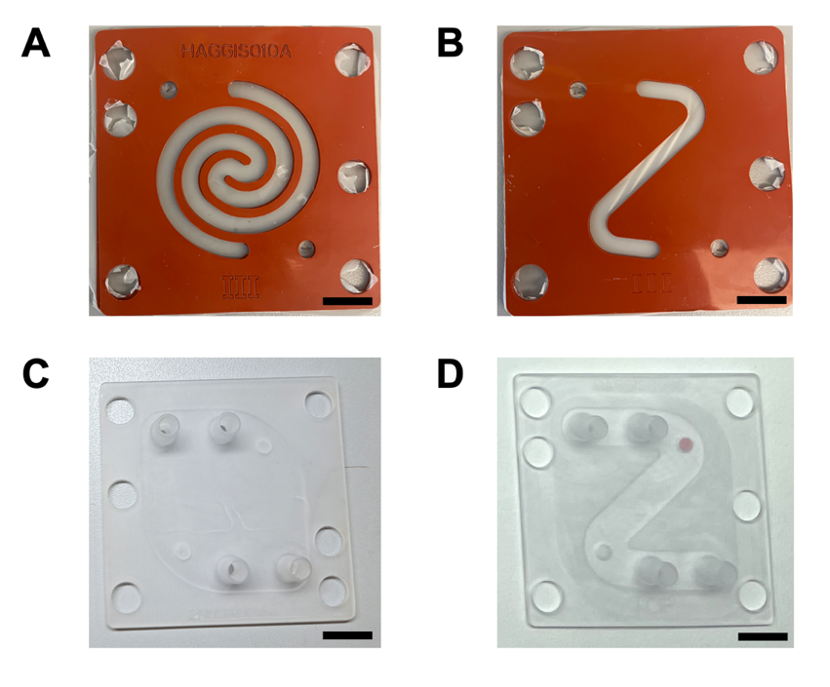
Figure 18: Spiral and Z-shaped HuMiX design.
A) Double spiral HuMiX membrane. B) Z-shaped HuMiX membrane. C) PC lid for spiral-shaped HuMiX. D) PC lid for Z-shaped HuMiX. PC, polycarbonate. Scale bars = 1cm.

Introduction of transepithelial electrical resistance electrodes

The HuMiX 2.0 version allowed for the insertion of chopstick electrodes for TEER measurements (Figure 19 A). In essence, the insertion of the electrodes led to the disruption in the maintenance of a sterile environment and could thus only be performed once. Hence, there was a need to develop electrodes that could be integrated in the HuMiX system to allow for real-time TEER measurements and assessment of gut barrier permeability. For the insertion of electrodes in the HuMiX system, the normal configuration of the gaskets was not suitable because the membrane area was concave (Figure 19 B). Thus, the assembly method of the silicone gaskets needed to be changed to have a flat surface (Figure 19 C). This adaptation allowed for a proper and even positioning of the electrodes.

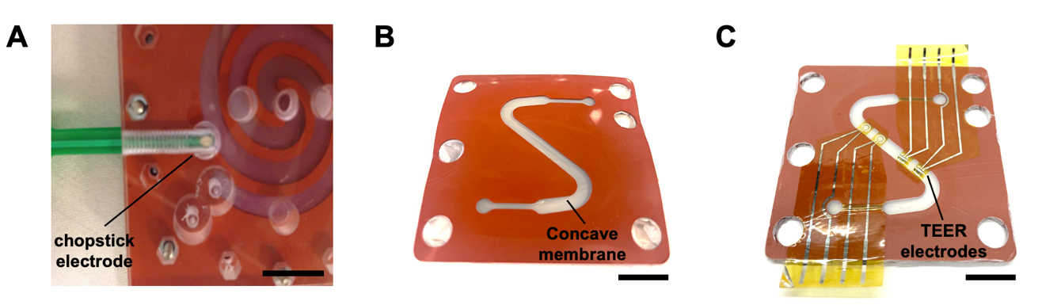
Figure 19: TEER measurements in HuMiX.
A) TEER measurement in HuMiX 1.0 via the insertion of chopstick electrodes. B) Normal HuMiX configuration with a concave membrane. C) New HuMiX configuration with a flat surface for the integration of TEER electrodes. Scale bars = 1cm. Figure A) adapted from Shah et al., 2016.

Introduction of bubble traps

Bubbles are a common problem in microfluidic systems (Leung et al., 2022). Bubble formation refers to the unwanted presence of gas bubbles in small channels where fluid flows. The reasons for bubble formation are numerous (Pereiro et al., 2019). Bubbles may appear upon device manipulation, when moving tubings or pushing liquid through a channel using a syringe. Moreover, temperature changes, the presence of structures prone to bubble formation and problems with sealing of chips lead to the formation and accumulation of air bubbles. When a bubble forms in a channel, it can completely obstruct it, thereby hindering the fluid to flow through. In addition, bubbles can physically damage a cell or disturb the nourishment of cells growing in the microfluidic channel. Measurements can be distorted due to the presence of bubbles. For instance, when measuring TEER in a microfluidic device, the presence of bubbles causes a high shift in impedance magnitude. Furthermore, bubbles make consistency between experimental replicates very challenging because they introduce variability between experiments.

Several techniques to reduce bubbles in systems exist. These can for instance be to improve sealing of the system, reduce the number of connectors and reduce dead areas where bubbles can be stuck. Moreover, the introduction of bubble traps can substantially limit the introduction of bubbles in a system. In this work, we used autoclavable bubble traps (95 μl, #LVF-KBT-M-A, Darwin Microfluidics, Paris, France) to reduce bubble formation in the HuMiX during operation. The use of bubble traps is described in section 4.2.3.

New seeding method

The standard method employed to seed cells in the HuMiX system is to push the cell suspension through the microfluidic channel using a syringe (Figure 20 A). In such manner, the cells are deposited on the cell membrane through gravity. However, this method only allows cells to be cultured on the top side of membrane, which is for instance the case for epithelial cells (Figure 20 B).
However, for the establishment of the gut-liver platform, the endothelial cells need to grow on the bottom side of the membrane as depicted in Figure 20 B. Thus, for the introduction of endothelial cells in the HuMiX system, we established a method whereby these cells were seeded on the HuMiX membrane prior to device priming Figure 20 C. After seeding, the device was then assembled as usual by flipping the membrane upside down.

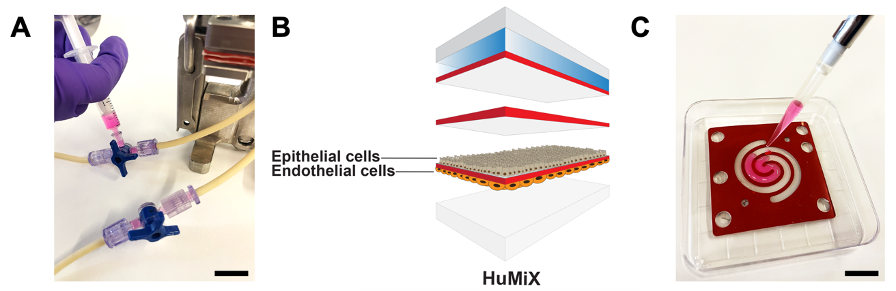
Figure 20: Seeding strategies for HuMiX.
A) Seeding strategy whereby cells are pushed through the channel via a syringe. B) Epithelial cells are seeded on the top side of the membrane. Endothelial cells are growing on the bottom side of the membrane. C) Seeding strategy implying to seed the cells on the bottom side of the membrane prior to HuMiX assembly. Scale bars = 1cm. Figure B) was created using Adobe Illustrator.

CONCLUSION

Evidence shows that gut bacteria affect drug metabolism processes, which must be uncovered to properly adapt treatment strategies. This work aims to establish an organ-on-chip-based gut-liver platform to better study how gut microbes affect drug metabolism processes. In this chapter, I described the common methodologies used for culturing cells and bacteria which laid the foundation for developing a gut-liver platform. Moreover, techniques to evaluate cell viability and functionality were described. Further technical details on the creation of the gut-liver platform as well as methods on metabolomic analysis to assess irinotecan metabolism will be described in the following chapter (4.1.3).

The importance of the intestinal barrier in drug metabolism processes is well defined. In this chapter, we explained the methodologies used to assess barrier integrity in vitro using chopstick electrodes and tight junction protein staining. The application of these techniques in the HuMiX system will be broadly described in chapter 4.2.3.

Finally, the engineering procedures described in this chapter contributed to the advancement of the establishment of the gut-liver platform as well as the integration of the TEER electrodes in HuMiX.

RESULTS

Manuscript I: An organ-on-chip platform for simulating drug metabolism along the gut-liver axis.

Contribution

As the first author, my personal contributions to this research paper encompassed the study design, planning, execution, and analysis of all experiments, along with the article writing, except for the metabolomic analysis.

Background and introduction

In section 1.2.5, I described the role of the microbiome in the metabolic transformation of drugs. In particular, I highlighted the fact that these metabolic transformations along the gut-liver axis may lead to the diminished response of drugs or the prolongation of toxic metabolites in the body (Enright et al., 2016). However, the complete extend and impact of microbiome-based influences on these processes remain unclear. This knowledge gap exists because there are limited experimental models representative of the intricate human gut environment. In section 1.3.4.1, I have highlighted examples of gut-on-chip models aiming to recreate the intestinal physiology (Costello et al., 2017; H. J. Kim et al., 2012; Maurer et al., 2019; Shah et al., 2016). However, these systems have a limited capacity to mimic the complex in vivo gut environment comprising a multitude of cells (bacterial, epithelial, endothelial cells and immune). To address this issue, I present a novel MOoC platform to forecast the effect of the gut microbiome on drug metabolism. This MOoC platform interfaces the HuMiX gut-on-chip (Shah et al., 2016) and the Dynamic42 liver-on-chip (Rennert et al., 2015) and thus replicates the bi-directional interconnection between the intestine and the liver. The HuMiX system was briefly introduced in section 1.3.4.1. In comparison to other gut-on-chip systems, HuMiX is composed of four parallel chambers and thus allows for the co-cultivation of anaerobic bacteria, intestinal epithelial cells, cells lining blood vessels and immune cells. The Dynamic42 liver-on-chip system, which was also described in section 1.3.4.1., recapitulates fundamental elements of liver metabolism and the microanatomical features of the human liver sinusoid. Thus, the interconnection of the HuMiX system and the Dynamic42 chip, serves as a promising model for creating a physiologically relevant platform that mimics the interaction between the gut and the liver.

One of the main challenges that needs to be faced when interconnecting two organ-on-chip systems is the choice of the appropriate medium. Choosing a suitable medium is important to fulfill the needs of each organ. Previously, common media have been supplemented with specific factors (hormones, vitamins, growth factors, etc.) (Maschmeyer et al., 2015). However, this requires the verification that these factors do not impact on cell viability. Otherwise, common media have been prepared by mixing cell-specific media in specific ratios (Edington et al., 2018; Esch et al., 2016). In this work, individual media were mixed in specific ratios to combine both organ chips. Thus, it was critical to test cell viability and function in the gut-liver platform.

Furthermore, this chapter describes how the established gut-liver platform, interfacing two existing OoCs; HuMiX and Dynamic42, was used to recapitulate the metabolism of a colorectal cancer drug, irinotecan. The metabolism of irinotecan was detailed in section 1.2.5.1. In short, the prodrug irinotecan is administered intravenously and is activated into SN-38 in the blood. Once SN-38 is formed in the blood stream, it reaches and targets the cancerous cells. In the liver, SN-38 is detoxified into SN-38G and transported back to the intestine through the biliary tract. In the intestine, irinotecan is reactivated into SN-38 through β-glucuronidase enzymes. This reactivation prolongs the presence of the active metabolite SN-38 in the body and leads to severe diarrhea in patients. Several intestinal bacteria have been described to express β-glucuronidases and to increase side effects in patients. Better understanding the effects of gut bacteria on irinotecan metabolism is crucial to improve treatment strategies. Thus, the example of irinotecan is valuable to fill this knowledge gab and serves as an effective means to validate the gut-liver platform.

The metabolic processes of cells can be influenced by the media flow rate in OoCs (Leung et al., 2022). The media flow rate can impact cell growth, nutrient supply, cell metabolism and removal of waste. In the case of drug testing in OoCs, the flow rate can affect drug delivery, distribution and metabolism. Thus, when designing an experiment in OoCs, the flow rate needs to be adjusted according to the type of cell, culture conditions and the purpose of the experiment (Wikswo et al., 2013). For simplification purposes, I thus kept the gut-liver platform under static conditions to avoid any disturbances caused by media flow. The duration of irinotecan treatment in this assay was determined according to the human-referenced half-life of irinotecan, which is 12 hours (Abigerges et al., 1995). Using liquid chromatography coupled to tandem mass spectrometry (LC-MS/MS), I was able to follow irinotecan together with its metabolites and demonstrate that the established gut-liver platform closely simulates irinotecan’s metabolism.

In section 1.2.5.1, I explained that SN-38G was shown to be reactivated by bacterial β-glucuronidase (Parvez et al., 2021; Yue et al., 2021). Ultimately this reactivation leads to the prolonged exposure of the toxic SN-38 metabolite in the body and thus triggers severe intestinal diarrhea in patients. Escherichia coli is involved, amongst others, in the transformation of SN-38G into SN-38, through its expression of β-glucuronidase (A. B. Roberts et al., 2013). However, the precise dynamics involved in this reactivation have not yet been studied in an OoC model. Thus, I aimed to use the gut-liver platform to better elucidate on the effect of E. coli on irinotecan metabolism.

The experiments included in this chapter, simulating irinotecan metabolism, resulted in low levels of SN-38G in the gut-liver platform (0,9 ng/ml). These levels of SN-38G I detected are inferior to in vivo levels of SN-38G (40-100 ng/ml, 12 hours after intravenous perfusion of irinotecan) (Czejka Martin J. et al., 2010; Raymond et al., 2003; Satoh T. et al., 2013; Wadsak & Farkouh, 2014). Given that the low levels detected in the gut-liver platform would not be sufficient to see an effect of reactivation, I addressed this issue by elevating SN-38G levels. Thus, I manually perfused the gut-liver platform with higher concentrations of SN-38G and assessed the impact of Escherichia coli to reactivate SN-38G into SN-38.

In vivo, gut bacteria are continuously exposed to a multitude of external factors. As a result, this triggers various enzymes to be expressed to respond to the environmental conditions. However, in vitro conditions differ compared to the in vivo environment and therefore bacterial enzyme expression may vary in vitro. Even if many bacteria possess the aptitude to produce β-glucuronidases, in some cases it might be essential to further induce their expression to see a metabolic effect. Hence, this chapter describes the methodologies used to further induce β-glucuronidase expression in E. coli.

Manuscript

Conclusion

The methodologies elucidated in this chapter were confronted with challenges. When interconnecting OoCs, several factors need to be considered. Ensuring a leak-free interconnection is crucial to avoid contaminations and the insertion of air bubbles in the cell culture area. Thus, proper sealing needed to be verified for the individual chips and for the interconnection lines that create the interface between and the Dynamic42 chip. Furthermore, a common media for interconnecting chambers with different cell types needs to be defined when interconnecting different OoCs. Here, I established a mixture between two cell type specific media to perfuse chambers interfacing the gut and liver cells.

The methodologies and findings presented in this chapter demonstrate that the designed gut-liver platform accurately simulates the cellular behaviour of both the gut and the liver. Remarkably, the cells remained viable and exhibited characteristic protein expression profiles within the gut-liver platform. Consequently, this novel gut-liver platform paves the way for a wide range of applications, including drug discovery, drug testing and drug metabolism studies.

The next step was to simulate the metabolism of irinotecan within the gut-liver platform, serving as a demonstration of the platform’s proof-of-concept. Notably, I demonstrate that THP-1 cells activate irinotecan into SN-38 and HepaRG cells detoxify SN-38 into SN-38G. The administered concentrations of irinotecan (5-12.5 μg/ml after dilution in the system) I used in these assays, resemble in vivo-relevant doses of 150-350 mg/m² (corresponding to 4-15 μg/ml). The subsequent activation of irinotecan in the gut-liver platform produced concentrations of SN-38 (3-17 ng/ml). These are comparable to in vivo plasma levels of 5-50 ng/ml. However, the inactivation of SN-38 into SN-38G was very low in the gut-liver platform (0,8 ng/ml), compared to what is found in human plasma (40-100 ng/ml) (Czejka Martin J. et al., 2010; Raymond et al., 2003; Satoh T. et al., 2013; Wadsak & Farkouh, 2014). These differences can have various explanations. UGT1A1 enzymes are responsible for the conversion of SN-38 into SN-38G. HepaRG cells were reported to have similar gene transcription levels than primary human hepatocytes (Hart et al., 2010). Although HepaRG might express similar mRNA levels, this does not necessarily mean that there is a similarity at the protein expression level. Thus, the lower amounts of SN-38G detected in the gut-liver platform could result from lower UGT1A1 levels compared to in vivo levels. Additionally, the reactivation of SN-38G into SN-38 is catalyzed by β-glucuronidase enzymes. These enzymes are expressed by a variety of mammalian cells (Naz et al., 2013). Thus, the transformation of SN-38G into SN-38 can be considered as a very dynamic process. Considering that the system was kept under static conditions for 12 hours, the HepaRG cells could have first inactivated SN-38 into SN-38G but also have been responsible for the reactivation of SN-38G into SN-38 via β-glucuronidase enzymes. A more indirect way to measure SN-38G would be to measure the expression of transporters (Parvez et al., 2021) or to measure UGTA1 enzymatic activity (Donato et al., 2010). Additionally, the activity of β-glucuronidase could be inhibited to avoid reconversion of SN-38G into SN-38 by mammalian cells.

Then, I explain how I used the gut-liver platform to validate the reactivation SN-38G into SN-38 through β-glucuronidases by the gut bacterium Escherichia coli. This particular bacterium was chosen because it is commonly associated with the development of colorectal cancer (1.1.3.2.1) and because it is known to express β-glucuronidase enzymes. Ultimately, the establishment of a gut-liver platform integrating gut bacteria might be a valuable tool to test the effect of bacteria on drug metabolism and lead to the development of treatments addressing the gut microbiome. The presented results provide insights on the reactivation of SN-38G into SN-38 by human and bacterial β-glucuronidases. According to the performed experiments, the addition of p-nitrophenyl-β-D-glucopyranoside (PNPG) and bile salts to the bacterial medium, stimulated the reactivation of SN-38G into SN-38. Moreover, this reactivation was already occurring at very early time points i.e., one hour after E. coli culture. Consistent with what was already described in humans, E. coli strongly contributes to the reactivation of SN-38G into SN-38 through β-glucuronidase. Hence, I used these insights to test specific conditions in the gut-liver platform. More specifically, I introduced E. coli in the bacterial HuMiX chamber and perfused it with SN-38G to assess whether E. coli transforms SN-38G into SN-38. After analysis of the bacterial outflow, I observed that E. coli reactivates SN-38G into SN-38 in the gut-liver platform and that this process is being initiated at early time points.

To conclude, I present how the gut-liver platform can be used as a novel tool to further elaborate on the process E. coli plays in the reactivation of SN-38G. Ultimately, the established gut-liver platform represents an effective tool to better understand interactions between the gut microbiota and other pharmaceutical compounds and contribute to the improvement of drug development strategies and therapeutic treatments. Better elucidating on the effect of gut bacteria on drug metabolism has several applications. Understanding the full scope of gut bacteria implicated in the metabolism of a drug and revealing the dynamics of these processes, can help to improve the efficacy and safety of drugs. This would help to prevent unwanted side effects and optimize treatment effects. Furthermore, innovative treatment strategies modulating the gut microbiome could specifically inhibit the negative effect of bacteria on a specific drug and enhance the growth of bacteria improving drug efficacy. Moreover, chemotherapeutic treatment strategies for could be improved by developing personalized treatment strategies including the microbial context of the patient.

Manuscript II: Integration of multiple flexible electrodes for real-time detection of barrier formation with spatial resolution in a gut-on-chip system

Contribution

Personal contributions to this research paper, as a shared first author, included literature research, the study design, the planning and conduction of all the experiments, the generation of schematic figures as well as the article writing. Data analysis for Figure 1, Figure 2 A and B, Figure 3, Figure 4, Figure S1, S4 and S5, Table S1 are not included in my personal contributions.

Background and introduction

In section 1.2, I highlighted the importance of barrier permeability in drug metabolism processes. In short, when the intestinal barrier is compromised, bacteria and bacterial-derived metabolites reach the blood circulation and cause liver toxicity (Lucchetti et al., 2021). This further leads to a perturbation in drug metabolism processes. Moreover, the importance of epithelial cells in the formation of a tight barrier and the use of TEER electrodes in OoCs for determining barrier tightness were described in section 1.1.2 and 1.3.4.3, respectively. This chapter highlights the methods used to integrate TEER electrodes in the HuMiX system to monitor real-time gut barrier permeability.

The previous HuMiX 1.0 version, described in section 3.6, allowed for the introduction of chopstick electrodes for the evaluation of TEER (Shah et al., 2016). Given the disruption of a sterile environment, this method only allowed for one-point measurements. Further considering the evolution of the HuMiX system, the current 3.0 HuMiX version necessitates the development of a new, more robust method for electrode integration. The development process of functional TEER electrodes for the HuMiX system spanned several years and underwent several iterations. Several prototypes were tested to improve the robustness of the system and arrive at the ready-to-use version which is further described in this chapter.

Common methods used for electrode integration in OoCs were not applicable to the HuMiX system because of its uneven surfaces, non-transparent materials and flexible layers. Thus, the integration of TEER electrodes in the HuMiX system required the use of a new fabrication method. This fabrication technique involved the deposition of thin-film metal electrodes on flexible substrates. Using a transfer-tape approach, the electrodes were easily integrated into HuMiX. To record information along the entire cell culture are, multiple electrodes were connected to an impedance analyzer through a multiplexer system. A dynamic normalization method was developed to account for the variations in the active measurement area.
In this chapter, I first describe the methodologies used for the design, fabrication and integration of thin-film electrodes into the HuMiX system. Then, I explain how the integrated electrodes were utilized for real-time measurements of TEER as a direct read-out on barrier permeability, disruption and recovery.

Manuscript

Conclusion

The integration of TEER electrodes in OoCs is a valuable tool to monitor barrier permeability of a cell layer. For the HuMiX system, with its complex geometry, flexible substrates and uneven surfaces, existing fabrication methods for TEER electrodes were not applicable. Thus, I describe a novel fabrication method for thin-film electrodes and the integration of these electrodes in the HuMiX system. The TEER electrodes we designed were capable of measuring TEER along the culture area of HuMiX. Thus, barrier permeability of the Caco-2 cell line could be monitored over 12 days. Additionally, we assessed the capacity of the TEER electrodes to detect disruption and recovery of the Caco-2 barrier. With the integration of multiple electrodes spanning over the cell culture membrane and the development of a multiplexer system, we were able to collect TEER from different locations. Interestingly, our findings indicate that the barrier was non-uniform along the cell culture area. This brings attention to the fact this non-uniformity of the barrier integrity may also apply to other OoCs. This work highly supports the integration of multiple electrodes in OoCs to monitor barrier formation more accurately along the cell culture surface. Furthermore, using TEER electrodes in OoCs is valuable for the effect of drug candidates on barrier function. Insights on intestinal barrier toxicity can be gained by measuring TEER in response to potential drugs. This could ultimately accelerate drug safety and development strategies.

GENERAL CONCLUSIONS AND PERSPECTIVES

This chapter describes general conclusions drawn over the course of the doctoral thesis. I discuss the methodologies used to develop a functional gut-liver platform, establish its proof-of-concept simulating irinotecan metabolism and validate the effect of Escherichia coli on irinotecan metabolism. Moreover, I explain the technology that was developed to integrate TEER electrodes in the HuMiX system to measure real-time barrier permeability at four positions along the cell culture area. Additionally, I describe open questions that could be tackled in future studies to accelerate drug discovery processes and ultimately improve treatment strategies.

General conclusions

The main aims of this dissertation consisted in establishing a functional gut-liver platform by interconnecting the HuMiX system and the Dynamic42 chip. HuMiX was developed and described to study the interaction between human cells and gut bacteria (Shah et al., 2016). The HuMiX gut-on-chip system was shown to faithfully recapitulate cues of the gastrointestinal tract environment and to control them. The Dynamic liver-on-chip system was demonstrated to replicate crucial characteristics of liver morphology (Rennert et al., 2015). There is an increasing interest in interconnecting two or more OoCs to create a MOoC system. MOoCs open avenues to study more complex mechanisms and diseases at the multi-organ level. However, the interconnection of individual OoCs involves several challenges.

The interfacing of two or more organ chips which involves the co-culture of different cell types with specific needs, requires the use of a common medium. In this work, I describe how I interface the hepatic Dynamic42 chamber and the bacterial HuMiX chamber by perfusing them with an established mixture of two cell type specific media. The assessment of hepatic metabolic function was confirmed by assessing the production of albumin and expression of cytochrome P450 enzymes.

To create the interconnection between the gut and the liver, it was essential to establish an endothelial chamber in the HuMiX system. Given that the common protocol used for cell seeding in HuMiX was not applicable for this purpose, I established an alternative seeding protocol (section 3.6.4). In brief, this protocol consisted in seeding endothelial HUVEC cells on the bottom side of the membrane prior to chip assembly. The subsequent experiments performed to validate this new technique showed that HUVEC viability was not compromised. Additionally, the endothelial HuMiX chamber required the presence of mature THP-1 cells. Thus, THP-1 monocytes were stimulated on-chip with phorbol myristate acetate (PMA) and their viability and differentiation into mature macrophages was evaluated.

When creating a connection between two OoCs with different sizes and chamber volumes, differences in pressure also need to be considered. These differences in pressure can result in leakages or imbalances in fluid flow. Given that the HuMiX system is larger than the Dynamic42 system, proper sealing techniques of the gut-liver platform needed to be ensured to avoid contamination and minimize the creation of leakages and air bubbles.

To demonstrate the feasibility of the gut-liver platform, I needed to carefully choose a suitable drug candidate. The selection of a drug candidate should align with the intended application of the system. Since my research primarily focused on colorectal cancer and considering that irinotecan is used in clinics to treat colorectal cancer, it was a reasonable choice. Additionally, irinotecan's metabolism and mode of action have been extensively investigated, providing a robust basis for my research. Furthermore, there is evidence indicating that Escherichia coli, a bacterium associated with colorectal cancer, can affect the metabolism of irinotecan. This connection further justified my decision.

In clinics, irinotecan is administered intravenously at doses between 150 and 350 mg/m². Since the gut-liver platform has several interconnected chambers, diffusion of compounds needs to be considered (Grant et al., 2021). The data I presented showed that irinotecan concentrations detected in the gut-liver compartments (5-12.5 μg/ml) were comparable to in vivo-relevant doses of 150-350 mg/m² (corresponding to 4-15 μg/ml). The gut-liver platform I described in this work closely simulated the metabolism of irinotecan. In brief, the prodrug irinotecan is activated into SN-38 in the blood and inactivated into SN-38G in the liver. The results I generated using the gut-liver platform demonstrated that after irinotecan perfusion, SN-38 and SN-38G metabolites were generated. The detected concentrations of irinotecan and SN-38 were physiologically relevant compared to in vivo plasma levels. However, SN-38G amounts were lower in the gut-liver platform compared to in vivo plasma concentrations. Differences in UGT enzymes, responsible for the conversion of SN-38 into SN-38G, can account for these dissimilarities. In addition, differences in media flow rates in the gut-liver platform can also explain drug interaction variabilities compared to in vivo observations.

As a next step in this work, I aimed to validate the applicability of the gut-liver platform for investigating how gut bacteria affect drug metabolism. Since previous studies had already described the impact of Escherichia coli in altering irinotecan metabolism through β-glucuronidases, I chose E. coli as a candidate for this study. However, it needs to be noted that the conditions in the gut-liver platform differ from the natural gut environment. Consequently, the production of β-glucuronidase by E. coli needed to be stimulated through the addition of PNPG in the bacterial medium.
The dynamics of SN-38 reactivation into SN-38G are not well documented. Thus, I assessed the rate at which E. coli could convert SN-38 into SN-38G. The results obtained from this analysis guided our selection of the conditions to be used in the gut-liver platform. The subsequent findings obtained in the platform highlighted the significant role of E. coli in reactivating SN-38G into SN-38, mainly during the first hour.

In this work I also highlighted the importance of integrating sensors in OoCs to monitor environmental cues and cell behavior. Since HuMiX is used in the context of colorectal cancer and drug metabolism, there was an urgent need to integrate TEER electrodes in HuMiX to monitor gut barrier permeability in response to external factors (drugs, bacteria, etc.). Given that the initially described spiral-shaped membrane of the HuMiX system presented a very complex structure for the integration of TEER electrodes, there was a need to readapt its shape. Thus, the Z-shaped HuMiX was developed for easing electrode integration but also for reducing bubble formation in the system. Furthermore, this project required the development of novel fabrication techniques for electrodes which were thin and flexible enough to be sandwiched in-between the HuMiX layers without causing leakages and go over uneven surfaces. This project involved several prototype development and testing phases before finding a robust an easy-to-use system. The ready-to-use TEER electrodes were composed of Platinum and Tantalum which were deposited on a flexible polyimide substrate. The tape-transfer method of these electrodes and their connection to printed circuit boards was a significant advantage of the system. The addition of multiplexer system and development of a mathematical simulation model allowed to record information of two HuMiX devices and to normalize TEER values appropriately. Furthermore, the electrodes were designed to measure TEER at four different positions along the cell surface area which allowed for the detection of differences in cell density along the HuMiX membrane.

Future perspectives

This study allowed for the establishment of a functional gut-liver platform simulating the metabolism of irinotecan and further verifying the effect of Escherichia coli on irinotecan metabolism. Furthermore, this work led to the integration of functional thin-film TEER electrodes in the HuMiX system, capable of assessing barrier integrity and disruption in real-time. Although this work has contributed to the development of a gut-liver platform and the integration of TEER sensors in HuMiX, more effort is needed to bring these technologies to the next level.

OoCs are microfluidic systems capable of simulating the microenvironment of a tissue or organ in a controlled way. Given that these systems have been proven to generate relevant read-outs, they represent valuable tools for pre-clinical studies (Ingber, 2022). To further increase their representation of the human in vivo situation, researchers are working towards their personalization by using patient-specific cells (Van Den Berg et al., 2019). These patient-derived cells are sourced from primary samples such as biopsies, urine, feces or blood. Compared to conventional cancer cell lines, patient-derived cells substantially increase the genetic and physiological resemblance of a patient. Organoids can for instance be derived from organ biopsies and are miniaturized three-dimensional structures that resemble an organ (J. Kim et al., 2020). Organoids mimic some functional and structural characteristics of the organ they are derived from. Given that organoids are valuable tools for the personalized study of disease processes, there is great interest to introduce them in OoCs (Kasendra et al., 2018). However, patient-specific material is difficult to acquire as biopsies often require invasive procedures through medical intervention. Another source which is derived from patients and commonly used in OoCs are induced pluripotent stem cells (iPSCs) (Low et al., 2021). iPSCs are reprogrammed from adult cells (skin or blood cells) and can be differentiated into nearly every type of cell. iPSC-derived cells have the advantage over patient-derived organoids that they can be maintained over long periods of time and that they can be expanded into large quantities of cells. OoCs including either patient-derived or iPSC-derived cells are named ‘patient-on-a-chip’. Complex diseases are being studied in these patient-on-chip systems (Palasantzas et al., 2023). Moreover, CRISPR/Cas9 technology is used in iPSCs for the precise introduction of genetic mutations (Dastidar et al., 2018; P. D. Hsu et al., 2014). Thus, the use of CRISPR/Cas9 in OoC context enables to study disease-associated mutations.

In the framework of the gut microbiome, personalization is particularly crucial given the interindividual differences of the gut microbial composition (Bäckhed et al., 2005). By inserting the fecal microbiota of a patient in OoCs, the unique gut microbiome of that patient can be represented. Furthermore, the interaction of the gut microbes and human intestinal cells can be studied in a controlled environment. This thesis highlights the effects of the microbiome on drug metabolism (Zimmermann et al., 2019). Thus, OoCs can be used to test how drugs can interact with a patient’s microbiome and impact intestinal cells. Tailoring medical treatment strategies to specific characteristics of a patient’s microbiome and genetic context could improve the prediction of drug response and reduce drug-related toxicities. Better assessing drug-microbiome interactions could become part of preclinical drug development strategies and complications due to interpersonal microbiome differences could be better predicted (Zimmermann et al., 2021). The personalization of the gut-liver platform presented in this work could thus advance the mechanistic understanding of drug-microbiome interactions. The integration of iPSC-derived intestinal and liver cells in the gut-liver platform for personalization purposes was previously described (Lucchetti et al., 2021). iPSC-derived intestinal and liver cells as well as a representative gut microbiome could be obtained from the same patient to establish a personalized gut-liver platform (Figure 21). This platform could be used to obtain a more complex and representative study of the microbiome’s effect on irinotecan metabolism. Specific β-glucuronidase inhibitors improving irinotecan-induced toxicity in mice were identified (Wallace et al., 2010). Thus, the personalized gut-liver platform could be used to confirm the effect of these inhibitors in a more representative model than mice. Moreover, this platform could be used to study how other compounds are processed by gut microbes. Haiser et al. (2014) have shown that the use of microbiome markers could be used to predict responses to drugs (Haiser et al., 2014). Furthermore, uncovering mechanistic effects of the gut microbiome on drugs could lead to the development of specific inhibitors. The development of enzymatic inhibitors was already shown to improve therapy against Parkinson’s disease (Rekdal et al., 2019). Moreover, the composition of the gut microbiome could be altered through diet, antibiotics, pre- and probiotics, or fecal microbiota transplantation if the full extent of drug-microbiome interactions were known. 5-fluorouracil, which is often used in combination with irinotecan to treat colorectal cancer, was shown to be inactivated by E. coli in mice (Spanogiannopoulos et al., n.d.). However, more mechanistic studies are needed to fully understand this process. Thus, the gut-liver platform could be used to study the effect of E. coli or a fully representative gut microbiome on irinotecan and 5-FU. Through this approach, irinotecan-induced toxic side effects and 5-FU efficacy could be improved. To conclude, further advancing the gut-liver platform to create a personalized system could pave the way towards precision medicine whereby bacteria involved in drug-microbiome interactions could be specifically targeted to alleviate side effects.

Organ scaling in OoCs is critical to maintain organ physiology and cell environment at a small-scale (Park et al., 2020; Shroff et al., 2022; Stokes et al., 2015). When interfacing multiple organ chips, it is important to consider organ size (cell density), flow rates, shear stress and total volume to scale these to physiological dimensions. Even though various scaling approaches have been described (allometric, proportional and functional scaling), no consensus on the most suitable approach has been achieved. In this work, a physiologically relevant connection between the gut and the liver was obtained by simulating the blood circulation and the biliary tract, thus enabling flow media from one organ to the other. In addition, irinotecan metabolism was simulated in the gut-liver platform by comparing metabolite concentration to in vivo plasma concentrations. However, proper scaling of the gut-liver platform is needed to accomplish proper translation of findings to humans. Approaches to create highly translational OoCs include further validation with human data (pharmacokinetic and pharmacodynamic studies), functional assays and read-outs, increases in biological complexity, optimization of specific-organ flow rates and the setup of long-term studies. In extension of my work, the introduction of patient-derived cells would thus substantially increase the validation of the gut-liver platform. More functional assays confirming cellular homeostasis and differentiation of patient-derived cells would need to be performed. These include studying albumin production, CYP450 activity, bile acid transport and zonation by the liver cells. On the Intestinal side, the presence of differentiated cells (absorptive, Paneth, goblet and enteroendocrine cells), mucus production, intestinal absorption of nutrients would need to be validated. Moreover, in vivo blood flow rates are different in the gut than and the liver. However, in this work a constant flow rate was used for both organ chips. Different perfusion approaches could thus be used to better control flow media in the respective organ chips. Furthermore, more extensive pharmacokinetic studies could include the study of drug absorption and distribution in the system and inform if these parameters correlate with in vivo data. Conducting pharmacodynamic studies would enlighten on the drug’s mechanism of action i.e., receptor interaction, generate dose-response curves and assess side effects.

Another important aspect that I described in this work involves the integration of sensors in OoCs to closely mimic and control the cells and their environment. Many sensors capable of measuring important cell parameters (pH, glucose, oxygen, lactate, barrier permeability) exist. The incorporation of these sensors in OoCs would add significant unique selling points for the use of OoCs over animal models. In this work, I outline the importance of integrating TEER sensors in OoCs to monitor gut barrier behavior in real-time. When designing new drugs, it is already common practice to assess intestinal barrier integrity in response to drugs (Peters et al., 2019). However, this is done using conventional Transwell systems. Given that OoCs better recapitulate human physiology, the integration of TEER electrodes in OoCs, represents a valuable tool to improve drug screening (Nicolas et al., 2021). As a future perspective of this work, the developed TEER technology could be integrated in the personalized gut-liver platform to study irinotecan-induced toxicity (Figure 21). More specifically, functional studies could be performed to determine which doses of irinotecan lead to intestinal toxicity and if toxicity is increased with the presence of gut bacteria. Additionally, the gut-liver platform with integrated electrodes could be used to screen for drugs inducing intestinal toxicity. Moreover, TEER electrodes could be useful to assess blood-brain barrier function in the context of the gut-brain axis. Recent findings suggest that the gut-derived metabolites can affect blood-brain barrier permeability and influence brain health (Parker et al., 2020). However, more work is needed to characterize the TEER electrodes in a new setup. If the developed TEER electrodes would be integrated in the personalized gut-liver platform, additional interferences of endothelial, immune and bacterial cells have to be considered. Thus, adjustments in normalization procedures are required to exclude these interferences and collect impedance measurements of the intestinal barrier. Moreover, the addition of bacteria in the HuMiX system could affect impedance measurements through biofouling. Biofouling which refers to the bacterial attachment on surfaces (Sultana et al., 2015), could lead to inaccurate TEER measurements and affect cell health.

Figure 21: Schematic of a personalized gut-liver platform with integrated TEER electrodes.
Patient-derived intestinal and liver cells are integrated in the gut-liver platform. Top and bottom TEER electrodes monitor intestinal barrier permeability. The effect of orally or intravenously administered drugs on barrier integrity could be assessed. The effect of the gut microbiome on drug metabolism could be studied. TEER, transepithelial electrical resistance. Figure created with Adobe Illustrator.

To conclude, the development of the OoC field is rapidly increasing and represents a valuable tool for improving drug discovery and treatment strategies. This work demonstrates the challenges that were faced and outlines strategies to further improve the predictive power of OoCs. This study thus represents a significant step forward in the improvement of OoCs, further strengthening their role in preclinical research.

Bibliography

Abigerges, D., Chabot, G. G., Armand, J.-P., H6rait, P., Gouyette, A., & Gandia, D. (1995). Phase I and Pharmacologic Studies of the Camptothecin Analog Irinotecan Administered Every 3 Weeks in Cancer Patients. In J Clin Oncol (Vol. 13).
Allaire, J. M., Crowley, S. M., Law, H. T., Chang, S. Y., Ko, H. J., & Vallance, B. A. (2018). The Intestinal Epithelium: Central Coordinator of Mucosal Immunity. In Trends in Immunology (Vol. 39, Issue 9, pp. 677–696). Elsevier Ltd. https://doi.org/10.1016/j.it.2018.04.002
Bäckhed, F., Fraser, C. M., Ringel, Y., Sanders, M. E., Sartor, R. B., Sherman, P. M., Versalovic, J., Young, V., & Finlay, B. B. (2012). Defining a healthy human gut microbiome: Current concepts, future directions, and clinical applications. In Cell Host and Microbe (Vol. 12, Issue 5, pp. 611–622). https://doi.org/10.1016/j.chom.2012.10.012
Bäckhed, F., Ley, R. E., Sonnenburg, J. L., Peterson, D. A., & Gordon, J. I. (2005). Host-Bacterial Mutualism in the Human Intestine. http://science.sciencemag.org/
Beal, J., Farny, N. G., Haddock-Angelli, T., Selvarajah, V., Baldwin, G. S., Buckley-Taylor, R., Gershater, M., Kiga, D., Marken, J., Sanchania, V., Sison, A., & Workman, C. T. (2020). Robust estimation of bacterial cell count from optical density. Communications Biology, 3(1), 512. https://doi.org/10.1038/s42003-020-01127-5
Bechmann, L. P., Hannivoort, R. A., Gerken, G., Hotamisligil, G. S., Trauner, M., & Canbay, A. (2012). The interaction of hepatic lipid and glucose metabolism in liver diseases. In Journal of Hepatology (Vol. 56, Issue 4, pp. 952–964). https://doi.org/10.1016/j.jhep.2011.08.025
Brown, E. M., Clardy, J., & Xavier, R. J. (2023). Gut microbiome lipid metabolism and its impact on host physiology. In Cell Host and Microbe (Vol. 31, Issue 2, pp. 173–186). Cell Press. https://doi.org/10.1016/j.chom.2023.01.009
Chen, W. L., Edington, C., Suter, E., Yu, J., Velazquez, J. J., Velazquez, J. G., Shockley, M., Large, E. M., Venkataramanan, R., Hughes, D. J., Stokes, C. L., Trumper, D. L., Carrier, R. L., Cirit, M., Griffith, L. G., & Lauffenburger, D. A. (2017). Integrated Gut/Liver Microphysiological Systems Elucidates Inflammatory Inter-Tissue Crosstalk. Biotechnol. Bioeng, 114, 2648–2659. https://doi.org/10.1002/bit.26370/abstract
Costello, C. M., Phillipsen, M. B., Hartmanis, L. M., Kwasnica, M. A., Chen, V., Hackam, D., Chang, M. W., Bentley, W. E., & March, J. C. (2017). Microscale Bioreactors for in situ characterization of GI epithelial cell physiology. Scientific Reports, 7(1). https://doi.org/10.1038/s41598-017-12984-2
Cryan, J. F., O’Riordan, K. J., Sandhu, K., Peterson, V., & Dinan, T. G. (2020). The gut microbiome in neurological disorders. In The Lancet Neurology (Vol. 19, Issue 2, pp. 179–194). Lancet Publishing Group. https://doi.org/10.1016/S1474-4422(19)30356-4
Cuevas-Ramos, G., Petit, C. R., Marcq, I., Boury, M., Oswald, E., & Nougayrède, J. P. (2010). Escherichia coli induces DNA damage in vivo and triggers genomic instability in mammalian cells. Proceedings of the National Academy of Sciences of the United States of America, 107(25), 11537–11542. https://doi.org/10.1073/pnas.1001261107
Czejka Martin J., Gruenberger Birgit, Kiss Andreas, Farkouh Andre, & Schueller Johannes. (2010). Pharmacokinetics of Irinotecan in Combination with Biweekly Cetuximab in Patients with Advanced Colorectal Cancer. Anticancer Research, 30, 23552360.
Dalsbecker, P., Adiels, C. B., & Goksör, M. (2022). Liver-on-a-chip devices: the pros and cons of complexity. In American Journal of Physiology - Gastrointestinal and Liver Physiology (Vol. 323, Issue 3, pp. G188–G204). American Physiological Society. https://doi.org/10.1152/ajpgi.00346.2021
Dastidar, S., Ardui, S., Singh, K., Majumdar, D., Nair, N., Fu, Y., Reyon, D., Samara, E., Gerli, M. F. M., Klein, A. F., De Schrijver, W., Tipanee, J., Seneca, S., Tulalamba, W., Wang, H., Chai, Y. C., In’t Veld, P., Furling, D., Tedesco, F. S., … VandenDriessche, T. (2018). Efficient CRISPR/Cas9-mediated editing of trinucleotide repeat expansion in myotonic dystrophy patient-derived iPS and myogenic cells. Nucleic Acids Research, 46(16), 8275–8298. https://doi.org/10.1093/nar/gky548
de Man, F. M., Goey, A. K. L., van Schaik, R. H. N., Mathijssen, R. H. J., & Bins, S. (2018). Individualization of Irinotecan Treatment: A Review of Pharmacokinetics, Pharmacodynamics, and Pharmacogenetics. In Clinical Pharmacokinetics (Vol. 57, Issue 10, pp. 1229–1254). Springer International Publishing. https://doi.org/10.1007/s40262-018-0644-7
Deguchi, S., & Takayama, K. (2022). State-of-the-art liver disease research using liver-on-a-chip. In Inflammation and Regeneration (Vol. 42, Issue 1). BioMed Central Ltd. https://doi.org/10.1186/s41232-022-00248-0
Delon, L. C., Guo, Z., Oszmiana, A., Chien, C. C., Gibson, R., Prestidge, C., & Thierry, B. (2019). A systematic investigation of the effect of the fluid shear stress on Caco-2 cells towards the optimization of epithelial organ-on-chip models. Biomaterials, 225. https://doi.org/10.1016/j.biomaterials.2019.119521
Dhurjad, P., Dhavaliker, C., Gupta, K., & Sonti, R. (2022). Exploring Drug Metabolism by the Gut Microbiota: Modes of Metabolism and Experimental Approaches. In Drug Metabolism and Disposition (Vol. 50, Issue 3, pp. 224–234). American Society for Pharmacology and Experimental Therapy. https://doi.org/10.1124/dmd.121.000669
Domínguez-Oliva, A., Hernández-Ávalos, I., Martínez-Burnes, J., Olmos-Hernández, A., Verduzco-Mendoza, A., & Mota-Rojas, D. (2023). The Importance of Animal Models in Biomedical Research: Current Insights and Applications. In Animals (Vol. 13, Issue 7). MDPI. https://doi.org/10.3390/ani13071223
Donato, M. T., Montero, S., Castell, J. V., Gómez-Lechón, M. J., & Lahoz, A. (2010). Validated assay for studying activity profiles of human liver UGTs after drug exposure: Inhibition and induction studies. Analytical and Bioanalytical Chemistry, 396(6), 2251–2263. https://doi.org/10.1007/s00216-009-3441-1
Douglas, A. E. (2019). Simple animal models for microbiome research. In Nature Reviews Microbiology (Vol. 17, Issue 12, pp. 764–775). Nature Publishing Group. https://doi.org/10.1038/s41579-019-0242-1
Douville, N. J., Tung, Y. C., Li, R., Wang, J. D., El-Sayed, M. E. H., & Takayama, S. (2010). Fabrication of two-layered channel system with embedded electrodes to measure resistance across epithelial and endothelial barriers. Analytical Chemistry, 82(6), 2505–2511. https://doi.org/10.1021/ac9029345
Du Bois, D., & Du Bois, E. F. (1915). A FORMULA TO ESTIMATE THE APPROXIMATE SURFACE AREA IF HEIGHT AND WEIGHT BE KNOWN. In Jour. Biol. Chem. http://archinte.jamanetwork.com/
Edington, C. D., Chen, W. L. K., Geishecker, E., Kassis, T., Soenksen, L. R., Bhushan, B. M., Freake, D., Kirschner, J., Maass, C., Tsamandouras, N., Valdez, J., Cook, C. D., Parent, T., Snyder, S., Yu, J., Suter, E., Shockley, M., Velazquez, J., Velazquez, J. J., … Griffith, L. G. (2018). Interconnected Microphysiological Systems for Quantitative Biology and Pharmacology Studies. Scientific Reports, 8(1). https://doi.org/10.1038/s41598-018-22749-0
Enright, E. F., Gahan, G. M., Joyce, S. A., & Griffin, B. T. (2016). The Impact of the Gut Microbiota on Drug Metabolism and Clinical Outcome.
Esch, M. B., Ueno, H., Applegate, D. R., & Shuler, M. L. (2016). Modular, pumpless body-on-a-chip platform for the co-culture of GI tract epithelium and 3D primary liver tissue. Lab on a Chip, 16(14), 2719–2729. https://doi.org/10.1039/c6lc00461j
Fassarella, M., Blaak, E. E., Penders, J., Nauta, A., Smidt, H., & Zoetendal, E. G. (2021). Gut microbiome stability and resilience: Elucidating the response to perturbations in order to modulate gut health. In Gut (Vol. 70, Issue 3, pp. 595–605). BMJ Publishing Group. https://doi.org/10.1136/gutjnl-2020-321747
Fedi, A., Vitale, C., Ponschin, G., Ayehunie, S., Fato, M., & Scaglione, S. (2021). In vitro models replicating the human intestinal epithelium for absorption and metabolism studies: A systematic review. In Journal of Controlled Release (Vol. 335, pp. 247–268). Elsevier B.V. https://doi.org/10.1016/j.jconrel.2021.05.028
Ferrell, N., Desai, R. R., Fleischman, A. J., Roy, S., Humes, H. D., & Fissell, W. H. (2010). A microfluidic bioreactor with integrated transepithelial electrical resistance (TEER) measurement electrodes for evaluation of renal epithelial cells. Biotechnology and Bioengineering, 107(4), 707–716. https://doi.org/10.1002/bit.22835
Fuchs, S., Johansson, S., Tjell, A., Werr, G., Mayr, T., & Tenje, M. (2021). In-line analysis of organ-on-chip systems with sensors: Integration, fabrication, challenges, and potential. In ACS Biomaterials Science and Engineering (Vol. 7, Issue 7, pp. 2926–2948). American Chemical Society. https://doi.org/10.1021/acsbiomaterials.0c01110
Garrett, W. S. (2015). Cancer and the microbiota. Science, 348(6230), 80–86. https://doi.org/10.1126/science.aaa4972
Gracia-Sancho, J., Caparrós, E., Fernández-Iglesias, A., & Francés, R. (2021). Role of liver sinusoidal endothelial cells in liver diseases. In Nature Reviews Gastroenterology and Hepatology (Vol. 18, Issue 6, pp. 411–431). Nature Research. https://doi.org/10.1038/s41575-020-00411-3
Grant, J., Özkan, A., Oh, C., Mahajan, G., Prantil-Baun, R., & Ingber, D. E. (2021). Simulating drug concentrations in PDMS microfluidic organ chips. Lab on a Chip, 21(18), 3509–3519. https://doi.org/10.1039/d1lc00348h
Greenhalgh, K., Ramiro-Garcia, J., Heinken, A., Ullmann, P., Bintener, T., Pacheco, M. P., Baginska, J., Shah, P., Frachet, A., Halder, R., Fritz, J. V., Sauter, T., Thiele, I., Haan, S., Letellier, E., & Wilmes, P. (2019). Integrated In Vitro and In Silico Modeling Delineates the Molecular Effects of a Synbiotic Regimen on Colorectal-Cancer-Derived Cells. Cell Reports, 27(5), 1621-1632.e9. https://doi.org/10.1016/j.celrep.2019.04.001
Groschwitz, K. R., & Hogan, S. P. (2009). Intestinal barrier function: Molecular regulation and disease pathogenesis. In Journal of Allergy and Clinical Immunology (Vol. 124, Issue 1, pp. 3–20). https://doi.org/10.1016/j.jaci.2009.05.038
Gu, X., Lu, Q., Zhang, C., Tang, Z., & Chu, L. (2021). Clinical Application and Progress of Fecal Microbiota Transplantation in Liver Diseases: A Review. In Seminars in Liver Disease (Vol. 41, Issue 4, pp. 495–506). Thieme Medical Publishers, Inc. https://doi.org/10.1055/s-0041-1732319
Guttman, J. A., & Finlay, B. B. (2009). Tight junctions as targets of infectious agents. In Biochimica et Biophysica Acta - Biomembranes (Vol. 1788, Issue 4, pp. 832–841). https://doi.org/10.1016/j.bbamem.2008.10.028
H Nakayama, T Kinouchi, K Kataoka, S Akimoto, Y Matsuda, & Y Ohnishi. (1997). Intestinal anaerobic bacteria hydrolyse sorivudine, producing the high blood concentration of 5-(E)-(2-bromovinyl)uracil that increases the level and toxicity of 5-fluorouracil. Pharmacogenetics, 7, 35–43.
Haiser, H. J., Seim, K. L., Balskus, E. P., & Turnbaugh, P. J. (2014). Mechanistic insight into digoxin inactivation by Eggerthella lenta augments our understanding of its pharmacokinetics. Gut Microbes, 5(2), 233–238. https://doi.org/10.4161/gmic.27915
Hart, S. N., Li, Y., Nakamoto, K., Subileau, E. A., Steen, D., & Zhong, X. B. (2010). A comparison of whole genome gene expression profiles of HepaRG cells and HepG2 cells to primary human hepatocytes and human liver tissues. Drug Metabolism and Disposition, 38(6), 988–994. https://doi.org/10.1124/dmd.109.031831
Hashim, H., Azmin, S., Razlan, H., Yahya, N. W., Tan, H. J., Manaf, M. R. A., & Ibrahim, N. M. (2014). Eradication of Helicobacter pylori infection improves levodopa action, clinical symptoms and quality of life in patients with parkinson’s disease. PLoS ONE, 9(11). https://doi.org/10.1371/journal.pone.0112330
Herland, A., Maoz, B. M., Das, D., Somayaji, M. R., Prantil-Baun, R., Novak, R., Cronce, M., Huffstater, T., Jeanty, S. S. F., Ingram, M., Chalkiadaki, A., Benson Chou, D., Marquez, S., Delahanty, A., Jalili-Firoozinezhad, S., Milton, Y., Sontheimer-Phelps, A., Swenor, B., Levy, O., … Ingber, D. E. (2020). Quantitative prediction of human pharmacokinetic responses to drugs via fluidically coupled vascularized organ chips. Nature Biomedical Engineering, 4(4), 421–436. https://doi.org/10.1038/s41551-019-0498-9
Hsu, C. L., & Schnabl, B. (2023). The gut–liver axis and gut microbiota in health and liver disease. In Nature Reviews Microbiology. Nature Research. https://doi.org/10.1038/s41579-023-00904-3
Hsu, P. D., Lander, E. S., & Zhang, F. (2014). Development and applications of CRISPR-Cas9 for genome engineering. In Cell (Vol. 157, Issue 6, pp. 1262–1278). Elsevier B.V. https://doi.org/10.1016/j.cell.2014.05.010
Iebba, V., Totino, V., Gagliardi, A., Santangelo, F., Cacciotti, F., Trancassini, M., Mancini, C., Cicerone, C., Corazziari, E., Pantanella, F., & Schippa, S. (2016). Eubiosis and dysbiosis: the two sides of the microbiota. In New Microbiologica (Vol. 39).
Ingber, D. E. (2022). Human organs-on-chips for disease modelling, drug development and personalized medicine. In Nature Reviews Genetics (Vol. 23, Issue 8, pp. 467–491). Nature Research. https://doi.org/10.1038/s41576-022-00466-9
Jalili-Firoozinezhad, S., Gazzaniga, F. S., Calamari, E. L., Camacho, D. M., Fadel, C. W., Bein, A., Swenor, B., Nestor, B., Cronce, M. J., Tovaglieri, A., Levy, O., Gregory, K. E., Breault, D. T., Cabral, J. M. S., Kasper, D. L., Novak, R., & Ingber, D. E. (2019). A complex human gut microbiome cultured in an anaerobic intestine-on-a-chip. Nature Biomedical Engineering, 3(7), 520–531. https://doi.org/10.1038/s41551-019-0397-0
Jameson, K. G., & Hsiao, E. Y. (2019). A novel pathway for microbial metabolism of levodopa. In Nature Medicine (Vol. 25, Issue 8, pp. 1195–1197). Nature Publishing Group. https://doi.org/10.1038/s41591-019-0544-x
Jass, J. R. (2007). Classification of colorectal cancer based on correlation of clinical, morphological and molecular features. In Histopathology (Vol. 50, Issue 1, pp. 113–130). https://doi.org/10.1111/j.1365-2559.2006.02549.x
Javdan, B., Lopez, J. G., Chankhamjon, P., Lee, Y. C. J., Hull, R., Wu, Q., Wang, X., Chatterjee, S., & Donia, M. S. (2020). Personalized Mapping of Drug Metabolism by the Human Gut Microbiome. Cell, 181(7), 1661-1679.e22. https://doi.org/10.1016/j.cell.2020.05.001
Johdi, N. A., & Sukor, N. F. (2020). Colorectal Cancer Immunotherapy: Options and Strategies. In Frontiers in Immunology (Vol. 11). Frontiers Media S.A. https://doi.org/10.3389/fimmu.2020.01624
Kasendra, M., Tovaglieri, A., Sontheimer-Phelps, A., Jalili-Firoozinezhad, S., Bein, A., Chalkiadaki, A., Scholl, W., Zhang, C., Rickner, H., Richmond, C. A., Li, H., Breault, D. T., & Ingber, D. E. (2018a). Development of a primary human Small Intestine-on-a-Chip using biopsy-derived organoids. Scientific Reports, 8(1). https://doi.org/10.1038/s41598-018-21201-7
Kasendra, M., Tovaglieri, A., Sontheimer-Phelps, A., Jalili-Firoozinezhad, S., Bein, A., Chalkiadaki, A., Scholl, W., Zhang, C., Rickner, H., Richmond, C. A., Li, H., Breault, D. T., & Ingber, D. E. (2018b). Development of a primary human Small Intestine-on-a-Chip using biopsy-derived organoids. Scientific Reports, 8(1). https://doi.org/10.1038/s41598-018-21201-7
Kciuk, M., Marciniak, B., & Kontek, R. (2020). Irinotecan—still an important player in cancer chemotherapy: A comprehensive overview. In International Journal of Molecular Sciences (Vol. 21, Issue 14, pp. 1–21). MDPI AG. https://doi.org/10.3390/ijms21144919
Kim, H. J., Huh, D., Hamilton, G., & Ingber, D. E. (2012). Human gut-on-a-chip inhabited by microbial flora that experiences intestinal peristalsis-like motions and flow. Lab on a Chip, 12(12), 2165–2174. https://doi.org/10.1039/c2lc40074j
Kim, J., Koo, B. K., & Knoblich, J. A. (2020). Human organoids: model systems for human biology and medicine. In Nature Reviews Molecular Cell Biology (Vol. 21, Issue 10, pp. 571–584). Nature Research. https://doi.org/10.1038/s41580-020-0259-3
Kim, J., & Lee, H. K. (2022). Potential Role of the Gut Microbiome In Colorectal Cancer Progression. In Frontiers in Immunology (Vol. 12). Frontiers Media S.A. https://doi.org/10.3389/fimmu.2021.807648
Langhans, S. A. (2018). Three-dimensional in vitro cell culture models in drug discovery and drug repositioning. In Frontiers in Pharmacology (Vol. 9, Issue JAN). Frontiers Media S.A. https://doi.org/10.3389/fphar.2018.00006
Leung, C. M., de Haan, P., Ronaldson-Bouchard, K., Kim, G. A., Ko, J., Rho, H. S., Chen, Z., Habibovic, P., Jeon, N. L., Takayama, S., Shuler, M. L., Vunjak-Novakovic, G., Frey, O., Verpoorte, E., & Toh, Y. C. (2022). A guide to the organ-on-a-chip. In Nature Reviews Methods Primers (Vol. 2, Issue 1). Springer Nature. https://doi.org/10.1038/s43586-022-00118-6
Li, X., George, S. M., Vernetti, L., Gough, A. H., & Taylor, D. L. (2018). A glass-based, continuously zonated and vascularized human liver acinus microphysiological system (vLAMPS) designed for experimental modeling of diseases and ADME/TOX. Lab on a Chip, 18(17), 2614–2631. https://doi.org/10.1039/c8lc00418h
Lloyd-Price, J., Abu-Ali, G., & Huttenhower, C. (2016). The healthy human microbiome. In Genome Medicine (Vol. 8, Issue 1). BioMed Central Ltd. https://doi.org/10.1186/s13073-016-0307-y
Low, L. A., Mummery, C., Berridge, B. R., Austin, C. P., & Tagle, D. A. (2021). Organs-on-chips: into the next decade. In Nature Reviews Drug Discovery (Vol. 20, Issue 5, pp. 345–361). Nature Research. https://doi.org/10.1038/s41573-020-0079-3
Lucchetti, M., Kaminska, M., Oluwasegun, A. K., Mosig, A. S., & Wilmes, P. (2021). Emulating the gut–liver axis: Dissecting the microbiome’s effect on drug metabolism using multiorgan-on-chip models. In Current Opinion in Endocrine and Metabolic Research (Vol. 18, pp. 94–101). Elsevier Ltd. https://doi.org/10.1016/j.coemr.2021.03.003
Ma, T. Y., Tran, D., Hoa, N., Nguyen, D., Merryfield, M., & Tarnawski, A. (2000). Mechanism of Extracellular Calcium Regulation of Intestinal Epithelial Tight Junction Permeability: Role of Cytoskeletal Involvement. In Microsc. Res. Tech (Vol. 51).
Malik, M. Y., Jaiswal, S., Sharma, A., Shukla, M., & Lal, J. (2016). Role of enterohepatic recirculation in drug disposition: cooperation and complications. In Drug Metabolism Reviews (Vol. 48, Issue 2, pp. 281–327). Taylor and Francis Ltd. https://doi.org/10.3109/03602532.2016.1157600
Marrero, D., Guimera, A., Maes, L., Villa, R., Alvarez, M., & Illa, X. (2023). Organ-on-a-chip with integrated semitransparent organic electrodes for barrier function monitoring. Lab on a Chip, 23(7), 1825–1834. https://doi.org/10.1039/d2lc01097f
Marrero, D., Pujol-Vila, F., Vera, D., Gabriel, G., Illa, X., Elizalde-Torrent, A., Alvarez, M., & Villa, R. (2021). Gut-on-a-chip: Mimicking and monitoring the human intestine. In Biosensors and Bioelectronics (Vol. 181). Elsevier Ltd. https://doi.org/10.1016/j.bios.2021.113156
Maschmeyer, I., Lorenz, A. K., Schimek, K., Hasenberg, T., Ramme, A. P., Hübner, J., Lindner, M., Drewell, C., Bauer, S., Thomas, A., Sambo, N. S., Sonntag, F., Lauster, R., & Marx, U. (2015). A four-organ-chip for interconnected long-term co-culture of human intestine, liver, skin and kidney equivalents. Lab on a Chip, 15(12), 2688–2699. https://doi.org/10.1039/c5lc00392j
Maurer, M., Gresnigt, M. S., Last, A., Wollny, T., Berlinghof, F., Pospich, R., Cseresnyes, Z., Medyukhina, A., Graf, K., Gröger, M., Raasch, M., Siwczak, F., Nietzsche, S., Jacobsen, I. D., Figge, M. T., Hube, B., Huber, O., & Mosig, A. S. (2019). A three-dimensional immunocompetent intestine-on-chip model as in vitro platform for functional and microbial interaction studies. Biomaterials, 220. https://doi.org/10.1016/j.biomaterials.2019.119396
Meunier, V., Bourrié, M., Berger, Y., & Fabre, G. (1995). The human intestinal epithelial cell line Caco-2; pharmacological and pharmacokinetic applications. In Cell Biology and Toxicology (Vol. 11). Kluwer Academic Publishers.
Movva, R., Lobb, M., Ó Cuív, P., Florin, T. H. J., Duley, J. A., & Oancea, I. (2016). Microbial metabolism of thiopurines: A method to measure thioguanine nucleotides. Journal of Microbiological Methods, 128, 102–107. https://doi.org/10.1016/j.mimet.2016.07.017
Naz, H., Islam, A., Waheed, A., Sly, W. S., Ahmad, F., & Hassan, M. I. (2013). Human β-glucuronidase: Structure, function, and application in enzyme replacement therapy. Rejuvenation Research, 16(5), 352–363. https://doi.org/10.1089/rej.2013.1407
Nichols, R. G., Peters, J. M., & Patterson, A. D. (2019). Interplay Between the Host, the Human Microbiome, and Drug Metabolism. In Human Genomics (Vol. 13). BioMed Central Ltd. https://doi.org/10.1186/s40246-019-0211-9
Nicolas, A., Schavemaker, F., Kosim, K., Kurek, D., Haarmans, M., Bulst, M., Lee, K., Wegner, S., Hankemeier, T., Joore, J., Domansky, K., Lanz, H. L., Vulto, P., & Trietsch, S. J. (2021). High throughput transepithelial electrical resistance (TEER) measurements on perfused membrane-free epithelia. Lab on a Chip, 21(9), 1676–1685. https://doi.org/10.1039/d0lc00770f
Noubissi, F. K., McBride, A. A., Leppert, H. G., Millet, L. J., Wang, X., & Davern, S. M. (2021). Detection and quantification of γ-H2AX using a dissociation enhanced lanthanide fluorescence immunoassay. Scientific Reports, 11(1), 8945. https://doi.org/10.1038/s41598-021-88296-3
Okumura, S., Konishi, Y., Narukawa, M., Sugiura, Y., Yoshimoto, S., Arai, Y., Sato, S., Yoshida, Y., Tsuji, S., Uemura, K., Wakita, M., Matsudaira, T., Matsumoto, T., Kawamoto, S., Takahashi, A., Itatani, Y., Miki, H., Takamatsu, M., Obama, K., … Hara, E. (2021). Gut bacteria identified in colorectal cancer patients promote tumourigenesis via butyrate secretion. Nature Communications, 12(1). https://doi.org/10.1038/s41467-021-25965-x
Omiecinski, C. J., Vanden Heuvel, J. P., Perdew, G. H., & Peters, J. M. (2011). Xenobiotic metabolism, disposition, and regulation by receptors: From biochemical phenomenon to predictors of major toxicities. In Toxicological Sciences (Vol. 120, Issue SUPPL.1). https://doi.org/10.1093/toxsci/kfq338
Ooka, M., Lynch, C., & Xia, M. (2020). Application of in vitro metabolism activation in high-throughput screening. In International Journal of Molecular Sciences (Vol. 21, Issue 21, pp. 1–16). MDPI AG. https://doi.org/10.3390/ijms21218182
Pabst, O., Hornef, M. W., Schaap, F. G., Cerovic, V., Clavel, T., & Bruns, T. (2023). Gut–liver axis: barriers and functional circuits. In Nature Reviews Gastroenterology and Hepatology. Nature Research. https://doi.org/10.1038/s41575-023-00771-6
Palasantzas, V. E. J. M., Tamargo-Rubio, I., Le, K., Slager, J., Wijmenga, C., Jonkers, I. H., Kumar, V., Fu, J., & Withoff, S. (2023). iPSC-derived organ-on-a-chip models for personalized human genetics and pharmacogenomics studies. In Trends in Genetics (Vol. 39, Issue 4, pp. 268–284). Elsevier Ltd. https://doi.org/10.1016/j.tig.2023.01.002
Park, D. Y., Lee, J., Chung, J. J., Jung, Y., & Kim, S. H. (2020). Integrating Organs-on-Chips: Multiplexing, Scaling, Vascularization, and Innervation. In Trends in Biotechnology (Vol. 38, Issue 1, pp. 99–112). Elsevier Ltd. https://doi.org/10.1016/j.tibtech.2019.06.006
Parker, A., Fonseca, S., & Carding, S. R. (2020). Gut microbes and metabolites as modulators of blood-brain barrier integrity and brain health. In Gut Microbes (Vol. 11, Issue 2, pp. 135–157). Taylor and Francis Inc. https://doi.org/10.1080/19490976.2019.1638722
Parvez, M. M., Basit, A., Jariwala, P. B., Gaborik, Z., Kis, E., Heyward, S., Redinbo, M. R., & Prasad, B. (2021). Quantitative investigation of irinotecan metabolism, transport, and gut microbiome activation. Drug Metabolism and Disposition, 49(8), 683–693. https://doi.org/10.1124/DMD.121.000476
Peppercorn, M. A., & Goldman, P. (1973). Distribution Studies of Salicylazosulfapyridine and its Metabolites. Gastroenterology, 64(2), 240–245. https://doi.org/10.1016/S0016-5085(73)80035-6
Pereiro, I., Fomitcheva Khartchenko, A., Petrini, L., & Kaigala, G. V. (2019). Nip the bubble in the bud: A guide to avoid gas nucleation in microfluidics. In Lab on a Chip (Vol. 19, Issue 14, pp. 2296–2314). Royal Society of Chemistry. https://doi.org/10.1039/c9lc00211a
Peters, M. F., Landry, T., Pin, C., Maratea, K., Dick, C., Wagoner, M. P., Choy, A. L., Barthlow, H., Snow, D., Stevens, Z., Armento, A., Scott, C. W., & Ayehunie, S. (2019). Human 3D Gastrointestinal Microtissue Barrier Function As a Predictor of Drug-Induced Diarrhea. Toxicological Sciences, 168(1), 3–17. https://doi.org/10.1093/toxsci/kfy268
Petersen, C., & Round, J. L. (2014). Defining dysbiosis and its influence on host immunity and disease. In Cellular Microbiology (Vol. 16, Issue 7, pp. 1024–1033). Blackwell Publishing Ltd. https://doi.org/10.1111/cmi.12308
Pongkorpsakol, P., Satianrapapong, W., Wongkrasant, P., Steinhagen, P. R., Tuangkijkul, N., Pathomthongtaweechai, N., & Muanprasat, C. (2021). Establishment of Intestinal Epithelial Cell Monolayers and Their Use in Calcium Switch Assay for Assessment of Intestinal Tight Junction Assembly. In Methods in Molecular Biology (Vol. 2367, pp. 273–290). Humana Press Inc. https://doi.org/10.1007/7651_2021_347
Powell, E. E., Wong, V. W. S., & Rinella, M. (2021). Non-alcoholic fatty liver disease. In The Lancet (Vol. 397, Issue 10290, pp. 2212–2224). Elsevier B.V. https://doi.org/10.1016/S0140-6736(20)32511-3
Rafii, F., Sutherland, J. B., Hansen, E. B., & Cerniglia, C. E. (1997). Reduction of Nitrazepam by Clostridium leptum, a Nitroreductase-Producing Bacterium Isolated from the Human Intestinal Tract. http://cid.oxfordjournals.org/
Ramzy, G. M., Koessler, T., Ducrey, E., McKee, T., Ris, F., Buchs, N., Rubbia-Brandt, L., Dietrich, P. Y., & Nowak-Sliwinska, P. (2020). Patient-derived in vitro models for drug discovery in colorectal carcinoma. In Cancers (Vol. 12, Issue 6). MDPI AG. https://doi.org/10.3390/cancers12061423
Raut, B., Chen, L. J., Hori, T., & Kaji, H. (2021). An open-source add-on evom® device for real-time transepithelial/endothelial electrical resistance measurements in multiple transwell samples. Micromachines, 12(3), 1–13. https://doi.org/10.3390/mi12030282
Rawla, P., Sunkara, T., & Barsouk, A. (2019). Epidemiology of colorectal cancer: Incidence, mortality, survival, and risk factors. In Gastroenterology Rev (Vol. 14, Issue 2, pp. 89–103). Termedia Publishing House Ltd. https://doi.org/10.5114/pg.2018.81072
Raymond, E., Fabbro, M., Boige, V., Rixe, O., Frenay, M., Vassal, G., Faivre, S., Sicard, E., Germa, C., Rodier, J. M., Vernillet, L., & Armand, J. P. (2003). Multicentre phase II study and pharmacokinetic analysis of irinotecan in chemotherapy-naïve patients with glioblastoma. Annals of Oncology, 14(4), 603–614. https://doi.org/10.1093/annonc/mdg159
Rebersek, M. (2021). Gut microbiome and its role in colorectal cancer. In BMC Cancer (Vol. 21, Issue 1). BioMed Central Ltd. https://doi.org/10.1186/s12885-021-09054-2
Rekdal, V. M., Bess, E. N., Bisanz, J. E., Turnbaugh, P. J., & Balskus, E. P. (2019). Discovery and inhibition of an interspecies gut bacterial pathway for Levodopa metabolism. Science, 364(6445). https://doi.org/10.1126/science.aau6323
Rennert, K., Steinborn, S., Gröger, M., Ungerböck, B., Jank, A. M., Ehgartner, J., Nietzsche, S., Dinger, J., Kiehntopf, M., Funke, H., Peters, F. T., Lupp, A., Gärtner, C., Mayr, T., Bauer, M., Huber, O., & Mosig, A. S. (2015). A microfluidically perfused three dimensional human liver model. Biomaterials, 71, 119–131. https://doi.org/10.1016/j.biomaterials.2015.08.043
Roberts, A. B., Wallace, B. D., Venkatesh, M. K., Mani, S., & Redinbo, M. R. (2013). Molecular insights into microbial β-glucuronidase inhibition to abrogate CPT-11 toxicity. Molecular Pharmacology, 84(2), 208–217. https://doi.org/10.1124/mol.113.085852
Roberts, M. S., Magnusson, B. M., Burczynski, F. J., & Weiss, M. (2002). Enterohepatic Circulation Physiological, Pharmacokinetic and Clinical Implications.
Rowland, I., Gibson, G., Heinken, A., Scott, K., Swann, J., Thiele, I., & Tuohy, K. (2018). Gut microbiota functions: metabolism of nutrients and other food components. In European Journal of Nutrition (Vol. 57, Issue 1). Dr. Dietrich Steinkopff Verlag GmbH and Co. KG. https://doi.org/10.1007/s00394-017-1445-8
Saitta, K. S., Zhang, C., Lee, K. K., Fujimoto, K., Redinbo, M. R., & Boelsterli, U. A. (2014). Bacterial β-glucuronidase inhibition protects mice against enteropathy induced by indomethacin, ketoprofen or diclofenac: Mode of action and pharmacokinetics. Xenobiotica, 44(1), 28–35. https://doi.org/10.3109/00498254.2013.811314
Satoh T., Yasui H., Muro K., Komatsu Y., Sameshima S., Yamaguchi K., & Sugihara K. (2013). Pharmacokinetic Assessment of Irinotecan, SN-38, and SN-38-Glucuronide: A Substudy of the FIRIS Study. Anticancer Research, 33, 3845–3854.
Schloss, P. D. (2018). identifying and overcoming threats to reproducibility, replicability, robustness, and generalizability in microbiome research. MBio, 9(3). https://doi.org/10.1128/mBio.00525-18
Schmitt, M., & Greten, F. R. (2021). The inflammatory pathogenesis of colorectal cancer. In Nature Reviews Immunology (Vol. 21, Issue 10, pp. 653–667). Nature Research. https://doi.org/10.1038/s41577-021-00534-x
Schoeler, M., & Caesar, R. (2019). Dietary lipids, gut microbiota and lipid metabolism. In Reviews in Endocrine and Metabolic Disorders (Vol. 20, Issue 4, pp. 461–472). Springer. https://doi.org/10.1007/s11154-019-09512-0
Sedrani, C., Gomez-Giro, G., Grandmougin, L., Schwamborn, J. C., & Wilmes, P. (2023). A Gut-on-a-Chip Model to Study the Gut MicrobiomeNervous System Axis. Journal of Visualized Experiments, 2023(197). https://doi.org/10.3791/64483
Shah, P., Fritz, J. V., Glaab, E., Desai, M. S., Greenhalgh, K., Frachet, A., Niegowska, M., Estes, M., Jäger, C., Seguin-Devaux, C., Zenhausern, F., & Wilmes, P. (2016). A microfluidics-based in vitro model of the gastrointestinal human-microbe interface. Nature Communications, 7. https://doi.org/10.1038/ncomms11535
Shroff, T., Aina, K., Maass, C., Cipriano, M., Lambrecht, J., Tacke, F., Mosig, A., & Loskill, P. (2022). Studying metabolism with multi-organ chips: New tools for disease modelling, pharmacokinetics and pharmacodynamics. In Open Biology (Vol. 12, Issue 3). Royal Society Publishing. https://doi.org/10.1098/rsob.210333
Silva, M., Brunner, V., & Tschurtschenthaler, M. (2021). Microbiota and Colorectal Cancer: From Gut to Bedside. In Frontiers in Pharmacology (Vol. 12). Frontiers Media S.A. https://doi.org/10.3389/fphar.2021.760280
Smith, N. F., Figg, W. D., & Sparreboom, A. (2006). Pharmacogenetics of irinotecan metabolism and transport: An update. In Toxicology in Vitro (Vol. 20, Issue 2, pp. 163–175). Elsevier Ltd. https://doi.org/10.1016/j.tiv.2005.06.045
Spanogiannopoulos, P., Kyaw, T. S., Guthrie, B. G. H., Bradley, P. H., Lee, J. V, Melamed, J., Noelle, Y., Malig, A., Lam, K. N., Gempis, D., Sandy, M., Kidder, W., Van Blarigan, E. L., Atreya, C. E., Venook, A., Gerona, R. R., Goga, A., Pollard, K. S., Turnbaugh, P. J., & Biohub, C. Z. (n.d.). A conserved enzyme found in diverse human gut bacteria interferes with anticancer drug efficacy Equal contributions. https://doi.org/10.1101/820084
Spinella, R., Sawhney, R., & Jalan, R. (2016). Albumin in chronic liver disease: structure, functions and therapeutic implications. In Hepatology International (Vol. 10, Issue 1, pp. 124–132). Springer India. https://doi.org/10.1007/s12072-015-9665-6
Srinivasan, B., Kolli, A. R., Esch, M. B., Abaci, H. E., Shuler, M. L., & Hickman, J. J. (2015). TEER Measurement Techniques for In Vitro Barrier Model Systems. In Journal of Laboratory Automation (Vol. 20, Issue 2, pp. 107–126). SAGE Publications Inc. https://doi.org/10.1177/2211068214561025
Stintzing, S. (2014). Management of colorectal cancer. F1000Prime Reports, 6. https://doi.org/10.12703/P6-108
Stokes, C. L., Cirit, M., & Lauffenburger, D. A. (2015). Physiome-on-a-Chip: The Challenge of “scaling” in Design, Operation, and Translation of Microphysiological Systems. In CPT: Pharmacometrics and Systems Pharmacology (Vol. 4, Issue 10, pp. 559–562). Nature Publishing Group. https://doi.org/10.1002/psp4.12042
Sultana, S. T., Babauta, J. T., & Beyenal, H. (2015). Electrochemical biofilm control: A review. Biofouling, 31(9), 745–758. https://doi.org/10.1080/08927014.2015.1105222
Takasuna, K., Hagiwara, T., Watanabe, K., Onose, S., Yoshida, S., Kumazawa, E., Nagai, E., & Kamataki, T. (2006). Optimal antidiarrhea treatment for antitumor agent irinotecan hydrochloride (CPT-11)-induced delayed diarrhea. Cancer Chemotherapy and Pharmacology, 58(4), 494–503. https://doi.org/10.1007/s00280-006-0187-8
Ternes, D., Karta, J., Tsenkova, M., Wilmes, P., Haan, S., & Letellier, E. (2020). Microbiome in Colorectal Cancer: How to Get from Meta-omics to Mechanism? In Trends in Microbiology (Vol. 28, Issue 5, pp. 401–423). Elsevier Ltd. https://doi.org/10.1016/j.tim.2020.01.001
Ternes, D., Tsenkova, M., Pozdeev, V. I., Meyers, M., Koncina, E., Atatri, S., Schmitz, M., Karta, J., Schmoetten, M., Heinken, A., Rodriguez, F., Delbrouck, C., Gaigneaux, A., Ginolhac, A., Nguyen, T. T. D., Grandmougin, L., Frachet-Bour, A., Martin-Gallausiaux, C., Pacheco, M., … Letellier, E. (2022). The gut microbial metabolite formate exacerbates colorectal cancer progression. Nature Metabolism, 4(4), 458–475. https://doi.org/10.1038/s42255-022-00558-0
Thomas, D. P., Zhang, J., Nguyen, N. T., & Ta, H. T. (2023). Microfluidic Gut-on-a-Chip: Fundamentals and Challenges. In Biosensors (Vol. 13, Issue 1). MDPI. https://doi.org/10.3390/bios13010136
Thursby, E., & Juge, N. (2017). Introduction to the human gut microbiota. In Biochemical Journal (Vol. 474, Issue 11, pp. 1823–1836). Portland Press Ltd. https://doi.org/10.1042/BCJ20160510
Tozaki, H., Emi, Y., Horisaka, E., Fujita, T., Yamamoto, A., & Muranishi, S. (1997). Degradation of insulin and calcitonin and their protection by various protease inhibitors in rat caecal contents: Implications in peptide delivery to the colon. Journal of Pharmacy and Pharmacology, 49(2), 164–168. https://doi.org/10.1111/j.2042-7158.1997.tb06773.x
Trefts, E., Gannon, M., & Wasserman, D. H. (2017). The liver. In Current Biology (Vol. 27, Issue 21, pp. R1147–R1151). Cell Press. https://doi.org/10.1016/j.cub.2017.09.019
Tu, Y., Wang, L., Rong, Y., Tam, V., Yin, T., Gao, S., Singh, R., & Hu, M. (2021). Hepatoenteric recycling is a new disposition mechanism for orally administered phenolic drugs and phytochemicals in rats. ELife, 10. https://doi.org/10.7554/ELIFE.58820
Turnbaugh, P. J., Ley, R. E., Hamady, M., Fraser-Liggett, C. M., Knight, R., & Gordon, J. I. (2007). The Human Microbiome Project. In Nature (Vol. 449, Issue 7164, pp. 804–810). Nature Publishing Group. https://doi.org/10.1038/nature06244
Turner, P. V. (2018). The role of the gut microbiota on animal model reproducibility. In Animal Models and Experimental Medicine (Vol. 1, Issue 2, pp. 109–115). John Wiley and Sons Inc. https://doi.org/10.1002/ame2.12022
Van Den Berg, A., Mummery, C. L., Passier, R., & Van der Meer, A. D. (2019). Personalised organs-on-chips: functional testing for precision medicine. Lab on a Chip, 19(2), 198–205. https://doi.org/10.1039/c8lc00827b
van der Helm, M. W., Henry, O. Y. F., Bein, A., Hamkins-Indik, T., Cronce, M. J., Leineweber, W. D., Odijk, M., van der Meer, A. D., Segerink, L. I., & Ingber, D. E. (2019). Non-invasive sensing of transepithelial barrier function and tissue differentiation in organs-on-chips using impedance spectroscopy. Lab on a Chip, 19(3), 452–463. https://doi.org/10.1039/c8lc00129d
van der Helm, M. W., Odijk, M., Frimat, J. P., van der Meer, A. D., Eijkel, J. C. T., van den Berg, A., & Segerink, L. I. (2016). Direct quantification of transendothelial electrical resistance in organs-on-chips. Biosensors and Bioelectronics, 85, 924–929. https://doi.org/10.1016/j.bios.2016.06.014
Vancamelbeke, M., & Vermeire, S. (2017). The intestinal barrier: a fundamental role in health and disease. In Expert Review of Gastroenterology and Hepatology (Vol. 11, Issue 9, pp. 821–834). Taylor and Francis Ltd. https://doi.org/10.1080/17474124.2017.1343143
Vernetti, L. A., Senutovitch, N., Boltz, R., DeBiasio, R., Ying Shun, T., Gough, A., & Taylor, D. L. (2016). A human liver microphysiology platform for investigating physiology, drug safety, and disease models. Experimental Biology and Medicine, 241(1), 101–114. https://doi.org/10.1177/1535370215592121
Veziant, J., Gagnière, J., Jouberton, E., Bonnin, V., Sauvanet, P., Pezet, D., Barnich, N., Miot-Noirault, E., & Bonnet, M. (2016). Association of colorectal cancer with pathogenic Escherichia coli: Focus on mechanisms using optical imaging. World Journal of Clinical Oncology, 7(3), 293–301. https://doi.org/10.5306/wjco.v7.i3.293
Wadsak, W., & Farkouh, A. (2014). In vivo disposition of irinotecan (CPT-11) and its metabolites in combination with the monoclonal antibody cetuximab. https://www.researchgate.net/publication/7159811
Wall, M. E., & Wani, M. C. (1996). Camptothecin and taxol: from discovery to clinic. In Journal of Ethnopharmacology (Vol. 51).
Wallace, B. D., Roberts, A. B., Pollet, R. M., Ingle, J. D., Biernat, K. A., Pellock, S. J., Venkatesh, M. K., Guthrie, L., O’Neal, S. K., Robinson, S. J., Dollinger, M., Figueroa, E., McShane, S. R., Cohen, R. D., Jin, J., Frye, S. V., Zamboni, W. C., Pepe-Ranney, C., Mani, S., … Redinbo, M. R. (2015). Structure and Inhibition of Microbiome β-Glucuronidases Essential to the Alleviation of Cancer Drug Toxicity. Chemistry and Biology, 22(9), 1238–1249. https://doi.org/10.1016/j.chembiol.2015.08.005
Wallace, B. D., Wang, H., Lane, K. T., Scott, J. E., Orans, J., Koo, J. S., Venkatesh, M., Jobin, C., Yeh, L. A., Mani, S., & Redinbo, M. R. (2010). Alleviating cancer drug toxicity by inhibiting a bacterial enzyme. Science, 330(6005), 831–835. https://doi.org/10.1126/science.1191175
Wastyk, H. C., Fragiadakis, G. K., Perelman, D., Dahan, D., Merrill, B. D., Yu, F. B., Topf, M., Gonzalez, C. G., Van Treuren, W., Han, S., Robinson, J. L., Elias, J. E., Sonnenburg, E. D., Gardner, C. D., & Sonnenburg, J. L. (2021). Gut-microbiota-targeted diets modulate human immune status. Cell, 184(16), 4137-4153.e14. https://doi.org/10.1016/j.cell.2021.06.019
Wikswo, J. P., Curtis, E. L., Eagleton, Z. E., Evans, B. C., Kole, A., Hofmeister, L. H., & Matloff, W. J. (2013). Scaling and systems biology for integrating multiple organs-on-a-chip. Lab on a Chip, 13(18), 3496–3511. https://doi.org/10.1039/c3lc50243k
Wilson, I. D., & Nicholson, J. K. (2017). Gut microbiome interactions with drug metabolism, efficacy, and toxicity. In Translational Research (Vol. 179, pp. 204–222). Mosby Inc. https://doi.org/10.1016/j.trsl.2016.08.002
Wolter, M., Grant, E. T., Boudaud, M., Steimle, A., Pereira, G. V., Martens, E. C., & Desai, M. S. (2021). Leveraging diet to engineer the gut microbiome. In Nature Reviews Gastroenterology and Hepatology (Vol. 18, Issue 12, pp. 885–902). Nature Research. https://doi.org/10.1038/s41575-021-00512-7
Yang, J., Hirai, Y., Iida, K., Ito, S., Trumm, M., Terada, S., Sakai, R., Tsuchiya, T., Tabata, O., & Kamei, K. ichiro. (2023). Integrated-gut-liver-on-a-chip platform as an in vitro human model of non-alcoholic fatty liver disease. Communications Biology, 6(1). https://doi.org/10.1038/s42003-023-04710-8
Yue, B., Gao, R., Wang, Z., & Dou, W. (2021). Microbiota-Host-Irinotecan Axis: A New Insight Toward Irinotecan Chemotherapy. In Frontiers in Cellular and Infection Microbiology (Vol. 11). Frontiers Media S.A. https://doi.org/10.3389/fcimb.2021.710945
Zhang, D., Luo, G., Ding, X., & Lu, C. (2012). Preclinical experimental models of drug metabolism and disposition in drug discovery and development. Acta Pharmaceutica Sinica B, 2(6), 549–561. https://doi.org/10.1016/j.apsb.2012.10.004
Zhang, X., Li, L., Butcher, J., Stintzi, A., & Figeys, D. (2019). Advancing functional and translational microbiome research using meta-omics approaches. In Microbiome (Vol. 7, Issue 1). BioMed Central Ltd. https://doi.org/10.1186/s40168-019-0767-6
Zheng, L., Kelly, C. J., & Colgan, S. P. (2015). Physiologic hypoxia and oxygen homeostasis in the healthy intestine. A review in the theme: Cellular responses to hypoxia. American Journal of Physiology - Cell Physiology, 309(6), C350–C360. https://doi.org/10.1152/ajpcell.00191.2015
Zihni, C., Mills, C., Matter, K., & Balda, M. S. (2016). Tight junctions: From simple barriers to multifunctional molecular gates. In Nature Reviews Molecular Cell Biology (Vol. 17, Issue 9, pp. 564–580). Nature Publishing Group. https://doi.org/10.1038/nrm.2016.80
Zimmermann, M., Patil, K. R., Typas, A., & Maier, L. (2021). Towards a mechanistic understanding of reciprocal drug–microbiome interactions. Molecular Systems Biology, 17(3). https://doi.org/10.15252/msb.202010116
Zimmermann, M., Zimmermann-Kogadeeva, M., Wegmann, R., & Goodman, A. L. (2019). Separating host and microbiome contributions to drug pharmacokinetics and toxicity. Science, 363(6427). https://doi.org/10.1126/science.aat9931

Appendices

Peer-reviewed publications

Appendix A

Review
Emulating the gut–liver axis: Dissecting the microbiome's effect on drug metabolism using multiorgan-on-chip models
Lucchetti M., Kaminska M., Oluwasegun A. K., Mosig A. S., & Wilmes P.

2021

Current Opinion in Endocrine and Metabolic Research

DOI: 10.1016/j.coemr.2021.03.003

Contributions:

- Literature research and manuscript writing
- Critical review of the entire manuscript
- Generation of figures

Appendix B

Research article
The often-overlooked colorectal cancer associated bacterium: Gemella morbillorum
Meyers M., Ternes D., Koncina E., Schorr L., Schmoetten M., Lucchetti M., Perez-Escriva P., Pozdeev V. I., Tsenkova M., Gilson C., Gaigneaux A., Ginolhac A., Haan S., Wilmes P., Puschhof J. and Letellier E.

To be submitted

Nature Microbiology

Contributions:

- Assisted in conducting mice experiments
- Preparation of bacterial cultures

Appendix C

Research article
iHuMiX: A personalised in vitro model for unravelling the role of human microbiome-immune interactions
Greenhalgh K., Baginska J., Martin-Gallausiaux C., De Rudder C., Atarashi K., Ternes D., Ramiro-Garcia J., Malabirade A., Lucchetti M., Sedrani C., Tanoue T., Mac Giolla Eain M., Grandmougin L., Letellier E., Barrett M., Zenhausern F., Guérin C., Ollert M., Seguin-Devaux C., Honda K., Wilmes P.

In review

NPJ Biofilms and Microbiomes

Contributions:

- Design and performance of revision HuMiX experiments

The bioavailability of a drug is determined by the concentration of the drug reaching the blood circulation.
Body surface dosing (BSA) is based on patient height and weight (Du Bois & Du Bois, 1915). Using BSA helps to improve drug efficacy, minimize drug toxicity and account for changes in pharmacokinetics according to patient’s factors. (Weight) kg^{0.425} x (Height) cm^{0.725} x 0.007184 = BSA in M²
Occludin is a tight junction protein.
Zonula occludens (ZO-1) is a tight junction protein.
Cadherin-5 is an adherens junction protein.
Cluster of differentiation (CD68) is a macrophage maturation marker.
Half-life (t_{1/2}) is defined as the amount of time required for the drug concentration measured in plasma to be reduced to exactly half of its starting concentration.

