Survey related to the paper “Empirical evaluation of behavioral interventions to enhance flexibility provision in smart charging”

Dear participant,
thank you for your interest in this study.
This study is conducted at the department FINATRAX of SnT, University of Luxembourg. By your participation, you support our research project on behaviors in electric vehicle charging. It takes a maximum of 10-15 minutes to complete the survey.
There are no right or wrong answers, we are only interested in your true and honest perspective. To ensure that the results of our study are meaningful, we would ask you to answer the survey completely and seriously. Participation in the survey is voluntary and open to anybody aged 18 and over. You can terminate the survey any time without stating reasons. All data will be kept strictly confidential.
At the end of the study you can take part in a lottery for five Amazon vouchers (1* 100€, 1* 40€, 3* 20€).
Thank you for your participation!

Part 1
How familiar are you with smart charging of electric vehicles?
Please rate yourself on a scale from 0 (not familiar at all) to 7 (extremely familiar). Please select 0 if you have never heard about it.
not familiar at all (1) | (2) | (3) | (4) | (5) | (6) | extremely familiar (7)

In order to be able to answer the questions in the survey, it is important to understand the explanation of smart charging. Please read it carefully:
Smart charging is a technology that allows the energy supplier to manage the charging of electric vehicles (EVs): The energy supplier considers both the requirements of the power system and the EV user needs.
Requirements of the power system: If most EVs are charged at the same time (e.g., after rush hour), this can overload the electricity grid. Imagine a residential neighbourhood with several EVs plugged in overnight at their home charging stations. By using smart charging, the load can be distributed across the time period EVs are plugged in. Some of those EVs can for example be charged between 22:00 and 1:00, some between 1:00 and 4:00 and some between 4:00 and 7:00.
EV user needs: Before charging, EV users enter their needs in a smart charging application:
- Departure time: The user says when to leave the next morning.
- Battery percentage: The user specifies how much battery percentage he/ she wants at departure time.
This way, the energy supplier knows which preferences to consider when managing the charging.

Based on the explanation of smart charging you just read, please select the appropriate answer.
Smart charging ...
- takes into account the requirements of the EV user and the power system.
- gives the energy provider complete control over the charging of EVs without considering EV user needs.
- exclusively maximises the EV users' profit.

Please indicate whether you would allow your energy supplier to control the charging process of your EV. Your energy supplier would ensure that your EV is charged to the desired battery percentage at departure.
 | Strongly disagree | Disagree | Some-what disagree | Neither agree nor disagree | Some-what agree | Agree | Strongly agree
I would have the charging process of my EV controlled by my energy supplier.

Please imagine this scenario to answer the next questions:
You come home at 18:00 with your electric vehicle (EV). Your battery percentage is 15%. The next day, you have to leave at 8:00 and drive 200km (round trip).
You have told your smart charging app that you have to drive 200km the next day.
Your smart charging app displays the following message:
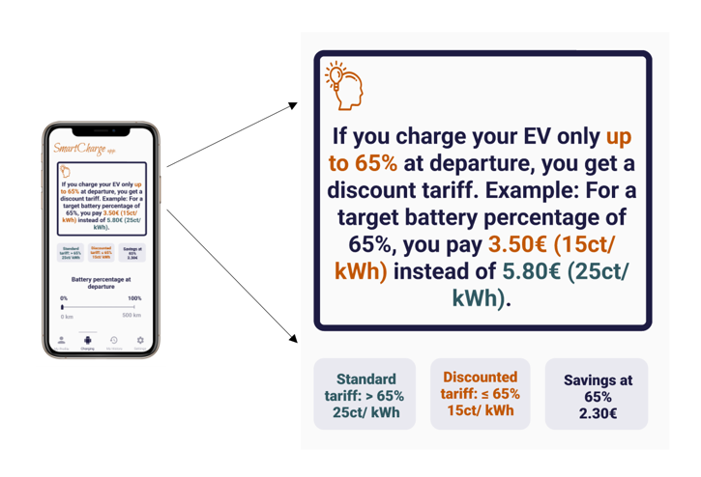

Your smart charging app asks you what battery percentage you want the next morning.
Reminder scenario: You come home at 18:00 with your EV. Your battery percentage is 15%. The next day, you have to leave at 8:00 and drive 200km (round trip).
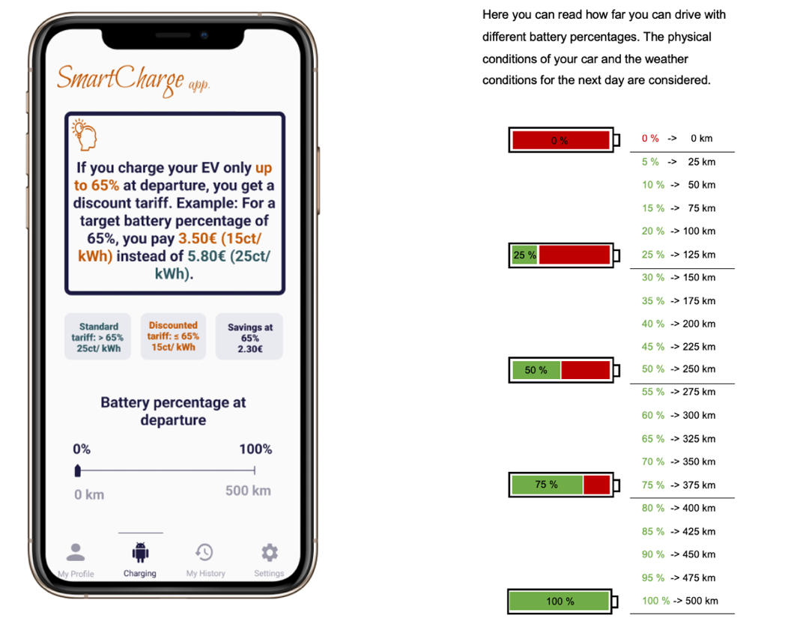

Which battery percentage would you like to have at departure the next morning?
Please choose a battery percentage from 0-100%. (Participants can select a value from 0-100%)
Which battery percentage should your EV always have as a mininum in case of unforeseen emergencies? (This implies that your EV would be always charged to that level at maximum charging power when plugged in.) This question does not refer to the previously described scenario.

Please choose an absolute minimum battery percentage from 0-100%. (Participants can select a value from 0-100%)

What information did you perceive on the mobile phone screen?
- Information on ...
- how I can save money.
- how I can get money in form of digital vouchers.
- that I saved CO2.
- how I can obtain more energy from renewables when charging.
- that I am among the 20% top smart chargers and received an environmental badge.
- the default battery percentage.
- that my EV is connected to the charging station.
- which battery percentage is best for the battery of my EV.
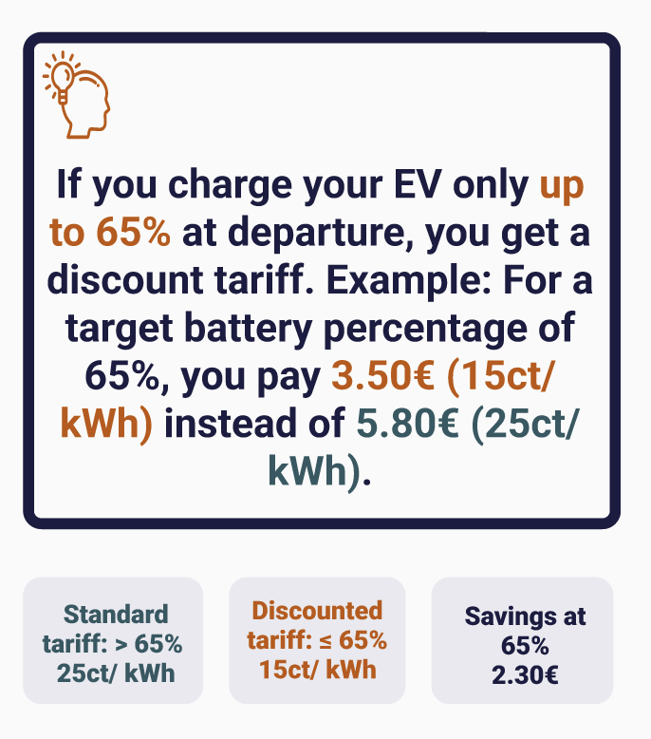

How did you perceive the following message (see screenshot below)? Your answers should reflect you personally and should not reflect any ideal case from your point of view. Please note that there are no right and wrong answers. Please choose a value from 1-7 in each row.
My judgement of this message is ...
Unpleasant (1) | (2) | (3) | (4) | (5) | (6) | Pleasant (7)
Annoying (1) | (2) | (3) | (4) | (5) | (6) | Nice (7)
Irritating (1) | (2) | (3) | (4) | (5) | (6) | Likeable (7)
Undesirable (1) | (2) | (3) | (4) | (5) | (6) | Desirable (7)
Part 2
The following questions are about your mobility behavior and vehicle usage.

Which of those transportation means cover currently the most of your mobility needs?
Please select 1-3 answers that apply to you.
- Electric vehicle
- Plug-in hybrid
- Combustion engine vehicle
- Public transport
- Bicycle
- Other:

How often do you drive an electric vehicle*?
Please select the answer that applies to you.
*Electric vehicles (EVs) are vehicles that are electrically powered (only fully battery-powered vehicles are considered in this study). They use electric motors for propulsion, which are powered by a battery.
- Never
- Once or twice a year
- Once or twice a month
- Once or twice a week
- Many times a week
- Every day
- Many times a day

How many vehicles does your household own?
- 0
- 1
- 2
- 3
- 4
- 5
- 6
- 7
- 8
- 9
- 10

How many of all your vehicles are electric vehicles?
- 0
- 1
- 2
- 3
- 4
- 5
- 6

How many people in your household have a driving licence?
- 0
- 1
- 2
- 3
- 4
- 5
- 6
- 7
- 8
- 9
- 10

Please indicate how many kilometres on average you daily drive your vehicle. (in km)

Part 3
The following questions are about your electric vehicle usage.

The electric vehicle I am using is ...
- a bought EV
- a leased EV
- a company EV
- Other:

How many kilometres can your electric vehicle roughly drive in electric mode? (in km)

What is the battery capacity of your electric vehicle in kWh? (in kWh)

Please indicate how many kilometres on average you daily drive your electric vehicle. (in km)

For how long is your electric vehicle standing at home on average on a weekday? (in hours)
(participants can select a value between 0-24h)

For how long is your electric vehicle standing at home on average on a weekend day? (in hours)
(participants can select a value between 0-24h)

Where do you mostly charge your electric vehicle?
- At home
- At work
- At a public charging station
- At commercial places
- Other:

Part 4
In the following, we ask you for your reasons to drive an electric vehicle. Your answers should reflect you personally and should not reflect any ideal case from your point of view. Please note that there are no right and wrong answers.
For each statement, please indicate how much you disagree or agree.

I drive an electric vehicle, because ...
 | Strongly disagree | Disagree | Some-what disagree | Neither agree nor disagree | Some-what agree | Agree | Strongly agree
it is comfortable to drive due to its silent motor.
it is easy to drive (e.g. no changing of the gears).
it is fun to drive due to its quick acceleration.
I like to try new technologies.
I can be part of the sustainability movement.
it is healthier due to lack of fumes and pollution.
I can be environmentally friendly. it helps me spend less on fuel.
it gives me governmental incentives (e.g. no taxes, no tolls, free parking spaces).
considering all costs, it is cheaper for me than driving conventional cars.
it helps me show others my personal values. it makes me feel proud. it is part of my identity. I am judged favourably by others.
it gives me governmental incentives (e.g. no taxes, no tolls, free parking spaces).
considering all costs, it is cheaper for me than driving conventional cars.
it helps me show others my personal values. it makes me feel proud. it is part of my identity. I am judged favourably by others.
it makes me feel proud. it is part of my identity.
I am judged favourably by others.

Are there other important reasons why you drive an electric vehicle?
If yes, please feel free to share them.

In the following, you see statements about environmental concerns and on the role of risk in life. Your answers should reflect you personally and should not reflect any ideal case from your point of view. There are no right and wrong answers.
For each statement, please indicate how much you disagree or agree.
 | Strongly disagree | Disagree | Some-what disagree | Neither agree nor disagree | Somewhat agree | Agree | Strongly agree
Humans are severely abusing the environment.
Despite our special abilities humans are still subject to the laws of nature.
The earth is like a spaceship with very limited room and resources.
The balance of nature is very delicate and easily upset.
If things continue on their present course, we will soon experience a major ecological catastrophe.

 | Strongly disagree | Disagree | Some-what disagree | Neither agree nor disagree | Some-what agree | Agree | Strongly agree
I do not feel comfortable about taking chances.
I prefer situations that have foreseeable outcomes.
Before I make a decision, I like to be absolutely sure how things will turn out.
I avoid situations that have uncertain outcomes.
I feel comfortable improvising in new situations.
I feel nervous when I have to make decisions in uncertain situations.

Part 5
In this last part of this survey, we would like to ask you to provide some personal information.
Your information will be kept anonymous and strictly confidential. However, this Information is important for our research.

What is your gender?
- Male
- Female
- Transgender Female
- Transgender Male
- Gender Variant/ Non-Conforming
- Prefer not to disclose
- Other:

How old are you? (in years)
(Participants can select a value between 18-100)

What is your nationality?
Please name the country or countries that apply. If you have several nationalities, please select the last option (other) and specify.
(Participants can select their nationalit(y)/(ies) out of a list of all nationalities)

Which highest degree of education do you have?
- No school diploma
- Some high school
- Highschool/ GED
- Some college
- Associates' degree
- Bachelor's degree
- Master's degree
- Doctoral degree
- Other:

What is your current occupation?
- Working professional (full-time)
- Working professional (part-time)
- Student Pensioner
- Housewife/ househusband
- Unemployed
- Other:

To which of the following industries is/ was your work or study field primarily related?
- Business, consultancy or management
- Accountancy, banking or finance
- Charity and voluntary work
- Creative arts or design
- Energy and utilities
- Engineering or manufacturing
- Environment or agriculture
- Healthcare
- Hospitality or events
- Computing or IT
- Law
- Law enforcement and security
- Leisure, sport or tourism
- Marketing, advertising or PR
- Media or digital
- Property or construction
- Public services or administration
- Recruitment or HR
- Retail
- Sales
- Science or pharmaceuticals
- Social care
- Teacher training or education
- Transport or logistics
- Other

What is your monthly net income?
- less than 1000 €
- 1000-2999 €
- 3000-4999 €
- 5000-6999 €
- 7000-8999 €
- ≥ 9000 €
In which country do you live?
(Participants could choose between all possible countries)

Do you feel that this survey has changed your attitude towards the topic of electric vehicles charging?
 | Strongly disagree | Disagree | Somewhat disagree | Neither agree nor disagree | Somewhat agree | Agree | Strongly agree
This survey has changed my attitude towards the topic of electric vehicles charging.

Thank you for your participation in this study.
In the following, you are invited to read information about the background and aim of this study. If you want to participate in the lottery, you can enter your email address in the next comment field. You can also indicate whether you would like to take part in two more of our surveys on smart charging in the future.

The intervention message is just illustrated for the high incentives group, but the other messages can be found in the paper.
The intervention message is just illustrated for the high incentives group, but the other messages can be found in the paper.

