

PhD-FSTM-2023-044
The Faculty of Science, Technology and Medicine

DISSERTATION

Defence held on 15/05/2023 in Esch-sur-Alzette

to obtain the degree of

DOCTEUR DE L’UNIVERSITÉ DU LUXEMBOURG

EN BIOLOGIE

by

Alessia SCIORTINO
Born on 4 February 1994 in Palermo (Italy)

Unravelling the Early Pathological Mechanisms in Parkinson’s Disease:
Insights from Alpha-Synuclein Dependent and Independent Models

Dissertation defence committee

Dr Michel Mittelbronn, dissertation supervisor
Professor, Université du Luxembourg

Dr Julia Schulze-Hentrich
Professor, Universität des Saarlandes

Dr Iris Behrmann, Chairman
Professor, Université du Luxembourg

Dr Jennifer Johnston
CEO, Nysnobio

Dr Djalil Coowar, Vice Chairman
Research scientist, Université du Luxembourg






UNRAVELING THE EARLY PATHOLOGICAL MECHANISMS IN PARKINSON’S DISEASE:
INSIGHTS FROM ALPHA-SYNUCLEIN DEPENDENT
AND INDEPENDENT MODELS

Dissertation by
Alessia SCIORTINO

DOCTOR OF PHILOSOPHY

University of Luxembourg
Doctoral School in Science and Engineering (DSSE)
Doctoral Programme in Systems and Molecular Biomedicine

Luxembourg 2018-2023


Funded by

Affidavit

I hereby confirm that the PhD thesis entitled “Unravelling the early pathological mechanisms in Parkinson’s Disease: Insights from alpha-synuclein dependent and independent models” has been written independently and without any other sources than cited. Ethical approvals for mouse experimentation have been obtained in accordance with the “Règlement grand-ducal du 11 janvier 2013 relatif à la protection des animaux utilisés à des fins scientifiques” adapted from and in line with the European Directive 2010/63/EU.

Luxembourg, 15 May 2023

Alessia Sciortino

Acknowledgements

I would like to thank the Luxembourg National Research Fund (FNR), the Quality Control in Parkinson’s Disease (PARK-QC) Doctoral Training Unit, and the University of Luxembourg for making this study possible.
To Manuel. Thank you for helping me through these difficult four years. Thank you for the scientific and moral support, for your mentoring, and for not letting me give up.
To Michel. Thank you for believing in me, for your supervision and your constructive criticism.
To Djalil, thank you for accepting to be part of my CET. Thank you for offering your point of view, for listening and for encouraging me.
To Dr Julia Schulze-Hentrich and Dr Jennifer Johnston. I am glad you accepted to be part of my jury. Your work and vision are truly inspiring for me, and you will forever be role models I will be looking at in the future.
To Lasse. Thank you for your insights, especially in the early months of this PhD, and thank you for helping to shape this thesis as we see it today.
To Oihane, Kris, Mélanie and Pierre. Thank you for teaching me, helping me, and be there for me. Thank you for making the long rainy days a little less grey.
To Beatriz, Irati, Antonia, Laetitia. Thank you for enriching the Neuropath group with your presence.
To all the colleagues from the LCNP. Thank you for the scientific discussions, the honest feedback, and your support.

To Sergio, thank you for sharing with me the pains and satisfactions of this journey.
To Mina, Nathasia, Nikki, and Raquel. Thank you for your friendship. Thank you for being inspiring, silly, supportive, and most importantly, always yourself. I am not the same person I was 5 years ago, and this is also thanks to you.
To Pierre P and Azure. Thank you for sharing 2+ years with me, despite the ups and (many) downs, and for supporting me to this day.
A mio fratello. Grazie per esserci, sempre. Grazie per esserci sempre stato. Non hai potuto scegliere di avere una sorella disastrosa come me, ma hai scelto di rimanere al mio fianco in tutti questi anni, e spero in quelli a venire.
Ai miei genitori. Grazie per aver creduto in me, per avermi sostenuta nelle mie scelte, anche e nonostante la consapevolezza che mi avrebbero portata sempre più lontana da voi.
Alla mia famiglia. Grazie per l’affetto incondizionato. Grazie per le risate, gli abbracci, i pranzi di Natale e le serate pizza in campagna. Ma soprattutto, grazie per la vostra presenza, nonostante la distanza.

Contents
Abstract 1
Introduction 5
1 Parkinson’s Disease 7
1.1 Brief history of Parkinson’s disease 7
1.2 Incidence, Diagnosis and Treatment 8
1.3 Neurodegeneration and neuropathology 10
1.3.1 Nigrostriatal degeneration 11
1.3.2 Alpha-synuclein pathology 12
1.4 Glial cells dysfunction 14
1.4.1 Astrocytes 14
1.5 Genetic component 15
1.5.1 SNCA 16
1.5.2 DJ-1 17
1.6 The gut and PD 18
2 Dementia in PD 19
2.1 Prevalence and clinical manifestation of dementia 19
2.2 Diagnosis and Treatment 20
2.3 Neurodegeneration 21
2.3.1 Neurotransmitter systems 21
2.3.2 Brain atrophy 23
2.4 Neuropathology 25
2.5 Genetic factors 26
Scope and Aims 29
Materials and Methods 37
Animals 39
Mouse colony management 39
Genotyping 40
Behavioural testing 41
Bacterial solution preparation and gavage 43
Euthanasia and tissue collection 43
LUHMES cells 45
Cell culture 45
MTT test 46
Immunofluorescence staining 47
Electron Microscopy 47
RNA analysis 49
RNA extraction 49
RT-qPCR 50
Microarray Analysis 51
RNA sequencing 51
Protein analysis 53
Protein extraction 53
Western Blot 53
Immunofluorescence staining on free-floating brain sections 54
Quantification of neurodegeneration 55
Immunofluorescence-staining on free-floating mouse brain sections with antigen retrieval 56
Immunofluorescent staining of colon sections 57
Immunohistochemistry staining on free-floating mouse brain sections ..58
Results 61
3 Modelling the early pathogenic events of Parkinson’s Disease in the SNCA*E46K mouse model 63
Preface 63
3.1 Transgenic animals overexpress alpha-synuclein by 1.8-fold in the ventral midbrain 65
3.2 HET mice show striatal age-dependent neurodegeneration in absence of dopaminergic cell loss in the Substantia Nigra 67
3.3 Gene expression deregulation in the midbrain largely precedes striatal neurodegeneration in SNCA*E46K heterozygous mice 70
3.4 Age-dependent gene expression deregulation in SNCA*E46K heterozygous mice 71
3.5 Males but not female SNCA*E46K heterozygous mice show sensory-motor impairments in the Adhesive Removal test 73
4 Characterisation of the SNCA*E46K transgenic mouse as a model for cognitive impairment in PD 75
Preface 75
4.1 Transgenic alpha-synuclein overexpression in the hippocampus of SNCA*E46K HET mice increases by age 77
4.2 Young male but not female SNCA*E46K transgenic mice show short memory impairments in the Y-maze test 80
4.3 Hippocampal gene expression changes are mostly driven by age 82
4.4 Transcriptional changes in SNCA*E46K HET mice are indicative of glutamatergic synaptic dysfunction 85
5 Age- and sex-dependent transcriptomic changes in the Park7^{-/-} mouse model of early Parkinson’s 93
Preface 93
5.1 8-months old DJ-1 KO males show extensive, sex-dependent deregulation in midbrain transcriptome 95
5.2 CYP1B1 mediates males’ increased susceptibility to DJ-1 loss 98
5.3 Transcriptional response to loss of DJ-1 might be mediated by the Nrf2/CYP1B1 pathway in midbrain astrocytes 100
6 Characterisation of parkinsonian phenotypes in a mouse model overexpressing the human wild-type alpha-synuclein gene 103
Preface 103
6.1 Transgenic alpha-synuclein is widely expressed in the brain of Thy1-Syn14 mice 104
6.2 Transgenic Thy1-Syn14 mice show pronounced motor impairments 106
6.3 Thy1-Syn14 transgenic mice do not show nigrostriatal degeneration 108
6.4 Transgenic Thy1-Syn14 female mice do not show obvious microglial response to alpha-synuclein overexpression 109
6.5 Transgenic Thy1-Syn14 mice do not show midbrain transcriptional alterations 111
7 Diet and bacterial exposure contribute to parkinsonian phenotypes 113
Preface 113
7.1 Transgenic alpha-synuclein is overexpressed with regional variance in brain and gut 114
7.2 Transgenic Thy1-Syn14 mice present age-dependent motor dysfunction 115
7.3 E. coli born Curli drives alpha-synuclein aggregation in Substantia Nigra and Striatum 117
7.4 The combination of fibre-deprivation and bacterial Curli drives neurodegeneration in Thy1-Syn14 mice 118
7.5 The combination of fibre-deprived diet and exposure to E. coli born Curli drives alpha-synuclein aggregation in the enteric nervous system 120
7.6 Alpha-synuclein overexpression is the main driver of gross motor impairments 122
8 In vitro models of neuronal toxicity 125
Preface 125
8.1 Characterisation of alpha-synuclein moieties by electron microscopy 127
8.2 Alpha-synuclein oligomers and PFFs cause a dose-dependent cytotoxicity in LUHMES cells 129
8.3 Glutamate excitotoxicity on LUHMES WT and DJ-1 cells 131
Discussion 133
Bibliography 153

List of Figures

Figure 1 Motor and non-motor symptoms associated with Parkinson's disease progression (Poewe et al., 2017) 10
Figure 2 The nigrostriatal circuit in normal brain and Parkinson's disease (adapted from Subramaniam and Federoff, 2017) 12
Figure 3 Model of alpha-synuclein aggregation (Mehra et al., 2019) 14
Figure 4 Neurotransmitter deficits associated with cognitive decline (modified from Aarsland et al., 2021). NC, normal cognition; MCI, mild cognitive impairment, VTA, ventral tegmental area. 23
Figure 5 Significant grey matter density differences between non-demented PD and PDD (Nagano-Saito et al., 2005). BA, Brodmann area. 25
Figure 6 Alpha-synuclein expression in SNCA*E46K mice. 66
Figure 7 Age-dependent degeneration in the dorsal striatum of HET SNCA*E46K mice but not the Substantia Nigra. 68
Figure 8 Transgenic alpha-synuclein levels directly correlate with striatal neurodegeneration. 69
Figure 9 Genotype-dependent and age-dependent differentially expressed genes in SNCA*E46K mice 72
Figure 10 Male but not female SNCA*E46K heterozygous mice present sensory impairments at early age. 74
Figure 11 Profiling of alpha-synuclein mRNA and protein expression in the hippocampus of HET and WT mice. 79
Figure 12 Young HET males but not females present short-term memory impairments in the Y-maze test 81
Figure 13 Differential expression in the hippocampus of SNCA*E46K mice and WT littermates is mostly driven by age. 84
Figure 14 Transcriptional changes in the hippocampus of young HET male mice. 86
Figure 15 Transcriptional changes in the hippocampus of old WT female mice. 88
Figure 16 Transcriptional changes in the hippocampus of middle-age HET female mice. 91
Figure 17 Transcriptional changes in the hippocampus of old HET female mice. 92
Figure 18 Male mice show a strong sex-specific transcriptomic response to DJ-1 knock-out at 8-months of age 97
Figure 19 Increased susceptibility to DJ-1 loss is mediated by CYP1B1 in 8-months old male mice 99
Figure 20 Nrf2 signal colocalizes with GFAP in the midbrain of DJ-1 mice. 101
Figure 21 Phosphorylated alpha-synuclein staining shows nuclear localisation in the brain of transgenic Thy1-Syn14 mice 105
Figure 22 6-months old Thy1-Syn14 transgenic mice display alpha-synuclein driven motor deficits 107
Figure 23 Transgenic Thy1-Syn14 mice do not present striatal degeneration 108
Figure 24 Microglia does not interact with alpha-synuclein inclusions in the Thy1-Syn14 mouse model 110
Figure 25 Transgenic Thy1-Syn14 mice do not show differential expression from WT littermates in the midbrain 111
Figure 26 Cellular markers for dopaminergic neurons, astrocytes and microglia are unchanged 112
Figure 27 Transgenic Thy1-Syn14 mice overexpress the human SNCA transgene in brain and colon, and present age-dependent motor impairments 116
Figure 28 Neurodegeneration in the nigrostriatal pathway of Thy1-Syn14 transgenic mice is driven by bacterial Curli and further exacerbated by fibre-deprivation 119
Figure 29 Fibre-deprivation and exposure to Curli drive alpha-synuclein aggregation in Thy1-Syn14 transgenic mice 121
Figure 30 Transgenic alpha-synuclein overexpression drives motor deficits in TG animals 123
Figure 31 Curli exposure and fibre-deprivation exacerbate motor phenotype in a subset of transgenic Thy1-Syn14 mice 124
Figure 32 Electron Microscopy imaging of alpha-synuclein moieties 128
Figure 33 Oligomers and PFFs show dose-dependent toxicity on LUHMES WT cells 130
Figure 34 DJ-1 KD might determine increased susceptibility to low levels glutamate stress 132

List of Tables

Table 1 Genes associated with the development of dementia 27
Table 2 List of alpha-synuclein moieties analysed 128

Nomenclature

αSyn alpha-synuclein
ΔEC isogenic Curli knock-out E. coli strain
AD Alzheimer’s Disease
ARE antioxidant response element
CNS central nervous system
CSF cerebral spinal fluid
DLB Dementia with Lewy bodies
E. coli Escherichia coli
EC Curli expressing E. coli
EM electron microscopy
ENS enteric nervous system
GDNF Glial cell derived neurotrophic factor
LBs Lewy bodies
LBD Lewy body dementias
LNs Lewy neurites
MCI Mild cognitive impairment
MCI-PD Parkinson’s disease with mild cognitive impairment
Pan-αSyn Total alpha-synuclein
PD Parkinson’s Disease
PDD Parkinson’s disease dementia
PFFs Pre-formed fibrils
PTMs Post-translational modifications
RBD Rapid eye movement sleep disorder
ROS Reactive oxygen species
SN Substantia nigra
SNCA Human alpha-synuclein gene
Snca Murine alpha-synuclein gene
SNpc Substantia nigra pars compacta
SNpr Substantia nigra pars reticulata

UNRAVELING THE EARLY PATHOLOGICAL MECHANISMS IN PARKINSON’S DISEASE:
INSIGHTS FROM ALPHA-SYNUCLEIN DEPENDENT
AND INDEPENDENT MODELS

Abstract

Affecting over 10 million people worldwide, Parkinson’s disease is the second most common neurodegenerative disorder. With only 10% of cases having a known genetic cause, PD aetiology largely remains an enigma. Endogenous factors such as genetic predisposition, and exogenous factors such as exposure to toxins and lifestyle choices, interplay in the initiation and acceleration of the disease. Despite some common hallmarks such as nigrostriatal degeneration and Lewy bodies pathology, PD clinical picture largely varies across patients. Non-motor symptoms are common and thought to emerge up to 20 years prior to diagnosis, and they range from gastro-intestinal dysfunction to sleep disturbances to hallucinations. 90% of PD patients present at least one neuropsychiatric symptom, and about 30% of total patients develop dementia. Interventions aimed to prevent or slowdown disease progression require a better understanding of the early molecular events which foster neuronal dysfunction and death. Longitudinal studies which allow the investigation of early pathological stages are challenging to achieve on patients-based study only, thus largely rely on the use of animal models. Specifically, rodents have very similar anatomy, physiology, and genetics to humans, and a good set of genetic/molecular tools are available to generate pathological models. In the present thesis, we ventured into the investigation of alpha-synuclein dependent and independent models of PD, to unravel the early molecular events driving PD pathogenesis.
Firstly, we investigated a genetic mouse model overexpressing the human, E46K mutated alpha-synuclein gene. We characterised neurodegeneration in the nigrostriatal pathway and motor deficits, detecting characteristics of an early-PD phenotype. Aiming to understand the molecular events driving neurodegeneration, we profiled the ventral midbrain transcriptome at different ages, uncovering that transcriptional changes are an early response to the alpha-synuclein challenge. Being the E46K mutation associated with dementia, we also profiled the hippocampus to investigate early transcriptional events linked with cognitive dysfunction in PD. We revealed that hippocampal dysfunction is mostly driven by the ageing process, operating over the interplay of genetic and gender predisposition.
Secondly, we profiled transcriptomic changes in the midbrain of the alpha-synuclein independent, Park7^{-/-} (DJ-1 KO) mouse model. Once again, we uncovered the interplay of sex and age in determining the susceptibility to the disease challenge, with males being more affected than females. Specifically, the response to DJ-1 loss of function appeared to be largely sex-specific, and to be mediated by the oestrogen pathway and the DJ-1/Nrf2/CYP1B1 axis. Even if sex-dimorphism has not been directly investigated in human Park7 PD cases due to their paucity, it has been reported in sporadic PD for several populations. Thus, our findings might significantly contribute to uncovering the reasons behind gender differences in PD.
Thirdly, we investigated a moderate overexpressor of wild-type alpha-synuclein (Thy1-Syn14), aiming to reach a compromise between genetic and idiopathic PD modelling. To understand how endogenous and exogenous factors interplay in disease onset and progression, we exposed transgenic mice to the amyloidogenic protein Curli and to a fibre deprived diet. We uncovered that microbiome insults and diet act in combination to promote disease progression, and we provided supporting evidence to the concept of a gut-brain axis in PD. Our results underline the relevance of lifestyle adjustments in the management of PD patients.
Finally, we investigated how different alpha-synuclein moieties and glutamate exposure might contribute to neurodegeneration. Even if these studies were left incomplete, we gained some preliminary indications which can represent a starting point for future research. We observed that both oligomers and fibrils are toxic forms of alpha-synuclein, and that a lack of standardisation in recombinant moieties production is a current issue that may halt
reproducibility in alpha-synuclein research. We also reported a higher susceptibility of DJ-1 knock-down cells to glutamate excitotoxicity, potentially underlying an additional mechanism through which DJ-1 loss of function is responsible for PD development.

Part I

Introduction

Parkinson’s Disease

Brief history of Parkinson’s disease
Described for the first time by James Parkinson in 1817, Parkinson’s disease (PD) is a neurodegenerative disorder of long duration, characterised by a peculiar tremor in the limbs which first earned it the name of shaking palsy. Initially perceived with “a slight sense of weakness, with a proneness to trembling”, the symptoms worsen up to the impairment of proper posture, motility, self-feeding and talking (Parkinson 2002). James Parkinson based his essay on the observation of 6 patients, out of which 3 were casually observed on the streets of London, and 1 was only observed from afar. A more extensive description of PD clinical manifestation came over 50 years later with the French neurologist Jean-Martin Charcot, during his teaching at the Salpêtrière hospital in Paris. Charcot described in detail the clinical spectrum of the disease, identifying in PD patients a continuous tremor manifested independently of voluntary movement; based on this observation, he differentiated PD from other types of motor disorders, specifically sclerosis. Given the variability with which PD manifests and evolves, Hoehn and Yahr proposed the first disease classification, ranging from Stage I to V, based on the disability level, which was meant to help predict the best therapy for each case (Hoehn and Yahr, 1967).
First suggested by Brissaud in 1894 and later confirmed by Trétiakoff, the substantia nigra – described by Brissaud himself as an “obscure […] territory at the border of the fibres of voluntary movement and those of involuntary movements” – was identified as the main anatomical structure whose damage could be responsible of the motor features characteristics of PD (Brissaud, 1894). But it wasn’t until a century after Parkinson’s initial description that the first pathological correlates of PD were identified. It was Friedrich Heinrich Lewy to report eosinophilic concentric inclusion bodies in the cytoplasm of the neurons of PD patients (Lewy, 1912). The composition of such inclusions, nowadays known as Lewy bodies (LBs), remained elusive until 1997, when Maria Grazia Spillantini identified alpha-synuclein – a pre-synaptic protein of unclear function at the time – as the main constituent of such characteristic inclusions in idiopathic PD (Spillantini et al. 1998).
The initial clinical and pathological observations were followed by prolific research so that, at present, PD is known to be a multifactorial syndrome where genetic and environmental factors are at a constant interplay. Affecting over 10 million people worldwide and with a prevalence expected to double by 2030, PD is currently the first most common movement disorder. Disability and death due to PD are increasing faster than for any other neurological disorder, and so is the toll on the health care system.

Incidence, Diagnosis and Treatment
PD is the first motor disorder, affecting 2-3% of the population over 65 years of age, with an incidence of up to 35 new cases per 100,000 individuals yearly accordingly to the studied population. Long-term disability linked to PD is increasing faster than for any other known neurodegenerative disorder, bringing a huge toll on the societal and economic burden. At least in some populations, men show a greater risk to develop PD (Wooten et al. 2004). The reasons for this difference are still under investigated but might include factors such as oestrogen neuroprotection during lifetime in women (Picillo et al. 2017) or higher exposure to pesticides and head injuries in men (Semchuk, Love, and Lee 1992). Despite the lower prevalence and the later-onset, women present higher adverse effects to medication, faster disease progression and a higher mortality ratio (Morgan et al. 2014).
The diagnosis of Parkinson’s disease relies on the presence of its classical motor symptoms, as defined by the International Parkinson and Movement Disorder Society. Diagnosis of parkinsonism is made when bradykinesia, a slowness of movements accompanied by shorter movement amplitude and speed, is present in combination with resting tremor and/or rigidity. For the diagnosis of clinical PD, 2 or more supportive criteria such as L-DOPA induced dyskinesia have to be present, while exclusion criteria need to be absent (Postuma et al. 2015). Based on the clinical observation of patients, two major subtypes of PD have been proposed: the tremor-dominant, where other motor symptoms are negligible; and the non-tremor-dominant, also described as postural instability gait disorder (PIGD) subtype (Thenganatt and Jankovic 2014).
Generally, the diagnosis of PD is made in the early stage of the illness, shortly after the onset of motor symptoms. Nevertheless, Parkinson’s does not start with its clinical manifestation, and motor symptoms are typically preceded by a variety of non-motor symptoms that can antedate the diagnosis by up to 20 years (Figure 1). Non-motor manifestations of PD include rapid eye movement (REM) sleep behaviour disorder, constipation, hyposmia, depression, hallucinations, and dementia (Chaudhuri and Schapira 2009). The occurrence and severity of non-motor symptoms is variable amongst patients, complicating the clinical picture of the disease.
Despite it has been known for centuries, there is still no cure for Parkinson’s disease, and the current treatments are meant to manage the symptoms to provide the patients with a better quality of life. The first breakthrough in PD therapy occurred in 1961, after discovering that striatal dopamine levels were reduced in PD patients (Ehringer and Hornykiewicz, 1960). Administration of the dopamine precursor L-DOPA aimed at replacing the striatal dopamine loss is still today the standard in the treatment of parkinsonism. However, the use of L-DOPA or other dopamine agonists is complicated by the insurgence of secondary motor symptoms (Bhattacharyya 2022). Once the medication loses its efficacy, the most common therapeutic approach becomes deep brain stimulation (DBS) of the subthalamic nucleus, which is achieved by the implantation of an electrode directly in the brain tissue. DBS has been proven to work best on patients with early-onset PD and high response to L-DOPA therapy, while it is not recommended in patients showing dementia, psychosis, or major depression (Bronstein et al. 2011).

Figure 1 Motor and non-motor symptoms associated with Parkinson's disease progression (Poewe et al., 2017)

Neurodegeneration and neuropathology
Macroscopically, the main pathological hallmark of PD is the loss of dopaminergic neurons in the substantia nigra pars compacta. Neurodegeneration in PD also extends to other structures, such as the locus coeruleus, the amygdala and the hypothalamus (Kalia and Lang 2015). Intracellularly, the principal hallmark of the disease is the aggregation of alpha-synuclein into cytoplasmic inclusions named Lewy Bodies. Mitochondrial, lysosomal and proteasomal dysfunction, impaired calcium homeostasis and neuroinflammation are widely recognised as additional hallmarks of PD pathology (Antony et al. 2013). For the scope of this thesis, only the nigrostriatal degeneration and the alpha-synuclein aggregation will be discussed further.

Nigrostriatal degeneration
The substantia nigra (SN) is one of the 4 nuclei that constitute the basal ganglia. It is located between the subthalamic region and the mesencephalon, and it is subdivided in pars compacta (SNpc) and pars reticulata (SNpr). The pars compacta houses the dopaminergic neurons, characterised by the deposition of neuromelanin, which gives the substantia nigra its characteristic dark coloration. The dopaminergic neurons project from the SNpc to the dorsal striatum, the biggest of the basal ganglia nuclei (Yelnik 2002). The dorsal striatum is subdivided in caudate and putamen, and it modulates movements, reward, and the combination of the two (Hollerman, Tremblay, and Schultz 2000; Subramaniam et al. 2018).
Evidence from studies on post-mortem patients’ samples and animal models suggests that neurodegeneration starts in the axonal processes of the striatal dopaminergic neurons, and from there it proceeds retrogradely towards the substantia nigra, culminating in neuronal cell death (Tagliaferro and Burke 2016). Moderate or severe nigrostriatal degeneration is considered to be the cause of the bradykinesia and rigidity that characterise Parkinson’s disease. In the dorsal striatum, the dopaminergic neurons form synapses with GABAergic neurons displaying D1 or D2 dopamine receptors, which in turn project to the globus pallidus interna (GPi) by direct or indirect means. Finally, inhibitory output from the GPi to the thalamus modulates normal motor function. In Parkinson’s disease patients, the loss of dopaminergic neurons – visualized by the loss of nigral pigmentation –, and the consequent depletion of striatal dopamine, lead to elevate inhibitory output from the GPi and reduction of the normal motor function (Subramaniam et al. 2018) (Figure 2).
Figure 2 The nigrostriatal circuit in normal brain and Parkinson's disease (adapted from Subramaniam and Federoff, 2017)

      - Alpha-synuclein pathology
Out of the 3 members of the synuclein family of proteins (composed of alpha-, beta-, and gamma-synuclein), only alpha- and beta-synuclein are found in the brain (George, 2002). Alpha-synuclein is a small protein of 140 amino-acids, generally subdivided into a lysin rich amino-terminus (residues 1-60), prone to acquire an α-helix amphipathic structure responsible for membrane binding; a highly hydrophobic central region (residues 61-95), known as the non-amyloid-beta component (NAC); and an unstructured acidic carboxy-terminal tail (residues 96-140), thought to be responsible for interactions with other proteins and small molecules (Breydo, Wu, and Uversky 2012). Despite being one of the most abundant proteins in the brain, alpha-synuclein’s function is still unclear. It has been shown to localise at presynaptic terminals and, to a lesser extent, in mitochondria and nuclei (Burré, Sharma, and Südhof 2018); and it is suggested to play a role in calcium homeostasis, neurotransmission (Butler, Sambo, and Khoshbouei 2017), DNA damage response (Schaser et al. 2019) and gene expression regulation (Siddiqui et al. 2012).
In its native state, alpha-synuclein lacks a well-defined structure and is therefore referred to as an intrinsically disordered protein (Uversky, Li, and Fink 2001). Under pathological conditions, unfolded alpha-synuclein monomers can misfold and alternatively aggregate into oligomeric and fibrillar structures (Figure 3), which are observed in a set of neurodegenerative conditions known as synucleinopathies (Coon and Singer 2020). According to their cellular localisation, alpha-synuclein aggregates are separated into Lewy Bodies (LBs) when in the cellular body, and Lewy Neurites (LNs) when in dystrophic axons and dendrites. Classical LBs are spherical aggregates of 4-25µm in diameter, composed by a dense core surrounded by a halo of 5-10nm wide fibrils, and rich in β-sheets structures (Spillantini et al. 1998). Even if alpha-synuclein is the main component, LBs have also been shown to include over 90 different denaturated proteins (Wakabayashi et al. 2013), and a mixture of fragmented membranes, vesicles, and organelles (Shahmoradian et al. 2019).
Alpha-synuclein’s aggregation potential derives from the NAC region, which contains imperfect repeats of 11-residues with a KTKEGV consensus core prone to form β-sheet structures (Rodriguez et al. 2015). Unsurprisingly, many of the familial mutation of the alpha-synuclein gene (SNCA) linked to PD fall in the NAC region. Different post translational modifications (PTMs), such as phosphorylation, nitration, oxidation, and ubiquitination, can modulate alpha-synuclein aggregation (Breydo, Wu, and Uversky 2012). In particular, phosphorylation at Serine 129 enhances aggregates formation in vitro, and it is estimated that up to 90% of alpha-synuclein in LBs is phosphorylated at this site (Fujiwara et al. 2002).

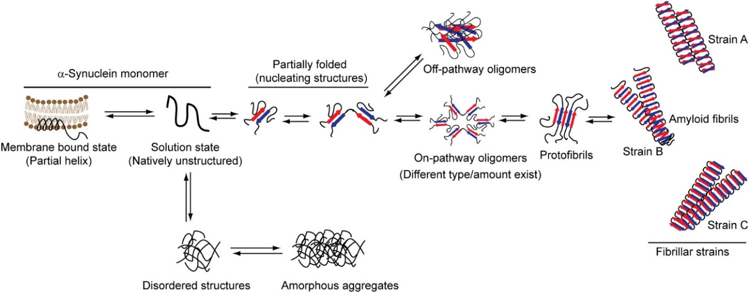
Figure 3 Model of alpha-synuclein aggregation (Mehra et al., 2019)

Glial cells dysfunction
Dysfunctional mechanisms in neurodegenerative diseases are not restricted to neuronal cells. In PD, a clear involvement of glial cells in disease progression has been described, and PD-related genes have been reported to be expressed also in glial cells (Domingues et al. 2020). For the scope of this thesis, the role of astrocytes in PD pathogenesis will be discussed.

Astrocytes
Astrocytes are the most abundant cells in the brain. They exert many physiological roles, and regulate amongst others synaptic transmission, synaptogenesis, energy metabolism, and permeability of the blood brain barrier (Sofroniew and Vinters 2010). Astrocytes promote dopaminergic neurons differentiation and survival via the release of neurotrophic factors such as FGF-2 and BDNF (Datta et al. 2018; Reuss and Unsicker 2000; Yang et al. 2014). In pathological conditions, astrocytes become dysfunctional and lose their ability to promote neuronal survival, thus contributing to neurodegeneration (Miyazaki and Asanuma 2020).
Astrocytes have been shown to protect neurons from oxidative stress damage (Miyazaki et al. 2011; Watts et al. 2005; W. Zhang et al. 2021). Oxidative stress is widely recognized as one of the major contributors to PD pathogenesis. Deficiency in the major antioxidant enzymes (Sian et al. 1994), as well as oxidative damage to lipids (Dexter et al. 1994), DNA (J. Zhang et al. 1999), and proteins (Floor and Wetzel 2002) have been reported in PD post-mortem brain tissue. Of importance, dopaminergic neurons in the SNpc have a greater susceptibility to oxidative stress damage (Mosharov et al. 2009). Numerous causative genes of early-onset familial PD are expressed in astrocytes and have been shown to influence astrocytes’ ability to respond to oxidative stress. DJ-1 is a multifunctional protein, suggested to act as a sensor of oxidative stress (Mitsumoto and Nakagawa 2001). In the brain, DJ-1 is highly expressed in astrocytes (Bandopadhyay 2004), and loss of DJ-1 has been shown to impair astrocytes-mediated neuroprotection in vitro (Lev et al. 2013; Mullett et al. 2013). Furthermore, DJ-1 has been reported to stabilize Nrf2, an astrocyte-specific transcription factor mediating the astrocytic antioxidant response (Clements et al. 2006); loss of DJ-1 in astrocytes could cause disruption of Nrf2 signalling, thus indirectly contributing to PD pathogenesis.

Genetic component
Parkinson’s disease is a multifactorial disease of unclear aetiology. Different factors have been shown to contribute to PD onset, including genetic predisposition, environmental factors, sex, and ageing. Only 5-15% of PD cases have a clear genetic cause and, up to date, 20 loci have been identified as causative for Parkinson’s disease. Mutations in genes implicated in mitochondrial function, such as DJ-1, PINK-1, or Parkin, are known to cause early-onset, autosomal recessive PD, while mutations in the synuclein gene (SNCA) cause autosomal dominant PD. Furthermore, mutations in other genes like glucocerebrosidase (GBA) are not causative of PD but can modify the risk of developing it. For the scope of this thesis, only the contribution of SNCA and DJ-1 will be discussed further.

SNCA
The association of alpha-synuclein to PD first came with the identification of alpha-synuclein as the main component of Lewy bodies (Spillantini et al. 1998). An additional breakthrough came with the discovery that some alpha-synuclein missense mutations, such as the A53T, the A30P and the E46K mutations, as well as alpha-synuclein gene duplication and triplication, are causative of autosomal dominant forms of PD (Chartier-Harlin et al. 2004; Polymeropoulos et al. 1997; Singleton et al. 2003; Zarranz et al. 2004, Kruger et al. 1998). Given its involvement in both sporadic and familial PD, alpha-synuclein is considered to be a central player in the pathological cascade, and it might contribute to disease pathogenesis through different mechanisms.
The E46K mutation was first identified by Zarranz in a Spanish family with autosomal dominant parkinsonism, present with visual hallucinations and early cognitive impairments (Zarranz et al., 2004). All family members showing signs of parkinsonism presented the novel mutation, while non-affected relatives as well as unrelated healthy controls, and other parkinsonian, DLB and dementia patients did not (Zarranz et al., 2004). The E46K mutation is located in the highly conserved N-terminal region of the alpha-synuclein protein, and it falls inside one of the conserved 11 amino acids repeats of the NAC. Here, the substitution of the negatively charged dicarboxylic glutamic acid with a positively charged lysine, is estimated to produce strong disturbances of protein structure and function. Indeed, the E46K mutation has been shown to increase the rate of alpha-synuclein fibrillization, and to produce fibrils with a twisted appearance, a width ranging between 5 and 14 nm and a much shorter crossover spacing compared to fibrils originated by wild-type alpha-synuclein (Choi et al. 2004). Alpha-synuclein bearing the E46K mutation has increased binding rates to liposomes (Choi et al., 2004). Its overexpression has been shown to inhibit the early stages of autophagy in vitro (Yan et al. 2014), and to impair phagocytosis both in vitro and in vivo (Gardai et al. 2013). In vivo, overexpression of E46K mutated alpha-synuclein has been shown to cause increased sensitivity to oxidative stress, leading to elevated neuronal susceptibility to neurotoxins (Cannon et al. 2013; Reiszadeh Jahromi et al. 2021).
Alpha-synuclein triplications are causative of early-onset DOPA-responsive parkinsonism and a more aggressive disease course. SNCA triplication kindreds show severe degeneration in Striatum, Substantia Nigra and Locus Coeruleus, and widespread Lewy body pathology (Muenter et al., 1998; Farrer et al., 2004; Ibanez et al., 2009). Dementia, visual and auditory hallucinations, and alterations of cognition at different levels are also present (Muenter et al., 1998; Farrer et al., 2004). SNCA duplication kindreds have a more variable presentation, with some cases being undistinguishable from idiopathic PD, and others presenting with hallucinations, delusions or dementia (Nishioka et al., 2009; Ikeuchi et al., 2008). Typically, duplication cases have a similar disease course to those with SNCA triplications, but a later disease onset. Overall, dosage of alpha-synuclein seems to be the determining factor for disease initiation and severity of progression.

DJ-1
The DJ-1 protein is encoded by the gene PARK7. DJ-1 is an ubiquitous protein, presenting many functions such as chaperone, protease, and oxidative stress sensor. An early-onset, autosomal recessive form of PD indicated as PARK7 PD, was first shown to co-segregate with the DJ-1 gene in 2003 (Bonifati et al. 2003). In the two families investigated, the DJ-1 gene presented either a homozygous genomic deletion of 14kb, or a homozygous point mutation resulting in the substitution of a leucine with a proline (L166P) (Bonifati et al. 2003). As a result, in the first case the DJ-1 protein is lacking, while in the second one is functionally inactive, suggesting that the loss of DJ-1 activity is pathogenic in PD.
Neurodegeneration in PARK7 PD might be linked to DJ-1 activity as an oxidative stress sensor. Upon ROS overproduction, DJ-1 is relocated to mitochondria, and at a later time point to the nucleus (Junn et al. 2009). In vitro, DJ-1 knock-out has been shown to alter mitochondrial calcium flux, to decrease mitochondrial transmembrane potential, and to increase ROS production (Giaime et al. 2012; Guzman et al. 2010; Krebiehl et al. 2010). DJ-1 knock-out mice present compromised mitochondrial function, and are hypersensitive to 1-methyl-4-phenyl-1,2,3,6-tetrahydropyridine (MPTP) stress (Hao, Giasson, and Bonini 2010; R. H. Kim et al. 2005). In the nucleus, DJ-1 acts as a co-activator of NF-κB, indirectly regulating mitochondrial membrane potential and cell viability (Xu et al. 2018).
Finally, DJ-1 may act as a chaperone following oxidative stress. When oxidized at the cysteine 106, DJ-1 has been shown to prevent alpha-synuclein aggregation (Zhou et al. 2006). Loss of DJ-1 might therefore contribute to neurodegeneration through increased Lewy pathology.

The gut and PD
The presence of α-synuclein aggregates in sympathetic and parasympathetic ganglia, as well as in the enteric nervous system (ENS) has fuelled the idea that PD might originate in the periphery (Cersosimo and Benarroch 2012; Hilton et al. 2014; Shannon et al. 2012). Alpha-synuclein aggregation is thought to propagate through the vagus nerve to lower brainstem regions (Braak et al. 2003; Holmqvist et al. 2014; S. Kim et al. 2019; Liu et al. 2017). Furthermore, gastrointestinal symptoms such as constipation are common in the preclinical phase of the disease. Although still controversial, the body-first hypothesis seems to fit the neuropathological presentation of at least a set of idiopathic PD patients presented with RBD (Horsager et al. 2020), where the gut has been proposed as the disease site of onset.
Microbial diversity and relative abundance play a key role in the maintenance of a healthy gut. Physiological changes in the gastrointestinal tract can affect microbiome composition, and thus increase disease risk. For example, fibre deprivation can cause a microbial shift, which in turn is responsible for colonic mucus erosion and decreased gut barrier integrity (Desai et al. 2016). Furthermore, bacterial amyloids can induce alpha-synuclein oligomerisation in the ENS, thus initiating PD pathogenesis (Chen et al. 2016; Haikal et al. 2021).

Dementia in PD

Prevalence and clinical manifestation of dementia
About 90% of PD patients present at least one neuropsychiatric symptom, making cognitive impairment one of the most widespread non-motor symptoms of PD (D Aarsland et al. 2007). Within a timeframe of 5 years from PD diagnosis, about half of PD patients that had normal cognition at baseline will develop mild cognitive impairment (MCI) (Pigott et al. 2015). Additionally, over 30% of newly diagnosed patients are reported to present MCI already at diagnosis (Santangelo et al. 2015). Patients presenting with MCI have higher chances to develop dementia (Pedersen et al. 2013). Globally, dementia in PD has a point prevalence of about 30% (Pigott et al., 2015), but the cumulative prevalence can be way higher than that. Several longitudinal studies such as the Sidney Multicentre Study, have shown that the prevalence of dementia in PD increases with disease duration, reaching about 80% in surviving patients at 20 years from diagnosis (Hely et al. 2008).
MCI in PD is associated with a stronger motor phenotype and a higher mortality (Levy, Stern, and Marder 2002). Older age at onset and longer disease duration are the biggest risk factors for progression from PD to Parkinson’s Disease with Dementia (PDD) (Giladi et al. 2000). Other factors associated with dementia include the postural instability and gait disorder (PIGD) subtype (Lichter, Benedict, and Hershey 2018), worse response to dopaminergic treatment (Marder et al. 1995), presence of REM sleep behaviour disorder (Marion et al. 2008) and visual hallucinations (Fenelon et al. 2000). The initial clinical manifestation of MCI is linked to the fronto-striatal degeneration, and it is characterised by dysexecutive syndrome and phonemic verbal fluency impairment (Hanagasi, Tufekcioglu, and Emre 2017; Pagonabarraga and Kulisevsky 2012). In the progression to dementia, it appears that the fronto-striatal dysfunction is accompanied by a posterior-cortical dysfunction, which manifests as impairment of attention and visuo-spatial functions, semantic verbal fluency impairment, and impairment of episodic and visual memory (Pagonabarraga and Kulisevsky, 2012; Hanagasi et al., 2017).

Diagnosis and Treatment
Diagnosis of PD-MCI and PDD is made upon the evaluation of impairment in the domains of attention, executive function, visuospatial function, and memory, over an already present diagnosis of PD. Diagnostic criteria proposed by the Movement Disorder Society conceive two levels based on the comprehensiveness of the assessment and the confidence of the diagnosis.
PD-MCI is characterised by reduced cognitive abilities that do not significally impair the patient’s independence, and is normally reported by the patient itself, the caretaker or the clinician, (Litvan et al. 2012). Level I assessment is based on impairment in at least two neuropsychological tests out of a small cognitive test selection (Litvan et al., 2012). Level II assessment is more comprehensive and includes at least 2 tests per cognitive domain; if deficits are present in at least two tests for the same cognitive domain, a single-domain PD-MCI is diagnosed, while if deficits are present across different domains, a multiple domain subtype is diagnosed (Litvan et al., 2012). PDD is defined as a robust impairment of at least two cognitive domains that is progressive and significantly halts the patient’s independence (Goetz, Emre, and Dubois 2009). Behavioural disturbances such as hallucinations, delusions, apathy and sleep disturbances, are a frequent feature of PDD, but their presence is not required for diagnosis. The presence of other diseases or abnormalities that can be the cause of mental impairment has to be excluded (Goetz, Emre abd Dubois 2009). For a diagnosis of probable PDD, patients must present typical PDD features in absence of features of uncertainty. If the patient presents with atypical features, and/or issues of uncertainty, only a diagnosis of possible PD can be made (Goetz, Emre and Dubois 2009). PDD exists on a spectrum within the group of diseases addressed as Lewy Body Dementias (LBD), and it is neuropathologically indistinguishable from Dementia with Lewy Bodies (DLB). Indeed, the two pathologies are currently only separated clinically based on the 1-year rule, diagnosing as DLB those cases where dementia occurs before or within one year from the onset of parkinsonism.
To date, no approved pharmacological treatment exists for PD-MCI. Only one drug, the cholinesterase inhibitor rivastigmine, has shown clinically significant albeit modest effects in PDD (Emre 2004), and is currently approved for treatment. Therefore, cognition in PD is mostly treated with non-pharmacological approaches. Cognitive training such as engagement in social activities and guided tasks, and physical exercise such as treadmill training, have been shown to promote short-term improvement of attention, mental flexibility, and overall cognition (da Silva et al. 2018).

Neurodegeneration
The molecular events underlying dementia in PD are still poorly understood. Contrarily to the classic manifestation of PD, which has been long linked to degeneration in the nigrostriatal pathway, several neuronal networks seem to contribute to PDD pathophysiology (Aarsland et al. 2021; Halliday et al. 2014). Degeneration in PDD is reported to affect dopaminergic, noradrenergic, and cholinergic nuclei that provide neurotransmitter input to the limbic region and the neocortex (Figure 4). The neurotransmitter deficits are widespread, and their severity increases with the worsening of cognitive decline (Aarsland et al. 2021; Halliday et al. 2014). The dementia-associated neurodegeneration in PDD patients is reflected in the atrophy of brain regions involved with memory processing and consolidation, specifically the hippocampus and the prefrontal cortex (Nagano-Saito et al. 2005).

Neurotransmitter systems
Dementia develops over the presence of severe dopaminergic degeneration. In PDD patients, additional degeneration of dopaminergic neurons in the medial SN has been shown (Rinne et al. 1989), and in vivo imaging suggests a reduction in cortical dopamine levels (Sasikumar and Strafella 2020).
The contribution of noradrenergic degeneration to the development of dementia is less investigated. PDD patients present degeneration of noradrenergic neurons in the locus coeruleus (Brunnström et al. 2011; Chan-Palay and Asan 1989), and increased alterations in noradrenergic markers in serum and CSF (van der Zee et al. 2018).
Deficits in the cholinergic system have long been correlated with cognitive impairment in Alzheimer’s and Parkinson’s disease (Mattila et al. 2001; Perry et al. 1978). Cholinergic degeneration is present in both PD with and without dementia, but in PDD the cholinergic circuit is more strongly impacted, with the degeneration extending to the lateral cholinergic system, which innervates frontal, parietal, and temporal cortices (Hirano, Shinotoh, and Eidelberg 2012). PD patients with MCI and dementia present degeneration of the nucleus basalis of Meynert, the major source of cholinergic innervation to cortex and amygdala, and of the medial septum, responsible for the cholinergic innervation of the hippocampus (Pereira et al. 2020).
PDD patients show reduced synaptic density in cortex and SN, with reductions in frontal, occipital, parietal and temporal cortices discriminating between PD cases with and without dementia (Andersen et al. 2021). Accordingly, PDD patients present reduced cortical levels of pre- and post-synaptic proteins (Bereczki et al. 2016). A positive correlation has been found between synaptic density and performance in executive functioning, attention, and visuospatial domains (Andersen et al. 2021).
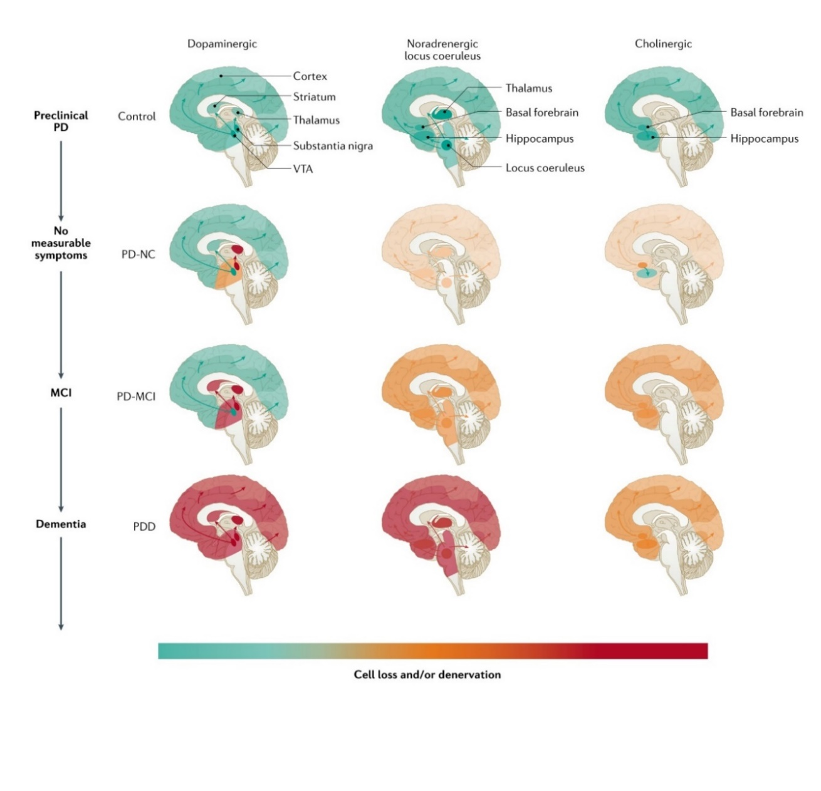
Figure 4 Neurotransmitter deficits associated with cognitive decline (modified from Aarsland et al., 2021). NC, normal cognition; MCI, mild cognitive impairment, VTA, ventral tegmental area.

Brain atrophy
Since the pathophysiological presentation of dementia in PD consists in impairment of spatial and working memory, it is not surprising that PDD patients show grey matter (GM) alterations in brain regions involved in memory encoding and consolidation. GM atrophy in PD-MCI and PDD has been reported in prefrontal cortex, medial temporal lobe, thalamus, and caudate (Kunst et al. 2019; Nagano-Saito et al. 2005; Pan et al. 2013) (Figure 5). For the scope of this thesis, only alterations in the medial temporal lobe will be discussed further.
The medial temporal lobe (MTL) is a neural system composed by the hippocampus and the adjacent entorhinal, perirhinal and para-hippocampal cortices. The MTL presents widespread connections with the neocortex, and is crucial in the encoding, consolidation and retrieval of memory informations (Lech and Suchan 2013). PDD patients present higher MTL atrophy when compared to both healthy controls and non-demented PD (Ibarretxe-Bilbao et al. 2008; Nagano-Saito et al. 2005; Pan et al. 2013). Within the MTL, a region of particular interest is the hippocampus. The hippocampus is a complex structure, involved in information processing and memory consolidation (Sekeres, Winocur, and Moscovitch 2018). Structurally, the hippocampus is subdivided in: dentate gyrus, receiving the input from the entorhinal cortex; cornu ammonis (CA), referred to as the hippocampus proper and further subdivided into 4 subfields (CA1 to CA4); and subiculum. The hippocampus has been implicated in the formation of both short-term and long-term memory (Sekeres, Winocur, and Moscovitch 2018). In the context of PD, hippocampal atrophy has been correlated with psychosis (Lenka et al. 2018) and learning deficits (Pereira et al. 2013). Reduction in hippocampal volume has been shown to be a predictor for cognitive impairment and progression to dementia (Aybek et al. 2009; Kandiah et al. 2014).
Input and output signals between the hippocampal formation and the cortex are regulated by the entorhinal cortex (Lavenex and Amaral 2000). Alzheimer’s disease research has shown that alterations in the entorhinal cortex precede hippocampal atrophy, underlying the importance of this structure in the early stages of dementia (Khan et al. 2003; Killiany et al. 2002). In PD, a reduction in the entorhinal cortex volume has been shown to differentiate demented and cognitively normal subjects, even when differences in the hippocampal volume are not detected (Goldman et al. 2012; Jia et al. 2019). Neuropathologically, a higher degree of Lewy pathology is observed in hippocampus and entorhinal cortex of demented patients (Bertrand et al. 2003), and the degree of Lewy pathology in these areas has been shown to correlate with the degree of cognitive impairment (Dag Aarsland et al. 2005; Churchyard and Lees 1997; Kövari et al. 2003).
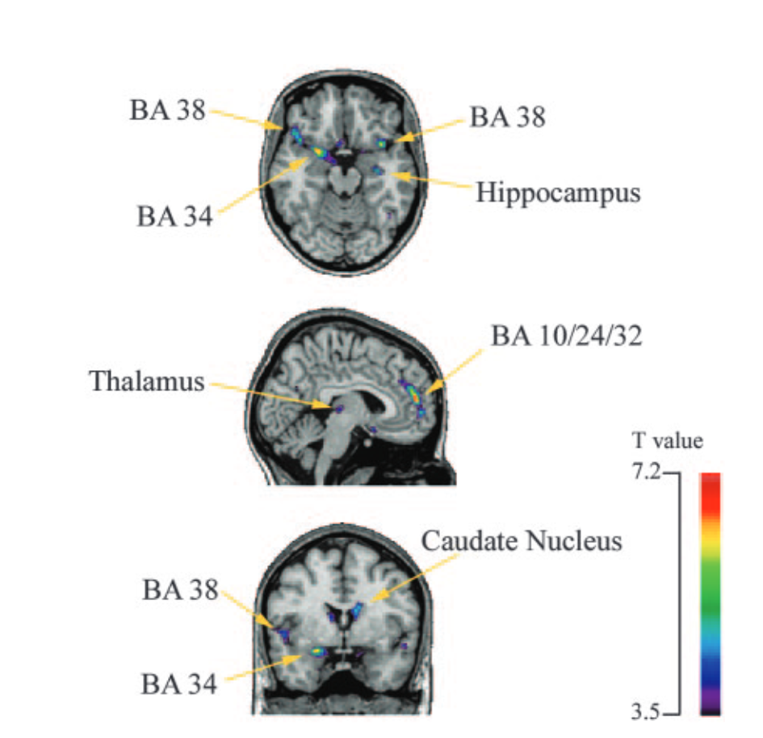
Figure 5 Significant grey matter density differences between non-demented PD and PDD (Nagano-Saito et al., 2005). BA, Brodmann area.

Neuropathology
The neuropathology of PDD is heterogeneous and involves a combination of alpha-synuclein, tau and amyloid-beta (Aβ) pathology, with cortical Lewy Body pathology being the predominant neuropathological feature in PDD.
Concomitant AD pathology is often reported in PD, with a higher extent of senile plaques and neurofibrillary tangles deposition in patients with dementia (Horvath et al. 2013; Jellinger 2012). A systematic review of autopsy studies reported moderate to severe tau and Aβ pathology in over a third of PDD cases, with prevalent pathology in the entorhinal cortex and the striatum (Smith et al. 2019). While tau pathology and Braak NFT stage have sometimes been directly associated with risk to develop dementia (Horvath et al. 2013), Aβ alone was never shown to be a strong predictor of dementia (Smith et al. 2019). Results suggest that LB pathology in the limbic region and in the cortex plays a fundamental role in the emergence and progression of dementia, while tau and Aβ pathologies overlap with Lewy pathology and contribute to heterogeneity in cognitive decline (Irwin and Hurtig 2018).

Genetic factors
Several genes causing familial PD have been implicated in the development of cognitive impairment and dementia (Table 1). Alpha-synuclein multiplications have been associated with a higher risk of dementia, and patients carrying triplications of the SNCA gene present early cognitive impairments and a more severe deterioration of cognitive performance (Book et al. 2018; Fuchs et al. 2007; Ross et al. 2008). Amongst SNCA gene mutations, the E46K mutation has been consistently associated with cognitive impairments and transition to PDD in all carriers (Somme et al. 2011; Zarranz et al. 2004).
Mutations in Parkin, PINK-1 and DJ-1, which cause recessive forms of PD, have often been associated with psychiatric disturbances such as hallucinations and depression, but the development of dementia is rare and estimated to be lower than in cases of sporadic PD (Kasten et al. 2018). Similarly, patients with LRRK-2 mutations do not show an increased risk for dementia when compared to non-carriers (Ben Sassi et al. 2012).
Other genes that do not directly cause parkinsonism, have been associated with a higher risk of cognitive impairment in PD. The apolipoprotein E epsilon 4 (APOE ε4) allele is over-represented in PD cases with dementia, and APOE ε4 presence is considered to be a predictor for cognitive decline (Pankratz et al. 2006). Genome-wide association studies have identified the microtubule-associated protein tau (MAPT) as a risk gene for PD (Zabetian et al. 2007); the H1/H1 haplotype has been shown to correlate with early development of dementia and greater cognitive decline (Goris et al. 2007). Mutations in the glucocerebrosidase (GBA) gene have been robustly associated with worse progression of cognitive deficits and a higher frequency of dementia (Straniero et al. 2020).
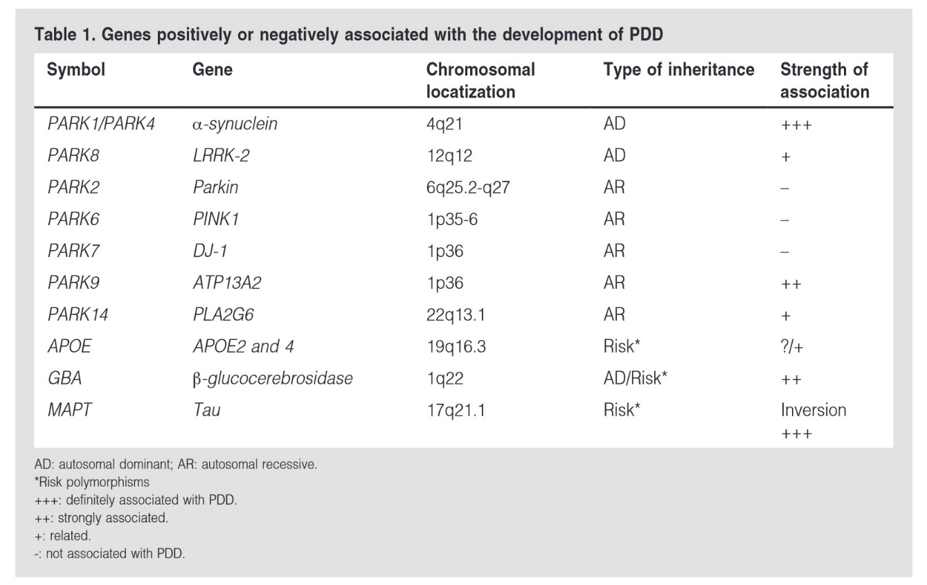
Table 1 Genes associated with the development of dementia (modified from Romo-Gutiérrez et al., 2014)

Part II

Scope and Aims

Parkinson’s disease is a complex multi-factorial disease of variable manifestation, whose onset, severity, and progression largely vary amongst the affected individuals. Moreover, PD manifestation varies across populations and is presented with gender differences, seemingly affecting men more than women. Human studies are limited by the accessibility of the brain, restricting neuropathological examinations to post-mortem specimens which only allow for the investigation of a snapshot of the end-stages of the pathological process. In recent years, the development of more and more sophisticated in vivo imaging techniques has allowed for a better investigation of the disease course, yet these results are rather descriptive, and remain confined to overt stages of pathology. Therefore, the investigation of pathogenic mechanisms in PD, and even more of those that occur early in time, largely relies on the use of animal models. Even if unable to reproduce the full nuances of the human pathology, animal models have proved to be essential tools in the understanding of pathogenetic mechanisms, allowing to dissect and separately investigate the contribution of different factors to the disease initiation and progression.
When the cause of the disease is known, one of the easiest ways to model the human pathology is via a genetic model based on genes associated with familial forms of the disease. In the case of PD, modelling of familial cases can be achieved by the overexpression of mutated genes such as the SNCA gene for autosomal dominant cases, or via the knock-out of genes causative of recessive forms of PD such as in the case of DJ-1. But with only 10% of cases clearly attributable to a known genetic cause, the investigation of PD achieved through genetic models mimicking familial cases is bound to be limited. Therefore, the development of models which come closer to idiopathic PD is of extreme importance. Given the relevance of alpha-synuclein in the progression of PD in both familiar and idiopathic cases, genetic models expressing the human, wild-type SNCA gene have been developed with this aim. These models are not only useful to study the role of alpha-synuclein pathology to PD progression but can represent a starting point to investigate the contribution on PD pathogenesis of other factors, such as environmental factors or life-style changes, which act in combination with a genetic predisposition. Finally, we must not forget that 90% of PD patients presents at least one neuropsychiatric symptom, and over 30% of the patients develops cognitive impairment and dementia as the disease worsens over time. With an increasing prevalence of dementia with disease duration, it has become more and more important to extend the analysis of PD beyond the classical nigrostriatal pathway, including regions such as the pre-frontal cortex and the hippocampus which are primarily involved in cognitive decline.
When aiming to model early events in the disease pathogenesis, a relevant tool is represented by gene expression analysis. Indeed, regulatory mechanisms controlling transcription can be activated early following the exposure to different types of stressors. In PD, gene expression alterations can happen in response to pathological events such as alpha-synuclein misfolding and reactive oxygen species production, and changes in gene expression can be expected to precede neuronal death. Furthermore, transcriptional regulation could change over time, following the patterns of disease progression. Once again, the longitudinal study of gene expression regulation during disease progression cannot be achieved in human samples and thus requires the use of in vivo models.

Aim 1: Modelling the early pathogenic mechanisms of PD in a genetic mouse model overexpressing the human E46K mutated alpha-synuclein gene
Genetic animal models of human pathology often rely on the overexpression of genes known to cause familial dominant forms of the studied disease. When it comes to Parkinson’s disease, the overexpression of the human wild-type or mutated alpha-synuclein gene (SNCA) in rodents has long been used to model the parkinsonian phenotype, and such models have allowed to shed light on some of the molecular mechanisms underlying PD pathology.
A transgenic mouse model overexpressing the human E46K-mutated SNCA gene has been created by Elan Pharmaceuticals. We have characterised this model to assess its validity in replicating the classical PD phenotype, focusing on nigrostriatal degeneration, midbrain gene expression alterations, and motor impairments. We have investigated young, mid-life and aged mice in order to shed light on the time progression of disease development with the aim to identify the early events driving neurodegeneration.

Aim 2: Modelling cognitive impairment in PD using the SNCA-E46K genetic mouse model
The heterozygous E46K mutation in the SNCA gene causes a dominant form of Parkinson’s disease characterised by early onset and cognitive deficits, and development of dementia by the end stages of the disease. As shown in Chapter 3, the SNCA*E46K mouse has shown potential to model the early phases of PD-linked neurodegeneration. In Chapter 4, we have investigated the possibility to use this same mouse to model cognitive impairment and its development in PD. To do so, we have profiled the hippocampus both in terms of neurodegeneration and transcriptional profile, and we have characterised the presence of memory impairments through behavioural testing. To elucidate response mechanisms over time, we have investigated both the gene expression and functional responses across different ages.

Aim 3: Modelling the early pathogenic mechanisms of PD in an alpha-synuclein independent context, using the Park7 knock-out mouse model
Loss-of-function mutations in the DJ-1 encoding gene Park7, are causative of familial recessive early-onset PD. The knock-out (KO) of DJ-1 in mice was shown to reproduce some aspects of PD pathology, such as dopaminergic deficits and increased sensitivity to oxidative stress, albeit with a generally mild phenotype. To investigate early pathological events linked to the loss of DJ-1, we profiled the gene expression changes in the ventral midbrain in young DJ-1 KO mice. Since Park7 mutations are reported to occur more frequently in men than women, we profiled male and female mice separately to uncover potential sex-specific responses to DJ-1 loss.

Aim 4: Modelling early Parkinson-like phenotype in a WT alpha-synuclein overexpressor model
Alpha-synuclein aggregation and Lewy body pathology are a classical hallmark of PD, characterising both familial and sporadic cases of the disease. A mild overexpression of the human, wild-type alpha-synuclein gene can represent a good approach to use genetic models to reproduce a phenotype which is closer to that of idiopathic PD. In Chapter 6, we characterise a novel mouse model overexpressing the human SNCA gene under the Thy1 murine promoter, through transcriptional profiling of the midbrain, neuropathological analysis of the striatum, and behavioural assessment.

Aim 5: Modelling the interplay of environmental and genetic factors in the initiation and progression of idiopathic PD
The majority of PD cases does not present a known genetic cause, and is determined by the interplay of genetic predisposition, biological processes, lifestyle and environmental factors. In Chapter 7, we used the Thy1-Syn14 mouse model characterised in Chapter 6 to investigate the contribution of a westernized diet poor in fibres and exposure to bacterial amyloidogenic protein Curli in the initiation and progression of PD-like pathologies.

Aim 6: Investigation of alpha-synuclein moieties and glutamate excitotoxicity in cellular models of PD
Despite the proven relevance of alpha-synuclein to PD pathology, there is still an on-going debate on whether the alpha-synuclein aggregates have a toxic effect. In recent years, new evidence have proposed oligomeric forms of alpha-synuclein, generated as intermediate species along the aggregation process, as the toxic species responsible for neuronal death and pathology spreading. In vitro synthetized alpha-synuclein moieties can be used to generate cellular or in vivo models of PD-like phenotypes, and could help understanding the relevance of each form of the alpha-synuclein protein in the pathogenesis of PD.
The primary excitatory neurotransmitter in the central nervous system is glutamate. Increases in extracellular glutamate levels cause aberrant synaptic signalling leading to neuronal death, making glutamate excitotoxicity a common pathological process in acute brain trauma and ischemia (Arundine and Tymianski 2004). Furthermore, the PD associated protein DJ-1 has been shown to protect against stroke-induced damage by modulating excitotoxicity (Aleyasin et al. 2007), opening up the possibility that excitotoxicity might play a role in PD as well. We initially used the glutamate treatment to set up a reliable system of neuronal toxicity, and later extended our investigation to DJ-1 knock-down cells.

Part III

Materials and Methods

Animals

Mouse colony management
For the present thesis, three different mouse lines were used. The transgenic mouse line BAC-Tg3(SNCA*E46K) overexpressing the E46K mutated, human synuclein, also known as Tg(SNCA*E46K)3Elan/J or “Line 3”, was generated by Elan Pharmaceuticals (USA) and first described in Gardai et al., 2013. The Park7^{Gt(XE726)Byg} | DJ-1⁻ mouse line was generating through a gene trap vector integration between exon 6 and 7 of the Dj-1 gene (Pham et al., 2010); in our facility, mice were back-crossed with C57BL/6N mice for over 20 generations before this study was performed. The transgenic mouse line B6.D2-Tg(Thy1-SNCA)14Pjk, known as Thy1-Syn14 line, overexpresses the human wild-type synuclein under the murine Thy1 promoter. Transgene expression levels have been described in Kahle et al., 2001, but the phenotype of the line has not been reported in detail. The mice were bred in the animal facility of the University of Luxembourg under specific and opportunistic pathogen-free conditions (SOPF), and were subsequently housed in specific pathogen-free conditions (SPF) with ad libitum access to water and food, and under exposure to a regular 12h day-night cycle.
All experiments received approval by the Animal Experimentation Ethics Committee of the University of Luxembourg, and were performed in agreement with the European Union directive 2010/63/EU and the 3R guidelines (https://www.nc3rs.org.uk/the-3rs).

Genotyping
For genotyping, DNA was extracted from ear or tail biopsies using the ExtractaTM DNA Prep for PCR-Tissue kit (QuantaBio), according to manufacturer’s instructions. Briefly, 30-50µl of the extraction reagent were added to each tube, and the biopsies were incubated at 94°C for 30 minutes. The samples were then cooled in ice for 1 minute and spun down. Finally, 30-50µl of the stabilization buffer were added to each sample, and the extracted DNA was kept on ice for immediate use or stored at -20°C.
Genotyping by PCR was performed using the KK4702 - KAPA PROBE FAST UNI genotyping kit (Sigma Aldrich), according to manufacturer’s instructions. In brief, a mix of 12.5μl of 2xKAPA2G Fast Hot Start Genotyping Mix, 1.25µl of 10µM forward and reverse primer, 2µl of DNA and 8µl of PCR grad water was prepared. The following 5-3 primer pairs were used:
- SNCA*E46K: forward, GAT-TTC-CTT-CTT-TGT-CTC-CTA-TAG-CAC-TGG; reverse GAA-GCA-GGT-ATT-ACT-GGC-AGA-TGA-GGC.
- DJ-1: forward, AGG-CAG-TGG-AGA-AGT-CCA-TC; reverse WT, AAC-ATA-CAG-ACC-CGG-GAT-GA; reverse KO, CGG-TAC-CAG-ACT-CTC-CCA-TC.
- SNCA WT: forward, AAG-GCC-AAG-GAG-GGA-GTT-GTG; reverse, TTC-CTC-AGA-AGG-CAT-TTC-ATA-AGC.
The PCR reaction was run on a Biometra TOne thermocycler (Westburg) using the following protocol: initial denaturation of 3 minutes at 95°C; 30 cycles of 95°C for 30 seconds, 65°C for 30 seconds (annealing) and 72°C for 1.5 minutes (elongation); final elongation at 72°C for 5 minutes. The PCR products were separated by electrophoresis on a 2% agarose gel (90V constant, 400mA), and visualized under UV light using the GelRed® Nucleic Acid Gel Stain (Biotium) and a Biometra BioDocAnalyze (Westburg).

Behavioural testing
Behavioural testing was executed before euthanasia. We tested for the presence of motor impairment using the Inverted Grid, the Adhesive Removal and the Grip Strength tests. The cognitive capability of transgenic and wild-type mice was assessed using the Y-maze test. All tests were conducted in SPF conditions.

Hindlimb clasping
Animals were suspended by the base of the tail for 10sec, and the hindlimb clasping was scored as follows: 0, if both hindlimb were stretched for >50% of the suspension time; 1, if one hindlimb was retracted for over 50% of the suspension time; 2, if both limbs were retracted for >50% of the time; 3, if both limbs were retracted for the whole duration of the test; 4, if limbs were retracted and animals twisted or curled up.

Grip strength
To assess the grip strength, we used a Bioseb’s grip strength metre (Vitrolles, France). Briefly, the mouse was placed in the middle of the grid and allowed to grab it with all paws. After few seconds, it was gently pulled back from the tail using a smooth continuous movement. Each mouse was tested three times and for each mouse, the results were averaged and normalized to the weight.

Inverted Grid
The Inverted Grid test was used to assess the muscular strength of the animals. The mice were brought to the experimental room 30 minutes before testing. The test was performed during the day phase of the 12h day-night cycle. The mice were placed on the centre of a metal grid suspended at about 20 cm from the tabletop, and the grid was rotated to an inverted position over 2 seconds. Once the inverted position was reached, a clock was started. The grid was held steadily for a total time of 30 seconds. The time of falling was recorded, otherwise the maximum time of 30 seconds was used.

Adhesive removal
We used the Adhesive Removal test to quantify fine sensory-motor deficits. The animals were tested one at a time, during the day phase of the 12h day-night cycle. Before performing the test, the mice were let habituate to the testing room for 30 minutes. Animals were placed in a round transparent arena and let habituate. After a 1 minute habituation, the mice were removed from the arena, and a piece of rectangular tape of 3 by 5 mm was placed on the left forepaw. The animals were reintroduced in the arena, and a timer for 2 minutes was set. Two experimenters independently recorded the time of first touch of the adhesive tape and the time at full removal of the tape. If the mouse did not manage to remove the adhesive, the maximum time of 120 seconds was reported. The test was performed twice per each mouse, and the best performance was selected for analysis.

Y-maze
The Y-maze test investigates spatial learning and short-term memory. The maze is composed by three arms placed at 120 degrees from each other. Mice were tested one at a time. The mouse was introduced in the maze at the end of one arm, facing away from the centre of the maze; the starting arm was alternated between tests to minimise potential biases. The mouse movements were recorded for a total time of 5 minutes. During the test time, two experimenters independently recorded the number of entries into each arm of the maze and the specific sequence of entrance. The mouse was considered as inside one arm if its shoulders were to surpass a 5cm point from the beginning of the arm. The EthoVision XT software v13 (Noldus) was used for video tracking.

Bacterial solution preparation and gavage
For the results presented in Chapter 7, mice were gavaged with a C600 E. coli strain (EC) and its isogenic Curli-operon Knock-out (ΔEC) strain, both gifted by Matthew Chapman (University of Michigan). PCR was used to confirm transcription of the Curli operon (csgA_F-5’-GCG-TGA-CAC-AAC-GTT-AAT-TTC-CA-3’, csgA_R-5’-CAT-ATT-CTT-CTC-CCG-AAA-AAA-AAC-AG-3’; csgB_F-5’-CCA-TCG-GAT-TGA-TTT-AAA-AGT-CGA-AT-3’, csgB_R-5’-AAT-TTC-TTA-AAT-GTA-CGA-CCA-GGT-CC-3’), and Congo red staining was used to confirm expression at the protein level. Culture of both E. coli strains was performed at 5% CO₂, 37°C in agitation at 300rpm, using Lennox broth. For oral administration, a suspension of 1010CFUs/ml in sterile PBS was used, and each mouse was gavaged with 100μL of bacterial solution or PBS, using reusable stainless steel 20G feeding needles (Fine Science Tools, 18060-20).

Euthanasia and tissue collection
The mice were anesthetized with a mixture of Ketamine (150mg/kg) and Medetomidine (1mg/kg), and transcardially perfused using room temperature PBS 1X. After euthanasia, the brains were extracted from the skull, placed on ice, and two hemi brains were separated using a metal blade. Different regions of interest (striatum, midbrain, hippocampus and cortex) were dissected for molecular biology analyses from one of the two hemi brains; the dissected brain regions were snap frozen in dry ice and stored at -80°C until use. The other hemi brain was fixed for 48 hours at 4°C in 4% PBS-buffered paraformaldehyde (PFA), and then stored in PBS + 0.02% sodium-azide at 4°C for immunohistochemistry. The fixed hemi brains were cut using a Leica vibratome VT1000 (Wetzlar), to generate 30-50µm thick free-floating sagittal sections, and the sections were stored at -20°C in a cryoprotectant medium (1% polyvinyl pyrrolidone, 50% ethylene glycol in 1X PBS) until further use.
After dissection, colon samples were fixed in a solution of 60% absolute methanol, 30% chloroform and 10% glacial acetic acid (Methacarn) for 2-4h at RT under a chemical hood. Tissues were then transferred to 90% ethanol and stored at 4°C. 4-5mm long transversal sections were cut from colon samples using a microtome blade. These were then inserted in histological cassettes maintaining the proximal-distal orientation. Samples were held in place in a perforated sponge soaked in ethanol, and were post-fixated for 24h in formalin. Next, a vacuum infiltration processor was used to process the samples. Following paraffin embedding, samples were cut in 3μm thick sections using a microtome. The slides were stored at 4°C until staining.

LUHMES cells

Cell culture
Wild-type and DJ-1 knock-down Lund human mesencephalic (LUHMES) cells were donated by the Integrative Cell Signalling group at the Luxembourg Centre for Systems Biomedicine (Meiser et al., 2016). Cells were grown in T75 flasks (ThermoFisher) or in multi-well plates, coated with 1mg/ml Poly-L-Ornithin (P-3655-100mg, Sigma-Aldrich) and 1mg/ml Fibronectin (F-1141-5mg, Sigma-Aldrich). For defrosting, cells were quickly warmed up and diluted in 10ml Advanced DMEM/F-12 (12634-010, Gibco/Invitrogen) without additives. The cell suspension was centrifuged at 300g for 5min, the supernatant was removed and the pellet was resuspended in 10ml of proliferation medium (for 10ml DMEM/F12: 100µl L-Glutamine (G7513, Sigma-Aldrich), 100µl N-2 (17502048, Gibco/Invitrogen), 2.5µl Recombinant Human FGF2 (4114-TC, R&D Systems)). Cells were incubated at 37°C in 5% CO₂, and split after 2 days, even if they had not reached confluence. Cells were regularly tested for mycoplasma contaminations using the MycoAlertTM Mycoplasma detection kit (LT07-418, Westburg).
For subculture, cells were grown in proliferation medium in T75 flasks and split when they reached 80% confluence. Cells were washed twice with 10ml of PBS and incubated with 4ml of TrypLE Express Enzyme (12604013, Gibco) at 37°C for 5min. 10ml of Advanced DMEM/F12 were added, and the cell suspension was centrifuged at 300g for 5min. The supernatant was removed, and the pellet was resuspended in 5ml Advanced DMEM/F12 without additives. Cells were counted in a Neubauer chamber and seeded in 10ml proliferation medium.
The differentiation process was split in two phases. For the pre-differentiation, 2 million cells were seeded in a T75 flask in 10ml proliferation medium. After 24h, proliferation medium was exchanged with differentiation medium (for 10ml Advanced/DMEM: 100µl L-Glutamine, 100µl N-2, 100µl db-cAMP (D0627, Sigma-Aldrich), 10µl tetracycline (T-7760, Sigma-Aldrich), and 1µl Recombinant Human GDNF (212-GD, R&D Systems). After additional 48h, the pre-differentiation was completed. Cells were detached with TrypLE and the pellet was resuspended in 10ml of differentiation medium; after counting, cells were plated in multi-well plates in desired quantity. After 72h incubation in differentiation medium, the differentiation process was completed and cells were ready for treatment.

MTT test
50.000 cells were plated in 96-wells plates. Four wells per condition were used. At the end of the differentiation process, medium was exchanged with ½ Neurobasal (21103-049, Gibco) ½ Advanced DMEM/F12 supplemented with L-Glutamine, N-2, db-cAMP, tetracycline and GDNF. After one day, cells were treated with alpha-synuclein moieties (see Chapter 8, Table 2) or Glutammate diluted at the appropriate concentration in Neurobasal medium without additives. For 5-days treatments, 100µl of fresh Neurobasal medium were added to each well. Cytotoxicity was tested using the Thiazolyl Blue Tetrazolium Bromide (MTT) assay (M5655-1G, Sigma-Aldrich) according to manufacturer’s instructions. Briefly, cells were washed twice with PBS 1X and incubated with a 1:10 dilution of MTT in Neurobasal medium for 3h at 37°C. Then, the medium containing the MTT reagent was removed, and cells were incubated in acidified isopropanol at 37°C protected from light until measurement. Absorbance of formazan was measured in a plate reader at 570nm (specific) and 690nm (non-specific). Absorbance at 690nm was then subtracted from 570nm absorbance values, then the average absorbance for each condition was calculated. Absorbance for “media only” was subtracted from averaged values, and the viability was calculated as a percentage of the absorbance value of the untreated cells (negative control). 1% triton was used as a positive control for cytotoxicity.

Immunofluorescence staining
For immunofluorescnce staining, 1 million cells were seeded on a glass cover slip in a 12-wells plate coated with poly-ornithin and fibronectin. Cells were fixed with 4% PFA in PBS 1X for 15min, then wells were washed 3 x 5min with PBS 1X. Cells were permeabilized with 0.05% Triton X-100 in PBS 1X for 3min on ice. After 3 x 5 min washing with PBS 1X, cells were incubated in a blocking solution of 10% fetal bovine serum (FBS) (10270-106, Life Technologies) for 1h at RT. Coverslips were incubated with 30µl of a mouse monoclonal anti-Tubulin β 3 (TUBB3) antibody (clone Tuj1, 11580, BioLegend, 1:500) diluted in 10% FBS for 90min at RT in a wet chamber. After incubation with the priary antibody, coverslips were placed once again in a 12-wells plate, and cells were washed 3 x 5min with PBS 1X. The Alexa Fluor® 594 goat anti mouse secondary antibody (1:1000) was diluted in 10% FBS and cells were incubated in secondary antibody for 60min at RT under a light trap. Cells were then washed 3 x 5min with PBS 1X and incubated in a 1:10,000 DAPI solution for 30min under a light trap. Cells were washed once with distilled water for 5min at RT, then the coverslips were mounted on a glass slide with 20µl of mounting medium. Slides were dried in the dark and stored at 4°C until imaging.

Electron Microscopy
Electron microscopy was used for the characterisation of alpha-synuclein monomers, oligomers and pre-formed-fibrils (PFFs). Alpha-synuclein moieties were diluted 1:10 in PBS 1X and samples were stored on ice. Sonication of PFFs was performed in a Bioruptor UCD 300 (Diagenode, Seraing, Belgium) for a total of 30 cycles (15sec ON + 15sec OFF) at 4°C. Samples were prepared for negative staining using the so-called ”direct application method”. Formvar/carbon coated 100 mesh copper grids (EMS, FCF100H-CU, Lot# 190405) were lined up on a glass coverslip and inspected under an optic microscope to ensure carbon film integrity. Grids were charged using a glow discharge apparatus at 0.1 mbar, 10 high tension (HT) for 10 seconds, and again inspected under the microscope. To increase contrast to allow for imaging of very small proteins, we stained the samples with depleted uranium. Briefly, under a chemical hood, we loaded 2µl of sample onto an imaging disk, waited for 1min and then blot off the excess on Whitman filter paper. Next, we dipped the disk in sterile purified water (Millipore) and blot the excess on Whitman paper for three times. Then, we dipped the disk in a drop of aqueous 2% uranyl acetate and left incubating for 20sec. We blotted off the excess on paper, let the grid dry, and washed once in mQ water. Then, we let the disks dry before image acquisition. Images were acquired with a Scanning Electron Microscope (Zeiss GeminiSEM 300) using an accelerating voltage of 20Kv.

RNA analysis

RNA extraction
The RNA was extracted from the brain regions of interest using the RNeasy Plus Universal Mini kit (Qiagen) following the manufacturer’s instructions. The frozen samples were placed in ice cooled racks and were homogenized in a Retsch Mixer Mill MM400 at 20Hz for 2 minutes using three 5mm steel balls pre-cooled at -20°C and 900µl of QIAzol lysis buffer (Qiagen). After homogenisation, the samples were let at room temperature for 5 minutes to allow the foam to disappear, then they were transferred in new RNase clean 1.5ml tubes. 100µl of gDNA eliminator solution were added, and the samples were vigorously shaken for 15 seconds. Subsequently, 180µl of chloroform were added, and the samples were once again shaken for 15 seconds. Homogenates were left at RT for 3 minutes, and then centrifuged at 12,000g for 15 minutes at 4°C. After centrifugation, the upper aqueous phase was collected into a new 1.5ml RNase clean tube, and an equal volume of 70% ethanol was added. The samples were gently mixed by pipetting, and 500µl were added to a RNeasy mini spin column and centrifuged at 8,000g for 30 seconds at RT. The flow-through was discarded, and the previous step was repeated with the remaining of the samples. Afterwards, 700µl of RWT buffer were added, and the columns were spun at 8,000g for 30 seconds. The flow-through was discarded, and the centrifugation was repeated using 500µl of RPE buffer. The flow-through was again discarded. Another 500µl of RPE buffer were added, and the columns were centrifuged at 8,000g for 2 minutes at RT. Next, the columns were transferred to a new collection tube and spun for 1 minute at maximum speed. Finally, the columns were placed into new 1.5ml RNase-free tubes, and the RNA was eluted with 50µl of RNase-free water by centrifugation at 8,000g for 1 minute.
The RNA samples were kept on ice for immediate use or stored at -80°C. The purity and quality of the RNA was assessed using the NanoDropTM 2000 (ThermoFischer Scientific) and the Agilent 2100 Bioanalyzer.

RT-qPCR
The RNA was retro-transcribed to cDNA using the SuperScriptTM III RT reverse transcriptase (Invitrogen). A mix of 1µg RNA, 1μL of oligo (dT) 20 (50μM), 1μL of 10mM dNTP mix and nuclease-free water up to a volume of 13µl was prepared on ice. The mixture was briefly spun down and heated at 65°C for 5 minutes. After cooling on ice for at least 1 minute, 4µl of 5x First Strand buffer, 1µl of 0.1M DTT, 1µl of RNase OUT and 1µl of Superscript reverse transcriptase (200 U/µl) were added to the mix. The mixture was briefly centrifuged and incubated at 50°C for 1 hour, and then at 70°C for 15min. 80µl of RNase-free water were added, and the cDNA samples were kept on ice for immediate use or stored at -20°C.
The Real Time (RT)-qPCR was performed using a LightCycler® 480 II (Roche). Briefly, a reaction mix was prepared using 1X iQTM SYBR® Green Supermix (Bio-Rad), 10µM forward and reverse primers, 2µl of cDNA and PCR grade water up to a volume of 20µl. Each sample was run in duplicates using a protocol that included an initial denaturation at 95°C for 3 minutes; and 40 cycles of a brief denaturation (30 seconds at 95°C), annealing (30 seconds at 62°C), and elongation (30 seconds at 72°C). Fluorescent data acquisition was performed during the annealing step using the LightCycler® 480 Software (version 1.5.0.39). GAPDH was used to normalize the expression values for each target gene (ΔCt), and fold change in expression was calculated as 2^(−ΔCt).
The following primers were used: murine Snca (forward 5′- CGC-ACC-TCC-AAC-CAA-CCC-G-3′; reverse 5’- TGA-TTT-GTC-AGC-GCC-TCT-CCC-3′), human SNCA (forward 5′- AAG-AGG-GTG-TTC-TCT-ATG-TAG-GC-3′; reverse 5′- GCT-CCT-CCA-ACA-TTT-GTC-ACT-T-3′), total SNCA (forward 5′- GAT-CCT-GGC-AGT-GAG-GCT-TA-3′; reverse 5′- GCT-TCA-GGC-TCA-TAG-TCT-TGG-3′), GAPDH (forward 5′- TGC-GAC-TTC-AAC-AGC-AACTC-3′; reverse 5′-CTT-GCT-CAG-TGT-CCT-TGC-TG-3′).

Microarray Analysis
For the microarray analysis, 150ng of total RNA per sample were used. Processing of the samples was performed with the Affymetrix GeneChip® WT PLUS Reagent Kit and the run was executed on GeneChip Mouse Gene 2.0ST Arrays (Affimetrix). The scanning was performed with Affymetrix® GeneChip® Scanner 3000. Quality control of the obtained data was performed using the Bioconductor SCAN.UPC package and the Bioconductor arrayQualityMetrics package respectively. Differential expression analysis was performed between genotypes as well as between age groups using the Bioconductor limma package with Benjamini-Hocberg correction for multiple testing. The Ensembl Biomart database (https://m.ensembl.org/info/data/biomart/ index.html) was used to identify human orthologues correspondent to the mouse DEGs. A text mining analysis for the term “Parkinson disease” from the Medical Subject Headings (MeSH) was performed using the Pointwise Mutual Information (PMI) co-occurrence measure. The GeneGO MetaCoreTM software (https:// portal.genego.com) was used to run a pathway enrichment analysis on the significant (adjusted p value ≤ 0.05) human orthologues of the mouse DEGs. Molecular sub-networks were determined using the “Analyze network” feature from the GeneGO MetaCoreTM software.

RNA sequencing
RNA sequencing was performed at the University of Luxembourg in collaboration with the sequencing platform of the Luxembourg Centre for Systems Biomedicine (LCSB). A total quantity of 1µg of RNA was used for mRNA sequencing. The Illumina Stranded mRNA Prep kit was used for library preparation, and the library was quantified using a QubitTM 4 Flurometer (Invitrogen). A single end sequencing for the DJ-1 KO and the Thy-Syn14 mouse samples, or a 2 x 50bp paired end sequencing for the SNCA*E46K mice was performed using a NextSeq2000 (Illumina), with a sequencing depth of ~24 million reads per sample.
For the differential expression analysis of Thy1-Syn14 and DJ-1 KO mice, quality of the reads was checked with FastQC (v0.11.5). Adapters were removed with PALEOMIX (v1.2.12) and ribosomal RNA reads were removed with SortMeRNA (v2.1). Mapping was performed with STAR (v2.3.2b) using the GRCm38 release 102 mouse genome as a reference. Obtained BAM files were validated using Picard (v2.10.9) and the read counts were produced in R using the featureCounts (Rsubread package, v1.28.1). Differential expression analysis was performed in R using the DESeq2 package (v1.20.0) using the counts as an input, and a cut-off of adjusted p-value ≤ 0.05.
For the differential expression analysis of SNCA*E46K animals, quality of the reads was assessed using FastQC (v0.11.4). High-quality reads were aligned with STAR (v2.7.9a), using a custom-built genome composed of the GRCm39 Mus musculus assembly and the human SNCA transgene together with Ensembl annotations v104. Quality of alignments was checked using samtools (v1.10) and visually inspected in the Integrative Genome Viewer. Normalised read counts were obtained in R using DESeq2 (v1.36.0). Transcripts covered with less than 20 reads in at least 75% of the samples were excluded from the analysis, leaving ~18500 genes for differential expression analysis. A generalised linear model was used to model the expression of genes as a function of genotype, age, and their interaction, and differentially expressed genes were determined using a cut-off of adjusted p-value ≤ 0.05. To minimise unwanted variation between samples, a surrogate variable analysis (sva, v3.44) was used. Functional enrichments among differentially expressed genes were obtained with Gprofiler2 (v0.2.1) with p_{FDR} ≤ 0.05.

Protein analysis

Protein extraction
For total protein extraction, the brain regions of interest were homogenized using a Dounce homogenizer in a lysis buffer containing 10mM Tris, 0.32M sucrose, 2mM EDTA, 1mM sodium orthovanadate (proteases inhibitor) (Sigma), and antiprotease cocktail (Roche). A volume of 400µl and 800µl of lysis buffer was used for hippocampus and cortex respectively. The protein extraction was performed on ice, and the extracted proteins were immediately frozen in dry ice and stored at -80°C until use.

Western Blot
Protein concentrations were determined by a Bradford assay using the Protein Assay Dye Reagent Concentrate (BioRad). Samples were mixed with 4x Laemmli sample buffer containing β-mercapto-ethanol and boiled at 95°C for 5 minutes. 12µg of total protein were run on a 15% SDS-PAGE gel using a mini-PROTEAN Tetra Handcast and Electrophoresis System (BioRad) at 200V constant. As a molecular weights marker, 10ul of the Precision Plus Protein Dual Color Standard were used. After separation, the proteins were transferred on a nitrocellulose membrane using the Trans-Blot Turbo Transfer System (BioRad). Protein transfer and correct separation was assessed using a Ponceau staining solution (Cleaver Scientific Ldt). After Ponceau staining, the membranes were washed with PBS + 0.01% Tween20 (PBS-Tw) and blocked with 3% milk in PBS-Tw for 2 hours at RT on a shaker. Primary antibodies were diluted in 3% milk in PBS-Tw and membranes were incubated overnight at 4°C on a shaker. For total alpha-synuclein detection, we used the rabbit polyclonal anti-pan-αSyn antibody (S3062, Sigma-Aldrich, 1:1000). For human alpha-synuclein detection, we used the mouse monoclonal anti-human-αSyn (clone Syn211, S5566, Sigma-Aldrich, 1:1000). As a loading control, we used a rabbit polyclonal anti-beta-Actin antibody (ab8227, Abcam, 1:1000), or a mouse monoclonal anti-α-tubulin antibody (clone [DM1A], ab7291, Abcam, 1:1000). The next day, membranes were washed 3 x 10 minutes in PBS-Tw and incubated with the secondary antibodies diluted in 3% milk in PBS-Tw for 1 hour at RT on a shaker. The LI-COR IRDyeR 800CW donkey anti-rabbit (1:10000), and the IRDyeR 680LT donkey anti-mouse (1:10000) were used. Next, membranes were washed 3 x 20 minutes at RT on a shaker and imaged with the Odyssey® CLx Infrared Imaging System (LI-COR Biosciences).
Protein concentration was quantified using the ImageJ software.

Immunofluorescence staining on free-floating brain sections
Immunofluorescence staining of free-floating brain sections was performed as previously described in Ashrafi et al., 2017. Briefly, sections were collected into a 24 wells plate with mesh and washed 3 x 10 minutes in PBS + 0.1% Triton X100 (PBS-T) to remove the cryo-protective solution. Then, the sections were permeabilised with a solution containing 1% Triton X100 and 3% H₂O₂ in PBS, for 30 minutes at RT on a shaker. Sections were washed 2 x 5 minutes with PBS-T and blocked with 5% BSA or goat serum in PBS-T for 1 hour at RT on shaker. After a quick rinse in PBS-T, sections were incubated overnight at RT on shaker with the primary antibodies diluted in 2% BSA in PBS-T. The following primary antibodies were used: mouse monoclonal anti-human-αSyn (clone Syn211, S5566, Sigma-Aldrich, 1:1000); rabbit polyclonal anti-pan-αSyn (S3062 Sigma-Aldrich, 1:1000); rabbit monoclonal murine specific αSyn (clone D37A6, 4179S, Cell Signalling, 1:1000); mouse monoclonal anti-pS129-αSyn (clone 11A5, #1347, Prothena Biosciences Inc., 1:1000); rabbit monoclonal anti-pS129-αSyn (ab51253, Abcam, 1:1000); chicken polyclonal anti-Tyrosine Hydroxylase (ab76442 Abcam, 1:1000); rabbit polyclonal anti-Tyrosine Hydroxylase (AB152, Merck/Sigma-Aldrich, 1:1000); rat monoclonal anti-Dopamine Transporter (clone DAT-Nt, MAB369, Millipore, 1:1000); rabbit anti-Iba1 (019-19741, Wako, 1:1000).
The next day, sections were washed 3 x 10 minutes in PBS-T. Then, sections were incubated with the appropriate Alexa Fluor® secondary antibodies diluted in 2% BSA in PBS-T, for 2 hours at RT on shaker under a light trap. Finally, sections were washed 3 x 10 minutes in PBS-T and mounted on SuperfrostTM slides (ThermoFisher Scientific). After drying for approximately 2 hours, sections were cover-slipped using the DAPI Fluoromount-G® mounting medium (Southern Biotech). The slides were dried for at least 24 hours before imaging.
The sections were imaged with a Zeiss AxioImager Z1 upright microscope equipped with an ApoTome.2 module for optical sectioning of fluorescence images, a PRIOR motorized slide stage, a “Colibri” LED system and a Zeiss MR R3 digital camera under the control of the Zeiss Blue Vision software. For alpha-synuclein qualitative profiling in the hippocampus, tiled (3x3 or 3x4) pictures of the whole hippocampus were taken at 10X magnification without ApoTome.2, and then converted into single Tiff files.

Quantification of neurodegeneration
For the quantification of striatal degeneration, 3 striatal pictures were acquired at 40X magnification (223.8 × 167.7 μm2) using the Apotome.2 module for each section, and 2 or 3 striatal sections were imaged for each animal. TH and DAT double stained sections were used. The images were converted to TIFF and analysed using the ImageJ software. Briefly, after thresholding, the percent area occupied and the mean grey value for both TH and DAT positive terminals was measured.
To correlate loss of TH-positive axons loss with levels of α-syn expression, TH/a-syn double stained sections were used. The quantification was performed similarly to TH/DAT immunostaining quantification.
The quantification of TH-positive neurons in the SNpc was carried on as described in (Ashrafi et al. 2017). Tiled pictures of the whole SN were acquired at 10X magnification (895 × 670μm) with regular epifluorescence. Pictures were taken every 200µm throughout the whole ventral midbrain, and were assigned to one of the four SN subregions. For each subregion, the region-of-interest occupied by TH+ neurons was quantified in up to 2 sections/level. The “Cumulated surface” was calculated summing values from each subregion for each mouse and converted to mm2.
For phosphorylated alpha-synuclein quantification in the dorsal striatum, sections were double stained for TH (for regional reference) and pS129-αSyn. 40X magnified pictures were converted to 8-bit and the threshold was set to “MaxEntropy”. On ImageJ, the images were scaled from pixels to µm, and the “Analyze Particles” tool was used to exclude larger non-synaptic particles (Size: 30.00-Infinity, Circularity: 0.25-1). The regions-of-interest (ROIs) to exclude were selected with the “XOR” tool of the ROI manager, and the phosphorylated alpha-synuclein positive area was quantified. For quantification in the SNpc, bigger particles were once again excluded with the same settings used for the dorsal striatum. A virtual grid (2500 µm2) was overlaid to each picture, and phosphorylated alpha-synuclein positive accumulations were manually counted: 1 count = 1 cell body for phosphorylated alpha-synuclein positive cell bodies, and number of particles per square for non-cell body (“other”) positive particles. Counts were normalized per square and summed for all 4 SN subregions.
Statistical analyses methods used are indicate for each experiment in the picture’s caption.

Immunofluorescence-staining on free-floating mouse brain sections with antigen retrieval
Double staining for GFAP and Nrf2 was performed with an antigen retrieval – immunofluorescence protocol. Prior to staining, free-floating mouse brain sections were incubated in 30% sucrose overnight. Sections were rinsed 3 x 5min with PBS 1X and then incubated for 30min at 80°C in pre-heated 10mM sodium citrate buffer (pH 8.5). The solution was then allowed to cool down to RT and sections were once again washed 3 x 5min in PBS 1X. Sections were then collected in a 48 well plate with 5% normal goat serum in TBS containing 0.5% Triton X-100, 0.5% sodium azide and 0.1% sodium citrate (TBS++++), and incubated 1h at RT on a shaker. After blocking, sections were incubated 48h on a shaker at 4°C in rabbit polyclonal anti-Nrf2 (AB_2545358, Invitrogen, 1:1500), and guinea-pig anti-GFAP (173004, Synaptic Systems, 1:600) diluted in TBS++++. After primary antibody incubation, sections were washed 3 x 15min in PBS 1X and then incubated for 30min in TBS++++. Secondary antibodies were diluted at 1:500 in TBS++++ and sections were incubated in antibody solution for 2h at RT on shaker. Finally, sections were washed 3 x 15min in PBS 1X and once with distilled water, and they were mounted on SuperfrostTM slides (ThermoFisher Scientific) and cover-slipped using the DAPI Fluoromount-G® mounting medium (Southern Biotech). The slides were dried for at least 24 hours before imaging. Sections were imaged with a Zeiss LSM800 confocal microscope, and the pictures were acquired at 20X or 40X magnification using the Zeiss Blue Vision software.

Immunofluorescent staining of colon sections
Colon sections were de-paraffinised by washing 3 x 5min in xylene. Sections were mounted on slides, and re-hydrated with 2 x 10min incubations in 100% ethanol (EtOH), 2 x 10min in 70% EtOH and 2 x 10min in 50% EtOH. Slides were washed once with distilled water, and then incubated with 0.1M citrate buffer pH 6.0 + 0.1% Tween20 for 30min at 80°C. Sections were let to cool down for 20min, and washed 2 x 5min with distilled water. To quench endogenous peroxidase activity, slides were incubated 15min in a 3% H₂O₂ methanol solution. Permeabilization was performed by incubating the slides 2 x 10min in a solution of 0.4% Triton X-100 and 1% BSA in PBS. Slides were incubated with a blocking solution (5% BSA in PBS- 0.4% Triton X-100 (PBST)) for 45 min, then washed once with distilled water. For primary antibody incubation, antibodies were diluted in blocking solution. The following antibodies were used: mouse monoclonal anti-human-αSyn (clone 211, S5566, Sigma-Aldrich, 1:1000); rabbit polyclonal anti-pan-αSyn (S3062, Sigma-Aldrich, 1:1000); chicken polyclonal anti-PGP9.5 (ab72910, Abcam; 1:1000), rabbit monoclonal anti-pS129-αSyn (ab51253, Abcam; 1:500). A hydrophobic pen (S2002, Dako) was used to delimitate the tissue, and a drop of primary antibody was added. Slides were incubated 2h at RT and then moved at 4°C in a humidified chamber for the night. The next day, slides were washed once with distilled water, then 2 x 5min in 1% BSA in PBST, and finally once again in distilled water. For immunofluorescence staining, tissues were circled again for secondary antibody incubation, and slides were incubated 2h at RT in a humidified chamber. Slides were washed 3 x 5min with PBST, briefly rinsed with dH₂O, and cover-slipped with DAPI Fluoromount-G® (0100-20, SouthernBiotech). For total and human αSyn staining, slides were incubated with biotinylated secondary antibodies for 2 hours, and then with an avidin-biotin-complex for 1h. Slides were washed 2 x 10min in PBST and revealed with a 3,3’-diaminobenzidine solution for 3min. Next, slides were washed 2 x 2min in mQ H₂O and 1 x 2min in dH₂O. Slides were counterstained with haematoxylin for 20sec and then rinsed in dH₂O and finally under tap water. Finally slides were de-hydrated by immersing them in 70% EtOH, 955 EtOH and xylene, and were mounted using Neo-Mount® (Merck).

Immunohistochemistry staining on free-floating mouse brain sections
Sections were washed 2 x 5min in PBS 1X and then incubated in a permeabilization solution containing 1.5% Triton X-100 and 3% H₂O₂ in PBS for 30min at RT on a shaker. Sections were then washed 3 x 5min with PBS-Triton X-100 0.1% (PBST) and blocked in 5% BSA in PBST for 1h at RT on shaker. Primary antibodies (mouse monoclonal anti-human-αSyn (clone Syn211, S5566, Sigma-Aldrich, 1:1000); mouse monoclonal anti-pS129-αSyn (clone 11A5, #1347, Prothena Biosciences Inc., 1:1000)) were diluted in 2% BSA solution in PBST and sections were incubated O/N at RT on shaker. The next day, sections were washed 3 x 5min in PBST and incubated 1h at RT on shaker in biotinylated secondary antibodies diluted 1:500 in PBS. In the meantime, an Avidin-Biotin Complex (ABC) solution, 1:500 in PBS, was prepared and incubated 45min at RT in the dark. Sections were washed 3 x 5min in PBST and then incubated in ABC solution for 1h at RT on shaker under a light trap. A 3,3’-diaminobenzidine (DAB) solution was prepared by diluting 1 DAB tablet in 40ml of double distilled (mQ) water. Prior to use, 5µl of H₂O₂ per 10ml DAB solution were added. Sections were washed 3 x 5min in PBST and then developed in DAB solution using regular intervals. Development was stopped by transferring the sections into Tris 0.1M at pH 8.8 for 5-10min and then in Tris 0.01 pH 8.8 until mounting. Sections were mounted on SuperfrostTM slides (ThermoFisher Scientific) in Neo-Clear® (Merck), and cover-slipped using Neo-Mount ® (Merck). Slides were dried at least 24h before imaging.

Part IV

Results

Modelling the early pathogenic events of Parkinson’s Disease in the SNCA*E46K mouse model

Preface

Most of the data presented in this chapter have been published in Molecular Neurobiology under the title “A new Synuclein-Transgenic Mouse Model for Early Parkinson’s Reveals Molecular Features of Preclinical Disease”. In regards to this publication, my contribution was limited to the characterisation of alpha-synuclein expression via RT-qPCR (Figure 6a). Nevertheless, being the results relative to the nigrostriatal degeneration and to the midbrain gene expression pivotal to the decision to employ this model in the work presented in Chapter 4, I have decided to include a larger part of the results. We observed that transgenic alpha-synuclein protein levels correlated with the degree of neurodegeneration in the striatum, and the experiments that I performed served as a validation of the intra-group variability in alpha-synuclein expression also at the mRNA level. The study was designed by Manuel Buttini. The breeding of the mouse cohort was performed by Kristopher J. Schmit and Heike Kollmus. The tissue workup was performed by Kristopher Schmit, Pierre Garcia and Amer Ashrafi. Genotyping and phenotyping were performed by Pierre Garcia and Amer Ashrafi. The microarray experiments were conducted by Nathalie Nicot, Tony Kaoma and Laurent Vallard, while the microarray data handling was performed by Kristopher Schmit. The bioinformatic pipeline was designed by Enrico Glaab and Diana M. Hendrickx, and Diana Hendrickx performed all the bioinformatical analyses. Figures 6, 7 and 9 presented in this thesis are displayed as in Hendrickx et al. 2021. Figure 8A was generated by Amer Ashrafi, Figure 8B by Pierre Garcia.
Additionally to the experiments of this publication, I have characterised the presence of sensory-motor deficits in four further cohorts of the same line, using the adhesive removal test. For the practical testing of the mice, I was assisted by Pierre Garcia or Mélanie Thomas. I then analysed and plotted the data, and the relative results are shown in Figure 10.

3.1 Transgenic animals overexpress alpha-synuclein by 1.8-fold in the ventral midbrain
The mouse model used in this study was first described in Gardai et al., 2013. Transgenic animals were created using a bacterial artificial chromosome (BAC) construct, and they overexpress the human E46K mutated alpha-synuclein (SNCA*E46K) under the regulation of endogenous regulatory sequences. Transgenic mice express the human transgene in heterozygosis and will therefore be referred to as “HETs” from now on. Female mice only were used, at three different timepoints (3-, 9- and 13-months). For each timepoint, 8 wild-type littermates (WT) and 8 transgenic mice carrying the transgene in heterozygosity (HET) were used. The expression levels of transgenic SNCA, murine Snca and total alpha-synuclein were quantified using RT-qPCR. As expected, the human transgene was detected in all HET mice, but not in wild-type (WT) littermates (Figure 6a). Interestingly, alpha-synuclein expression levels were variable across littermates. Murine Snca was expressed at similar levels between HET and WT mice. Levels of total alpha-synuclein where higher in HET mice compared to their WT littermates by approximately a 1.8-fold increase, reflecting the overexpression of the human transgene (Figure 6a). Human and total alpha-synuclein were qualitatively analysed in the whole brain by immunofluorescence staining. Transgenic SNCA appears to be expressed widely in the brain, neocortex, striatum, midbrain and hippocampus, with a distribution pattern comparable to that of endogenous Snca (Figure 6b).

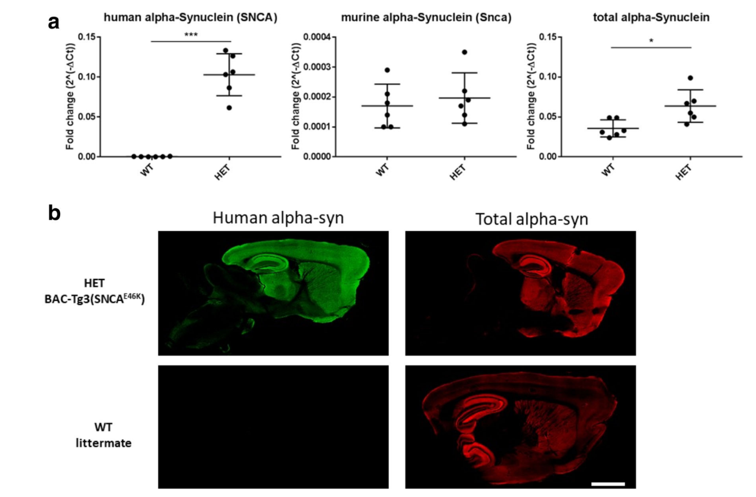
Figure 6 Alpha-synuclein expression in SNCA*E46K mice.
a) RT-qPCR measurements of human alpha-synuclein transgene, murine endogenous Snca gene and total synuclein. b) Fluorescence immunostaining for human and pan-alpha-synuclein.
Stats: unpaired Student’s T test, * = p<0.05, *** = p<0.001
WT = wild-type littermates, HET = transgenic SNCA*E46K animals.
Scale bar (b) = 1.4mm

3.2 HET mice show striatal age-dependent neurodegeneration in absence of dopaminergic cell loss in the Substantia Nigra
TH-positive axons and DAT-positive synapses were quantified in the striatum of HET and WT mice at 3, 9 and 13 months of age. Both measurements showed an age-dependent decline in HET mice, with neurodegeneration starting to appear at 9 months of age (Figure 7a and 7b). At the same time points, no loss of TH-positive neurons was observed in the SN (Figure 7c). Since striatal degeneration in absence of nigral neuronal loss is a feature of early PD, this model appears to be suitable for the studying of the early stages of PD pathology, and of the molecular events that lead to striatal degeneration.
To exclude that the striatal degeneration was the consequence of a transgenic insertion artefact, we correlated the levels of TH-positive axons with the relative levels of transgenic alpha-synuclein in the striatum of 13-months old mice (Figure 8). The TH-positive signal showed a significant inverse correlation with alpha-synuclein levels (r = −0.94, p = 0.017, by Spearman). Similar results were obtained in another cohort of mice by correlating transgenic alpha-synuclein protein levels with DAT-positive signal (Figure 8B, r = -0.71, p = 0.038, by Pearson). Taken together, these results indicate that the observed degeneration is a real consequence of SNCA overexpression.

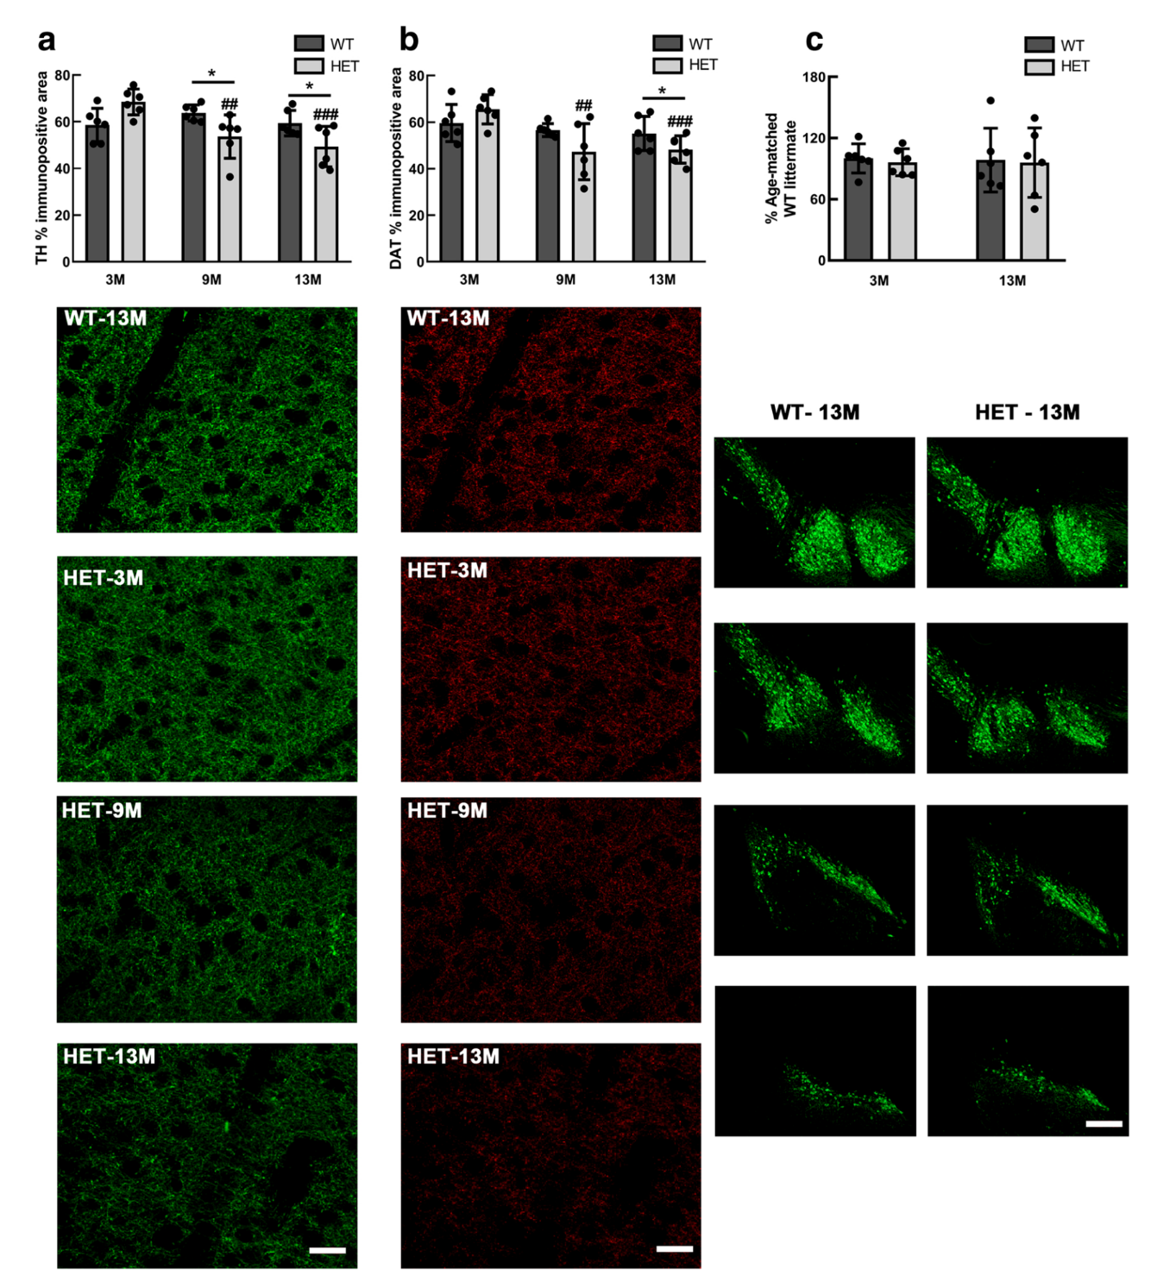

Figure 7 Age-dependent degeneration in the dorsal striatum of HET SNCA*E46K mice but not the Substantia Nigra.
a) Quantification (top) and representative immunofluorescent images (bottom, green channel) for Tyrosine Hydroxylase. b) Quantification (top) and representative immunofluorescent images (bottom, red channel) for Dopamine Transporter. c) Quantification of TH-positive neurons (top) and representative immunofluorescent images of the different levels of the Substantia Nigra (bottom).
N = 6 mice per group, all females. Stats: two-way ANOVA. * = p< 0.05, ## = p< 0.01, ### = p<0.001. Scale bar = 30µm in a) and b), 100µm in c).

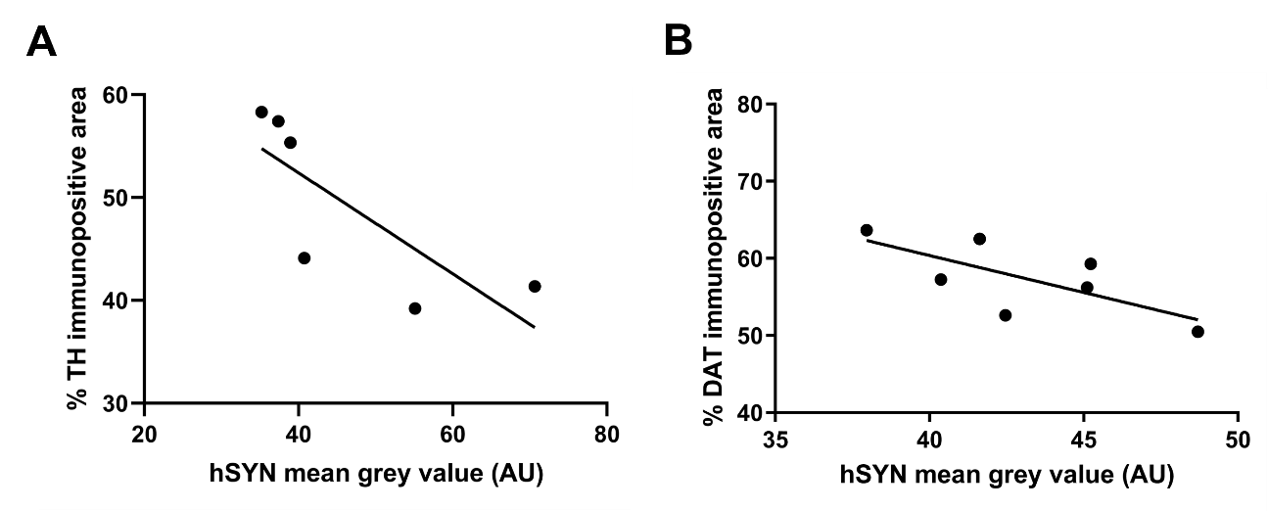
Figure 8 Transgenic alpha-synuclein levels directly correlate with striatal neurodegeneration.
(A) N = 6. Mice were 13 months old. Stats: Spearman, two-tailed. (B) N = 7. Mice were 13 months old. Stats: Pearson, one-tailed.

3.3 Gene expression deregulation in the midbrain largely precedes striatal neurodegeneration in SNCA*E46K heterozygous mice
Differential gene expression analysis was performed comparing HET and WT mice at each time point. The highest number of differentially expressed genes (DEGs) was detected at 3 months of age (584 DEGs), while only 5 genes were differentially expressed at 9-months and none at 13-months old mice. The DEGs at 9-months did not show any overlap with those at 3-months of age (Figure 8a).
Pathway analyses of the 584 DEGs identified at 3 months showed an alteration of serotonin and glutamate neurotransmission, which have been shown to regulate dopaminergic neurons’ firing. We also identified the G-protein-coupled receptor (GPCR) signalling pathway as predominantly deregulated; interestingly, some GPCRs are known to be involved in modulating the activity of nigral neurons, dopamine D2 receptors can act as GPCRs, and synucleins (including alpha-synuclein) are substrates for GPCR kinases. The top 10 deregulated pathways also included the prostaglandin pathway, and the Wnt/beta-catenin and NF-kB pathways, known to modulate dopaminergic neurons differentiation and maintenance. Significantly altered GO terms included synaptic signalling, inorganic cation homeostasis and memory. Despite no altered pathways were identified at 9 months, over 60 GO biological processes differed between WT and HET mice. The top GO terms included developmental processes, actin filament-based movement, and ERK1/2 pathway.
Network analysis of DEGs identified mitochondrial translation as the major deregulated sub-network at 3 months of age, suggesting that mitochondrial dysfunction largely precedes striatal neurodegeneration. At 9 months of age, the main altered subnetwork was calcium homeostasis, suggesting calcium dysregulation plays an important role in the ongoing striatal degeneration.

3.4 Age-dependent gene expression deregulation in SNCA*E46K heterozygous mice
Age-associated DEGs driven by the alpha-synuclein challenge were investigated by extracting those genes whose expression changed continuously over ageing in HET mice only. The process of DEGs selection is illustrated in Figure 8b, and lead to the identification of 161 DEGs for further analysis. Age-dependent deregulated pathways showed a switch between up and down regulation. Top pathways that were first upregulated and then downregulated included cell differentiation, cell migration and GPCR signalling. The top GO terms detected referred to GPCR signalling, purinergic signalling and development. No pathways that were first downregulated and then upregulated were identified, but over 100 GO terms showed this pattern. Top GO terms included GPCR signalling, calcium homeostasis and sensory perception.
In agreement with the pathway and GO term analyses, dysregulated networks switching between up and down regulation were associated with cell morphogenesis and differentiation, while networks switching between down and upregulation were associated with synaptic and GPCR signalling.

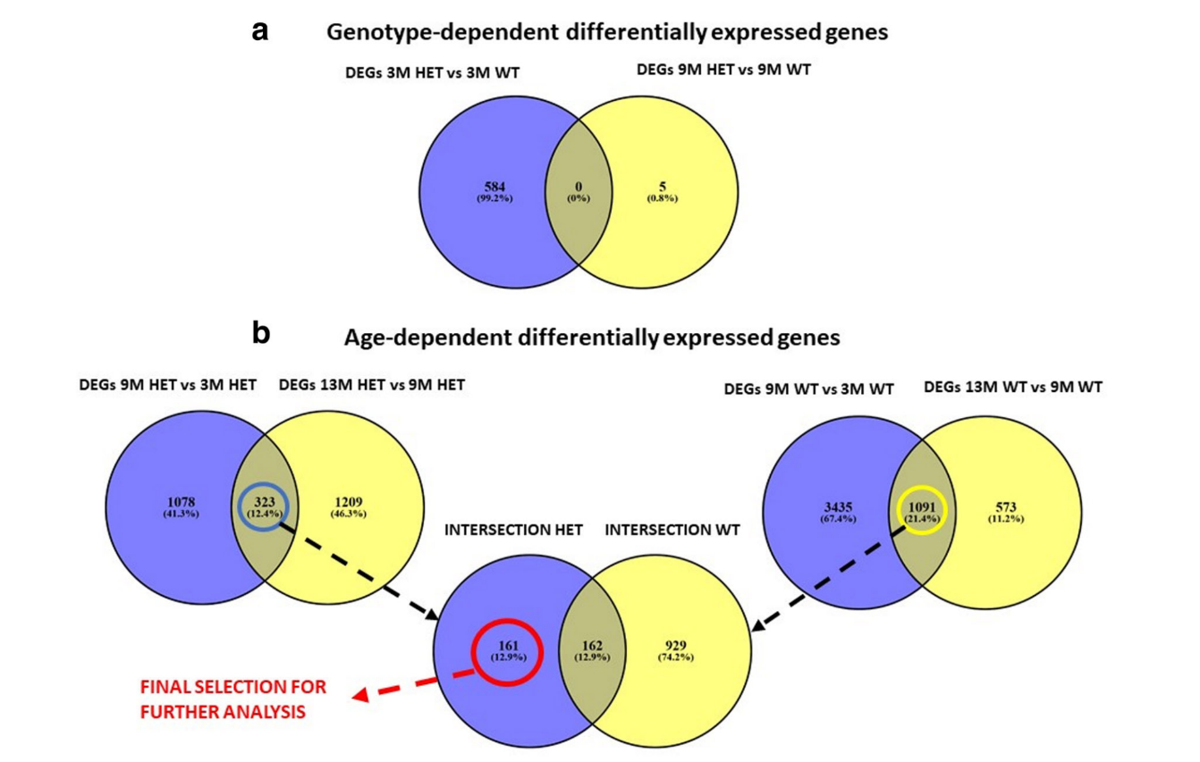
Figure 9 Genotype-dependent and age-dependent differentially expressed genes in SNCA*E46K mice
a) Venn diagram showing the overlap between the genotype-dependent DEGs identified at 3- and 9-months of age. b) Venn diagrams showing the age-dependent DEGs for HET (left) and WT (right) mice, and their relative intersections.
DEGs = differentially expressed genes, WT = wild-type littermates, HET = transgenic SNCA*E46K animals, 3M = 3-months old, 9M = 9-months old, 13M = 13-months old

3.5 Males but not female SNCA*E46K heterozygous mice show sensory-motor impairments in the Adhesive Removal test
Nigrostriatal degeneration is known to be responsible for the motor impairments observed in PD. The motor performance of the SNCA*E46K mice was evaluated at 4, 8, 14 and 17 months, using the adhesive removal test. The test was performed as described in Materials and Methods. 8 months male HET mice showed a significant impairment in the detection of the adhesive tape, as demonstrated by the delay in the “First Touch” measurements when compared to their WT counterpart (Figure 9A, left panel). Interestingly, this impairment was not detected at the earlier timepoint of 4 months of age, nor seems to be present at later timepoints. A similar profile is observed when looking at the time of removal of the adhesive tape (Figure 9B, left panel). Since no significant differences are present between genotypes regarding the time interval necessary to remove the adhesive tape (Figure 9C, left panel), we can conclude that the observed phenotype is primarily linked to a sensory deficit in detecting the presence of the tape rather than to a motor deficit in performing its removal from the paw.
Opposite to what observed in males, female SNCA*E46K HET mice appear to perform significantly better than their WT littermates already at 4 months of age, and this trend is maintained up to 14 months of age, even if a rather big intra-group variability needs to be taken into account at this specific timepoint (Figure 9A and 9B, right panels). Once again, no significant differences are detected in the interval of time necessary for adhesive tape removal (Figure 9C), suggesting that the increased performance versus WT littermates is linked to the sensory function.
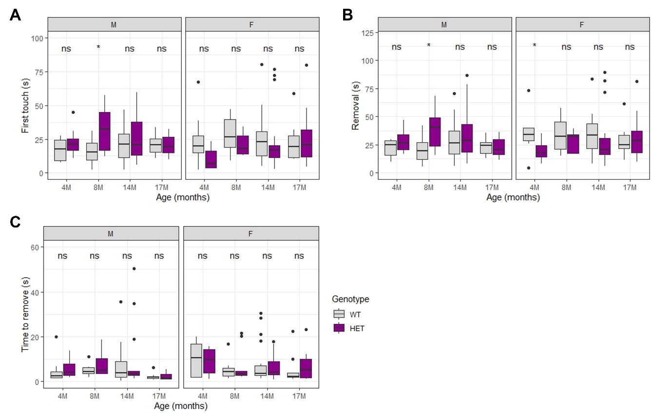
Figure 10 Male but not female SNCA*E46K heterozygous mice present sensory impairments at early age.
A) Time measurements in seconds for first touch of the adhesive tape for male (left) and female (right) mice. B) Time in seconds for the removal of the adhesive tape for male (left) and female (right) mice. C) Time in seconds of the interval necessary for the removal of the adhesive tape, measured as Removal time – First Touch time, for male (left) and female (right) mice.
N = 8-10 mice per group. Stats: Kruskal-Wallis test. ns = non-significant, * = p< 0.05.
WT = wild-type littermates, HET = transgenic SNCA*E46K animals, 4M = 4-months old, 8M = 8-months old, 14M = 14-months old, 17M = 17-months old, M = male mice, F = female mice.

4 Characterisation of the SNCA*E46K transgenic mouse as a model for cognitive impairment in PD

Preface
The familial E46K mutation in the SNCA gene is associated with autosomal dominant PD with hallucinations and dementia (Zarranz et al. 2004). In demented patients, the degeneration of the dopaminergic neurons in the nigrostriatal pathway is accompanied by additional neuronal degeneration in the pre-frontal cortex and in the medial temporal lobe. A major contributor to the memory impairments characteristics of dementia is hippocampal atrophy. Indeed, hippocampal atrophy not only significantly discriminates demented from non-demented patients, but its extent can be used to effectively predicted conversion to dementia in pre-demented patients.
In the previous chapter, I have demonstrated that the overexpression of the E46K mutated SNCA in a transgenic mouse is sufficient to reproduce a striatal degeneration in the dopaminergic neurons which is resemblant of that of the early stages of PD. Furthermore, we have shown that gene expression changes in the midbrain occur early in time and largely precede neurodegeneration. To investigate whether the overexpression of the E46K mutated SNCA can also reproduce early stages of cognitive impairment, in the present chapter we will focus our attention on the hippocampus.
I was responsible for the mouse cohort’s management including genotyping, breeders selection and assignation of mice to study cohorts. With the help of my colleagues (Pierre Garcia, Mélanie Thomas and Kristopher J. Schmit), I performed all behavioural testing, euthanasia and tissue collection. With the exception of the RNA-sequencing bioinformatic analysis (Thomas Hentrich), I carried out all the experiments described below, starting from sample processing to statistical analyses and figures making. Experiments were performed according to the Materials and Methods described in the Part III of this thesis. I personally generated Figure 11 and 12. Based on the differential gene expression lists provided by Thomas Hentrich, I generated the volcano plots in Figure 14A, 15A, 16A and 17A, and the Ingenuity Pathway Analysis report in Figure 14D, 15D, 16D and 17D. Figures 13, 14B and C, 15B and C, 16B and C, 17B and C were generated by Thomas Hentrich.
A manuscript enclosing the results presented in this Chapter is currently under preparation.

4.1 Transgenic alpha-synuclein overexpression in the hippocampus of SNCA*E46K HET mice increases by age
The expression of alpha-synuclein has been reported for the midbrain (Chapter 3, Hendrickx et al. 2021), but has not yet been fully investigated for other brain regions. Therefore, quantification of alpha-synuclein transgene expression and protein levels in the hippocampus was necessary for the investigation of α-synuclein overexpression’s impact in the development of hippocampal dysfunction and cognitive impairment in PD.
We investigated gene expression through RT-qPCR and protein levels through Western Blot, comparing expression levels across genotypes, ages and sexes. Gene expression of the murine alpha-synuclein gene (Snca) did not change between transgenic and wild-type (WT) animals, and expression levels were constant during ageing and did not differ in male versus female animals (Figure 11A, top). Transgenic synuclein (SNCA) expression was detected only in transgenic animals (Figure 11A, bottom). Transgenic alpha-synuclein mRNA expression levels appeared to increase with age in both male and female mice, although this trend was more pronounced in males. Differences in SNCA mRNA expression levels for HET mice across ages did not reach significance after correction for multiple comparisons. On the other hand, when looking at alpha-synuclein protein (αSyn) levels, expression appeared to be constant across ages for males, while it seemed to increase with age in female mice (Figure 11B, bottom). Differences in alpha-synuclein protein levels did not reach statistical significance, even when considering the youngest and oldest HET females (Wilcoxon rank sum exact test with Benjamini-Hochberg correction for multiple comparisons; 3M vs 8M, p = 0.091; 3M vs 14M, p = 0.091). Staining with a pan-alpha-synuclein antibody (pan-αSyn), that detects both endogenous (Snca) and transgenic (SNCA) synuclein, showed consistently higher expression levels in HET mice, reflecting the overexpression of the human transgene (Figure 10B, top). Pan-αSyn protein levels did not appear to differ much between male and female mice, and overall, we detected an average 4.37-fold increase (p = 2.2e-16) in total synuclein expression in HET mice versus their WT littermates. The distribution profile for SNCA, Pan-αSyn, and Serine 129 phosphorylated alpha-synuclein (pS129-αSyn) are presented in Figure 10C. The SNCA transgene is expressed only in HET mice, and the expression is uniform across the hippocampal CA1-CA3 subregions, and slightly weaker in the dentate gyrus (DG) (Figure 11C, top row). Similarly, Pan-αSyn is uniformly expressed in the CA1-CA3 subfields, with lower expression levels for the DG (Figure 11C, middle row). As already observed in the western blot experiments, Pan-αSyn expression is higher in HET mice (Figure 11C, middle row). Phospho-synuclein is expressed in both WT and HET mice, although the overall expression is higher in transgenic mice (Figure 11C, bottom row). While phosphorylated alpha-synuclein expression appears to be stable across ages in HET mice, in WT mice an increased expression over time can be observed. Furthermore, in both WT and HET mice, the expression profile of phosphorylated alpha-synuclein is not homogeneous, with the highest level of expression observed in the neurons of the CA3 hippocampal subfield (Figure 11C, bottom row). Additionally, HET mice present phosphorylated alpha-synuclein positive nuclear staining in the cortex surrounding the hippocampus, a staining pattern which is not present in their WT littermates. No differences were observed for gender in any of the immunofluorescence stainings (data not shown).

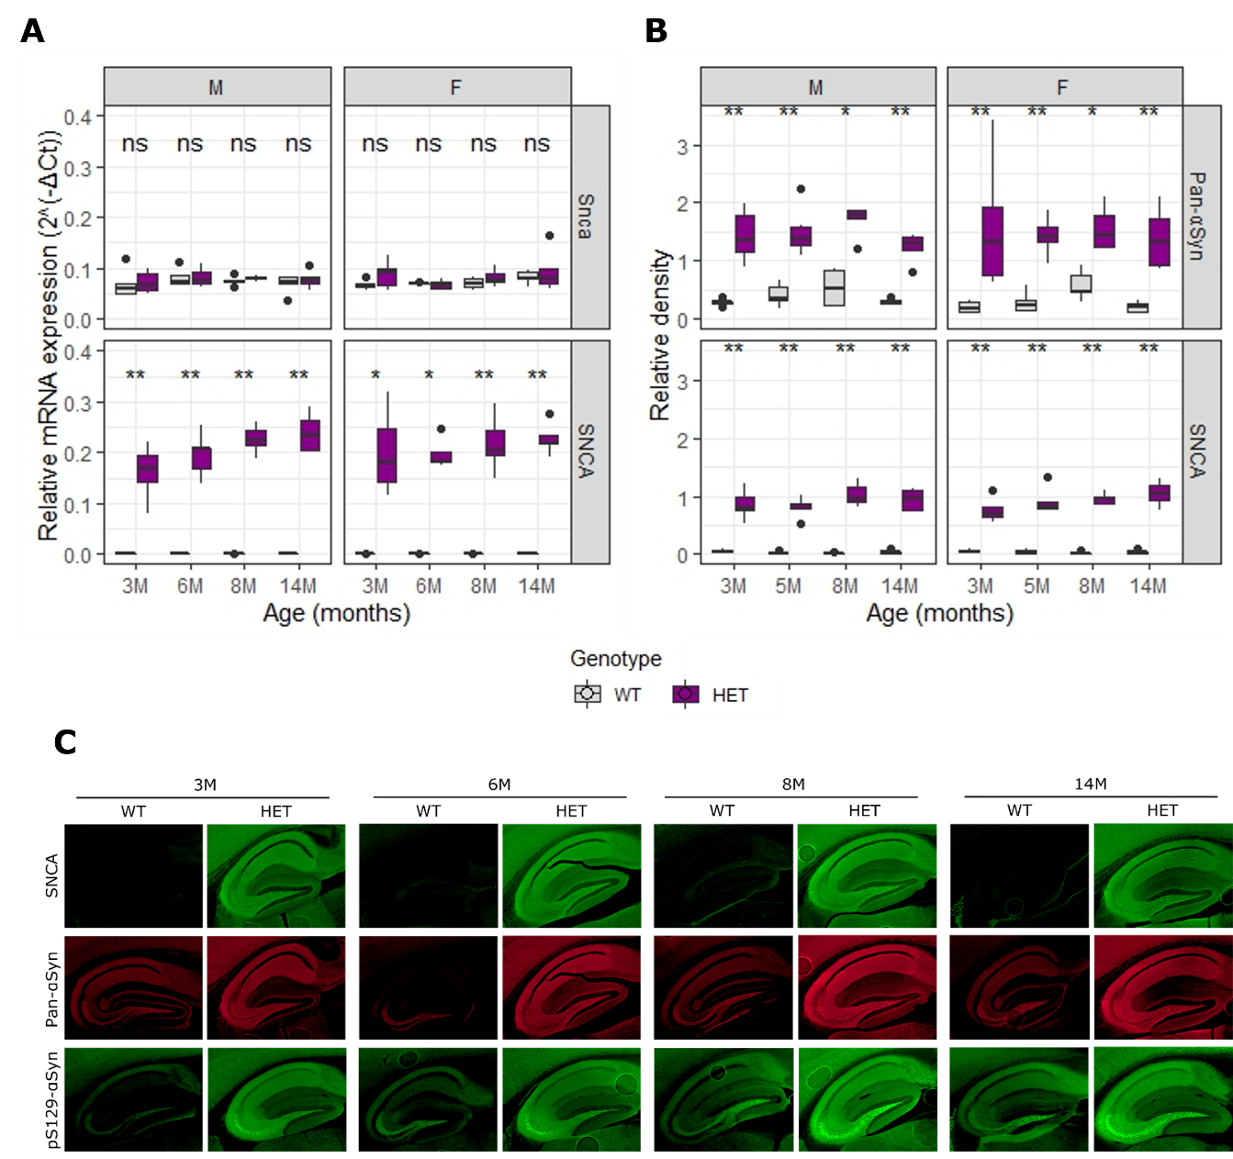
Figure 11 Profiling of alpha-synuclein mRNA and protein expression in the hippocampus of HET and WT mice.
A) Boxplots showing the relative mRNA expression level of Snca (top) and SNCA (bottom) in WT (grey) and HET (purple) mice aged 3-, 6-, 8- and 14- months. No differences were observed between sexes. n = 4 to 6 mice/group. B) Boxplots showing the relative density of total (Pan-αSyn) and human (SNCA) alpha-synuclein protein in WT (grey) and HET (purple) mice. Relative density was calculated from western blot images, using Actin as a reference protein. n = 4 to 6 mice/group. C) Representative immunofluorescence images for human (SNCA), total (Pan-αSyn) and serine 129 phosphorylated alpha-synuclein (pS129- αSyn) staining for WT and HET animals at different ages.
N = 5-6 mice per group. Stats: Kruskal-Wallis test, ns = non-significant, * = p<0.05, ** = p<0.01
WT = wild-type littermates, HET = transgenic SNCA*E46K animals, 3M = 3-months old, 6M = 6-months old, 8M = 8-months old, 14M = 14-months old, Snca = murine alpha-synuclein, SNCA = human alpha-synuclein, Pan-αSyn = total alpha-synuclein, pS129-αSyn = alpha-synuclein phosphorylated at serine 129.

4.2 Young male but not female SNCA*E46K transgenic mice show short memory impairments in the Y-maze test
One of the major roles of the hippocampus is the encoding, processing, and retrieving of information. Hippocampal neurodegeneration will cause a loss in proper hippocampal function, leading to memory loss.
The Y-Maze Spontaneous Alternation test measures the inclination of rodents to explore new environments. Cognitively unimpaired animals show a preference to enter a new arm of the maze over one that has been previously visited (alternations > 50%), and the hippocampus plays a fundamental role in the regulation of this task. We tested mice from young (4-months old) to aged (17-months old). When compared to WT littermates, male HET mice showed a significant difference in the percentage of spontaneous alternations at 4-months of age (Figure 12A, left; p = 0.022). Impairments in performing the test are not present in older HET males, nor in the HET females at any of the investigated timepoints (Figure 12A). Overall, males appeared to perform slightly better than females at 8 and 14 months of age, although the difference in the alternation’s percentage was not significant, and this phenomenon was independent of the genotype.
HET mice did not show significant differences when compared to their WT littermates regarding the total number of visits to the maze arms (entries) – a parameter that in mice correlates with a hyperactive phenotype – at any of the studied ages. Both the male and female mice groups presented an average of 25 entries, with lower entries numbers detected for both gender and genotypes at 8 months (Figure 12B). Given that each time point constituted a cohort, and each cohort was tested separately from the others, it is possible that the decrease in entries observed at 8-months is the result of a variability in testing conditions determined by factors such as external noise which are out of our control.
The presence of an impairment limited to early time points is reminiscent of the motor phenotype described in Chapter 3. We can speculate that during the ageing process, transgenic mice are able to compensate such deficits, restoring their cognitive performance to levels comparable to those of WT mice. As for the adhesive removal test, males seem to be more affected than females, suggesting that sex differences might impact the manifestation of parkinsonism phenotypes consequent to transgenic alpha-synuclein overexpression.
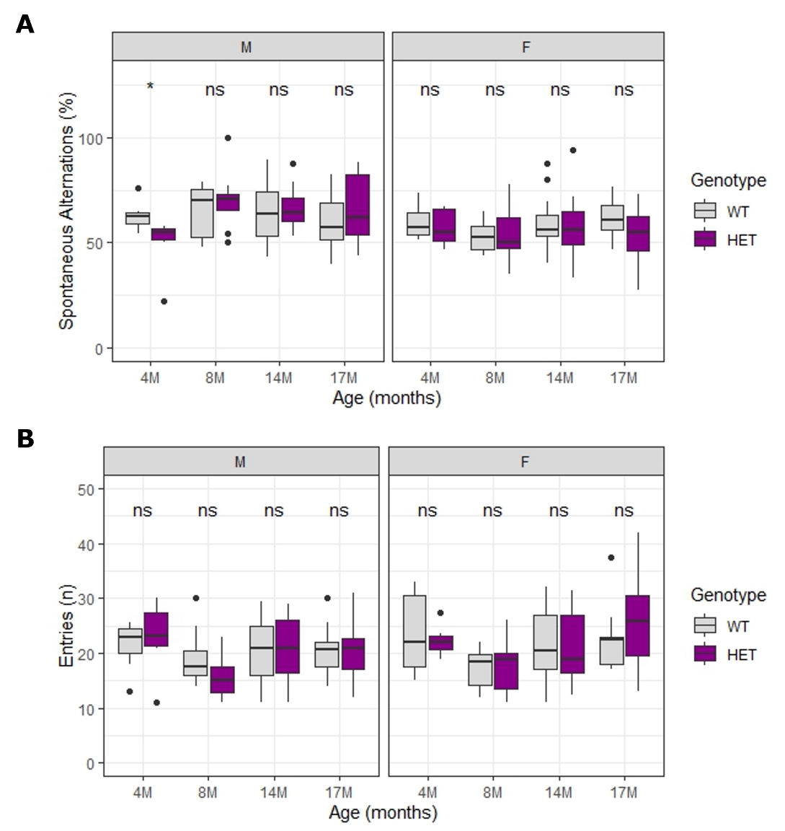
Figure 12 Young HET males but not females present short-term memory impairments in the Y-maze test
A) Percentage of spontaneous alternations for male (left) and female (right) mice at different ages. B) Number of total entries in the maze’s arms in male (left) and female (right) mice.
Stats: Kruskal-Wallis test. ns = non-significant, * = p< 0.05.
WT = wild-type littermates, HET = transgenic SNCA*E46K animals, M = males, F = females, 4M = 4-months old, 8M = 8-months old, 14M = 14-months old, 17M = 17-months old.

4.3 Hippocampal gene expression changes are mostly driven by age
The hippocampal transcriptome was analysed in transgenic and wild-type mice at 3-, 6-, 8- and 14-months of age. The unsupervised clustering of all samples showed an almost full partitioning by genotype for male mice, with only two wild-type, 3-months old samples clustering amongst the transgenic ones (Figure 13A, left), but no such separation was observed for female mice (Figure 13A, right). No separation was observed based on the four different age groups for both sexes. Furthermore, samples appeared to partition into subgroups, which could not be explained by any known genetic, technical, or environmental parameter known to us. Indeed, unbiased and blind machine learning approaches predicted a single batch (data not shown). Based on these results, we feel rather confident in excluding a batch effect in our samples, and we speculate that the observed partitioning is due to the background strain used, being the mice B6-D2 hybrids. When we run an unrestricted surrogate variable analysis on the data, and used the predicted surrogates to correct the data, we obtained a clear partitioning of the samples by genotype for both sexes (Figure 13B). Moreover, within each cluster, samples appeared now to be organised on a gradient that nicely reflects age, and the direction and spread of such gradient was uniform within the 4 clusters.
Notwithstanding the observed clustering across the genotype axis, we found that only the transgene and few other genes were responsible for it, with no differences between the age groups nor the two sexes (Figure 13C, horizontal lines). Indeed, most of the gene expression changes occur along the age axis (Figure 13C, vertical lines), with the highest number of DEGs for males observed between 3- and 6-months old HET mice, and the highest number of DEGs appearing at later time points for females of both genotypes. Overall, gene expression changes seem to be stronger in females, as indicated by the presence of a higher number of DEGs compared to males.

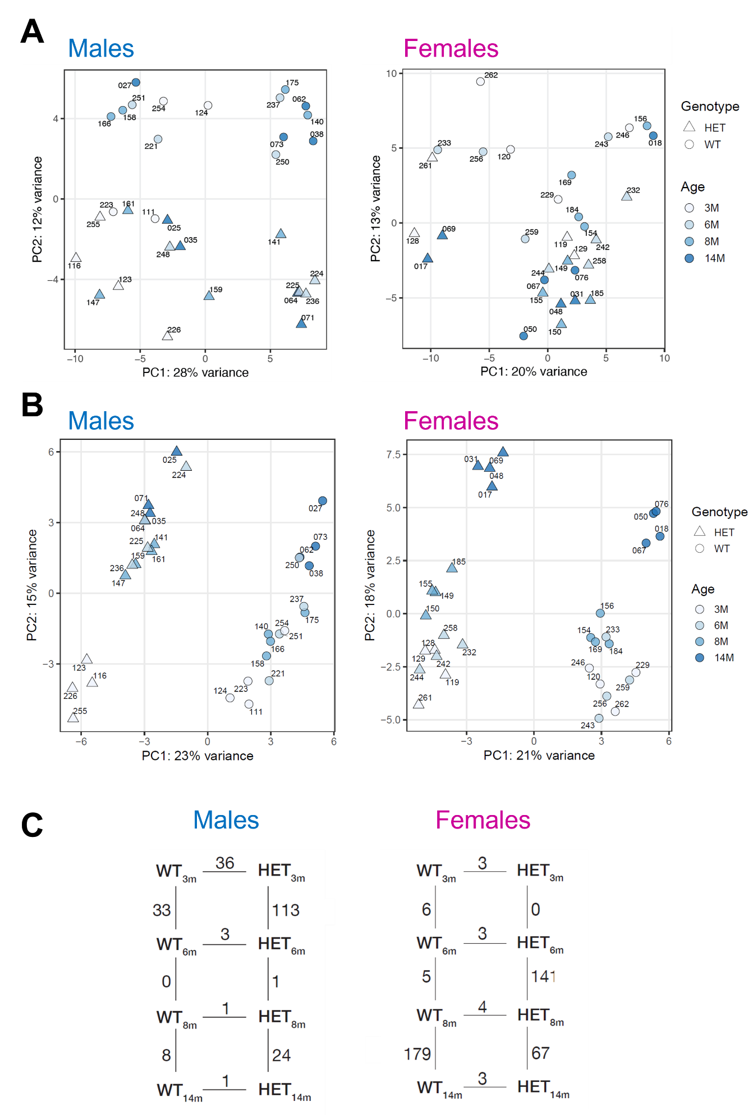

Figure 13 Differential expression in the hippocampus of SNCA*E46K mice and WT littermates is mostly driven by age.
A) PCA plot for all age and genotype groups before correction for male (left) and female (right) mice. The samples mostly separate according to genotype, and further partition according to unknown factors. B) PCA plot for all age and genotype groups after correction of the data for male (left) and female (right) mice. The samples nicely separate according to genotype (x axis), and further distribute following an age-dependent gradient. C) Differentially expressed genes in male (left) and female (right) mice. Genotype-dependent DEGs are plotted horizontally, age-dependent DEGs within the same genotype are plotted vertically.
N = 4 mice per group. WT = wild-type littermates, HET = transgenic SNCA*E46K animals, 3M = 3-months old, 6M = 6-months old, 8M = 8-months old, 14M = 14-months old.

4.4 Transcriptional changes in SNCA*E46K HET mice are indicative of glutamatergic and calcium signalling dysfunction
Overall, male mice of both genotypes presented a low number of DEGs. The most consistent transcriptional deregulation was observed between 6- and 3-months old HET mice, with a total of 113 DEGs. Most of the DEGs were up-regulated at 6-months of age (73/113 or 65% up-regulated (Figure 14A, orange), 40/113 or 35% down-regulated (Figure 14A, purple)). When plotting the 113 DEGs for all male mice, the differential expression of these genes showed a clear pattern between 3- and 6-months old HET mice (Figure 14B, columns 5 and 6). When looking at WT mice at the same age, this pattern of expression could also be identified, but the differential expression was weaker than that of HET mice (Figure 14B, columns 1 and 2). GO term analysis was enriched for synaptic membrane component, cell development and ion channel complex (Figure 14C). To have a better understanding of the impaired processes in mid-age SNCA*E46K HET males, we run an Ingenuity Pathway Analysis ® (Qiagen) with the 113 DEGs as input. The most significantly impaired pathway predicted by the IPA® tool “Canonical Pathways” was Synaptic Long Term Depression (LTD), a central process in the regulation of synapse strength and plasticity, mostly involving modulation of L-glutamate signalling (Figure 14D). Other relevant pathways were Calcium Signalling, which is involved in the maintenance and survival of neurons; Neuropathic Pain Signalling in Dorsal Horn Neurons, which even if not directly connected to hippocampal function, might be reflective of neuronal damage; and Synaptogenesis Signalling, a pathway involved in synapse formation, maintenance and elimination contributing to synapse remodelling and plasticity. These pathways presented a negative z-score and thus were predicted to be inhibited. The predicted impairment was specifically linked to the down-regulation of genes encoding glutammate receptors and calcium voltage-gated channels (data not shown), potentially reflecting an occurring dysfunction in the hippocampus of 6-months old HET mice.

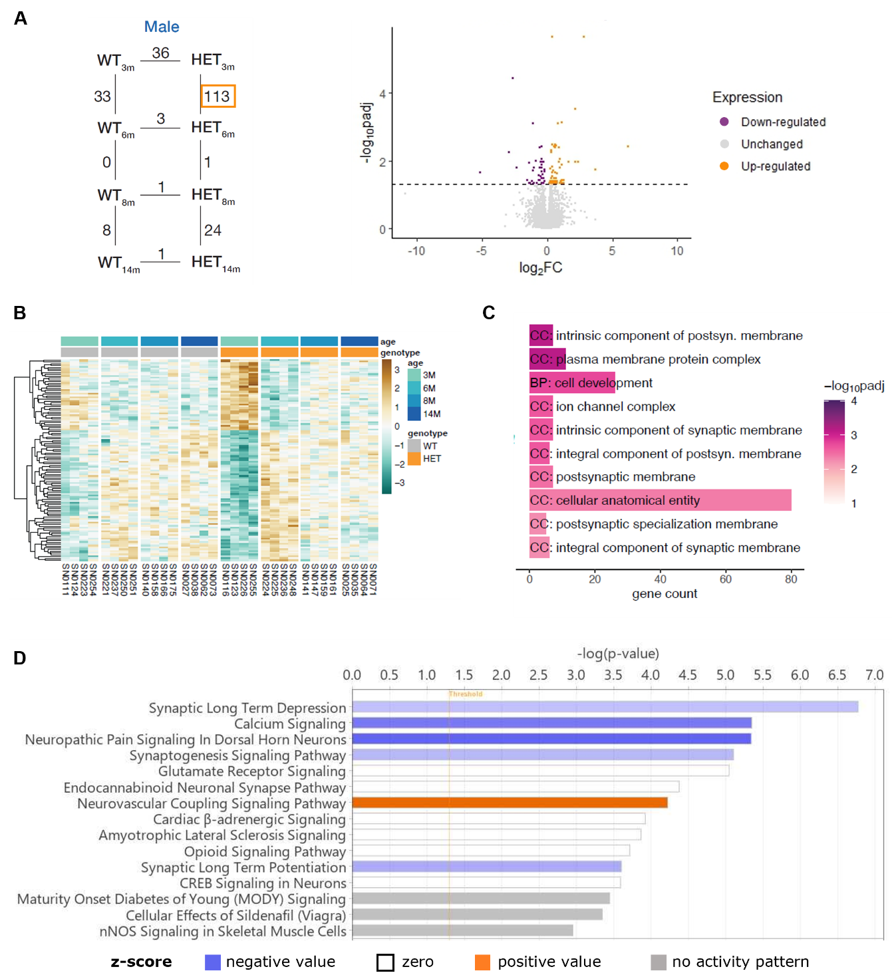
Figure 14 Transcriptional changes in the hippocampus of young HET male mice.
A) Volcano plot illustrating the up- and down-regulated genes in 6 vs 3 months old HET male mice. The horizontal dashed line indicates the cut-off of adjusted p-value <= 0.05. B) Heatmap showing the gene expression pattern of the 113 DEGs for both genotypes and all age groups in males. A clear pattern of gene expression can be identified between 3- and 6-months old HET mice, while the expression is more variable for old HET and WT mice. C) Top 10 GO terms between 6- and 3-months old HET male mice. D) Top 15 deregulated pathways predicted by Ingenuity Pathway Analysis ® “Canonical Pathways”. Threshold (orange line): -log(pval) = 1.3 or pval = 0.05.
N = 4 mice per group. WT = wild-type littermates, HET = transgenic SNCA*E46K animals, 3M = 3-months old, 6M = 6-months old, 8M = 8-months old, 14M = 14-months old.
Transcriptional changes in female mice were detected later in time. Compared to what observed in males, there are only few DEGs between 6- and 3-months old mice, with most of the DEGs occurring between 14- and 8- months in WT animals (179 DEGs), and between the 8- and 6-months old (141 DEGs) and the 14- and 8-months old (67 DEGs) groups in HET mice. To better understand the transcriptional changes which might be differentially regulating ageing in HET and WT female mice, we analysed the 3 biggest group of DEGs separately.

- DEGs between 14- and 8-months old WT female mice
179 genes are differentially expressed between 14- and 8-months old WT female mice, with the majority of the genes getting downregulated at the later timepoint (117/179 or 65% down-regulated (Figure 15A, purple), 62/179 or 35% up-regulated (Figure 15A, orange)). The same pattern of expression is visible in HET mice at the same age, even though the strength of these changes is lower than that observed in WT mice, possibly indicating that HET mice fail to activate, at least to some extent, age-related transcriptional changes (Figure 15B). Finally, the expression of the investigated 179 genes in young mice for both genotypes is variable, and no clear expression patterns can be identified, suggesting that these genes might be relevant only at later times in life (Figure 14B). As identified by the GO term enrichment analysis, dysregulated processes include synapse, protein binding, and development (Figure 15C). IPA® Pathway analysis yielded similar results, highlighting deficits in CSDE1 signalling, RhoGDI signalling and nNOS signalling, known to be responsible for neuronal differentiation, synaptic plasticity, and neurotransmission (Figure 15D), possibly indicating reduced synaptic function with ageing.

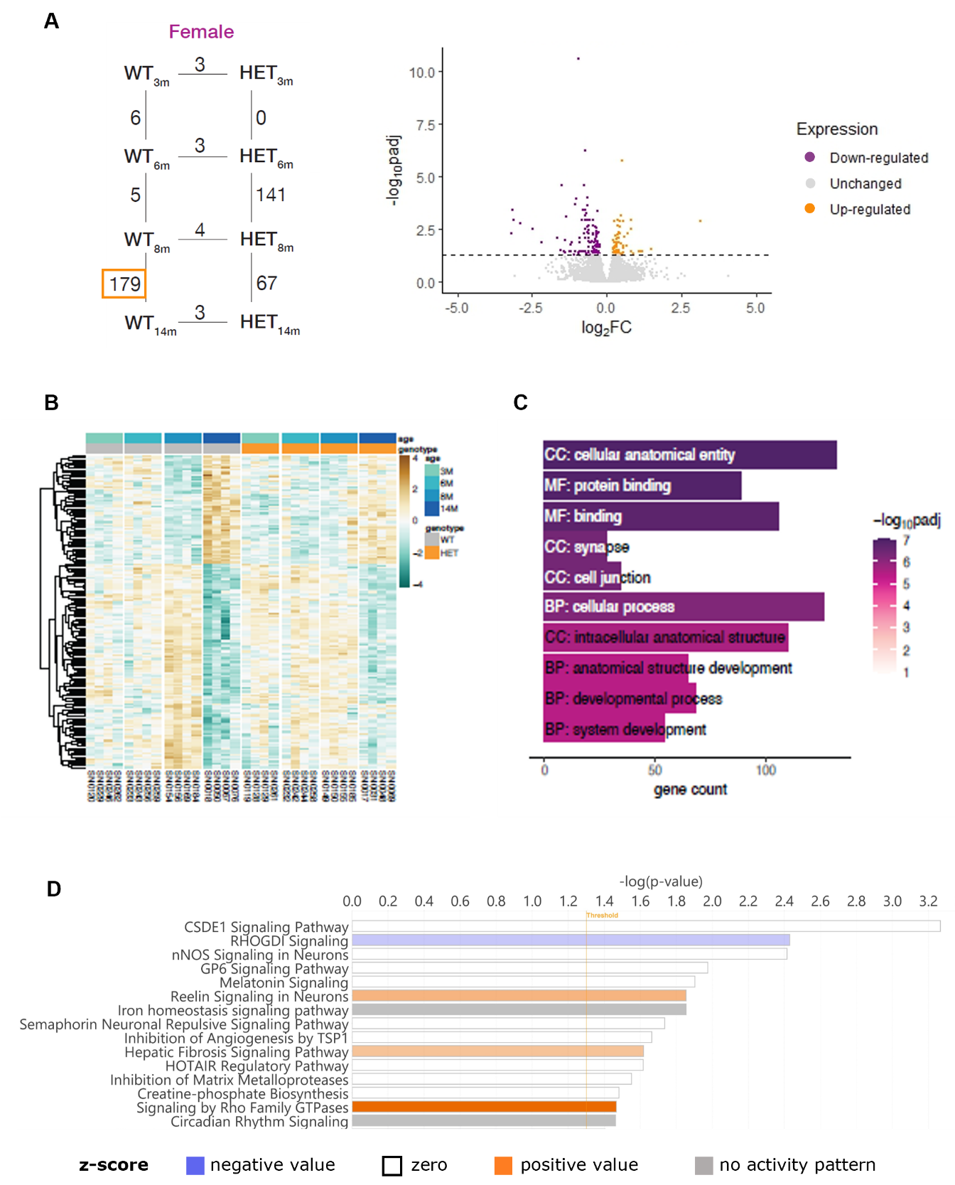
Figure 15 Transcriptional changes in the hippocampus of old WT female mice.
A) Volcano plot illustrating the up- and down-regulated genes in 14 vs 8 months old HET female mice. The horizontal dashed line indicates the cut-off of adjusted p-value <= 0.05. B) Heatmap showing the gene expression pattern of the 179 DEGs in female mice for both genotypes and all age groups. A clear pattern of gene expression can be identified between 8- and 14-months old WT mice, while the expression is more variable for HET and young WT mice. C) Top 10 GO terms between 14- and 8-months old WT mice. D) Top 15 deregulated pathways predicted by Ingenuity Pathway Analysis ® “Canonical Pathways”. Threshold (orange line): -log(pval) = 1.3 or pval = 0.05.
N = 4 mice per group. WT = wild-type littermates, HET = transgenic SNCA*E46K animals, 3M = 3-months old, 6M = 6-months old, 8M = 8-months old, 14M = 14-months old.
- DEGs between 8- and 6-months old HET female mice
141 genes were differentially expressed between 8- and 6-months old HET female mice, with the majority of the genes being downregulated at 8-months of age (81/141 or 58% down-regulated (Figure 16A, purple), 60/141 or 42% up-regulated (Figure 16A, orange)). WT mice at the same age show a similar expression pattern despite it being weaker, while the expression for the 3- and 14-months old groups in both genotypes is variable and no clear expression pattern can be identified (Figure 16B). GO terms are enriched for synapse and component of synaptic membrane (Figure 16C). IPA® predicted the inhibition of Synaptogenesis Signalling following the downregulation of NMDA and Ephrin receptors as the most impaired process, while Calcium Signalling appears to be up-regulated, possibly as a compensatory mechanism to the occurring synaptic dysfunction (Figure 16D). Other relevant findings included the predicted inhibition of GPCR signalling, a pathway whose deregulation with ageing results in increased vulnerability to neurodegenerative pathologies; and the predicted inhibition of c-AMP-mediated signalling and CREB signalling, known to mediate hippocampal function and memory formation through its involvement in synaptic plasticity.

- DEGs between 14- and 8-months old HET female mice
67 genes were differentially expressed between female HET mice at 14- and 8-months of age. Most of the genes appear to be downregulated in 14-months old mice compared to their younger littermates (50/67 or 75% down-regulated (Figure 17A, purple), 17/67 or 25% up-regulated (Figure 17A, orange)). Aged HET female mice samples cluster well together, and the switch in the expression can be easily visualized when plotting these DEGs (Figure 17B). Gene expression is not as consistent in young HET mice and in WT mice at all ages, with no clear expression pattern visible and high intra-group variability (Figure 17B). The top 10 GO terms detected were associated with synaptic and axonal function, and neuronal projection (Figure 17C). Only the down-regulation of one gene (Cell Migration Inducing Hyaluronidase 1 (Cemip)) was shared between these 67 DEGs and the 179 DEGs identified in the WT mice at the same timepoint, indicating that different processes might be involved in the ageing of HET versus WT mice. Once again IPA® predicted inhibition of Synaptogenesis Signalling pathway and Synaptic Long-Term Potentiation, accompanied by predicted inhibition of c-AMP and GPCR signalling (Figure 17D). These predictions were mostly linked to the downregulation of calcium/calmodulin-dependent protein kinase, glutamate receptor and protein kinase C genes.
Taken altogether, these results suggest the downregulation of synaptic plasticity and neurotransmission as an early event contributing to cognitive impairment.
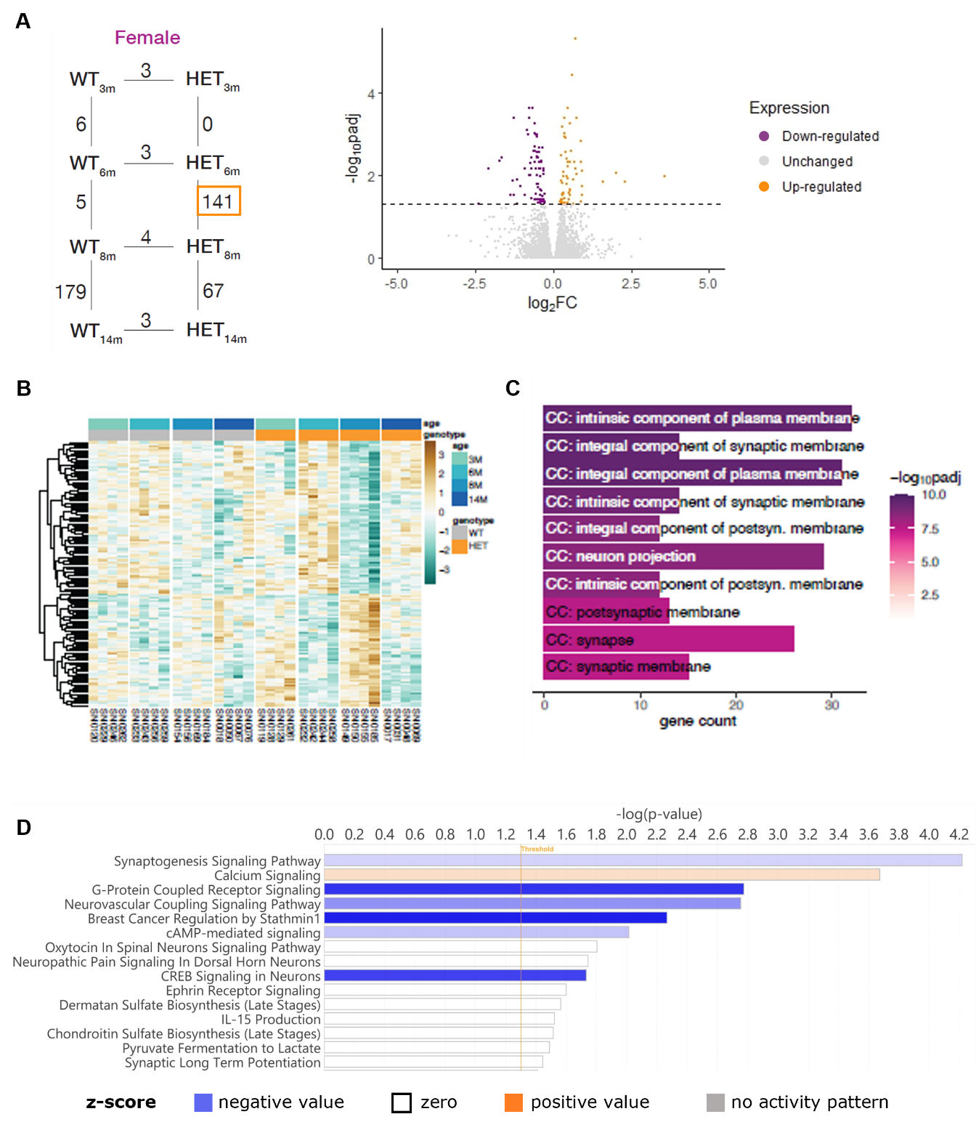
Figure 16 Transcriptional changes in the hippocampus of middle-age HET female mice.
A) Volcano plot showing the gene expression pattern for the 141 DEGs between 8- and 6-months old HET female mice. B) Heatmap of the 141 DEGs in 8M vs 6M HET females for both genotypes and all ages. A clear pattern of gene expression can be identified in 8M HET mice, while the expression is more variable for the other groups. C) Top 10 GO terms between 8- and 6-months old HET mice. D) Top 15 deregulated pathways predicted by Ingenuity Pathway Analysis ® “Canonical Pathways”. Threshold (orange line): -log(pval) = 1.3 or pval = 0.05.
N = 4 mice per group. WT = wild-type littermates, HET = transgenic SNCA*E46K animals, 3M = 3-months old, 6M = 6-months old, 8M = 8-months old, 14M = 14-months old.
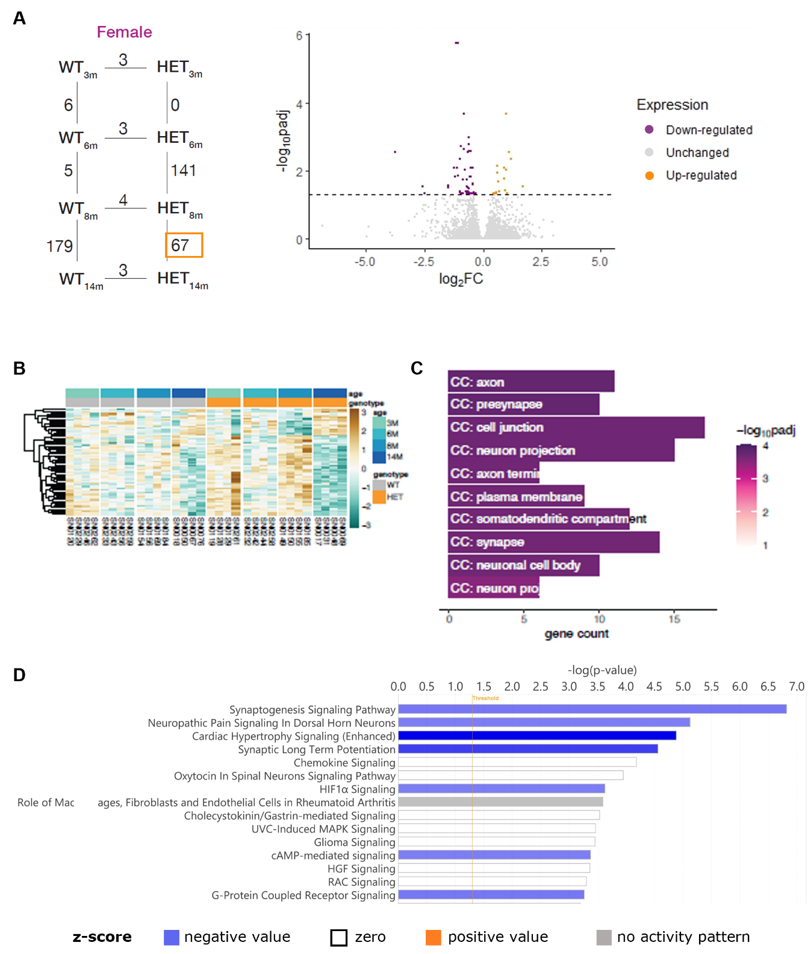
Figure 17 Transcriptional changes in the hippocampus of old HET female mice.
A) Volcano plot showing the gene expression pattern for the 67 DEGs between 14- and 8-months old HET female mice. B) Heatmap showing the gene expression pattern of the 67 DEGs between 14- and 8-months old HET female mice for both genotypes and all ages. A clear pattern of gene expression can be identified in the aged HET mice, while the expression is more variable for young mice. C) Top 10 GO terms between 14- and 8-months old HET female mice. D) Top 15 deregulated pathways predicted by Ingenuity Pathway Analysis ® “Canonical Pathways”. Threshold (orange line): -log(pval) = 1.3 or pval = 0.05.
N = 4 mice per group. WT = wild-type littermates, HET = transgenic SNCA*E46K animals, 3M = 3-months old, 6M = 6-months old, 8M = 8-months old, 14M = 14-months old.

5 Age- and sex-dependent transcriptomic changes in the Park7^{-/-} mouse model of early Parkinson’s

Preface
Park7 mutations which result in the loss of function of the encoded protein DJ-1 are a known cause of familial PD. DJ-1 functions include chaperone activity and atypical peroxiredoxin-like peroxidase, and DJ-1 has been shown to protect mitochondria from oxidative stress. Indeed, oxidative and mitochondrial stress following DJ-1 loss of function are recognized as a main driver of PD pathology. DJ-1 knock-out (KO) mouse models present dopaminergic deficits despite the lack of overt dopaminergic neurons degeneration, which is why they represent a potential model for early pathological mechanisms in PD.
The results shown in this chapter represent the starting findings of a study in collaboration with Sergio Helgueta Romero, where we investigated transcriptomic changes occurring in the midbrain of 3- and 8-months old Park7^{-/-} mice. The presented results and additional ones will be presented by Sergio Helgueta as part of his doctoral thesis, and a manuscript summarising the main findings is currently in preparation. Regarding the work shown in this chapter, I was responsible for the DJ-1 KO mouse colony management, including genotyping and cohorts’ selection, and performed the euthanasia and tissue collection. The RNA-sequencing was performed by Rashi Halder, and the differential expression analysis as well as gene expression confirmation by RT-qPCR was performed by Sergio Helgueta. I participated in the interpretation of the RNA-sequencing results, and I performed the brain cutting and immunofluorescence staining. I generated the Volcano plots in Figure 18 and run the Ingenuity Pathway Analysis (Figure 19A) according to the gene expression lists provided by Sergio Helgueta. Figures 19B and C were generated by Sergio Helgueta. I fully generated Figure 20.

5.1 8-months old DJ-1 KO males show extensive, sex-dependent deregulation in midbrain transcriptome
We investigated gene expression changes in the midbrain of 3- and 8-months old DJ-1 knock-out (KO) mice. At 3-months of age, very few DEGs were detected both in male and female mice (Figure 18A, top). At 8-months of age, female showed a moderate transcriptomic deregulation, with only 101 DEGs identified (Figure 18A, bottom right), while male mice presented a robust age-dependent deregulation, with 746 DEGs identified (Figure 18A, bottom left). The majority of DEGs in male mice were downregulated (560/746 or 75% down-regulated (Figure 18A, bottom left, purple), 186/746 or 25% up-regulated (Figure 18A, bottom left, orange)). Out of the identified DEGs at 8-months of age, only 8 genes were shared between male and female mice (data not shown).
Given the sex differences in gene expression changes, we decided to further investigate which proportion of the 746 DEGs in males were sex dependent. To do so, we identified differentially expressed genes between male and female 8-months old WT mice (2516 DEGs, out of which 1307 down-regulated and 1209 up-regulated), and we compared them with the genes differentially expressed between WT and DJ-1 KO males at 8 months of age. About a third of the differentially expressed genes (247/746) at 8-months were found to be sex-dependent (Figure 18B, left), indicating that sex and sex-related processes play an important role in the susceptibility to DJ-1 loss of function. The majority of the sex-dependent DEGs were down-regulated (Figure 18B, right; 211/247 or 85% down-regulated, 36/247 or 35% up-regulated).

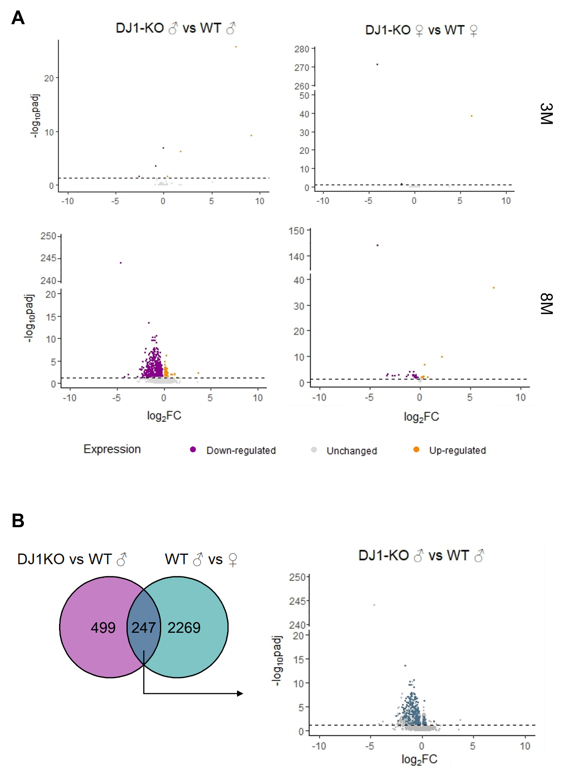
Figure 18 Male mice show a strong sex-specific transcriptomic response to DJ-1 knock-out at 8-months of age
A) Volcano plots illustrating transcriptomic changes occurring in the midbrain at 3-months of age (top) and 8-months of age (bottom) for male (left) and female (right) DJ-1 KO mice versus wild-type littermates. B) Sex-specific DEGs in 8-months old DJ-1 KO males. Venn diagram (left) and Volcano plot (right) illustrating gene expression of the identified 247 sex-specific DEGs. All DEGs were selected with a cutoff of adjusted p-value < 0.05.
WT = wild-type littermates, DJ1-KO = DJ-1 knock-out animals, 3M = 3-months old, 8M = 8-months old, ♂ = male mice, ♀ = female mice, DEGs = differentially expressed genes, padj = adjusted p-value, FC = fold change.

5.2 CYP1B1 mediates males’ increased susceptibility to DJ-1 loss
To have a better idea about the impaired processes in 8-months old DJ-1 KO mice, we run an Ingenuity® Pathway Analysis (IPA®, Qiagen) on the differential expression data. In particular, we focused on the predicted “Upstream Regulators” with the aim to identify the main regulatory events responsible for the observed transcriptional alterations. The top upstream regulator was beta-oestradiol, a precursor of the female hormone oestrogen, predicted to be inhibited in DJ-1 KO males (Figure 19A). Oestrogens have been shown to be protective in PD, and might explain the sex differences observed in PD incidence between male and female individuals. One of the enzymes responsible for the biosynthesis and metabolism of oestrogens is cytochrome P450 1B1, encoded by the gene CYP1B1. The expression of CYP1B1 is regulated by the antioxidant/electrophile response element (ARE) pathway. Amongst the regulators of CYP1B1, of particular interest is the nuclear factor-erythroid 2 p45-related factor 2 (Nrf2), which has been shown to be directly stabilised by DJ-1. The CYP1B1 gene was found to be downregulated in DJ-1 KO males when compared to their WT littermates, while its expression was unchanged in female mice (Figure 19C). Another function of CYP1B1 is catalysing the conversion of retinal in retinoic acid. Interestingly, retinoic acid (tretinoin) appeared amongst the top 10 predicted upstream regulators of our analysis (Figure 19A). Specifically, tretinoin was predicted to be inhibited in DJ-1 KO male mice, a finding which is in agreement with the observed reduction in CYP1B1 levels. These results indicate that CYP1B1 might play a central role in the sex-dependent dimorphic response following DJ-1 loss.

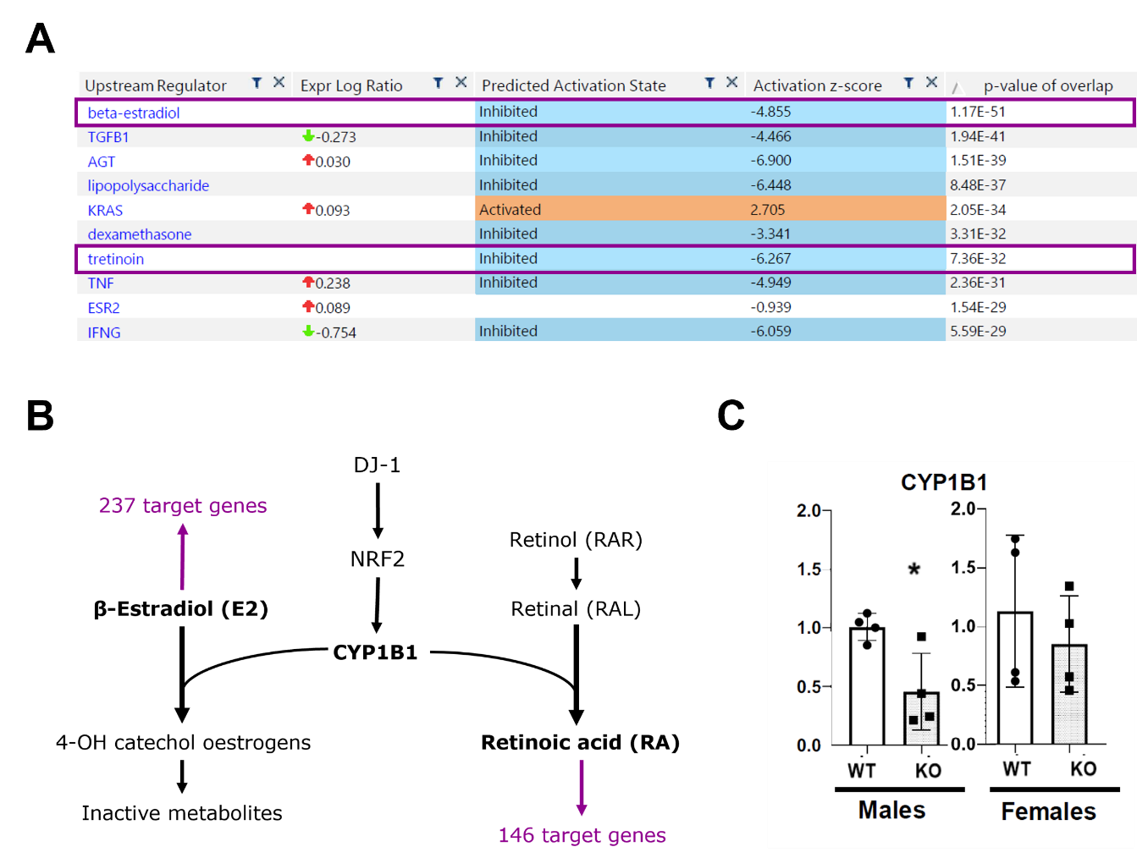
Figure 19 Increased susceptibility to DJ-1 loss is mediated by CYP1B1 in 8-months old male mice
A) Top 10 Upstream Regulators of transcriptomic changes in DJ-1 KO male mice predicted by Ingenuity® Pathway Analysis. Purple boxes highlight beta-estradiol and retinoic acid (tretinoin). B) Schematic representation of CYP1B1 role in estrogens and retinoic acid metabolism. Target genes for beta-estradiol and retinoic acid were predicted by IPA®. C) Relative mRNA expression levels of CYP1B1 in male and female DJ-1 KO and WT mice. Stats: Wilcoxon test; * = p< 0.05.
WT = wild-type littermates, KO = DJ-1 knock-out animals,

5.3 Transcriptional response to loss of DJ-1 might be mediated by the Nrf2/CYP1B1 pathway in midbrain astrocytes
Nrf2 has been shown to be directly stabilised by DJ-1, and to be overexpressed in astrocytes. Therefore, we decided to investigate Nrf2 expression in glial fibrillary acidic protein (GFAP) positive cells in the midbrain of DJ-1 KO and WT male mice. Not many commercially available antibodies exist for Nrf2, and among those only few are reported to work in immunofluorescence/immunohistochemistry. Only one antibody worked for us on mouse brain free-floating immunostaining, but it still presented a strong background signal that was not ameliorated after antigen retrieval. Therefore, we could evaluate GFAP/Nrf2 staining only qualitatively in our samples. We had a look at the astrocytes surrounding the substantia nigra, where we consistently identified overlaps between the Nrf2 signal and the GFAP+ astrocytic processes (Figure 20, white arrows). This staining pattern was equally detected in wild-type and DJ-1 knock-out mice. Overall, we could confirm Nrf2 expression in midbrain astrocytes, supporting the hypothesis that the sex-dependent transcriptomic effects seen on the midbrain of DJ-1 KO male mice are regulated by the DJ-1/Nrf2/CYP1B1 axis.

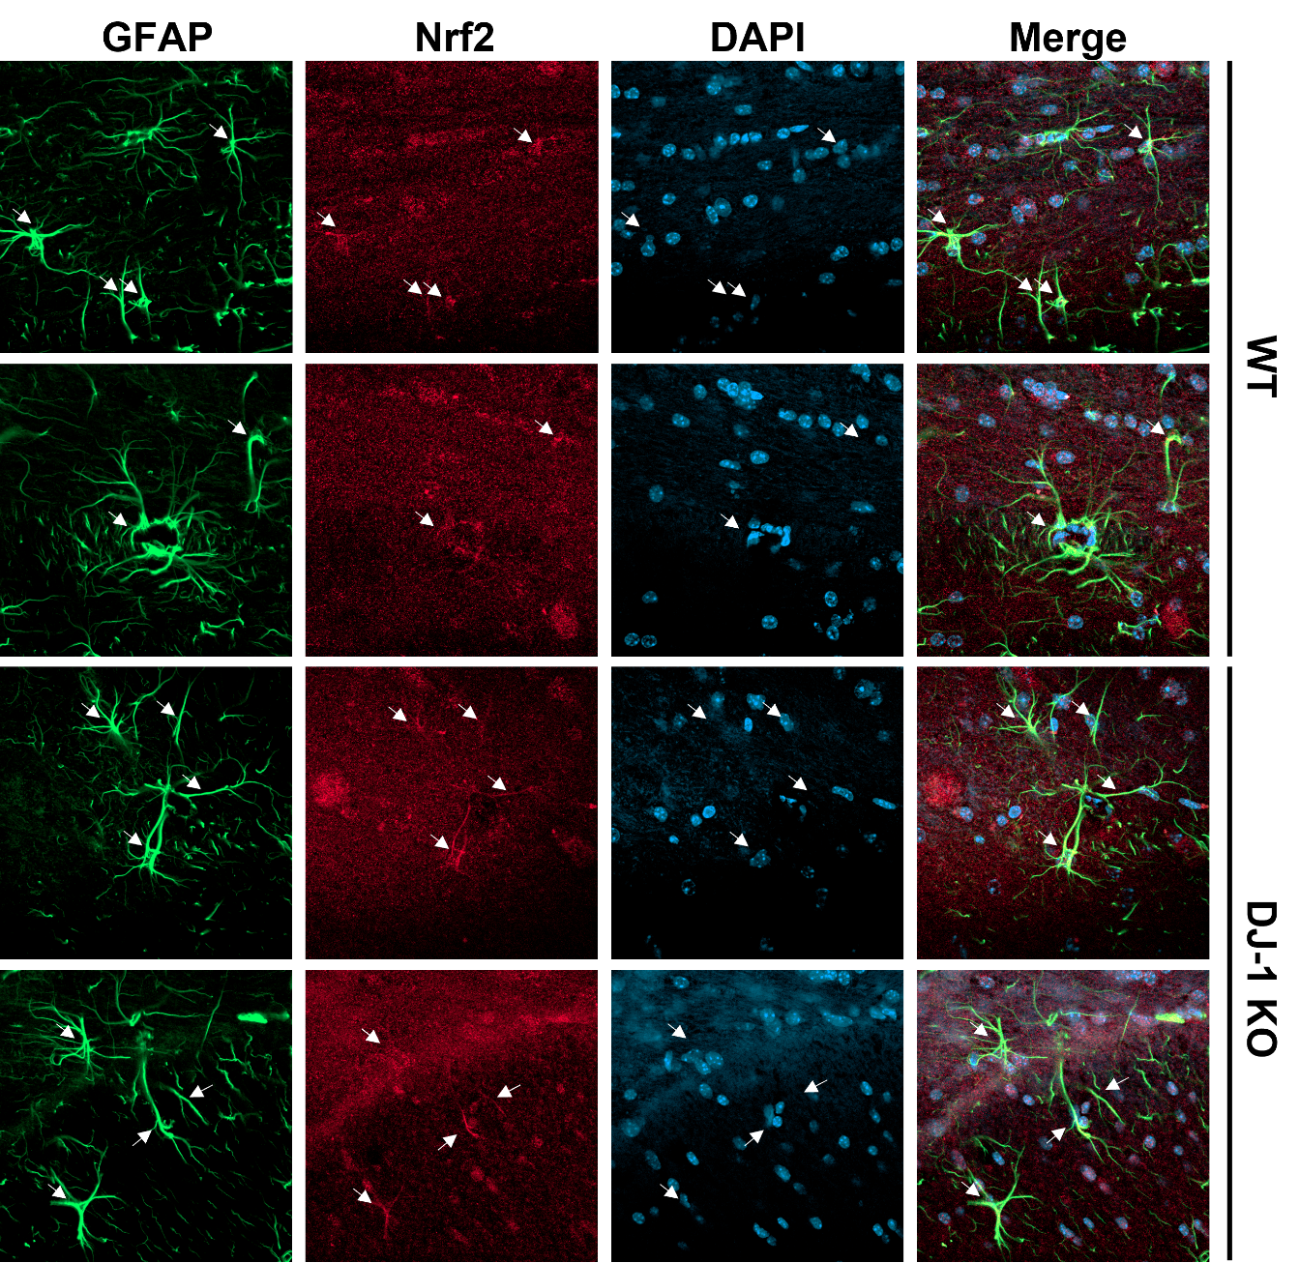
Figure 20 Nrf2 signal colocalizes with GFAP in the midbrain of DJ-1 mice.
Representative 40X immunofluorescence images illustrating GFAP and Nrf2 staining in 8-months old WT and DJ-1 KO male mice. GFAP/Nrf2 double stained astrocytic processes are marked by white arrows.
WT = wild-type littermates, DJ-1 KO = DJ-1 knock-out animals, GFAP = glial fibrillary acidic protein, Nrf2 = nuclear factor-erythroid 2 p45-related factor 2, DAPI = 4′,6-diamidino-2-phenylindole.

6 Characterisation of parkinsonian phenotypes in a mouse model overexpressing the human wild-type alpha-synuclein gene

Preface
The Thy1-Syn14 transgenic mouse overexpresses the human wild-type alpha-synuclein under the murine Thy1 promoter. Since transgene overexpression is reported to be low (1.3-fold overexpression in whole brain, Kahle et al. 2001), we have investigated the possibility to use this model to study early idiopathic PD.
I was responsible for the mouse colony management and the genotyping, I performed the behavioural tests, euthanasia and tissue collection together with Kristopher J. Schmit and Oihane Uriarte Huarte. I performed the brain cutting and staining, and quantified striatal neurodegeneration. I was also responsible of the pre-processing of the samples for RNA-sequencing analysis (RNA extraction, quality control and qPCR validation). The RNA-sequencing was executed by Rashi Halder at the sequencing platform of the Luxembourg Centre for Systems Biomedicine, and the RNA data were analysed by Sergio Helgueta Romero. I generated the Figures 21 to 24, while Figures 25 and 26 were generated by Sergio Helgueta as the final step of the differential expression analysis.

6.1 Transgenic alpha-synuclein is widely expressed in the brain of Thy1-Syn14 mice
We quantified endogenous and transgenic alpha-synuclein expression in the midbrain of female mice at 3-months of age. Murine endogenous alpha-synuclein is expressed at the same levels in wild-type (WT) and transgenic (TG) mice, with some intra-group variability which is more pronounced in TG animals (Figure 21A, left). Human alpha-synuclein is expressed only by TG animals (Figure 21A, right; p = 0.043).
The expression profile of alpha-synuclein was investigated by immunohistochemistry in 6-months old mice. Human SNCA is expressed in transgenic (TG) mice only (Figure 21B). The expression is detectable in the whole brain with some regional differences. Since transgenic synuclein expression is detected in both Substantia Nigra and Striatum (Figure 21D), the two canonical brain regions degenerated in PD, this mouse model looked suitable for investigating PD like pathology. We also investigated the expression of phosphorylated alpha-synuclein, since phosphorylation at Serine 129 has been shown to be enriched in alpha-synuclein aggregates. Phospho-alpha-synuclein is detected in both WT and TG mice, but TG animals show higher levels of expression (Figure 21C). Furthermore, compared to WT mice where the staining appears mostly synaptic, TG mice show a nuclear staining pattern in all the imaged brain regions, and this was particularly evident in cortex and hippocampus (Figure 21E).

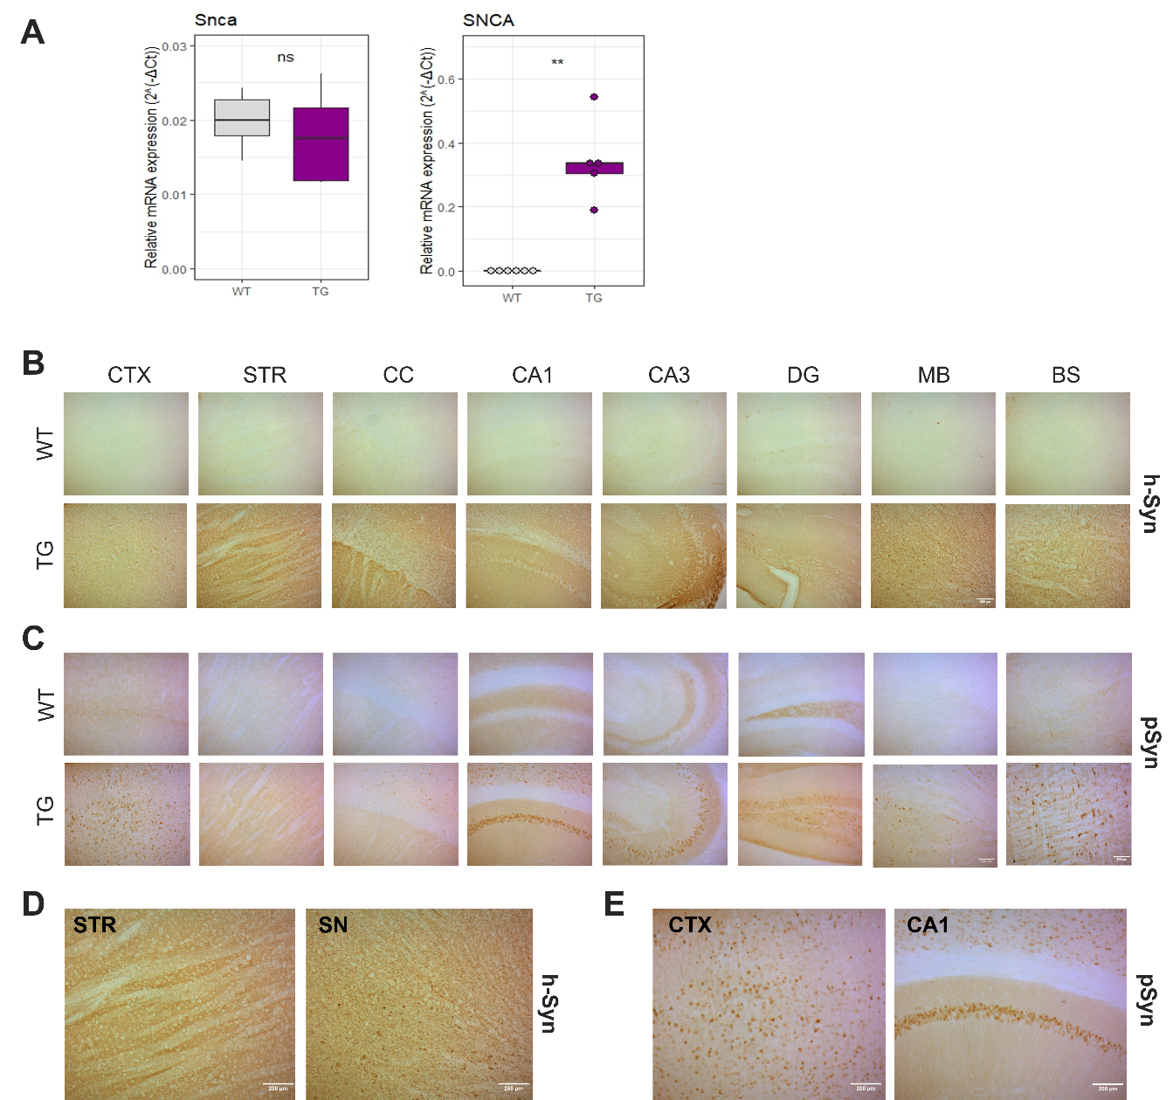
Figure 21 Phosphorylated alpha-synuclein staining shows nuclear localisation in the brain of transgenic Thy1-Syn14 mice
A) Relative mRNA expression levels of murine and human alpha-synuclein in the midbrain of TG (purple) and WT (grey) 3-months old female mice. Stats: Wilcoxon test. ns = non-significant, * = p< 0.05. B) Representative immunohistochemistry images for human synuclein in WT (top) and TG (bottom) animals in different brain regions. C) Representative immunohistochemistry images for phosphorylated alpha-synuclein staining in WT (top) and TG (bottom) mice. D) Magnifications of human synuclein staining in striatum and midbrain of TG mice. E) Magnifications of phosphorylated alpha-synuclein staining in the cortex and hippocampus of TG mice.
10X magnification, scale bar: 200µm
WT = wild-type littermates, TG = transgenic Thy1-Syn14 mice, CTX = cortex, STR = striatum, CC = corpus callosum, CA1 = cornu Ammonis 1 of the hippocampus, CA3 = cornu Ammonis 3 of the hippocampus, DG = dentate gyrus, MB = midbrain, BS = brainstem, h-Syn = human alpha-synuclein, pSyn = phosphorylated alpha-synuclein.

6.2 Transgenic Thy1-Syn14 mice show pronounced motor impairments
The motor performance of Thy1-Syn14 female mice was evaluated at the age of 6-months. The hindlimb clasping has been shown to be an indicator of lesions in the motor pathway in mouse models of neurodegeneration. Female Thy1-Syn14 transgenic mice did not show any impairment in hindlimb clasping, receiving all a score of “0” (Figure 22A). The inverted grid test allows for the measurement of the grip strength of the 4 paws simultaneously. Female TG mice showed a significant reduction in hanging time compared to their WT littermates (p = 0.0028, Figure 22B). The adhesive removal test is a sensory-motor test based on the ability of the mice to detect and remove an adhesive tape placed at the bottom of the front paw. TG mice showed increased delays in both detection (First Touch, p = 0.012) and removal (Removal, p = 0.012) times compared to their WT littermates (Figure 22C, left and middle), but no significant differences in total removal time (Figure 22C, right) indicating TG mice present a deficit in sensing but not in motor function.

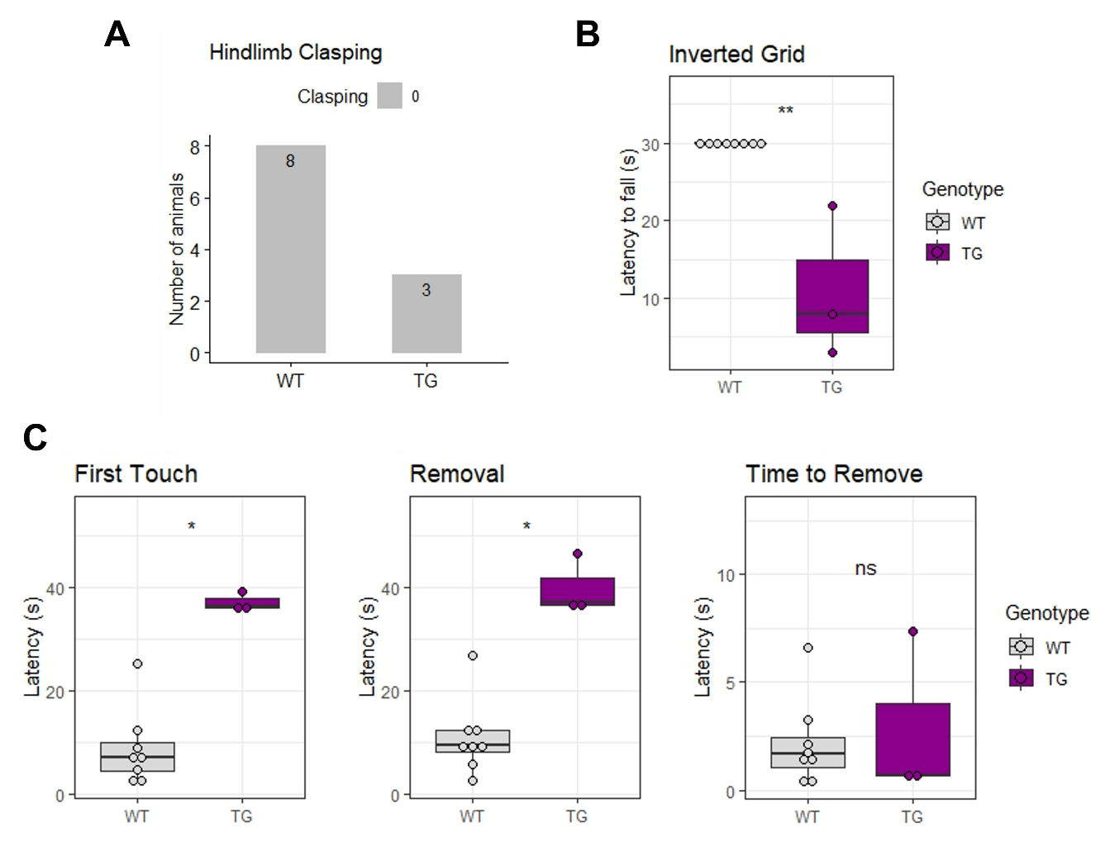
Figure 22 6-months old Thy1-Syn14 transgenic mice display alpha-synuclein driven motor deficits
A) Stacked bar plot illustrating hindlimb clasping scores for WT (left) and transgenic (right) mice. The numbers inside the bars indicate the number of mice. B) Boxplot illustrating performance in the inverted grid test for WT (left) and transgenic (right) Thy1-Syn14 mice. C) Adhesive removal test results. The “Time to Remove” is calculated as “Removal” – “First Touch”.
Stats: Wilcoxon test; ns = non-significant, * = p< 0.05, ** = p< 0.01
WT = wild-type littermates, TG = transgenic Thy1-Syn14 animals.

6.3 Thy1-Syn14 transgenic mice do not show nigrostriatal degeneration
Degeneration of the dorsal striatum was investigated in 1-, 3- and 14-months old female mice through quantification of tyrosine hydroxylase (TH) and dopamine transporter (DAT) occupied area in double immuno-stained sections. Transgenic mice did not show a significant difference in both TH (Figure 23A) and DAT (Figure 23B) occupied area percentage compared to their wild-type littermates, at any of the investigated time points. Therefore, alpha-synuclein overexpression does not seem to cause dopaminergic neurodegeneration in this model. This finding might be explained 1) by an adaptation to the high alpha-synuclein overexpression levels already since a young age, or 2) by the fact that alpha-synuclein overexpression levels are not the strongest in the midbrain, thus potentially impacting the nigrostriatal pathway less than other neuronal pathways in the brain of Thy1-Syn14 mice.
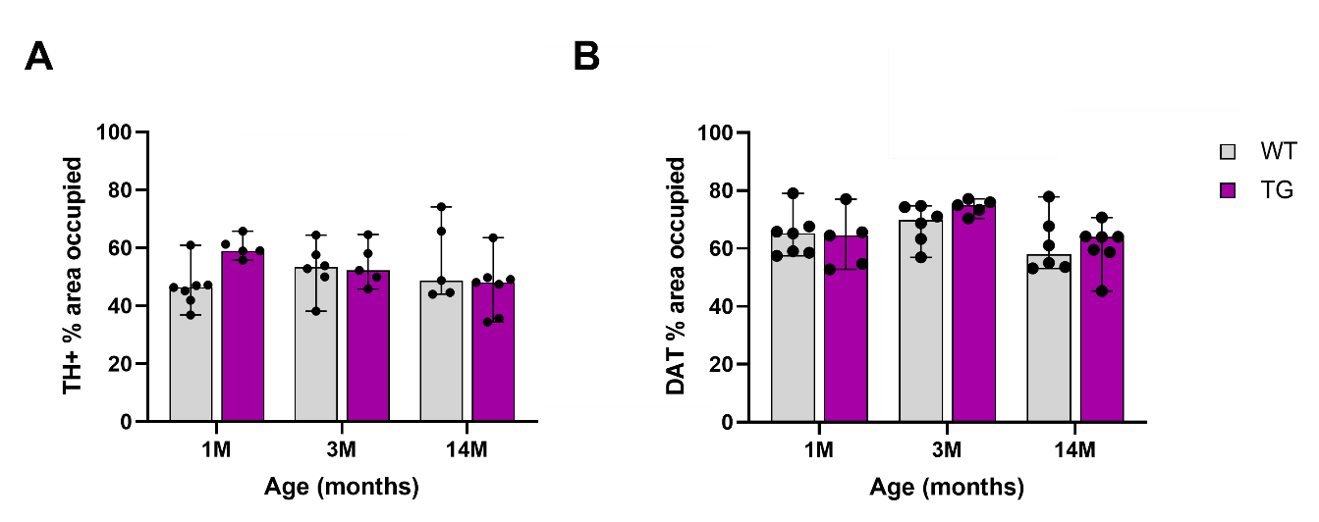
Figure 23 Transgenic Thy1-Syn14 mice do not present striatal degeneration
A) Quantification of tyrosine hydroxylase occupied area in the dorsal striatum of Thy1-Syn14 transgenic female mice (purple) and their wild-type littermates (grey) at 1-, 3- and 14-months of age. 2-3 section per mouse were quantified, and each dot represents the median percentage area occupied value for a mouse. B) Quantification of Dopamine transporter occupied area in the dorsal striatum of Thy1-Syn14 transgenic female mice (purple) and their wild-type littermates (grey) at 1-, 3- and 14-months of age. 2-3 section per mouse were quantified, and each dot represents the median percentage area occupied value for a mouse.
Stats: Wilcoxon test; all comparisons were non-significant.
WT = wild-type littermates, TG = transgenic Thy1-Syn14 animals, 1M = 1-month old, 3M = 3-months old, 14M = 14-months old. All mice were females. TH = tyrosine hydroxylase, DAT = dopamine transporter.

6.4 Transgenic Thy1-Syn14 female mice do not show obvious microglial response to alpha-synuclein overexpression
Growing research has shown that PD pathology is perpetrated by a neuroinflammatory response characterised by the activation of resident microglia (Garcia et al., 2022). Microglial response can be activated by several factors, including oligomeric or fibrillar forms of alpha-synuclein (Su et al., 2007; Zhang et al., 2005). To test if neuroinflammation was present in transgenic Thy1-Syn14 mice in response to alpha-synuclein overexpression, we performed a double staining for phospho-synuclein and for ionized calcium-binding adaptor molecule 1 (Iba1), which shows an increased expression in activated microglia. Representative figures of the immunofluorescence staining are shown in Figure 24A. At a first glance, Iba1 expression did not appear to be different between WT ang TG mice both at 3- and 14-months of age, while as shown already by immunohistochemistry in Figure 21B, phospho-synuclein is expressed at higher levels in TG animals, with differences already detectable by eye in cortex and hippocampus. Staining for alpha-synuclein is mostly detected in the nuclei in the cortex and in the CA1 region of the hippocampus. In the same areas, microglia cells are also detected, but they do not seem to interact with the alpha-synuclein overexpressing neurons (Figure 24B left and middle). Furthermore, microglial activation has been linked with a more amoeboid shape, while in our samples microglial cells appear ramified, indicating a resting state (Stence, Waite, and Dailey 2001). Similar results were found in the substantia nigra (Figure 24B, right). Overall, no differences were observed between mice at 3- and 14-months of age, nor between WT and TG mice. Taken together, these data suggest that the overexpression of alpha-synuclein in Thy1-Syn14 mice does not cause a direct microglia response. Furthermore, the alpha-synuclein load does not seem to differ much at young versus old ages. This might induce the activation of compensatory mechanisms to alpha-synuclein overexpression already at early points in life, potentially explaining why transgenic mice do not show increased microglial response despite consistent levels of alpha-synuclein overexpression.

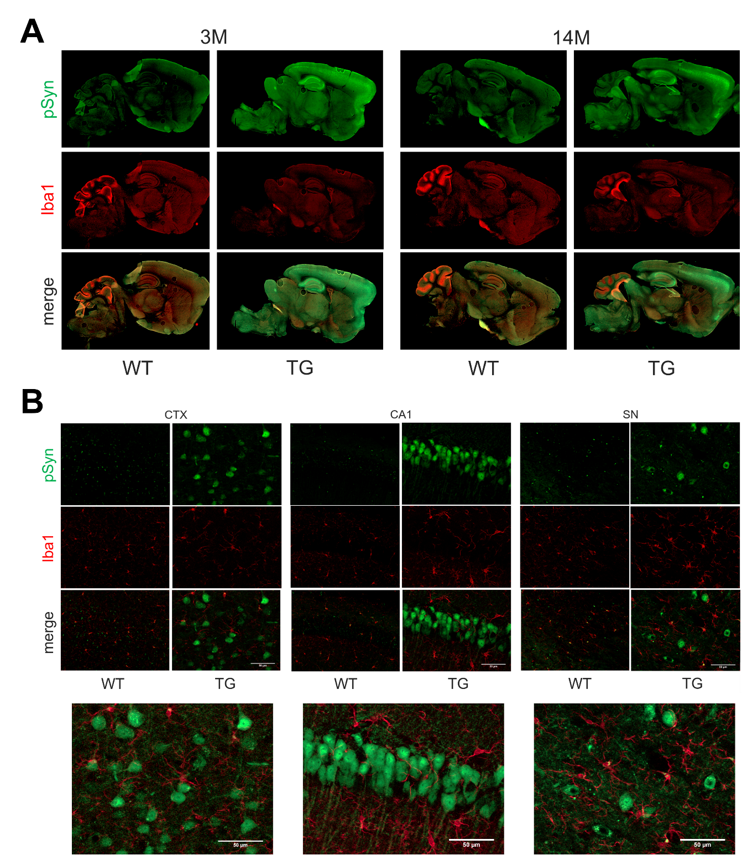
Figure 24 Microglia does not interact with alpha-synuclein inclusions in the Thy1-Syn14 mouse model
A) Representative immunofluorescence pictures of a sagittal section of the whole brain for phosphorylated alpha-synuclein (top) and Iba1 (middle) for WT and TG female mice at 3 and 14 months of age. B) Top: Representative immunofluorescence pictures for phosphorylated alpha-synuclein and Iba1 in cortex (left), hippocampus (middle) and substantia nigra (right) for WT and TG female mice at 14 months of age; Bottom: Magnifications of the “merge” channel for TG mice for each brain region. 40X magnification, scale bar = 50µm.
WT = wild-type littermates, TG = transgenic Thy1-Syn14 animals, 3M = 3-months old, 14M = 14-months old, CTX = cortex, CA1 = cornu Ammonis 1 of the hippocampus, SN = substantia nigra, pSyn = phosphorylated alpha-synuclein, Iba1 = ionized calcium-binding adaptor molecule 1

6.5 Transgenic Thy1-Syn14 mice do not show midbrain transcriptional alterations
To investigate whether the parkinsonian-like motor phenotype was accompanied by transcriptional changes, we performed bulk RNA-sequencing on the ventral midbrain of 3- and 14-months old female mice. At both timepoints, transgenic mice did not show DEGs when compared to their WT littermates (Figure 25A). A differential expression was detected only for SNCA and Thy1, reflecting the overexpression of the transgene in TG mice (Figure 25B). The lack of DEGs could be attributed to compensatory mechanisms to the transgene overexpression, which is already established at birth. Alternatively, transcriptional changes might be occurring at a timepoint that was not investigated, for example during midlife. Markers specific for dopaminergic neurons (Figure 26A), microglia (Figure 26B) and astrocytes (Figure 26C) were also unchanged, suggesting an equal representation of these cell types across all samples.
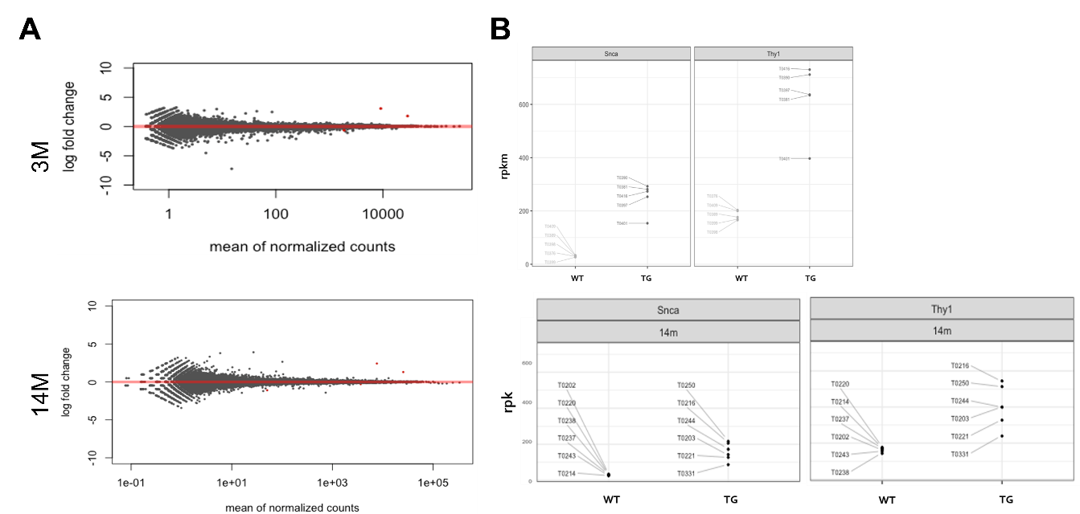
Figure 25 Transgenic Thy1-Syn14 mice do not show differential expression from WT littermates in the midbrain
A) MA plots displaying the results of the differential expression analysis for 3- and 14-months old TG vs WT mice. B) Differential expression of SNCA and Thy1 in 3-months old (top) and 14-months old (bottom) Thy1-Syn14 mice.
WT = wild-type littermates, TG = transgenic Thy1-Syn14 animals, 3M = 3-months old, 14M = 14-months old. n (3M) = 5 mice per group, n (14M) = 6 mice per group. All mice were female.
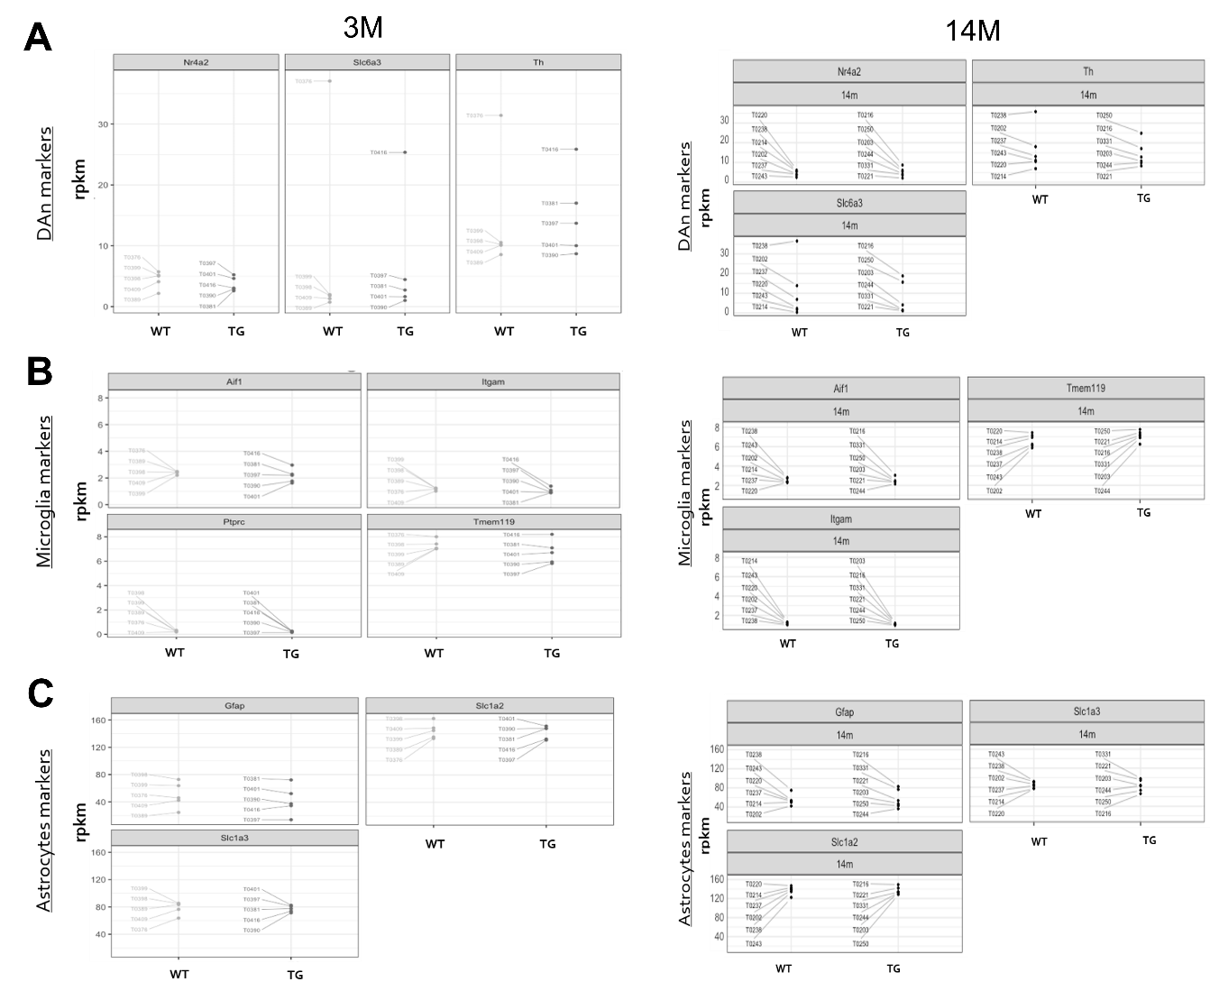
Figure 26 Cellular markers for dopaminergic neurons, astrocytes and microglia are unchanged
A) Expression levels for Nuclear receptor 4A2 (Nr4a2), tyrosine hydroxylase (Th) and Solute carrier family 6 member 3 (Slc6a3) in TG and WT Thy1-Syn14 mice at 3- (left) and 14- (right) months. B) Expression levels for Allograft inflammatory factor 1 (Aif1), Integrin subunit alpha M (Itgam), Protein tyrosine phosphatase receptor type C (Ptprc), and Transmembrane protein 119 (Tmem119) in WT and TG Thy1-Syn14 mice at 3- (left) and 14- (right) months. C) Expression levels for Glial fibrillary acidic protein (Gfap), Solute carrier 1A2 (Slc1a2) and Solute carrier 1A3 (Slc1a3) in WT and TG Thy1-Syn14 mice at 3- (left) and 14- (right) months.
WT = wild-type littermates, TG = transgenic Thy1-Syn14 animals, 3M = 3-months old, 14M = 14-months old, DAn = dopaminergic neurons. n (3M) = 5 mice per group, n (14M) = 6 mice per group; all mice were female.

7 Diet and bacterial exposure contribute to parkinsonian phenotypes

Preface
Sporadic cases of PD are of unknown aetiology and results from an interplay of environmental, biological, and genetic influences. Lifestyle changes such as diet can act as modulators of PD risk, by influencing the gut microbiome and consequently alpha-synuclein aggregation in the enteric nervous system. To investigate the contribution of gastrointestinal imbalances in the development of PD, we combined a fibre deprived diet with exposure to the bacterial amyloid protein Curli, in a mouse model overexpressing the SNCA gene.
The work presented in this Chapter is part of a study currently available as a pre-print on biorxiv under the title “Dietary fibre deprivation and bacterial curli exposure shift gut microbiome and exacerbate Parkinson’s disease-like pathologies in an alpha-synuclein-overexpressing mouse”, and submitted to Cell Press Community Review under the title “Pathogenic effects of fibre deprivation and Curli in Parkinson’s disease”. I was directly involved in mouse cohort management and genotyping, I participated in the behavioural testing of the mice both at baseline and after treatment, and I was responsible for the characterisation of murine Snca and transgenic SNCA expression in the brain and gut of the mice at baseline via RT-qPCR and Western Blot techniques. The Figures presented in this Chapter (27 to 31) were generated by Kristopher Schmit and are presented such as in (Schmit et al. 2022).

7.1 Transgenic alpha-synuclein is overexpressed with regional variance in brain and gut

The expression levels of murine and transgenic alpha-synuclein were quantified in 9-months old male mice at the RNA level by RT-qPCR and at the protein level via Western Blot, as described in Material and Methods. In the brain, endogenous synuclein expression did not differ between WT and transgenic (TG) animals both in the midbrain and in the striatum, but the expression was significantly lower in the midbrain (p< 0.0001) (Figure 27A). As expected, the human transgenic alpha-synuclein was expressed only in TG animals, and the levels of expression did not differ between the two brain region investigated (Figure 27B). These results were confirmed by protein level quantification, using a pan-αSyn antibody (Figure 27B). TG mice overexpressed alpha-synuclein with a 2.91-fold increase in the midbrain (p= 6.67E-4), and by a 6.67-fold increase in the striatum (p= 6.67E-4). Furthermore, alpha-synuclein expression was significantly higher in the striatum, reflecting the difference in alpha-synuclein expression already detected by qPCR.
Alpha-synuclein expression was analysed in both the proximal and distal tract of the colon. Alpha-synuclein expression was detected by RT-qPCR, however at very low levels compared to the brain. This is not surprising, given that neurons constitute only 1% of the cells in the colon. Transgenic SNCA expression was limited to TG animals without regional differences, while endogenous Snca was expressed at higher levels in proximal compared to distal colon (Figure 27C). Given the very low levels of synuclein expression in the colon, quantification of protein level through western blot was not possible. Nevertheless, qualitative staining for both pan-αSyn and human alpha-synuclein in the gut confirmed synuclein expression in enteric neurons (Figure 27D).

7.2 Transgenic Thy1-Syn14 mice present age-dependent motor dysfunction
Motor performance of TG mice and their WT littermate was assessed using the inverted grid and adhesive removal tests, and clasping score. The inverted grid test allows to evaluate grip strength, a parameter correlating with striatal dysfunction. TG mice showed progressive reduction in the hanging time with age, while the performance of WT mice did not change (Figure 27E). The age-dependent decline in motor function of TG mice was confirmed by the hindlimb clasping score; once again, no differences were detected for WT mice (Figure 27F). Sensory-motor function was evaluated with the adhesive removal test. Motor deficits started to appear at 9-months of age as visualized by a delay in both time of first touch (Figure 27G, left) and time at removal (Figure 27G, right). Overall, the performance of male TG mice appeared to be similar to that of female mice previously discussed in Chapter 6.2. In female Thy1-Syn14 mice, we did not observe striatal degeneration with ageing (Chapter 6.3), suggesting that the motor deficits might be caused to impairments in pathways other than the nigrostriatal. Furthermore, the progressive worsening of the motor phenotype suggests that alpha-synuclein overexpression drives motor deficits in combination with the ageing process.

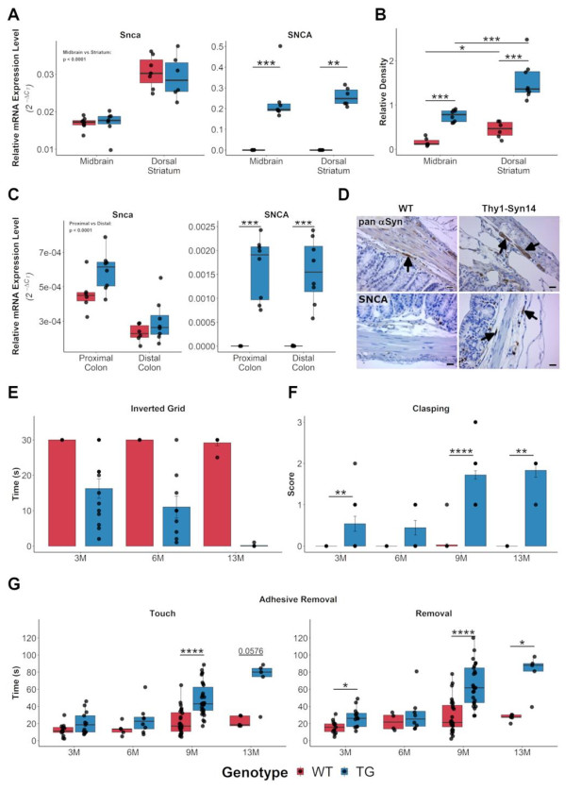
Figure 27 Transgenic Thy1-Syn14 mice overexpress the human SNCA transgene in brain and colon, and present age-dependent motor impairments
A) relative mRNA expression levels for Snca (left) and SNCA (right) in striatum and midbrain. B) Quantification of pan-αSyn expression in midbrain and striatum. C) Relative mRNA expression levels for Snca (left) and SNCA (right) in proximal and distal colon. D) representative immunohistochemical stainings images for pan-αSyn and SNCA in the colon. E) Inverted grid test, showing a progressive reduction in latency to fall in TG mice. F) Hindlimb clasping scores for TG and WT mice at different ages. G) Adhesive removal test results for WT and TG mice at different ages.
Stats: Mann-Whitney U, corrected for FDR; * = p < 0.05, ** = p < 0.01, *** = p < 0.001, **** = p < 0.0001.
WT = wild-type littermates, TG = transgenic Thy1-Syn14 animals, 3M = 3-months old, 6M = 6-months old, 9M = 9-months old, 13M = 13-months old

7.3 E. coli born Curli drives alpha-synuclein aggregation in Substantia Nigra and Striatum
To evaluate the influence of environmental and lifestyle factors on the progression of Parkinson-like phenotypes, Thy1-Syn14 mice were exposed to fibre-deprivation and bacterial Curli challenges, either alone or in combination. Since the nigrostriatal pathway degeneration is the main cause of motor phenotypes in PD, we investigated alpha-synuclein aggregation and neurodegeneration in the SN and in the striatum of Thy1-Syn14 mice.
To quantify alpha-synuclein aggregation levels, we performed an immunofluorescence staining using the pS129-αSyn antibody, which specifically binds to phosphorylated alpha-synuclein. Only the results for TG mice are shown (Figure 28). In the dorsal striatum, the highest levels of phosphorylated alpha-synuclein staining were detected in the FR EC group, and phosphorylated alpha-synuclein levels were significantly different to those of the FR ΔEC group (Figure 28A). In the Substantia Nigra pars compacta (SNpc), phosphorylated alpha-synuclein positive signal was localized either in the cell body or in neurite-like structures. Phosphorylated alpha-synuclein staining for both signal types were the highest in the FD EC challenged transgenic mice (Figure 27B). Qualitatively, we observed three forms of aggregates: bead like varicosities (Figure 28B, bottom panel, white arrows), spheroid aggregates (Figure 28B, bottom panel, open white arrows), and corkscrew-like aggregates (Figure 28B, bottom panel, blue arrows). Taken together, these results suggest that E. coli originated Curli is the main factor responsible for phosphorylated alpha-synuclein positive aggregates formation, and that fibre-deprivation contributes to this process.

7.4 The combination of fibre-deprivation and bacterial Curli drives neurodegeneration in Thy1-Syn14 mice
In Chapter 6.3 we have reported that the overexpression of transgenic alpha-synuclein in Thy1-Syn14 mice is not sufficient to cause nigrostriatal degeneration. To investigate whether the diet challenge or the bacterial challenge could lead, alone or in combination, to neurodegeneration in the nigrostriatal pathway, we quantified Tyrosine Hydroxylase (TH) and Dopamine Transporter (DAT) staining in the dorsal striatum. Nor fibre-deprivation nor Curli exposure caused a neurodegenerative phenotype in WT mice, thus only results for TG mice are presented. While TG mice exposed to the fibre-rich diet did not show significant differences from WT mice, staining for both markers was significantly reduced in TG mice exposed to the combined FD and EC challenges (Figure 28C and D). In the SNpc, loss of dopaminergic neurons was evaluated by quantification of the TH-positive occupied area as described in Materials and Methods. Significant DAn loss was present in both the FR EC and FD EC groups, indicating a major contribution of bacterial Curli to neuronal loss (Figure 28E). Nevertheless, the neuronal loss was exacerbated by the fibre-deprivation, suggesting that dietary changes can increase the susceptibility to Curli-dependent neurodegeneration. Furthermore, the absence of neuronal deficits in WT mice indicates that the presence of a pre-existing risk factor, such as alpha-synuclein overexpression, appears to be necessary for bacterial- and diet-dependent neurodegeneration.

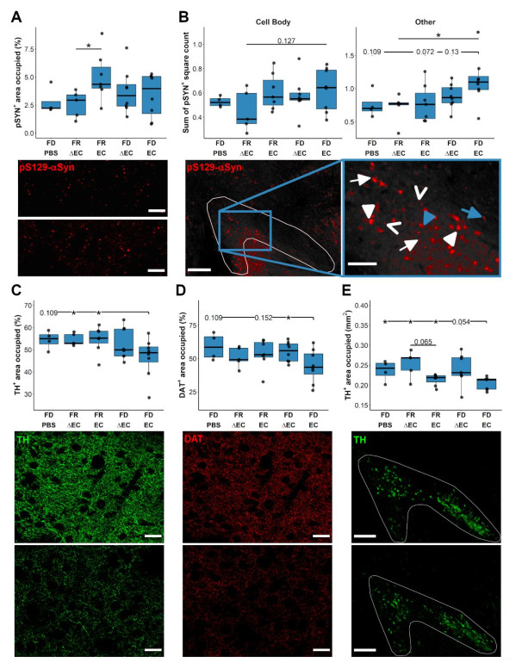
Figure 28 Neurodegeneration in the nigrostriatal pathway of Thy1-Syn14 transgenic mice is driven by bacterial Curli and further exacerbated by fibre-deprivation
A) Quantification of pS129-αSyn+ area occupied and representative immunofluorescent images (40X magnification, scale bar 50μm) of pS129-αSyn staining for FR ΔEC (top) and FR EC (bottom) in the dorsal striatum. B) Quantification of pS129-αSyn+ cell body (left) and neurite-like (right) staining, and representative immunofluorescent images (left: 10X tiles, scale bar: 250μm; right: zoom in, scale bar: 100μm) of pS129-αSyn staining in the SNpc. C) Quantification and representative images (40X, scale bar: 50μm; top: FR ΔEC; bottom: FD EC) of TH+ fibres in the dorsal striatum. D) Quantification and representative images (40X, scale bar: 50μm; top: FR ΔEC; bottom: FD EC) of DAT+ synapses in the dorsal striatum. E) Quantification and representative images (10X, scale bar: 250μm; top: FR ΔEC; bottom: FD EC) of TH+ signal in the SNpc.
Stats: Mann-Whitney U test, not corrected for FDR.
SNpc = substantia nigra pars compacta, FD = fibre-deprived diet, FR = fibre-rich diet or normal chow, PBS = phosphate buffered saline solution, ΔEC = Curli-KO E. coli, EC = wild-type Curli expressing E. coli, pSYN = phosphorylated alpha-synuclein, TH = Tyrosine hydroxylase, DAT = dopamine transporter.

7.5 The combination of fibre-deprived diet and exposure to E. coli born Curli drives alpha-synuclein aggregation in the enteric nervous system
PD patients have often been reported to present alpha-synuclein aggregation in the periphery. To test if the exposure to the amyloidogenic bacterial protein Curli and fibre-deprivation, either alone or in combination, could affect alpha-synuclein aggregation in our mice, we stained the colon with an antibody against phosphorylated alpha-synuclein (pS129-αSyn). The phosphorylated alpha-synuclein positive signal was quantified in ganglions positively stained for the neuronal cytoplasmic marker protein gene product 9.5 (PGP9.5). Both WT and TG mice presented positive phosphorylated alpha-synuclein staining in the myenteric plexus, but only TG mice exposed to both the fibre-deprivation and the E. coli born Curli presented significantly elevated levels of phosphorylated alpha-synuclein staining compared to all the other treatment groups (Figure 29, left). These results suggest that the presence of elevated alpha-synuclein levels, the lack of dietary fibre and the exposure to bacterial amyloidogenic compounds alone are not sufficient to drive alpha-synuclein aggregation, and that pathogenic phenotypes result from the combination of genetic predisposition and environmental factors.

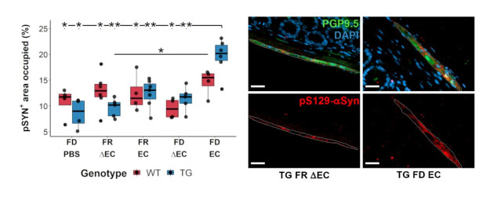
Figure 29 Fibre-deprivation and exposure to Curli drive alpha-synuclein aggregation in Thy1-Syn14 transgenic mice
A) Quantification of phosphorylated alpha-synuclein positive occupied area in PGP9.5 positive neurons of the myenteric system. B) Representative immunofluorescence images illustrating the difference between FR ΔEC and FD EC challenged TG mice. Mice challenged with fibre-deprivation and Curli exposure present a higher pS129-αSyn+ occupied area, and bigger pS129-αSyn+ particles.
WT = wild-type littermates, TG = transgenic Thy1-Syn14 animals, FD = fibre deprived diet, FR = fibre rich diet or normal chow, PBS = phosphate buffered saline solution, ΔEC = Curli-KO E. coli, EC = wild-type Curli expressing E. coli
A
B

7.6 Alpha-synuclein overexpression is the main driver of gross motor impairments
To investigate whether the exposure to bacterial Curli and/or fibre-deprivation would exacerbate the motor impairment shown by 9-months old transgenic Thy1-Syn14 mice (refer to chapter 7.1, and Figure 30), we assessed hindlimb clasping, grip strength and performance in the adhesive removal test in challenged mice. WT and TG mice already presented different clasping scores already at baseline. During the 9-weeks treatment phase, WT mice did not show any change in hindlimb clasping, while TG mice worsened over time (Figure 30A). The same results were observed for the grip strength (Figure 30B). Nor the exposure to Curli nor the fibre-deprivation showed an effect on the motor function, suggesting that the transgenic alpha-synuclein overexpression is the main driver of motor deficits. Latency to touch and latency to remove in the adhesive removal test showed similar results to those observed at baseline, with TG mice performing significantly worse than their WT littermates (Figure 30C and 31A). Nevertheless, when looking at the time necessary to perform the tape removal (interval between touch and removal times), TG mice always showed longer removal times compared to their WT littermates, and the latency to remove the tape was greater in the FD EC challenged group (Figure 31A). Furthermore, when comparing baseline and endpoint, 3 out of 6 FD EC challenged TG mice showed worse performances than at baseline, while all the other treatment groups improved compared to their initial performance (Figure 31B). Even if not statistically significant, these results indicate that the combination of Curli and fibre-deprivation might exacerbate motor deficits in aged TG mice.

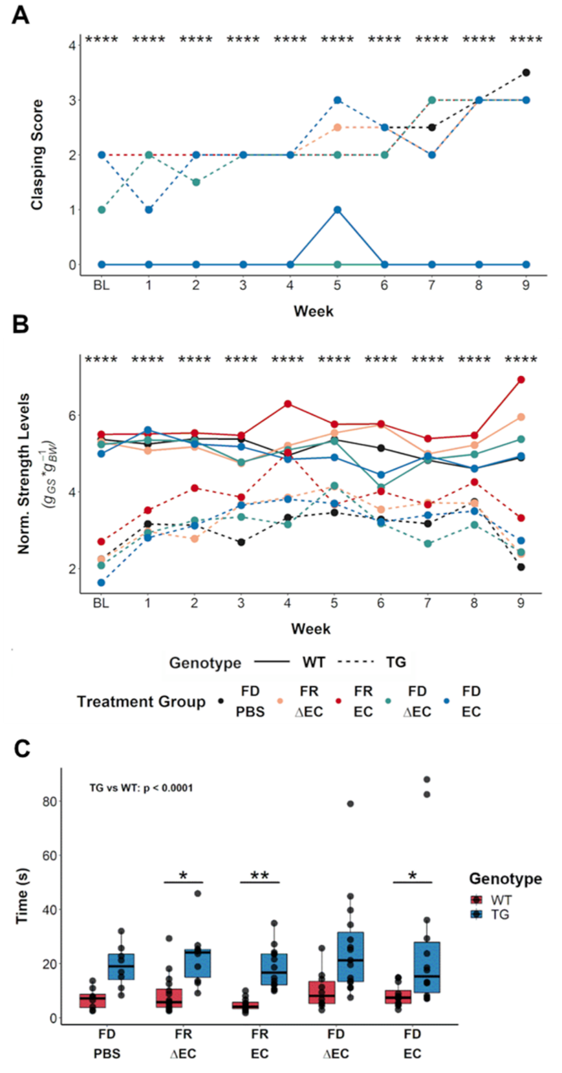
Figure 30 Transgenic alpha-synuclein overexpression drives motor deficits in TG animals
A) Longitudinal visualization of hindlimb clasping scores for all treatment groups (median value for each group). B) Longitudinal visualization of grip strength for all treatment groups (median value for each group). C) Boxplots illustrating the latency to touch in all groups after the 9-week long in life treatment phase.
Stats: Mann-Whitney U test and FDR correction. * = p< 0.05, ** = p< 0.01, **** = p< 0.0001. Comparison between TG and WT groups in C) was performed by Kruskal-Wallis with FDR correction.
WT = wild-type littermates; TG = transgenic Thy1-Syn14 animals, FD = fibre deprived diet, FR = fibre rich diet or normal chow, PBS = phosphate buffered saline solution, ΔEC = Curli-KO E. coli, EC = wild-type Curli expressing E. coli
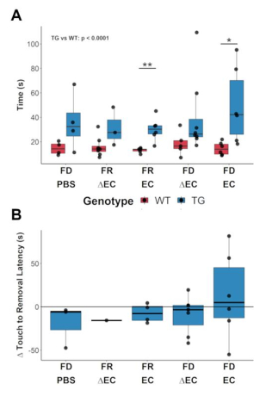
Figure 31 Curli exposure and fibre-deprivation exacerbate motor phenotype in a subset of transgenic Thy1-Syn14 mice
A) Latency to removal of the adhesive tape in all treatment groups after the 9-week long in life treatment phase. B) Touch to removal interval for transgenic Thy1-Syn14 mice (FD PBS: n=3, FR ΔEC: n=1, FR EC: n=5, FD ΔEC: n=6, FD EC: n=6).
Stats: Mann-Whitney U test, not corrected for FDR; *, p < 0.05; **, p < 0.01.
WT = wild-type littermates, TG = transgenic Thy1-Syn14 animals, FD = fibre-deprived diet, FR = fibre-rich diet or normal chow, PBS = phosphate buffered saline solution, ΔEC = Curli-KO E. coli, EC = wild-type Curli expressing E. coli

8 In vitro models of neuronal toxicity

Preface
In PD, alpha-synuclein exist in equilibrium between monomeric, oligomeric, and aggregated forms. While monomers are recognised to be non-toxic, a consensus on the biological activity of oligomers and fibrils has not been reached yet. For long, fibrils have been considered to be the toxic form of alpha-synuclein due to them being the major constituent of Lewy bodies. Nevertheless, in recent years the idea that alpha-synuclein toxicity is caused mostly by oligomeric forms, and that fibrils are the result of protective cellular mechanism processes has been advanced. The use of laboratory-synthetized alpha-synuclein proteins in vitro and in vivo can help answer these questions.
Glutamate represents the main excitatory neurotransmitter in the CNS. Excitotoxicity caused by increased levels of extracellular glutamate is a common pathological process in neurodegeneration following brain trauma and ischemia. We hypothesize that genetic factors causing PD, such as the loss of function of the DJ-1 protein, could lead to an increased sensitivity to glutamate excitotoxicity, thus contributing to PD pathogenesis.
The results presented in this Chapter are part of a side project that was, unfortunately, dramatically hit by the SARS-COV-2 pandemic. They should have included transcriptomic analyses following alpha-synuclein and glutamate treatment of wild-type and DJ-1 knock-down cells, but they ended up being suspended at the stages of initial characterisation. Therefore, results are incomplete, and the conclusions that can be taken are only preliminary.
Alpha-synuclein moieties were either purchased from StressMarq or kindly donated by ETAP-Lab and Cantabio Pharmaceuticals Inc. LUHMES wild-type and DJ-1 knock-down cells were provided by the Integrative Cell Signaling group at the Luxembourg Centre for Systems Biomedicine. I performed all described experiments, with the exception of the electron microscopy imaging which was performed by Felix Kleine-Borgmann. I made a composite of EM images acquired by Felix Kleine-Borgmann in Figure 32, and entirely generated Figures 33 and 34.

8.1 Characterisation of alpha-synuclein moieties by electron microscopy
We have characterised commercially and non-commercially available alpha-synuclein monomers, oligomers, and pre-formed fibrils (PFFs). A list of the investigated alpha-synuclein moieties can be find in Table 2.
All the analysed monomers presented a similar circular shape, although the type 1 monomers from StressMarq were smaller compared to both the type 2 from the same vendor, and monomers provided by ETAP-Lab (Figure 32A). Furthermore, ETAP-Lab monomer preparation also included some bigger rod-structure, suggesting they could be a mix of monomers and oligomers. The two analysed alpha-synuclein oligomers preparation showed the highest variability. Oligomers from StressMarq overall resembled monomers both in shape and size (Figure 32B, left). On the other hand, oligomers from ETAP-Lab formed bigger, intertwined structures, resembling what is typically observed for fibrils (Figure 32B, right). Finally, we analysed three pre-formed fibrils preparation, with or without sonication before imaging. All three preparations showed similar elongated structures reaching over 300nm in length (Figure 32C, top). Sonication did not seem to affect Cantabio PFFs much, while it causes the breaking up of fibrils in shorter structures in both the StressMarq type 1 and type 2 fibrils (Figure 32C, bottom). Overall, we confirmed that alpha-synuclein moieties’ characteristics appear to vary from one preparation to the other, potentially contributing to variability and reproducibility issues in in vivo and in vitro studies.
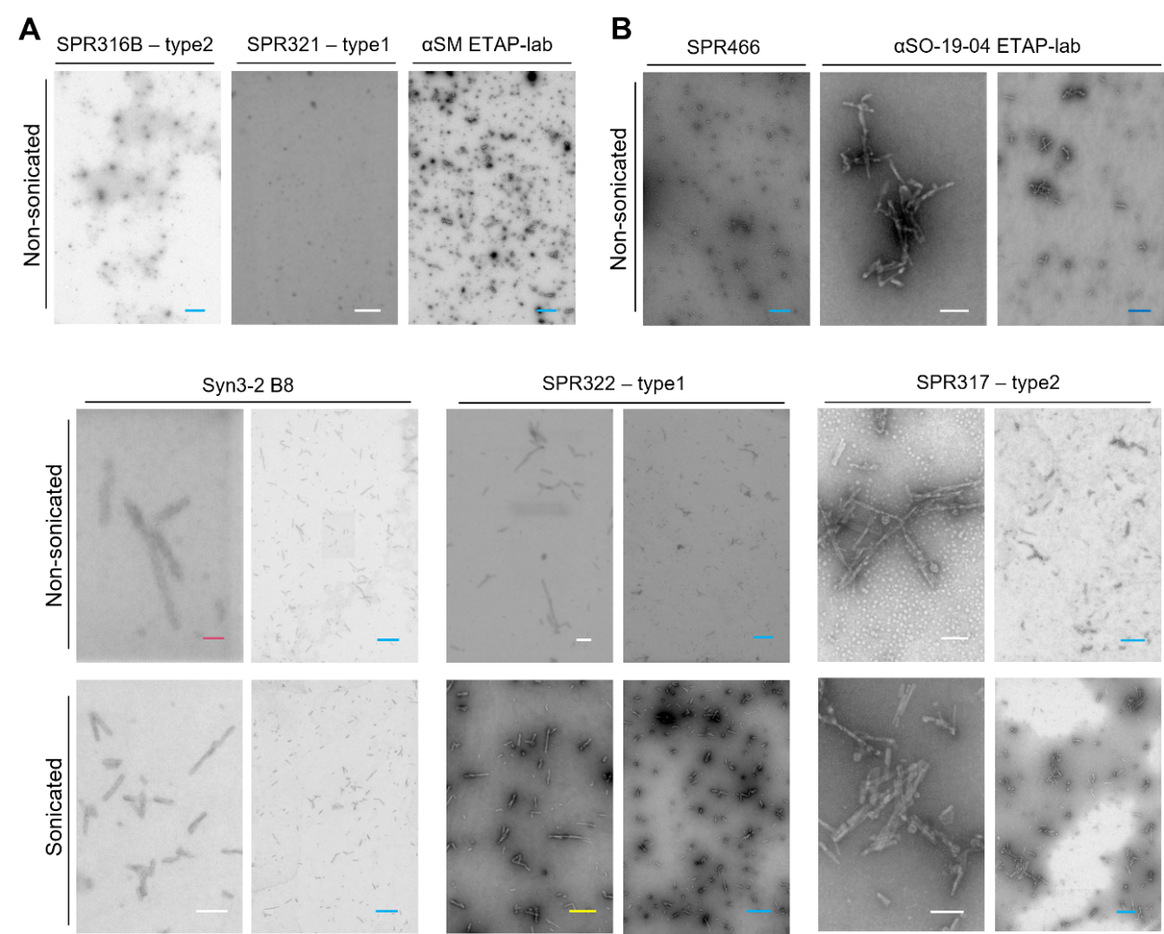
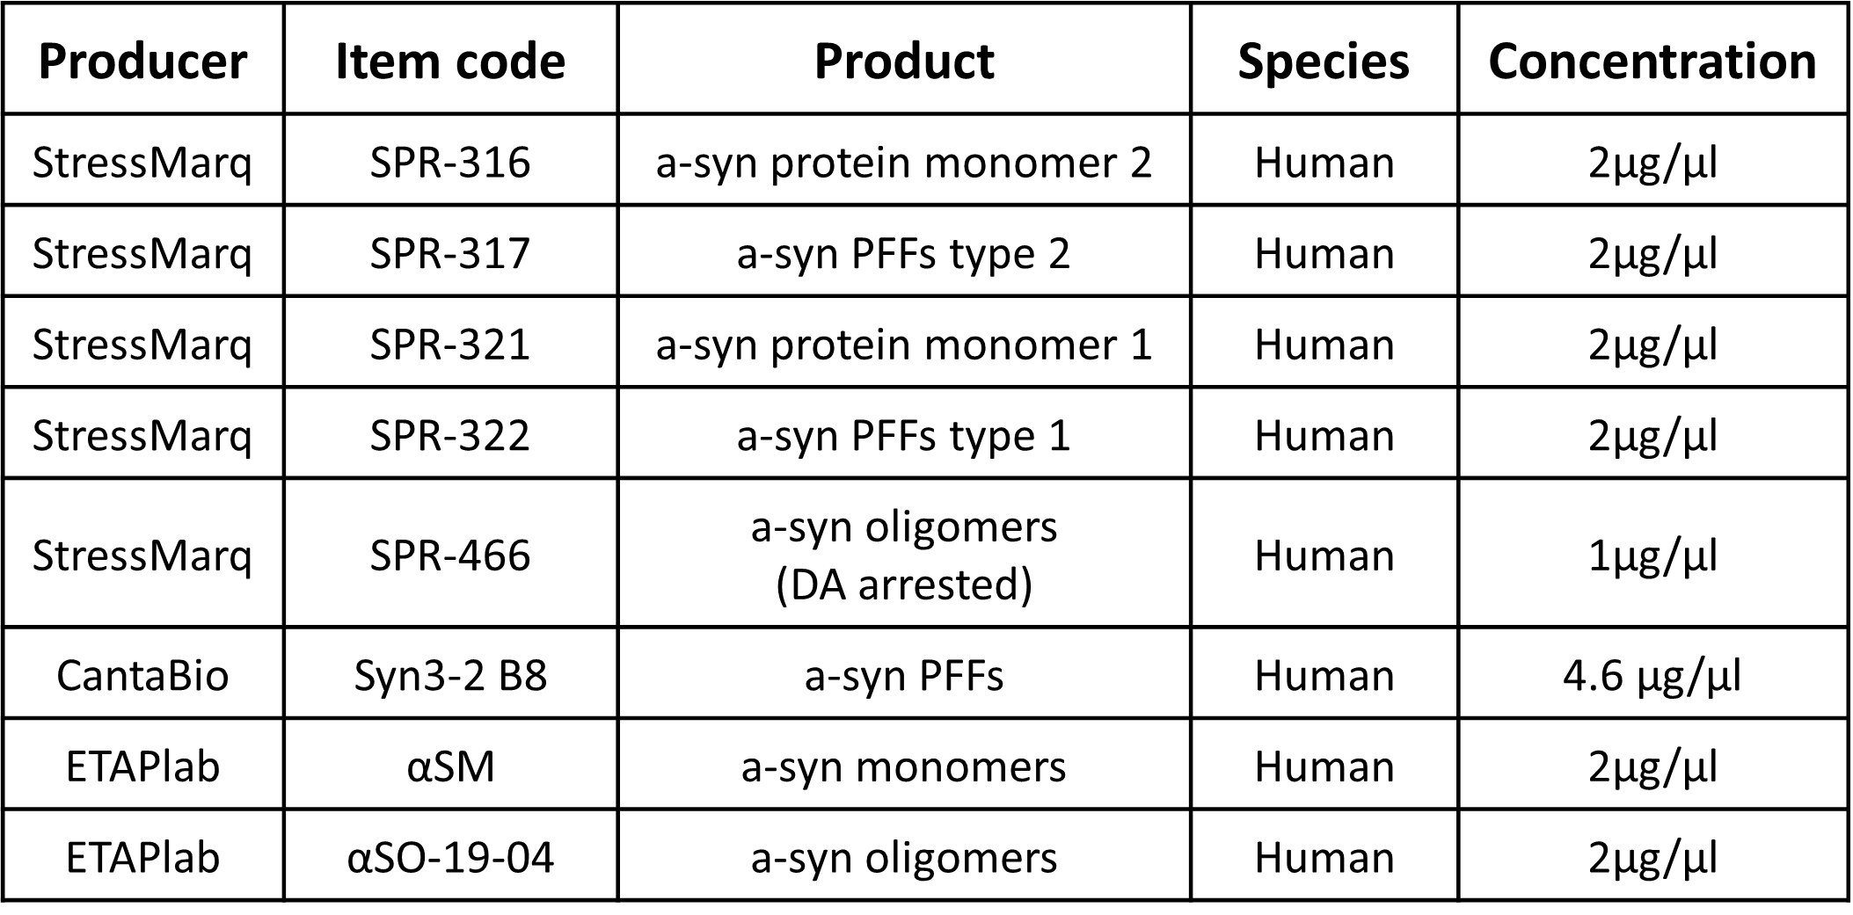
Figure 32 Electron Microscopy imaging of alpha-synuclein moieties
A) Representative images for alpha-synuclein monomers from each provider. All preparations were non sonicated. B) Representative images for alpha-synuclein oligomers for each provider. All were non sonicated. C) Representative images for alpha-synuclein pre-formed fibrils for each provider, with (top) or without (bottom) sonication.
Scale bars: Pink, 40nm; White, 100nm; Yellow, 200nm; Blue, 300nm.
Table 2 List of alpha-synuclein moieties analysed. The indicated concentration is that of the initial stock.

8.2 Alpha-synuclein oligomers and PFFs cause a dose-dependent cytotoxicity in LUHMES cells
Cytotoxicity was evaluated for all StressMarq alpha-synuclein moieties, and for Cantabio PFFs on neuronally differentiated LUHMES wild-type cells. Only one experiment was performed for type 1 and type 2 monomers (Figure 33A). Monomers were tested in concentrations ranging from 0.0005 to 5µM, for a 5-day exposure treatment. For all concentration, no cytotoxic effect was observed. StressMarq oligomers were characterised a bit more extensively. Two dose-response experiments assessing oligomers’ effect on cell viability after 24h for concentrations ranging from 0.0001 to 1µM were performed. Even despite a rather big variability before the two replicates, a trend for increased toxicity with dosage can be observed (Figure 33B). Cytotoxicity for 2, 12 and 24h exposure to 0.5 and 1µM concentrations was also evaluated. Again, there was some variability between the two replicates. Overall, the 0.5µM treatment did not seem to induce toxicity at any of the timepoints (Figure 33C, left), while 1µM oligomers treatment was toxic already at 2h (about 20% reduced cell viability), with the highest toxicity detected at 24h (Figure 33C, right). Overall, concentration more than exposure time seems to be the driving factor of oligomers’ cytotoxicity. To note, a 24h treatment with 1µM oligomers seemed to produce an average of 50% of reduction in cell variability both Figure 33B and 33C displaying a total of 4 independent experiments, suggesting that the toxic effect of the oligomeric moieties is indeed real. Only one experiment was available for pre-formed fibrils. PFFs were tested in serial dilutions ranging from 5 to 0.005µM, for a 5-day treatment. Both type 1 (yellow) and type 2 (orange) PFFs from StressMarq were not toxic at the lowest concentration, and showed to induce a dose-dependent cytotoxicity with a rapid decline to respectively 60 and 30% reduced viability at 0.5µM and only 20 and 10% residual viability at the highest tested dose (Figure 33D). Fibrils from Cantabio (red) showed a high toxic effect already at the lowest concentration, and cytotoxicity levels remained rather constant for all concentrations tested (Figure 33D). Previous reports on Cantabio PFFs action showed only a mild effect after 5 days of treatment, and thus are in contradiction with our findings. Therefore, this test would need to be repeated to understand if the differences observed are resulting from a technical issue or are a real biological consequence linked to the different cell type used.
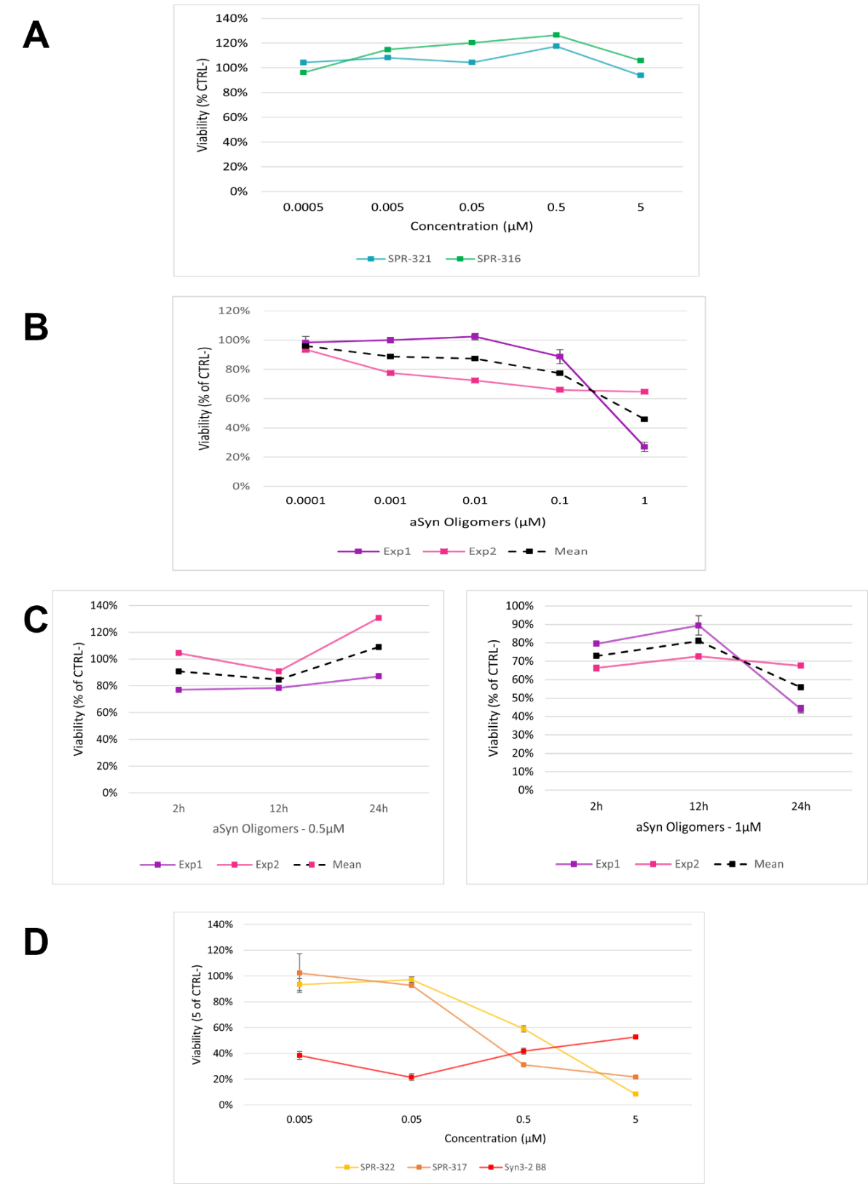
Figure 33 Oligomers and PFFs show dose-dependent toxicity on LUHMES WT cells
A) MTT test results for type 1 and type 2 monomers from StressMarq. Treatment was 5-days long. B) MTT test result for StressMarq oligomers after 24h treatment. C) MTT tests results of 2-, 12- and 24-hours treatment with 0.5 (left) or 1 (right) µM StressMarq oligomers. D) MTT test results for a 5-day treatment with different concentrations of PFFs. Each point represents a replicate, and each replicate is obtained by averaging the values of 4 wells of a 96-wells plate.
CTRL- = negative control (untreated cells), Exp1 = experiment/replicate 1, Exp2 = experiment/replicate 2, 2h = 2 hours treatment, 12h = 12 hours treatment, 24h = 24 hours treatment. References for alpha-synuclein moieties’ names are found in Table 2.

8.3 Glutamate excitotoxicity on LUHMES WT and DJ-1 cells
To investigate whether DJ-1 loss would predispose to neuronal excitotoxicity, we treated neuronally differentiated LUHMES wild-type (WT) and DJ-1 knock-down (DJ-1 KD) cells with glutamate. As a first step in our study, we confirmed the DJ-1 KD phenotype by RT-qPCR. DJ-1 KD cells showed reduced DJ-1 expression (~20% of the WT) at all differentiation stages, while expression in WT cells decreased with the differentiation process (Figure 34A). Next, we checked that both DJ-1 KD and WT cells were differentiating in comparable ways, by measuring transcript levels of the differentiation markers neuronal nuclei (NeuN), synapsin-1 (Syn1) and beta-tubulin III (Tuj1). NeuN and Syn1 were expressed only at low levels in undifferentiated and pre-differentiated WT and DJ-1 KD cells, and their expression increased significantly at the end of the differentiation process (Figure 34B, left and middle panels). Tuj1 expression levels showed a gradual increase along the differentiation process (Figure 33B, right). Expression of Tuj1 was also confirmed at the protein level through immunofluorescence (Figure 34C). Cells present a ramified appearance, indicative of their differentiation into neuronal cell types. Despite some intra-group variability, expression levels were not significatively different between WT and DJ-1 KD cells, confirming that cells of both genotypes differentiate correctly and in an equal fashion.
Glutamate excitotoxicity was tested for a 24h treatment with 0.01, 0.1, 1 and 10mM concentration. Treatment with 0.01 and 0.1mM concentrations was not toxic in WT cells, although it has to be kept in mind that only one experiment was available for this set-up (Figure 34D). More replicates were available for the 1 and 10mM concentrations. WT cells did not show reduction in cell viability following a 24h treatment with 1mM Glu, while the results were highly variable at 10mM, with some replicates showing no effect and others showing elevated cytotoxicity levels (Figure 34D). Four replicates were available for glutamate treatment of DJ-1 KD cells. Surprisingly, DJ-1 KD cells consistently showed a 50% toxicity with the lowest dose of glutamate, while the 0.1, 1 and 10mM concentrations seemed to be moderately toxic (Figure 34D). Even if only preliminary, these results suggest that DJ-1 KD cells might present higher susceptibility to glutamate excitotoxicity, with cytotoxic effect shown already at low doses of Glu exposure. Conversely, at high doses of Glu (10mM in our case), glutamate mediated excitotoxicity appears to affect WT and DJ-1 KD cells at similar levels, suggesting that protective mechanisms in WT cells can only compensate for low levels of glutamate stress.
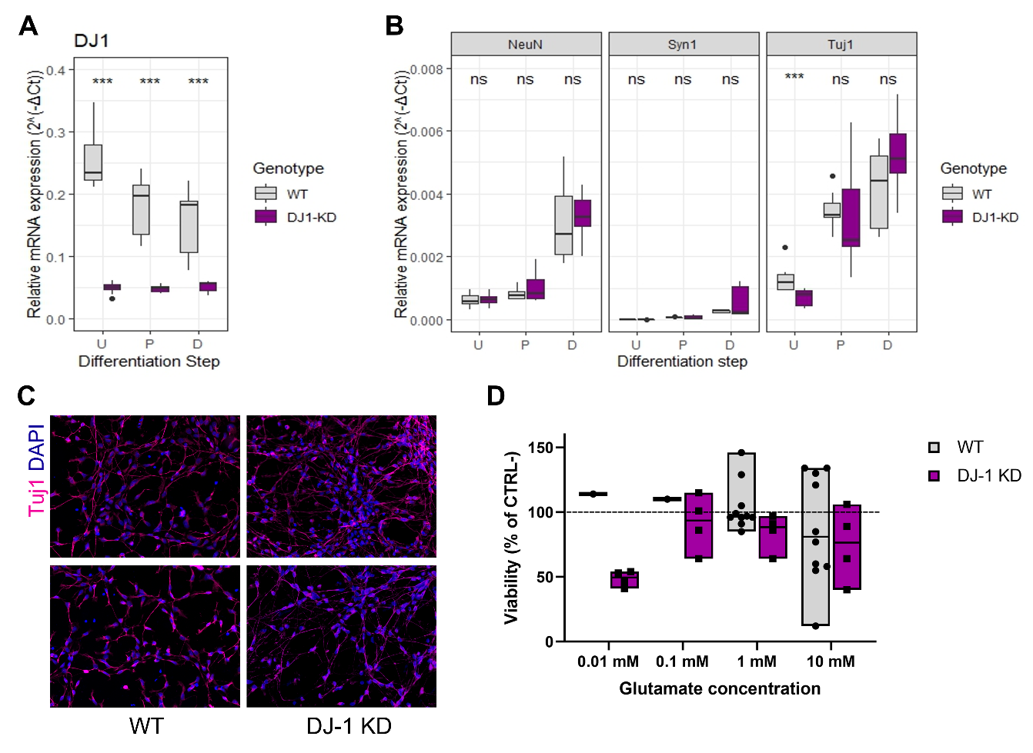
Figure 34 DJ-1 KD might determine increased susceptibility to low levels glutamate stress
A) Relative mRNA expression of DJ-1 in WT and DJ-1 KD LUHMES cells. Stats: Wilcoxon test, *** = p< 0.01. B) Relative mRNA expression levels for NeuN, Syp1 and Tuj1 in WT and DJ-1 KD LUHMES cells. Stats: Wilcoxon test, *** = p< 0.01. C) Representative immunofluorescence images for Tuj1 staining in differentiated WT and DJ-1 cells. 20X magnification. D) MTT test results showing glutamate excitotoxicity at 24h of treatment. Each point represents a replicate, and each replicate is obtained by averaging the values of 4 wells of a 96-wells plate. Stats: Kruskall-Wallis, non-significant.
WT = LUHMES wild-type cells, DJ-1 KD = LUHMES cells with stable knock-down of DJ-1, u = undifferentiated, P = pre-differentiated, D = differentiated, NeuN = neuronal nuclei, Syn1 = synapsin-1, Tuj1 = beta-tubulin III, CTRL- = negative control (untreated cells)

Part V

Discussion

Given its complexity and multifaceted presentation, the investigation of Parkinson’s disease’s pathological mechanisms is currently a challenge. On one hand, human samples are only available post-mortem, representing in the vast majority of cases the terminal endpoint of the pathology. This not only makes impossible to investigate the early phases of the disease, and how pathological and compensatory mechanisms interact over time, but also gives out an extremely complicated clinical image, made up by an overlap of protein aggregation, neurodegeneration, neuroinflammation and multi-level dysfunctions, that is challenging to analyse to say the least. On the other hand, in vivo and in vitro approaches allow for the selective investigation of specific pathways and their longitudinal contribution to PD pathogenesis, but with the risk of stepping into an oversimplification, thus resulting poorly translatable to the human medicine.
PD patients start to experience a variety of non-motor symptoms several years before diagnosis, suggesting that even if not clinically evident, PD pathology starts as early as two decades before a diagnosis can be made. At the appearance of motor symptoms, 60% of dopaminergic neurons in the Substantia Nigra are already lost (Fearnley and Lees 1990), meaning that studies which aim to understand the molecular mechanisms that lead to dopaminergic degeneration should focus on the prodromal phase of the disease. Since human tissue from the early stages of PD is for obvious reasons scarcely available, animal and cellular models are still an essential tool to investigate the longitudinal progression of PD phenotypes. Furthermore, animal models allow for the dissection of complex diseases into individual contributing factors, thus bringing us to a better understanding of phenotypes otherwise too complex to be interpreted. Nevertheless, we must not forget that such models present a series of limitations. First of all, mice present a 2-year lifespan and can be exposed to only a limited number of controlled challenges, while the human pathology takes decades to develop and results from the combination of genetic, environmental and lifestyle factors. The ability to reproduce only partially the complexity of the human disease can be a strength as well as a limitation of such models, and a non-negligible inter-model variability can be a challenge when trying to translate experimental observations to the human condition. Fundamentally, the reproducibility of some changes across different models will strengthen the relevance of such processes in disease pathogenesis. From this point of view, a good approach to avoid model artefacts and obtain more valuable results would be to investigate the same processes in, for example, alpha-synuclein dependent and independent models. Furthermore, different models are suitable for different purposes, making the choice of the most appropriate model perhaps the most important step in each research projects.
In this thesis, we have investigated three different mouse models and, partially, a cellular model of PD. We detail how each model presents specific and shared characteristics with the others, and how each one of them can be used in a different context to investigate specific aspects of PD pathogenesis.

The SNCA*E46K mouse model of early PD
Several regions of interest exist in the brain relative to PD pathology. The nigrostriatal pathway is an obvious choice, considering that its degeneration represents the main pathological feature of PD, and major cause of its classical motor symptoms. But PD pathological presentation is not only limited to motor symptoms, and particularly relevant are also cognitive features, especially when considering that 90% of PD patients presents at least one neuropsychiatric symptom (D Aarsland et al. 2007). In this regard, another important brain region worth investigating is the hippocampus.
SNCA*E46K transgenic mice expressed the human alpha-synuclein in both midbrain and hippocampus, with higher expression levels for both SNCA mRNA and protein detected in the latter. When both genders and more time points were investigated, SNCA mRNA levels appeared to increase, albeit not significantly, over time in both male and female mice, while protein levels increased only in females. Since murine Snca levels did not change between genotypes nor age groups, the differences observed in neurodegeneration and behavioural tests are to be attributed to the overexpression of transgenic alpha-synuclein only.
Dopaminergic neurons (DAn) degeneration has been shown to start at the axon terminals in the striatum and retrogradely progress to the Substantia Nigra, resulting in DAn loss (Cheng, Ulane, and Burke 2010). Compared to humans, DAn cell death appears to be harder to achieve in rodents, and to require a strong pathological insult such as neurotoxin treatment or pre-formed fibrils injection (Betarbet et al. 2000; Fornai et al. 2005; Garcia et al. 2020; Hernandez-Baltazar, Zavala-Flores, and Villanueva-Olivo 2017). When it comes to SNCA genetic models of PD, DAn loss is not observed even in high overexpressors such as the “Line 61” model, despite the elevated striatal axonal loss and the strong motor phenotype (Chesselet et al. 2012). Considering that acute neurotoxic events are rarely a cause for PD, and that the pathology evolves over time through the accumulation of smaller pathological insults, the use of milder models appears to be more translatable to the human condition. In milder genetic mouse models, DAn cell loss is rarely observed, but various degrees of degeneration in tyrosine hydroxylase (TH) positive fibres and dopamine transporter (DAT) positive axons can be present. Given that neurodegeneration in these mice does not extend beyond the striatum, they are generally considered as appropriate models for the early stages of neurodegeneration. We have shown that the SNCA*E46K appears to be one of such models, showing in female HET mice an age-dependent neurodegeneration in the striatum with significant fibres loss starting from 9-months of age, in absence of DAn loss in the substantia nigra.
Accordingly to the characteristics of early-PD model and the mild neurodegeneration, HET mice did not present sensory-motor impairments, the only exception being 8-months old HET males. Whereas a technical problem for this specific timepoint cannot be excluded, it is striking how male and female mice behaviour differ from one another, with female mice showing consistently better performances not only compared to WT females but also to HET males, especially at young ages. Even if this difference does not reach significance, it is a trend worth taking into consideration. It is possible that the differences in alpha-synuclein protein levels observed between male and female HET mice for the hippocampus are also present in the SN and/or the striatum; if similarly to the hippocampus females were to show lower alpha-synuclein levels at 3-months of age compared to males, this could explain the better performance in adhesive detection at a young age. Furthermore, sex could play a role in the response to alpha-synuclein overexpression, with male showing a worse response and thus a tendentially stronger sensory phenotype. At the oldest age of 17-months, both male and female HET mice perform equally to each other and equally to their wild-type littermates, virtually eliminating any difference that was observed at the earlier time points. Compensatory mechanisms to alpha-synuclein overexpression could be particularly active in male mice, allowing them to recover their sensory performance at later timepoints. Somatosensory deficits constitute a well-known non-motor symptom of PD, and are considered to be caused by a dysfunction of the basal ganglia (Juri, Rodriguez-Oroz, and Obeso 2010). PD patients show impaired tactile perception in active sensory stimulation tasks (Sathian et al. 1997), as well as hypoactivation of the sensory motor cortex in response to passive sensory stimulation (Boecker et al. 1999; Cao et al. 2011). Impaired tactile perception in humans appears to be caused by increased tactile and thermal sensory thresholds, accompanied by epidermal nerve fibres loss, nerve remodelling and demyelination (Nolano et al. 2008). Furthermore, sensory deficits have been shown to not always correlate with motor impairments (Cury et al. 2016). In light of these findings, the absence of a motor phenotype in presence of some degree of sensory deficit in SNCA*E46K transgenic mice supports the validity of this line as a model for early-PD pathology.
Similar conclusions can be reached when looking at the short-term memory impairment, as measured by performance in the Y-maze test. Here, male HET mice showed a significant impairment (p = 0.022) when compared to their WT littermates at 4-months of age, while no differences were detected for older male mice, or for female mice at any time point. Worse performance of young male HET mice might be explained by tendentially increased alpha-synuclein protein levels in the hippocampus at 3-months of age when compared to female mice, and compensatory mechanisms to alpha-synuclein overexpression might restore cognitive performance with ageing. Furthermore, the absence of a strong cognitive impairment might reflect the early-PD phenotype of this model, meaning that the alpha-synuclein insult might not be strong enough to cause a detectable phenotype over the compensatory response that is bound to happen during ageing.
Neurodegeneration is a complex process involving responses both at the protein and transcript level. While investigating the SNCA*E46K mouse model, we decided to focus on the transcriptional changes occurring in the substantia nigra and in the hippocampus in response to alpha-synuclein overexpression. In the midbrain, the majority of gene expression changes was detected at 3-months of age, long before any striatal neurodegeneration was detectable, and the number of differentially expressed genes sharply decreased with age as the degeneration took place. These findings indicate that gene expression regulation represents the earliest response to alpha-synuclein overexpression challenge, and are in agreement with what observed in other models (Miller et al. 2007). Impaired processes at the 3-months timepoint involved synaptic function, DAn differentiation and maintenance, mitochondrial translation, and calcium homeostasis, all known to be involved in PD pathogenesis. These changes can reflect the early signs of neuronal dysfunction, or the activation of the related pathways might represent the first compensatory mechanism to the disease challenge. Interestingly, no pathways related to neuroinflammation were identified. Absence of neuroinflammation could be the result of overexpression of transgenic SNCA in microglia which inhibits proper microglial function (Gardai et al. 2013), or the alpha-synuclein challenge could possibly be not strong enough to activate microglial response. Intra-striatal injection of alpha-synuclein PFFs has been shown to cause strong microglial activation at 3-months post-injection independently of phosphorylated alpha-synuclein deposition and neurodegeneration in WT mice, while the injection of alpha-synuclein oligomers provoked a stronger and faster (already at 13 days post-injection) microglial response (Garcia et al. 2020). It is possible that the alpha-synuclein species responsible for neuronal damage differ from those causing microglial activation, and that the latter are not majorly produced in the SNCA*E46K transgenic mouse. Age-dependent DEGs did not appear to increase or decrease with age, but rather to switch their directionality over time, possibly reflecting complex interactions and responses to the chronic alpha-synuclein overexpression injury. Age-dependent deregulated pathways were associated with cellular differentiation, synaptic activity and GPCR signalling. Since GPCRs can be targeted pharmacologically, related DEGs and proteins could represent potential druggable targets worth investigating further.
In the hippocampus, the majority of gene expression changes was linked to the ageing process more than to the transgene overexpression. Interestingly, once again we detected different patterns in male versus female transgenic mice, indicating that both sex and age play a factor in the response to SNCA overexpression. In particular, most of the gene expression changes were observed early for males (between 3- and 6-months of age), and at later times for females (between 8- and 14-months of age), with stronger changes for female mice. Our findings reflect the common knowledge that men and women do age differently, being this linked to biological factors such as hormonal levels, or to socio-economical status. Sexual dimorphism is observed in PD risk, with men showing increased prevalence but women presenting worse symptoms in many human populations (Morgan et al. 2014). Genes that appeared to be strongly differentially expressed in HET mice between two timepoints, showed only a mild regulation in WT animals and vice versa, indicating that WT and HET mice respond differently to the ageing challenge. On one hand, we could speculate that HET mice fail to activate pathways that are essential for healthy ageing. On the other, HET specific deregulated pathways might reflect the adaptative process to the alpha-synuclein challenge, thus potentially having a neuroprotective value. Indeed, deregulated pathways in both male and female HET mice were linked to synaptic membrane function, calcium and glutamate signalling, possibly reflecting the occurring synaptic dysfunction, or a compensatory overactivation in response to the neuronal degeneration.

The Park7^{-/-} (DJ-1 KO) mouse model
DJ-1 KO mouse models have been extensively characterised. They are reported to present mitochondrial impairments and increased susceptibility to oxidative stress (Giaime et al. 2012), and to present none to mild neurodegeneration accordingly to the murine strain they are developed onto (Rousseaux et al. 2012). Even in the absence of overt neurodegeneration, transcriptomic changes might be occurring in the midbrain (Miller et al. 2007), and their investigation can help to elucidate early pathogenetic molecular mechanisms leading to PD manifestation. In our model, transcriptomic changes between WT and DJ-1 KO mice are detected at 8-months of age, and are 8 times stronger in male versus female mice. Furthermore, when looking at the deregulated genes in male mice, a third of the DEGs appear to be sex specific. These results point in the direction of a higher susceptibility to the disease challenge in males, and overall indicate that not only genetic predisposition, but also the combination of ageing and sex plays a relevant role in PD-phenotype manifestation. Park7-linked familial cases of PD are rare, accounting for only about 1% of total cases (Abou-Sleiman et al. 2003), thus it is very hard to investigate sex dimorphisms in PD caused by DJ-1 loss of function. Nevertheless, since higher prevalence of sporadic PD is reported at least in some populations for male individuals, the different response in male and female mice towards DJ-1 knock-out is not totally surprising.
Our analyses pointed out oestrogen-related pathways as responsible for the transcriptomic changes observed in male DJ-1 KO mice. Oestrogens have been shown to provide neuroprotection in women (Picillo et al. 2017), thus lower levels of oestrogens might act in combination with DJ-1 KO to worsen pathological events in male mice. The alterations in the oestrogen-related pathways appeared to be mediated by CYP1B1, a member of the cytochrome P450 enzymatic family (CYPs) which is responsible for beta-oestradiol (E2) conversion in 4-OH catechol oestrogens (Parl et al. 2009). CYPs enzymes play an important role in oxidation of steroids, fatty acids, and xenobiotics (Danielson 2002). Some of the family members, including CYP1B1, have been reported to be regulated by the nuclear factor-erythroid 2 p45-related factor 2 (Nrf2) – antioxidant/electrophile response element (ARE) pathway (Hayes and Dinkova-Kostova 2014). Nrf2, also known as Nfe2l2, is a transcription factor involved in protection against oxidative stress and maintenance of the cellular redox homeostasis. Interestingly, Nrf2 has been shown to be stabilised by DJ-1, thus mediating the increase of oxidative stress in DJ-1 deficient cells (Clements et al. 2006). In post-mortem PD brains, nigral Nrf2 accumulation and increased expression of Nrf2 target proteins have been reported (van Muiswinkel et al. 2004; Ramsey et al. 2007, Schipper et al 1998). While Nrf2 levels have been shown to be increased in neurons (Ramsey et al. 2007), Nrf2 target genes appear to be strongly expressed in astrocytes (Van Muiswinkel et al. 2004; Schipper et al. 1998). In our mouse model, we could confirm Nrf2 expression in astrocytes closely located to the SN, supporting the potential involvement of Nrf2 in the observed gene expression deregulation. Overall, our results support the hypothesis that the increased susceptibility to DJ-1 loss of function observed in male mice is sex-dependent and mediated by the DJ-1/Nrf2/CYP1B1 axis.

The Thy1-Syn14 mouse model
Alpha-synuclein recovers a pivotal role in PD. Mutations in the synuclein gene, as well as gene multiplication are a direct cause of autosomal dominant PD (Polymeropoulos et al. 1997; Ross et al. 2008; Zarranz et al. 2004). But alpha-synuclein dysfunctions, first of all in the form of abnormal aggregation, are detected in idiopathic PD as well as in familial cases caused by mutations in genes different from SNCA (Dickson 2018; Spillantini et al. 1998). Therefore, the use of genetic models overexpressing wild-type alpha-synuclein, especially when such overexpression occurs at low to medium levels, is not to be limited to familial PD, but can prove to be relevant for idiopathic PD as well. The Thy1-Syn14 mouse model falls in this category, overexpressing transgenic wild-type human synuclein in the midbrain with a 2.91-fold increase, and in the striatum with a 6.67-fold increase, as well as in other brain regions and at lower levels in the colon.
Alpha-synuclein overexpression alone was sufficient to cause PD-like motor impairments that appeared to worsen with ageing. Such deficits were not directly linked to degeneration in the nigrostriatal pathway. Indeed, both male and female Thy1-Syn14 transgenic mice did not show loss of TH nor DAT positive synaptic terminals in the striatum even at the age of 14-months, and no significant transcriptomic changes were detected in the midbrain of female mice at 3- and 14-months. It is possible that the low levels of alpha-synuclein overexpression in the midbrain of Thy1-Syn14 transgenic mice are responsible for the lack of the classical nigrostriatal impairments often seen in PD mouse models. Nevertheless, the alpha-synuclein challenge encompasses several brain regions, such as the spinal cord, and the combined effect must be sufficiently strong to determine the observed motor phenotype.
Transgenic mice presented a lack of obvious microglial activation. On one hand, the regional alpha-synuclein insult might not be strong enough to activate a neuroinflammatory response; on the other, lack of neuroinflammation might reflect compensatory mechanism taking place in response to the alpha-synuclein challenge. Repeated administration of LPS has been shown to induce immune tolerance, downregulating microglial pro-inflammatory response in vitro and in vivo (Lajqi et al. 2020; Wendeln et al. 2018), and the resulting microglia desensitisation appeared to be neuroprotective in a mouse model of AD (Wendeln et al. 2018). We can speculate that the persistent alpha-synuclein challenge induces similar changes in the microglia profile in our model, thus preventing neuroinflammation. Finally, alpha-synuclein injection models have shown that microglia react to alpha-synuclein spreading but not necessarily to its accumulation, suggesting oligomers as the reactive species (Garcia et al. 2020). We can therefore speculate that microglia activating versus neuron damaging alpha-synuclein moieties are produced in different quantities in different models, thus explaining variable neuroinflammatory phenotypes across mouse lines.
Curli is a bacterial protein with amyloidogenic properties, which has been shown to stimulate alpha-synuclein aggregation and cause PD-like pathologies in vivo (Chen et al. 2016; Sampson et al. 2020). Similarly to Chen and colleagues, we observed alpha-synuclein protein accumulation in the gut of animals gavaged with Curli-producing E. coli. We did also detect increased levels of phosphorylated alpha-synuclein in the striatum and substantia nigra of Curli-exposed mice, a result which is in agreement with what reported by Sampson and colleagues. Furthermore, exposure to Curli exacerbated neurodegeneration in both brain regions. A diet poor in fibres has been shown to have dramatic effects on gut microbiota, forcing a foraging on host-secreted mucus glycoproteins and causing mucus erosion in return (Desai et al. 2016). The thinning of the mucus layer determines impairments in the colonic barrier function, exposing the host to greater bacterial access (Desai et al. 2016). In our model, fibre deprivation alone did not cause alpha-synuclein aggregation nor neurodegeneration, but it did exacerbate Curli-driven impairments, possibly by increasing the myenteric plexus’ exposure to Curli-producing E. coli. In the present study, we did not elucidate the mechanism of alpha-synuclein pathology propagation from the ENS to the CNS. According to Braak’s spreading hypothesis, alpha-synuclein deposition starts in the dorsal motor nucleus of the vagus nerve, and gradually moves towards higher brain regions, causing the progressive appearance of non-motor and motor symptoms (Braak et al. 2003). Moreover, epidemiological studies have associated truncal vagotomy with lower risk of PD (Liu et al. 2017). Propagation of alpha-synuclein pathology through the vagus was investigated by Kim and colleagues by injection of alpha-synuclein pre-formed fibrils in the gastro-intestinal tract of non-transgenic mice (S. Kim et al. 2019). They reported phosphorylated alpha-synuclein accumulations in the SN at 3-months after injection, and significant neurodegeneration at 7-months (S. Kim et al. 2019). Furthermore, truncal vagotomy abolished alpha-synuclein spreading (S. Kim et al. 2019). Overall, our results support the hypothesis of a gut-brain axis in PD, and the combinatorial action of genetic and life-style factors in disease initiation and progression, reinforcing the role of life-style adaptations in disease prevention and/or mitigation.

Common features across the SNCA*E46K, Park7^{-/-} and Thy1-Syn14 models
Even if based on different constructs, the three mouse model investigated did present some commonalities. Shared features between models might be worth to take into consideration, since they could highlight biologically relevant mechanisms involved in disease initiation and progression. Additionally, some of the discussed aspects play an important role in the obtained study results, and thus are worth considering during the initial study design.
First of all, we detected obvious sex-differences in the SNCA*E46K and DJ-1 KO models in terms of gene expression changes. The number of DEGs differed from male to female mice, with one sex being more affected by transcriptional changes than the other. Furthermore, transcriptional changes appeared to be a function of age and region. For example, in SNCA*E46K mice the highest number of DEGs was detected at 3-months of age in the midbrain, but at 8- and 14-months of age in the hippocampus, with the other timepoints showing few to none deregulated genes. Similar results were observed when comparing 3- and 8-months old DJ-1 KO mice. For Thy1-Syn14 mice, transcriptomic analyses are available only for female mice at young (3-months) and old (14-months) ages. Even if no transcriptional changes were observed at the investigated timepoints, we cannot exclude that transcriptional deregulation occurs at another age, nor we can be sure that male mice will show the same results. Sex-dimorphism was observed in SNCA*E46K mice and, to lesser extent in Thy1-Syn14 mice, also in terms of behavioural performance. Male transgenic SNCA*E46K mice showed stronger impairments in both the adhesive removal and the Y-maze tests. Male and female Thy1-Syn14 mice were evaluated together only at 6-months of age. At this timepoint, male transgenic mice showed some clasping phenotype (4/9 mice presented a clasping score of 1), while all transgenic females were scored 0. Despite the fact that Thy1-Syn14 transgenic male mice were significantly impaired already at 3-months of age, they did not show motor deficits in the adhesive removal test at 6-months while females did. Taken together, our results underline the importance of investigating both male and female mice, even when results of specific experiments at specific times do not show obvious differences between genders and might lead to the wrong conclusion that no sex-specific dissimilarities are present in the model at all. Furthermore, we highlight the importance of looking at the right timepoint, especially when evaluating dynamic processes such as gene expression regulation and transcriptional changes, or phenotypes that can change over time such as behavioural impairments.
Another common feature to the investigated alpha-synuclein overexpression models is the apparent lack of microglial involvement, an aspect that is not new in the field and that may have contributed to the under-investigation of neuroinflammation as a main pathological process in PD. Even if by indirect means, we did not observe evidence for microglial response in SNCA*E46K transgenic animals (via analysis of de-regulated pathways in both midbrain and hippocampus), nor in Thy1-Syn14 transgenic animals (via staining of Iba1 positive cells). In other models, the overexpression of alpha-synuclein alone has been shown to determine microglial activation (Su et al. 2008), and alpha-synuclein pre-formed fibrils and oligomers injections have been shown to induce differential microglia response in WT mice (Garcia et al. 2020), implying a role for variable alpha-synuclein species representation across models in the differential neuroinflammatory response. Moreover, repeated inflammatory stimulation through LPS administration has been shown to reduce microglial activation (Lajqi et al. 2020; Wendeln et al. 2018), suggesting immune tolerance could play a role in the lack of microglial response in some mouse models.
Many factors, such as the type of transgenic construct and the overexpression levels, can contribute to the variability observed between models, and inter-model variability could determine totally different outcomes following the same hypothesis. The selection of the most appropriate model represents therefore one of the most important steps in a study design.

Cellular models of neurotoxicity
Compared to mouse models, cellular 2D cultures are fast and cost-effective. Cellular models can be used to test simple hypothesis and to study molecular mechanisms following a specific stimulus. Lund human mesencephalic (LUHMES) cells are human embryonic neuronal precursor cells that can be easily and reliably differentiated to postmitotic neurons by treatment with appropriate differentiation factors. We used such differentiated cells to investigate the effects of alpha-synuclein and glutamate on cellular toxicity.
Analyses of alpha-synuclein moieties revealed a certain degree of variability in alpha-synuclein structure between different preparations/providers and, even if only a small set of experiments was performed, provided indications on variable effects on cellular toxicity. Alpha-synuclein moieties are routinely produced from E. coli, but a variety of different protocols are currently in use. Variations in protein extraction, purification and storage can alter alpha-synuclein aggregation properties and thus change the outcome of down-stream applications and induce replicability issues (Al-Azzani, König, and Outeiro 2022; Polinski et al. 2018). Not only differences from one laboratory to the other and from one producer to the other are present, but batch-to-batch variability has been reported even within the same provider. Our preliminary results confirm that lack of standardization in alpha-synuclein recombinant protein production is still an issue in the use of alpha-synuclein moieties in in vitro and in vivo studies.
Compared to the rather high variability observed in alpha-synuclein preparations, glutamate excitotoxicity is a way easier to control process. In our experiments, we have observed a high variability between replicates of the same experimental settings, especially for the 10mM treatment. These results are partially linked to the difficulties encountered in re-establishing cell culture after the shut-down of the laboratories following the SARS-COV-2 outbreak, thus it is difficult to dissect which is the biological relevance of our findings. Overall, results for DJ-1 KD cells treatment with low doses of glutamate seem to be more reliable, and suggest a higher susceptibility of DJ-1 KD cells to excitotoxicity. This is in agreement with the observations by Aleyasin and colleagues in DJ-1 KO cerebellar granule neurons (Aleyasin et al. 2007). Specifically, over-stimulation of glutamate receptors induces higher calcium influx and consequent ROS production and oxidative stress (Juurlink and Sweeney 1997). Loss of function or reduced levels of DJ-1 would render the cells less able to compensate for the oxidative stress, thus explaining the higher sensitivity to glutamate excitotoxicity.

Part VI

Conclusions and Future Perspectives

The work presented in this thesis offers a comparison between different PD disease models, highlighting their similarities and differences. Since the results on the cellular models were only preliminary, they will not be discussed further. On the other hand, the major findings of the presented research about PD mouse models can be summarised in: 1) genetic mouse models of PD (and potentially of other neurodegenerative diseases) present sex-dimorphic features that can range from low, as seen in the Thy1-Syn14 mouse, to strong, as presented in the DJ-1 KO mouse; 2) pathological events develop as a function of age, with changes appearing at certain timepoints but not others, or switching in directionality along the ageing process; 3) pathological events appear to be region-specific, with the same challenge, e.g. alpha-synuclein overexpression, leading to different outcomes accordingly to the brain region taken under analysis; 4) different mouse models reproduce different pathological features, and are thus suitable for the investigation of separate disease processes.
The already advanced pathological stage at diagnosis renders impossible to achieve proper cure of neurodegenerative diseases, so that treatment is only restricted to symptoms management and slowness of symptomatology progression. An early diagnosis, dependent on the development of early biomarkers, will be essential for advancement of therapeutic interventions in Parkinson’s and other neurodegenerative disorders. Unfortunately, the modelling of the prodromal phase of PD remains a challenge. In this thesis, we have focused on the use of genetic models presenting a mild phenotype either in terms of neuropathology or behavioural deficits, as our interest was in the investigation of the early stages of Parkinson’s disease. We have also investigated the effect of diet and microbial changes in the initiation and modulation of PD phenotype, following the idea that, at least in some cases, PD pathology originates in the periphery. We were able to assess progressive worsening of PD-like phenotypes, such as age-dependent neurodegeneration in the striatum of SNCA*E46K mice, or exacerbation of alpha-synuclein pathology in brain and gut of Thy1-Syn14 mice following 9-weeks long bacterial and diet challenges. Tracking back these changes and investigating a timepoint in the life of the mice when such impairments are not yet present, can give us an idea of what are the earliest event driving PD pathogenesis. Nevertheless, in these and other mouse models of PD, a full overlap with the human prodromal phase is still missing. Features such as sleep disturbances, constipation or hyposmia which are characteristic of prodromal PD are not common in animal models of the same pathology, or perhaps are still under investigated. Non-motor disturbances can be observed in toxic models (Greene, Noorian, and Srinivasan 2009; Rodrigues et al. 2014; Vo et al. 2014), but are rare and their analysis is generally hampered by the strong motor symptoms and neurodegenerative features. Better results are obtained with alpha-synuclein overexpressing models, where alpha-synuclein inclusions are sometimes reported in the olfactory bulb (Fleming et al. 2008; Taguchi et al. n.d.; S. Zhang, Xiao, and Le 2015). Overall, it is impossible for a single disease model to reproduce the whole spectrum of pre-clinical, prodromal, and clinical advanced stages of PD, nor this is the scope of disease modelling. Indeed, the possibility to dissect a complex multifactorial process into its constituent components, and to investigate the different stages of disease development separately is a feature that cannot be achieved when primarily utilising human specimens, and thus represents one of the major strengths of disease models. In this regard, mouse models are still an essential tool in neurodegenerative research, and the availability of models that can reproduce either prodromal or early neurodegenerative symptoms of human PD will be essential in biomarkers development for early diagnostics and therapeutic approaches.

Part VII

Bibliography

Aarsland, D et al. 2007. “Neuropsychiatric Symptoms in Patients with Parkinson’s Disease and Dementia: Frequency, Profile and Associated Care Giver Stress.” Journal of Neurology, Neurosurgery & Psychiatry 78(1): 36–42.
Aarsland, Dag et al. 2005. “Neuropathology of Dementia in Parkinson’s Disease: A Prospective, Community-Based Study.” Annals of Neurology 58(5): 773–76.
Aarsland et al. 2021. “Parkinson Disease-Associated Cognitive Impairment.” Nature Reviews Disease Primers 7(1): 47.
Abou-Sleiman, Patrick M. et al. 2003. “The Role of PathogenicDJ-1 Mutations in Parkinson’s Disease.” Annals of Neurology 54(3): 283–86.
Al-Azzani, Mohammed, Annekatrin König, and Tiago Fleming Outeiro. 2022. “Production of Recombinant Alpha-Synuclein: Still No Standardized Protocol in Sight.” Biomolecules 12(2): 324.
Aleyasin, Hossein et al. 2007. “The Parkinson’s Disease Gene DJ-1 Is Also a Key Regulator of Stroke-Induced Damage.” Proceedings of the National Academy of Sciences 104(47): 18748–53.
Andersen, Katrine B. et al. 2021. “Reduced Synaptic Density in Patients with Lewy Body Dementia: An [ ¹¹ C ] UCB‐J PET Imaging Study.” Movement Disorders 36(9): 2057–65.
Antony, Paul M. A., Nico J. Diederich, Rejko Krüger, and Rudi Balling. 2013. “The Hallmarks of Parkinson’s Disease.” FEBS Journal 280(23): 5981–93.
Arundine, M., and M. Tymianski. 2004. “Molecular Mechanisms of Glutamate-Dependent Neurodegeneration in Ischemia and Traumatic Brain Injury.” Cellular and Molecular Life Sciences (CMLS) 61(6): 657–68.
Ashrafi, Amer et al. 2017. “Absence of Regulator of G-Protein Signaling 4 Does Not Protect against Dopamine Neuron Dysfunction and Injury in the Mouse 6-Hydroxydopamine Lesion Model of Parkinson’s Disease.” Neurobiology of Aging 58: 30–33.
Aybek, Selma et al. 2009. “Hippocampal Atrophy Predicts Conversion to Dementia after STN-DBS in Parkinson’s Disease.” Parkinsonism & Related Disorders 15(7): 521–24.
Bandopadhyay, R. 2004. “The Expression of DJ-1 (PARK7) in Normal Human CNS and Idiopathic Parkinson’s Disease.” Brain 127(2): 420–30.
Ben Sassi, Samia et al. 2012. “Cognitive Dysfunction in Tunisian LRRK2 Associated Parkinson’s Disease.” Parkinsonism & Related Disorders 18(3): 243–46.
Bereczki, Erika et al. 2016. “Synaptic Proteins Predict Cognitive Decline in Alzheimer’s Disease and Lewy Body Dementia.” Alzheimer’s & Dementia 12(11): 1149–58.
Bertrand, Ewa et al. 2003. “Degenerative axonal changes in the hippocampus
and amygdala in Parkinson's disease.” Folia neuropathologica 41(4): 197–207.

Betarbet, Ranjita et al. 2000. “Chronic systemic pesticide exposure reproduces
features of Parkinson's disease.” Nature neuroscience 3(12): 1301–1306.

Bhattacharyya, KalyanB. 2022. “The Story of Levodopa: A Long and Arduous Journey.” Annals of Indian Academy of Neurology 25(1): 124.
Boecker, H. et al. 1999. “Sensory Processing in Parkinson’s and Huntington’s Disease.” Brain 122(9): 1651–65.
Bonifati, Vincenzo et al. 2003. “Mutations in the DJ-1 Gene Associated with Autosomal Recessive Early-Onset Parkinsonism.” Science 299(5604): 256–59.
Book, Adam et al. 2018. “A Meta-Analysis of α-Synuclein Multiplication in Familial Parkinsonism.” Frontiers in Neurology 9: 1021.
Braak, Heiko et al. 2003. “Staging of Brain Pathology Related to Sporadic Parkinson’s Disease.” Neurobiology of Aging 24(2): 197–211.
Breydo, Leonid, Jessica W. Wu, and Vladimir N. Uversky. 2012. “α-Synuclein Misfolding and Parkinson’s Disease.” Biochimica et Biophysica Acta (BBA) - Molecular Basis of Disease 1822(2): 261–85.
Bronstein, Jeff M. et al. 2011. “Deep Brain Stimulation for Parkinson Disease: An Expert Consensus and Review of Key Issues.” Archives of Neurology 68(2). http://archneur.jamanetwork.com/article.aspx?doi=10.1001/archneurol.2010.260 (November 22, 2022).
Brunnström, H., N. Friberg, E. Lindberg, and E. Englund. 2011. “Differential Degeneration of the Locus Coeruleus in Dementia Subtypes.” Clinical Neuropathology 30(05): 104–10.
Burré, Jacqueline, Manu Sharma, and Thomas C. Südhof. 2018. “Cell Biology and Pathophysiology of α-Synuclein.” Cold Spring Harbor Perspectives in Medicine 8(3): a024091.
Butler, Brittany, Danielle Sambo, and Habibeh Khoshbouei. 2017. “Alpha-Synuclein Modulates Dopamine Neurotransmission.” Journal of Chemical Neuroanatomy 83–84: 41–49.
Cannon, Jason R. et al. 2013. “Expression of Human E46K-Mutated α-Synuclein in BAC-Transgenic Rats Replicates Early-Stage Parkinson’s Disease Features and Enhances Vulnerability to Mitochondrial Impairment.” Experimental Neurology 240: 44–56.
Cao, H. et al. 2011. “Altered Brain Activation and Connectivity in Early Parkinson Disease Tactile Perception.” American Journal of Neuroradiology 32(10): 1969–74.
Cersosimo, Maria G., and Eduardo E. Benarroch. 2012. “Autonomic Involvement in Parkinson’s Disease: Pathology, Pathophysiology, Clinical Features and Possible Peripheral Biomarkers.” Journal of the Neurological Sciences 313(1–2): 57–63.
Chan-Palay, V., and E. Asan. 1989. “Alterations in Catecholamine Neurons of the Locus Coeruleus in Senile Dementia of the Alzheimer Type and in Parkinson’s Disease with and without Dementia and Depression.” The Journal of Comparative Neurology 287(3): 373–92.
Chartier-Harlin, Marie-Christine et al. 2004. “␣-Synuclein Locus Duplication as a Cause of Familial.” 364: 3.
Chaudhuri, K Ray, and Anthony HV Schapira. 2009. “Non-Motor Symptoms of Parkinson’s Disease: Dopaminergic Pathophysiology and Treatment.” The Lancet Neurology 8(5): 464–74.
Chen, Shu G. et al. 2016. “Exposure to the Functional Bacterial Amyloid Protein Curli Enhances Alpha-Synuclein Aggregation in Aged Fischer 344 Rats and Caenorhabditis Elegans.” Scientific Reports 6(1): 34477.
Cheng, Hsiao-Chun, Christina M. Ulane, and Robert E. Burke. 2010. “Clinical Progression in Parkinson Disease and the Neurobiology of Axons.” Annals of Neurology 67(6): 715–25.
Chesselet, Marie-Francoise et al. 2012. “A Progressive Mouse Model of Parkinson’s Disease: The Thy1-ASyn (‘Line 61’) Mice.” Neurotherapeutics 9(2): 297–314.
Choi, Woong et al. 2004. “Mutation E46K Increases Phospholipid Binding and Assembly into Filaments of Human α-Synuclein.” FEBS Letters 576(3): 363–68.
Churchyard, A., and A. J. Lees. 1997. “The Relationship between Dementia and Direct Involvement of the Hippocampus and Amygdala in Parkinson’s Disease.” Neurology 49(6): 1570–76.
Clements, Casey M. et al. 2006. “DJ-1, a Cancer- and Parkinson’s Disease-Associated Protein, Stabilizes the Antioxidant Transcriptional Master Regulator Nrf2.” Proceedings of the National Academy of Sciences 103(41): 15091–96.
Coon, Elizabeth A., and Wolfgang Singer. 2020. “Synucleinopathies:” CONTINUUM: Lifelong Learning in Neurology 26(1): 72–92.
Cury, R.G. et al. 2016. “Sensory Abnormalities and Pain in Parkinson Disease and Its Modulation by Treatment of Motor Symptoms.” European Journal of Pain 20(2): 151–65.
Danielson, PB. 2002. “The Cytochrome P450 Superfamily: Biochemistry, Evolution and Drug Metabolism in Humans.” Current Drug Metabolism 3(6): 561–97.
Datta, Indrani, Kavina Ganapathy, Rema Razdan, and Ramesh Bhonde. 2018. “Location and Number of Astrocytes Determine Dopaminergic Neuron Survival and Function Under 6-OHDA Stress Mediated Through Differential BDNF Release.” Molecular Neurobiology 55(7): 5505–25.
Desai, Mahesh S. et al. 2016. “A Dietary Fiber-Deprived Gut Microbiota Degrades the Colonic Mucus Barrier and Enhances Pathogen Susceptibility.” Cell 167(5): 1339-1353.e21.
Dexter, David T. et al. 1994. “Increased Levels of Lipid Hydroperoxides in the Parkinsonian Substantia Nigra: An HPLC and ESR Study.” Movement Disorders 9(1): 92–97.
Dickson, Dennis W. 2018. “Neuropathology of Parkinson Disease.” Parkinsonism & Related Disorders 46: S30–33.
Domingues, Ana V. et al. 2020. “Glial Cells in Parkinson´s Disease: Protective or Deleterious?” Cellular and Molecular Life Sciences 77(24): 5171–88.
Emre, Murat. 2004. “Dementia in Parkinson’s Disease: Cause and Treatment.” Current Opinion in Neurology 17(4): 399–404.
Fearnley, J. M., and A. J. Lees. 1990. “STRIATONIGRAL DEGENERATION: A CLINICOPATHOLOGICAL STUDY.” Brain 113(6): 1823–42.
Fenelon, G. 2000. “Hallucinations in Parkinson’s Disease: Prevalence, Phenomenology and Risk Factors.” Brain 123(4): 733–45.
Fleming, Sheila M. et al. 2008. “Olfactory Deficits in Mice Overexpressing Human Wildtype -Synuclein.” European Journal of Neuroscience 28(2): 247–56.
Floor, Erik, and Mary G. Wetzel. 2002. “Increased Protein Oxidation in Human Substantia Nigra Pars Compacta in Comparison with Basal Ganglia and Prefrontal Cortex Measured with an Improved Dinitrophenylhydrazine Assay.” Journal of Neurochemistry 70(1): 268–75.
Fornai, Francesco et al. 2005. “Parkinson-like syndrome induced by continuous
MPTP infusion: convergent roles of the ubiquitin-proteasome system and alpha-synuclein.” Proceedings of the National Academy of Sciences of the United States of America, 102(9): 3413–3418.
Fuchs, J. et al. 2007. “Phenotypic Variation in a Large Swedish Pedigree Due to SNCA Duplication and Triplication.” Neurology 68(12): 916–22.
Fujiwara, Hideo et al. 2002. “α-Synuclein Is Phosphorylated in Synucleinopathy Lesions.” Nature Cell Biology 4(2): 160–64.
Garcia, Pierre et al. 2020. Neurodegeneration and Neuroinflammation Are Linked, but Independent of α -Synuclein Inclusions, in a Seeding/Spreading Mouse Model of Parkinson’s Disease. Neuroscience. preprint. http://biorxiv.org/lookup/doi/10.1101/2020.08.05.237750 (April 5, 2022).
Gardai, Shyra J. et al. 2013. “Elevated Alpha-Synuclein Impairs Innate Immune Cell Function and Provides a Potential Peripheral Biomarker for Parkinson’s Disease” ed. Kostas Vekrellis. PLoS ONE 8(8): e71634.
Giaime, Emilie et al. 2012. “Loss of DJ-1 Does Not Affect Mitochondrial Respiration but Increases ROS Production and Mitochondrial Permeability Transition Pore Opening” ed. Marcel P. van der Brug. PLoS ONE 7(7): e40501.
Giladi, N et al. 2000. “Risk Factors for Dementia, Depression and Psychosis in Long-Standing Parkinson’s Disease.” : 13.
Goetz, Christopher G., Murat Emre, and Bruno Dubois. 2009. “Parkinson’s Disease Dementia: Definitions, Guidelines, and Research Perspectives in Diagnosis.” Annals of Neurology 64(S2): S81–92.
Goldman, Jennifer G. et al. 2012. “Entorhinal Cortex Atrophy Differentiates Parkinson’s Disease Patients with and without Dementia: Entorhinal Cortex Parkinson’s Disease Dementia.” Movement Disorders 27(6): 727–34.
Goris, An et al. 2007. “Tau and α-Synuclein in Susceptibility to, and Dementia in, Parkinson’s Disease.” Annals of Neurology 62(2): 145–53.
Greene, James G., Ali Reza Noorian, and Shanthi Srinivasan. 2009. “Delayed Gastric Emptying and Enteric Nervous System Dysfunction in the Rotenone Model of Parkinson’s Disease.” Experimental Neurology 218(1): 154–61.
Guzman, Jaime N. et al. 2010. “Oxidant Stress Evoked by Pacemaking in Dopaminergic Neurons Is Attenuated by DJ-1.” Nature 468(7324): 696–700.
Haikal, Caroline et al. 2021. “The Bacterial Amyloids Phenol Soluble Modulins from Staphylococcus Aureus Catalyze Alpha-Synuclein Aggregation.” International Journal of Molecular Sciences 22(21): 11594.
Halliday, Glenda M., James B. Leverenz, Jay S. Schneider, and Charles H. Adler. 2014. “The Neurobiological Basis of Cognitive Impairment in Parkinson’s Disease: Neurobiology of Parkinson’s Disease Dementia.” Movement Disorders 29(5): 634–50.
Hanagasi, Hasmet A., Zeynep Tufekcioglu, and Murat Emre. 2017. “Dementia in Parkinson’s Disease.” Journal of the Neurological Sciences 374: 26–31.
Hao, Ling-Yang, Benoit I. Giasson, and Nancy M. Bonini. 2010. “DJ-1 Is Critical for Mitochondrial Function and Rescues PINK1 Loss of Function.” Proceedings of the National Academy of Sciences 107(21): 9747–52.
Hayes, John D., and Albena T. Dinkova-Kostova. 2014. “The Nrf2 Regulatory Network Provides an Interface between Redox and Intermediary Metabolism.” Trends in Biochemical Sciences 39(4): 199–218.
Hely, Mariese A. et al. 2008. “The Sydney Multicenter Study of Parkinson’s Disease: The Inevitability of Dementia at 20 Years: Twenty Year Sydney Parkinson’s Study.” Movement Disorders 23(6): 837–44.
Hendrickx, Diana M. et al. 2021. “A New Synuclein-Transgenic Mouse Model for Early Parkinson’s Reveals Molecular Features of Preclinical Disease.” Molecular Neurobiology 58(2): 576–602.
Hernandez-Baltazar, D et al. 2017. “The 6-hydroxydopamine model and
parkinsonian pathophysiology: Novel findings in an older model.” Neurologia (Barcelona, Spain) 32(8): 533–539.
Hilton, David et al. 2014. “Accumulation of α-Synuclein in the Bowel of Patients in the Pre-Clinical Phase of Parkinson’s Disease.” Acta Neuropathologica 127(2): 235–41.
Hirano, Shigeki, Hitoshi Shinotoh, and David Eidelberg. 2012. “Functional Brain Imaging of Cognitive Dysfunction in Parkinson’s Disease.” Journal of Neurology, Neurosurgery & Psychiatry 83(10): 963–69.
Hoehn, Margaret M. “Parkinsonism: Onset, Progression, and Mortality.” : 17.
Hollerman, Jeffrey R., Leon Tremblay, and Wolfram Schultz. 2000. “Involvement of Basal Ganglia and Orbitofrontal Cortex in Goal-Directed Behavior.” In Progress in Brain Research, Elsevier, 193–215. https://linkinghub.elsevier.com/retrieve/pii/S0079612300260159 (November 22, 2022).
Holmqvist, Staffan et al. 2014. “Direct Evidence of Parkinson Pathology Spread from the Gastrointestinal Tract to the Brain in Rats.” Acta Neuropathologica 128(6): 805–20.
Horsager, Jacob et al. 2020. “Brain-First versus Body-First Parkinson’s Disease: A Multimodal Imaging Case-Control Study.” Brain 143(10): 3077–88.
Horvath, Judit et al. 2013. “Neuropathology of Dementia in a Large Cohort of Patients with Parkinson’s Disease.” Parkinsonism & Related Disorders 19(10): 864–68.
Ibarretxe-Bilbao, N. et al. 2008. “Hippocampal Head Atrophy Predominance in Parkinson’s Disease with Hallucinations and with Dementia.” Journal of Neurology 255(9): 1324–31.
Irwin, David J, and Hurtig, Howard I 2018. “The Contribution of Tau, Amyloid-Beta and Alpha-Synuclein Pathology to Dementia in Lewy Body Disorders.” Journal of Alzheimer’s Disease & Parkinsonism 08(04). https://www.omicsonline.org/open-access/the-contribution-of-tau-amyloidbeta-and-alphasynuclein-pathology-todementia-in-lewy-body-disorders-2161-0460-1000444-103649.html (March 15, 2023).
Jellinger, Kurt A. 2012. “Neurobiology of Cognitive Impairment in Parkinson’s Disease.” Expert Review of Neurotherapeutics 12(12): 1451–66.
Jia, Xiuqin et al. 2019. “Entorhinal Cortex Atrophy in Early, Drug-Naive Parkinson’s Disease with Mild Cognitive Impairment.” Aging and disease 10(6): 1221.
Junn, Eunsung et al. 2009. “Mitochondrial Localization of DJ-1 Leads to Enhanced Neuroprotection.” Journal of Neuroscience Research 87(1): 123–29.
Juri, Carlos, MariCruz Rodriguez-Oroz, and Jose A. Obeso. 2010. “The Pathophysiological Basis of Sensory Disturbances in Parkinson’s Disease.” Journal of the Neurological Sciences 289(1–2): 60–65.
Juurlink, Bernhard H.J, and Marva I Sweeney. 1997. “Mechanisms That Result in Damage During and Following Cerebral Ischemia.” Neuroscience & Biobehavioral Reviews 21(2): 121–28.
Kahle, Philipp J et al. “Subcellular Localization of Wild-Type and Parkinson’s Disease-Associated Mutant ␣-Synuclein in Human and Transgenic Mouse Brain.”
Kalia, Lorraine V, and Anthony E Lang. 2015. “Parkinson’s Disease.” The Lancet 386(9996): 896–912.
Kandiah, Nagaendran et al. 2014. “Hippocampal Volume and White Matter Disease in the Prediction of Dementia in Parkinson’s Disease.” Parkinsonism & Related Disorders 20(11): 1203–8.
Kasten, Meike et al. 2018. “Genotype-Phenotype Relations for the Parkinson’s Disease Genes Parkin , PINK1 , DJ1: MDSGene Systematic Review: MDSGene REVIEW: Parkin , PINK1 , DJ1.” Movement Disorders 33(5): 730–41.
Khan, Naheed L. et al. 2003. “Parkin Disease: A Phenotypic Study of a Large Case Series.” Brain 126(6): 1279–92.
Killiany, R. J. et al. 2002. “MRI Measures of Entorhinal Cortex vs Hippocampus in Preclinical AD.” Neurology 58(8): 1188–96.
Kim, Raymond H. et al. 2005. “Hypersensitivity of DJ-1-Deficient Mice to 1-Methyl-4-Phenyl-1,2,3,6-Tetrahydropyrindine (MPTP) and Oxidative Stress.” Proceedings of the National Academy of Sciences 102(14): 5215–20.
Kim, Sangjune et al. 2019. “Transneuronal Propagation of Pathologic α-Synuclein from the Gut to the Brain Models Parkinson’s Disease.” Neuron 103(4): 627-641.e7.
Kövari, Enikö et al. 2003. “Lewy Body Densities in the Entorhinal and Anterior Cingulate Cortex Predict Cognitive Deficits in Parkinson’s Disease.” Acta Neuropathologica 106(1): 83–88.
Krebiehl, Guido et al. 2010. “Reduced Basal Autophagy and Impaired Mitochondrial Dynamics Due to Loss of Parkinson’s Disease-Associated Protein DJ-1” ed. Leonard Petrucelli. PLoS ONE 5(2): e9367.
Krüger, Reiko et al. 1998. “Ala30Pro mutation in the gene encoding alpha-
synuclein in Parkinson's disease.” Nature genetics 18(2): 106–108.
Kunst, Jonas et al. 2019. “Patterns of Grey Matter Atrophy at Different Stages of Parkinson’s and Alzheimer’s Diseases and Relation to Cognition.” Brain Topography 32(1): 142–60.
Lajqi, Trim et al. 2020. “Memory-Like Responses of Brain Microglia Are Controlled by Developmental State and Pathogen Dose.” Frontiers in Immunology 11: 546415.
Lavenex, Pierre, and David G. Amaral. 2000. “Hippocampal-Neocortical Interaction: A Hierarchy of Associativity.” Hippocampus 10(4): 420–30.
Lech, Robert K., and Boris Suchan. 2013. “The Medial Temporal Lobe: Memory and Beyond.” Behavioural Brain Research 254: 45–49.
Lenka, Abhishek et al. 2018. “Hippocampal Subfield Atrophy in Patients with Parkinson’s Disease and Psychosis.” Journal of Neural Transmission 125(9): 1361–72.
Lev, Nirit et al. 2013. “Knocking Out DJ-1 Attenuates Astrocytes Neuroprotection Against 6-Hydroxydopamine Toxicity.” Journal of Molecular Neuroscience 50(3): 542–50.
Levy, G, Y Stern, and K Marder. “The Association of Incident Dementia with Mortality in PD.” : 7.
Lichter, David Gordon, Ralph Holmes Boring Benedict, and Linda Ann Hershey. 2018. “2 Importance of Balance-Gait Disorder 3 as a Risk Factor for Cognitive Impairment, 4 Dementia and Related Non-Motor 5 Symptoms in Parkinson’s Disease.” : 14.
Litvan, Irene et al. 2012. “Diagnostic Criteria for Mild Cognitive Impairment in Parkinson’s Disease: Movement Disorder Society Task Force Guidelines: PD-MCI Diagnostic Criteria.” Movement Disorders 27(3): 349–56.
Liu, Bojing et al. 2017. “Vagotomy and Parkinson Disease: A Swedish Register–Based Matched-Cohort Study.” Neurology 88(21): 1996–2002.
Marder, K. et al. 1995. “The Frequency and Associated Risk Factors for Dementia in Patients With Parkinson’s Disease.” Archives of Neurology 52(7): 695–701.
Marion, M.-H., M. Qurashi, G. Marshall, and O. Foster. 2008. “Is REM Sleep Behaviour Disorder (RBD) a Risk Factor of Dementia in Idiopathic Parkinson’s Disease?” Journal of Neurology 255(2): 192–96.
Mattila, Petri M. et al. 2001. “Choline Acetyltransferase Activity and Striatal Dopamine Receptors in Parkinson’s Disease in Relation to Cognitive Impairment.” Acta Neuropathologica 102(2): 160–66.
Miller, Renee M. et al. 2007. “Wild-Type and Mutant α-Synuclein Induce a Multi-Component Gene Expression Profile Consistent with Shared Pathophysiology in Different Transgenic Mouse Models of PD.” Experimental Neurology 204(1): 421–32.
Mitsumoto, Atsushi, and Yasuhito Nakagawa. 2001. “DJ-1 Is an Indicator for Endogenous Reactive Oxygen Species Elicited by Endotoxin.” Free Radical Research 35(6): 885–93.
Miyazaki, Ikuko et al. 2011. “Astrocyte-Derived Metallothionein Protects Dopaminergic Neurons from Dopamine Quinone Toxicity.” Glia 59(3): 435–51.
Miyazaki, Ikuko, and Masato Asanuma. 2020. “Neuron-Astrocyte Interactions in Parkinson’s Disease.” Cells 9(12): 2623.
Morgan, John C. et al. 2014. “Mortality in Levodopa-Treated Parkinson’s Disease.” Parkinson’s Disease 2014: 1–8.
Mosharov, Eugene V. et al. 2009. “Interplay between Cytosolic Dopamine, Calcium, and α-Synuclein Causes Selective Death of Substantia Nigra Neurons.” Neuron 62(2): 218–29.
van Muiswinkel, F.L et al. 2004. “Expression of NAD(P)H:Quinone Oxidoreductase in the Normal and Parkinsonian Substantia Nigra.” Neurobiology of Aging 25(9): 1253–62.
Mullett, Steven J., Roberto Di Maio, J. Timothy Greenamyre, and David A. Hinkle. 2013. “DJ-1 Expression Modulates Astrocyte-Mediated Protection Against Neuronal Oxidative Stress.” Journal of Molecular Neuroscience 49(3): 507–11.
Nagano-Saito, A. et al. 2005. “Cerebral Atrophy and Its Relation to Cognitive Impairment in Parkinson Disease.” Neurology 64(2): 224–29.
Nolano, M. et al. 2008. “Sensory Deficit in Parkinson’s Disease: Evidence of a Cutaneous Denervation.” Brain 131(7): 1903–11.
Pagonabarraga, Javier, and Jaime Kulisevsky. 2012. “Cognitive Impairment and Dementia in Parkinson’s Disease.” Neurobiology of Disease 46(3): 590–96.
Pan, Ping Lei et al. 2013. “Gray Matter Atrophy in Parkinson’s Disease with Dementia: Evidence from Meta-Analysis of Voxel-Based Morphometry Studies.” Neurological Sciences 34(5): 613–19.
Pankratz, Nathan et al. 2006. “Presence of an APOE4 allele results in
significantly earlier onset of Parkinson's disease and a higher risk with dementia.” Movement disorders: official journal of the Movement Disorder Society 21(1): 45–49.
Parkinson, James. 2002. “An Essay on the Shaking Palsy.” J Neuropsychiatry Clin Neurosci: 14.
Parl, Fritz F et al. 2009. “Estrogen Metabolism and Breast Cancer: A Risk
Model Annals of the New York Academy of Sciences 1155: 68–75.
Pedersen, Kenn Freddy, Jan Petter Larsen, Ole-Bjorn Tysnes, and Guido Alves. 2013. “Prognosis of Mild Cognitive Impairment in Early Parkinson Disease: The Norwegian ParkWest Study.” JAMA Neurology 70(5): 580.
Pereira, Joana B. et al. 2013. “Regional Vulnerability of Hippocampal Subfields and Memory Deficits in Parkinson’s Disease: Hippocampal Subfields in PD.” Hippocampus 23(8): 720–28.
Pereira, Joana B. 2020. “Longitudinal Degeneration of the Basal Forebrain Predicts Subsequent Dementia in Parkinson’s Disease.” Neurobiology of Disease 139: 104831.
Perry, E K et al. 1978. “Correlation of Cholinergic Abnormalities with Senile Plaques and Mental Test Scores in Senile Dementia.” BMJ 2(6150): 1457–59.
Pham, TT et al. 2010. “DJ-1-deficient mice show less TH-positive neurons in
the ventral tegmental area and exhibit non-motoric behavioural impairments.” Genes, brain, and behavior 9(3): 305–317.
Picillo, Marina et al. 2017. “The Relevance of Gender in Parkinson’s Disease: A Review.” Journal of Neurology 264(8): 1583–1607.
Pigott, Kara et al. 2015. “Longitudinal Study of Normal Cognition in Parkinson Disease.” Neurology 85(15): 1276–82.
Poewe, Werner et al. 2017. “Parkinson disease.” Nature reviews. Disease
primers 3(1):17013
Polinski, Nicole K. et al. 2018. “Best Practices for Generating and Using Alpha-Synuclein Pre-Formed Fibrils to Model Parkinson’s Disease in Rodents.” Journal of Parkinson’s Disease 8(2): 303–22.
Polymeropoulos, Mihael H. et al. 1997. “Mutation in the α-Synuclein Gene Identified in Families with Parkinson’s Disease.” Science 276(5321): 2045–47.
Postuma, Ronald B. et al. 2015. “MDS Clinical Diagnostic Criteria for Parkinson’s Disease: MDS-PD Clinical Diagnostic Criteria.” Movement Disorders 30(12): 1591–1601.
Ramsey, Chenere P. et al. 2007. “Expression of Nrf2 in Neurodegenerative Diseases:” Journal of Neuropathology and Experimental Neurology 66(1): 75–85.
Reiszadeh Jahromi, Samaneh, S. R. Ramesh, David I. Finkelstein, and Mohammad Haddadi. 2021. “α-Synuclein E46K Mutation and Involvement of Oxidative Stress in a Drosophila Model of Parkinson’s Disease” ed. Hélio Teive. Parkinson’s Disease 2021: 1–12.
Reuss, Bernhard, and Klaus Unsicker. 2000. “Survival and Differentiation of Dopaminergic Mesencephalic Neurons Are Promoted by Dopamine-Mediated Induction of FGF-2 in Striatal Astroglial Cells.” Molecular and Cellular Neuroscience 16(6): 781–92.
Rinne, Juha O., Jaana Rummukainen Mlic, Leo Paljärvi, and Urpo K. Rinne. 1989. “Dementia in Parkinson’s Disease Is Related to Neuronal Loss in the Medial Substantia Nigra: Dementia in Nigral Degeneration.” Annals of Neurology 26(1): 47–50.
Rodrigues, Lais S. et al. 2014. “Olfactory Impairment in the Rotenone Model of Parkinsonâ€TMs Disease Is Associated with Bulbar Dopaminergic D2 Activity after REM Sleep Deprivation.” Frontiers in Cellular Neuroscience 8. http://journal.frontiersin.org/article/10.3389/fncel.2014.00383/abstract (February 14, 2023).
Rodriguez, Jose A. et al. 2015. “Structure of the Toxic Core of α-Synuclein from Invisible Crystals.” Nature 525(7570): 486–90.
Romo-Gutiérrez, Diego 2015. “Factores genéticos de la demencia en la
enfermedad de Parkinson (EP) [Genetic factors associated with dementia in Parkinson's disease (PD)].” Gaceta medica de Mexico 151(1): 110–118.
Ross, Owen A. et al. 2008. “Genomic Investigation of α-Synuclein Multiplication and Parkinsonism.” Annals of Neurology 63(6): 743–50.
Rousseaux, Maxime W. C. et al. 2012. “Progressive Dopaminergic Cell Loss with Unilateral-to-Bilateral Progression in a Genetic Model of Parkinson Disease.” Proceedings of the National Academy of Sciences 109(39): 15918–23.
Sampson, Timothy R et al. 2020. “A Gut Bacterial Amyloid Promotes α-Synuclein Aggregation and Motor Impairment in Mice.” eLife 9: e53111.
Santangelo, Gabriella et al. 2015. “Mild Cognitive Impairment in Newly Diagnosed Parkinson’s Disease: A Longitudinal Prospective Study.” Parkinsonism & Related Disorders 21(10): 1219–26.
Sasikumar, Sanskriti, and Antonio P. Strafella. 2020. “Imaging Mild Cognitive Impairment and Dementia in Parkinson’s Disease.” Frontiers in Neurology 11: 47.
Sathian, K, J Green, J L Vitek, and M R DeLong. “Tactile Spatial Acuity and Roughness Discrimination:”
Schaser, Allison J. et al. 2019. “Alpha-Synuclein Is a DNA Binding Protein That Modulates DNA Repair with Implications for Lewy Body Disorders.” Scientific Reports 9(1): 10919.
Schipper, Hyman M. et al. 1998. “Neural heme oxygenase-1 expression in idiopathic Parkinson's
disease.” Experimental neurology 150(1): 60–68.
Schmit, Kristopher J et al. 2022. Dietary Fibre Deprivation and Bacterial Curli Exposure Shift Gut Microbiome and Exacerbate Parkinson’s Disease-like Pathologies in an Alpha-Synuclein-Overexpressing Mouse. Neuroscience. preprint. http://biorxiv.org/lookup/doi/10.1101/2022.03.21.485143 (December 13, 2022).
Sekeres, Melanie J., Gordon Winocur, and Morris Moscovitch. 2018. “The Hippocampus and Related Neocortical Structures in Memory Transformation.” Neuroscience Letters 680: 39–53.
Semchuk, K. M., E. J. Love, and R. G. Lee. 1992. “Parkinson’s Disease and Exposure to Agricultural Work and Pesticide Chemicals.” Neurology 42(7): 1328–1328.
Shahmoradian, Sarah H. et al. 2019. “Lewy Pathology in Parkinson’s Disease Consists of Crowded Organelles and Lipid Membranes.” Nature Neuroscience 22(7): 1099–1109.
Shannon, Kathleen M. et al. 2012. “Alpha-Synuclein in Colonic Submucosa in Early Untreated Parkinson’s Disease: Colonic α-Synuclein in Parkinson’s Disease.” Movement Disorders 27(6): 709–15.
Sian, Jeswinder et al. 1994. “Alterations in Glutathione Levels in Parkinson’s Disease and Other Neurodegenerative Disorders Affecting Basal Ganglia.” Annals of Neurology 36(3): 348–55.
Siddiqui, Almas et al. 2012. “Selective Binding of Nuclear Alpha-Synuclein to the PGC1alpha Promoter under Conditions of Oxidative Stress May Contribute to Losses in Mitochondrial Function: Implications for Parkinson’s Disease.” Free Radical Biology and Medicine 53(4): 993–1003.
da Silva, Franciele Cascaes et al. 2018. “Effects of Physical Exercise Programs on Cognitive Function in Parkinson’s Disease Patients: A Systematic Review of Randomized Controlled Trials of the Last 10 Years” ed. Stephen D Ginsberg. PLOS ONE 13(2): e0193113.
Singleton, A. B. et al. 2003. “α-Synuclein Locus Triplication Causes Parkinson’s Disease.” Science 302(5646): 841–841.
Smith, Callum et al. 2019. “Neuropathology of Dementia in Patients with Parkinson’s Disease: A Systematic Review of Autopsy Studies.” Journal of Neurology, Neurosurgery & Psychiatry: jnnp-2019-321111.
Sofroniew, Michael V., and Harry V. Vinters. 2010. “Astrocytes: Biology and Pathology.” Acta Neuropathologica 119(1): 7–35.
Somme, Johanne H. et al. 2011. “Initial Neuropsychological Impairments in Patients with the E46K Mutation of the α-Synuclein Gene (PARK 1).” Journal of the Neurological Sciences 310(1–2): 86–89.
Spillantini, Maria Grazia et al. 1998. “Parkinson’s Disease and Dementia with Lewy Bodies.” Proc. Natl. Acad. Sci. USA: 5.
Stence, Nick, Marc Waite, and Michael E. Dailey. 2001. “Dynamics of Microglial Activation: A Confocal Time-Lapse Analysis in Hippocampal Slices.” Glia 33(3): 256–66.
Straniero, Letizia et al. 2020. “The SPID-GBA Study: Sex Distribution, Penetrance, Incidence, and Dementia in GBA-PD.” Neurology Genetics 6(6): e523.
Su, Xiaomin et al. 2008. “Synuclein Activates Microglia in a Model of Parkinson’s Disease.” Neurobiology of Aging 29(11): 1690–1701.
Subramaniam, Sudhakar R. et al. 2018. “Chronic Nicotine Improves Cognitive and Social Impairment in Mice Overexpressing Wild Type α-Synuclein.” Neurobiology of Disease 117: 170–80.
Tagliaferro, Patricia, and Robert E. Burke. 2016. “Retrograde Axonal Degeneration in Parkinson Disease.” Journal of Parkinson’s Disease 6(1): 1–15.
Taguchi, Tomoyuki et al. “A-Synuclein BAC Transgenic Mice Exhibited RBD-like Behaviour and Hyposmia: A Prodromal Parkinson’s Disease Model.”
Thenganatt, Mary Ann, and Joseph Jankovic. 2014. “Parkinson Disease Subtypes.” JAMA Neurology 71(4): 499.
Uversky, Vladimir N., Jie Li, and Anthony L. Fink. 2001. “Evidence for a Partially Folded Intermediate in α-Synuclein Fibril Formation.” Journal of Biological Chemistry 276(14): 10737–44.
Vo, Quynh et al. 2014. “Polysomnographic Features of Sleep Disturbances and REM Sleep Behavior Disorder in the Unilateral 6-OHDA Lesioned Hemiparkinsonian Rat.” Parkinson’s Disease 2014: 1–8.
Wakabayashi, Koichi et al. 2013. “The Lewy Body in Parkinson’s Disease and Related Neurodegenerative Disorders.” Molecular Neurobiology 47(2): 495–508.
Watts, Lora Talley, Mary Latha Rathinam, Steven Schenker, and George I. Henderson. 2005. “Astrocytes Protect Neurons from Ethanol-Induced Oxidative Stress and Apoptotic Death.” Journal of Neuroscience Research 80(5): 655–66.
Wendeln, Ann-Christin et al. 2018. “Innate Immune Memory in the Brain Shapes Neurological Disease Hallmarks.” Nature 556(7701): 332–38.
Wooten, G F. 2004. “Are Men at Greater Risk for Parkinson’s Disease than Women?” Journal of Neurology, Neurosurgery & Psychiatry 75(4): 637–39.
Xu, Shaoqing, Xiaodong Yang, Yiwei Qian, and Qin Xiao. 2018. “Parkinson’s Disease-Related DJ-1 Modulates the Expression of Uncoupling Protein 4 against Oxidative Stress.” Journal of Neurochemistry 145(4): 312–22.
Yan, Jia-Qing et al. 2014. “Overexpression of Human E46K Mutant α-Synuclein Impairs Macroautophagy via Inactivation of JNK1-Bcl-2 Pathway.” Molecular Neurobiology 50(2): 685–701.
Yang, Fan et al. 2014. “Activated Astrocytes Enhance the Dopaminergic Differentiation of Stem Cells and Promote Brain Repair through BFGF.” Nature Communications 5(1): 5627.
Yelnik, J. 2002. “Functional Anatomy of the Basal Ganglia.” Movement Disorders 17(S3): S15–21.
Zabetian, Cyrus P. et al. 2007. “Association Analysis of MAPT H1 Haplotype and Subhaplotypes in Parkinson’s Disease.” Annals of Neurology 62(2): 137–44.
Zarranz, Juan J. et al. 2004. “The New Mutation, E46K, of α-Synuclein Causes Parkinson and Lewy Body Dementia: New α-Synuclein Gene Mutation.” Annals of Neurology 55(2): 164–73.
van der Zee, Sygrid et al. 2018. “Monoaminergic Markers Across the Cognitive Spectrum of Lewy Body Disease.” Journal of Parkinson’s Disease 8(1): 71–84.
Zhang, Jing et al. 1999. “Parkinson’s Disease Is Associated with Oxidative Damage to Cytoplasmic DNA and RNA in Substantia Nigra Neurons.” The American Journal of Pathology 154(5): 1423–29.
Zhang, Sufang, Qian Xiao, and Weidong Le. 2015. “Olfactory Dysfunction and Neurotransmitter Disturbance in Olfactory Bulb of Transgenic Mice Expressing Human A53T Mutant α-Synuclein” ed. Xiao-Jiang Li. PLOS ONE 10(3): e0119928.
Zhang, Wenqian et al. 2021. “Astrocyte-Derived Exosomes Protect Hippocampal Neurons after Traumatic Brain Injury by Suppressing Mitochondrial Oxidative Stress and Apoptosis.” Aging 13(17): 21642–58.
Zhou, Wenbo et al. 2006. “The Oxidation State of DJ-1 Regulates Its Chaperone Activity Toward α-Synuclein.” Journal of Molecular Biology 356(4): 1036–48.

