“When publics co-produce history in museums: skills, methodologies and impact of participation”

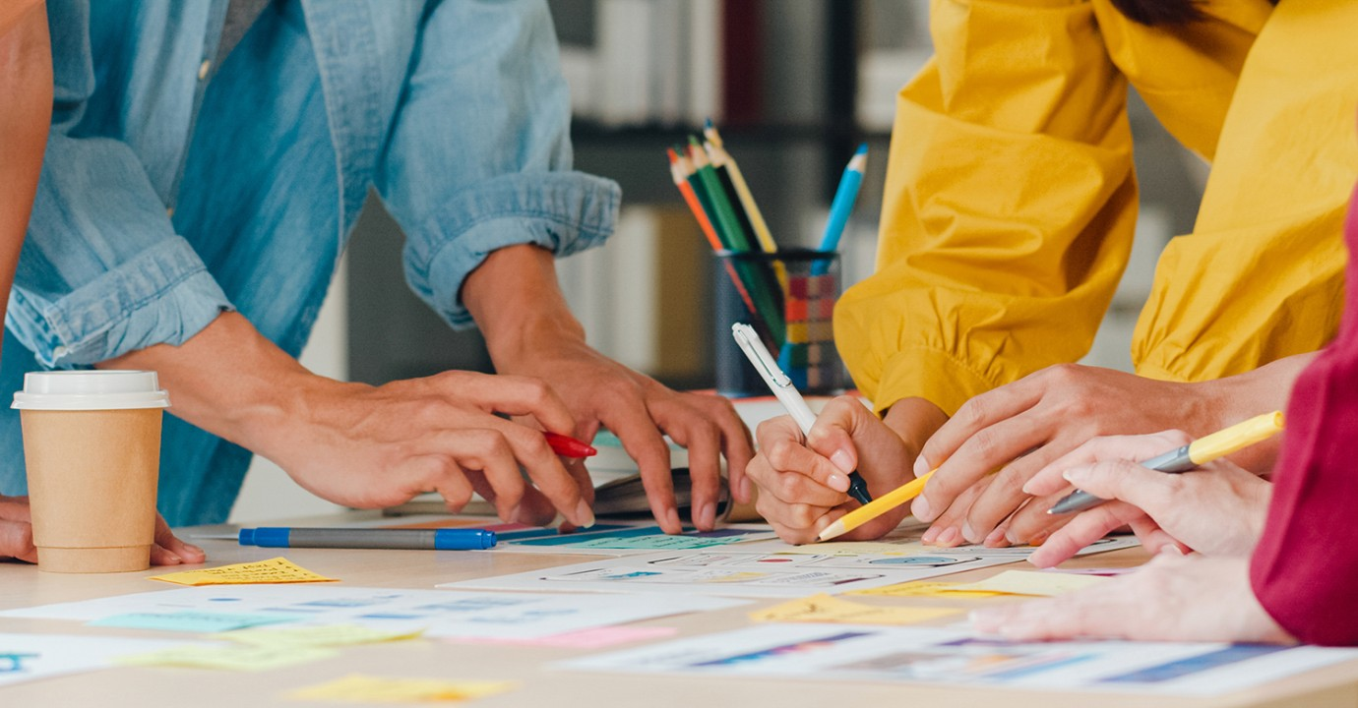

Organised by the Public History as new Citizen Science of the Past (PHACS) project, the 2022 symposium focuses on groups and communities becoming active participants in the production of history in museums. Different publics do not simply consume history in museums (as visitors or users) but may also contribute to preserving, producing, and exhibiting history. The symposium will explore questions such as what groups and communities can bring to the production of history in museums and their impact on historical narratives and on the institutions representing them. It will also delve into the limits and challenges of participatory practices and co-production processes in history museums.
What can public participants (not) do? What skills and knowledge are necessary? What are the examples of collaborative decision-making processes that allow contributions from the different publics and how do they affect the role and functioning of museums?

Join us and our international panellists to discover more and engage in this stimulating and relevant conversation!

7 December 2022

Online
Register >

Programme

Wednesday 7 December 2022

09.00 Welcome and opening of the Symposium

09.15 - 10.30 First Panel: Different expertise and voices in history co-production
Chair: Thomas Cauvin

- “Keeping coal mining alive’: when eyewitnesses co-produce public histories of mining work”, Grace Simpson.
- “Participation at Fondazione Museo Storico del Trentino: A complex set of practices for a complex territory", Elena Montanari
- “Guraban and Our Journeys Our Stories: Chinese Voices and Aboriginal stories- collaborative community history at Hurstville Museum & Gallery", Claire Baddeley & Vanessa Jacob

10.30-10.45 Coffee Break

10.45 – 12.00 Second Panel: Participation with publics, citizen science and co-creation
Chair: Grace Simpson

- “Museum Clubs in Poland as tools to facilitate participation in a historical and contemporary perspective”, Marta Kopiniak
- “Leeds Museums and Galleries 200th birthday biography”, Catherine Robins
- “Collecting the Anthropocene Together: Developing a Participatory, Digital and experimental platform on Environmental Transformations", Aurelia Desplain

12.00-13.00 Lunch Break

13.00 - 14.15 Third Panel: Diversifying the narratives through participation
Chair: Camilla Portesani

- “Co-designing University Museum Together with Students: A Case Study from Keio Museum Commons, Japan”, Dr Goki Miyakita & Yu Homma
- “Community-based, Collaborative Curating with Children in Cape Town", Monica Eileen Patterson
- “The Fear of Participation in Pakistani Museums”, Dr Shaila Bhatti

14.15-14.30 Coffee Break

14.30 - 15.45 Fourth Panel: Multiple voices in museums and their impact
Chair: Chris Reynolds

- “A community of creators: The multiple impacts of Library of Congress crowdsourcing volunteers", Abigail Shelton
- “Closing or widening the gap? Participation and super-diversity”, Tina de Gendt
- “Who says communities need museums? Where does the real expertise lie?”, Graham Black

15.45-16.00 Coffee Break

16.00- 17.15 Fifth Panel: Critical reflections on participation and its principles
Chair: Tina de Gendt

- “Voices of ’68: The role of co-production in meeting the challenges of the past in Northern Ireland”, Chris Reynolds
- "Public history and participation: the role of trust in co-creative practice", Lorna Elms
- "Museum participation as labor: An ethnographic inquiry", Irene Hilden & Andrei Zavadski

17.15-17.30 Conclusive remarks and thanks

More information required? Please contact us at phacs@uni.lu.

