THE IMPORTANCE OF CONCESSION REVENUES IN THE
PRIVATIZATION of AIRPORTS

David gillen*  Sauder School of Business  2053 Main Mall  University of British Columbia  Vancouver, BC Canada V6T1Z2  (604) 822-8352  Email: david.gillen@sauder.ubc.ca |  | Benny mantin  Department of Management Sciences  University of Waterloo  200 University Avenue West  Waterloo, Ontario, Canada N2L 3G1  (519) 888-4567 x32235  Email: bmantin@uwaterloo.ca

Abstract
We investigate the tradeoff between the airport’s concession and aeronautical revenues— two complementary services. Increasing the frequency of flights may result with congestion which could stimulate demand for concessions, but may also harm the demand for flights. When passengers have a low valuation for the concession good, the opportunity for concession revenue is small and the airport focuses its revenue on the aeronautical (i.e., landing) fees. With a sufficiently large valuation for concession goods, the airport may lower the aeronautical charges to stimulate greater flight frequency in order to lower airfares thereby attracting more passengers ultimately to increase concessions revenues. It is in the latter case where we observe minimal loss of aeronautical welfare when airports are privatized. Thus, our research could help guide decision makers in the airport privatization process. Namely, we find that privatization is not recommended unless the potential for concession revenues is sufficiently large.

Keywords: airports, airlines, concession, congestion, privatization

Acknowledgements: we are indebted to the referees whose comments and suggestions have significantly improved the paper. We also thank seminar participants at the Graduate School of Economics, Kyoto University, the International Transport Policy Research Unit, the University of Tokyo and participants at the Kuhmo Nectar Conference, Berlin, and the 16th International Conference of Hong Kong Society for Transportation Studies for comments.

* Corresponding author

INTRODUCTION
In recent decades, the view that airports were public utilities to serve as a form of public capital input in an airline’s production function has been changing. Airports are increasingly run as businesses, by delivering both aeronautical services—such as connectivity to passengers and landing and taking off management as well as baggage handling to airlines—and a platform for concessions—namely facilitating ancillary services such terminal retail, parking and a range of real estate developments (Gillen, 2011). These are two complementary categories of revenue generating services. Focusing on the two primary outputs (flights and retail concession services), the airport faces strategic decisions when pricing those aeronautical services (charged to airlines) and concession services (charged to passengers): more flights enhance aeronautical revenue, but at the same time the airport becomes more congested thereby incurring delay costs for both passengers and airlines, which may ultimately affect demand for flights. At the same time, such delays may induce passengers, who spend more time at the airport, to spend more on concession services. How shall airports set the prices for these two services? Namely, will the airports internalize the externality (negative impact of congestion vs. benefit from concessions) and cross subsidize flights by using revenue from concessions?
The changing perspective of airports from public utilities to businesses is coupled with a shift to move airport governance from public to more private sector participation. The move to privatization has been motivated by a number of factors (see Gillen, 2011, for a review). The UK was the first to privatize a subset of airports beginning in 1987. This was followed, over the next twenty years, by varying degrees of privatization in Australia, Canada, New Zealand, EU member states, Mexico, Chile, India and others (Gillen, 2011). An interesting feature of the privatization process is to note whether price regulation was coupled with privatization. In Australia and New Zealand, for example, dual till price regulation was put in place after privatization, but this evolved into a form of light handed price regulation. Canada privatized airports as not-for-profit entities and therefore did not require price regulation. The UK privatized nearly all of their airports and only four were brought under price regulation; as of 2014 only two remain under designation, Heathrow and Gatwick. In continental Europe the position taken was that airports should be regulated when they are fully or semi privatized. The U.S. has been slow to move to privatization and currently all airports are owned by some form of government; state, county and/or municipality. However, U.S. airports are effectively privately operated, with a high degree of contracting out.
The evidence then suggests that governments have preference for elimination of (costly) regulation. As an increasing number of governments are moving to privatize airports, a question emerges: under what circumstances can a shift to privatization take place without, or minimal, loss of economic welfare? In the UK where all airports have been privatized except Manchester, even small airports with a small amount of schedule air service are profitable (Starkie, 2008). Thus, concession services play an important role in sustaining airport viability. Government, in principle, is concerned with the economic welfare from aeronautical services. Although the convention in the current literature is to assume that consumption of concession services carries positive welfare effects, in our view the value of non-aviation services can vary from near zero to some positive value. Concession services can be simply a substitute for similar services consumed elsewhere; hence, the impact on total economic welfare is negligible. Namely, a retail good purchased at the airport or at the mall should have similar levels of welfare. Therefore, we consider it important to examine how passengers value concession services in considering the welfare effects of an airport ownership change. Accordingly, a government’s decision to move towards privatization is determined by whether or not economic welfare from aeronautical services falls with a change in governance. Thus, the motivation for this paper is to assess when governments should be concerned that privatization may reduce economic welfare.
A few papers already suggest that, in several circumstances, privatization of airports may result in a welfare outcome that is consistent with the welfare level under public ownership (Czerny, 2013; D’Alfonso et al., 2013; Zhang and Czerny, 2012). Those contributions differ significantly in their approach from this paper in how they model the interaction between airports, airlines, retail operations, and passengers. Those differences are summarized in next section (see Table 1). Importantly, our focus is on understanding the impact of the concession revenue potential on the welfare distortion—if such exists—when airports are privatized. Specifically, how passengers’ willingness to pay for the concession good influence the incentive of the government to privatize airports.
In our modeling framework we consider the interaction between the airport’s decision on the aeronautical charges, which influence the airlines’ choice of frequency to offer, which in turn directly affects the level of congestion at the airport and may stimulate passengers’ demand for flights. The level of congestion then further affects the airlines’ profit and hence feeds back into the airlines’ frequency decisions. The overall demand for flights and the level of congestion at the airport ultimately determine the magnitude of demand for concessions consumed at the airport. This is outlined in Figure 1.

Figure 1. How aeronautical charges affect demand for concessions
Airport: Aeronautical charges
Airline: Frequency of flights

Demand for flights

Congestion

Demand for concessions

We find that concession revenue is a key factor in the decision to privatize. If the potential for concession revenue is small, airports focus their attention on aeronautical revenue—in which case privatization could result in a major loss of welfare. Importantly, however, we find that if the potential for concession revenue is sufficiently large, a private airport will adopt similar externality internalization—it will cross-subsidize the charges to the airlines by using concession revenues. That is, the airport shares its concession revenues with the airline(s) by charging lower aeronautical fees, thereby incentivizing the airline(s) to supply more flights and deliver more passengers. Although this reduction in aeronautical fees intensifies the congestion at the airport, it also results with increased concession revenues, which as stated above, is partially shared with the airline(s). It is in this case the economic (aeronautical) welfare loss due to privatization is minimized.

Literature Review
The mainstream literature that models the interaction between airports, airlines, and passengers, traditionally assumes a vertical structure (see Basso and Zhang, 2007; and Zhang and Czerny, 2012). Passengers interact heavily with the airport: they arrive at the airport and use and pay for many of the services provided (directly or indirectly) by the airport. These services may determine and affect passengers’ choices of airport, or even mode of travel. Airports also have a key role in shaping the market structure by the set of aeronautical fees they charge the airlines and passengers, the design of the airport systems, and the airport capacity. All of these factors could substantially affect the level of interaction between passengers and airlines.
Starkie’s insight (2001, 2008) that airports, even with market power, would have less incentive to use or abuse this power because of the complementarity between aeronautical and concession revenues, is a good example of two-sided platform thinking recognizing that there are (two) interdependent demands to consider when setting prices. This insight is in line with Zhang and Zhang’s (1997) that a subsidy from concession operations to aeronautical operations may be required. In Czerny’s (2006) model, passengers make decisions based on their combined surplus from both aeronautical and concession services. Specifically, surplus gained from consumption of concession services may compensate for surplus loss due to high airfares.
Yang and Zhang (2011) consider a related model where the airport charges a per passenger fee to the airlines that offer horizontally differentiated goods. They assume a linear delay cost function imposed on passengers (as in De Borger and Van Dender, 2006; and Basso and Zhang, 2007), and implicitly ignore the role of frequency. Unlike Czerny (2006), Yang and Zhang model passengers’ consumption decisions (aeronautical and concession) as being made sequentially, rather than simultaneously. The consumption of concession services in their model depends only on the number of passengers and on their valuations for the concession service.
D’Alfonso et al. (2013) use a model with the pricing of aeronautical and concession services that includes congestion, and they characterize different passenger types with differing values of time. In their model, the incentives for the airport to adjust aeronautical fees, to take advantage of the positive externality between concession revenues and congestion, works in two opposing ways depending on passenger types. Lowering aeronautical fees increases leisure passenger demand more than business passenger demand and therefore congestion increases. Increases in congestion lead to an increase in business travellers’ effective fares, which is greater than the increase in leisure travellers fares, thus reducing business demand for flights. Our paper differs from D’Alfonso et al.’s (2013) on several dimensions. Importantly, we consider passengers’ demand for frequency and accordingly airlines set both frequency and airfares (and hence we do not assume that load factors are fixed), and we assume that congestion costs also impose an increase in the airline’s operating costs. D’Alfonso et al. (2013) focus on regulation, whereas in this paper we focus on privatization incentives. A related paper by Czerny (2013) also considers privatization of airports by focusing on the distinction between welfare neutral goods and welfare enhancing goods (such as car rental). Table 1 summarizes the modeling differences between those two papers and our contribution.

Table 1. Modelling framework with respect to related papers
 | Airport charges | Retail revenue | Congestion | Demand for frequency | a/c capacity | Passenger types | Airline decision | Airline competition | Public Airport is budget constrained?
Czerny (2013) | Pax fee | Fixed per pax profit | Yes (cost to airline) | No | No | No | Number of pax | Yes | No
D’Alfonso et al. (2013) | Pax fee | Function of dwell time | Yes (cost to pax) | No | Normalized | Yes: different time and concession valuations | Number of pax | Yes | No
This paper | a/c fee | Function of dwell time | Yes (cost to both airline and pax) | Yes | Yes | Yes (but separately) | Frequency and price | In the appendix | Yes
Note: Pax is passenger, a/c is aircraft

Lastly, Gillen and Mantin (2013) study airports both as vertical input and platform structures (where passengers seek connectivity and the airline seeks passengers) in the absence of concession revenues and congestion considerations. Other contributions include, Zhang and Zhang (2003, 2010) who consider capacity choices by private and public airports.
In this paper, we extend the literature on airport privatization. The primary focus is to determine how an airport makes pricing decisions for aeronautical and concession services when congestion occurs to affect both passengers and airlines. Our focus is on privatization incentives as we show the critical element of potential concession revenues in affecting the loss of aeronautical welfare. Herein we emphasize the importance of the scope of concessions. We show that only under certain magnitude conditions, private and public operations are largely consistent, otherwise, a major loss of (aeronautical) welfare may be experienced due to privatization (which may, in turn, induce the need for regulation).

Modeling Approach
In setting prices, the airport faces a trade-off due to the complementarity between aeronautical revenues (generated via per flight fees charged to airlines) and concession revenues (generated from passengers as they spend time at the airport): increasing the aeronautical charges induces the airline to reduce the frequency of flights. By doing so, on the one hand, congestion is relaxed thereby stimulating some demand for flights, whereas on the other hand, if passengers have preference for frequency then such a move hurts demand for flights. The overall impact on demand affects concessions revenue which is also affected by congestion—the more time passengers have to spend at the airport, the more likely they are to spend on concessions; the airport seeks to strike a balance between concession revenues and aeronautical revenues.
To begin, the aggregate passengers’ utility function is represented as
$U=Vq-\frac{1}{2}βq^{2}$, (1)
where q is the number of seats consumed, V is a measure of the value of frequency (marginal utility of an additional flight) and passengers have preference for frequency (see Richard, 2003; Adler and Hanany, 2010), β is the change in utility from consuming an additional seat. We assume that V is concave with regards to the frequency of flights, $f$, offered by the airline, specifically,
$V=f^{a}$ (2)
with $0≤a≤1.$ Thus, if $a$ is strictly positive, passengers gain utility from higher frequency due to greater connectivity (Gillen and Mantin, 2013) or due to their reduced schedule delay cost (Brueckner, 2004; Heimer and Shy, 2006; Kawasaki, 2008; Lin, 2013; Swaroop et al. 2012).
We assume, for simplicity, a single airline offering service to a single airport. The airport has a capacity for flights, F, and as frequency increases, congestion at the airport increases. Following Yang and Zhang (2011), among others, for simplicity and tractability we assume that the congestion function is linear, f/F. The airline charges an airfare, $p$; however, the effective price that passengers pay is the sum of airfare plus the cost of time wasted due to congestion; let δ denote passengers’ value of time. Hence, we have
$p+δ\frac{f}{F}=\frac{∂U}{∂q}$, (3)
which gives rise to the following demand function
$q=\frac{f^{a}F-pF-δf}{βF}$. (4)
Note that frequency of flights enters the demand function in two ways. The first is the positive effect of frequency as it acts to reduce the schedule delay of passengers. The second is the negative effect which emerges due to the increased capacity utilization. Swaroop et al. (2012), for example, address these two conflicting outcomes by considering slot controlling the airport. The airport charges the airline a landing fee of c per flight. The airline also suffers from the effect of congestion. Letting $γ$ denote the airline’s cost due to congestion, the airline is maximizing the following profit function:
$π_{Airline}=pq-cf- γ\frac{f}{F}$. (5)
$s.t. q≤fs,$
where s is a flight’s seating capacity. The airline chooses $f$, and $p$.
The airport offers two services, aeronautical services to airlines for a fee c per flight and concession services to passengers for at a price P_{c} per unit purchased. Similar to Lin (2006), Castillo-Manzano (2010) and D’Alfonso et al. (2013), we assume that the consumption of goods at the airport is further related to the time that passengers spend at the airport—a finding that was supported empirically by Geuens et al. (2004) and Torres et al. (2005); the longer a passenger stay at the airport, the more likely they are to consume concession goods. As in Lin (2006) and Yang and Zhang (2011), passengers are considered to make sequential decisions, and choose to consume the concession goods only once at the airport. Specifically, we consider that passengers have some valuation for this concession, which is uniformly distributed over [0,M]. Thus, the demand for concession goods, Q_{c}, is given by
$Q_{c}=\frac{M-P_{c}}{M}κ\frac{f}{F}q$ (6)
where the first term, (M-P_{c})/M, is the proportion of consumers whose valuation exceed the concession price, P_{c}, the second term, $κ$ (f/F), is the probability that the passengers have the opportunity to buy the concession good ($κ$ is a coefficient, $κ≤1$), and q is the number of passengers at the airport (from equation 4). As congestion increases, delays increase and passenger demand for concession goods increases as well. κ can be interpreted as the proportion of passengers who are likely to be engaged in purchasing some concession good. Assuming that fixed capacity, F, is a sunk cost, the airport’s profit is given by:
$π_{Airport}=fc+P_{c}Q_{c}.$ (7)
While a private airport maximizes its profit, a public airport seeks to maximize economic welfare from aeronautical services under break-even budget constraint. That is, a public airport can generate positive surplus, but cannot lose money, and that it is focused on providing connectivity for the passengers it serves. Therefore the relevant economic welfare will be based on aeronautical services and not concession services. The argument is that the core product for the airport is providing connectivity, and that the concession services are optional in that passengers are simply transferring spending from one location to another. Hence, the economic welfare of the community does not necessarily change with the consumption of concession goods. Even in the case where increased concession good consumption occurs with increased congestion, the consumption is a transfer from future consumption elsewhere.
Economic welfare is defined as the summation of airport profit, airline profit, and consumer surplus from aeronautical services only. Therefore, welfare is
$W=π_{Airport}+π_{Airline}+CS,$ (8)
where $CS=\int_{{p=p}^{*}}^{∞}{q(p)dp}$, where $p^{*}$ is the equilibrium airfare set by the airline. This approach of absenting away from the surplus generated from concessions (which is merely a transfer of surplus, from consumers, to the airport), is closely related to the models studied by Basso and Zhang (2010) and D’Alfonso et al. (2013). These authors suggest that decision makers may associate different weights to the different streams of surplus. In line with their assumption, we proceed by assuming that the airport’s decision maker seeks to maximize welfare from aeronautical activity only, that is, the decision maker is associating zero weight to consumers’ surplus from concession activities at the airport.
With this definition of economic welfare, with concessions not entering the welfare measure, the airport—either public or private—may exercise any market power it may have to extract revenue from passengers, through concession activities. However, the motivation for such action by a public airport is to lower airport fees, c, to airlines which will increase economic welfare; the charge may be negative, meaning the airport is offering the infrastructure below cost to an airline to provide service and increase connectivity. The private airport may not share the same incentive, and will, instead, seek to maximize the stream of revenues from both aeronautical and concession revenues. Yet, the questions that emerge are whether or not private airport ownership offers the infrastructure at below cost, and whether or not a privately held airport cross-subsidizes its services? Moreover, can the first-best outcome be achieved under private ownership?
The analysis begins with the case where passengers have no preference for frequency (Section 4). This can be seen as the limiting case for what is observed in the passenger market, which is composed of leisure passengers and business passengers. Leisure passengers are more price sensitive, while business passengers are more time sensitive (see Gillen et al., 2007, and Brons et al., 2002) preferring greater frequency. In Section 5, we consider the presence of passengers’ demand for frequency, in order to study the effect on frequency of the airport pricing decisions in the presence of concession demand. We consider the first-best behavior, that is, pricing decisions taken by the (aeronautical) welfare maximizing regulator.

No preference for frequency (a=0)
In this section, we consider the case where passengers have no demand for frequency i.e., a=0. Even when passengers do not care about frequency, the airport still has an incentive to induce the airline to offer greater frequency, as frequency is a source of revenue. This incentive is amplified in the presence of concession demand.
Substituting the demand function from (4) into the airline’s objective function (5), it can be written as follows:
$π_{Airline}=p\frac{F(1-p)-δf}{βF}-cf- γ\frac{f}{F}$. (9)
$s.t. \frac{F(1-p)-δf}{βF}≤fs,$
It can be observed that the airline’s incentive is to offer as few flights as possible (as profit is decreasing in $f$). Thus, the number of flights offered is determined by the binding constraint $f=\frac{F(1-p)}{sβF+δ}s$. In that case, solving the airline’s problem from (6), using the Karush-Kuhn-Tucker conditions, yields:
$p=\frac{F\left(s+c\right)+γ}{2sF}$ and $f=\frac{F\left(s-c\right)-γ}{2s(βsF+δ)}$. (10)
This airfare indicates that the airline passes through half of the airport charges as $\frac{∂p}{∂c}=\frac{1}{2s}$ (the division by s is to spread the charge among the s passengers on the plane). s can be interpreted as the size or gauge of the aircraft and q/f the average load factor.
Before proceeding with the analysis, we impose the following assumption, which is required in our setting to ensure positive airport profit in the limiting case (when both M and a are zero) under private airport ownership:
Assumption 1: $sF>γ$.
We further impose an upper bound on the value of M. This assumption is required to guarantee that the welfare is concave with respect to c. Specifically, we impose this constraint to ensure that welfare does not increase convexly in c once airports can generate concession revenue.
Assumption 2: $M<\frac{2(βsF+δ)}{κ}$.

Airport under Public Ownership
Let the superscript G (government) denote the outcomes of the model under a publicly owned airport. The welfare maximizing public airport will charge $P_{c}^{G}=\frac{M}{2}$ to passengers. With a binding airport break-even constraint, we find that airport charges are:
$c^{G}=-\frac{(sF-γ)Mκ}{F(8βsF+8δ-Mκ)}$. (11)
By construction, as the public airport needs to break even, and as the revenue from concession is strictly positive, the airport charges to the airline are strictly negative (implying $8βsF+8δ>Mκ$ which is consistent with Assumption 2). The public airport generates revenue from concessions to cross-subsidize airside operations, and in doing so increases social welfare. We set the per flight cost to the airport at zero, this negative airport charge is simply a subsidy offered by the airport; the airport sells landing rights below cost. This scenario is not unrealistic or even uncommon. There is evidence from some European airports that they are willing to attract airlines, to serve their catchment area, by paying the airline to do so.
Under public ownership, we have $f^{G}=\frac{4(sF-γ)}{s(8βsF+8δ-Mκ)}$, $p^{G}=\frac{4s^{2}F^{2}β+sF\left(4δ-Mκ+4γβ\right)+4γδ}{sF(8βsF+8δ-Mκ)}$, $π_{Airline}^{G}=\frac{16{\left(sF-γ\right)}^{2}(βsF+δ)}{sF(8βsF+8δ-Mκ)}$, and $π_{Airport}^{G}=0$. Consequently, in the absence of demand for frequency, social welfare under public ownership is $W^{G}=\frac{{24(sF-γ)}^{2}(βsF+δ)}{sF{(8βsF+8δ-Mκ)}^{2}}$. We have the following result.
Proposition 1: When there is no demand for frequency, a=0, under public ownership, as M increases, the airport decreases the airport charges, which results in greater frequency, albeit at a lower fare to the passengers, that ultimately yields higher profit to the carrier, as well as higher social (aeronautical) welfare.
Proof: It follows immediately that $\frac{∂c^{G}}{∂M}<0$, $\frac{∂f^{G}}{∂M}>0$, $\frac{∂p^{G}}{∂M}<0$, $\frac{∂π_{Airline}^{G}}{∂M}>0$, and $\frac{∂W^{G}}{∂M}>0$. $∎$
This result suggests that as passengers’ valuation for the concession good, M, increases, the public airport is in a better position to internalize the externality and increase the cross-subsidization offered to the airlines in order to increase their portfolio of flights offered to passengers. Moreover, as M goes up and more flights are offered, the airfare decreases and both passengers and airlines are better off, and overall (aeronautical) welfare increases.

Airport under Private Ownership
Does private ownership follow the same trade-off as the public airport? Namely, will a privately held airport offer the same cross-subsidy available to airlines serving a public airport? Will an increase in M also imply a reduction in c and an overall increase in welfare? Lastly, can private ownership reach the first best outcome, and if not, can regulation correct this deviation?
Let the superscript P denote the outcomes of the model under a privately owned airport. The profit maximizing airport sets the price for the concession good at
$P_{c}^{P}=\frac{M}{2}$, (12)
and the profit maximizing airport fee charged to the airline is
$c^{P}=\frac{(sF-γ)(4βsF+4δ-Mκ)}{F(8βsF+8δ-Mκ)}$. (13)
Before proceeding with the remainder of the analysis of privately owned airports, consider briefly the limiting instance where M=0. That is, when passengers generate no demand for concession goods, or alternatively, when the airport has not set up the infrastructure such that it will attract concession revenue from passengers. The airport will set the optimal (profit maximizing) airport fee charged to the airline as $c^{P}=\frac{sF-γ}{2F}$. This airport charge increases with the plane capacity, s, and with the airport capacity, F, but decreases with the airline congestion cost factor, $γ$. This outcome is the result when passengers do not value frequency, and the airline fills the plane to minimize frequency. At the same time, the airport is negatively affected by such a frequency decision by the airline, as the airport relies solely on inducing frequency to generate profit from additional passengers. Hence, larger plane capacity is detrimental to airport revenues in such a case, and therefore the airport “penalizes” the airline for using large airplanes in the form of higher landing charges. With larger airport capacity, the airline is essentially better off as congestion decreases. Consequently, the airport raises the airport fees to extract a portion of the savings from lower congestion costs obtained by the airline. Lastly, as the congestion costs imposed on the airline increase—larger $γ$—the airport must decrease the airport fee in order to induce the airline to offer more flights; the lower landing fee will offset the increased costs to the airline due to congestion. Recall that we have assumed that $sF>γ$ (Assumption 1), which ensures positive airport profit when both M and a are zero. The intuition behind Assumption 1 follows from rearranging the optimal landing fee $c^{P}=\frac{sF-γ}{2F}=\frac{\frac{q}{f}F-γ}{2F}=\frac{\frac{q}{f/F}-γ}{2F}=\frac{q-γ(f/F)}{2f}$. Imposing the condition $sF>γ$ is equivalent, in this setting, to the condition $q-γ\left(\frac{f}{F}\right)>0$. The latter expression states that the total demand served by the airline exceeds the airline’s congestion cost so the airline has a continued incentive to add flights.
Returning to the case where M>0, we have $c^{P}=\frac{(sF-γ)(4βsF+4δ-Mκ)}{F(8βsF+8δ-Mκ)}$; since $sF>γ$ by Assumption 1 and the denominator is positive by Assumption 2. Yet, this landing fee can still be negative. When concession revenue is positive, the airport may have an incentive to pay the airline in order to bring passengers to the airport who would consume concession goods. This incentive will be governed by the value of M which essentially drives the change in demand for concession goods with a change in airfare. The airport is treating the airport fee and concession price as a two-part price with the airport fee providing the opportunity for more concession demand through adjustments to the airfare (See, for example, Mitchell, 1978). Subsidizing flights can result in an increase in aggregate airport profit.
Proposition 2: (i) When a=0, the airport landing fee charged under private ownership, $c^{P}$, is decreasing in the valuation for concession, M; (ii) moreover, this fee is negative if $M>\frac{4(βsF+δ)}{κ}$.
Proof: (i) This follows from $\frac{∂c^{P}}{∂M}=-\frac{4α\left(sF-γ\right)\left(4βsF+δ\right)}{F{\left(8βsF+8δ-Mκ\right)}^{2}}$, and since $sF>γ$ (to guarantee positive airport profit when M=0), $\frac{∂c^{P}}{∂M}<0$. (ii) Solving $c^{P}<0$, we have $M>\frac{4(βsF+δ)}{κ}$. $∎$
It is interesting to compare the two streams of revenue to the airports: aeronautical revenue, $f^{P}c^{P}$, and concession revenue, $P_{c}^{P}Q_{c}^{P}$.
Proposition 3: When a=0, under private ownership concession revenue exceeds aeronautical revenue if $M>\frac{8(βsF+δ)}{3κ}$.
Proof: Solving $P_{c}^{P}Q_{c}^{P}- f^{P}c^{P}>0 ⟺ \frac{{\left(sF-γ\right)}^{2}\left(3Mκ-8βsF-8δ\right)}{Fs{\left(8βsF+8δ-Mκ\right)}^{2}}>0 ⟺ M>\frac{8(βsF+δ)}{3κ}$. $∎$
To complete the analysis, under private ownership, we have that $f^{P}=\frac{2(sF-γ)}{s(8βsF+8δ-Mκ)}$, $p^{P}=\frac{6s^{2}F^{2}β+sF\left(6δ-Mκ+2γβ\right)+2γδ}{sF(8βsF+8δ-Mκ)}$, $π_{Airline}^{P}=\frac{4{\left(sF-γ\right)}^{2}(βsF+δ)}{sF(8βsF+8δ-Mκ)}$, $π_{Airport}^{P}=\frac{{\left(sF-γ\right)}^{2}}{sF(8βsF+8δ-Mκ)}$, and the aeronautical welfare in this case is $W^{P}=\frac{{(sF-γ)}^{2}(14βsF+14δ-Mκ)}{sF{(8βsF+8δ-Mκ)}^{2}}$.

Proposition 5: When there is no demand for frequency, a=0, under private ownership, as M increases, the airport decreases the airport charges, which results in greater frequency, albeit at a lower fare to the passengers, that ultimately yields higher profit to the carrier and higher profit to the airport, as well as higher aeronautical welfare.
Proof: $\frac{∂c^{P}}{∂M}<0$ follows from Proposition 2; It is immediate to show that $\frac{∂f^{P}}{∂M}>0$, $\frac{∂p^{P}}{∂M}<0$, $\frac{∂π_{Airline}^{P}}{∂M}>0$, $\frac{∂π_{Airport}^{P}}{∂M}>0$, and $\frac{∂W^{P}}{∂M}>0$.

This result suggests that the behavior of the privately held airport imitates that of the public airport. Essentially, it posts the same price to the passengers, but sets the airport fee charged to the airline quite differently. Although an increase in M implies a decrease in the airport fee, which ultimately can become negative—just as in the public ownership case—unless M is sufficiently high, the airport fee will be strictly positive. Imposing a positive airport fee induces a much lower frequency and consequently the airfares charged by the airlines are higher. This is summarized by the following statement.

Proposition 6: When there is no demand for frequency, a=0, the frequency of flights, and hence the level of congestion, under public airport ownership is twice the frequency under private airport ownership; the airfare is higher under private ownership and the (aeronautical) welfare is greater under public ownership.
Proof: Under public ownership the frequency of flights is $f^{G}=\frac{4(sF-γ)}{s(8βsF+8δ-Mκ)}$, whereas the frequency of flights under private ownership is $f^{P}=\frac{2(sF-γ)}{s(8βsF+8δ-Mκ)}$. Hence, $\frac{f^{G}}{f^{P}}=2$. With respect to airfares, we have that $P^{P}-P^{G}=\frac{2\left(sF-γ\right)\left(βsF+δ\right)}{sF\left(8βsF+8δ-Mκ\right)}>0$. Lastly, we prove that welfare is greater under public ownership: $W^{G}-W^{P}=\frac{{\left(sF-γ\right)}^{2}\left(10βsF+10δ+Mκ\right)}{sF{\left(8βsF+8δ-Mκ\right)}^{2}}$. $∎$
To conclude, similar to the public airport, the private airport takes advantage of the increase in passengers’ valuation for the concession good, M, to reduce the overall airport fee charged to the airlines. Yet, while a public airport uses the increase in M to cross-subsidize, the private airport uses M to increase total profitability. Nevertheless, the increase in M yields the same sequence of effects as in a publicly owned airport: frequency goes up, airfares go down, airline profit increases, and total welfare increases.

concave increasing preference for Frequency (a= ½)
Next we consider the case where passengers demand frequency and connectivity. We assume that a= ½. This is somewhat reflective of business travellers who demand greater flexibility and connectivity to facilitate efficient business travel. In the presence of passengers demand for frequency, we raise the following questions: will the same tradeoff and behavior that was presented and demonstrated in the previous section (i.e., when passengers do not demand frequency) reemerge? Naturally, as passengers demand frequency, the relative elasticities change and the airport might focus on aeronautical demand as a revenue resource.
When passengers demand frequency, the interaction between the various decision makers changes. The airline now has an incentive to increase the flight frequency. Hence, a public airport operator may need to penalize the airline for offering excessive frequency, as this frequency may hurt the overall level of welfare through increased congestion costs. Indeed, the airline may be able to internalize some of the congestion externality, but the regulator may need to intervene to make the proper adjustments.
We begin with the limiting case where no concession demand exists, M=0. This limiting case allows us to examine how the airport sets the charges in a relatively simple scenario and it further allows us to estimate the solutions in the more comprehensive scenario. It follows from (4) that $q=\frac{\sqrt{f}F-pF-δf}{βF}$, and we use Karush-Kuhn-Tucker conditions to solve the problem faced by the airline, which was given in (5). Consequently, we find that if the constraint is not binding, then the profit maximizing frequency is $f=\frac{F\left(5-3\sqrt{F\left(F+32cβF+32γβ\right)}+16β(Fc+γ)\right)}{8δ^{2}}$ with a price of $p=\frac{F+\sqrt{F\left(F+32cβF+32γβ\right)}-16β(Fc+γ)}{16δ}$. If the airline’s capacity constraint is binding, we find that $f=\frac{9sF+3FX-16(γsFβ+γδ+cF^{2}sβ+cFδ)}{32s(sFβ+{δ)}^{2}}$ and $p=\frac{3sF^{2}+FX-16(γsFβ+γδ+cF^{2}sβ+cFδ)}{32sF(sFβ+δ)}$ where $X=\sqrt{s(9sF^{2}-32(γsFβ+cF^{2}sβ+γδ+cFδ)}$.
The remainder of the analysis in this section is rather complex, and therefore we proceed by conducting numerical simulations (an approach similar to Benoot et al., 2013). We (numerically) examine the behavior of frequency, airfare and demand as a function of the airport charges, c. As can be seen from Figure 2, frequency is decreasing in c as expected. However, frequency first decreases rapidly in c but as it reaches a threshold, the capacity constraint becomes binding and the airline reduces frequency at a slower rate; although the increase in c incentivizes the airline to further drop frequency, it does so at a slower rate, as it must provide minimal frequency in order to satisfy the corresponding demand. At this point, we can see that the airline starts increasing the airfare as a mechanism to compensate for the “excess” frequency it provides passengers. That is, given the high value of c, the airline would like to further reduce frequency, but the airline’s capacity constraint is binding, and further reducing frequency will limit demand. Hence, the airline needs to “slow down” the decrease in frequency. We also observe that demand is decreasing throughout the range—evidently, the decrease in frequency dominates the changes in airfares.
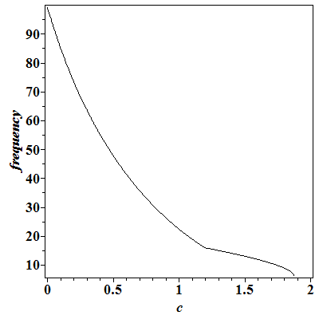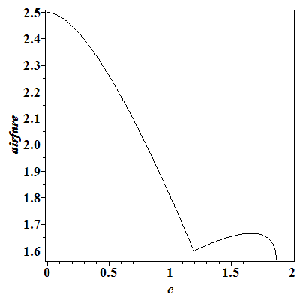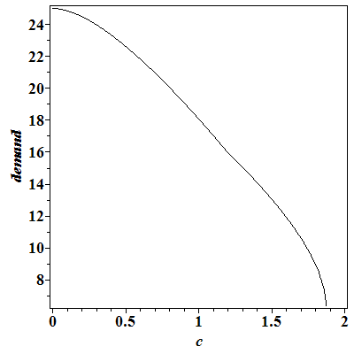
Figure 2. Frequency, airfare, and demand as a function of c;
Parameter values: F=100, β=0.1, δ =5, γ=0.5, s=1, M=0

Consider the maximization problem faced by the public airport. Welfare seems to be quasi-concave in c: it increases in c and subsequently after some threshold is met, the aircraft capacity constraint becomes binding and (aeronautical) welfare decreases, albeit at a slower rate. Numerical simulations suggest that the (aeronautical) welfare maximizing value is always small or even negative. Thus, the airport does not need to impose high landing fees to limit the airline from offering greater frequency. However, as the numerical illustrations below reveal, the airport may need to restrict the value of c to ensure that the airport profit is non-negative.
Next consider the profit maximizing airport. Figure 3 shows how the airport’s profit is first concave in c up to approximately c=1, after this the aircraft capacity constraint becomes binding, and profit increases and reaches another maxima for some higher values of c. Thus, the airport needs to consider both maximas and decide whether it would rather have a low c with a large frequency or a high c with a low frequency of flights. In the panel on the left, there is no demand for concession, and considering the two airport profit maximas, the airport sets a high fee. By contrast, in the case depicted in the right panel, where the airport faces a potential to generate revenues from concessions, the airport sets a low fee which stimulates a high demand for frequency. The difference is intuitive, but important: in the left panel the airport earns no revenue from concession and relies solely on aeronautical movements, while in the case shown in the right panel the airport internalizes the revenue made from concessions and offers a low landing fee to stimulate movements and increase the number of passengers.
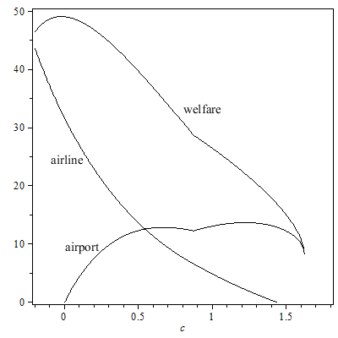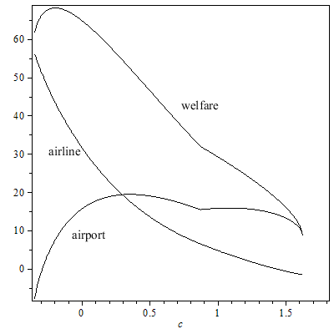
Figure 3. (Aeronautical) welfare, airline and airport profits as a function of c
Parameter values: F=75, β=0.1, δ =5, γ=5, s=1; in left plot M=0, in right plot M=5, κ=1
Next, we utilize the structure of profit and (aeronautical) welfare from Figure 3 to obtain additional insights into privatization strategies. Specifically, from Figure 3 it is evident that in the absence of concessions, the (aeronautical) welfare loss can be substantial if a private airport sets a high fee as compared with the low fee charged by the public airport. However, in the presence of concessions, the (aeronautical) welfare loss is rather minimal, as the private airport sets a low fee to stimulate frequency, and consequently demand for concessions.

Public Ownership
Under public ownership, numerical simulations reveal that the airport never has the incentive to impose high fees on the airline to suppress the overall frequency of flights. On the contrary, unless M=0, the airport charges are always negative. That is, since we abstract away from the cost to the airport, this means that the airport will use the concession revenues to cross-subsidize aeronautical movements (just as we proved in the case where passengers do not demand frequency).
Consider Figure 4. If M is sufficiently low, the airport budget constraint is binding. In that case the airport uses the entire amount of concession revenue to cross subsidize flight frequency. However, a higher (aeronautical) welfare could have been achieved had the airport been allowed to lose money. Once M is sufficiently high, the airport does not use all the revenue from concessions to cross subsidize aeronautical movements and the airport actually makes positive profit! More precisely, after some threshold level of M, the airport charges keep decreasing in M, but at a slower rate, as the airport balances the increased revenue from concessions on the one hand, and the airline’s profit as well as consumer welfare on the other hand, evidently the change in demand is rather minimal as M changes. Importantly, when M is sufficiently high, demand is slightly decreasing in M—despite the increase in frequency and the marginally lower airfares, the effective airfare (which includes congestion costs) is in fact increasing. The latter appears to slightly dominate the effect of frequency utility to passengers.
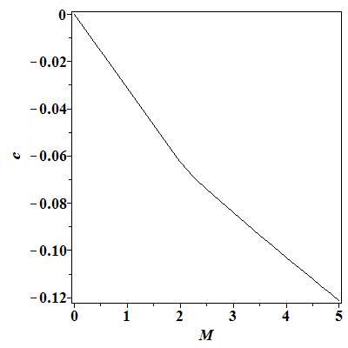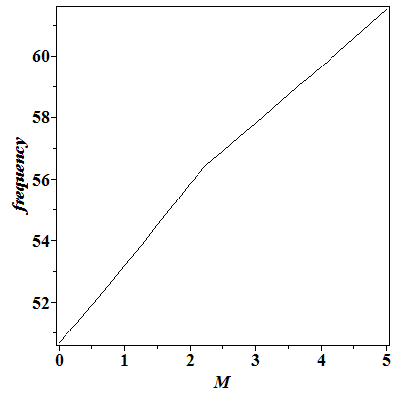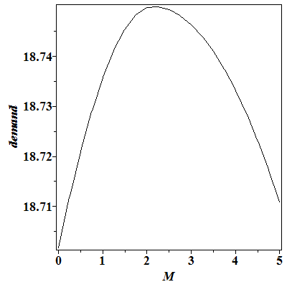
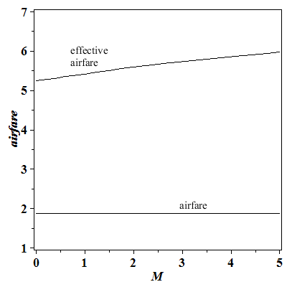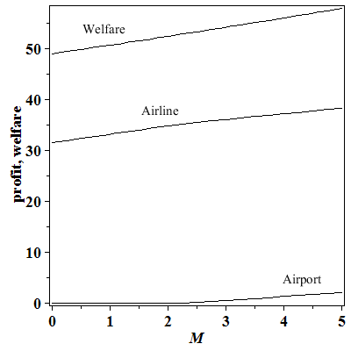
Figure 4. Public ownership: Frequency, airfare, and demand as a function of M;
Parameter values: F=75, β=0.1, δ =5, γ=5, s=1, κ=0.5

Private Ownership
Under private ownership, we find that the airport will apply different pricing policies, depending on the value of M. If M is sufficiently low, so that the potential for concession revenue is rather low, the airport will impose high fees on the airline for use of the airport. This is intuitive as the airport relies primarily on aeronautical revenues to generate its profit. As M increases, the airport reduces the charges to induce the airline to offer more frequency. With lower airport charges, the airline passes on some of the savings to the passengers, as one can observe the airfare slightly decreases, but the effective airfare increases. The latter effect is dominated by the increased frequency, and consequently demand increases.
Consider Figure 5. when M is sufficiently high, the airport finds that the alternative strategy is more profitable. It offers low airport charges to the airline, who in turn offer significantly more frequency, thereby stimulating demand, which dramatically increases concession revenue. At that point we observe a significant jump in frequency, airfare, demand, airline profit, and overall (aeronautical) welfare.

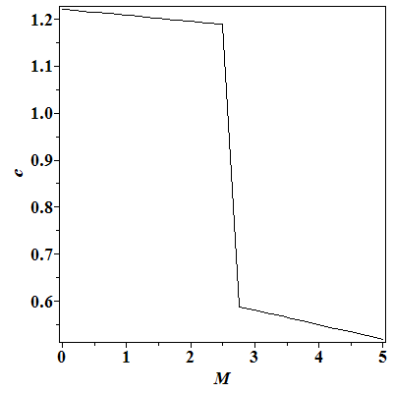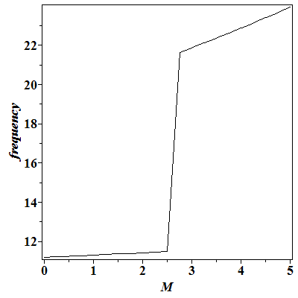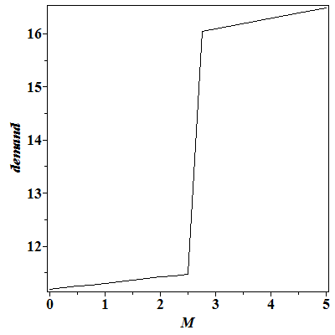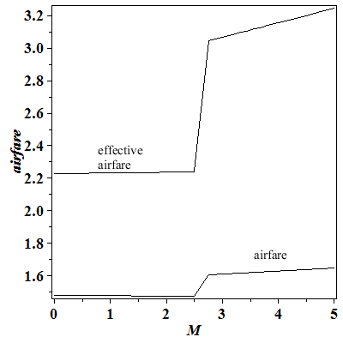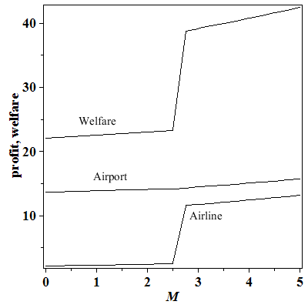
Figure 5. Private ownership: Frequency, airfare, and demand as a function of M;
Parameter values: F=75, β=0.1, δ =5, γ=5, s=1, κ=0.5

Conclusions
In this paper we develop a model that illustrates the importance of the role of concession revenues in privatizing airports. As the airport faces and prices services to interdependent customer groups, we studied the implications that frequency and congestion have on the pricing decision made by the airport, and ultimately on aeronautical welfare. The public airport, in our model, needs to trade-off the welfare generated by stimulating greater frequency, keeping in mind the congestion costs from delays imposed both on passengers and airlines alike, and the revenue generated by concession revenues, which are linked to the time passengers spend at the airport. The private airport, on the other hand, is solely concerned with generation of revenue and seeks to trade-off revenue gained from aeronautical activity and revenue from concessions.
Our model highlights the vital role of concession revenues in airport privatization decisions. The results clearly demonstrate that if the potential for concession revenues is small, the private airport will focus attention on generating revenue from aviation activity, thereby suppressing aviation activity and ultimately resulting with a large aeronautical welfare loss. By contrast, if the potential for concession revenue is sufficiently large, the private airport imitates the pricing policy adopted by the public airport; namely, the airport cross-subsidizes aviation activity by using revenue from concessions. With this outcome, the airport stimulates the airline(s) to increase frequency, which generates greater aeronautical welfare, and the overall aeronautical welfare loss is minimized. These insights can guide decision makers in the privatization process and even indicate the degree of regulation that may be introduced: when the welfare loss is small, light-handed regulation might suffice, whereas in a high welfare loss environment, a more intensive regulatory framework might be required.
There are several extensions to this research that could relax some of the assumptions adopted in this paper. Extending the framework to include competition between airlines is a natural extension. However, the effect of competition is not expected to generate new insights. In the appendix we demonstrate the trade-off in the instance where a=0. Intuitively, under competition the airfare decreases and the combined frequency offered by airlines increases, but the qualitative insight remain exactly as before. Another avenue is inclusion of another airport in to derive insights about privatization and airport pricing when the two airports are located in different jurisdictions and governance (as well as regulation) may differ. Following the work by Mantin (2012), this is expected to induce airport operators to increase their aeronautical charges due to the complementarity effect and may further stimulate the incentive to privatize airports. Finally, the literature as described earlier is primarily dominated by methodological paper; hence this literature can immensely benefit from empirical work that would test the differing models and predictions made by the various papers.

REFERENCES
Adler, N. and Hanany E. 2010. Capacity Tradeoffs and Trading Capacity (mimeo, Sauder School of Business, University of British Columbia).
Basso, L. and A. Zhang. 2007. An Interpretative Survey of Analytical Models and Airport pricing, in Darin lee (ed.), Advances in Airline Economics, Volume 2, The Economics of Airline Institutions, Operations and Marketing, Elsevier, Amsterdam.
Basso, L., and A. Zhang. 2010. Pricing vs. slot policies when airport profits matter. Transportation Research Part B, 44 (3): 381-391.
Benoot, W., Brueckner, J.K., and Proost, S. 2013. Intercontinental-airport regulation, Transportation Research Part B, 52: 56-72.
Brons, M., E. Pels, P. Nijkamp and P. Rietveld. 2002. Price Elasticities of Demand for Passenger Air Travel: A Meta Analysis, Journal of Air Transport Management, 8(3), 165-175.
Brueckner, J.K. 2004. Network structure and airline scheduling, The Journal of Industrial Economics, 52, 291-312.
CAPA. 2013. Chicago Midway Airport Privatization: Anatomy of a US airport lease. Available at http://centreforaviation.com/analysis/chicago-midway-airport-privatisation-anatomy-of-a-us-airport-lease-99948.
Castillo-Manzano, J. 2010. Determinants of commercial revenues at airports: Lessons learned from Spanish regional airports, Tourism Management, 31, 788–796.
Czerny, A. 2006. Price-cap regulation of airports: Single-till versus dual-till, Journal of Regulatory Economics, 30, 85-97.
Czerny, A. 2013. Public versus private airport behavior when concession revenues exist. Economics of Transportation, 2(1), 38-46.
D’Alfonso, T., C. Jiang, and Y. Wan. 2013. Airport Pricing, Concession Revenues and Passenger Types, Journal of Transport Economics & Policy, 47(1), 71-89
De Borger, B. and Kurt Van Dender. 2006. Prices, Capacities and Service levels in a Congestible Bertrand Duopoly, Journal of Urban Economics, 60(2), 264-283
Dixit, A. 1979. A Model of Duopoly Suggesting a Theory of Entry Barriers, Bell Journal of
Economics, 10(1), 20–32.
Gillen, D. and B. Mantin. 2013. Transportation Infrastructure Management: One and Two Sided Market Approaches, Journal of Transport Economics and Policy, 47(2), 207-227.
Gillen, D. 2011. The Evolution of Airport Ownership and Governance, Journal of Air Transport Management, 17(1), 3-13.
Gillen, D., W. G. Morrison, and C. Stewart. 2007. Air Travel Demand Elasticities: Concepts, Issues and Measurement in Darin Lee (ed.) Advances in Airline Economics, Volume 2, The Economics of Airline Institutions, Operations and Marketing, Elsevier, Amsterdam.
Globe and Mail. 2012. An Ominous Flight Pattern: More Canadians Opting for U.S. Airports, August 23. Available at http://www.theglobeandmail.com/report-on-business/an-ominous-flight-pattern-canadians-opting-for-us-airports/article1316044/?page=all.
Geuens, M., D. Vantomme, and M. Brengman. 2004. Developing a typology of airport shoppers,
Tourism Management, 25, 615–22.
Heimer, O., Shy, O. 2006. Code-sharing agreements, frequency of flights and profits under parallel operation. In: D. Lee (Ed.), Advances in Airline Economics, vol. 1, 163-181. Elsevier, Amsterdam.
Kawasaki, A. 2008. Network effects, heterogenous time value and network formation in the airline market, Regional Science and Urban Economics, 38, 388-403.
Lin, M. H. 2006. Hub-Airport Competition: Connecting Time Differentiation and Concession Consumption, Australian Economic Papers, 45 (4), 299-317.
Lin, M. H. 2013. Airport privatization in congested hub–spoke networks, Transportation Research Part B, 54, 51-67.
Mantin, B. 2012. Airport complementarity: Private vs. government ownership and welfare gravitation. Transportation Research Part B, 46(3), 381-388.
Mitchell, B. 1978. Optimal Pricing of Local Telephone Service, American Economic Review, Vol. 68. No.4 (September) 517-537
Richard, O. 2003. Flight Frequency and Mergers in Airline Markets, International Journal of Industrial Organization, 21, 907-922.
Rochet, J.-C. and J. Tirole, 2003. Platform Competition in two-sided markets, Journal of European Economic Association, 1, 990-1029.
Starkie, D. 2001. Reforming UK airport regulation, Journal of Transport Economics and Policy 35, pp. 119-135.
Starkie, D. 2008. The Airport industry in a Competitive Environment: A UK Perspective, OECD/ITF Discussion Paper No. 2008-15, July.
Starkie, D. 2014. The Airport Industry, presentation to the Airports Council International Conference, London, UK, February.
Swaroop, P., B. Zou, M.O. Ball, and M. Hansen. 2012. Do More US Airports Need Slot Controls? A Welfare-Based Approach to Determine Slot Levels. Transportation Research Part B: Methodological. 46(9).
Torres, E., Dominguez, J. S., Valdes, L., and Aza, R. 2005. Passenger waiting time in an airport and expenditure carried out in the commercial area. Journal of Air Transport Management, 11(6), 363-367.
Transportation Research Board. 2013. ACRP Report 98, Understanding Airline and Passenger Choice in a Multi-Airport Region, TRB, National Academy of Sciences Washington DC.
Yang, G. and A. Zhang. 2011. Price Cap regulation at Congested Airports, Journal of Regulatory Economics, 39, 293-312.
Zhang, A. and Y. Zhang. 1997. Concession revenue and optimal airport pricing, Transportation Research Part E, 33, 287-296.
Zhang, A. and Y. Zhang. 2003. Airport charges and capacity expansion: Effects of concessions and privatization, Journal of Urban Economics, 53, 53-75.
Zhang, A. and Y. Zhang. 2010. Airport capacity and congestion pricing with both aeronautical and commercial operations. Transportation Research Part B, 44(3), 404-413.
Zhang, A. and A. Czerny. 2012. Airports and Airlines Economics and Policy: An Interpretive Review of Recent Research, The Economics of Transportation, 1(1-2),15-34.

Appendix: The effect of competition
In this appendix we briefly illustrate the effect of competition. In the absence of competition, we assumed that the airline was setting price and frequency, which is equivalent to setting quantity and frequency. Considering a competition between n airlines, we assume they simultaneously set their frequencies and compete in a Cournot type of competition. Specifically, we utilize (4) to express the inverse demand function
$p=\frac{f^{a}F-qβF-δf}{F}$, (14)
where $q$ and $f$ are the total demand and total frequency operated by the two airlines. That is, $q=\sum_{i=1}^{n}{q_{i}}$ and $f=\sum_{i=1}^{n}{f_{i}}$. Thus, each airline $i, i=1,⋯,n$, maximizes its own profit function:
$π_{A,i}=pq_{i}-cf_{i}- γ\frac{f_{i}}{F}$. (15)
$s.t. q_{i}≤f_{i}s,$
To illustrate the effect of competition, we consider the case when a=0. Solving simultaneously for the two airlines, we obtain
$q_{i}=\frac{F\left(s-c\right)-γ}{(n+1)(βsF+δ)}$ and $f_{i}=\frac{F\left(s-c\right)-γ}{(n+1)s(βsF+δ)}$, (16)
which implies $p=\frac{F\left(s+nc\right)+nγ}{(n+1)sF}$. Intuitively, the price under competition is lower than in the case of a single airline (since $\frac{F\left(s+c\right)+γ}{2sF}-\frac{F\left(s+nc\right)+nγ}{\left(n+1\right)sF}=\frac{(n-1)(F\left(s-c\right)-γ)}{2(n+1)sF}<0$ which follows from Assumption 1). At the same time, the two airlines increase the total frequency (since
$\frac{F\left(s-c\right)-γ}{(n+1)s\left(βsF+δ\right)}-\frac{F\left(s-c\right)-γ}{2s\left(βsF+δ\right)}=\frac{(n-1)(F\left(s-c\right)-γ)}{2(n+1)s(βsF+δ)}$>0).
As before the welfare maximizing public airport will charge $P_{c}^{G}=\frac{M}{2}$ to passengers. Below we proceed with the case of n=2 (i.e., duopoly in airline market). The airport charges are:
$c^{G}=-\frac{(sF-γ)(Mκ-2δ)}{F(6βsF+8δ-Mκ)}$. (17)
Note, the budget constraint is not binding any longer. The competition induces airlines to offer more frequency, thereby reducing the airport’s need to fully cross-subsidize.
Similarly, the profit maximizing airport sets the price for the concession good at $P_{c}^{P}=\frac{M}{2}$
and the profit maximizing airport fee charged to the airline is
$c^{P}=\frac{(sF-γ)(3βsF+3δ-Mκ)}{F(6βsF+6δ-Mκ)}$. (18)
Lastly, Proposition 6 holds in a very similar fashion as in the case of a single airline. We have the following proposition for the competitive setting.
Proposition A1: When there is a duopoly airline market and no demand for frequency, a=0, the frequency of flights, and hence the level of congestion, under public airport ownership is larger than the frequency under private airport ownership; the airfare is higher under private ownership and the (aeronautical) welfare is greater under public ownership.
Proof: Under public ownership the frequency of flights is $f^{G}=\frac{4(sF-γ)}{s(6βsF+8δ-Mκ)}$, whereas the frequency of flights under private ownership is $f^{P}=\frac{2(sF-γ)}{s(6βsF+6δ-Mκ)}$. Hence, $f^{G}-f^{P}>0$. With respect to airfares, we have that $P^{P}-P^{G}=\frac{2\left(sF-γ\right)\left(βsF+δ\right)(6βsF+4δ-Mκ)}{sF(6βsF+6δ-Mκ)(6βsF+8δ-Mκ)}>0$. Lastly, we prove that welfare is greater under public ownership: $W^{G}-W^{P}=\frac{{\left(sF-γ\right)}^{2}{\left(6βsF+4δ-Mκ\right)}^{2}}{sF{(6βsF+8δ-Mκ)\left(6βsF+6δ-Mκ\right)}^{2}}$. $∎$

We use the term connectivity in the broader context of enabling access to other destinations. Such connectivity is provided through expanding the number of destinations, flights, and the variety of airlines serving the airport. In this paper connectivity is measured via frequency of flights.
Government can introduce some form of price regulation along with privatization. This is addressed elsewhere in the literature; see extensive review by Zhang and Czerny (2012). Essentially, there are two primary forms of price cap regulation: singe-till and dual-till. Under the former revenues from both aeronautical and concession services are considered in the regulated price cap, whereas under the latter only revenues from aeronautical services are considered.
Stewart Airport, NY, is the only example of US airports that have been privatized but its lease was sold to Port Authority of New York and New Jersey in 2009. The Midway Airport privatization floundered with the financial crises of 2008 and remains publicly owned. In February 2013 there was a renewed initiative to privatize Midway. Also in February 2013 Puerto Rico’s San Juan Luis Munoz Marin Airport went under lease to a private operator. The U.S. has had an airport privatization program in place since 1996. This program allows up to 10 airports to be potentially privatized (see CAPA, 2013).
A limiting example is heliports in cities such as New York and Vancouver where no concessions (i.e., commercial) services are offered simply because passengers do not value them, they value only aeronautical services. Ryanair’s terminal in Bremen Germany has little or no concession services, as does Oxford Airport in the UK (see Starkie, 2014).
Using the distinction offered by Czerny (2013), the type of concession services we account for is retail services rather than car rentals. The pricing of the latter good type has a fundamental effect on the consumption of aviation goods. Indeed, the concession revenue modeled herein is driven by congestion—a feature that can only be associated with retail services and not with car rental type of goods.
In many cases, high long-term parking fees have resulted in passengers choosing an alternative mode or choosing an alternative airport in a multi-airport region. See Globe and Mail (2012) and Transportation Research Board (2013).
An example is the 2011 decision by the Vancouver Airport to raise the passenger service fee by 30%, and to grant airlines a five year freeze on landing fees, and a zero fee on any net increase in capacity for five years.
An airport that plays such a role can be perceived as a two-sided market (2SM). The concept of 2SMs was popularized by Rochet and Tirole (2003). Generally, in multi-sided markets there are network externalities. Thus, in a two-sided market, participants on each side of the market care about the level of participation and usage of the other side (the externality). There is a differential treatment of each side of the market and the profit and the cost allocation depends on the price structure, not only on the total price. Consistent with our modeling approach, an airport can be perceived as a three-sided market, by distinguishing between airline service, airport service and concession service.
This form is commonly assumed in the literature following Dixit (1979) as it generally gives rise to a linear demand function.
In our analysis, as is clarified later on, we consider only two values of a: 0 and ½. The former implies no preference for frequency whereas the latter indicated preference that is concave increasing in the frequency $f$.
Relaxing this assumption is discussed in Section 6 and in the appendix.
An alternative approach would be to consider a more general congestion function following an M/M/1 queuing system. However, such a model is complex to analyze, and numerical simulations reveal that the insights are consistent with our linear congestion approach.
By ‘effective price’ we mean the full resource cost to the passenger.
This linear approximation for congestion imposes some limitation on the range of parameter values that can be considered. The value of $a$ in equation (2), that measures the marginal benefit that passengers place on additional flights, cannot be too close to 1. With this commonly used linear approximation, both the airline and the passengers do not fully incur the true costs of the congestion, especially when f is high. Thus, any additional flight could yield positive profit for the airline, which might seek to keep increasing f, possibly to infinity.
It is also possible in this model to introduce some fixed amount of concession demand for each passenger on the argument that all passengers will always consume some, however small, amount of concession good/service even with no delay.
Note that in our formulation we abstract away from the operational cost of providing the airport infrastructure. Hence, the cost is normalized to zero, and consequently a negative airport fee can be interpreted as below cost. Indeed, if c is sufficiently low it could imply that the airport fee is, in fact, negative.
As an example, if a flight is delayed, a passenger may opt to purchase a beverage and consume it before the flight rather than purchase it on the flight.
The value of the Lagrangian multiplier is $-\frac{2sF^{2}βc+2sFβγ+δF(c+s)+δγ}{2Fs(sFβ+δ)}$.
When the break-even budget constraint is relaxed, one can show that the corresponding airport charge to the airline constitutes a net subsidy, resulting in an airport incurring losses. A net subsidy is beyond the scope of our current work.
The condition $8βsF+8δ>Mκ$ has to be satisfied to guarantee a strictly positive frequency of flights.
Paying airlines to provide flights, on the expectation of making up this cost and more with concession revenue, is not uncommon in some locations. Ryanair, a low cost carrier in Europe, is well known for negotiating low, and in some cases zero or negative landing fees, on the promise to provide a certain number of daily flights; examples of negative landing fees for Ryanair have been noted in Lubec in Germany, Charleroi in Belgium and Derry in Ireland.
This is true for a number of publicly owned airports that have traditionally focused attention on providing efficient service in the sense that the time that passengers spent at the airport is minimized.
Recognizing that in this setting the airline fills the airplanes to capacity, one can also consider the effect of airplane capacity on the airport charge. Specifically, one can prove that when a=0, the airport charge, $c^{P}$, is increasing in s if $s>\frac{Mκ-8δ+\sqrt{Mκ(8δ-Mκ+8βγ)}}{8βF}$, or $s<\frac{Mκ-8δ-\sqrt{Mκ(8δ-Mκ+8βγ)}}{8βF}$. This result implies that when the aircraft size is sufficiently large, the level of congestion declines as there are fewer flights (with larger aircraft) and the airport takes advantage of the larger aircraft size and increases the airport landing charges, $c^{P}$. When s is sufficiently low, the airport would like to have more passengers to consume concession goods. The airport needs to incentivize the airline to increase the number of flights to increase the number of passengers and, hence, reduce the airport charge as s decreases.
Note that if c is set too high—about 1.5 in the figure—the airline no longer makes a profit.
Mantin (2012) showed that privatization could be triggered by the incentive to induce welfare gravitation in the presence of airport complementarity: by privatizing an airport, the operator charges airlines higher fees. This hurts domestic passengers, but the increased revenue from foreign passengers more than compensate for this welfare loss.

