Supplementary data for ‘Removal of 27 micropollutants by selected wetland macrophytes in hydroponic conditions’

In this document are present supplementary data to the publication Removal of 27 micropollutants by selected wetland macrophytes in hydroponic conditions.

S.1. Analytical method (Quantification limits)
Group | Substance | LOQ clean water | LOQ waste water
 |  | ng/l | ng/l
Pharmaceuticals | Atenolol | 100 | 250
 | Bezafibrate | 5 | 20
 | Carbamazepine | 5 | 5
 | Clarithromycin | 10 | 50
 | Ciprofloxacin | 50 | 500
 | Cyclophosphamide | 5 | 5
 | Diclofenac | 5 | 5
 | Erythromycin | 20 | 100
 | Ketoprofen | 5 | 5
 | Lidocaine | 5 | 5
 | Metoprolol | 5 | 10
 | Propranolol | 20 | 100
 | N4-acetylsulfamethoxazole | 5 | 10
 | Sulfamethoxazole | 5 | 5
Pesticides/Herbicides etc. | Carbendazim | 5 | 5
 | Deet | 10 | 20
 | Diuron | 5 | 10
 | Isoproturon | 5 | 5
 | Terbutryn | 5 | 10
 | Mecoprop | 10 | 100
 | Tolyltriazole | 5 | 20
 | Glyphosate | 5 | 20
 | AMPA (Aminomethylphosphonic acid) | 5 | 20
Fluorosurfactants | Perfluorooctanesulfonic acid (PFOS) | 10 | 100
 | Perfluorooctanoic acid (PFOA) | 5 | 20
Corrosion inhibitor | Benzotriazole | 5 | 20

Tab. 2: Inorganic salts used for nutrient solution.
Chemical | Substance | Molar mass (g/mol) | C_{substance} (mg/l) | C_{ions} (mg/l)
K | KH₂PO₄ | 136.09 | 132 | 38
PO₄ |  |  |  | 92
K | KNO₃ | 101.10 | 650 | 251
NO₃ |  |  |  | 399
Ca | CaCl₂ * 2H₂O | 147.00 | 92 | 25
Cl |  |  |  | 44
Mg | MgSO₄ * 7H₂O | 246.30 | 69 | 6.8
SO₄ |  |  |  | 26.9
Na | NaHCO₃ | 84.00 | 59 | 16
HCO₃ |  |  |  | 43

S.2. Results

In Fig. 1 – 3 are present values of pH (Fig. 1), conductivity (Fig. 2) and concentrations of (PO₄)³⁻ ions (Fig. 3).
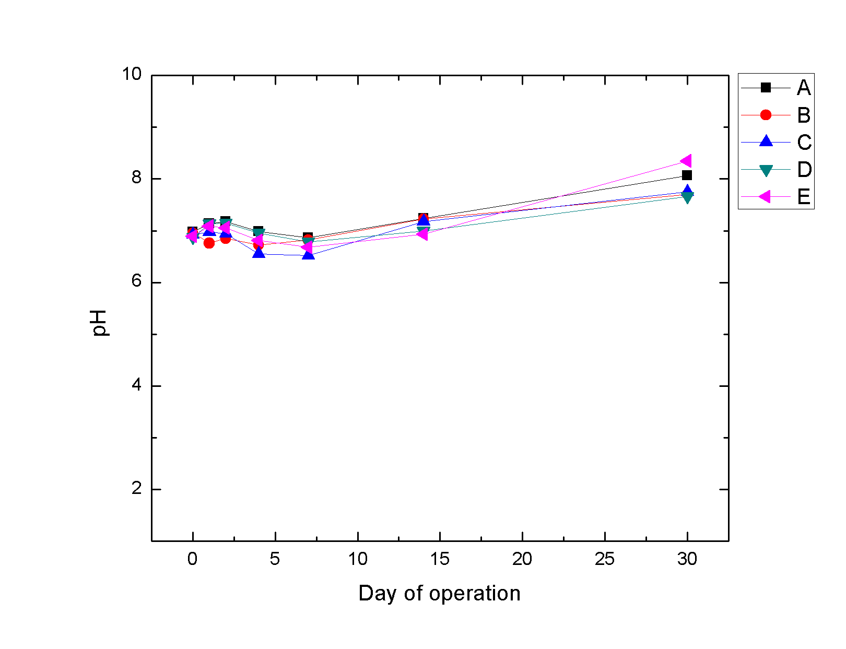
Fig. 1. pH values of controls A-E during the phytoremediation experiment.
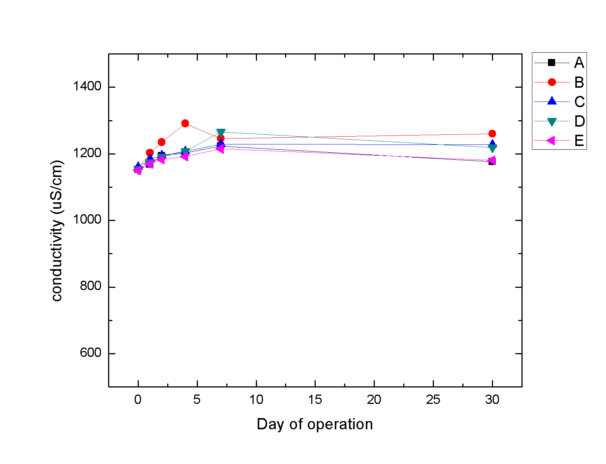
Fig. 2. Conductivity values of controls A-E during the phytoremediation experiment.

The phosphate increase at the end of the experiment (Fig. 3) could be a result of a partial lysis of the plants. (Wang et al., 2018)

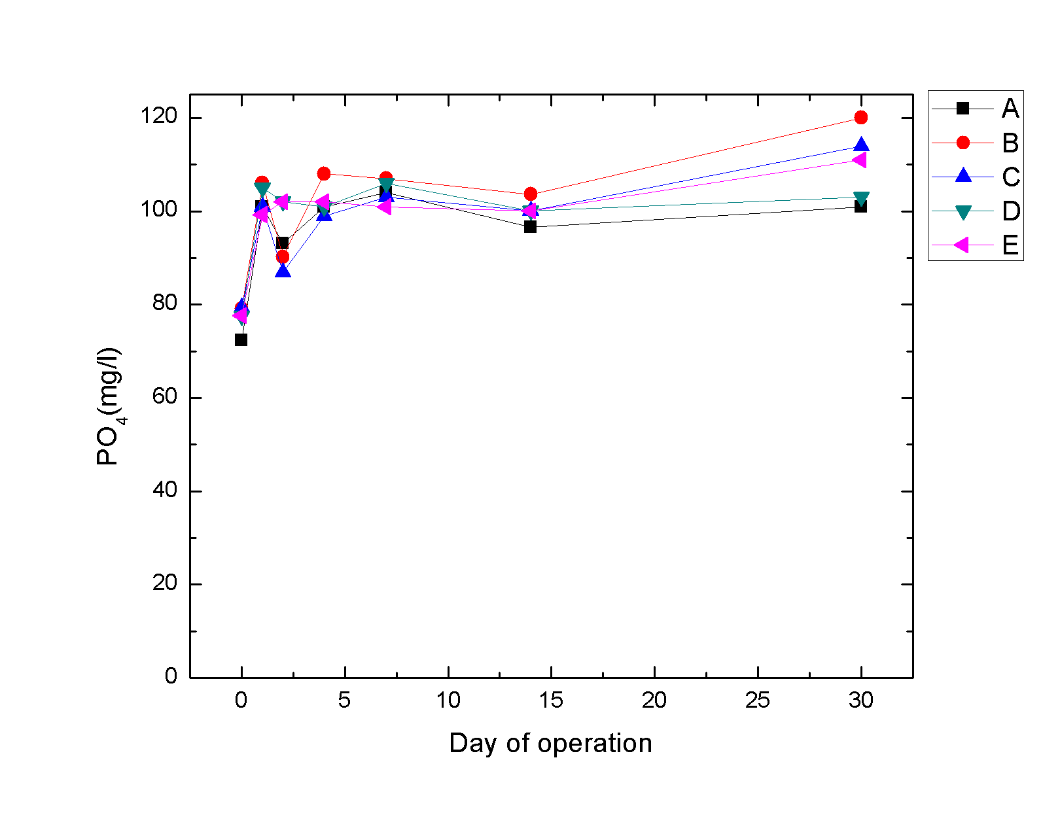
Fig. 3. Concentrations of (PO₄)³⁻ ions of controls A-E during the phytoremediation experiment.

The values of redox potential (Fig. 4) and dissolved oxygen (Fig. 5) were decreasing, which was a result of a slow lysis of the plants, caused by mechanical damage from change of the conditions, phytotoxic effect due to exposition to some MP (e.g. antibiotics and herbicides)
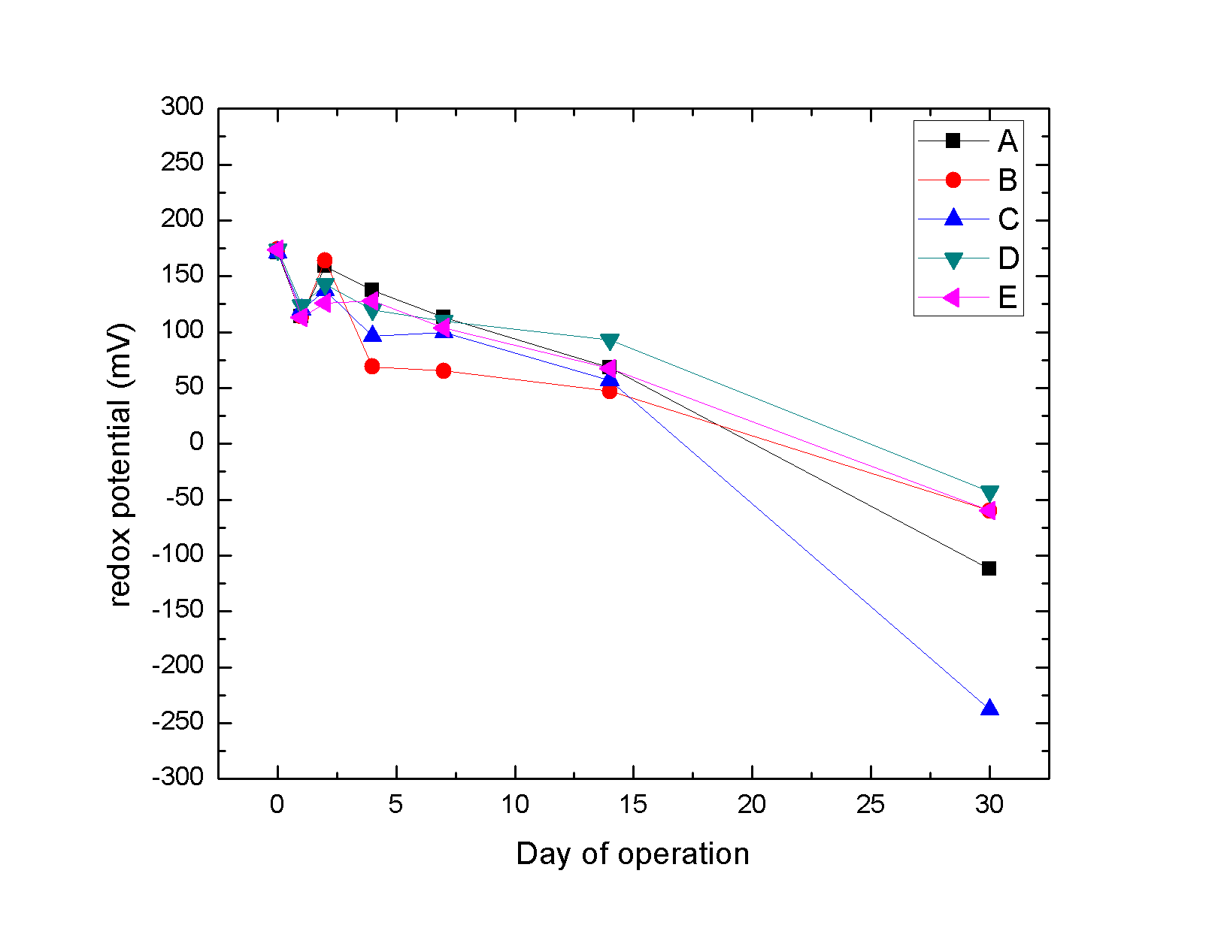
Fig. 4. Values of redox potential of the liquid solutions of controls A-E during the phytoremediation experiment.

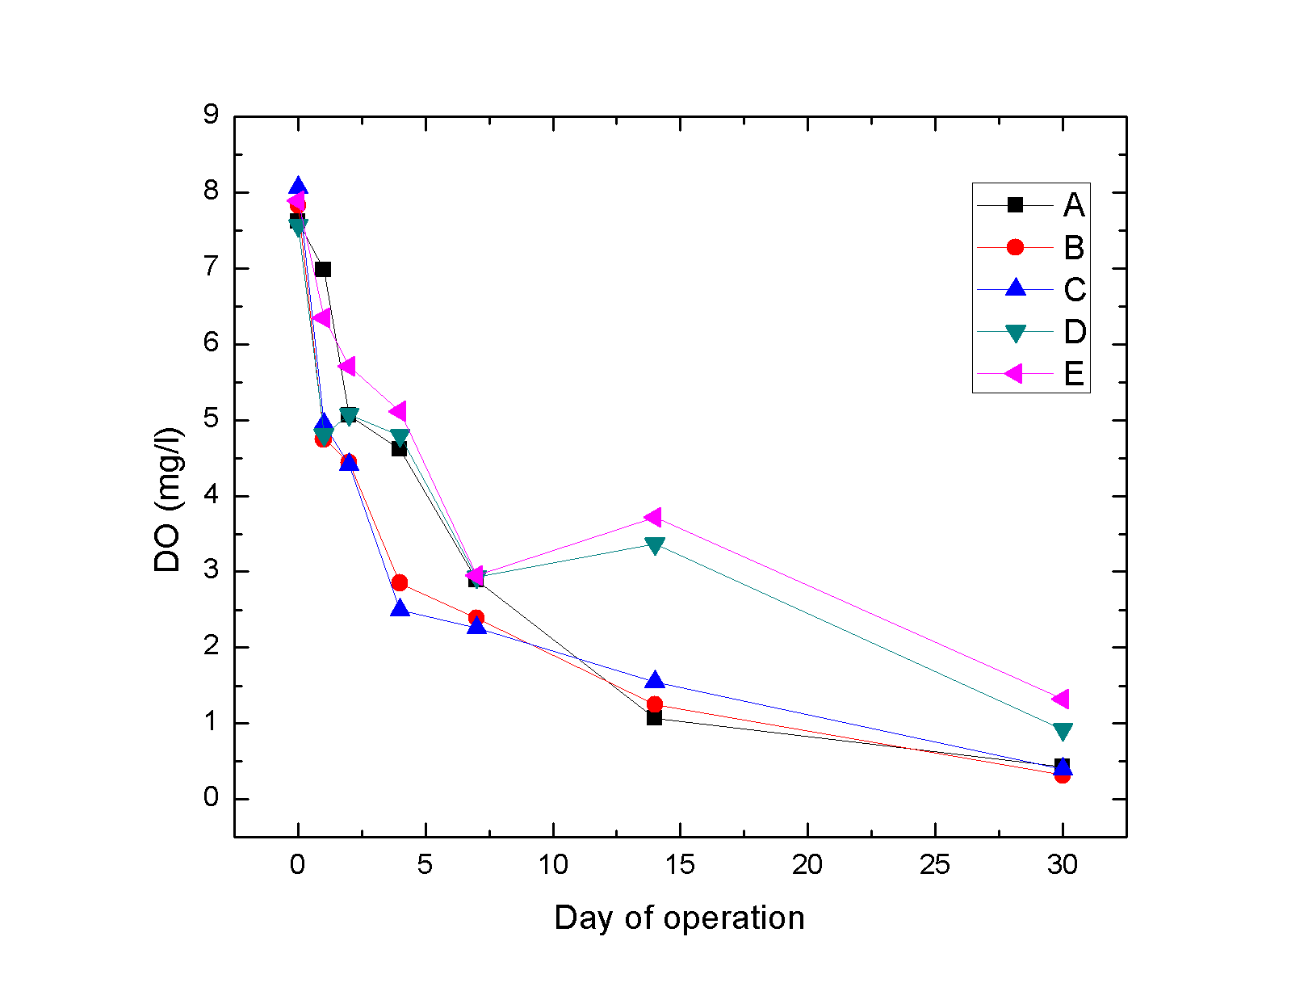
Fig. 5. Concentration of dissolved oxygen in the liquid solutions of controls A-E during the phytoremediation experiment.
In Figs 6 – 10 are present initial and final concentrations of all measured compounds in controls A – E.
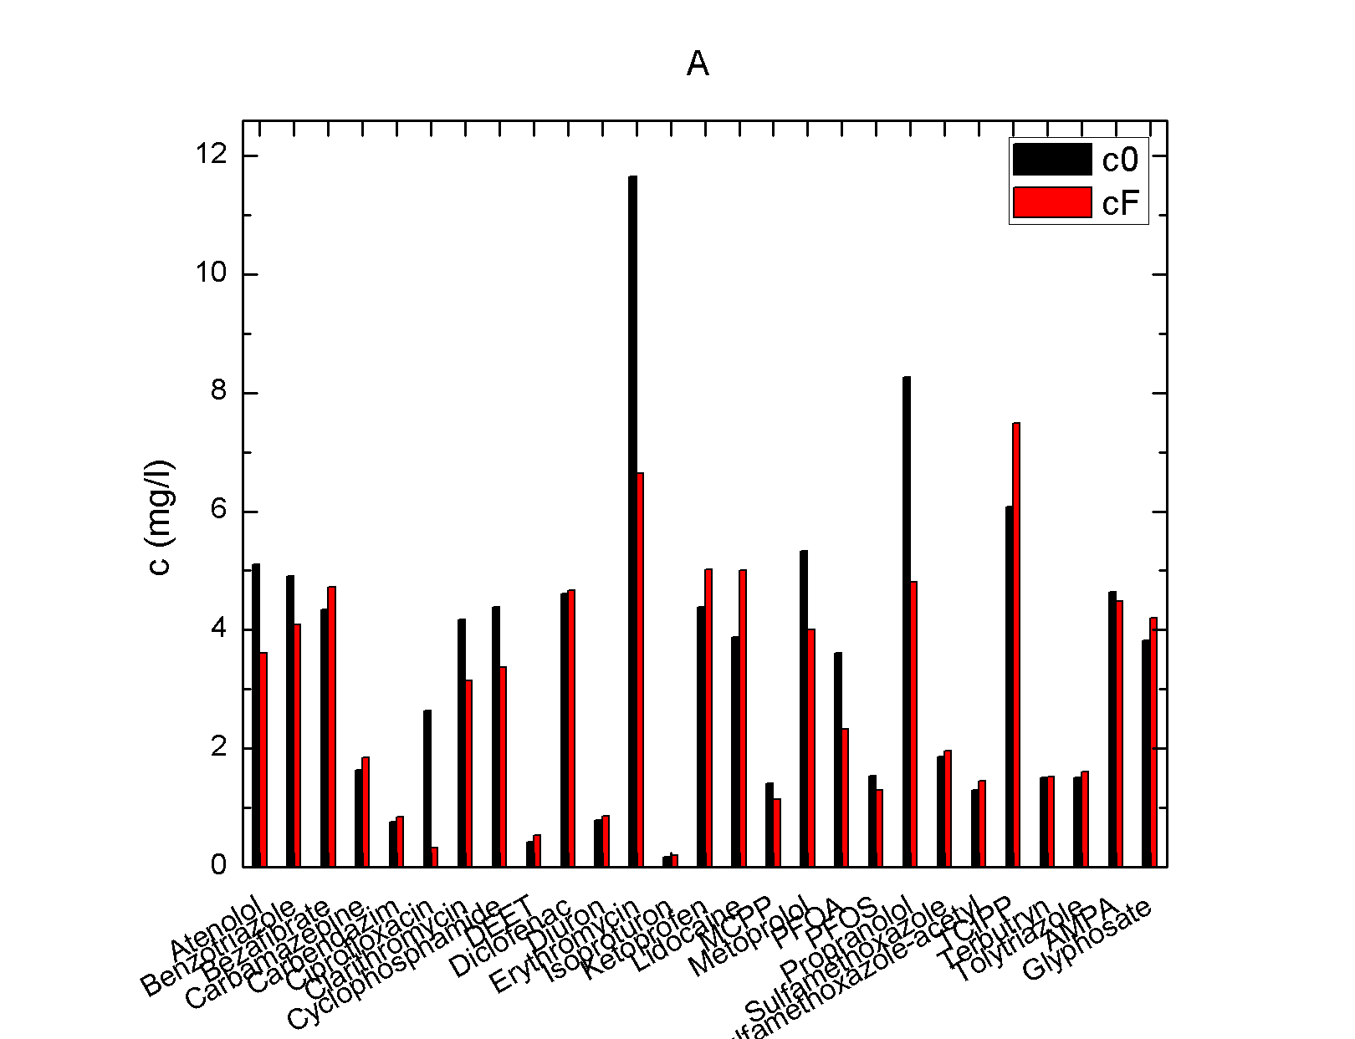
Fig. 6. Initial and final concentrations of the control A.
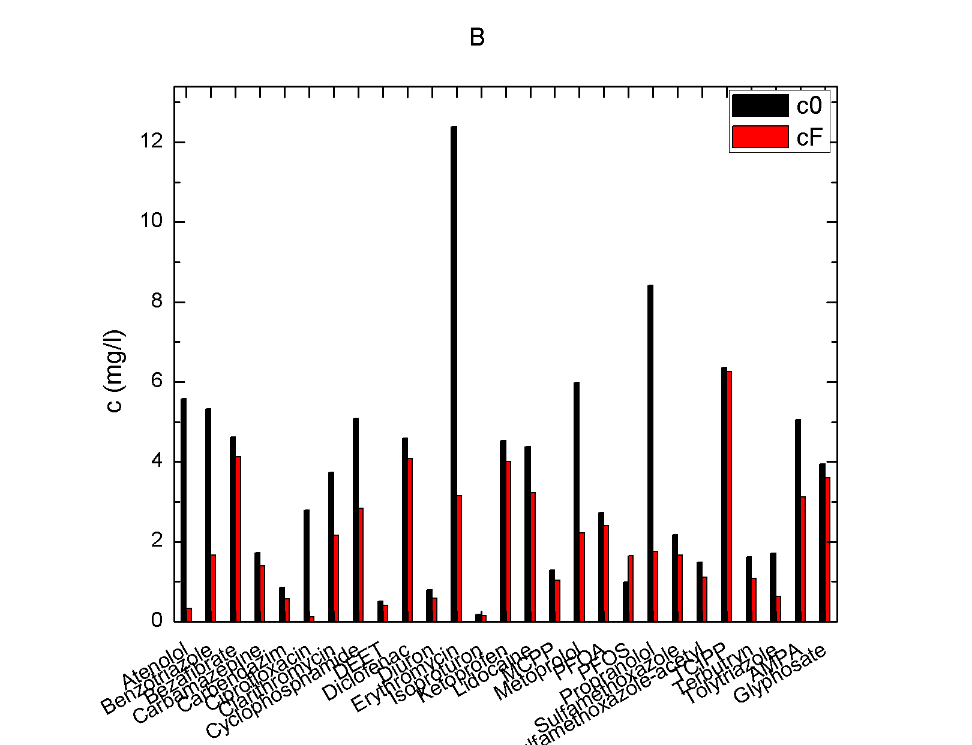
Fig. 7. Initial and final concentrations of the control B.

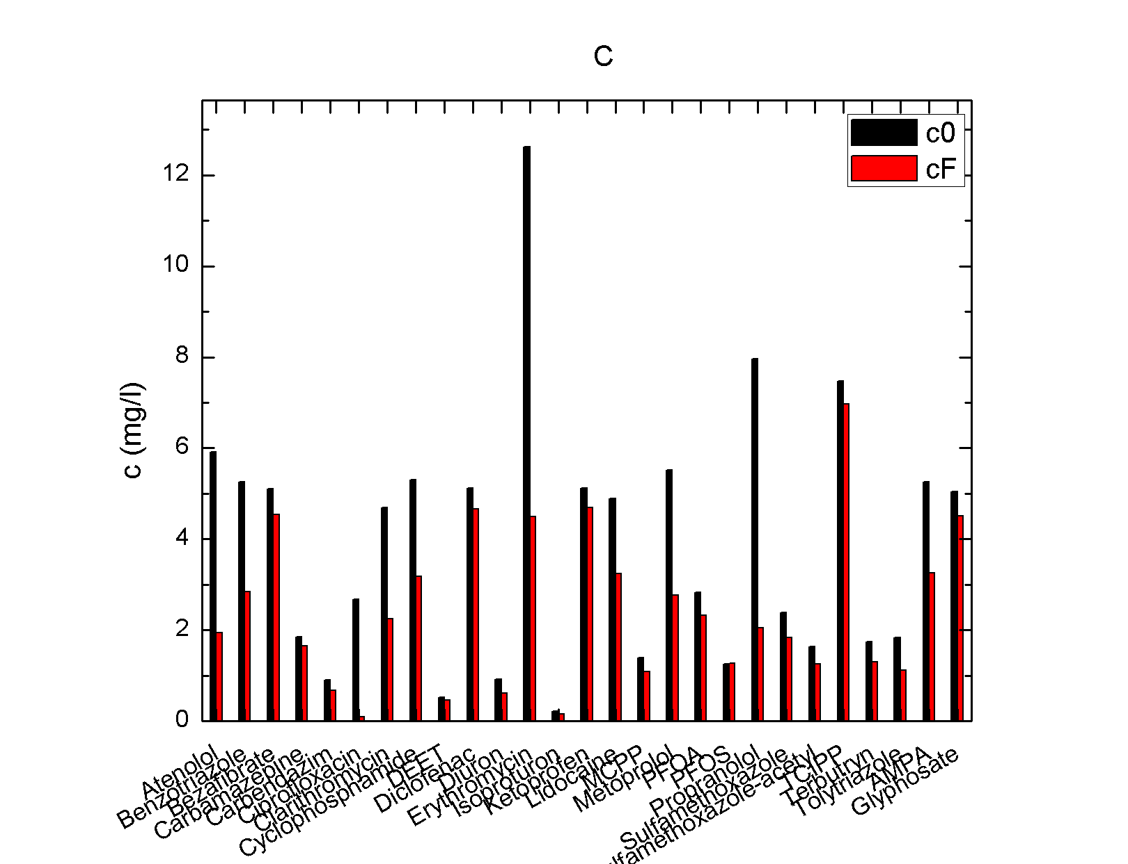
Fig. 8. Initial and final concentrations of the control C.
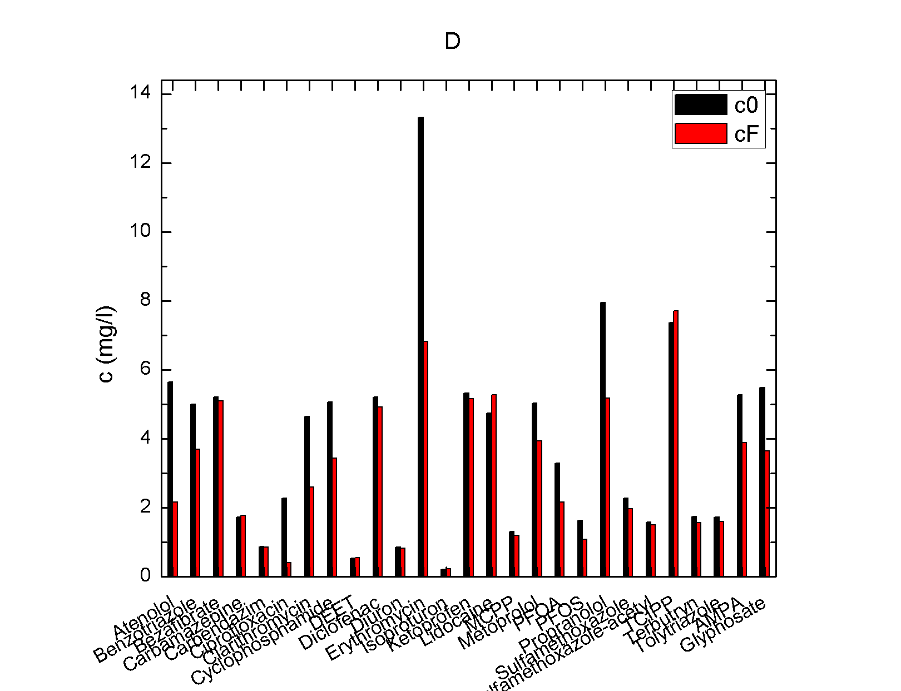
Fig. 9. Initial and final concentrations of the control D.

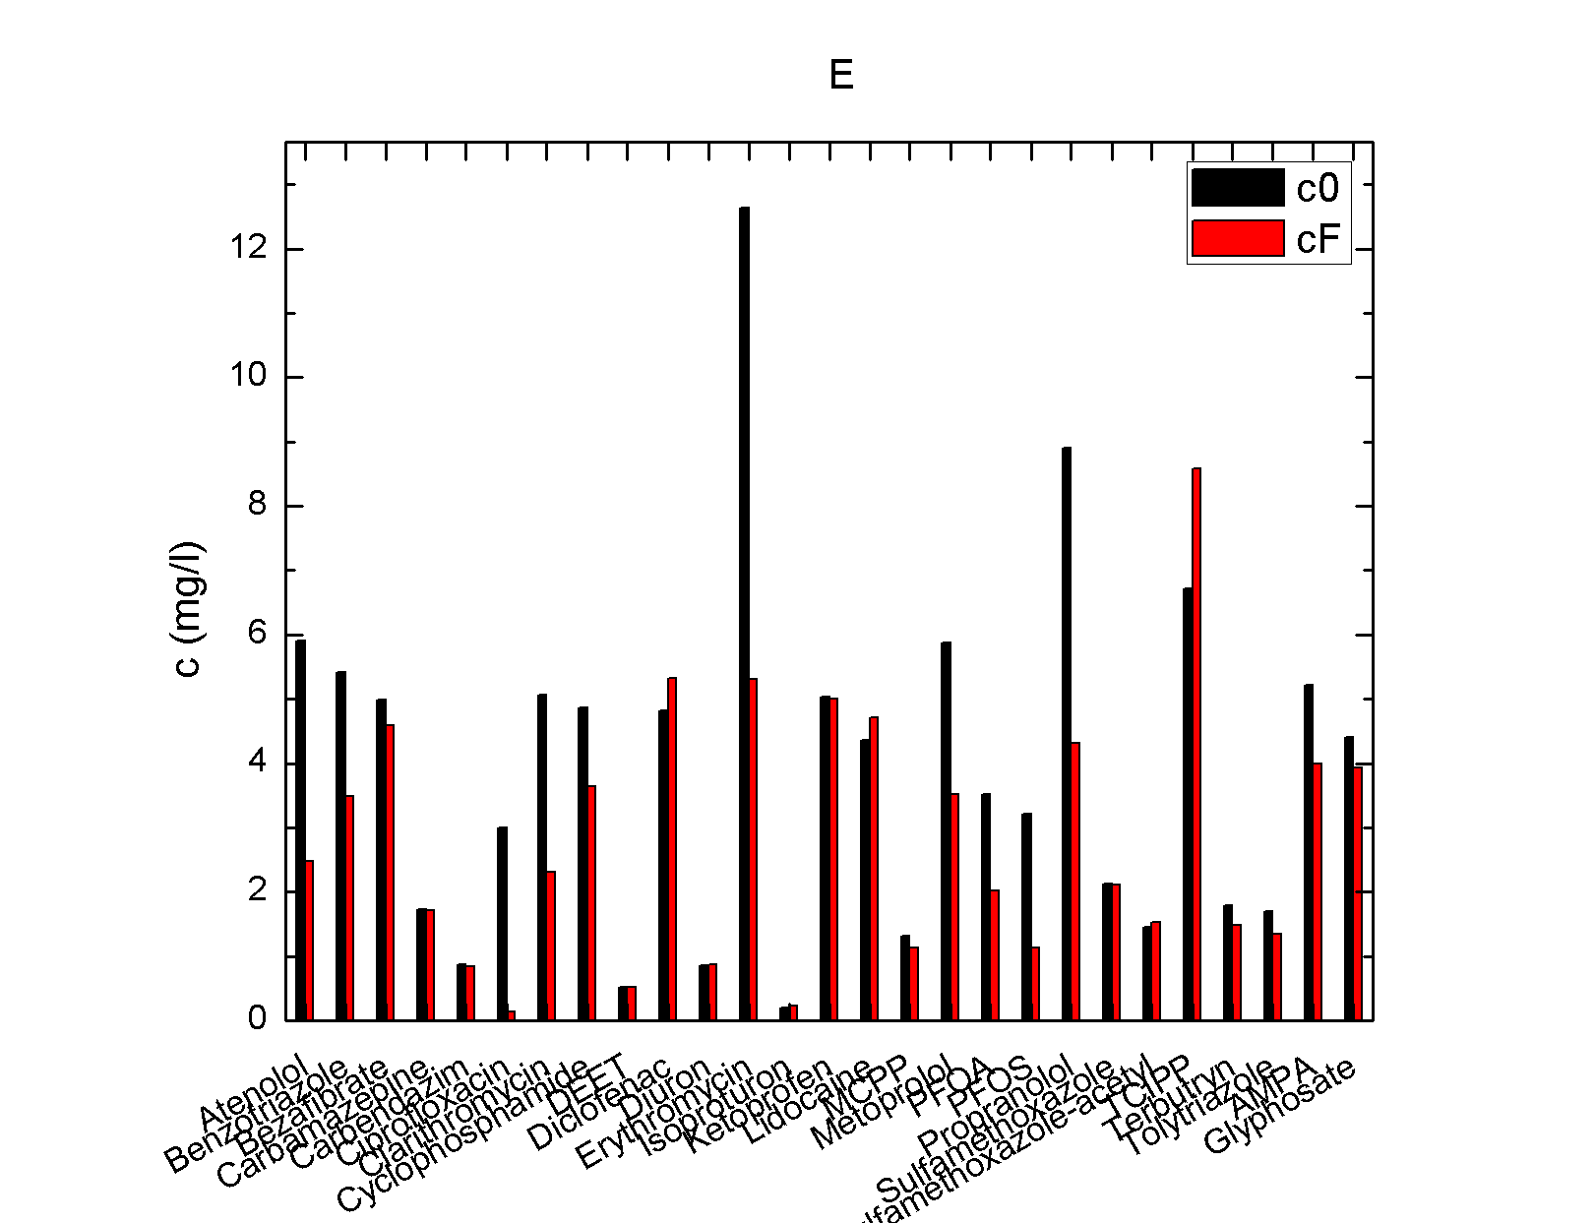
Fig. 10. Initial and final concentrations of the control E.

Higher final than initial concentrations of some compounds (i.e. Bezafibrate, Ketoprofen, Lidocaine, TCIPP) can be caused by desorption of the MPs from the plants, caused by the slow lysis.

Wang, L., Liu, Q., Hu, C., Liang, R., Qiu, J., & Wang, Y. (2018). Phosphorus release during decomposition of the submerged macrophyte Potamogeton crispus. Limnology, 19(3). https://doi.org/10.1007/s10201-018-0538-2

