Supplementary Information

Behaviour of 27 selected emerging contaminants in Vertical Flow Constructed Wetlands as post-treatment for municipal wastewater

Silvia Venditti ^{a*}, Hana Brunhoferova, Joachim Hansen
ª University of Luxembourg, Chair of Urban Water Management, 6, rue Coudenhove-Kalergi, L-1359, Luxembourg
* Corresponding author. Tel.: +352 (0) 27 58 88 5007
E-mail address: silvia.venditti@uni.lu

S.0 Information substrates for Lab and pilot-scale installations

Table S0

 | Grain size | Grain density | Bulk density
Biochar, Palaterra* | 2 – 5 mm | n.p.** | n.p.
Zeolite Zeobon | 2.5 – 5 mm | n.p. | 900 kg/m3
Sand Liapor | 0 – 3 mm | 1450±150 kg/m3 | 550±80 kg/m3

*the biochar used in this project is not a standardized material and thus properties can change based on the production
**n.p.= not provided

S.1 Chemo-physical properties of target compounds

Table S1

Substance | Chemical  formula | Molar Mass | Octanol-water partitioning Log KOW |  | pKa
 |  | g  mol⁻¹ | Experimental  ACD-Lab | Predicted | strongest  basic | strongest  acid
Atenolol | C₁₄H₂₂N₂O₃ | 266.3 | -0.465 | 0.43 | 9.67 | 14.08
Bezafibrate | C₁₉H₂₀ClNO₄ | 361.8 | 1.591 | 3.99 | -0.84 | 3.83
Carbamazepine | C₁₅H₁₂N₂O | 236.3 | 0.792 | 2.77 | -3.8 | 15.96
Clarithromycin | C₃₈H₆₉NO₁₃ | 748.0 | 1.66 | 3.16 | 8.38 | 12.46
Ciprofloxacin | C₁₇H₁₈FN₃O₃ | 331.3 | 1.809 | 0.65 | 8.68 | 5.76
Cyclophosphamide | C₇H₁₅Cl₂N₂O₂P | 261.0 | 0.8 | 0.23 | -0.57 | 12.78
Diclofenac | C₁₄H₁₁Cl₂NO₂ | 296.1 | 2.219 | 4.06 | -2.1 | 4
Erythromycin | C₃₇H₆₇NO₁₃ | 733.9 | 1.141 | 2.83 | 8.38 | 12.44
Ketoprofen | C₁₆H₁₄O₃ | 254.3 | 1.651 | 2.81 | -7.5 | 3.88
Lidocaine | C₁₄H₂₂N₂O | 234.3 | 8.01 | 3.63 | 7.75 | 13.78
Metoprolol | C₁₅H₂₅NO₃ | 267.4 | 0.72 | 1.79 | 9.67 | 14.09
Propranolol | C₁₆H₂₁NO₂ | 259.3 | 2.023 | 3.1 | 9.67 | 14.09
N4-acetylsulfamethoxazole | C₁₂H₁₃N₃O₄S | 295.3 | 0.326 | 1.48 | nn | nn
Sulfamethoxazole | C₁₀H₁₁N₃O₃S | 253.3 | 0.255 | 0.89 | 1.97 | 6.16
Carbendazim | C₉H₉N₃O₂ | 191.2 | nn | 1.52 | 4.2 | nn
Deet | C₁₂H₁₇NO | 191.3 | nn | 1.96 | nn | nn
Diuron | C₉H₁₀Cl₂N₂O | 233.1 | nn | 2.88 | nn | 13.18
Isoproturon | C₁₂H₁₈N₂O | 206.3 | nn | 2.32 | nn | 13.79
Terbutryn | C₁₀H₁₉N₅S | 241.4 | nn | 1.28 | 6.72 | 14.31
Mecoprop | C₁₀H₁₁ClO₃ | 214.6 | nn | 2.84 | nn | 3.1
Tolyltriazole | C₇H₇N₃ | 133.2 | 0.974 | 1.8 | nn | nn
Glyphosate | C₃H₈NO₅P | 169.0 | nn | -2.36 | 0.8 | nn
AMPA | CH₆NO₃P | 111.0 | -1.4296 | -2.76 | nn | nn
PFOS | C₈HF₁₇O₃S | 500.0 | nn | 7.03 | nn | nn
PFOA | C₈HF₁₅O₂ | 414.0 | 5.905 | 7.75 | nn | nn
Benzotriazole | C₆H₅N₃ | 119.1 | 0.582 | 1.34 | nn | nn
TCPP | C₆H₁₂Cl₃O₄P | 285.5 | nn | 1.53 | nn | nn

S.2 Analytical method

Table S.2

Substance | Chemical  formula | LOQ clean water | LOQ waste water | Recovery rate clean water | Recovery rate waste water
 |  | ng L⁻¹ | ng L⁻¹ | % | %
Atenolol | C₁₄H₂₂N₂O₃ | 100 | 250 | 8 | 1
Bezafibrate | C₁₉H₂₀ClNO₄ | 5 | 20 | 82 | 76 (3)
Carbamazepine | C₁₅H₁₂N₂O | 5 | 5 | 92 | 80
Clarithromycin | C₃₈H₆₉NO₁₃ | 10 | 50 | 21 | 23
Ciprofloxacin | C₁₇H₁₈FN₃O₃ | 50 | 500 | 33 | 56
Cyclophosphamide | C₇H₁₅Cl₂N₂O₂P | 5 | 5 | 72 | 82
Diclofenac | C₁₄H₁₁Cl₂NO₂ | 5 | 5 | 78 | 96
Erythromycin | C₃₇H₆₇NO₁₃ | 20 | 100 | 14 | 7
Ketoprofen | C₁₆H₁₄O₃ | 5 | 5 | 78 | 86 (3)
Lidocaine | C₁₄H₂₂N₂O | 5 | 5 | 71 | 76
Metoprolol | C₁₅H₂₅NO₃ | 5 | 10 | 82 | 41
Propranolol | C₁₆H₂₁NO₂ | 20 | 100 | 33 | 33
N4-acetylsulfamethoxazole | C₁₂H₁₃N₃O₄S | 5 | 10 | 83 | 28 (3)
Sulfamethoxazole | C₁₀H₁₁N₃O₃S | 5 | 5 | 81 | 71
Carbendazim | C₉H₉N₃O₂ | 5 | 5 | 83 | 77 (3)
Deet | C₁₂H₁₇NO | 10 | 20 | 93 | 71 (3)
Diuron | C₉H₁₀Cl₂N₂O | 5 | 10 | 69 | 85 (3)
Isoproturon | C₁₂H₁₈N₂O | 5 | 5 | 89 | 72 (3)
Terbutryn | C₁₀H₁₉N₅S | 5 | 10 | 4 | 73 (3)
Mecoprop | C₁₀H₁₁ClO₃ | 10 | 100 | 87 | 96 (3)
Tolyltriazole | C₇H₇N₃ | 5 | 20 | 77 | 69 (3)
Glyphosate | C₃H₈NO₅P | 5 | 20 | n.a. | n.a.
AMPA | CH₆NO₃P | 5 | 20 | n.a. | n.a.
PFOS | C₈HF₁₇O₃S | 10 | 100 | 28 | 53 (3)
PFOA | C₈HF₁₅O₂ | 5 | 20 | 73 | 89 (3)
Benzotriazole | C₆H₅N₃ | 5 | 20 | 89 | 75 (3)
TCPP | C₆H₁₂Cl₃O₄P | 10 | 50 | 91 | 62 (3)

(3) estimated in synthetic wastewater

S.3 Macropollutants data (Lab-scale investigation)

Table S.3 Statistical data of influent and effluent concentrations (mg L⁻¹), removal efficiencies (%) and physicochemical parameters (average value from 30 measurements ± standard deviation)

N=30 |  | Influent | A | B | C | D | E | F
COD | mg L⁻¹ | 72±12.2 | 4±3.6 | 4±3.1 | 5±3.6 | 4±3.3 | 4±3.7 | 3±3.5
 | Removal rate (%) |  | 94 | 95 | 93 | 95 | 95 | 95
TN | mg L⁻¹ | 15.3±3.9 | 12.6±5.5 | 11.8±5.2 | 12.8±5.7 | 12.1±4.1 | 12.4±4.5 | 12.3±4.2
 | Removal rate (%) |  | 18 | 23 | 17 | 21 | 19 | 20
PO4-P | mg L⁻¹ | 2.6±2.9 | 0.5±1.1 | 2.3±2.2 | 1±0.87 | 1.8±1.6 | 0.5±0.9 | 0.8±1.29
 | Removal rate (%) |  | 79 | 13 | 61 | 30 | 81 | 68
pH |  | 6.44±1.4 | 6.40±1.4 | 6.48±1.4 | 6.43±1.4 | 6.47±1.3 | 6.50±1.3 | 6.45±1.3
EC | uS cm⁻¹ | 303±48 | 368±65 | 406±49 | 391±67 | 410±61 | 387±73 | 375±57
DO | mg L⁻¹ | 7.37±2.24 | 6.5±1.1 | 6.5±1.2 | 6.4±1.0 | 6.5±1 | 6.4±1.1 | 6.5±1.1

Figure S.3 Elimination of TP in the lysimeters
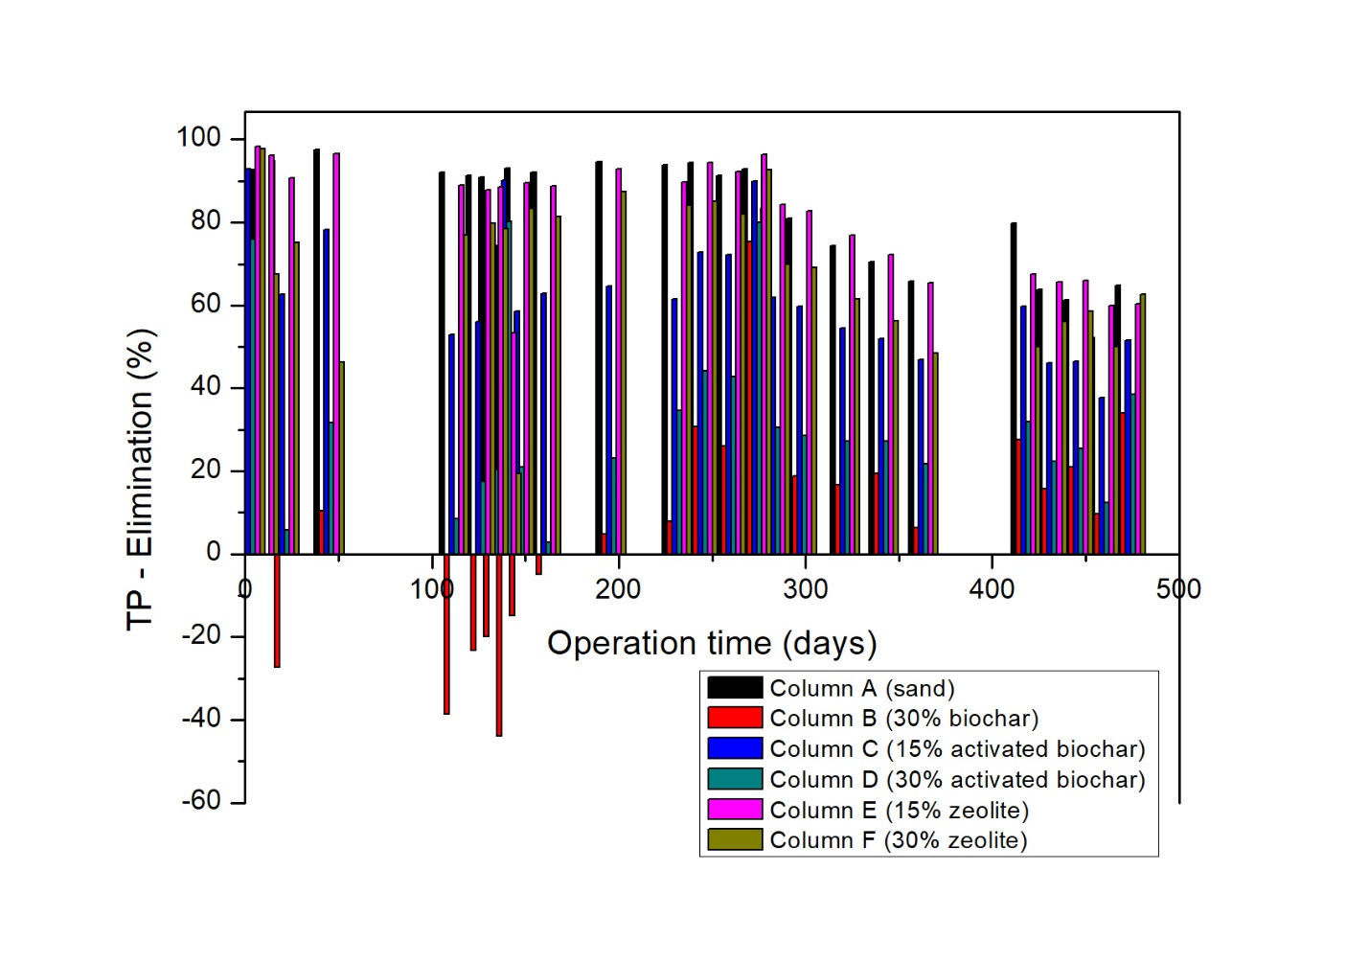

S.4 Micropollutants data (Lab-scale investigation)

Table S.4 Data of influent and effluent concentrations (mg L⁻¹), (average values ± standard deviation) (N=15)

 | Influent | Column A | Column B | Column C | Column D | Column E | Column  F
High and stable elimination
Atenolol
Min | 25811 | 258 | 247 | 242 | 252 | 242 | 216
Max | 95512 | 1701 | 3410 | 3390 | 2648 | 566 | 3660
Average | 51112.3 | 404.4 | 524 | 599 | 477.4 | 318.8 | 541
Standard deviation (ng) | 21863 | 81.7 | 696 | 779 | 543 | 74.6 | 775
Bezafibrate
Min | 3874.0 | 2.2 | 2.2 | 2.1 | 2.2 | 2.1 | 2.1
Max | 10818.0 | 171.0 | 50.0 | 228.0 | 124.0 | 23.6 | 370.0
Average | 5401.3 | 19.7 | 12.3 | 21.7 | 16.5 | 7.4 | 30.3
Standard deviation (ng) | 1618.0 | 38.4 | 13.9 | 53.5 | 30.4 | 5.7 | 81.5
Carbamazepine
Min | 2004.0 | 3.1 | 3.0 | 2.9 | 3.0 | 2.9 | 2.9
Max | 4748.0 | 66.6 | 211.0 | 18.4 | 108.0 | 28.7 | 182.0
Average | 2837.1 | 10.1 | 16.4 | 5.9 | 11.2 | 6.7 | 15.3
Standard deviation (ng) | 777.5 | 14.3 | 45.9 | 3.6 | 23.3 | 5.7 | 39.6
Clarithromycin
Min | 3139.0 | 4.0 | 3.4 | 3.2 | 3.9 | 3.3 | 3.7
Max | 7906.0 | 482.0 | 1187.0 | 629.0 | 190.0 | 124.0 | 701.0
Average | 5295.1 | 84.8 | 95.1 | 72.6 | 43.5 | 32.3 | 71.5
Standard deviation (ng) | 1322.3 | 144.5 | 261.1 | 151.0 | 57.2 | 40.0 | 170.3
Diclofenac
Min | 292.0 | 2.8 | 2.8 | 2.7 | 2.8 | 2.7 | 2.5
Max | 6237.0 | 146.0 | 20.7 | 50.4 | 83.8 | 32.4 | 277.0
Average | 4380.9 | 17.6 | 7.0 | 6.6 | 8.4 | 6.9 | 21.4
Standard deviation (ng) | 1366.2 | 34.3 | 5.2 | 10.9 | 17.9 | 7.9 | 60.8
Ketoprofen
Min | 200.0 | 2.3 | 2.2 | 2.1 | 2.2 | 2.1 | 2.5
Max | 11389.0 | 83.0 | 26.6 | 12.0 | 110.0 | 17.5 | 309.0
Average | 4680.6 | 8.7 | 5.4 | 3.8 | 9.0 | 4.7 | 22.1
Standard deviation (ng) | 1907.8 | 17.2 | 5.8 | 2.0 | 23.2 | 3.3 | 66.6
Lidocaine
Min | 234.0 | 2.5 | 2.4 | 2.4 | 2.5 | 2.4 | 2.4
Max | 8409.0 | 151.0 | 14.2 | 10.3 | 12.7 | 8.8 | 403.0
Average | 5153.4 | 11.0 | 4.6 | 4.1 | 4.4 | 3.8 | 41.4
Standard deviation (ng) | 1611.5 | 32.1 | 2.5 | 1.8 | 2.5 | 1.3 | 118.9
Metoprolol
Min | 442.0 | 2.9 | 3.0 | 2.8 | 2.8 | 2.8 | 2.8
Max | 10565.0 | 305.0 | 32.5 | 22.3 | 159.0 | 14.2 | 690.0
Average | 6189.5 | 23.1 | 9.5 | 6.4 | 12.3 | 6.3 | 42.2
Standard deviation (ng) | 2344.2 | 65.0 | 8.6 | 5.4 | 33.8 | 4.0 | 148.9
Propranolol
Min | 186.0 | 3.0 | 3.0 | 2.9 | 2.9 | 2.7 | 2.6
Max | 7190.0 | 179.0 | 25.1 | 32.8 | 20.8 | 9.5 | 291.0
Average | 4635.1 | 17.1 | 8.1 | 5.5 | 5.2 | 4.7 | 18.3
Standard deviation (ng) | 1464.16 | 37.39 | 6.60 | 6.29 | 3.79 | 1.97 | 62.55
Benzotriazole
Min | 3874.0 | 7.1 | 7.6 | 7.4 | 6.7 | 6.1 | 3.4
Max | 7630.0 | 316.0 | 135.0 | 123.0 | 260.0 | 567.0 | 448.0
Average | 5295.7 | 60.1 | 40.9 | 38.4 | 39.9 | 62.9 | 79.7
Standard deviation (ng) | 985.0 | 83.3 | 35.9 | 35.6 | 59.1 | 124.7 | 133.3
Carbendazim
Min | 828.0 | 2.8 | 2.8 | 2.7 | 2.8 | 3.2 | 2.7
Max | 1961.0 | 36.9 | 16.8 | 12.5 | 5.0 | 131.0 | 80.9
Average | 1193.0 | 5.5 | 4.5 | 4.5 | 3.5 | 19.7 | 8.5
Standard deviation (ng) | 278.0 | 7.7 | 3.3 | 2.9 | 0.6 | 31.6 | 17.9
Diuron
Min | 748.0 | 2.4 | 2.4 | 2.6 | 2.5 | 2.5 | 2.2
Max | 2181.0 | 38.4 | 12.0 | 17.6 | 9.2 | 17.8 | 80.2
Average | 1187.1 | 5.6 | 3.9 | 4.1 | 3.8 | 4.4 | 8.3
Standard deviation (ng) | 438.6 | 8 | 2.2 | 3.3 | 1.8 | 3.5 | 17.8
Isoproturon
Min | 720.0 | 2.7 | 2.8 | 2.8 | 2.7 | 2.8 | 2.6
Max | 1509.0 | 37.8 | 4.3 | 4.0 | 8.2 | 6.9 | 78.5
Average | 993.9 | 5.2 | 3.4 | 3.4 | 3.7 | 3.6 | 7.3
Standard deviation (ng) | 233.5 | 7.9 | 0.4 | 0.3 | 1.2 | 0.9 | 17.2
Terbutryn
Min | 1571.0 | 2.8 | 2.7 | 2.6 | 2.8 | 2.6 | 2.6
Max | 2979.0 | 57.1 | 6.6 | 4.7 | 5.2 | 7.7 | 76.8
Average | 2068.9 | 6.6 | 3.8 | 3.8 | 3.8 | 4.0 | 7.5
Standard deviation (ng) | 308.2 | 12.2 | 0.8 | 0.5 | 0.6 | 1.2 | 16.8
Tolyltriazole
Min | 1482.0 | 3.5 | 3.5 | 3.4 | 3.5 | 3.6 | 3.3
Max | 2851.0 | 66.5 | 14.0 | 9.7 | 14.0 | 8.6 | 124.0
Average | 2148.2 | 7.5 | 4.8 | 4.5 | 4.6 | 4.6 | 10.4
Standard deviation (ng) | 359.6 | 13.9 | 2.3 | 1.4 | 2.2 | 1.5 | 26.8
Glyphosate
Min | 3750.0 | 4.6 | 4.4 | 4.4 | 4.4 | 0.1 | 0.1
Max | 8190.0 | 86.2 | 31.4 | 20.5 | 19.5 | 0.3 | 2.5
Average | 5191.0 | 10.5 | 10.5 | 5.9 | 7.0 | 0.1 | 0.4
Standard deviation (ng) | 920.0 | 18.3 | 8.3 | 3.5 | 4.1 | 0.1 | 0.7
High but unstable elimination
Ciprofloxacin
Min | 2154.0 | 22.9 | 23.4 | 22.5 | 23.4 | 23.4 | 22.0
Max | 15088.0 | 1189.0 | 656.0 | 708.0 | 667.0 | 646.0 | 2920.0
Average | 9156.6 | 323.5 | 273.2 | 271.5 | 264.5 | 261.6 | 504.2
Standard deviation (ng) | 3583.6 | 314.8 | 239.1 | 255.7 | 247.7 | 236.7 | 734.7
Erythromycin A
Min | 862.0 | 19.4 | 19.0 | 18.2 | 19.0 | 18.2 | 18.2
Max | 6685.0 | 65.3 | 76.5 | 35.6 | 53.1 | 48.6 | 66.6
Average | 3216.2 | 30.1 | 31.7 | 28.4 | 29.0 | 28.1 | 30.9
Standard deviation (ng) | 2319.0 | 10.0 | 12.1 | 5.1 | 7.7 | 7.0 | 11.6
N4-acetylsulfamethoxazole
Min | 12.4 | 8.5 | 8.2 | 8.0 | 8.3 | 8.0 | 8.0
Max | 88.8 | 12.5 | 12.5 | 13.3 | 12.0 | 22.2 | 12.4
Average | 51.2 | 10.3 | 10.3 | 10.5 | 10.3 | 10.6 | 10.2
Standard deviation (ng) | 15.2 | 1.2 | 1.3 | 1.4 | 1.2 | 2.9 | 1.4
DEET
Min | 1873.0 | 3.9 | 3.9 | 4.1 | 4.0 | 4.0 | 2.9
Max | 3645.0 | 58.3 | 129.0 | 79.4 | 38.0 | 55.0 | 1453.0
Average | 2532.6 | 12.9 | 31.7 | 15.7 | 14.1 | 13.9 | 110.4
Standard deviation (ng) | 565.2 | 13.0 | 37.7 | 19.3 | 11.8 | 12.9 | 323.3
TCPP
Min | 3509.0 | 250.0 | 254.0 | 170.0 | 139.0 | 99.6 | 73.2
Max | 9559.0 | 3564.0 | 9249.0 | 2661.0 | 2078.0 | 2572.0 | 2719.0
Average | 6239.6 | 851.9 | 1481.1 | 707.3 | 561.1 | 558.3 | 625.0
Standard deviation (ng) | 2003.2 | 771.6 | 2461.3 | 679.9 | 521.9 | 571.8 | 726.3
Medium elimination
Cyclophosphamide
Min | 4284.0 | 3.6 | 138.0 | 27.9 | 26.3 | 3.3 | 2.6
Max | 7110.0 | 5154.0 | 4624.0 | 3709.0 | 3133.0 | 4368.0 | 4968.0
Average | 5627.5 | 1211.5 | 2282.1 | 1370.6 | 1053.5 | 1202.0 | 1986.9
Standard deviation (ng) | 786.9 | 1479.4 | 1243.0 | 1141.9 | 821.4 | 1355.7 | 1548.1
MCPP
Min | 554.0 | 2.3 | 20.9 | 2.4 | 3.2 | 2.4 | 1.9
Max | 1312.0 | 112.0 | 255.0 | 57.7 | 19.1 | 103.0 | 3154.0
Average | 898.7 | 12.2 | 95.6 | 11.0 | 6.0 | 9.6 | 201.4
Standard deviation (ng) | 212.2 | 25.6 | 61.9 | 13.0 | 3.9 | 22.3 | 698.2
AMPA
Min | 3390.0 | 56.1 | 257.0 | 113.0 | 136.0 | 43.8 | 61.3
Max | 8640.0 | 4110.0 | 4630.0 | 4010.0 | 3060.0 | 3140.0 | 5270.0
Average | 5578.5 | 1087.9 | 2298.1 | 1312.6 | 1522.9 | 850.7 | 1470.4
Standard deviation (ng) | 1393.7 | 1238.3 | 1162.1 | 1252.7 | 935.4 | 1021.5 | 1566.5
PFOS
Min | 291.0 | 4.5 | 11.9 | 5.3 | 5.5 | 5.5 | 3.9
Max | 6576.0 | 1700.0 | 2938.0 | 1061.0 | 1034.0 | 1437.0 | 1942.0
Average | 2390.2 | 266.9 | 596.3 | 225.7 | 204.8 | 231.5 | 277.9
Standard deviation (ng) | 1726.6 | 451.0 | 746.0 | 291.4 | 278.5 | 430.8 | 525.3
PFOA
Min | 1019.0 | 96.3 | 188.0 | 253.0 | 294.0 | 119.0 | 2.1
Max | 3130.0 | 2479.0 | 2895.0 | 2145.0 | 2019.0 | 2234.0 | 2642.0
Average | 2113.5 | 1009.9 | 1303.0 | 1149.9 | 1079.8 | 872.4 | 933.4
Standard deviation (ng) | 644.4 | 807.6 | 782.5 | 561.9 | 589.8 | 583.3 | 796.4

S.4.1 Compounds with high and stable elimination

Pharmaceuticals

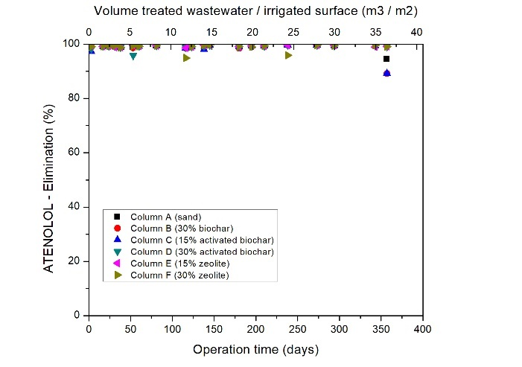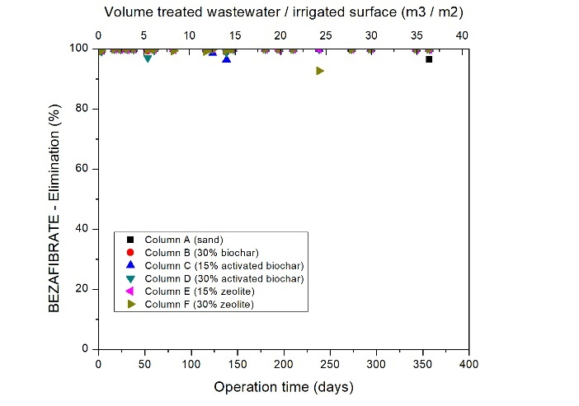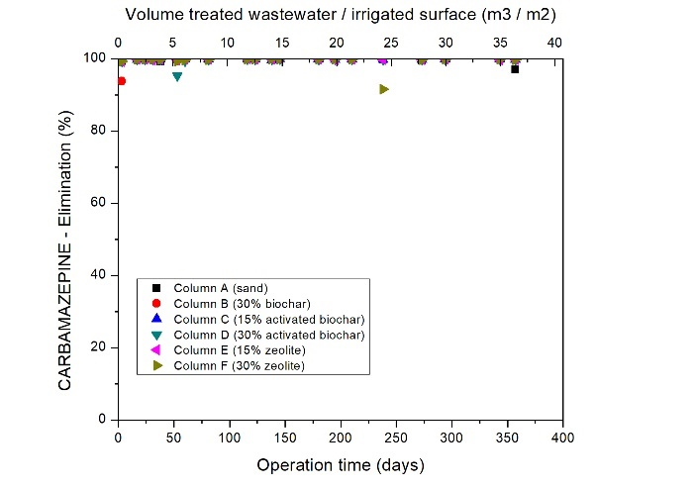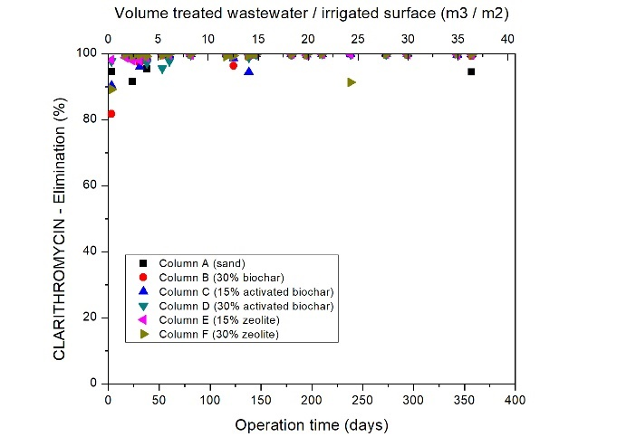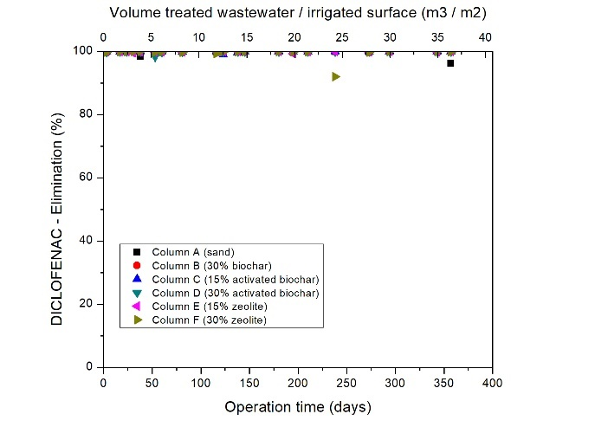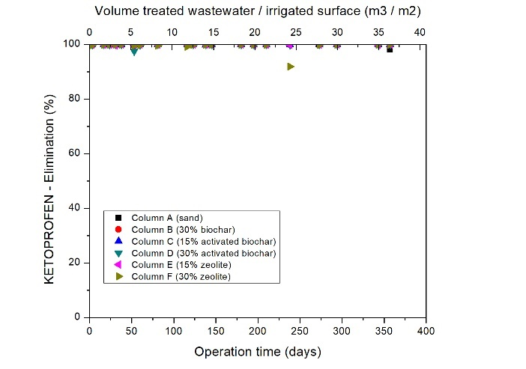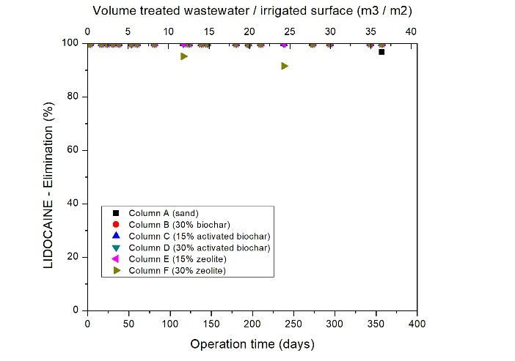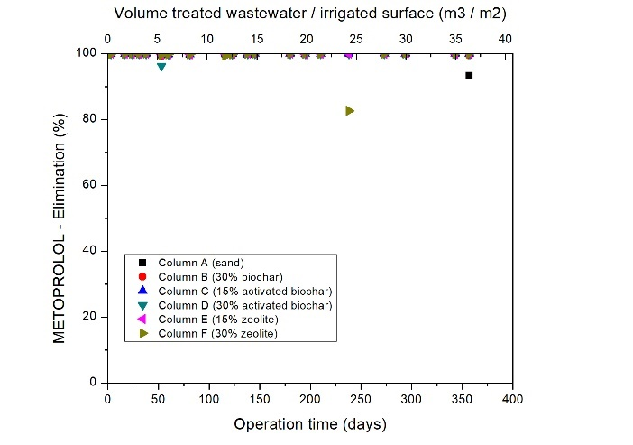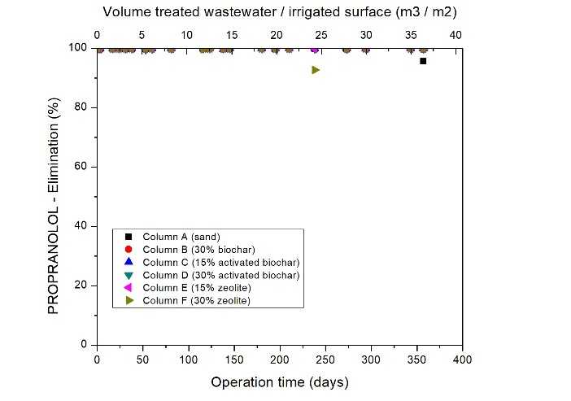

Pesticides/Herbicides etc

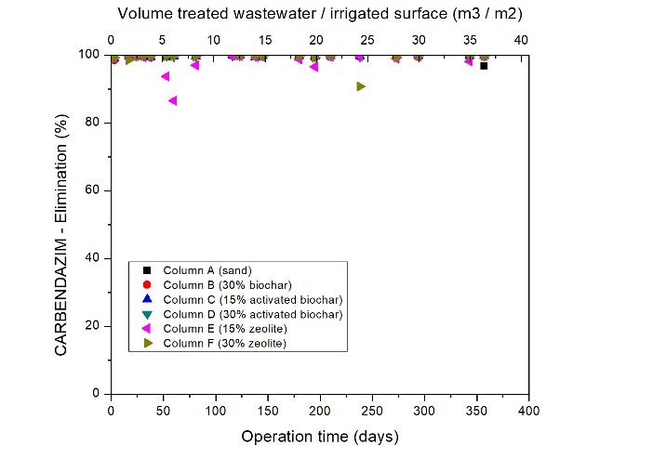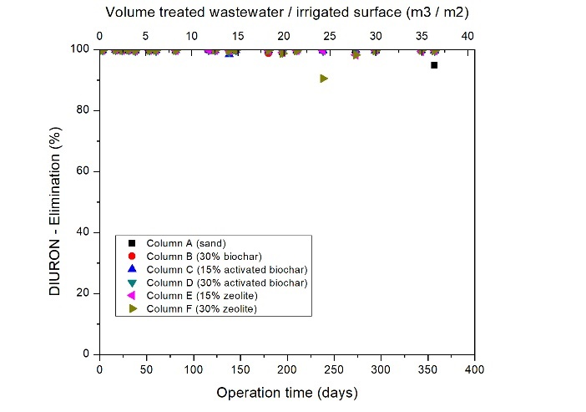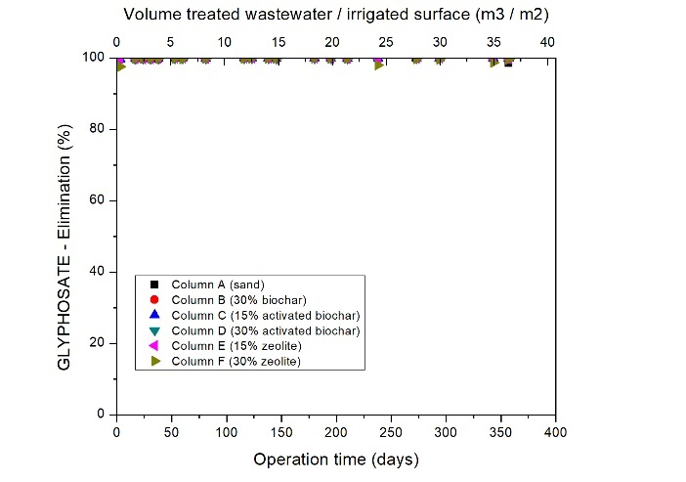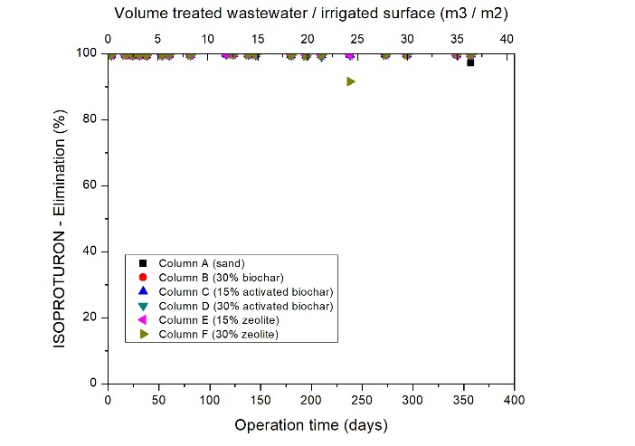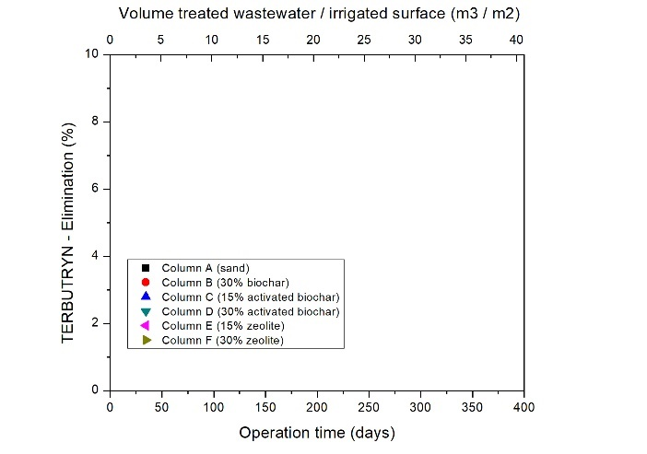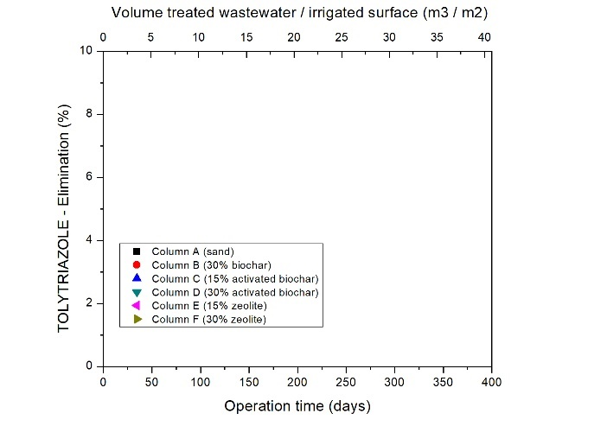

Corrosion inhibitor

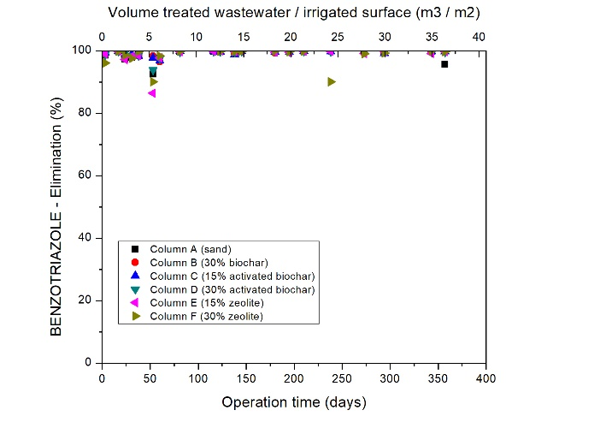

S.4.2 Compounds with high and unstable elimination

Pharmaceuticals

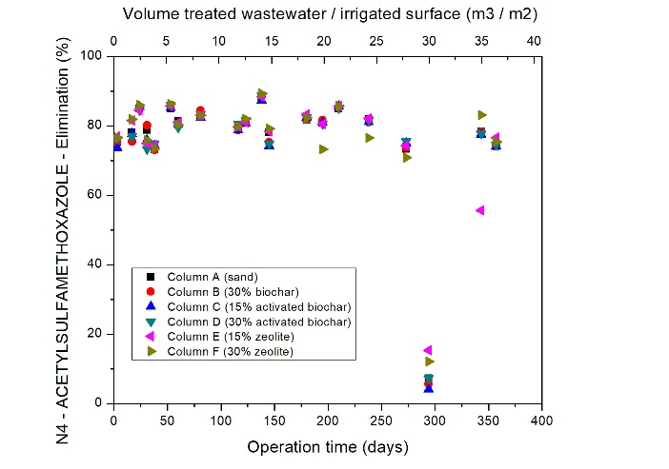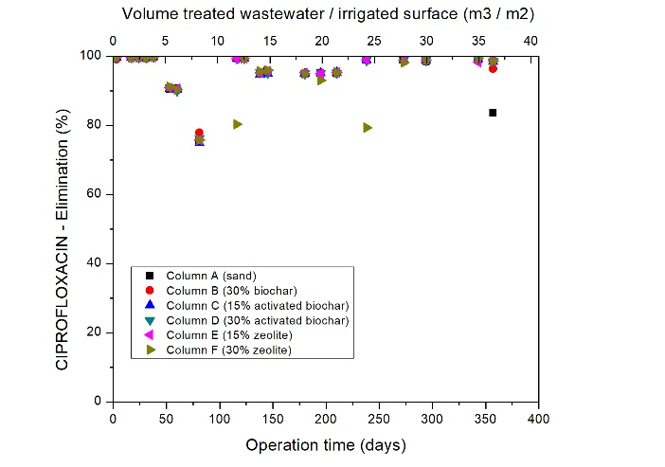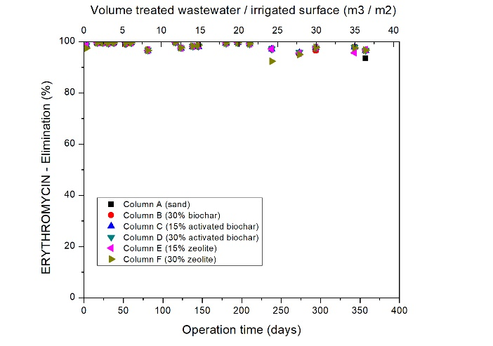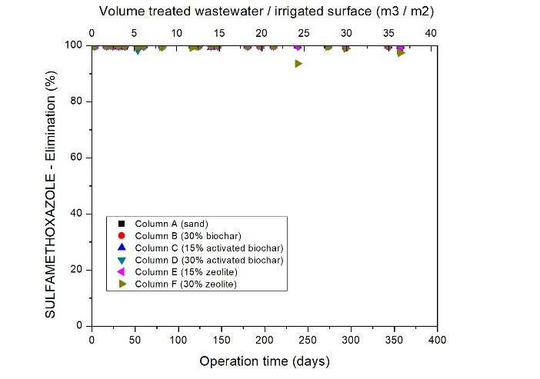
Pesticides/Herbicides etc

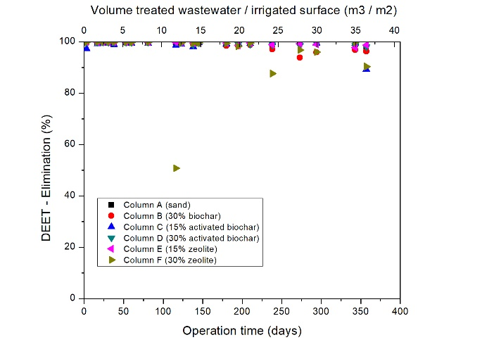

S.4.3 Compounds with medium elimination

Pharmaceuticals

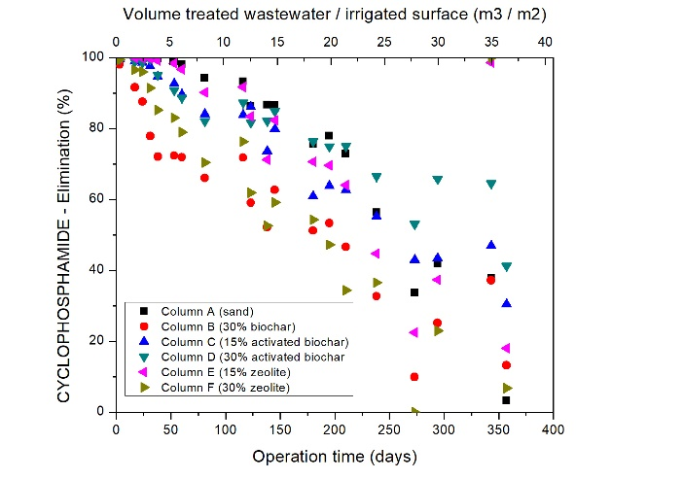

Pesticides/Herbicides etc

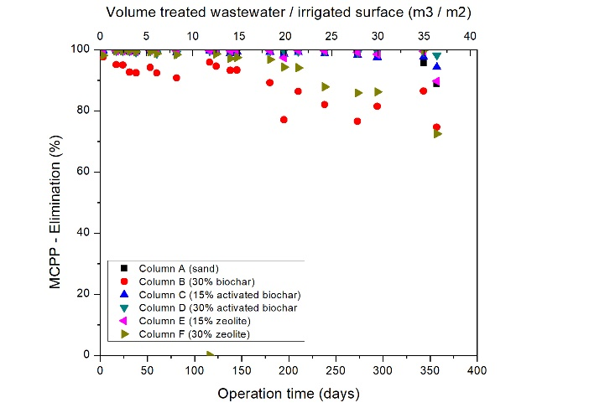

S.5 Breakthrough curves

AMPA

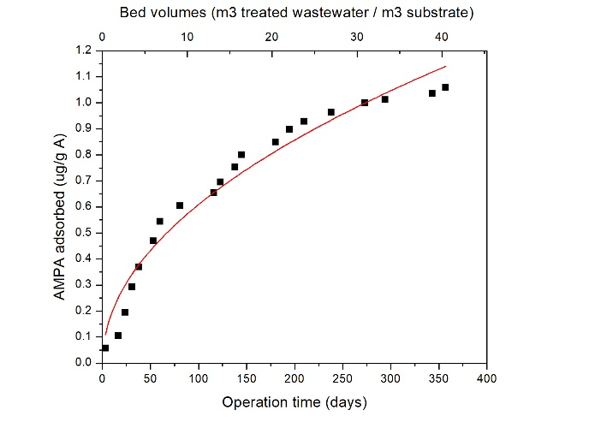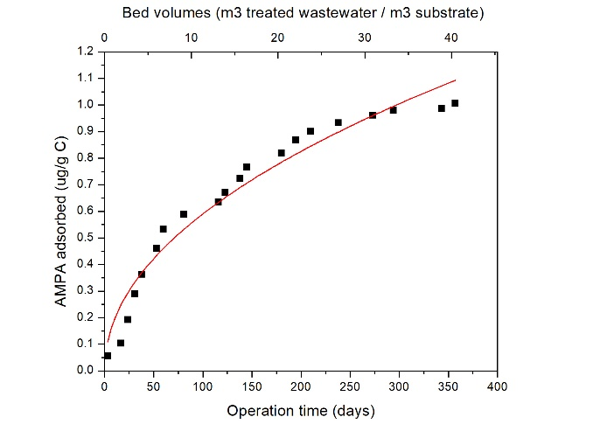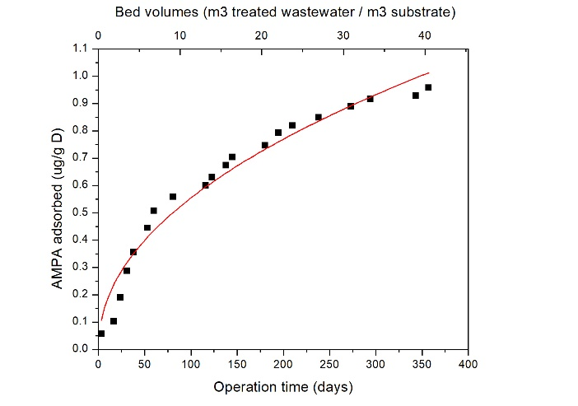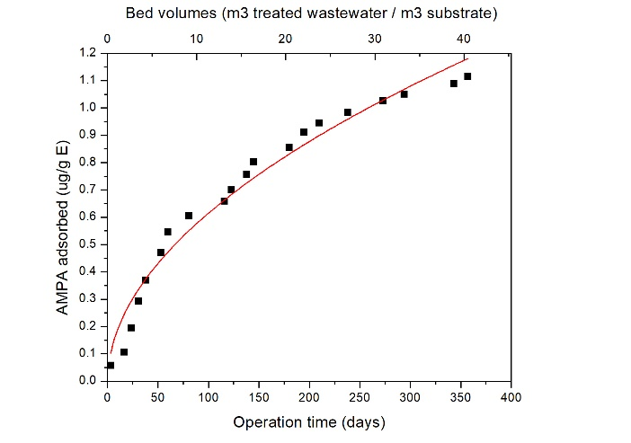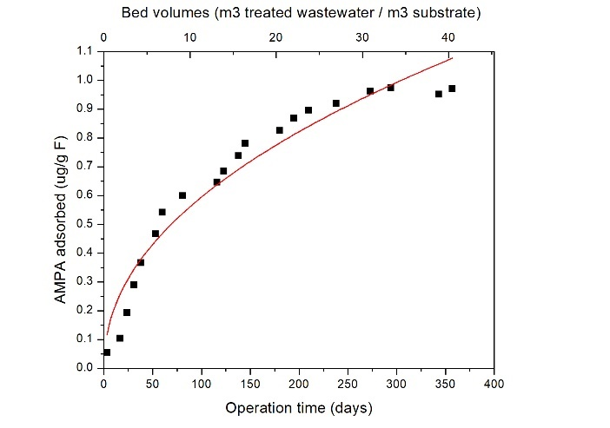

Cyclophosphamide

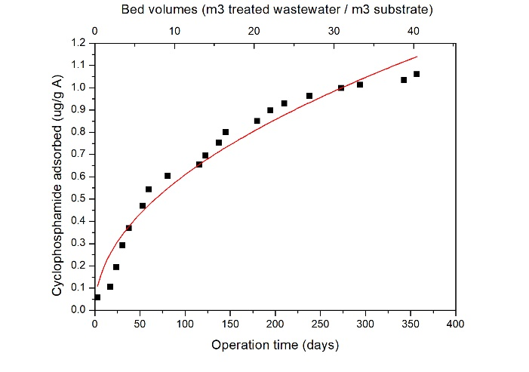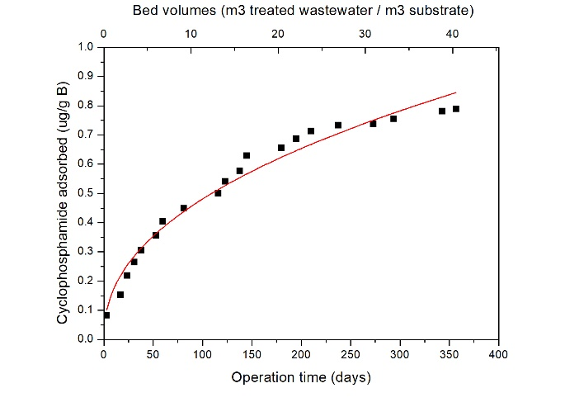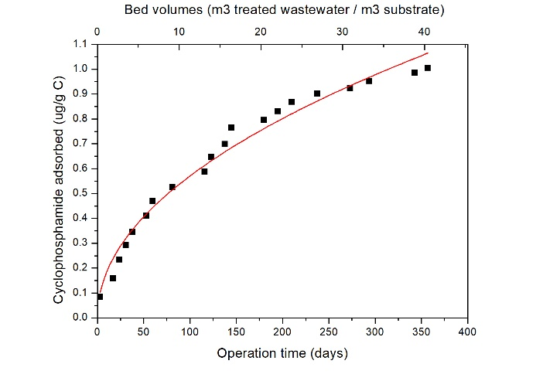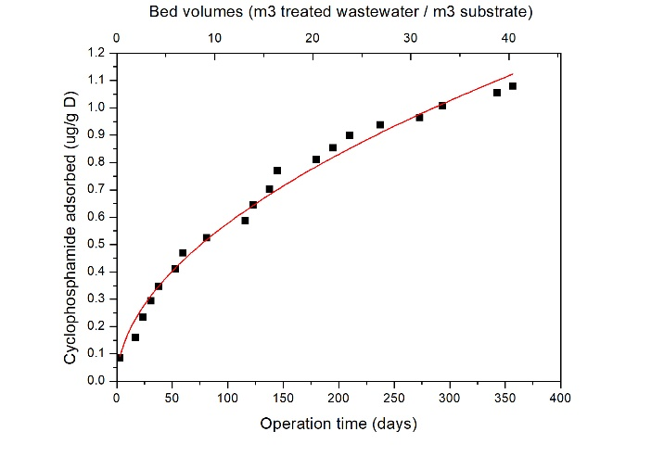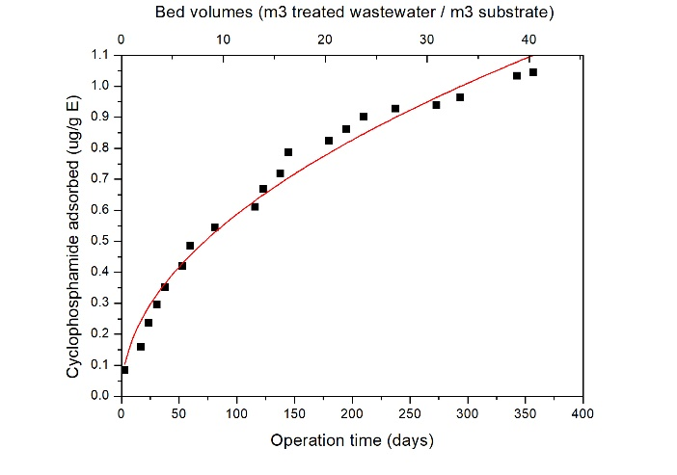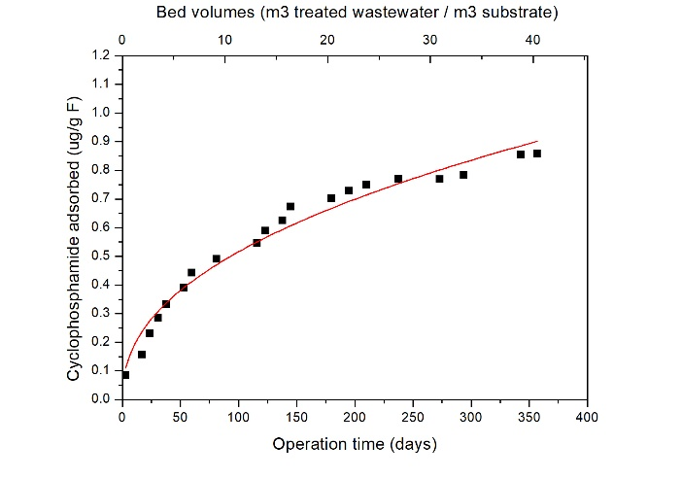

MCPP

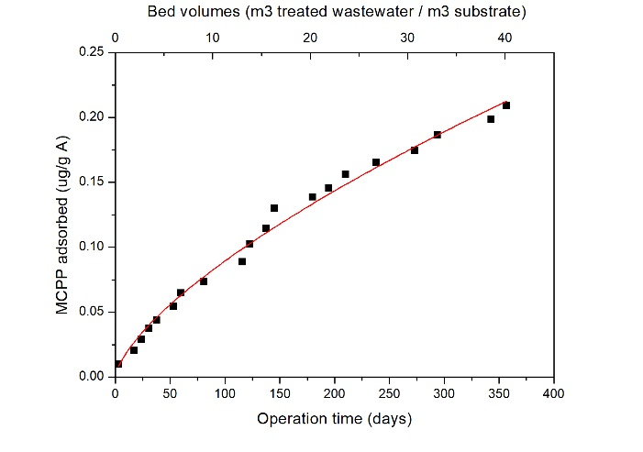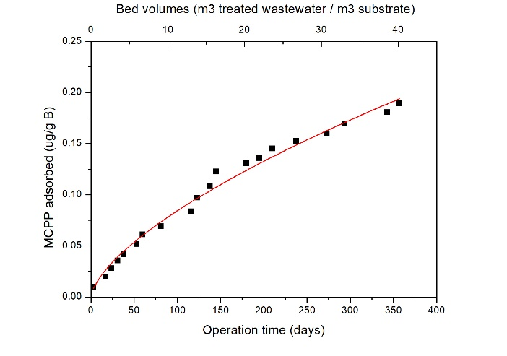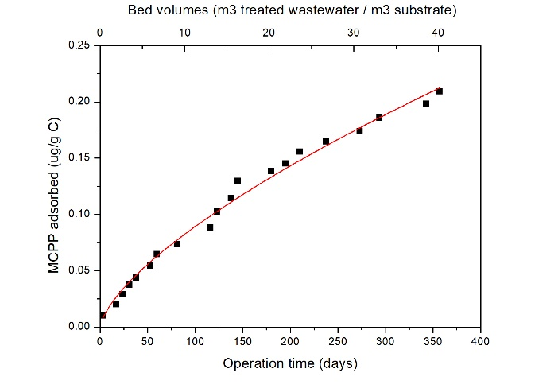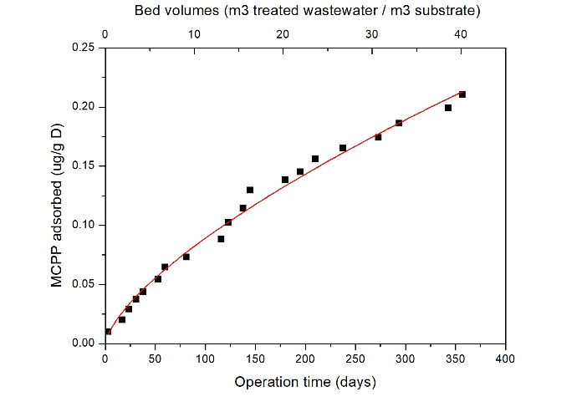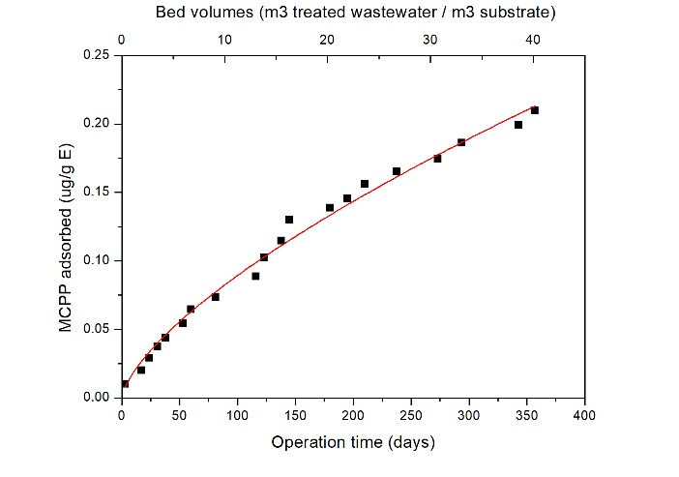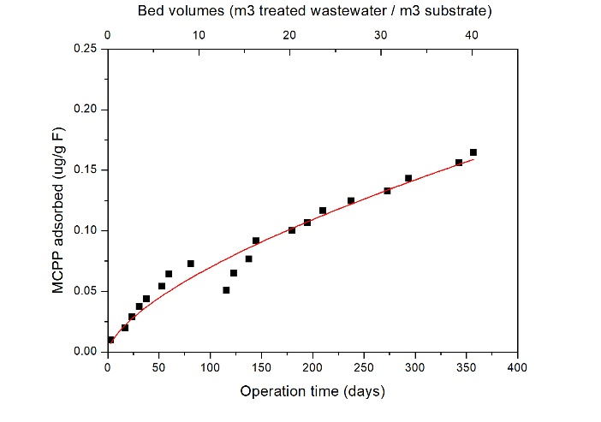

S.6 Modelled degradation kinetics

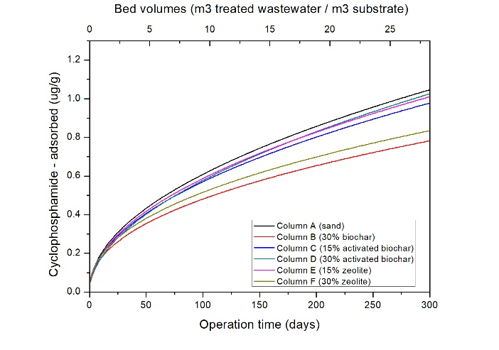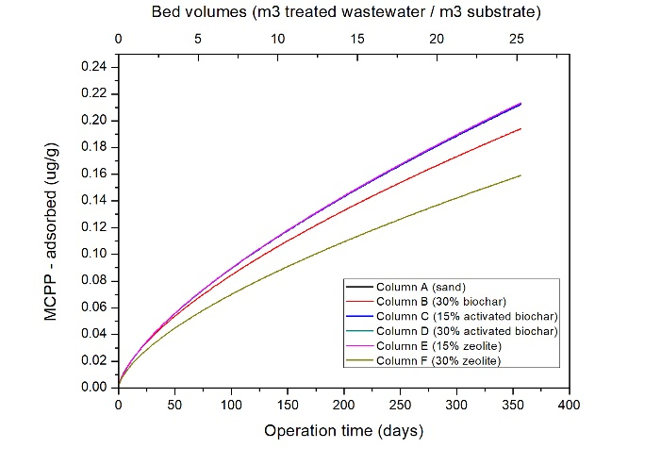

S.7 Progression rates
