**SI: Near surface defects: Cause of deficit between internal and external open-circuit voltage in solar cells**

Mohit Sood*1, Aleksander Urbaniak2, Christian Kameni Boumenou1, Thomas Weiss1, Hossam Elanzeery1, Finn Babbe1,3, Florian Werner1,4, Michele Melchiorre1, Susanne Siebentritt1

(E-mail address: mohit.sood@uni.lu)

1*Department of Physics and Materials Science, University of Luxembourg, Belvaux, L-4422, Luxembourg*

2*Faculty of Physics, Warsaw University of Technology, Koszykowa 79, Warszawa 00-662, Poland*

*3Chemical Sciences Division, Joint Center for Artificial Photosynthesis, Lawrence Berkeley National Laboratory, Berkeley, USA*

*4Hydrosat, 9, rue du Laboratoire, L-1911 Luxembourg*



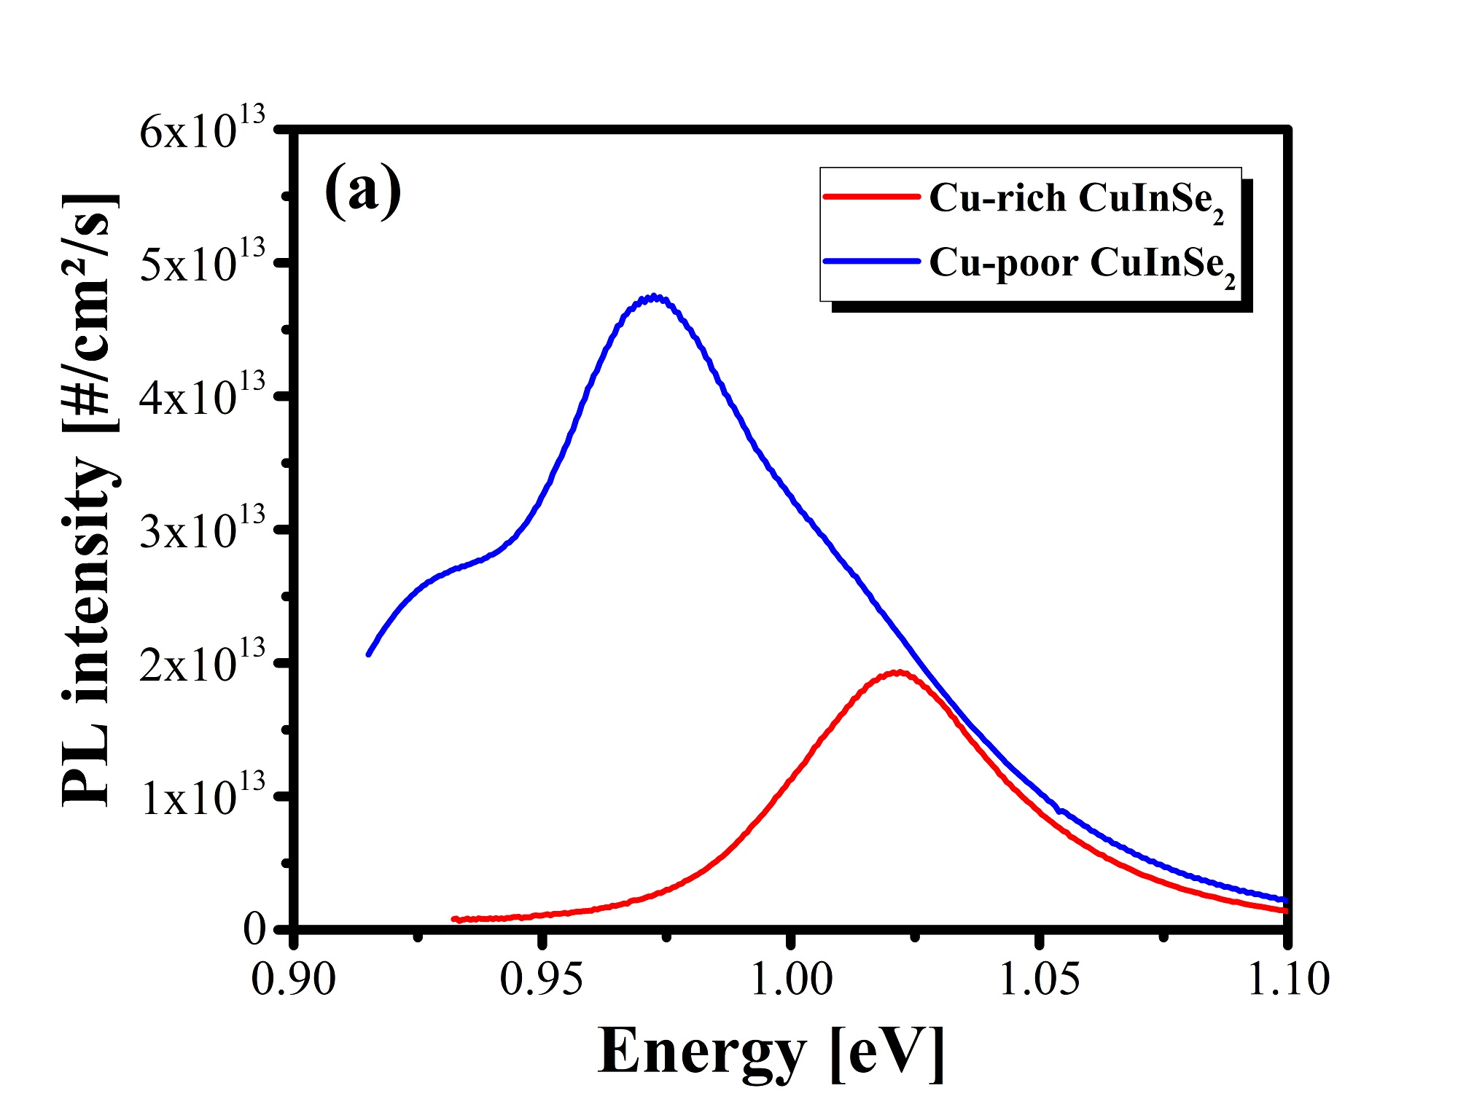

***Figure S1***. (a) Exemplary measured calibrated PL spectra of Cu-rich and Cu-poor CuInSe2 absorbers covered with CdS buffer layer. (b) Arrhenius plot corresponding to the admittance spectra of a Cu-rich CuInSe2 device measured at different DC voltage bias. (c) The activation energy obtained from the slope of data form Arrhenius plot. The activation energy is almost the same with different bias.

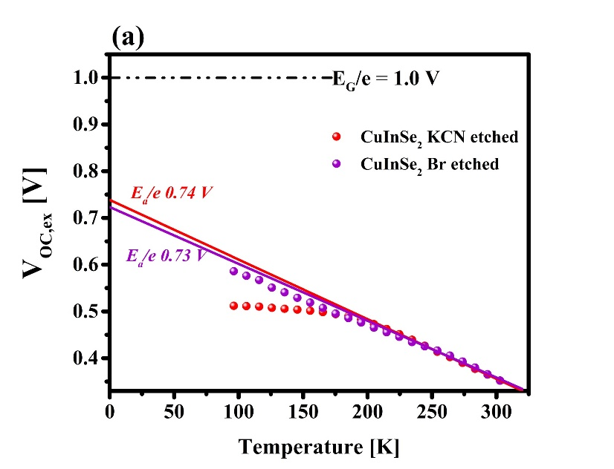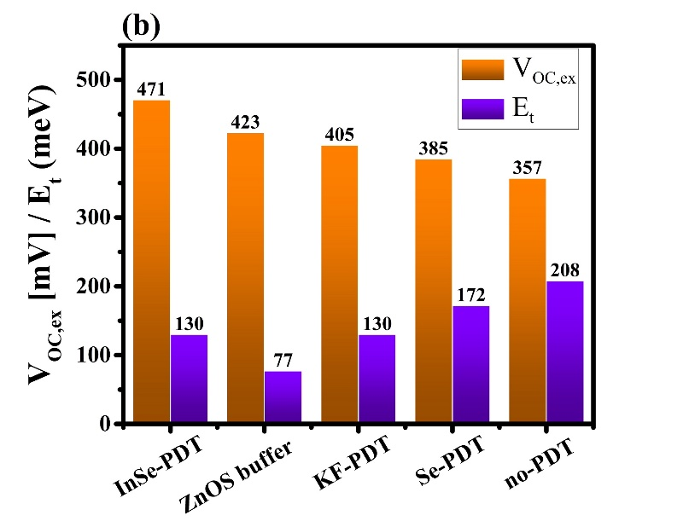

***Figure S2.*** (a) VOC,ex measurements of 10% KCN and 0.01M Br solution etched CuInSe2 solar cells. (b) Summary of VOC,ex values and defect energy (Et) obtained from admittance spectroscopy of post KCN treated devices and the untreated device.

**Passivation of near surface defect by UHV annealing**

The UHV annealing at 280 oC for 30mins at a base pressure < 2 x 10 -9 mbar, was performed on a Cu-rich CISe absorber to assess its ability to passivate sub-surface defects via measuring its impact on the ADM spectra, particularly on the deep defect signature. After UHV annealing the absorber along with a reference sample were finished into solar cell using the baseline process. Figure S3a displays the ADM spectra of reference device, where the highlighted capacitance step in the middle is the commonly observed ~200meV defect. The signature capacitance step disappears in the device prepared with UHV annealed absorber Figure S3b, thus leaving only a step with activation energy of ~86meV. Figure S3c shows the inflection point of capacitance data plotted in Arrhenius plot together with results presented earlier for a better comparison. Apart from UHV annealed device’s data points, all other data points scatter very close to the same line and therefore very likely originates from the same defect signature. This indicates the passivation of the 200meV defect at least to the detection limits of ADM. The passivation is further supported by the activation energy Ea of the dominant recombination channel obtained by VOC,ex extrapolation of the device. As stated before the VOC,ex extrapolation at 0K of the devices dominated by sub-surface defects does not go to the band gap but rather to a value less than the bandgap determined from inflection point in external quantum efficiency measurements. For the UHV annealed device VOC,ex extrapolation goes almost to the bandgap (Figure S4). Therefore, from ADM spectroscopy and VOC,ex extrapolation we conclude that the UHV annealing is an alternate passivation method for the 200meV defect.

 



***Figure S3***. Admittance spectra of CISe solar cell prepared from (a) 10% KCN etched absorber (b) 10% KCN etched UHV annealed absorber. (c) Arrhenius plot of KCN etched and UHV annealed solar cell along with KCN etched and bromine etched Schottky device.



***Figure S4.*** External open-circuit voltage (VOC,ex) measurements of CuInSe2 device prepared with 10 % KCN etched absorber and UHV annealed 10% KCN etched absorber.

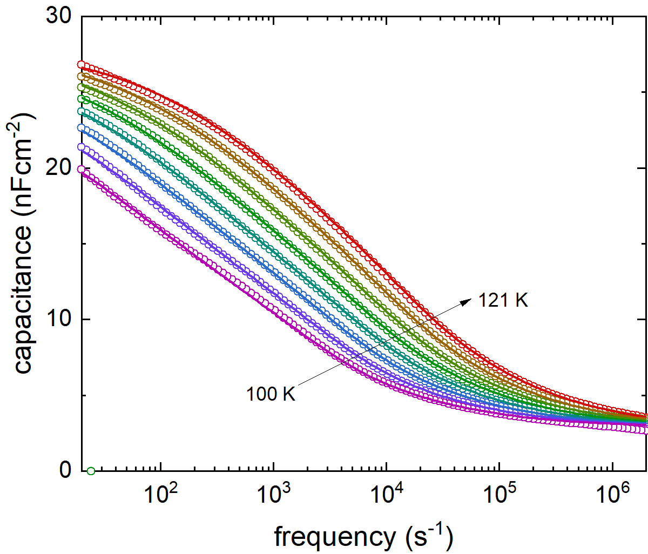

***Figure S5.*** Experimental data (open symbols) and the corresponding fit (solid lines) for the double capacitance step of the sample shown in Figure 3d.

***Table S1.*** *Simulation parameters used to in this work. For achieving a value of VOC,in comparable to as observed in optical measurements, a deep defect level at 300 meV is introduced in the CISe absorber layer.*

|  |  |  |  |  |  |
| --- | --- | --- | --- | --- | --- |
| **Parameter** | **CuInSe2** | **p+ CuInSe2** | **CdS** | **ZnO/AZO** | **IF defects**  **CuInSe2/CdS** |
| **Thickness (μm)** | 2.5 | 0.050 | 0.050 | 0.350 | - |
| **Band gap(eV)** | 1.0 | 1.0 | 2.40 | 3.45 | - |
| **Dielectric permittivity (relative)** | 13.6 | 13.6 | 10 | 10 |  |
| **Electron affinity(eV)** | 4.6 | 4.6 | 4.6 | 4.6 | - |
| **Electron mobility(cm2/Vs)** | 20 | 20 | 50 | 50 | - |
| **Hole mobility(cm2/Vs)** | 10 | 10 | 20 | 20 | - |
| **Doping(1/cm3)** | 1x1016 | 1x1016 | 1x1016-17 | 1x1017-19 | - |
| **Defect density(1/cm3)**  **Single acceptor**  **from CuInSe2 valence band** | 1x1016  300meV | 1x1016  300meV & 5x1016  220meV or 780 meV | - | - | 1x1012**cm-2**  650meV |
| **Capture cross-section**  **electrons (cm-2)** | 1x10-15 | 1x10-12  for 220meV or 780 meV | - | - | 1x10-12 |
| **Capture cross-section**  **holes (cm-2)** | 1x10-15 | 1x10-13  for 220meV or 780 meV | - | - | 3x10-16 |

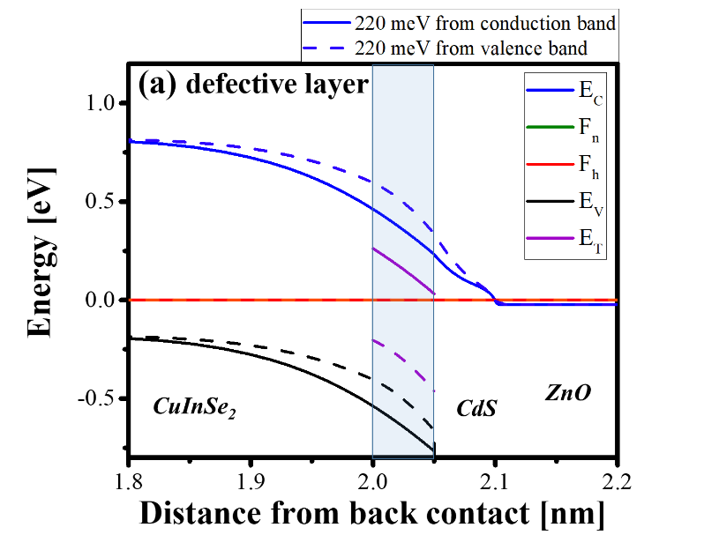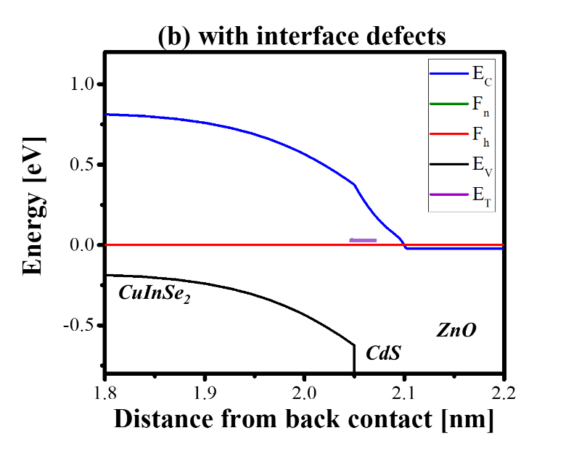

  

***Figure S6.*** Simulated band diagram of the device at 300K in equilibrium with (a) defective layer, in solid defects placed 220 meV away from conduction band and in dashed defects placed 220 meV away from conduction band, and (b) interface defects. In purple the defect position is shown. (c) and (d) Show recombination profiles as a function of distance from the back contact at VOC,ex for simulated devices with two defective layer models always comparing with interface defects model. For the defective layer models (dashed line) dominant recombination appear to occur near the surface of the absorber, whereas in defective interface model (solid line) they occur at the interface. (e) Simulated I-V curve of a reference device with no defective layer no defective interface.

 

***Figure S7***. Activation energy (Ea) and short-circuit current density (Jsc) as a function of defect density in the defective layer (a) defect placed 220 meV away from conduction band (b) defect placed 220 meV away from valence band.

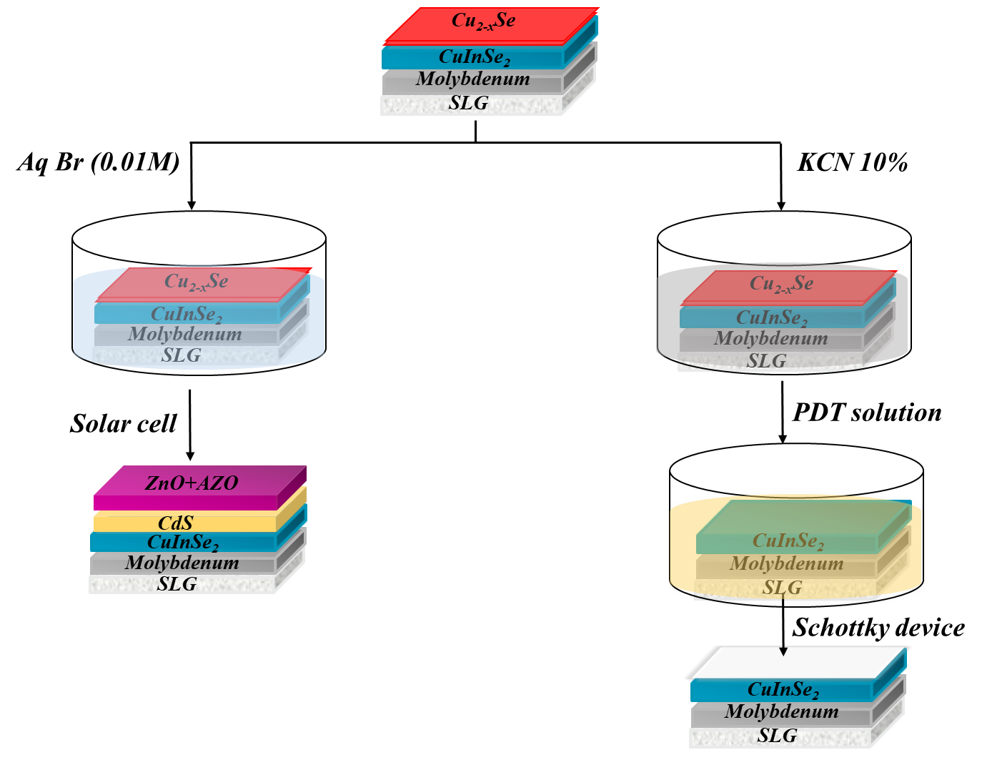

***Figure S8.*** *A schematic diagram showing the procedure used for bromine etching and post deposition treatment (Zn, Cd and S-PDT). The secondary phase Cu2-XSe are etched from Cu-rich absorber using 10% KCN for 5 minutes, followed by PDT of absorbers in either ammoniac Zn or Cd or S solution at 80o C . Finally, aluminum is deposited on the absorber to make schottky contact. In case of bromine etching buffer (CdS) and window (aluminum doped zinc oxide i.e. AZO) followed by nickel aluminum grids are deposited.*

**Defective layer model with defects 220 meV away from valence band**

A defective layer with deep defects ~220 meV away from valence band also can reproduce criterion (i), (ii) and (iii) as shown below.

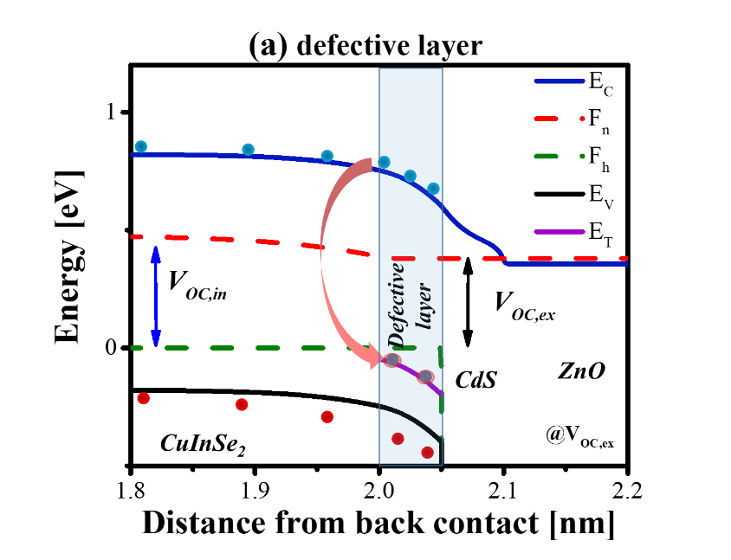

 

**Figure S9.** (a) Simulated band diagram of the device at external open-circuit (VOC,ex) voltage with defective layer containing defects at 220 meV away from valence band. (b) Simulated open-circuit voltage (VOC,ex) values of the device with defective layer (close to valence band) and of the device with interface defects. (c) Simulated I-V curve at different temperatures of devices with defective layer (close to valence band) and with defective interface. (d) The electron and hole barrier as the function of temperature and its extrapolation to 0 K.