Warrior Candidates:
Do Voters Value Combat Experience in Postwar Elections?

Josip Glaurdić¹ and Christophe Lesschaeve
University of Luxembourg

Orcid IDs:
https://orcid.org/0000-0001-6904-9986
https://orcid.org/0000-0002-0632-6760

¹ Corresponding author

Institute of Political Science
University of Luxembourg
2, avenue de l’Université
L-4365 Esch-sur-Alzette

T +352 46 66 44 6259

josip.glaurdic@uni.lu
christophe.lesschaeve@uni.lu

Authors unavailable 1-15 August 2021, except by email.

Electoral competition in postwar societies is often dominated by war veterans. The question whether voters actually reward candidates’ records of war service, however, remains open. We answer it using a unique dataset with detailed information on the records of combat service of nearly four thousand candidates in two cycles of parliamentary elections held under proportional representation rules with preferential voting in Croatia. Our analysis shows war veterans’ electoral performance to be conditional on the voters’ communities’ exposure to war violence: combat veterans receive a sizeable electoral bonus in areas whose populations were more exposed to war violence, but are penalized in areas whose populations avoided destruction. This divergence is particularly pronounced for candidates of nationalist rightwing parties, demonstrating the importance of the interaction between lived war experiences and political ideology in postwar societies.

Keywords: postwar elections; voter choice; war veterans; preferential voting; Croatia.

Never was so much owed by so many to so few.
Winston Churchill, 1940
Military men are just dumb, stupid animals to be used as pawns in foreign policy.
Henry Kissinger, 1974
Winston Churchill’s famous words captured the prevailing sentiment of gratitude of the British public to the Royal Air Force pilots who were fighting with extraordinary courage against the Luftwaffe in the Battle of Britain. Kissinger, on the other hand, allegedly coined his maxim to annoy his rival, the White House Chief of Staff General Alexander Haig, in the last days of the Vietnam War and the Nixon Presidency. These two quotes were not only the products of two very different men speaking in two very different historical contexts surrounding two very different wars. They also captured two common stereotypes of men and women who served in combat: one of valor, patriotism, and sacrifice, and the other of mindless service as little more than cannon fodder. How do these stereotypes translate to the world of electoral politics once the violence ends? Do war veterans who choose to run for office capitalize on presumably positive popular sentiment among voters, or are they penalized at least among some voters for their records of service? As examples ranging from Weimar Germany (Ziemann 2012) through post-World War II United States (Teigen 2018), to contemporary Kosovo (Capussela 2015) demonstrate, war veterans have outsized political influence in postwar societies. But do voters actually value war veteran politicians’ records of service in combat?
The short answer to that question is that we do not know. The evidence we have from the United States, where the relationship between political candidates’ records of combat service and their electoral fortunes has arguably been researched the most, is at best mixed and highly dependent on the wars in question. Both World War II heroes and Vietnam War draft dodgers have been elected to the Presidency. Tangible evidence on this issue from post-conflict societies whose populations experienced violence firsthand is even slimmer, arguably non-existent. Obviously, collecting reliable electoral data in post-conflict societies, particularly related to candidates’ war records, can be exceptionally difficult. Nevertheless, the inability of the literature to fully account for the drivers of voter choice in post-conflict societies – especially drivers related to the recent war past, which may be precluding the politics in these societies from moving forward – has been regrettable.
We provide answers to these questions using a unique dataset on nearly four thousand candidates in the 2015 and 2016 parliamentary elections in Croatia, organized under proportional representation rules with preferential voting. Our dataset includes information on the length of candidates’ combat service in Croatia’s armed and police forces during the country’s 1991-1995 War of Independence. This information was publicly available (and hotly debated) in a dedicated online registry of war veterans at the time of the two electoral campaigns, providing us with a unique test of how candidates’ war pasts are related to their electoral fortunes. We pair our candidate-level data with a string of variables on the level of Croatia’s 556 relatively small municipalities, including information on the local population’s exposure to war violence. The results of our analysis are clear. Croatian voters, even two decades after the war, generally reward veterans at the ballot box for their combat service. Voters do that, however, conditional on their own communities’ exposure to war violence. In areas whose populations were more exposed to war violence, combat veterans receive a sizeable electoral bonus. In areas whose populations avoided destruction, however, combat veterans are actually penalized. This divergence is particularly pronounced for candidates and voters of nationalist rightwing parties that were decisively shaped by the 1991-1995 war, demonstrating the importance of the interaction between lived war experiences and political ideology in postwar societies. Although its War of Independence remains politically salient to this day, we believe Croatia actually presents a particularly difficult case for our analysis due to the temporal distance of the war from the two electoral campaigns, the decisive nature of the war’s resolution in Croatia’s victory, and the country’s move toward European integration. This suggests that the general thrust of our findings, which show how war experiences affect the nature of postwar political competition, should be portable to other postwar settings, though obviously more research in other contexts is needed to test our propositions.

Combat Veterans as Electoral Candidates: Valence, Experiential Closeness, and Ideology
Research on the relationship between politicians’ military or war experience and their electoral fortunes has been dominated by contributions focused on the US context. Ever since the 1948 proposition by Albert Somit that military heroes had much higher chances of being elected to the presidency, the value of veteran status has been virtually taken for granted by the observers of US elections and the establishments of the two parties (Karsten 2012). The actual record of veteran candidates in electoral contests, however, has been rather mixed. Somit and Tanenhaus (1957) found veterans substantially overrepresented among both Republican and Democrat candidates in congressional elections of the early 1950s, but faring no better or worse than their non-veteran counterparts at the ballot box. Looking at congressional elections five decades later, Teigen (2008) found veteran experience bringing a slight electoral advantage only to Republican nominees. Despite strong survey evidence of voters’ positive ratings of military leaders on their integrity, knowledge, abilities, and leadership in comparison to other traditional pools of political candidates (McDermott and Panagopoulos 2015), more recent experimental research has found that there was no across-the-board benefit for veteran candidates among American voters. Veterans seem to be considered more competent on defense and security issues (Teigen 2013), as well as more hawkish, but this translates only to an adjustment in the voter preference function concerning veteran Democrat candidates among some segments of the electorate (McDermott and Panagopoulos 2015). In other words, American voters do hold some stereotypical views of veteran candidates and use their military experience as a heuristic for policy and trait views. Nevertheless, it is unclear whether this translates into tangible electoral benefits for veteran candidates.
More critical than this ambiguity regarding American voters’ views of politicians with records of military service, however, is the fact that we know very little about voters’ views of the candidates’ war pasts in societies with experiences of conflict on their own soil. A number of aggregate-level findings from post-conflict polities demonstrates that electoral competition can be decisively determined by the patterns of violence and the population’s allegiances in the ended conflict (e.g. Costalli and Ruggeri 2019; Hadzic, Carlson, and Tavits 2020). We do not know, however, whether voters in post-conflict societies actually value individual candidates’ records of military service. Clearly, this has been the case due to a number of practical obstacles in conducting electoral research in post-conflict contexts. Post-conflict societies often have far from perfect democratic institutions and electoral competitions, not to mention that reliable systematic data on politicians’ war pasts is extremely hard to come by for researchers. Notwithstanding these evident obstacles, however, the limitations of the literature in understanding the drivers of war-related voter choice in postwar polities is puzzling and unfortunate. Democratic electoral competition is often seen as the best way forward for post-conflict societies (Flores and Nooruddin 2012). If voters make their choices based on candidates’ performance on the battlefield in the ended conflict, however, electoral competition could be – directly or indirectly – perpetuating the dynamics of the conflict and preventing postwar societies from moving on and leaving past in the past.
Wars can obviously arise from a variety of prewar circumstances, and they can lead to a variety of postwar political developments. Candidates’ records of combat service, therefore, can serve as signals or heuristics for different traits and policy stances, depending on the context. Regardless of this context dependency, however, we argue there are three pathways that could link combat service to electoral success: valence, experiential closeness, and ideology. First, it would be reasonable to assume that candidates’ military service is viewed as an indicator of their valence (Nyhuis 2016) in the eyes of the voters supporting the same side in the ended conflict. Service in combat could signify for these voters a number of positive traits such as courage, patriotism, initiative, leadership, sacrifice. It could obviously also signify some negative traits such as extremism, aggression, or mindless and unquestioning service. On balance, however, it seems safe to propose that most voters would, all else equal, reward candidates with a record of service in armed combat on the side of the forces that fought for the voters’ side and that the extent of this reward should be proportional to the length of service. From what we know about wars and their effects on postwar politics (especially when it comes to wars of the sort fought in former Yugoslavia), we argue this would be the case even in conflicts where the armed forces often fought without regard for the conventions of war. We therefore hypothesize that:
H1: Candidates’ electoral performance has a significant and positive relationship with the length of their service in combat.
The second pathway linking combat experience with electoral success stems from experiential closeness between veterans and voters who live in areas that also experienced combat. Indeed, wars do not affect societies and their populations uniformly. Some regions and some people are spared exposure to violence, and some end up being on the frontlines. It would be illusory to expect political candidates’ combat experience to be valued evenly across the whole electorate. This line of reasoning is supported by a long line of research going back to the early studies of voter behavior in the United States (e.g. Campbell et al. 1960) that shows voters reward those candidates they are familiar with (André, Wauters, and Pilet 2012), as well as those who have the same sociodemographic characteristics. Voters are more likely to support candidates who share their ethnicity (McConnaughy et al. 2010), religion (Heath, Verniers, and Kumar 2015), gender (Van Erkel 2019), race (Philpot and Walton 2007), or social class (Heath 2015). These findings of voter-candidate socio-demographic closeness having a significant effect on voter choice are portable across different geographic, temporal, and institutional contexts and are robust regardless of the type of electoral rules (proportional vs. majoritarian) or elections themselves (intra-party vs. inter-party, partisan vs. non-partisan). This is in many ways unsurprising. In elections, voters choose not only their policy representatives, but also their social representatives. It is understandable that one would expect candidates who come from similar social backgrounds or who have similar life experiences to represent one’s interests when it comes to values as well as policy making more accurately and diligently (Cutler 2002). In the context of post-conflict societies, this could mean that candidates’ experiences of combat service would be disproportionally valued by those who shared those experiences. This includes not only veterans, but also other voters and communities who were directly exposed to war violence. Candidates who served in combat should therefore do better in areas disproportionally affected by war violence because the electorates in these areas perceive war veteran candidates as experientially close. Although exposing the causal mechanism behind this connection, as well as testing for the possible alternative explanations, is beyond the scope of this paper and will be the subject of further research, we feel confident in hypothesizing that:
H2: Candidates’ length of service in combat leads to a greater electoral bonus in areas more affected by war violence.
Thirdly and finally, service in combat is not only a cue to voters about the candidates’ personality traits, their capacity for political leadership, or their ability to represent other people affected by war violence. It can also be a strong cue about potentially very important sets of political or ideological beliefs. As already mentioned, in the US context, military veterans are perceived as holding more interventionist foreign policy views (McDermott and Panagopoulos 2015). They are also perceived as more competent in policy areas such as defense and security, and they are believed to have personal traits such as strength and decisiveness. With defense and security belonging to a set of policy issues “owned” by the Republican Party, and the personality traits commonly associated with veterans also being commonly associated with Republicans (Hayes 2005), it is little wonder that American veterans are commonly more associated with the political right and that Republican voters are more willing to consider candidates of the other party if they are veterans (McDermott and Panagopoulos 2015).
There is no reason to believe that candidates’ combat experience would not act as strong ideological cues in postwar societies as well. All wars are inherently political. They are not only the continuation of politics by other means, as Clausewitz proposed two centuries ago, but they also create political reality and force individuals to take highly politicized positions. This is particularly the case in conflicts such as revolutions, insurrections, or civil wars where fighting is often done by ideologically committed volunteers, rather than regular conscript armies. Wars of Yugoslavia’s dissolution in the 1990s were exactly such conflicts. Although their roots were complex, one could safely say that they were driven by nationalist ideologies and the competing desires of different national groups to secure statehood and territorial sovereignty (Ramet 2006). It would therefore be reasonable to consider people who fought in these wars to be more likely to hold ideologically nationalist or rightwing views, or for these views to be seen as more genuine and sincere by voters when held by someone who served in the war. Such an assumption is even more logical considering the nature of politics in the region in the two decades since the end of the wars. Political competition in the postwar polities of Southeast Europe has been decisively impacted by the unresolved grievances stemming from the wars, high profile cases in a failed attempt at internationalized transitional justice, as well as issues of how to care for the segments of the population directly affected by the war such as refugees, veterans, victims, and their families. Through this maelstrom, war veterans have more often than not found enthusiastic allies on the political right (Dolenec 2017). Therefore, it would be reasonable to assume that their combat service would be more valued among rightwing voters in general, and particularly among rightwing voters in areas disproportionally affected by war violence where these ideological commitments would be even more salient. This is why we finally hypothesize that:
H3: Candidates’ length of service in combat leads to a greater electoral bonus among rightwing voters.
H3a: Candidates’ length of service in combat leads to a greater electoral bonus among rightwing voters in areas more affected by war violence.

Croatian Electoral Politics and the 1991-1995 War of Independence
Croatia declared independence from Yugoslavia in June 1991. Violence exploded that summer, though the armed rebellion of the Croatian Serbs assisted by the Belgrade regime of Slobodan Milošević started already a year earlier. By the time the war ended in the summer of 1995 with Croatia’s victory and the exodus of about 200 thousand Croatian Serbs, the death toll on both sides stood at 20,000, with 20% of the country’s population experiencing forcible displacement, 10% of the total housing stock destroyed, and direct war damages estimated at $50-80 billion (Vlada 1998).
The war – known as Homeland War in Croatia – had a number of long-lasting effects not only on Croatia’s economy and society, but also on the nature of its political competition. About 20% of Croatia’s adult male population – some 300-350 thousand men – had direct experience of combat. Many of them organized after the war into highly influential veterans’ organizations and found welcoming partners on the political right, especially in the Croatian Democratic Union (HDZ) – the dominant center-right party that led Croatia into independence and throughout the war (Dolenec 2017). Croatia’s politics in the postwar period became defined by the effort of the HDZ to create a winning platform that merges contemporary concerns with the war past. On the one hand, the HDZ profiled itself as perhaps a more clientelist and protectionist, but still staunchly pro-European, version of the German Christian Democrats. On the other hand, it actively built the mythology of the Homeland War and dominated the debates about the causes, nature, and conduct of the war, as well as about the policies related to those who bore the brunt of the war effort. The extensive system of social benefits the HDZ implemented to cater to this population has arguably been the single most important policy area of clear distinction between the HDZ and its principal opponents, the Social Democrats (SDP). The clash between the two sides has been such that, upon coming to power in 2011, the SDP-led coalition made the registry of Croatia’s war veterans accessible online, ostensibly in an effort to publicly shame those veterans who gained their status fraudulently. Upon its return to power, the HDZ removed the registry from public view in December 2017, citing negligible number of cases of fraud discovered (Mochtak, Glaurdić, and Lesschaeve 2020). Though notable, the clear distinctions between the main political camps in Croatia when it comes to the country’s recent war past and the different social groups created by war violence are rather common in most post-conflict societies. From the differences in the approach of the German Christian Democrats and Social Democrats toward the post-World War II expellees to the differences in the policies and discourse of the Serbian nationalists and liberals toward their country’s role in the conflicts of the 1990s, political competition in post-conflict societies is often significantly affected by the recent past.
Unsurprisingly, survey-based research has found veteran status to be one of the most dominant predictors of right-wing political allegiance in Croatia (Bagić and Kardov 2018; Lesschaeve 2019). Similarly, research on the level of Croatia’s communities has found local population’s exposure to war violence to be the strongest predictor of support for the HDZ, suggesting that Croatia’s political competition is dominated by this “nation-building” or “war-past” cleavage (Glaurdić and Vuković 2016). These findings are in line with a string of similar findings in other postwar societies – from contemporary Bosnia and Herzegovina (Hadzic, Carlson, and Tavits 2020) to post-World War II Italy (Costalli and Ruggeri 2019) – that show how exposure to and participation in war violence can dominate communities’ and individuals’ postwar political lives.
One of the clearest ways in which exposure to and participation in war violence can affect individuals’ postwar political lives is by increasing their level of political engagement. The tendency of war veterans, particularly those personally involved in combat, to have higher levels of political engagement has been confirmed in polities with experiences of conflict as diverse as Uganda (Blattman 2009) and the United States (Leal and Teigen 2018). Croatia is no exception. Party politics in postwar Croatia has been dominated not only by debates related to the recent war past, but also by politicians with personal combat experiences. Figure 1 shows the proportion of male candidates and members of parliament who were combat veterans and were nominated and elected on the electoral lists of the HDZ- and the SDP-led coalitions from the first truly postwar election in 2000 until 2016. We focus here on male candidates since 95% of Croatian combat troops were men. If we included women in these comparisons, the difference between the two blocs would be even more pronounced since the HDZ nominates far fewer women than the SDP. It should be noted that more than 80% of Croatian MPs during this period have been elected from these two lists, so the trends shown in Figure 1 are more than indicative. As is immediately apparent, the center-right HDZ has consistently nominated more combat veterans among its male candidates than the center-left SDP, though both parties have substantially over-represented combat veterans in comparison to the general population. This over-representation has reached such heights that more than 50% of the HDZ’s male candidates were combat veterans in 2007 and 2011, and more than 50% of the HDZ’s male MPs were combat veterans in 2011. As a comparison, a decade and a half after World War II, about 40% of the adult male population in the United States and about 60% of members of Congress were veterans (Teigen 2018). Croatia thus perfectly fits the pattern of most postwar societies: war veterans have outsized political influence even decades after the violence had ended. These similarities between the trends observed in Croatia and those observed in other societies that experienced war convince us that, although we need to be cognizant of the specificities of the Croatian case, our findings should be portable across a range of cases of post-conflict polities.
[Figure 1 about here]

Data and Method
To examine whether electoral performance of political candidates is dependent on their war past, we analyze the results of the 2015 and 2016 elections for the Croatian parliament. We make this choice for two reasons: 1) Croatian electoral rules and comprehensive reporting of results for these two elections; and 2) public availability of exceptionally detailed data on candidates’ war pasts during this period. All Croatian elections since 2000 have been held under proportional representation rules, with the country divided into ten districts, each electing fourteen MPs. Party lists, however, were closed until 2015 when they were partially opened. Since then, voters cast either a vote for a party list or a preference vote for one specific candidate on the party list who can move up the list ranking if s/he gets more than 10% of all preference votes cast for their party’s candidates in the electoral district (Odbor za zakonodavstvo 2015). In addition to candidates’ party affiliations and list placement, ballot materials also included candidates’ academic titles (if they chose to list them), address, and date of birth. Two thirds of Croatian voters have used the option of casting a preference vote in these two elections (66.6% in 2015 and 66.0% in 2016), making preferential voting comparatively much more popular than in other European countries with similar electoral systems. Croatian Electoral Commission reports votes for each candidate disaggregated to individual precincts, enabling us to match voting patterns with Croatia’s municipal structure. This is important because of the wealth of economic, sociodemographic, and war-related data on the level of Croatia’s relatively small (median population of less than 3000 inhabitants) 556 municipalities. Moreover, as discussed above, the Croatian Registry of War Veterans was publicly available during this period on a searchable online platform. This enabled not only us, but also the general public, to collect detailed data on the electoral candidates’ war pasts. Indeed, the extent of press coverage shows that politicians’ veteran status was under media and public scrutiny during this period, making it clear that voters not only had perfect information on this aspect of the candidates’ biographies, but also were exceptionally interested in it. Within 24 hours of the Registry becoming public, for example, more than three million users logged in to its platform.
Here it should be noted that the level of information available in the Registry of War Veterans enabled us to model candidates’ war experience in a much more nuanced way than has been the case in comparable studies. Modelling veteran status dichotomously (or at best trichotomously) has a long tradition in political science, both when examining the differences between veterans and non-veterans in the general population and when investigating different electoral fortunes of political elites. This approach to studying the political impact of veteran status has hardly changed since it was introduced by Somit’s seminal 1948 study (e.g. Brady and Rappoport 1973; Klingler and Chatagnier 2014; McDermott and Panagopoulos 2015; Teigen 2018). Only a few attempts have been made to incorporate the intensity or duration of the combat experienced during military service (e.g. Grossman et al. 2015; Lesschaeve 2019). In this study, instead of relying on dichotomies or survey respondents’ self-reporting, we used the Registry of War Veterans to get information on the candidates’ number of days served in the combat sector of the Croatian armed and police forces during the War of Independence. In our view, our principal explanatory variable Combat days represents the most accurate and fine-grained measurement of veterans’ war service. Our operationalization of this variable implies the assumption of a linear relationship between combat service and electoral results. We make this choice due to the resulting simplicity of interpretation and the elegance of our theoretical propositions. Nevertheless, as a robustness check, we also test all our models with veteran status as a dichotomous variable as well as with the cubic root of Combat days to account for possible diminishing electoral returns to combat service.
While the two elections in question were only a year apart, the turnover in candidates was substantial. Of all candidates who ran in the 2015 election, only 15% participated in the 2016 election, resulting in the sample of 3806 unique and 4452 total candidates. Once again, in the Croatian electoral system, voters first have to choose which party they want to vote for, after which they can opt to cast a list vote, or a vote for a particular candidate. We are primarily interested in the second part, i.e. explaining why voters are attracted to a particular candidate and choose him/her over other candidates of his/her party, and over a list vote. Therefore, our dependent variable is the proportion of votes cast in favor of a candidate of all votes cast for the candidate’s party in a given municipality (list votes plus preferential votes). This method follows the literature standard when it comes to studying vote preferences in open and flexible list systems (Allik 2015; van Erkel and Thijssen 2016; Dettman, Pepinsky and Pierskalla 2017). In the analyses, however, we weight the observations by the absolute number of votes that are behind the proportion. This ensures that, for instance, 5 votes out of 10 is not considered equal to 500 votes out of 1000, because in that case results would be skewed toward the patterns found in small parties and small municipalities.
By disaggregating the election results on the municipal level, we essentially create a stacked dataset where candidate*municipality is the base unit of analysis. This stacking procedure artificially inflates the number of observations at each level, and failing to account for this would result in an underestimation of the regression coefficients’ standard errors, and an overestimation of statistical significance (Rabe-Hesketh and Skrondal 2012). In addition, candidates are embedded in lists, which are in turn embedded in political parties. Given these various levels in the data, and because the dependent variable is a proportion, we employ a binomial multilevel regression with random intercepts for the candidate, list, party, and municipal level.
On the candidate level, we control for variables generally shown to have a significant effect on voters’ decision making: gender (Fulton 2014; Devroe and Wauters 2018), age (Tavits 2010; Dettman, Pepinsky, and Pierskalla 2017), incumbency (Dahlgaard 2016; Salas 2016; Dettman, Pepinsky, and Pierskalla 2017), academic title on the ballot (McDermott 2005; Tavits 2010; Jankowski 2016), and the ln-transformed distance between the candidate’s place of residence and the municipal center to capture the decreasing marginal effect of distance on voting patterns (Górecki and Marsh 2011; Arzheimer and Evans 2012; Jankowski 2016). Our models also include three variables capturing the candidates’ positioning on the election lists (List position, First list place, and Last list place). Candidates’ list placement has been consistently shown as having significant impact on voter decision making (Marcinkiewicz 2014; Blom-Hansen et al. 2016; Van Erkel and Thijssen 2016). In many ways, it can be understood as a proxy for the candidates’ “quality” or pre-election standing within the party, making it the most important set of control variables in our models. All of these variables, except incumbency, are explicitly or implicitly (in the case of gender, which can be deduced from candidates’ names, and distance, which can be deduced from candidates’ addresses) in the ballot materials, and the candidates’ war service – if not already widely known in the community, as is often the case – was easily checkable online in the Registry of War Veterans. These variables capture the vast majority of variables used in similar studies of voter choice in PR systems with open lists, which should help alleviate concerns about the endogeneity of our explanatory variable of interest Combat days and help strengthen our causal claims. On the level of party lists, we control for the number of war veteran candidates; total party vote (i.e. list + preference votes) in a given municipality; and party list ideology coded on a scale of 1-5 after reviewing party programs with 1 representing left, 2 center-left, 3 center, 4 center-right, and 5 right. Figure 2 shows the level of representation of veteran candidates on party lists across the ideological spectrum in the two elections, the proportion of preference votes they earned, and the average list position allocated to them by the parties. What is immediately apparent is that veterans are far more represented and better positioned on the lists of center-right and right parties. They also receive a clear bonus in preference votes from all voters, except from those voting for the parties on the far left end of the spectrum.
[Figure 2 about here]
On the municipal level, we again follow the literature on preferential voting and control for variables generally considered to have potential effect on the propensity of the voters to cast preference, as opposed to list, votes: adult population’s average years of education; rate of unemployment; proportion of the population belonging to the ethnic majority, i.e. Croats; and the ln-transformed average weighted settlement size in the municipality as a measure of urbanization (André, Wauters, and Pilet 2012; Wauters et al. 2016). Additionally, as explained above, we are particularly interested in the community-level effects of exposure to war violence on voter choice. In other words, we want to see if voters from areas more affected by war violence are more likely to prefer candidates with combat experience. We measure exposure to war violence of the municipal population with the incidence of disability caused by war violence, which was captured in Croatia’s 2011 census. This is our variable War disabled. Figure 3 shows two maps of Croatia. The top map shows the prevalence of war-related disability in municipal population according to the 2011 census, with the figures clearly varying based on the closeness of the lines of engagement between the two sides, shown on the map with the frontline at the time of the arrival of UN troops in early 1992. It is important to note that this variable captures the war experiences of the whole surviving population (i.e. without distinction whether they were veterans or civilians due to data limitations) currently living in the municipalities in question, and not the experiences of the population that used to live in the municipalities at the time of the war due to possible migration during and after the conflict. We would argue this is exactly what researchers in our position would want as the variable captures the war experiences of the average voters in the municipality at the time of the elections in question. The bottom map, on the other hand, shows the prevalence of municipal preference votes allocated to veteran candidates, together with the borders of Croatia’s ten electoral districts. The juxtaposition of the two maps is highly indicative: while vote proportions are obviously also a factor of parties’ nomination strategies, the differences within electoral districts and their overlap with the patterns shown in the top map are striking. Finally, we account for differences between the 2015 and 2016 elections by including a dummy variable in all our models. The base model used to estimate the result for candidate i, on list j, of party k, and in municipality l presented in the next section of the article can be written as follows:
$$Y_{ijkl}=β_{0}+β_{{combat days}_{i}}+β_{{gender}_{i}}+β_{{age}_{i}}+β_{{age squared}_{i}}+β_{{list position}_{i}}+β_{{first position}_{i}}+β_{{last position}_{i}}+β_{{incumbent}_{i}}+β_{{academic title}_{i}}+β_{{ln distance}_{il}}+β_{{veterans on the list}_{j}}+β_{{party score}_{jl}}+β_{{ideology}_{k}}+β_{{war disabled}_{l}}+β_{{unemployment}_{l}}+β_{{education}_{l}}+β_{{urbanization}_{l}}+β_{{\% Croats}_{l}}+β_{election dummy}+ζ_{i}+ζ_{j}+ζ_{k}+ζ_{l}+ε_{ijkl}$$
We further test our hypotheses 2, 3, and 3a by estimating a series of cross-level interactive models between the variables Combat days, War disabled, and Ideology. Table 1 gives the summary statistics of all variables.
[Figure 3 about here]
[Table 1 about here]

Results
Table 2 presents the results of our findings, split up into four models that correspond to our four hypotheses. Our most basic proposition, expressed in hypothesis 1, was that candidates’ electoral performance had a significant and positive relationship with the length of their service in combat. As Model 1 shows, that is clearly the case. The variable Combat days is in the expected direction and statistically significant at the 0.01 level. A candidate who served in the combat sector of the Croatian armed and police forces for the duration of the war (i.e. slightly over two thousand days) could expect to get 0.74 percentage points more in preferential votes than the candidate who did not serve in the armed forces at all. We show this effect graphically in Figure 4. Considering that candidates received on average 1.8% preferential votes per municipality, this is a substantively important effect.
[Figure 4 about here]
Regarding covariates, women are penalized by voters by 0.29 percentage points: a small, though statistically significant effect, showing Croatian voters’ mild bias against female candidates. Candidates’ age, here conceptualized through two variables Age and Age², does not seem to have an effect on preferential vote. Having an academic title on the ballot, on the other hand, increases the candidate’s preferential vote by 0.4 percentage points, in line with similar findings in other contexts (McDermott 2005; Tavits 2010; Jankowski 2016). Incumbency, here modeled as being a member of parliament or the government cabinet, does have a statistically significant and substantively notable effect, bringing incumbents additional 1.53 percentage points – again in line with similar findings in other geographic and temporal contexts (Dahlgaard 2016; Salas 2016; Dettman, Pepinsky, and Pierskalla 2017). We also confirm a string of findings on the importance of candidates’ geographic closeness to the voters (Górecki and Marsh 2011; Arzheimer and Evans 2012; Jankowski 2016). Candidate who resides 100 km away from the municipality can expect nearly 0.81 percentage points fewer preferential votes than the candidate who resides in the municipality.
What seems to really make a difference, however, is candidates’ placement on the electoral lists. As stated above, list placement is obviously not random, but a proxy for the candidates’ overall standing in the party and among voters. The first candidate on the list receives on average more than 18 percentage points of all party votes. This is in sharp contrast to the other candidates, though we see a substantial uptick in the preferential votes for bottom candidates. All of this is in line with a long series of findings highlighting the importance of candidates’ list placement (Marcinkiewicz 2014; Blom-Hansen et al. 2016; Van Erkel and Thijssen 2016). Finally, when it comes to party-level and municipality-level findings, Model 1 suggests that voters of smaller parties are more likely to use preferential votes; and that preferential voting is more likely to be used in more rural areas with higher unemployment and lower overall level of education. This last finding runs counter to those who suggest preferential voting is more likely to be used by voters who have the personal resources (like education) needed to sufficiently distinguish among different candidates (André, Wauters, and Pilet 2012). Figures A10 and A11 in the online appendix visualize the relation between the significant control variables and preferential votes.
[Table 2 about here]
Our second hypothesis suggested that the level of voter support for candidates with experience of war combat was conditional on the level of voter communities’ exposure to war violence. We proposed this was the case because voters in municipalities affected by warfare could more easily relate to candidates with combat experience and potentially because their policy preferences were more likely to be in harmony. We test this proposition in Model 2 where we interact the variable Combat days with the variable War disabled. As Table 2 shows, this interaction is highly statistically significant at the 0.001 level and is in the expected direction. We show this effect in Figure 5 where we present the effect of combat service on preferential vote in municipalities with comparatively few war disabled (i.e. one standard deviation below the mean) and in municipalities with comparatively many war disabled (i.e. one standard deviation above the mean). In municipalities less affected by war violence, candidates’ combat service actually decreases their appeal to voters, whereas the opposite is true in municipalities more affected by war violence. If we have two equal candidates, where one of them did not serve in combat and the other one served throughout the whole war, the non-veteran would be projected to win 2% and the veteran 1.7% of their party’s vote in a municipality relatively unaffected by war violence. In a municipality relatively strongly affected by war violence, however, this relationship flips, with the non-veteran now projected to win 1.7% and the veteran 3.1% of their party’s vote. This finding offers evidence in favor of our hypothesis 2, as well as its refinement. The case is not only that voters in war-affected areas put a premium on candidates’ combat experience. Voters in areas less affected by war actually put a premium on candidates’ lack of combat experience. They likely do that because they find such candidates closer both in experience and in policy preferences. Croatia’s extensive system of benefits for war veterans and war-affected areas is a constant bone of contention in Croatian politics (Žunec 2006). Voters in areas less affected by war violence likely see combat veterans as champions of that system and thus not working in their interest.
[Figure 5 about here]
Our hypothesis 3, on the other hand, proposed that the level of voter support for candidates with experience of war combat was conditional on their political ideology. We suggested that, due to the nation-building nature of Croatia’s War of independence, combat experience would be particularly prized among voters of rightwing parties. Although data presented in Figure 2 suggested that was indeed the case, the results of our Model 3 suggest that this conclusion cannot be made if we model candidates’ war experience through the variable Combat days. The interaction between Combat days and Party ideology is statistically insignificant, thus offering evidence against our third hypothesis. Our hypothesis 3a, however, proposed that the relationship between Party ideology, Combat days, and candidates’ preferential votes could further be conditioned by the level of local exposure to war violence. Influenced by previous scholarship on the close relationship between exposure to war violence and the pattern of electoral support for the center-right HDZ (Glaurdić and Vuković 2016), we proposed that combat experience might work in favor of rightwing candidates particularly in war affected areas where ideological commitments would be more salient. We test this hypothesis in our Model 4 where we interact the variables Party ideology, Combat days, and War disabled. As the results in Table 2 show, our hypothesis 3a is supported. The interaction is highly statistically significant and in the expected direction.
We show this conditional relationship in Figure 6 where the left pane shows the effect of candidates’ service in combat on preferential votes for leftwing parties, conditional on municipalities’ exposure to war violence; and the right pane shows the same for the rightwing parties (leftwing here means one standard deviation, i.e. 1.45, below and rightwing means one standard deviation above the mean value for Party ideology of 3.23). The relationship between Combat days and War disabled that we observed in Model 2 and Figure 5 seems to be largely driven by rightwing parties. Their candidates’ war past is especially important for their voters. Rightwing voters in areas less affected by war violence do not value candidates’ combat service, whereas those in areas more affected by war violence value it greatly. In our view, this finding could be the reason why we did not find support for our third hypothesis, which looked at the relationship between the length of combat service and ideology in the aggregate. That finding in some ways captures the Janus-like nature of the political right in postwar Croatia: on the one hand, Croatian political right is turned toward the past and the building of the mythology of Croatia’s Homeland War and a strong and loyal electorate among the war veterans and their families; on the other hand, it is driven (as well as torn) by more contemporary questions of economic development, corruption, and the role of political conservatism in policymaking. As Figure 6 suggests, rightwing voters in areas disproportionally affected by war violence are likely more drawn to the former, and those in areas disproportionally unaffected by war violence to the latter.
[Figure 6 about here]
This conclusion, however, is somewhat tempered by the fact that our robustness checks with a veteran/non-veteran dichotomy and a non-linear operationalization of Combat days did suggest, in addition to confirming the results reported in Table 2, that the relation between veteran status and preferential votes could indeed be dependent on Party ideology in line with Hypothesis 3. Since veteran status is normally modeled dichotomously in the literature, we present our analyses with a dichotomous variable Combat veteran in Table 3 here and we present the findings of the models with a cubic root transformation of Combat days in Table A2 in the Online Appendix (see also the accompanying figures A2-A9 in the appendix).
[Table 3 about here]

Conclusions
Over the past decade, our understanding of the relationship between conflict, democratization, and elections has improved dramatically. We know more about the conditions under which armed groups transform into political parties (Manning and Smith 2016); about the effect of timing of post-conflict elections on conflict relapse and reconstruction (Flores and Nooruddin 2012); or about the impact of competitiveness on the propensity for post-conflict electoral violence (Cederman, Skrede Gleditsch, and Hug 2013). Our understanding of voter choice in postwar societies, however, remains rather limited, particularly when it comes to voters’ evaluation of candidates’ records of war service. This is a serious shortcoming. Michel Foucault (1997: 15) famously turned Clausewitz’s dictum on its head and proposed that politics is a continuation of war by other means. Elections, however, are supposed to mark the end of war and the onset of peace. They are supposed to help postwar societies transform from armed conflict to democratic competition. If postwar voters, however, make their choices based on their own, their communities’ or electoral candidates’ war pasts, it is questionable to which extent such a transformation is genuine or even possible.
This article sheds light on that question by analyzing a uniquely detailed and valuable dataset combining information on the level of nearly four thousand electoral candidates and more than five hundred communities in two electoral cycles in Croatia. Although recent war past has remained electorally salient in Croatia through the efforts of political entrepreneurs on the ideological right, we believe Croatia should be considered a particularly difficult testing ground for our propositions. Post-conflict politicization of war violence and policy differentiation toward different social strata disproportionally affected by conflict is par for the course in most post-conflict societies. Moreover, Croatia’s War of Independence ended two decades prior to the observed elections and it ended with a clear victory where the vanquished side was largely forced into exile. In other words, the conflict was temporally distant and the ethnic/national cleavage at the root of the war was no longer existent. Nevertheless, our analysis convincingly shows that even two decades after a seemingly resolved armed conflict, voters to a substantial extent base their electoral preferences on their communities’ and political candidates’ war pasts. Voters generally reward candidates with records of combat service. This relationship is, however, conditional on the exposure to war violence of voters’ communities and on voters’ and candidates’ ideological orientations. In areas more affected by war violence, combat veterans are electorally rewarded. In areas less affected by war violence, they are electorally punished. This divergence is particularly pronounced for war veteran candidates of nationalist rightwing parties. We believe this finding, particularly in light of the geographic and historical context of post-Yugoslav space, underscores the importance of the interaction between lived war experiences and political ideology in postwar societies. Moreover, we believe all of these findings would have been even stronger had our study been conducted in a post-war polity with a more temporally close and potentially still unresolved conflict.
Although our findings are obviously context specific, we believe they offer a broad array of portable lessons across a range of postwar polities. Replicating our study in other cases would admittedly be difficult. Not all post-conflict societies have free and fair elections with fine-grained data made available and electoral rules advantageous for answering research questions of our interest in place. Finding reliable data on candidates’ war pasts is even more difficult – in Croatia, these data were available during a brief window of time. Although some may view the availability and public prominence of these data in Croatia as a factor heightening their electoral relevance that may make our findings not portable, we are of a different view. The availability of the registry of war veterans certainly made our job easier, but we do not believe it changes the general thrust of our findings: when voters know a candidate’s war past, it significantly affects their electoral choice. Besides, most candidates’ war pasts are generally known in local communities, not least because those candidates who fought in the war make sure to highlight it during the campaign. All of these are reasons why we believe that our principal observations would likely be confirmed in other similar settings. Wars are transformative experiences for individuals and their communities. They give people lessons about the world and about other people around them. They alter their political and economic needs and preferences. It is therefore perfectly understandable that voters would base at least part of their postwar electoral choices on those war experiences – their own and the experiences of political candidates. Just as it is perfectly understandable that this relationship would be conditioned by political ideology, particularly if that ideology is somehow related to the nature of the ended conflict. Whether this allows postwar societies to move forward and leave past in the past, however, is an open question.

Notes
References
Allik, Mirjam. 2015. “Who stands in the way of women? Open vs. closed lists and candidate gender in Estonia.” East European Politics 31(4): 429–451.
André, Audrey, Bram Wauters, and Jean-Benoit Pilet. 2012. “It’s not only about lists: Explaining preference voting in Belgium.” Journal of Elections, Public Opinion and Parties 22(3): 293–313.
Arzheimer, Kai and Jocelyn Evans. 2012. “Geolocation and voting: Candidate-voter distance effects on party choice in the 2010 general election in England.” Political Geography 31(5): 301–310.
Bagić, Dragan and Kruno Kardov. 2018. “Politička participacija i stranačke preferencije ratnih veterana u Hrvatskoj.” Politička misao 55(3): 82–103.
Blattman, Christopher. 2009. “From violence to voting: War and political participation in Uganda.” American Political Science Review 103(2): 231–247.
Blom-Hansen, Jens, Jørgen Elklit, Søren Serritzlew, and Louise Riis Villadsen. 2016. “Ballot position and election results: Evidence from a natural experiment.” Electoral Studies 44: 172–183.
Brady, David and Leon Rappoport. 1973. “Violence and Vietnam: A comparison between attitudes of civilians and veterans.” Human Relations 26(6): 735–752.
Campbell, Angus, Philip E. Converse, Warren E. Miller, and Donald E. Stokes. 1960. The American Voter. New York, NY: John Wiley.
Capussela, Andrea Lorenzo. 2015. State-building in Kosovo: Democracy, Corruption and the EU in the Balkans. London: I.B. Tauris.
Costalli, Stefano and Andrea Ruggeri. 2019. “The long-term electoral legacies of civil war in young democracies: Italy, 1946–1968.” Comparative Political Studies 52(6): 927–961.
Dahlgaard, Jens Olav. 2016. “You just made it: Individual incumbency advantage under proportional representation.” Electoral Studies 44: 319–328.
Dettman, Sebastian, Thomas B. Pepinsky, and Jan H. Pierskalla. 2017. “Incumbency advantage and candidate characteristics in open-list proportional representation systems: Evidence from Indonesia.” Electoral Studies 48: 111–20.
Devroe, Robin and Bram Wauters. 2018. “Political gender stereotypes in a list-PR system with a high share of women MPs: Competent men versus leftist women?” Political Research Quarterly 71(4): 788–800.
Dolenec, Danijela. 2017. “A soldier’s state? Veterans and the welfare regime in Croatia.” Anali Hrvatskog politološkog društva 14: 55–77.
Flores, Thomas Edward and Nooruddin, Irfan. 2012. “The effect of elections on postconflict peace and reconstruction.” Journal of Politics 74(2): 558–570.
Foucault, Michel. 1997. Society Must Be Defended: Lectures at the Collège de France, 1975-1976. New York: Picador.
Fulton, Sarah A. 2014. “When gender matters: Macro-dynamics and micro-mechanisms.” Political Behavior 36(3): 605–630.
Glaurdić, Josip and Vuk Vuković. 2016. “Voting after war: Legacy of conflict and the economy as determinants of electoral support in Croatia.” Electoral Studies 42: 135–145.
Górecki, Maciej A. and Michael Marsh. 2011. “Not just ‘friends and neighbours’: Canvassing, geographic proximity and voter choice.” European Journal of Political Research 51(5): 563–582.
Grossman, Guy, Devorah Manekin, and Dan Miodownik. 2015. “The political legacies of combat: Attitudes toward war and peace among Israeli ex-combatants.” International Organization 69(4): 981–1009.
Hadzic, Dino, David Carlson, and Margit Tavits. 2020. “How exposure to violence affects ethnic voting.” British Journal of Political Science 50(1): 345–362.
Hayes, Danny. 2005. “Candidate qualities through a partisan lens: A theory of trait ownership. American Journal of Political Science 49(4): 908–923.
Heath, Oliver. 2015. “Policy representation, social representation and class voting in Britain.” British Journal of Political Science 45(1): 173–193.
Heath, Oliver, Gilles Verniers, and Sanjay Kumar. 2015. “Do Muslim voters prefer Muslim candidates? Co-religiosity and voting behavior in India.” Electoral Studies 38: 10-18.
Jankowski, Michael. 2016. “Voting for locals: Voters’ information processing strategies in open-list PR systems.” Electoral Studies 43: 72–84.
Karsten, Peter. 2013. “Veteran electability to the presidency: A critique of the Somit thesis.” Armed Forces & Society 38(3): 486–499.
Klingler, Jonathan D. and J. Tyson Chatagnier. 2014. “Are you doing your part? Veterans’ political attitudes and Heinlen’s conception of citizenship.” Armed Forces & Society 40(4): 673–695.
Leal, David L. and Jeremy M. Teigen. 2018. “Military service and political participation in the United States: Institutional experience and the vote.” Electoral Studies 53: 99–110.
Lesschaeve, Christophe. 2019. “Voting after violence: How combat experiences and postwar trauma affect veteran and voter party choices in Croatia’s 2003 postwar elections.” Armed Forces & Society Online first.
Manning, Carrie and Ian Smith. 2016. “Political party formation by former armed opposition groups after civil war.” Democratization 23(6): 972–989.
Marcinkiewicz, Kamil. 2014. “Electoral contexts that assist voter coordination: Ballot position effects in Poland.” Electoral Studies 33: 322–334.
McConnaughy, Corrine M., Ismail K. White, David L. Leal, and Jason P. Casellas. 2010. “A Latino on the ballot: Explaining coethnic voting among Latinos and the response of white Americans.” Journal of Politics 72(4): 1199–1211.
McDermott, Monika L. 2005. “Candidate occupations and voter information shortcuts.” Journal of Politics 67(1): 201–219.
McDermott, Monika L. and Costas Panagopoulos. 2015. “Be all that you can be: The electoral impact of military service as an information cue.” Political Research Quarterly 68(2): 293–305.
Mochtak, Michal, Josip Glaurdić, and Christophe Lesschaeve. 2020. “Talking war: Representation, veterans, and ideology in postwar parliamentary debates.” Government & Opposition, online first, https://doi.org/10.1017/gov.2020.25, 1–23.
Nyhuis, Dominic. 2016. “Electoral effects of candidate valence.” Electoral Studies 42: 33–41.
Odbor za zakonodavstvo Hrvatskoga sabora. 2015. “Zakon o izborima zastupnika u Hrvatski sabor (pročišćeni tekst).” Narodne novine 66(1259), 15 June.
Philpot, Tasha S. and Hanes Walton Jr. 2007. “One of our own: Black female candidates and the voters who support them.” American Journal of Political Science 51(1): 49–62.
Rabe-Hesketh, Sophia and Anders Skrondal. 2012. Multilevel and Longitudinal Modeling Using Stata. College Station, TX: Stata Press.
Ramet, Sabrina P. 2006. The Three Yugoslavias: State Building and Legitimation, 1918-2005. Bloomington, IN: Indiana University Press.
Salas, Christian. 2016. “Incumbency advantage in multimember districts: Evidence from congressional elections in Chile.” Electoral Studies 42: 213–221.
Somit, Albert. 1948. “The military hero as presidential candidate.” Public Opinion Quarterly 12(2):192–200.
Somit, Albert and Joseph Tanenhaus. 1957. “The veteran in the electoral process: The House of
Representatives.” Journal of Politics 19(2): 184–201.
Tavits, Margit. 2010. “Effect of local ties on electoral success and parliamentary behavior: The case of Estonia.” Party Politics 16(2): 215–235.
Teigen, Jeremy M. 2008. “Invoking military credentials in congressional elections, 2000–2006.” In Inside Defense: Understanding the U.S. Military in the 21st Century, eds. Derek Reveron and Judith Stiehm (London: Palgrave Macmillan): 115–125.
Teigen, Jeremy M. 2013. “Military experience in elections and perceptions of issue competence: An experimental study with television ads.” Armed Forces & Society 39(3): 415–433.
Teigen, Jeremy M. 2018. Why Veterans Run: Military Service in American Presidential Elections, 1789–2016. Philadelphia, PA: Temple University Press.
Van Erkel, Patrick F.A. 2019. “Sharing is caring: The role of voter-candidate similarities in intra-party electoral competition.” European Political Science Review 11(1): 75–89.
Van Erkel, Patrick F.A. and Peter Thijssen. 2016. “The first one wins: Distilling the primacy effect.” Electoral Studies 44: 245–254.
Vlada Republike Hrvatske. 1998. Nastavak obnove ratom stradalih područja. Narodne novine 159.
Wauters, Bram, Peter Thijssen, Peter van Aelst, and Jean-Benoit Pilet. 2016. “Centralized personalization at the expense of decentralized personalization. The decline of preferential voting in Belgium (2003–2014).” Party Politics 24(5): 511–523.
Ziemann, Benjamin. 2012. Contested Commemorations: Republican War Veterans and Weimar Political Culture. Cambridge, UK: Cambridge University Press.
Žunec, Ozren. 2006. “Apsolutna žrtva i relativna kompenzacija: proturječja društvenog položaja veterana i državne skrbi za ratne veterane i invalide.” Polemos 9(2): 11–41.

Biographies
Josip Glaurdić is an Associate Professor of Political Science and Head of the Institute of Political Science at the University of Luxembourg. He is also Principal Investigator on the project Electoral Legacies of War (ELWar) funded by the European Research Council Starting Grant. He earned his PhD in political science from Yale University.

Christophe Lesschaeve is a Post-doctoral Research Associate at the Institute of Political Science, University of Luxembourg. His research interests focus on representation, issue congruence between voters and political elites, and voter behavior – particularly in post-conflict societies. He earned is PhD in political science from the University of Antwerp.

Acknowledgements
Research on this article was supported by the European Research Council Starting Grant 714589 to Josip Glaurdić. The authors would like to thank Leo Fel and Ljubica Glaurdić for their research assistance.

Data Availability

All data used in this article are available at https://elwar.uni.lu/publications.

Table 1. Summary statistics

Variable | Mean | S.E. | Min. | Max.
Combat days | 140.85 | 397.65 | 0 | 2157
Gender | 0.41 | 0.49 | 0 | 1
Age | 46.68 | 13.10 | 18 | 96
List position | 7.50 | 4.03 | 1 | 14
First list place | 0.07 | 0.26 | 0 | 1
Last list place | 0.07 | 0.26 | 0 | 1
Incumbent | 0.05 | 0.22 | 0 | 1
Academic title | 0.16 | 0.36 | 0 | 1
Distance (ln) | 10.76 | 0.98 | 0 | 13.02
Veterans on the list | 3.29 | 2.17 | 0 | 11
Party vote (%) | 6.45 | 13.08 | 0 | 85.9
Party ideology | 3.14 | 1.44 | 1 | 5
War disabled | 0.15 | 0.13 | 0 | 1.03
Unemployment | 0.18 | 0.10 | 0.03 | 0.53
Education | 9.85 | 0.87 | 5.93 | 12.13
Urbanization | 6.92 | 1.25 | 3.81 | 13.31
% Croats | 88.87 | 17.14 | 1.78 | 100
Election dummy | 0.51 | 0.50 | 0 | 1

Table 2. Determinants of preferential vote with Combat days as an explanatory variable

 | Model 1 |  |  | Model 2 |  |  | Model 3 |  |  | Model 4
 | B | S.E. | Sig. | B | S.E. | Sig. | B | S.E. | Sig. | B | S.E. | Sig.
Combat days | 5x10⁻⁵ | 2x10⁻⁵ | ** | -7x10⁻⁵ | 2x10⁻⁵ | *** | -2x10⁻⁵ | 5x10⁻⁵ |  | 4x10⁻⁶ | 5x10⁻⁵
Gender | -0.040 | 0.013 | ** | -0.041 | 0.013 | ** | -0.041 | 0.013 | ** | -0.041 | 0.013 | **
Age | -0.005 | 0.003 |  | -0.005 | 0.003 |  | -0.005 | 0.003 |  | -0.005 | 0.003
Age² | 4x10⁻⁵ | 3x10⁻⁵ |  | 4x10⁻⁵ | 3x10⁻⁵ |  | 4x10⁻⁵ | 3x10⁻⁵ |  | 4x10⁻⁵ | 3x10⁻⁵
List position | -0.045 | 0.002 | *** | -0.045 | 0.002 | *** | -0.045 | 0.002 | *** | -0.045 | 0.002 | ***
First list place | 1.015 | 0.025 | *** | 1.018 | 0.025 | *** | 1.015 | 0.025 | *** | 1.017 | 0.025 | ***
Last list place | 0.427 | 0.026 | *** | 0.426 | 0.026 | *** | 0.427 | 0.026 | *** | 0.426 | 0.026 | ***
Incumbent | 0.265 | 0.031 | *** | 0.266 | 0.030 | *** | 0.265 | 0.031 | *** | 0.266 | 0.030 | ***
Academic title | 0.084 | 0.021 | *** | 0.084 | 0.021 | *** | 0.085 | 0.021 | *** | 0.086 | 0.021 | ***
Distance (ln) | -0.272 | 3x10⁻⁴ | *** | -0.272 | 3x10⁻⁴ | *** | -0.272 | 3x10⁻⁴ | *** | -0.272 | 3x10⁻⁴ | ***
Veterans on the list | 0.006 | 0.006 |  | 0.007 | 0.006 |  | 0.006 | 0.006 |  | 0.007 | 0.006
Party vote | -0.134 | 0.005 | *** | -0.155 | 0.005 | *** | -0.134 | 0.005 | *** | -0.120 | 0.005 | ***
Party ideology | 0.028 | 0.016 |  | 0.029 | 0.016 |  | 0.026 | 0.016 |  | 0.059 | 0.016 | ***
War disabled | -0.036 | 0.039 |  | -0.266 | 0.039 | *** | -0.036 | 0.039 |  | 0.457 | 0.043 | ***
Unemployment | 0.283 | 0.064 | *** | 0.321 | 0.064 | *** | 0.286 | 0.065 | *** | 0.299 | 0.065 | ***
Education | -0.030 | 0.008 | *** | -0.030 | 0.008 | *** | -0.030 | 0.008 | *** | -0.029 | 0.008 | ***
Urbanization | -0.015 | 0.004 | *** | -0.014 | 0.004 | ** | -0.015 | 0.004 | *** | -0.015 | 0.004 | ***
% Croats | -0.032 | 0.028 |  | -0.026 | 0.028 |  | -0.031 | 0.028 |  | -0.038 | 0.028
Election dummy | 0.008 | 0.023 |  | 0.009 | 0.023 |  | 0.009 | 0.023 |  | 0.009 | 0.023
Combat days x War disabled |  |  |  | 0.001 | 0.000 | *** |  |  |  | -1x10⁻⁴ | 4x10⁻⁵ | ***
Combat days x Party ideology |  |  |  |  |  |  | 1x10⁻⁵ | 1x10⁻⁵ |  | -2x10⁻⁵ | 1x10⁻⁵
War disabled x Party ideology |  |  |  |  |  |  |  |  |  | -0.215 | 0.006 | ***
Combat days x War disabled x Party ideology |  |  |  |  |  |  |  |  |  | 2x10⁻⁴ | 1x10⁻⁵ | ***
Intercept | 1.494 | 0.112 | *** | 1.500 | 0.112 | *** | 1.493 | 0.111 | *** | 1.411 | 0.111 | ***
n (Candidates, Parties, Municipalities) | 4452 / 50 / 556 |  |  | 4452 / 50 / 556 |  |  | 4452 / 50 / 556 |  |  | 4452 / 50 / 556
∆ AIC | -1,095,571 |  |  | -1,101,585 |  |  | -1,095,571 |  |  | -1,103,073
Note: *p<0.05; **p<0.01; ***p<0.001; ∆ AIC indicates the decrease in AIC when compared to the empty model.

Table 3. Determinants of preferential vote with the dichotomous Combat veteran as an explanatory variable

 | Model 1 |  |  | Model 2 |  |  | Model 3 |  |  | Model 4
 | B | S.E. | Sig. | B | S.E. | Sig. | B | S.E. | Sig. | B | S.E. | Sig.
Combat veteran | 0.06 | 0.02 | *** | -0.05 | 0.02 | ** | -0.04 | 0.04 |  | -0.03 | 0.04
Gender | -0.03 | 0.01 | * | -0.03 | 0.01 | * | -0.03 | 0.01 | * | -0.03 | 0.01 | *
Age | -6x10-3 | 3x10-3 | * | -7x10-3 | 3x10-3 | * | -6x10-3 | 3x10-3 | * | -6x10-3 | 3x10-3 | *
Age² | 5x10-5 | 3x10-5 |  | 5x10-5 | 3x10-5 |  | 5x10-5 | 3x10-5 |  | 6x10-5 | 3x10-5
List position | -0.04 | 0.00 | *** | -0.04 | 0.00 | *** | -0.04 | 0.00 | *** | -0.04 | 0.00 | ***
First list place | 1.02 | 0.03 | *** | 1.02 | 0.03 | *** | 1.02 | 0.03 | *** | 1.02 | 0.03 | ***
Last list place | 0.43 | 0.03 | *** | 0.43 | 0.03 | *** | 0.43 | 0.03 | *** | 0.43 | 0.03 | ***
Incumbent | 0.26 | 0.03 | *** | 0.27 | 0.03 | *** | 0.27 | 0.03 | *** | 0.27 | 0.03 | ***
Academic title | 0.08 | 0.02 | *** | 0.08 | 0.02 | *** | 0.09 | 0.02 | *** | 0.09 | 0.02 | ***
Distance (ln) | -0.27 | 0.00 | *** | -0.27 | 0.00 | *** | -0.27 | 0.00 | *** | -0.27 | 0.00 | ***
Veterans on the list | 5x10-3 | 6x10-3 |  | 5x10-3 | 6x10-3 |  | 4x10-3 | 6x10-3 |  | 5x10-3 | 6x10-3
Party vote | -0.13 | 0.01 | *** | -0.15 | 0.01 | *** | -0.13 | 0.01 | *** | -0.11 | 0.01 | ***
Party ideology | -0.03 | 0.03 |  | 0.03 | 0.02 |  | 0.02 | 0.02 |  | 0.06 | 0.02 | ***
War disabled | -0.04 | 0.04 |  | -0.31 | 0.04 | *** | -0.04 | 0.04 |  | 0.40 | 0.04 | ***
Unemployment | 0.28 | 0.06 | *** | 0.32 | 0.07 | *** | 0.29 | 0.06 | *** | 0.30 | 0.06 | ***
Education | -0.03 | 0.01 | *** | -0.03 | 0.01 | *** | -0.03 | 0.01 | *** | -0.03 | 0.01 | ***
Urbanization | -0.02 | 0.00 | *** | -0.01 | 0.00 | ** | -0.02 | 0.00 | *** | -0.01 | 0.00 | ***
% Croats | -0.03 | 0.03 |  | -0.03 | 0.03 |  | -0.03 | 0.03 |  | -0.04 | 0.03
Election dummy | 9x10-3 | 2x10-2 |  | 9x10-3 | 2x10-2 |  | 9x10-3 | 2x10-2 |  | 9x10-3 | 2x10-2
Combat veteran x War disabled |  |  |  | 0.66 | 0.01 | *** |  |  |  | -0.03 | 0.04
Combat veteran x Party ideology |  |  |  |  |  |  | 0.03 | 0.01 | ** | -8x10-3 | 1x10-2
War disabled x Party ideology |  |  |  |  |  |  |  |  |  | -0.22 | 0.01 | ***
Combat veteran x War disabled x Party ideology |  |  |  |  |  |  |  |  |  | 0.21 | 0.01 | ***
Intercept | 1.52 | 0.11 | *** | 0.66 | 0.01 | *** | 1.53 | 0.11 | *** | 1.46 | 0.11 | ***
n (Candidates, Parties, Municipalities) | 4452 / 50 / 556 |  |  | 4452 / 50 / 556 |  |  | 4452 / 50 / 556 |  |  | 4452 / 50 / 556
∆ AIC | -1,095,574.6 |  |  | -1,099,575.1 |  |  | -1,095,580 |  |  | -1,100,824.8
Note: *p<0.05; **p<0.01; ***p<0.001; ∆ AIC indicates the decrease in AIC when compared to the empty model.

Figure 1. Combat veterans in Croatian postwar parliamentary elections 2000-2016

Figure 2. Combat veteran candidates in 2015 and 2016 elections by ideology

Figure 3. War disability and votes for combat veterans in 2015 and 2016

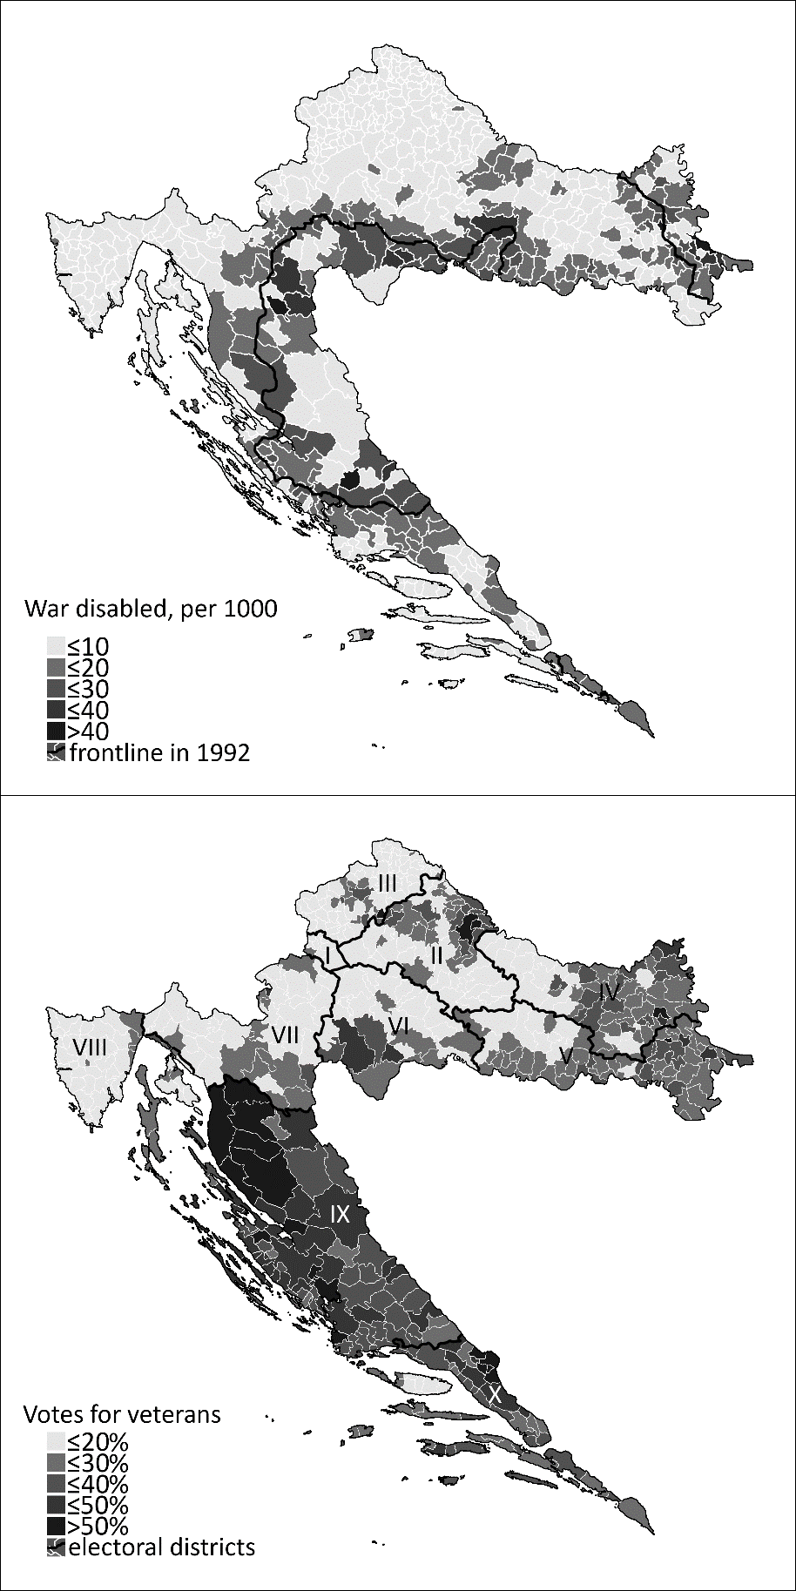
Figure 4. Effect of candidates’ service in combat on preferential votes

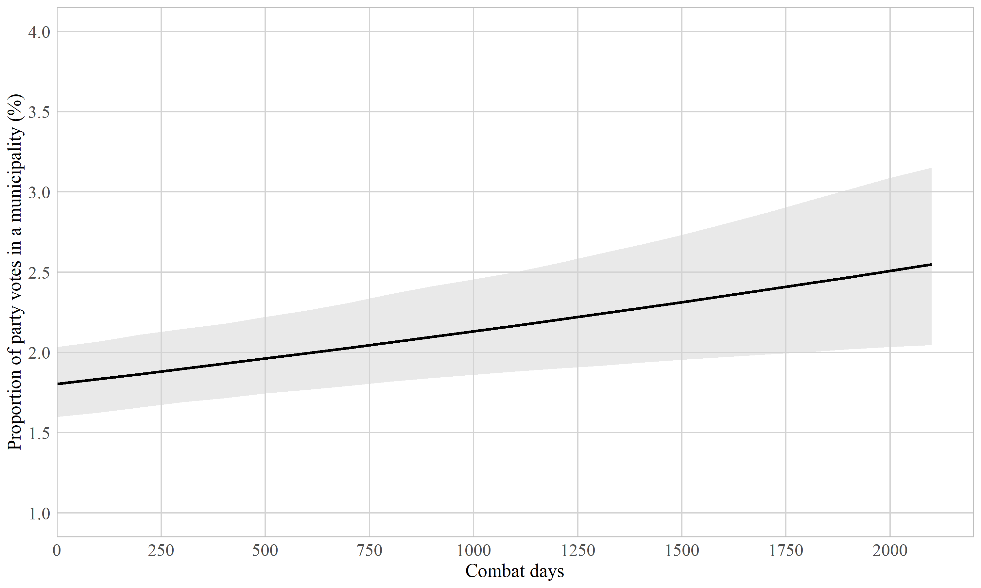

Figure 5. Effect of candidates’ service in combat on preferential votes, conditional on municipalities’ exposure to war violence

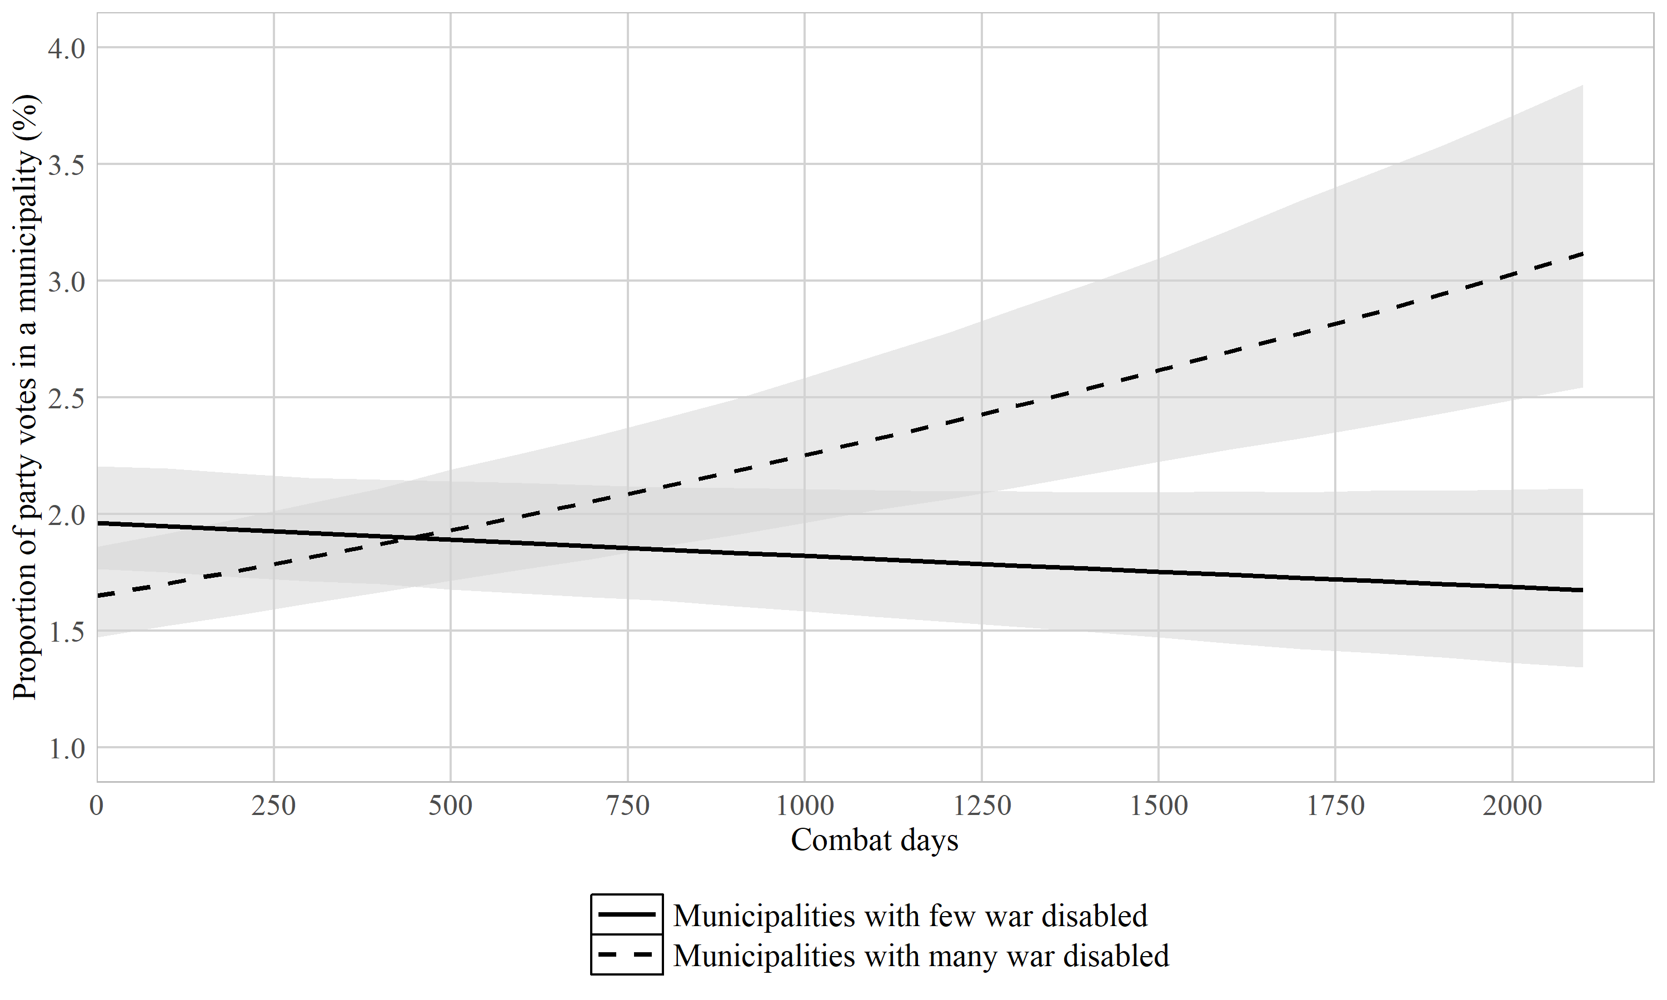

Figure 6. Effect of candidates’ service in combat on preferential votes for leftwing and rightwing parties, conditional on municipalities’ exposure to war violence

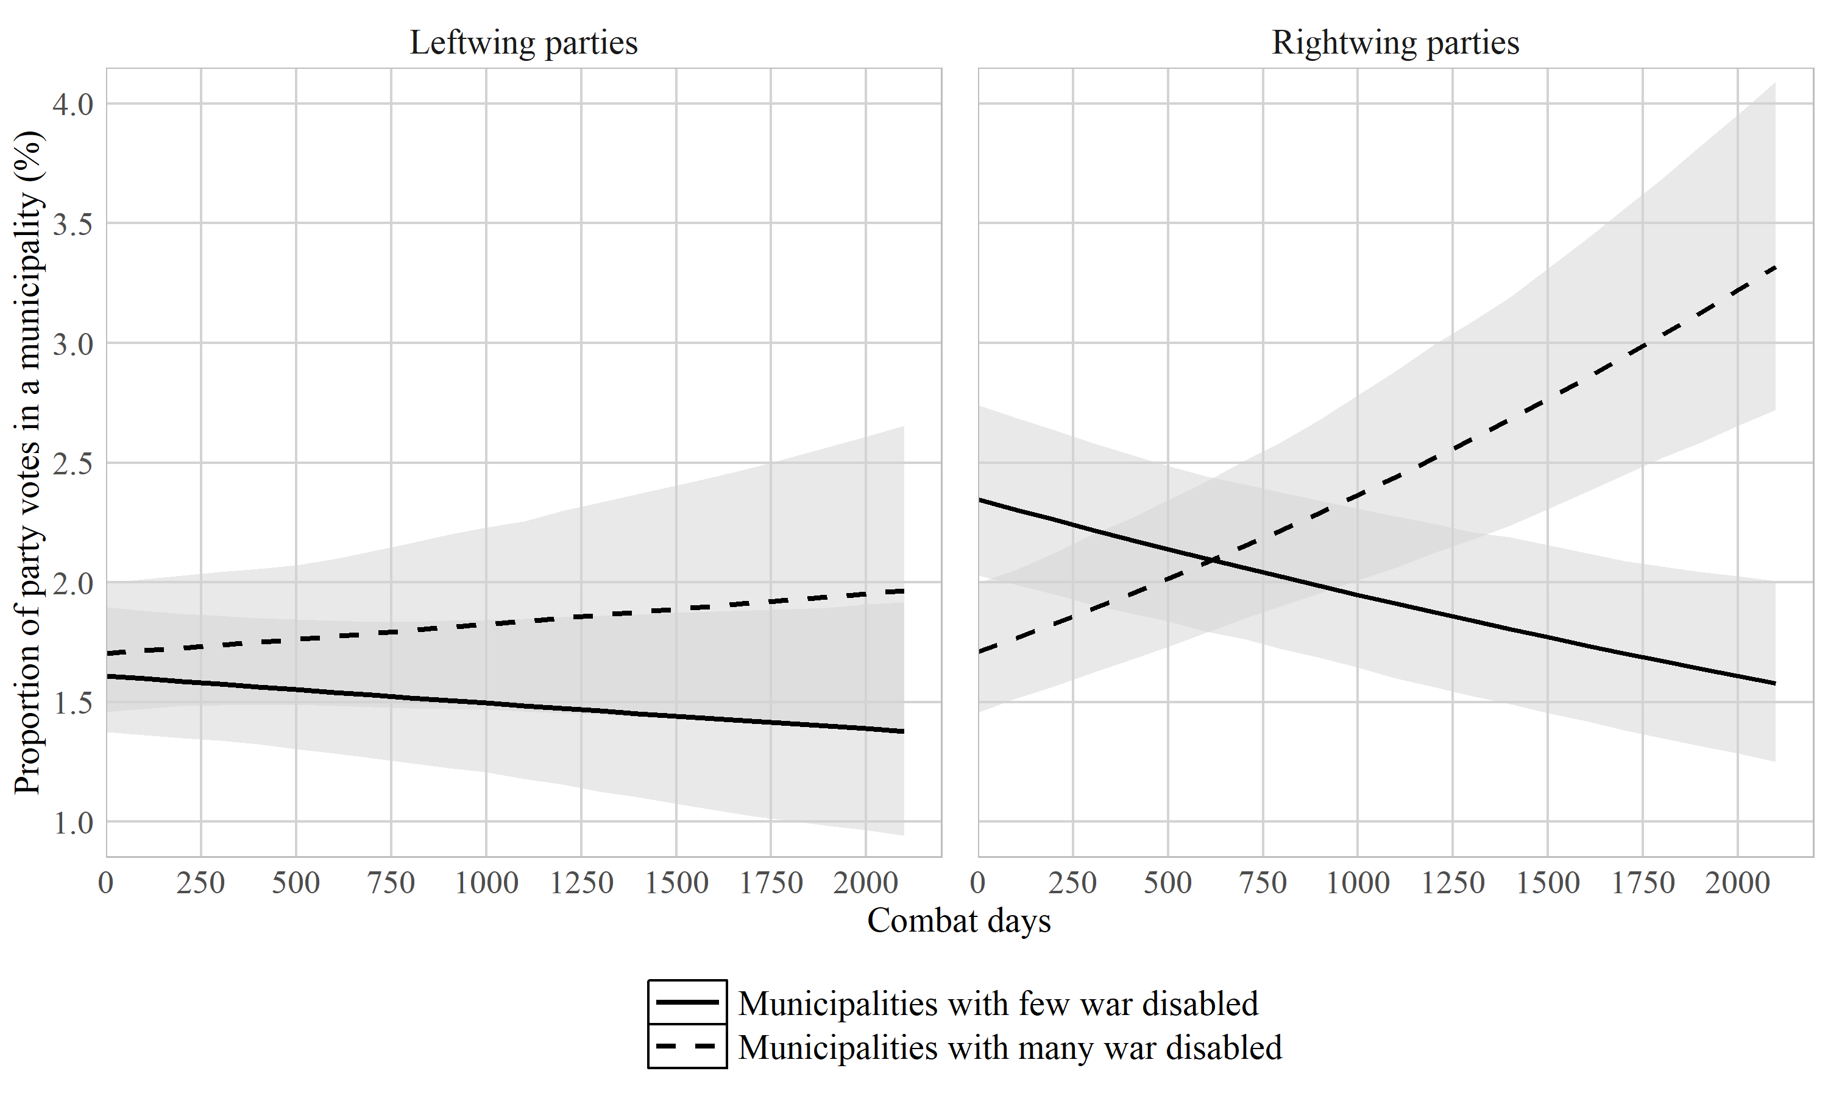

M.L. 2012. “Registar branitelja ruši sve rekorde.” Index.hr. Available at: https://www.index.hr/vijesti/clanak/Registar-branitelja-rusi-sve-rekorde-U-nesto-vise-od-24-sata-registar-pretrazilo-tri-milijuna-posjetitelja!/653387.aspx (last accessed 10 December 2020).
About 23% of candidates were combat veterans. The distribution of Combat days can be viewed in the Online Appendix in Figure A1.
As a robustness check, we reran the analyses with the votes not disaggregated on the municipal level. The results, reported in the Online Appendix in Table A1, confirm the findings reported in Table 2.
Several studies (e.g. Allik, 2015; van Erkel and Thijssen, 2016) rely on a linear model with log-transformed vote proportions as the dependent variable instead of a binomial model. Since both approaches arrive at similar results, as our robustness checks showed, we report the findings of the more straightforward binomial model here.
Community-level effects of exposure to war violence could also originate from the experiences of neighboring municipalities. However, we argue that the present operationalization constitutes a conservative estimation of community-level war exposure’s effect on voter choice. The concern is essentially that voter choices in municipalities with low war exposure are similar to those in high war exposure municipalities because of their proximity to the latter. The extent to which this is true makes the variable War disabled a weaker predictor of voter choice. Arguably, had we been able to better capture geographical correlational structures, the effect of the variable would have been stronger. As a result, the relation between War disabled and voter choice reported below underestimates their ‘true’ relation, rendering the analyses more conservative tests of our hypotheses.
While there is a relation between Combat days and Party ideology, this correlation (r = 0.17) is not nearly high enough to raise concerns about the validity of the analyses. Furthermore, when we ran Model 2, with the interaction between Combat days and War disabled, separately for left- and right-wing parties, the conclusions of Model 4 were corroborated (see Table A5 in the Appendix).
In early 2020, the Ministry of Veterans’ Affairs of the Federation of Bosnia and Herzegovina made its registry of war veterans available online (https://registri.fmbi.gov.ba/). It remains to be seen for how long.

