Eco-construction for Sustainable Development: Concept of a Material and Component Bank

Laddu Bhagya Jayasinghe1, Daniele Waldmann2

1 University of Luxembourg, 6 Avenue de la Fonte, L-4364 Esch/Alzette, [bhagya.jayasinghe@uni.lu](mailto:bhagya.jayasinghe@uni.lu)

2 University of Luxembourg, 6 Avenue de la Fonte, L-4364 Esch/Alzette, [daniele.waldmann@uni.lu](mailto:daniele.waldmann@uni.lu)

[Abstract]. The European Commission has recently promulgated the concept of Circular Economy as a new pathway towards sustainability, in particular through new policy initiatives such as the Circular Economy Action Plan (CEAP). Since the environmental impact of the construction industry with the depletion of natural resources and the raising CO2 emissions will have to be reduced in the future, the need of recycling and even reusing entire building components supporting the principles of circular economy have been identified. The direct reuse of components extracted from old deconstructed buildings presents an energy-efficient and environmental-friendly solution. However, the reuse of components can be hindered by e.g. the lack of information on the availability of decommissioned structural components and uncertainties on the warranty of structural components. To handle this process an additional independent institution acting as Material and Component (M&C) Bank is needed. This entity assures activities such as e.g. the identification of reusable components in buildings which are proposed for selective dismantling; the condition assessment; the data management and the data transfer from a previously deconstructed building to a new building; and finally, an official certification of the components’ conformity for another service life in a new application. In the current paper, a concept for such a M&C bank is presented. This study investigates the potential of a M&C bank in the framework of circular economy concepts for the planning of sustainable and circular buildings with a reduced eco-footprint by focusing on the reuse of decommissioned structural components. The concept, main businesses and work operation of the bank are discussed. Furthermore, a digital representation of the bank as BIM-based M&C bank needed to publicize the availability of the reusable components to the market and to enable circular business models by showing their circular pathways are described.

**Keywords:** Sustainability, construction and demolition waste, material and component bank, reuse, building information modelling

Introduction

The construction sector has a significant negative impact on the environment, and buildings consume large amount of global resources and generate vast amount of construction and demolition (C&D) waste such as concrete, bricks, steel, wood, glass, plastic materials, excavated soil, etc. (Poon, Yu, Wong, & Cheung, 2004). As a result, sustainability principles continue to grow within the construction industry to adopt environmentally friendly construction methods and waste management methods.

Sustainable development is most widely defined as the development that meets the needs of the present without compromising future generations (Brundtland, 1987). The European Commission noted that circular economy systems have huge benefit for sustainable development and adopted new policy initiatives such as the Circular Economy Action Plan (CEAP) to encourage policy makers, academia and industry towards sustainability (COM, 2020). It includes everything from production to consumption, repair, manufacturing and waste management. The circular economy is a fundamental shift from a linear economy, which is based on take, make and dispose to a more sustainable model that reduces the extracting of raw materials from finite natural resources and stops producing the waste at the other end. It transforms the linear approach into a closed loop, which is very much dependent on the use of secondary raw materials. The circular economy contributes to a sustainable development in the construction sector, as it eliminates systematic physical degradation of natural resources, amount of waste produced by construction and the volume of raw materials extracted from earth.

In circular economy, reuse and recycling are the key strategies to maximize the use of materials through moving materials from one application and producing new materials out of waste, respectively (Pan, et al., 2015). Although recycling of materials is a common practice, direct reuse is a more beneficial use of building materials at the end of a service life. This is because recycling requires more energy usage as compared to the energy needed for material reuse (Addis, 2006). Furthermore, the reuse of structural components from old buildings would provide many benefits for the environment and for energy and resource saving (Aye, Ngo, Crawford, Gammampila, & Mendis, 2012). Kummati housing estate rehabilitation project in Raahe in Finland during 2008-2010 showed that 36% of savings in construction cost when reuse of concrete wall panels (Huuhka, Kaasalainen, Hakanen, & Lahdensivu, 2015). In German, precast concrete elements was reused in a new housing project in Mehrow and resulted in 30% reduction in cost (Stacey, 2011). A unique recent BAMB project (BAMB, 2020) explored the view of buildings as material banks within which components are retained at high value for future reuse. Several pilot projects presented which can be incorporated circular economy in such a development (e.g. BRIC building and new office building).

The recent research has proven that the development of the Building Information Modelling (BIM) based on sustainable tools for estimating the energy and environmental performances of buildings (e.g. Salvage performance, life cycle assessment regarding energy consumption, CO2 emission, waste generation) during the early design stages would be beneficial in adopting circular economy principles in the construction industry (Akanbi, et al., 2018; Ghisellini, Ripa, & Ulgiati, 2018). Akanbi et al. developed a BIM-based building salvage performance estimator to evaluate the salvage performance of structural components of buildings during their useful life and found that building design with steel structures, demountable connections and prefabricated assemblies are mostly reusable (Akanbi, et al., 2018). Bilal et al. discussed the potential of BIM-based waste prediction in the construction industry and identified twelve (12) critical features that can be implemented in BIM-based tools for construction waste prediction and minimization (Bilal, et al., 2015). Galic et al. adopted a BIM-based approach to identify instabilities when deconstruction of a steel structure for further reuse or relocation (Galic, Dolacek-Alduk, Cerovecki, Glick, & Abramovic, 2014). Honic et al. presented a BIM-based Material Passport, which acts as an optimization tool in early design stages and an inventory at the end of the life-cycle of a single building (Honic, Kovacic, Sibenik, & Rechberger, 2019).

However, there is no circular economy market that supports the reuse of whole structural components (Waldmann, 2017). In order to bridge this gap, a new circular economy strategy, which is called Material and Component (M&C) bank, has been developed within the EU funded Eco-Construction for Sustainable Development (ECON4SD) project. It paves the way to increase sustainability of construction by effectively managing the reuse of structural components and recycling of materials (Cai & Waldmann, 2019). The authors propose and develops a BIM-based tool as a digital representation of the bank, which allows to store information of the materials and components of buildings preparing them for an application in circular economy perspective (Jayasinghe & Waldmann, 2020).

As part of the ECON4SD project, this paper discusses the concept, key businesses and work operation of the M&C bank, as well as a broader framework of a BIM-based tool that will be able to assess recycling and reuse potential of materials and components.

Overview of research

Reuse is recognized as a better practice in the construction industry to recover the value of building materials. However, the lack of data standardization to identify potentially reusable components as well as to re-certificate the decommissioned components providing a guarantee of their future structural reliability are the major obstacles for reusing structural components. Recently, there are few projects such as e.g. the project BAMB (BAMB, 2020) which try to provide related tools to increase the value of building materials for recovery and reuse. Certainty in material properties and manufacturing data are important to provide the quality assurance and warranty of reusable components as well as professional indemnity insurance for the designers. There is currently limited information available about how to reuse structural components. Therefore, an additional institution is needed playing the role of a living Material Bank, which organizes the transfer of components for reuse extracted from old deconstructed buildings to a new structure including condition assessment, conditioning, management of the related BIM data and certification of these components.

Fig. 1 demonstrates the concept of the M&C bank, which is closely linked with Design for Deconstruction (DfD). In Fig. 1, the dashed line shows the core business of the bank that permits to establish the circular economy in construction. DfD helps to increase the useful life of components of a structure by making them available as material stocks for the future (Tingley & Davison, 2011). Structures with DfD can easily reach high level of circular economy in the construction sector. DfD should be introduced in the planning phase to improve the technical usability of structural components of structures. Crowther (Crowther, 2005) produced a list of general concepts and principles for deconstruction. For the structures without DfD, some smart demolition technologies are needed to separate the part of the components, which can be reused in new structures, from the C&D waste (Cai & Waldmann, 2019). As shown in Fig. 1, through the M&C bank the information on the disassembly and reuse potential for structural components can be provided for the next utilization. However, new deconstruction strategies and set of processes such as (i) designing reasonable demountable connections with reasonable mechanical properties and durability, (ii) assessing residual performance and (iii) evaluating the possibility of reassembly must be developed to facilitate the disassembly of structural components after a life-cycle of a building (Waldmann, 2017).



Fig. 1 Concept of M&C bank. The figure is modified from (Cai & Waldmann, 2019)

The role of the M&C bank on the transfer of decommissioned components from the old structures to the new structures is illustrated in Fig. 2. The key functions of the bank are identified as follows:

* ***Database*** – The bank must be able to extract and store the characteristics of materials and components in existing buildings. Thus, a detailed database that contains material specifications, design relevant parameters, dis- and re-assembly details, connection details, load-bearing capacities, aging and deterioration and suppliers’ information must be established. This means that the database will provide all kind of information on the components in a building to allow their reuse in a context of circular economy. These data can be effectively used to identify the recyclable and reusable potentials of the materials and then, separate the recyclable and reusable materials from the waste. Since BIM contains all the information about materials and components with numerous life-cycle related data, such as material properties, geographic information, quantities, function, life, composition and cost (Kensek, 2015), a BIM-coupled database promises a solution to the digital representation of the bank. Producing appropriately categorized and detailed information about components will help contractors and designers to easily identify the (future) availability of reusable components as well as their condition.



Fig. 2 Role of the M&C bank. The figure is modified from (Jayasinghe & Waldmann, 2020)

* ***Assessment and conditioning*** – Uncertainties on the condition of the structural components for reuse is one of the main barriers for the reuse of disassembled components. The bank is responsible to conduct a condition assessment of components by forecasting their future condition considering the time-dependent impacts and material degradation. Once the structural components that will be decommissioned for reuse are identified, an adequate plan for structural condition assessment and the determination of the reaming load-bearing capacity and the service life of the structural components has to be done. In addition, with the help of the bank and by considering the chemical properties of the materials and specification of recyclable materials, environmental and human risk assessments can be adapted to separate the toxic and hazardous materials from the recyclable materials in order to improve the efficiency of recycling as well as economic value of recovered recyclable materials.
* ***Certification and storage*** – The reuse of structural components can be hindered by the lack of the certification for the reuse. Thus, with the help of the bank, after the condition assessment of the components is done, the certification of the materials and components can be formalized with the support from Government politics to provide the guarantee on the components to reuse after the first lifespan. For that, the data from the M&C bank can be directly linked to the relevant certification systems. It is the most crucial process that the bank has to perform (Cai & Waldmann, 2019). Furthermore, it is not very likely that the decommissioned components can immediately go from a deconstructed site to a new construction site. Thus, the reusable components have to be stored for a certain time before reuse. Hence, another prime consideration of the bank should be to provide safe and reasonable storage strategies to avoid local damage of components during storage.
* ***Production of new components*** – Another important role of the bank is to cooperate with designers and contractors to promote the production of new components using recycled materials. In addition, solutions for detachable connections between different components have to be found in order to enable further reuse in the next application.
* ***Monitoring and tracking*** – After implemented reuse components or new components produced by recycled materials in a new structure, the bank will keep in touch with the owner/users of structure and will closely monitor the structure. For that, the bank will propose a proper monitoring concept and will provide some suggestions and recommendations for repairing and strengthening of the structures any degradation occurs. In the future, new structures could be leased by the building owners. These owners will have to closely monitor the buildings with elaborated monitoring concepts. The data provided by the monitoring will be fed into the BIM model and so, be available at any time. The flowchart in Fig. 3 identifies the methodology and major tasks that can be undertaken in an investigation before rehabilitation. Such an investigation could be initiated at different stages of life-span of a structure such as an anticipated change in use, at the end of design working life, structural deterioration due to time-dependent actions and structural damage by accidental actions.

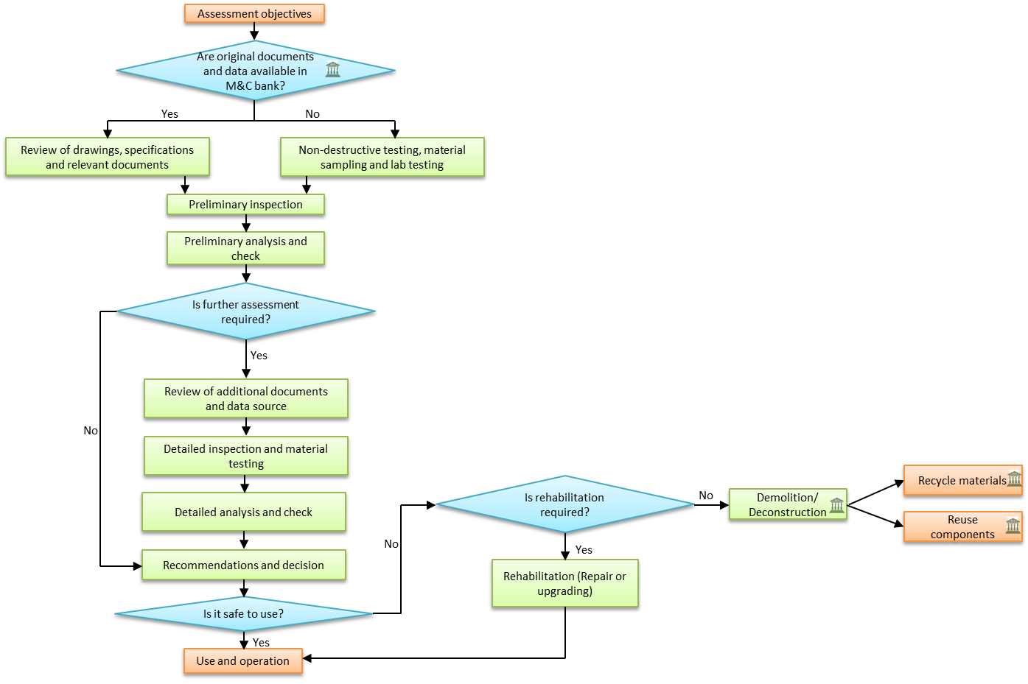

Fig. 3 Methodology in an investigation

Several challenges exist on the implementation of the M&C bank in practical. A major challenge is that the majority of buildings are not designed for the reuse of components due to the lack of market for them. On the other hand, if the buildings are designed for deconstruction/reuse, the initial construction cost of the buildings could be high compared to conventional construction. Other concerns are related to feasibility to extract building components from old buildings at the end of their service life and to determination of their remaining value for reuse in future buildings. Thus, the M&C bank should be a company or institution in large scale which have managers, engineers, researchers, technicians, market analysts etc. to be able to address above-mentioned challenges (Cai & Waldmann, 2019). Such an organization of the bank will increase its effectiveness for the recovering of the materials and components during the deconstruction. Since the reuse of building components involves several suppliers at the end, the entire market will be often not owned by a single company. Therefore, it is needed to have an intensive collaboration between other construction companies in order to maintain the circular economy to related leasing activities. Indeed, the logistic sector has to be linked to cover the transportation and storage operations related to the reuse of building components. In addition, the bank must evaluate the market potential and value of the recyclable materials and reusable components in order to promote high-level sustainability in the construction industry. Moreover, the bank has to maintain a strong collaboration with the government bodies in order to standardize the data and re-certify the components for reusing. The bank can act as an independent bank, which is responsible for the clients, or as a dependent bank which is strongly dependent on the main contractor and responsible for the contractor, but not for the client directly (Cai & Waldmann, 2019). The independent bank as a chance for a greater collaboration between different parties in the construction industry, while the dependent bank will only connect with the contractor for the supply of materials and components or exchange the related information of the project.

## BIM-to-Material Bank workflow

These days, a growing number of architects, engineers and contractors are using BIM, which is an intelligent model-based process that connect all the professionals in the construction industry, ultimately helping them to efficiently plan, design, construct and operate buildings and structures. With BIM, designers can create digital 3D models that include detailed geometric information and semantic information of components in a building. BIM can also facilitate the data management that is useful to identify recyclable and reusable components in advance and to identify cost and risk in the waste disposal at the deconstruction stage of a building (Liu, Osmani, Demian, & Baldwin, 2015; Volk, Stengel, & Schultmann, 2014; Wang, Wang, Wang, Yung, & Jun, 2013). This information, which provide information for decision-making calculation, could be used by the M&C bank to reduce the intensive work of collecting data about building components. Since the transparency and accessibility on information will be increased through BIM, having a BIM-coupled digital representation of the materials and components in a structure will expand the reusable M&C market. The representation of the BIM-coupled digital M&C bank is illustrated in Fig. 4.

As illustrated in Fig. 4, it is expected that the BIM models for future buildings are available. However, BIM models may not be available for some existing structures. In this case, the digitization of the physical structure can be done through the use of BIM, adopting the existing information and specifications as well as collected information from a real evaluation of the structures during the deconstruction phase. Since the BIM includes quantities and properties of building components, the developed BIM model can more accurately estimate the amount and type of waste and identify the recyclable and reusable potentials of building materials.

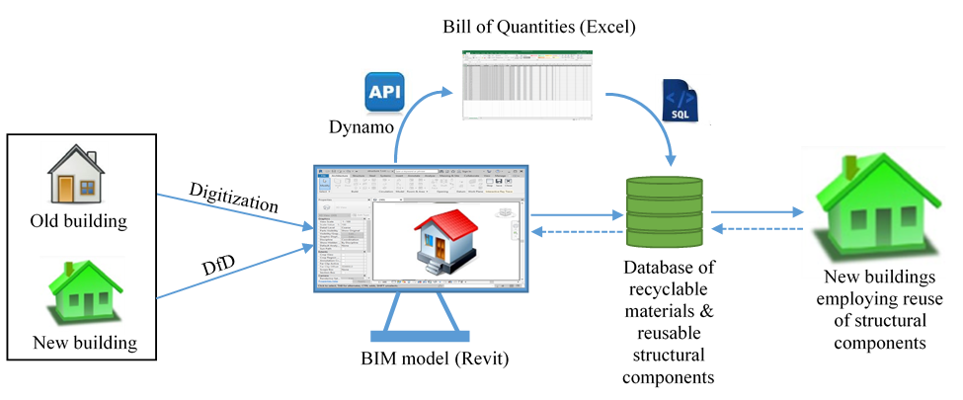

Fig. 4 The representation of BIM-coupled digital M&C bank

There are different strategies which exist for the development of an interoperable workflow and algorithm that integrate the relevant information in the BIM model to the database. In this paper, the data flow from the BIM model to the database or vice versa is achieved by developing a script using a visual programming language DYNAMO, as shown in Fig. 4. The DYNAMO script can be used to access the data structure in the Revit BIM model and obtain information from it, and then insert it into an Excel sheet. The Dynamo script can be divided into four parts that have different functionalities such as (i) element take-off, (ii) database reading, (iii) calculation and (iv) export of data to Excel. All the relevant geometrical and material properties of structural elements (such as slabs, beams, columns, walls) are extracted and then, the mathematical approach based calculation takes under the consideration of material and element type to identify the reusable and recyclable materials as well as to predict the total volume of demolition waste. This spreadsheet could be used to be automatically added to the chosen database, MYSQL.

To make it possible to assess the recyclability of materials and reusability of components, some newly created parameters have to be added into the BIM model in the form of shared parameters. Some of the identified important information which is incorporated into the BIM model is shown in Fig. 5. This information can be used for various purposes. For example, structural properties in function of time are helpful for structural assessments to determine whether the components can be reused, while design properties of the components provide instructions on how to reuse them in a new structure. Chemical properties and thermal properties are needed to conduct environmental and energy assessments, respectively.



Fig. 5 Custom parameters to be incorporated in BIM model

## The digital representation of the bank

A digital representation of the bank is needed to publicize the available recyclable materials and reusable components to the market. The proposed digital system for the bank consists of a repository database, a server, a web application and end user terminals, as shown in Fig. 5. The database management system is created using a SQL server, and MYSQL is used for the database connection. It stores all information related to the BIM model elements. The connection of the MYSQL database is made directly to the BIM model, by writing parameters to the database. In MYSQL database, several tables are created according the type of element (i.e. column, beam, slab and wall) and type of material (i.e. concrete, steel, wood and masonry). Each table has a set of values that uniquely identifies the row. Two rows cannot be identical and no repeating groups of data are allowed when writing to the database. A unique ID for the element is kept for each element in the database and the BIM model to serve a permanent link between the M&C bank and BIM model. Three specific types of relationships (i.e. one-to-one relationship, one-to-many relationship and many-to-many relationship) are used to define the logical connection between the records in two or more tables.



Fig. 5 The system architecture

Database Management System (DBMS) is the only way to access to the information in the database. DBMS is a collection of programs which control and manage the database system. A web application is developed using PHP and MYSQL which allows end users (e.g. designers and planners, suppliers, contractors, government and client) to access the information in database and to perform project-based modifications of the database by e.g. adding data or changing the retrieval of data. It contains, a set of web pages including the project database, the material database, the components database and the assessments database in addition to the *log-in* and *home* pages. It is developed to upload the generated excel file using DYNAMO script, described above, so that the data will be automatically added and stored in the database. The amount of C&D waste are automatically calculated. In addition, reusable and recyclable materials are automatically identified and separated from the C&D waste. The information of each element is summarized in an appropriate list so that users can easily check the properties of all the elements. This will help users to easily identify the availability of reusable components and their condition. More details can be found in ref. (Jayasinghe & Waldmann, 2020).

As described above, the M&C bank should be able to keep available all kind of information on the materials and components extracted from several buildings for a long time throughout the whole life span of the buildings. This is performed by establishing a centralized database that could built a vast number of elements for future market of reuse components and recycle materials. The buildings recently built usually have BIM, sometimes, coupled with material passports (Luscuere, 2017) and life cycle assessment (LCA) software (Eleftheriadis, Duffour, & Mumovic, 2018). Therefore, automate the integration of information in BIM models into database makes it easier to collect and update the data. However, the information previously identified for reuse is needed to incorporate into the BIM model in the form of shared parameters. The accessibility and the interoperability of the BIM-to-Bank workflow throughout the whole life span of the buildings is a major concern because the maintenance of the software during such a long period will be not feasible (Bertin, Mesnil, Jaeger, Feraille, & Le Roy, 2020). Link of the bank to the material directory databases, which provide the data on material composition, recycling potentials, reusability and LCA data, will provide the required information on the bank for taking reliable and sustainable decisions. However, lack of adequate data on the construction and deconstruction processes as well as reusability and recycling potentials of materials available in the existing material directories is a big issue to identify and separate the reusable and recyclable materials from the C&D waste. On the other hand, the values on database have to be regularly updated, even if such a material directory exist and link to the database.

## Conclusions

In this paper, the proposed concept of a Material and Component Bank which has been developed within the research project “Eco-Construction for Sustainable Development” is presented. The proposed bank will promote a circular economy in the construction industry by effectively managing the recyclable and reusable materials and components extracted from old buildings to new ones. The key businesses and roles are also introduced. In addition, a BIM-coupled system is discussed which is a digital representation of the bank and which allows to increase the transparency and accessibility of the bank. Since it provides information on disassembly of the components and the reuse and recycle potential for materials and components, it promotes the design for deconstruction leading to a high level of sustainability in the construction sector. The developed BIM-based web tool can facilitate the data management which allows designers of future buildings to easily identify the availability and the condition of the recyclable materials and reusable components in advance which could be useful for a further application. The BIM-based web tool will also be helpful to identify the cost and risk in waste disposal at the deconstruction stage by using the volume details by material type which could provide more detailed information on the waste. This information will help contractors to calculate waste disposal fees and decision-makers to make adequate decisions for minimization and sustainable management of C&D waste. However, the accuracy of the results depends on the accuracy on the precision of the database, which is again depending on the precision of the BIM model and the accuracy of the data takeoff. Thus, it is recommended to check the BIM model using a control tool, in order to be error-free, before transferring the information from the BIM model to the bank.

**Acknowledgements** This paper was developed within the framework of the European project “Eco-Construction for Sustainable Development (ECON4SD) ” financed by Fonds européen de développement régional (FEDER) (Grant No.:2017-02-015-15).

# References

Addis, B. (2006). *Building with reclaimed components and materials: A design hand book for reuse and recycling.* London: Earthscan.

Akanbi, L. A., Oyedele, L. O., Akinade, O. O., Ajayi, A. O., Delgado, M. D., Bilal, M., & Bello, S. A. (2018). Salvaging building materials in a circular economy: a BIM based whole-life performance estimator. *Resources, Conservation and Recycling, 129*, 175-186.

Aye, L., Ngo, T., Crawford, R. H., Gammampila, R., & Mendis, P. (2012). Life cycle greenhouse gas emissions and energy analysis of prefabricated reusable building modules. *Energy and Buildings, 47*, 159-168.

BAMB. (2020). *Buildings As Material Banks*. Retrieved June 2020, from https://www.bamb2020.eu/

Bertin, I., Mesnil, R., Jaeger, J.-M., Feraille, A., & Le Roy, R. (2020). A BIM-based framework and databank for reusing load-bearing structural elements. *Sustainability, 12*, 3147.

Bilal, M., Oyedele, L. O., Qadir, J., Munir, K., Akinade, O. O., Ajayi, S. O., . . . Owolabi, H. A. (2015). Analysis of critical features and evaluation of BIMsoftware: towards a plug-in for construction wasteminimization using big data. *International Journal of Sustainable Building Technologyand Urban Development, 6*(4), 211-228.

Brundtland, G. H. (1987). Our common future: report of the world commission on environment. *Medicine and War, 4*(1), 300.

Cai, G., & Waldmann, D. (2019). A material and component bank to facilitate material recycling and component reuse for a sustainable construction industry: concept and preliminary study. *Clean Technologies and Environmental Policy, 21*, 2015-2032.

COM. (2020, March 11). *EU Circular Economy Action Plan.* Retrieved from European Commission. Environment: https://eur-lex.europa.eu/resource.html?uri=cellar:9903b325-6388-11ea-b735-01aa75ed71a1.0017.02/DOC_1&format=PDF

Crowther, P. (2005). Design for disassembly-themes and principles. *RAIA/BDP Environmental Design Guide.*

Eleftheriadis, S., Duffour, P., & Mumovic, D. (2018). BIM-embedded life cycle carbon assessment of RC buildings using optimised structural design alternatives. *Energy and Buildings, 173*, 587-600.

Galic, M., Dolacek-Alduk, Z., Cerovecki, A., Glick, D., & Abramovic, M. (2014). BIM in planning deconstruction projects. *eWork and eBusiness in Architecture, Engineering and Construction: ECPPM 2014.* Vienna, Austria.

Ghisellini, P., Ripa, M., & Ulgiati, S. (2018). Exploring environmental and economic costs and benefits of a circular economy approach to the construction and demolition sector. A literature review. *Journal of Cleaner Production, 178*, 618-643.

Honic, M., Kovacic, I., Sibenik, G., & Rechberger, H. (2019). Data- and stakeholder management framework for the implementation of BIM-based Material Passports. *Journal of Building Engineering , 23*, 341-350.

Huuhka, S., Kaasalainen, T., Hakanen, J. H., & Lahdensivu, J. (2015). Reusing concrete panels from buildingsfor building: Potential in Finnish 1970s mass housing. *Resources Conservation and Recycling, 101*, 105-121.

Iacoboaea, C., Aldea, M., & Petrescu, F. (2019). Construction and demolition waste - A challenge for the european union? *Theoretical and Empirical Researches in Urban Management, 14*(1), 30-52.

Jayasinghe, L. B., & Waldmann, D. (2020). Development of a BIM-based web tool as a material and component bank for a sustainable construction industry. *Sustainability, 12*(5), 1766.

Kensek, K. (2015). BIM guidelines inform facilities management databases: a case study over time. *Buildings, 5*, 899-916.

Liu, Z., Osmani, M., Demian, P., & Baldwin, A. (2015). A BIM-aided construction waste minimisation framework. *Automation in Construction, 59*, 1-23.

Luscuere, L. M. (2017). Materials Passports: Optimising value recovery from materials. *Proceedings of the Institution of Civil Engineers – Waste and Resource Management*, *170(1)*, pp. 25-28.

Pan, S.-Y., Du, M. A., Huang, I.-T., Liu, I.-H., Chang, E.-E., & Chiang, P.-C. (2015). Strategies on implementation of waste-to-energy (WTE) supply chain for circular economy system: a review. *Journal of Cleaner Production, 108*, 409-421.

Poon, C. S., Yu, A. T., Wong, S. W., & Cheung, E. (2004). Management of construction waste in public housing projects in Hong Kong. *Construction Management and Economics, 22*(7), 675-689.

Stacey, M. (2011). *Concrete: a studio design guide.* London: RIBA.

Teo, M. M., & Loosemore, M. (2001). A theory of waste behaviour in the construction industry. *Conctruction, Management and Economics, 19*(7), 741-751.

Tingley, D. D., & Davison, B. (2011). Design for deconstruction and material reuse. *Proceedings of the Institution of Civil Engineers - Energy*, (pp. 195-204).

Volk, R., Stengel, J., & Schultmann, F. (2014). Building Information Modeling (BIM) for existing buildings - literautre review and future needs. *Automation in Construction, 38*, 109-127.

Waldmann, D. (2017). Demountable construction enables strucutral diversity. *Open Access Gov.*, 212-213.

Wang, Y., Wang, X., Wang, J., Yung, P., & Jun, G. (2013). Engagement of facilities management in design. *Advances in Civil Engineering, 2013*, 189105.