Journal of Clinical Medicine
Manuscript ID: jcm-404601

Increased Circulating VAP-1 Levels are Associated with Liver Fibrosis in Chronic Hepatitis C Infection
Marcel Kraemer ¹, Marcin Krawczyk ^{1,2}, Fozia Noor ³, Frank Grünhage ^{1,4}, Frank Lammert ¹ and Jochen G. Schneider ^{1,3,5,}*
¹ Department of Internal Medicine II, Saarland University Medical Center, 66421 Homburg, Germany
² Laboratory of Metabolic Liver Diseases, Centre for Preclinical Research, Department of General, Transplant and Liver Surgery, Medical University of Warsaw, 02-097 Warsaw, Poland
³ Luxembourg Centre for Systems Biomedicine (LCSB), University of Luxembourg, L-4367 Belvaux, Luxembourg
4 Department of Gastroenterology and Oncology, Rhein-Kreis-Neuss Hospital, Grevenbroich, Germany
⁵ Centre Hospitalier Emile Mayrisch, L-4240 Esch-sur-Alzette, Luxembourg
* Correspondence: jg.schneider@outlook.com; Fax: +35246664436154

Supplementary Figures
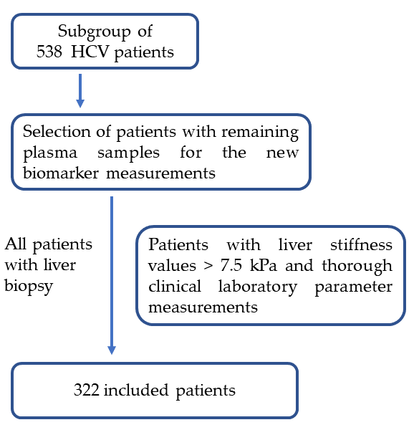
Figure S1: Description of the study cohort. The study was on a subgroup of a large cohort of 899 patients [15]. We selected 538 patients with chronic HCV infection. Of these patients 322 were selected based on the availability of blood samples, biopsy results, comprehensive measurement of clinical laboratory values, availability of liver stiffness values higher than 7.5 kPa to include patients representing fibrosis stage 2-4. Patients in the F0/F1 stage still represented the majority (153 out of 322).

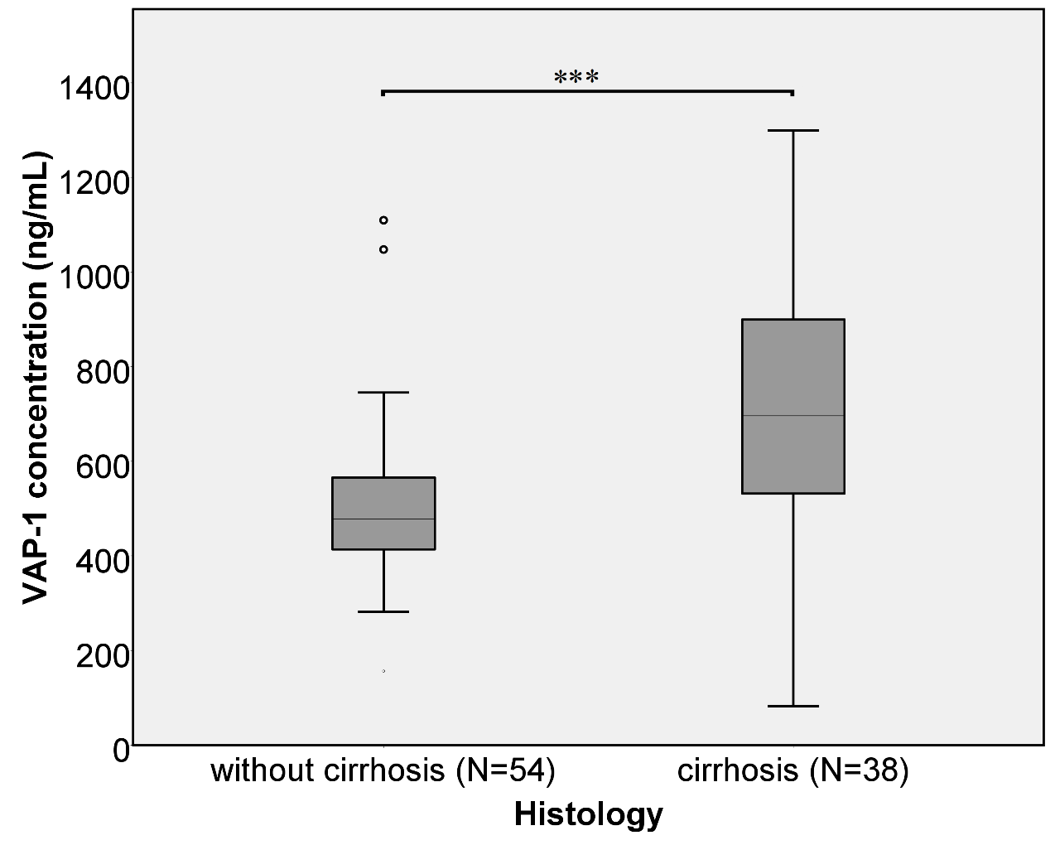

Figure S2. VAP-1 concentration without and with liver cirrhosis. The classification is based on the biopsy results (F0- F3 = no cirrhosis; F4 = cirrhosis; p < 0.001***). Significance is given as *** p<0.001.

