SUPPORTING INFORMATION:
Controlling electrical and optical properties of zinc oxide thin films grown by thermal atomic layer deposition with oxygen gas
Authors: Tai Nguyen^{1,2}, Noureddine Adjeroud¹, Mael Guennou², Jérôme Guillot¹, Yves Fleming¹, Anne-Marie Papon³, Didier Arl¹, Kevin Menguelti¹, Raoul Joly^{1,2},
Narciso Gambacorti³, Jérôme Polesel-Maris^{1,*}
¹ Materials Research and Technology Department, Luxembourg Institute of Science and Technology, 41, rue du Brill, L-4422 Belvaux, Luxembourg

²Physics and Materials Science Research Unit, University of Luxembourg, Campus Limpertsberg, 162 Avenue de la Faïencerie, L-1511 Luxembourg

³Univ. Grenoble Alpes, CEA, LETI, F-38000 Grenoble, France

* Corresponding author: jerome.polesel@list.lu

Lattice parameter calculation
The lattice parameters a and c of wurtzite hexagonal structure ZnO were calculated by using Bragg’s law:
λ = 2d_{hkl}sinθ (1)
where λ is the X-ray wavelength; and d_{hkl} is the spacing between planes with Miller indices h, k, and l.
For the hexagonal structure, the relationship between the spacing d_{hkl} and lattice parameters a and c is given below:
$\frac{1}{d_{(hkl)}^{2}}= \frac{3}{4}\left(\frac{h^{2}+ hk + k^{2}}{a^{2}}\right)+ \frac{l^{2}}{c^{2}}$ (2)
Then the lattice constants a and c were calculated by following equations (3) and (4), according to (100) and (002) diffraction planes:
$a=\frac{λ}{\sqrt{3 }sinθ}$ (3)
and $c=\frac{λ}{sinθ}$ (4)

Absorption coefficient calculation
The absorption coefficient α is calculated by the Beer-Lambert law¹
$α=\frac{2.303*A_{f}}{t}$ (5)
here t is the thickness of the film, and A_{f} is the absorbance of the film calculated by measuring the reflectance and transmittance spectra of the ZnO thin films on glasses and the reference glass and is deduced by following:
On glass:
T_{g} = 1 – A_{g} – R_{g} (6)
On glass + film:
T_{gf} = 1 – A_{g} – A_{f} – R_{f} (7)
Taking (6) – (7), we have:
A_{f} = (T_{g} –T_{gf}) – (R_{f} – R_{g})
Here T, A, and R are transmittance, absorbance, and reflectance. The subscript g, f, and gf are denoted for glass, film and glass + film.

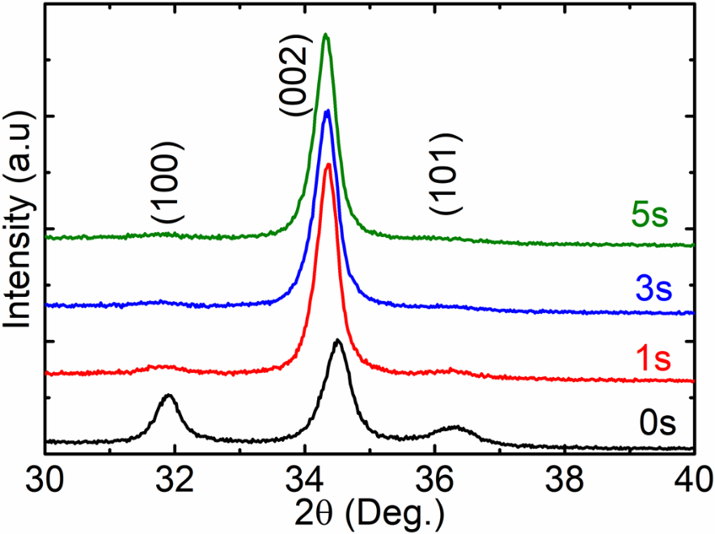
Figure S1: Grazing incidence X-ray diffraction (ω=0.5°) of ZnO thin films samples with differences of oxygen gas pulsing time on glass samples.

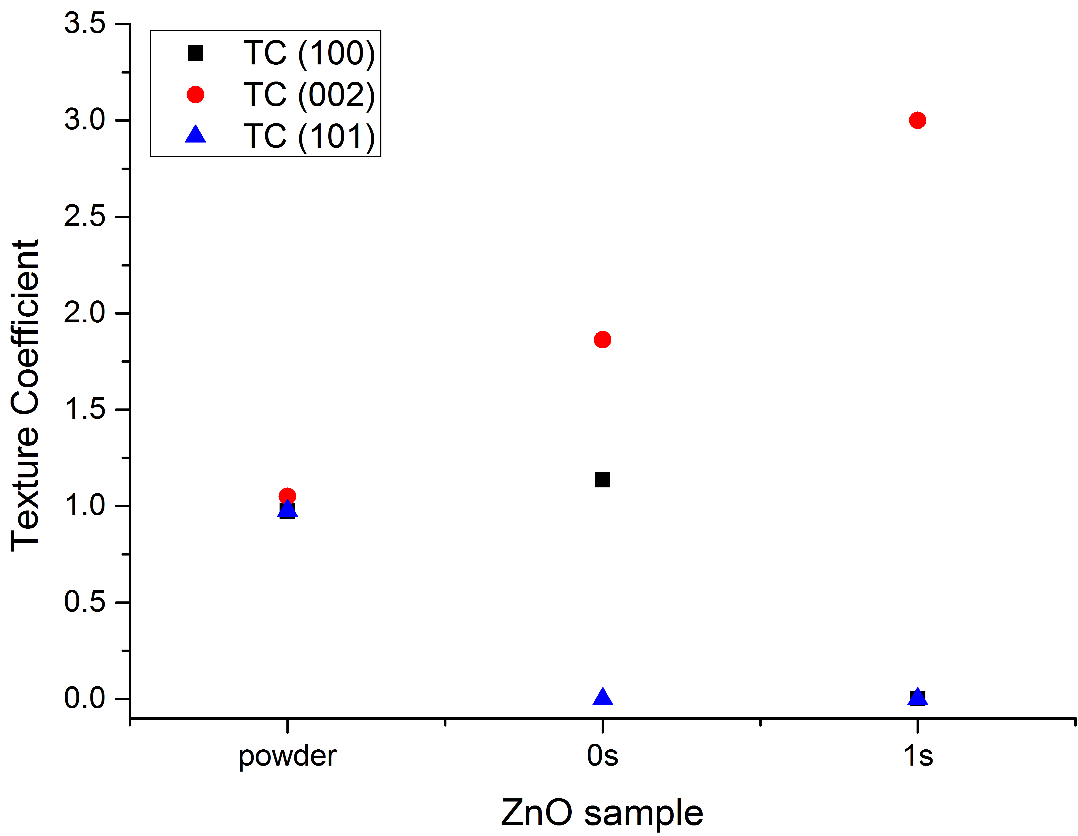
Figure S2: Texture Coefficients measured in θ-2θ mode in accordance to Harris et al.² and Moutinho et al.³. For the calculation of TC, the (100), (002) and (101) Bragg reflections for the ZnO powder sample as well as the two ZnO thin film samples grown without oxygen (0 s) and grown in the presence of oxygen gas (1 s). As expected for an isotropic randomly oriented ZnO powder sample, the texture coefficients are very close to 1.

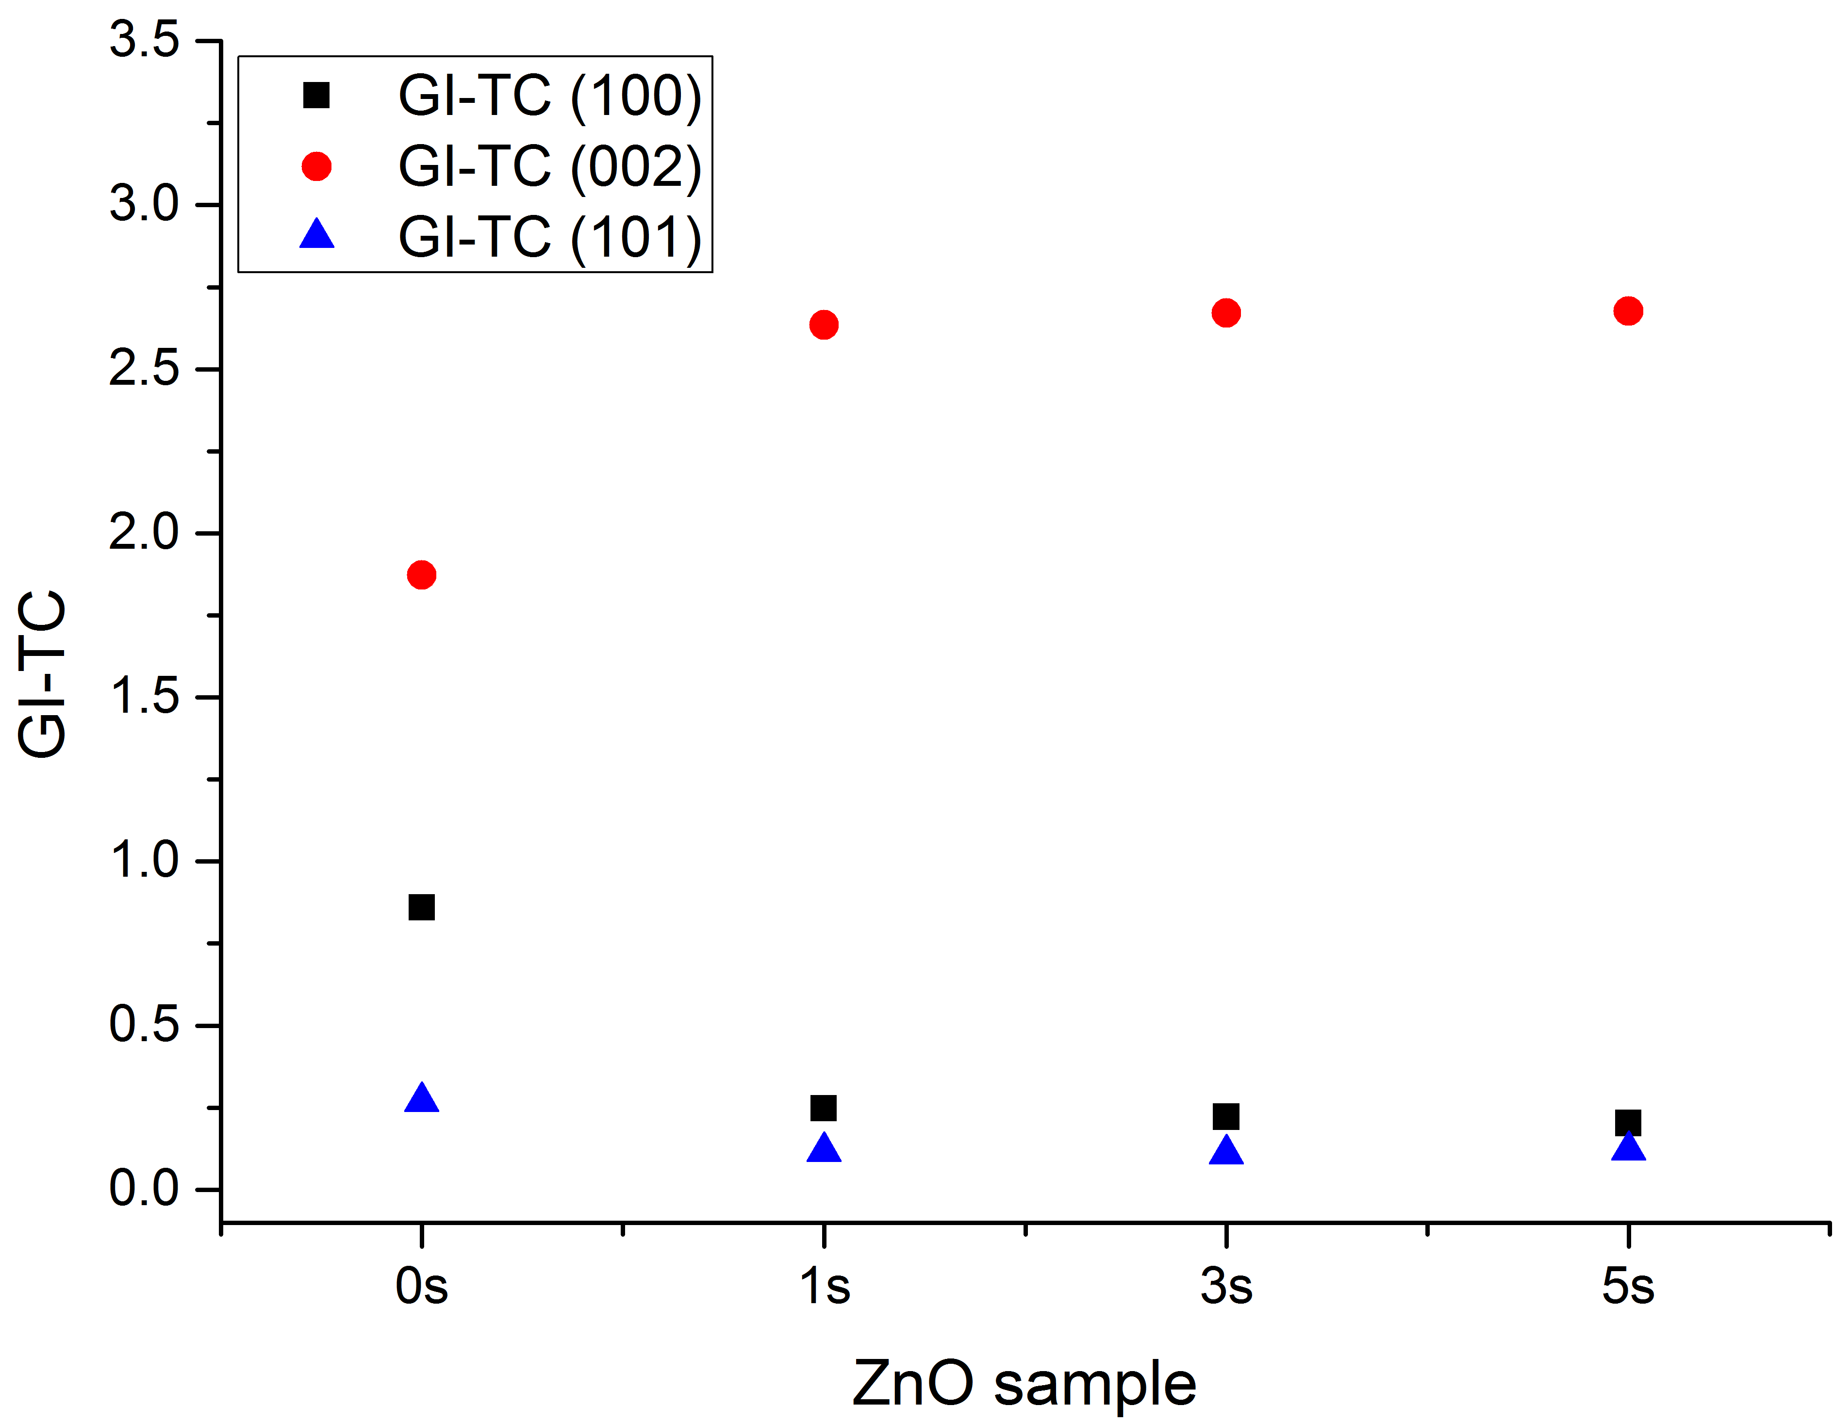
Figure S3: GI-TC values measured on the ZnO thin film samples 0 s, 1 s, 3 s and 5s . It can be noticed that the GI-TC of (002) Bragg reflection for samples 1 s, 2 s and 3 s is almost 3. This means that these ZnO thin film samples have a strong (002) preferred orientation. Reference sample as well as ZnO thin film samples were measured in grazing incidence. The instrument configuration was the same for all samples.

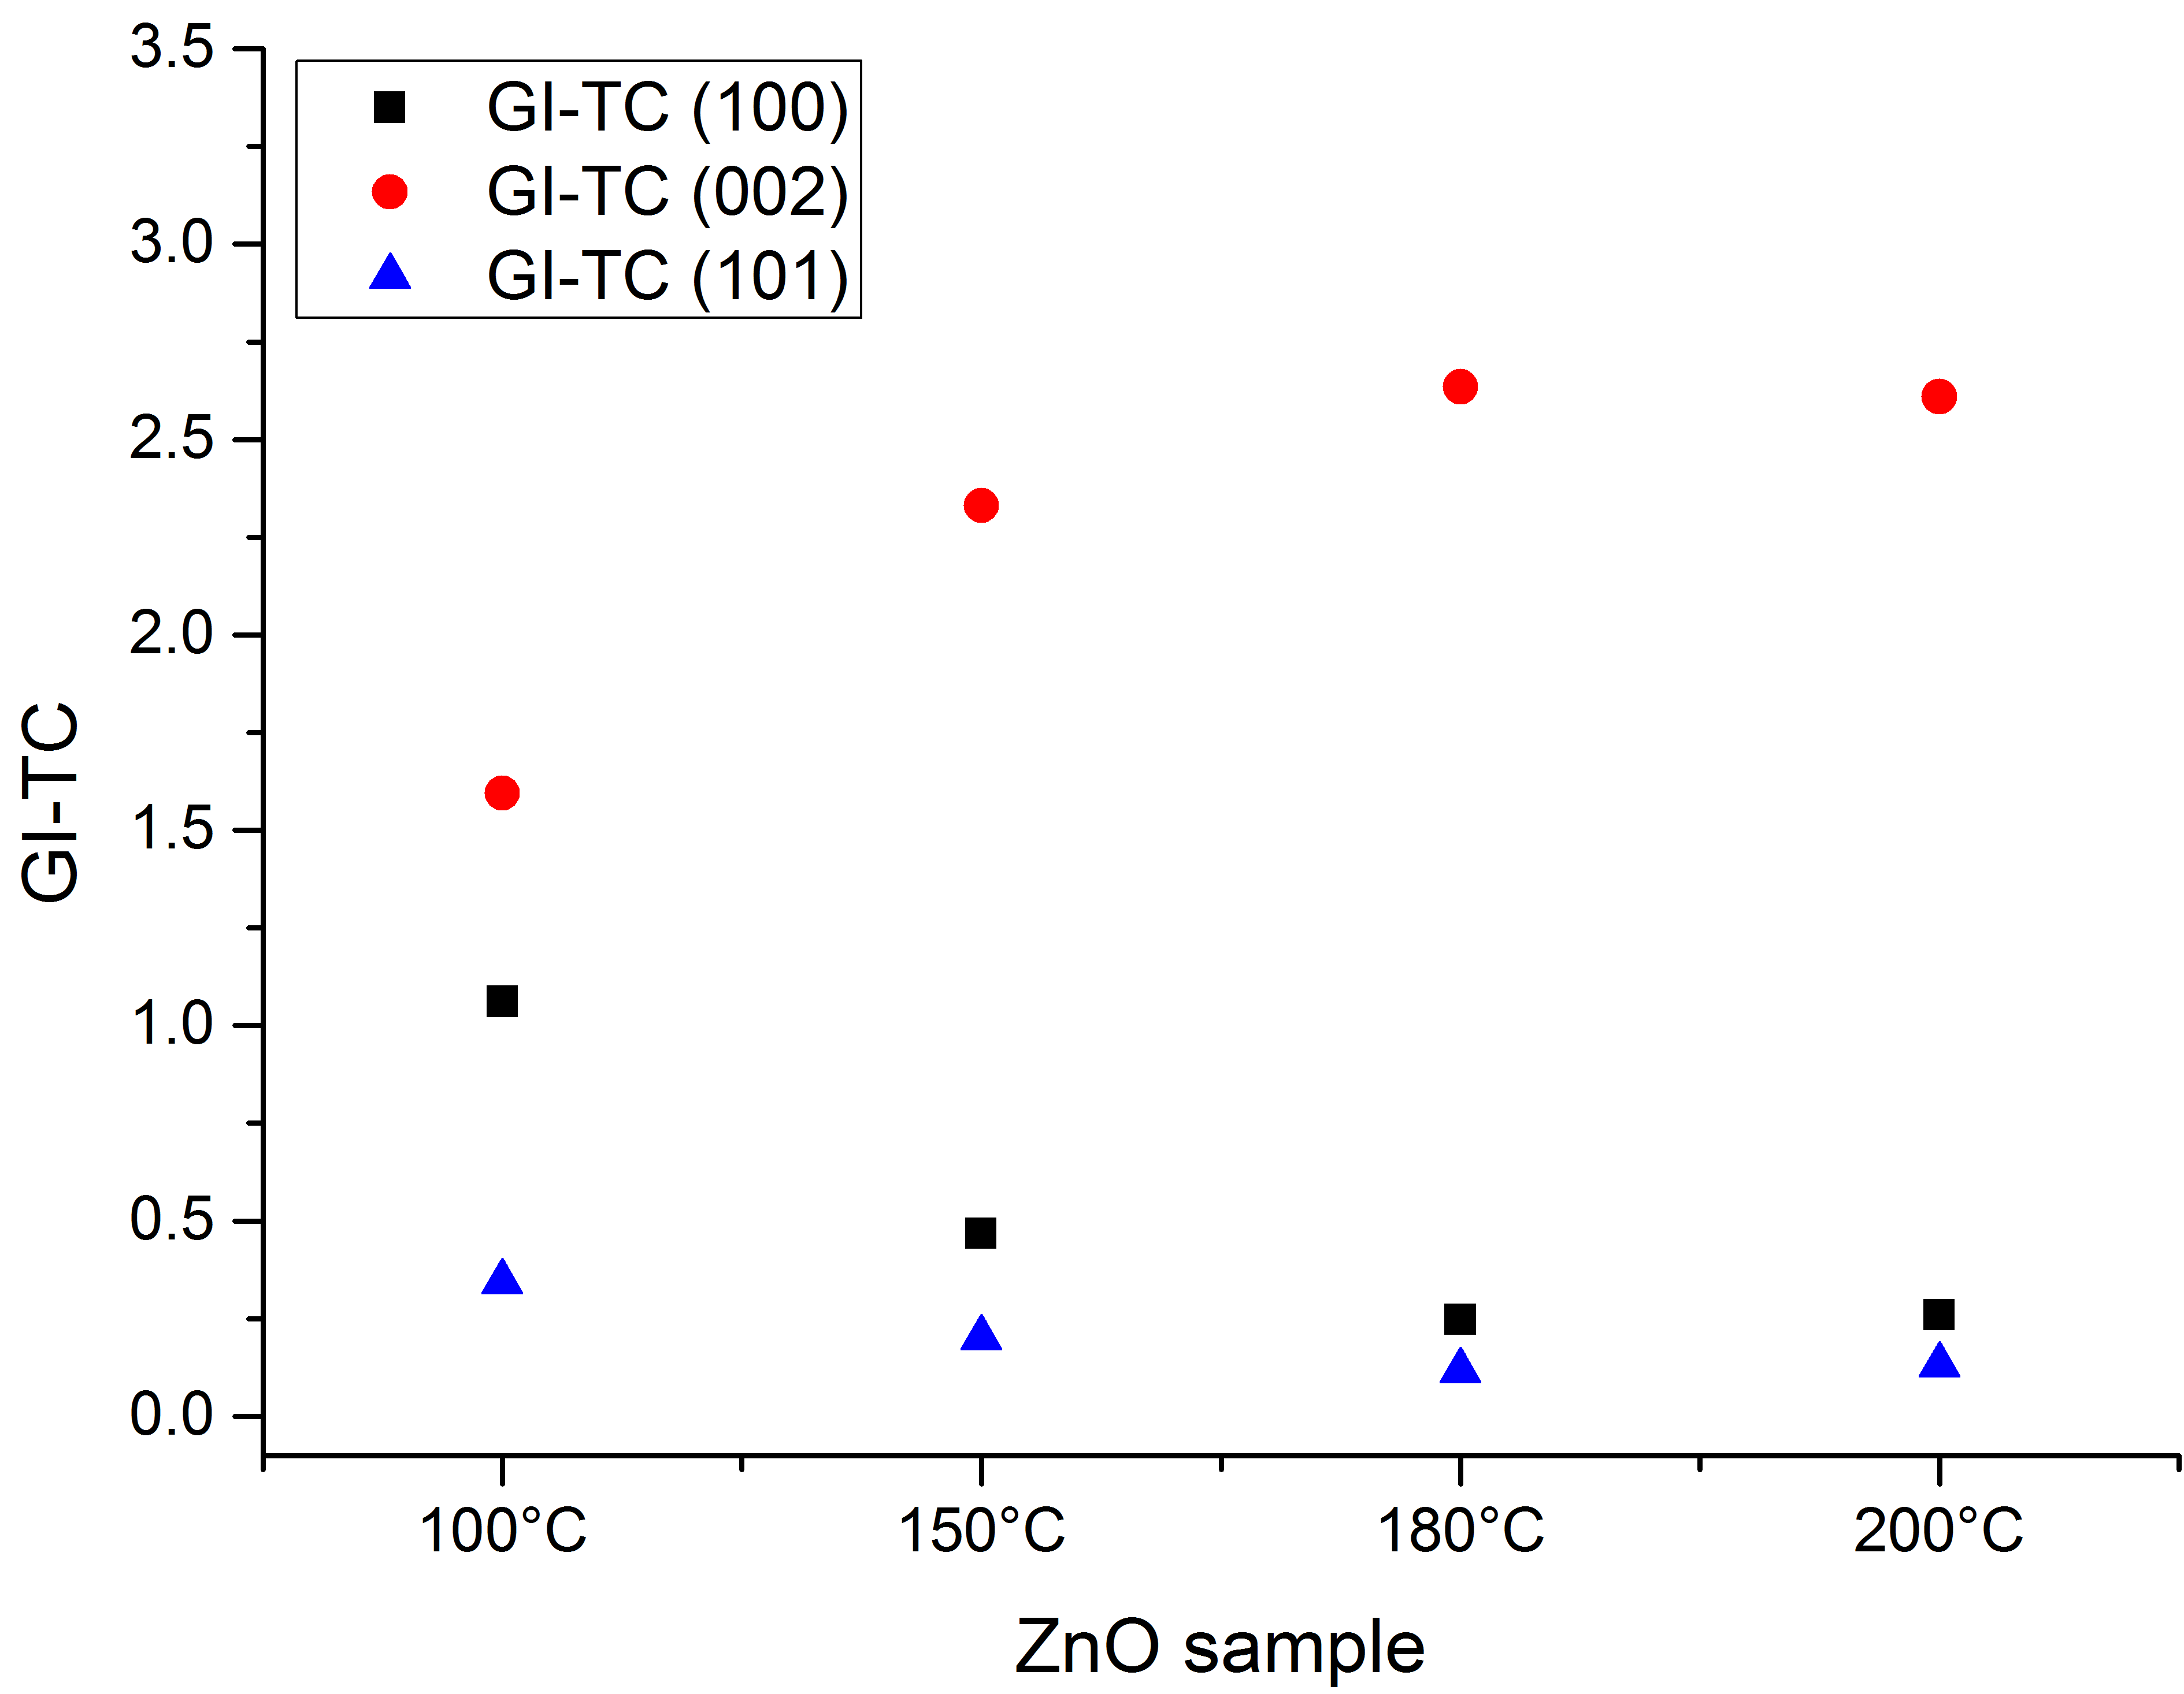
Figure S4: GI-TC values measured on the ZnO thin film samples 100 °C, 150 °C, 180 °C and 200 °C. It can be noticed that the GI-TC of (002) Bragg reflection for samples 180 °C and 200 °C is almost 3. This means that these ZnO thin film samples have a strong (002) preferred orientation whereas samples 100 °C and 150 °C have some degree of preferred orientation. Reference sample as well as ZnO thin film samples were measured in grazing incidence. The instrument configuration was the same for all samples.

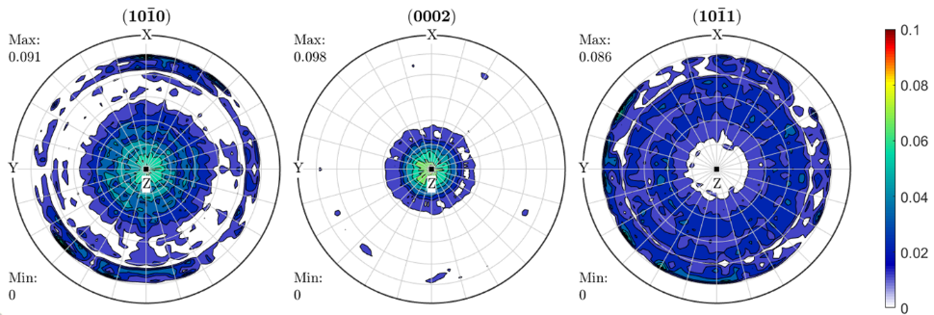
Figure S5: Pole figures measured on ZnO thin film deposited at 180 °C without the presence of O₂ gas pulses (filled and non-filled contour plot respectively). In this figure, the depicted poles are denoted using the Bravais-Miller notation (h k i l) with h+k+i =0.

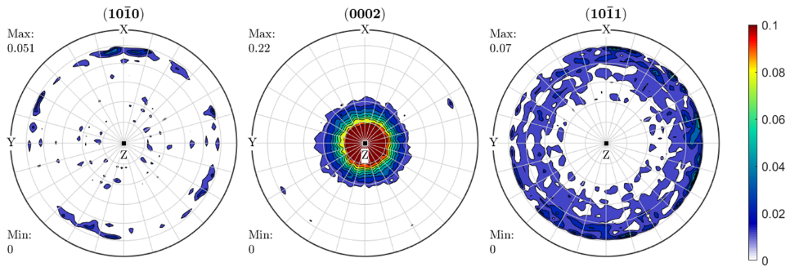
Figure S6: Pole figures measured on ZnO thin film deposited at 180 °C with the presence of O₂ gas pulses (filled and non-filled contour plot respectively). In this figure, the depicted poles are denoted using the Bravais-Miller notation (h k i l) with h+k+i =0.

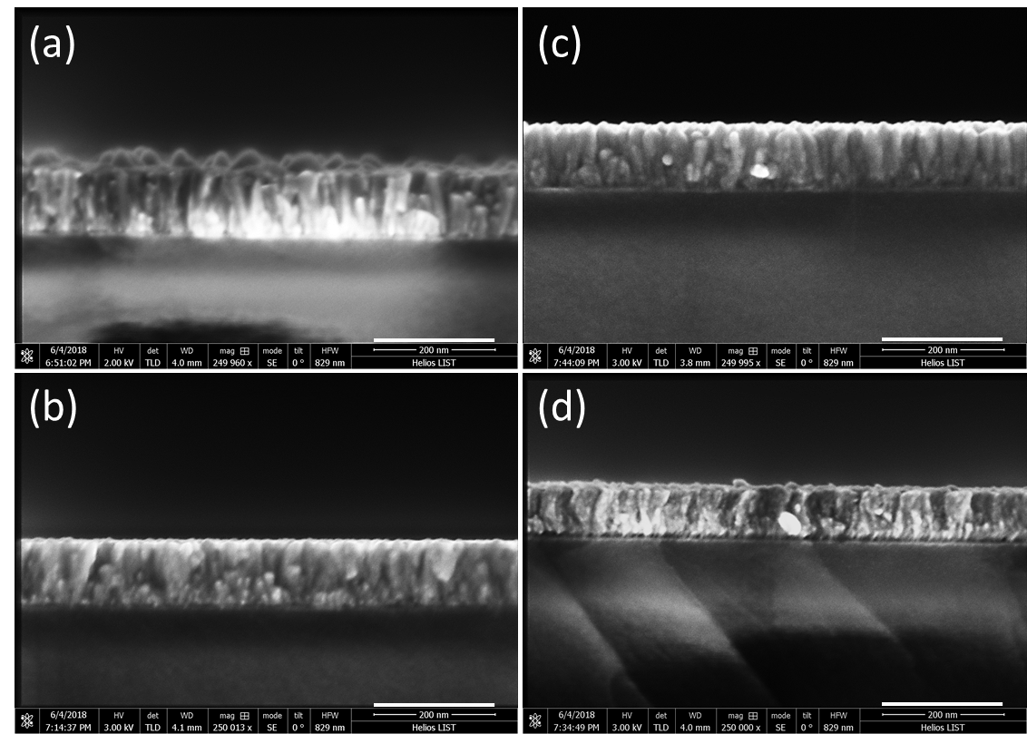
Figure S7: SEM cross-sections of ZnO thin films with varying the O₂ pulsing time in the ALD sequence and the sample temperature such as: a) 0 s, 180 °C, b) 1 s, 180 °C, c) 1 s, 200 °C, and d) 1 s, 100 °C . The scale bar is 200 nm.

Figure S8: Transmission Electron Microscopy (TEM) images of ZnO ALD growth during 5000 cycles at substrate temperature of 180 °C without the presence of O₂ gas pulsing. a) Cross section view detailing the stacks with AlN as a bottom layer. b) Detailed view of the bottom part of the ZnO film at the interface with the AlN film. c) Diffraction pattern obtained with 1300 nm selected area diaphragm.

Figure S9: Transmission Electron Microscopy (TEM) images of ZnO ALD growth during 5000 cycles at substrate temperature of 180 °C with the presence of O₂ gas pulsing in each cycle. a) Cross section view detailing the stacks with AlN as a bottom layer. b) Diffraction pattern obtained with 700 nm selected area diaphragm.

Figure S10: SEM top view micrograph of ZnO thin film grown at 100 °C without O₂

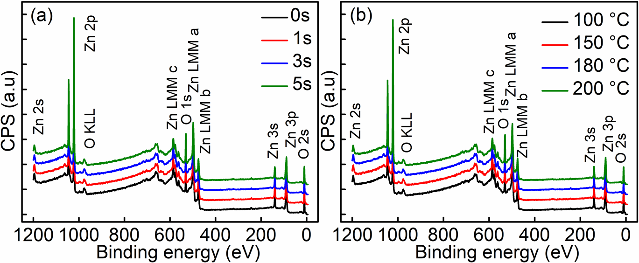
Figure S11: XPS survey of ZnO thin films with (a) varying oxygen pulsing times, and (b) different substrate temperatures acquired after Ar⁺ sputter cleaning. The XPS analysis performed on the samples oust the hypothesis of a significant impurities presence, the detection limit of this technique⁴ being in the range of 0.5 at.% for elements such as C, N and Cl in a ZnO film .

Figure S12: Peak deconvolution of O 1s edge for the ZnO sample grown with 1s of oxygen gas at 180 °C. A main peak located at 530.60 eV and a secondary peak located at 532.25 eV are referred to O-Zn bond of Zn-OH and chemisorbed oxygen, respectively.

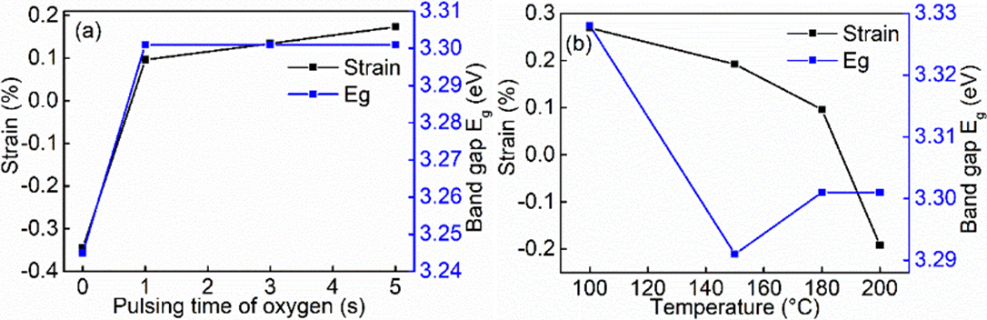Figure S13: Dependences of strain and optical band gap of ZnO thin films by varying (a) oxygen pulsing times, and (b) substrate temperatures.

REFERENCES:
(1) Rakesh, K. S.; Rabhajeet, S. R.; Yadav, B. C.; TiO₂-PANI nanocomposite thin film prepared by spin coating technique working as room temperature CO₂ gas sensing, J Mater Sci: Mater Electron, 27 (2016) 11726-11732. doi:10.1007/s10854-016-5310-y
(2) Harris, G. B. X. Quantitative Measurement of Preferred Orientation in Rolled Uranium Bars. London, Edinburgh, Dublin Philos. Mag. J. Sci., 43 (1952)113-123. doi:10.1080/14786440108520972
(3) Moutinho, H. R.; Hasoon, F. S.; Abulfotuh, F.; Kazmerski, L. L. Investigation of Polycrystalline CdTe Thin Films Deposited by Physical Vapor Deposition, Close‐spaced Sublimation, and Sputtering. J. Vac. Sci. Technol. A Vacuum, Surfaces, Film., 13 (1995)2877-2883. doi: 10.1116/1.579607
(4) Shard, A. G., Detection limits in XPS for more than 6000 binary systems using Al and Mg Kα X‐rays, Surf. Inter. Analysis, 46 (2014) 175-185. doi:10.1002/sia.5406

