Additional information on the sample, measures, analyses strategy and results

Additional information on the sample
Data are drawn from the 2017/2018 survey round of the Health Behaviour in School-Aged Children (HBSC) study. In the 2017/18 survey 47 countries across Europe, North America and the Middle East collected data using the same study protocol (Inchley et al., 2018). Two of those countries, Israel and Turkey are missing from the international dataset, as data for both countries were not submitted in time. Armenia, Canada, England, France, Georgia, Greenland, Latvia, Lithuania, Slovakia, and North Macedonia had to be excluded from the analysis due to not collecting data on immigration background. Datasets for Belgium (French) and Belgium (Flemish) were merged and the same was done for datasets from Scotland and Wales. Among the remaining 33 countries, country level data on income equality and gender equality were available for all countries, and data on migration and integration policies (MIPEX) were available for all countries except Albania, Azerbaijan, Kazakhstan, Moldova, Serbia, Russia, and Ukraine (in total 26 countries).

Country specific descriptive statistics
Table 1 below details for each country the total sample size, the MIPEX, Gini, and GII scores, the years from which Gini data stems, the sample size available for our analyses, separate for life dissatisfaction and psychosomatic complaints, the percentage of girls, the percentage of immigrants, mean age, mean life dissatisfaction and mean psychosomatic complaints.

Additional information on the measures
Individual level indicators
Immigration background: Adolescents were asked where they themselves, their mother and their father were born. The response options included the name of the national survey country (1), the countries from which the top five immigrant groups come at national level for the survey country (2 to 6); and other (open response question) (7). Adolescents were considered as having an immigration background if at least one of their parents were born outside of the survey country. For historical reasons adolescents in Denmark were not regarded as immigrants if their parents were born in Greenland, adolescents in the Republic of Ireland were not regarded as immigrants if their parents were born in Northern Ireland and adolescents in former Yugoslavian countries were not regarded as immigrants if their parents were born in another former Yugoslavian country.

Additional information on MAIHDA
The conventional approach to quantitatively establishing intersectionality entails fitting a regression model with main effect parameters as well as a complete inventory of all possible first-, second- and higher order interaction terms. If one of those interactions terms shows a significant effect this is seen as evidence of intersectionality [1].
In recent years, however, researchers have been pointing out a number of weaknesses in this approach. In particular they argue that this approach becomes unfeasible once a larger number of dimensions of social inequality is considered, because every added dimension grows the number of main effects-, first-, second- and higher order interaction terms that need to be estimated geometrically. This (a) limits the parsimoniousness and scalability of the model [1], (b) complicates the interpretation of results [2], and (c) might lead to false positive intersectional effects as a result of multiple testing [3].
As a solution to these issues they suggest an intersectional repurposing of Multilevel Analysis of Individual Heterogeneity and Discriminatory Accuracy (MAIHDA) [4]. Rather than interacting all dimensions of social inequality with one another, they treat all possible unique combinations of those dimensions as strata in a two-level hierarchical random effects model. Adjusting for main effects for all dimensions of social inequality, remaining strata-level residuals serve as evidence of intersectionality. Such a model is (a) more parsimonious and scalable, as inclusion of further dimensions of social inequality only adds further main effects parameters to the model and increases the number of strata [1], (b) more easily interpretable, as for each strata we obtain an estimate of how the actual mean in the stratum differs from what would be expected based on additive main effects [2], and (c) less prone to false positive intersectional effects since stratum-level residuals are shrunken as a function of strata size, inter-, and intra-strata variance [3, 5].

In MAIHDA analyses, first a null model is fit:
In MAIHDA the null model only includes the overall intercept $β_{0}$ (i.e. the overall mean of the dependent variable) as well as the estimated strata level residuals $μ_{j}$for all j strata and individual level residuals $e_{ij}$ for the i individuals in the j strata:
$$y_{ij}=β_{0}+μ_{j}+e_{ij}$$
$$μ_{j} \sim N\left(0,σ_{μ}^{2}\right)$$
$$e_{ij} \sim N\left(0,σ_{e}^{2}\right)$$

Then a main effects model is fit:
The main effects model additionally includes $(L-1)∙K$main effect dummies for the L values of the K dimensions of social inequality (Bell et al. 2019):
$$y_{ij}=β_{0}+\sum_{k=1}^{K}{}\sum_{l=1}^{L-1}{}{β_{kl}X_{kl}+ μ}_{j}+e_{ij}$$
$$μ_{j} \sim N\left(0,σ_{μ}^{2}\right)$$
$$e_{ij} \sim N\left(0,σ_{e}^{2}\right)$$

The stratum-level residuals $μ_{j}$in the main effects models in conjunction with their associated Bayesian 95% credible intervals inform us about which strata perform better or worse than would be expected based on additive main effects.

Variance Partition Coefficient:
In MAIHDA the variance partition coefficient (VPC) of the null model serves as a measure of Discriminatory Accuracy [2, 4]. Akin to a model fit statistic like R², it indicates how well individual scores on the outcome variable can be predicted based on the individual’s combination of social group memberships.
Based on the null model the Variance Partition Coefficients (VPC) is calculated as follows:
VPC = $\frac{Between Strata Variance}{Total Variance}⋅100 \%$= $\frac{σ_{μ}^{2}}{σ_{μ}^{2}+σ_{e}^{2}}⋅100\%$

Proportional Change in Variance:
The Proportional Change in variance (PCV) relates the variance of the stratum-level residuals in the main effects model (the difference between the stratum mean and the expected mean for that stratum based on an additive model) to the variance of stratum-level residuals in the null model (the difference between stratum means and the overall mean) and informs us about how much of the differences between individuals in different strata is explained by additive main effects. Accordingly, the unexplained part is attributable to intersectional effects Based on the null model and the main effects model the Proportional Change in Variance (PCV) is calculated as follows:
PCV = $\frac{{Betweeen Strata Variance}_{Null Model - {Between Strata variance}_{Main Effects Model}}}{{Between Strata Variance}_{Null Model}}⋅100 \%$
= $\frac{σ_{μ,Null Model - }^{2}σ_{μ,Main Effects Model}^{2}}{σ_{μ,Null Model}^{2}}⋅100\%$

Additional information on the results
Strata
Table 2 below details sample sizes per stratum for all four sets of strata examined in our study.

Main Effect Parameters
Table 3 below details main effect parameters for all estimated MAIHDA main effects models.

Stratum-Level Residuals
Figures 1 to 8 below show the stratum-level residuals for all estimated MAIHDA main effects models. If the plotted Bayesian 95% Credible Intervals do not contain the value 0 this means that the mean for the stratum in question significantly differs from what would be expected based on additive effects.

Table 1. Country specific descriptive statistics
Country | Total N | MIPEX² | Gini² | Gini  year | GII² | N  Life dissatisfaction | N  Psychosomatic  complaints | % Girl | %  Immigrant | M  Age | M  Life dissatisfaction | M Psychosomatic complaints
Albania | 1765 | N.A. | 29.00 | 2012 | 0.24 | 1376 | 1379 | 54.50 | 4.17 | 13.55 | 1.86 | 6.26
Austria | 4129 | 50.10 | 30.50 | 2015 | 0.07 | 3554 | 3522 | 50.69 | 30.33 | 13.28 | 2.29 | 6.66
Azerbaijan | 4586 | N.A. | 26.60 | 2005 | 0.32 | 4269 | 4089 | 51.83 | 3.85 | 13.27 | 1.62 | 4.83
Belgium¹ | 8353 | 67.45 | 27.70 | 2015 | 0.05 | 7416 | 7284 | 50.46 | 35.07 | 13.13 | 2.26 | 7.05
Bulgaria | 4548 | 41.86 | 37.40 | 2014 | 0.22 | 4280 | 4280 | 51.63 | 3.82 | 13.53 | 2.17 | 7.44
Croatia | 5169 | 42.73 | 31.10 | 2015 | 0.12 | 4645 | 4390 | 49.02 | 5.69 | 13.80 | 1.91 | 6.41
Czech Republic | 11564 | 45.03 | 25.90 | 2015 | 0.12 | 10661 | 10125 | 49.66 | 12.57 | 13.37 | 2.20 | 7.11
Denmark | 3181 | 58.62 | 28.20 | 2015 | 0.04 | 2772 | 2718 | 51.43 | 21.19 | 13.33 | 2.32 | 6.40
Estonia | 4725 | 45.84 | 32.70 | 2015 | 0.12 | 4437 | 4425 | 49.86 | 16.81 | 13.78 | 2.27 | 8.09
Finland | 3146 | 68.83 | 27.10 | 2015 | 0.06 | 2876 | 2890 | 50.35 | 9.72 | 13.92 | 2.25 | 8.56
Germany | 4347 | 60.68 | 31.70 | 2015 | 0.07 | 3929 | 3931 | 53.05 | 31.86 | 13.41 | 2.31 | 6.81
Greece | 3863 | 43.74 | 36.00 | 2015 | 0.12 | 3644 | 3607 | 50.12 | 24.63 | 13.82 | 2.46 | 8.16
Hungary | 3789 | 45.06 | 30.40 | 2015 | 0.26 | 3541 | 3548 | 52.81 | 7.19 | 13.52 | 2.42 | 8.46
Iceland | 6996 | 45.05 | 27.80 | 2014 | 0.06 | 6362 | 6267 | 49.83 | 18.13 | 13.60 | 2.38 | 8.26
Ireland | 3833 | 51.78 | 31.80 | 2015 | 0.11 | 3243 | 3239 | 49.39 | 32.75 | 13.41 | 2.45 | 7.01
Italy | 4144 | 58.86 | 35.40 | 2015 | 0.09 | 3964 | 3958 | 51.79 | 17.92 | 13.68 | 2.42 | 10.14
Kazakhstan | 4868 | N.A. | 27.50 | 2017 | 0.20 | 4435 | 4169 | 49.61 | 12.47 | 13.25 | 1.43 | 4.94
Luxembourg | 4070 | 57.43 | 33.80 | 2015 | 0.07 | 3540 | 3545 | 49.90 | 72.24 | 13.49 | 2.36 | 8.21
Malta | 2576 | 39.68 | 29.40 | 2015 | 0.22 | 2314 | 2313 | 51.90 | 25.81 | 13.44 | 2.67 | 9.62
Moldova | 4686 | N.A. | 25.90 | 2017 | 0.23 | 1414 | 1398 | 49.85 | 5.25 | 13.55 | 1.76 | 7.24
Netherlands | 4698 | 60.06 | 28.20 | 2015 | 0.04 | 4491 | 4480 | 51.32 | 22.80 | 13.51 | 2.23 | 5.96
Norway | 3127 | 68.51 | 27.50 | 2015 | 0.05 | 2844 | 2804 | 51.49 | 24.73 | 13.02 | 2.10 | 6.22
Poland | 5224 | 41.14 | 30.80 | 2016 | 0.13 | 4912 | 4809 | 50.80 | 1.47 | 13.59 | 2.52 | 7.94
Portugal | 6126 | 74.98 | 35.50 | 2015 | 0.09 | 5258 | 5258 | 52.24 | 25.18 | 13.31 | 2.27 | 6.27
Romania | 4567 | 44.60 | 35.90 | 2015 | 0.31 | 3930 | 3826 | 51.19 | 5.04 | 13.20 | 1.67 | 7.85
Russia | 4281 | N.A. | 37.70 | 2015 | 0.26 | 4001 | 3920 | 52.28 | 16.28 | 13.82 | 2.59 | 6.95
Serbia | 3933 | N.A. | 28.50 | 2015 | 0.18 | 3738 | 3610 | 50.55 | 3.60 | 13.98 | 1.75 | 6.25
Slovenia | 5667 | 44.41 | 25.40 | 2015 | 0.05 | 5313 | 5221 | 49.20 | 4.89 | 13.59 | 2.03 | 6.08
Spain | 4320 | 59.73 | 36.20 | 2015 | 0.08 | 4166 | 4113 | 51.67 | 20.46 | 13.62 | 1.91 | 5.64
Sweden | 4185 | 77.84 | 29.20 | 2015 | 0.04 | 3759 | 3763 | 50.27 | 36.62 | 13.63 | 2.54 | 9.05
Switzerland | 7510 | 48.74 | 32.30 | 2015 | 0.04 | 7049 | 7018 | 49.60 | 53.19 | 13.42 | 2.31 | 7.20
Ukraine | 6660 | N.A. | 25.00 | 2016 | 0.28 | 5657 | 5581 | 51.25 | 11.24 | 13.40 | 2.32 | 8.40
United Kingdom¹ | 20972 | 57.18 | 33.20 | 2015 | 0.12 | 16439 | 16222 | 50.38 | 14.44 | 13.52 | 2.38 | 7.35
Notes. ¹ = Individual data for the United Kingdom and Belgium are aggregate regional data (excluding Northern Ireland). ² = Country-level indicators were categorized into tertiles. Colour coding indicates the ranking of the countries on the national level indicators: darkgrey indicates high levels of equality/inclusivity, medium grey indicates medium levels and light grey indicates low levels

Table 2. Sample sizes per stratum for all four sets of strata that were used
 |  | Boy |  |  |  |  |  | Girl
 |  | Native |  |  | Immigrant |  |  | Native |  |  | Immigrant
 |  | Low  SES | Middle  SES | High  SES | Low  SES | Middle  SES | High  SES | Low SES | Middle SES | High SES | Low SES | Middle SES | High SES | Total
Life dissatisfaction
Gender  Equality | Low | 5872 | 5641 | 5489 | 440 | 520 | 683 | 6128 | 6508 | 5842 | 483 | 556 | 793 | 38955
 | Medium | 8739 | 9015 | 8959 | 1835 | 1724 | 1628 | 8927 | 9490 | 9399 | 2003 | 1843 | 1736 | 65298
 | High | 5164 | 6058 | 5972 | 2939 | 2248 | 2176 | 5511 | 5693 | 6382 | 3115 | 2286 | 2432 | 49976
 | Total | 19775 | 20714 | 20420 | 5214 | 4492 | 4487 | 20566 | 21691 | 21623 | 5601 | 4685 | 4961 | 154229
MIPEX | Low | 6684 | 7079 | 6548 | 862 | 777 | 767 | 6749 | 6703 | 7394 | 876 | 720 | 902 | 46061
 | Medium | 5665 | 5785 | 5886 | 2416 | 2024 | 1944 | 5641 | 6451 | 6115 | 2404 | 2141 | 2067 | 48539
 | High | 3681 | 4274 | 4421 | 1654 | 1353 | 1347 | 4151 | 4565 | 4385 | 1994 | 1466 | 1448 | 34739
 | Total | 16030 | 17138 | 16855 | 4932 | 4154 | 4058 | 16541 | 17719 | 17894 | 5274 | 4327 | 4417 | 129339
Income  Equality | Low | 7529 | 7620 | 7554 | 2549 | 2124 | 2168 | 7618 | 8337 | 7979 | 2565 | 2314 | 2351 | 60708
 | Medium | 4289 | 4881 | 4808 | 1051 | 996 | 895 | 4615 | 5502 | 4840 | 1183 | 1074 | 877 | 35011
 | High | 7957 | 8213 | 8058 | 1614 | 1372 | 1424 | 8333 | 7852 | 8804 | 1853 | 1297 | 1733 | 58510
 | Total | 19775 | 20714 | 20420 | 5214 | 4492 | 4487 | 20566 | 21691 | 21623 | 5601 | 4685 | 4961 | 154229
Psychosomatic complaints
Gender  Equality | Low | 5725 | 5510 | 5348 | 433 | 498 | 664 | 6010 | 6378 | 5745 | 480 | 546 | 776 | 38113
 | Medium | 8450 | 8786 | 8761 | 1794 | 1696 | 1609 | 8778 | 9377 | 9295 | 1979 | 1827 | 1725 | 64077
 | High | 5084 | 5996 | 5890 | 2894 | 2215 | 2148 | 5472 | 5656 | 6358 | 3108 | 2275 | 2416 | 49512
 | Total | 19259 | 20292 | 19999 | 5121 | 4409 | 4421 | 20260 | 21411 | 21398 | 5567 | 4648 | 4917 | 151702
MIPEX | Low | 6395 | 6868 | 6343 | 831 | 744 | 749 | 6583 | 6596 | 7292 | 852 | 703 | 882 | 44838
 | Medium | 5591 | 5713 | 5828 | 2386 | 2010 | 1931 | 5611 | 6411 | 6099 | 2402 | 2138 | 2075 | 48195
 | High | 3650 | 4241 | 4392 | 1631 | 1336 | 1329 | 4138 | 4549 | 4377 | 1988 | 1457 | 1435 | 34523
 | Total | 15636 | 16822 | 16563 | 4848 | 4090 | 4009 | 16332 | 17556 | 17768 | 5242 | 4298 | 4392 | 127556
Income  Equality | Low | 7410 | 7520 | 7473 | 2524 | 2108 | 2154 | 7568 | 8265 | 7949 | 2555 | 2307 | 2339 | 60172
 | Medium | 4150 | 4771 | 4713 | 1045 | 982 | 886 | 4534 | 5471 | 4797 | 1194 | 1075 | 886 | 34504
 | High | 7699 | 8001 | 7813 | 1552 | 1319 | 1381 | 8158 | 7675 | 8652 | 1818 | 1266 | 1692 | 57026
 | Total | 19259 | 20292 | 19999 | 5121 | 4409 | 4421 | 20260 | 21411 | 21398 | 5567 | 4648 | 4917 | 151702

Table 3. Main effect regression coefficients for all estimated MAIHDA main effects models
 |  | Life dissatisfaction |  |  |  | Psychosomatic complaints
 | Only individual characteristics |  | MIPEX | Income Equality | Gender Equality | Only individual characteristics | MIPEX | Income Equality | Gender Equality
Intercept | 1.95*  (1.83;2.06) |  | 2.36*  (2.28;2.45) | 1.95* (1.83;2.06) | 1.99*  (1.87;2.12) | 5.16*  (4.84;5.47) | 5.60*  (5.38;5.82) | 5.12*  (4.80;5.43) | 5.26*  (4.91;5.59)
Age | .22*  (.21;.22) |  | .21*  (.21;.22) | .22*  (.21;.22) | .22*  (.21;.22) | .59*  (.57;.61) | .64*  (.62;.66) | .59*  (.57;.60) | .59*  (.57;.60)
Girl | .31*  (.25;.37) |  | .34*  (.30;.39) | .31*  (.26;.36) | .29*  (.23;.36) | 2.27*  (2.18;2.36) | 2.35*  (2.25;2.45) | 2.28*  (2.18;2.39) | 2.22*  (2.08;2.36)
Immigrant | .21*  (.14;.27) |  | .20*  (.15;.25) | .19*  (.14;.24) | .21*  (.15;.28) | .49*  (.39;.59) | .48*  (.37;.59) | .47*  (.35;.58) | .52*  (.37;.66)
Medium SES | -.30*  (-.37;-.23) |  | -.3*  (-.36;-.24) | -.30*  (-.36;-.24) | -.32*  (-.4;-.23) | -.28*  (-.39;-.17) | -.29*  (-.42;-.16) | -.28*  (-.41;-.15) | -.28*  (-.46;-.10)
High SES | -.51*  (-.59;-.43) |  | -.50*  (-.57;-.45) | -.52*  (-.58;-.47) | -.54*  (-.64;-.47) | -0.29*  (-.40;-1.8) | -.34*  (-.50;-.18) | -.30*  (-.40;-.17) | -.29*  (-.52;-.11)
Random Effects – Null Model
Between-Stratum Variance | 0.14 |  | 0.10 | 0.10 | 0.11 | 2.15 | 1.77 | 1.57 | 1.48
Within-Stratum Variance | 3.22 |  | 3.12 | 3.21 | 3.20 | 31.02 | 30.06 | 30.97 | 30.99
Random Effects – Main Effects Model
Between-Stratum Variance | 0.00 |  | 0.00 | 0.00 | 0.01 | 0.00 | 0.01 | 0.02 | 0.01
Within-Stratum Variance | 3.22 |  | 3.09 | 3.15 | 3.15 | 31.02 | 29.22 | 29.86 | 29.85
Notes. Models were additionally adjusted for survey country. Bayesian 95% Credible Interval in parentheses. Natives, low family SES and boys was set as the reference groups.
* p < 0.001

Figure 1 – Stratum-level residuals with Bayesian 95% credible intervals for life dissatisfaction with individuals nested in strata according to only individual characteristics
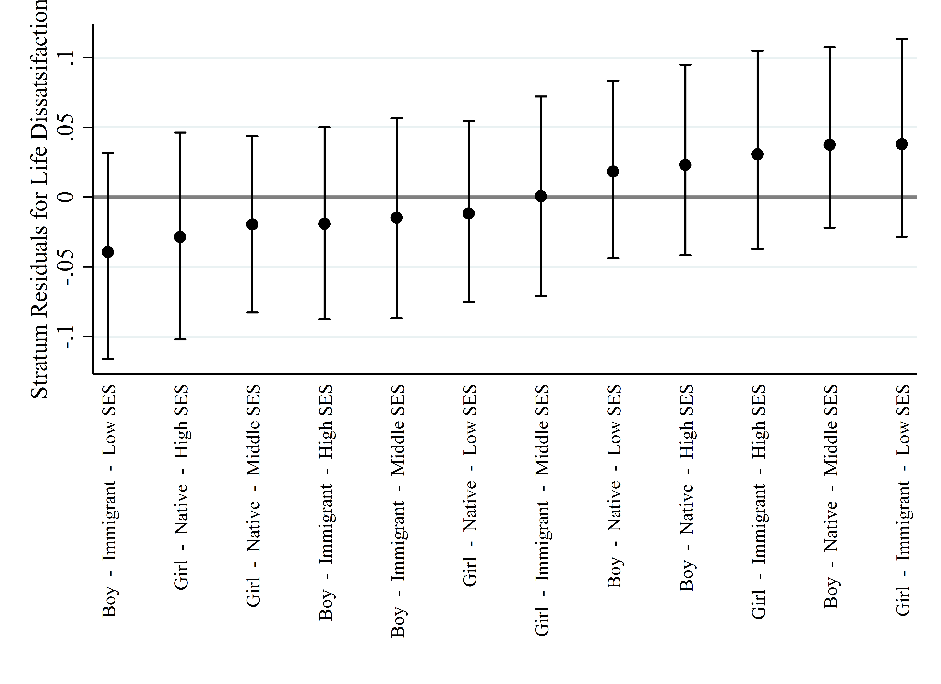
Figure 2 – Stratum-level residuals with Bayesian 95% credible intervals for psychosomatic complaints with individuals nested in strata according to only individual characteristics
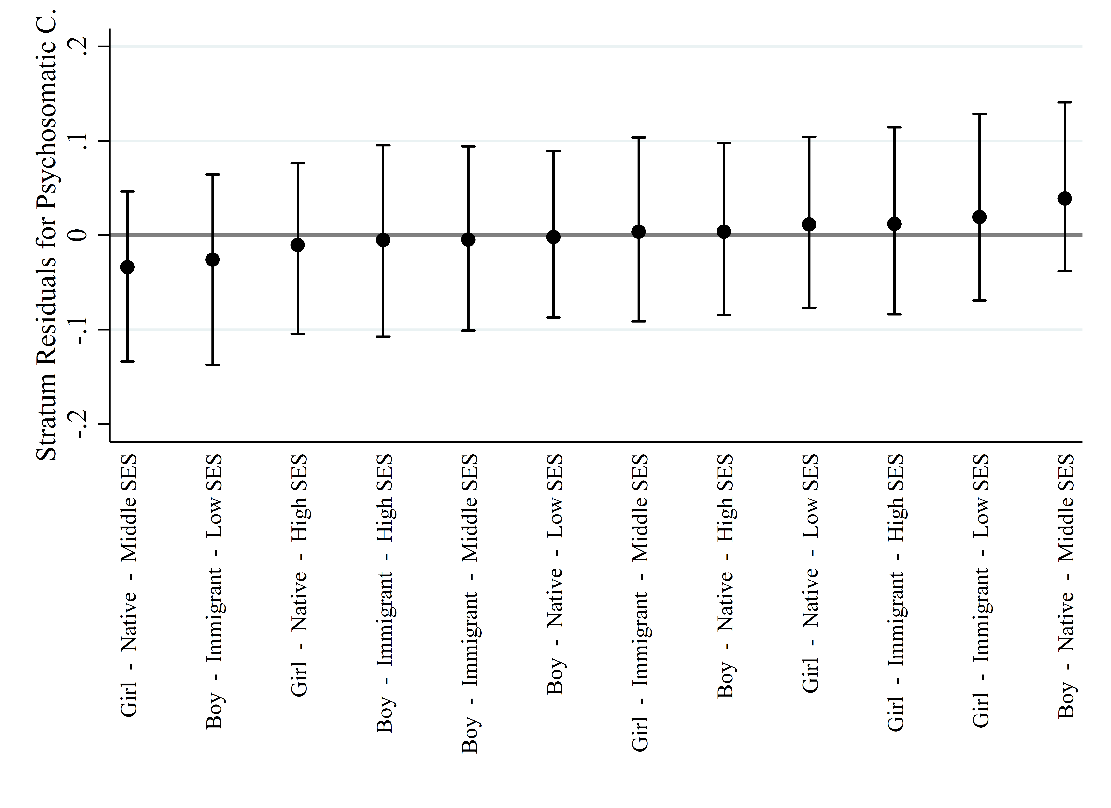
Figure 3 – Stratum-level residuals with Bayesian 95% credible intervals for life dissatisfaction with individuals nested in strata according to individual characteristics and national migration and integration policies
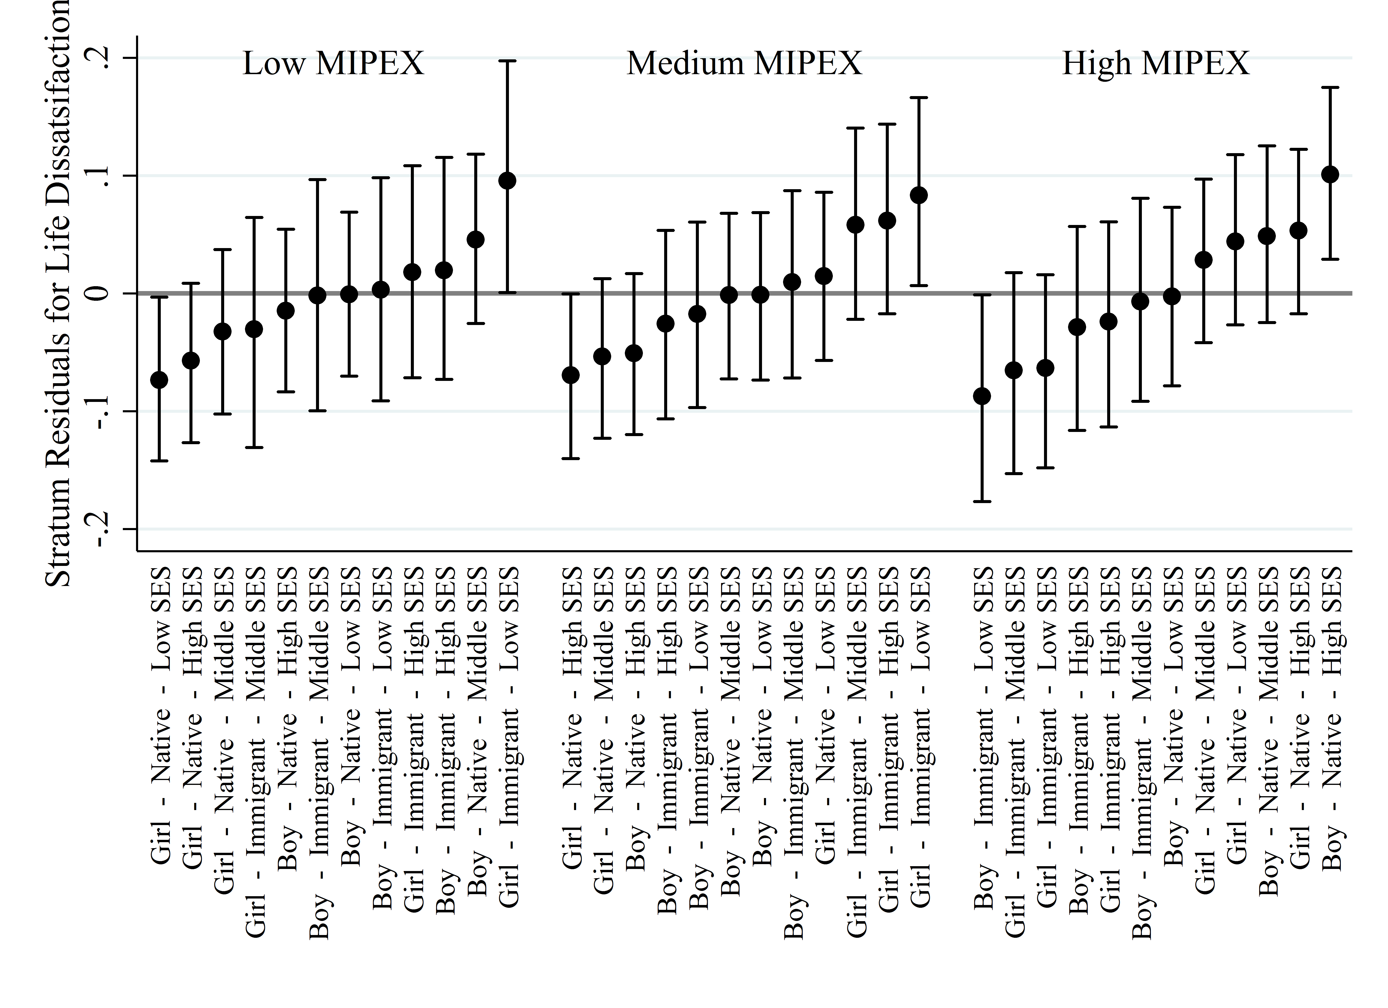
Figure 4 – Stratum-level residuals with Bayesian 95% credible intervals for psychosomatic complaints with individuals nested in strata according to individual characteristics and national migration and integration policies
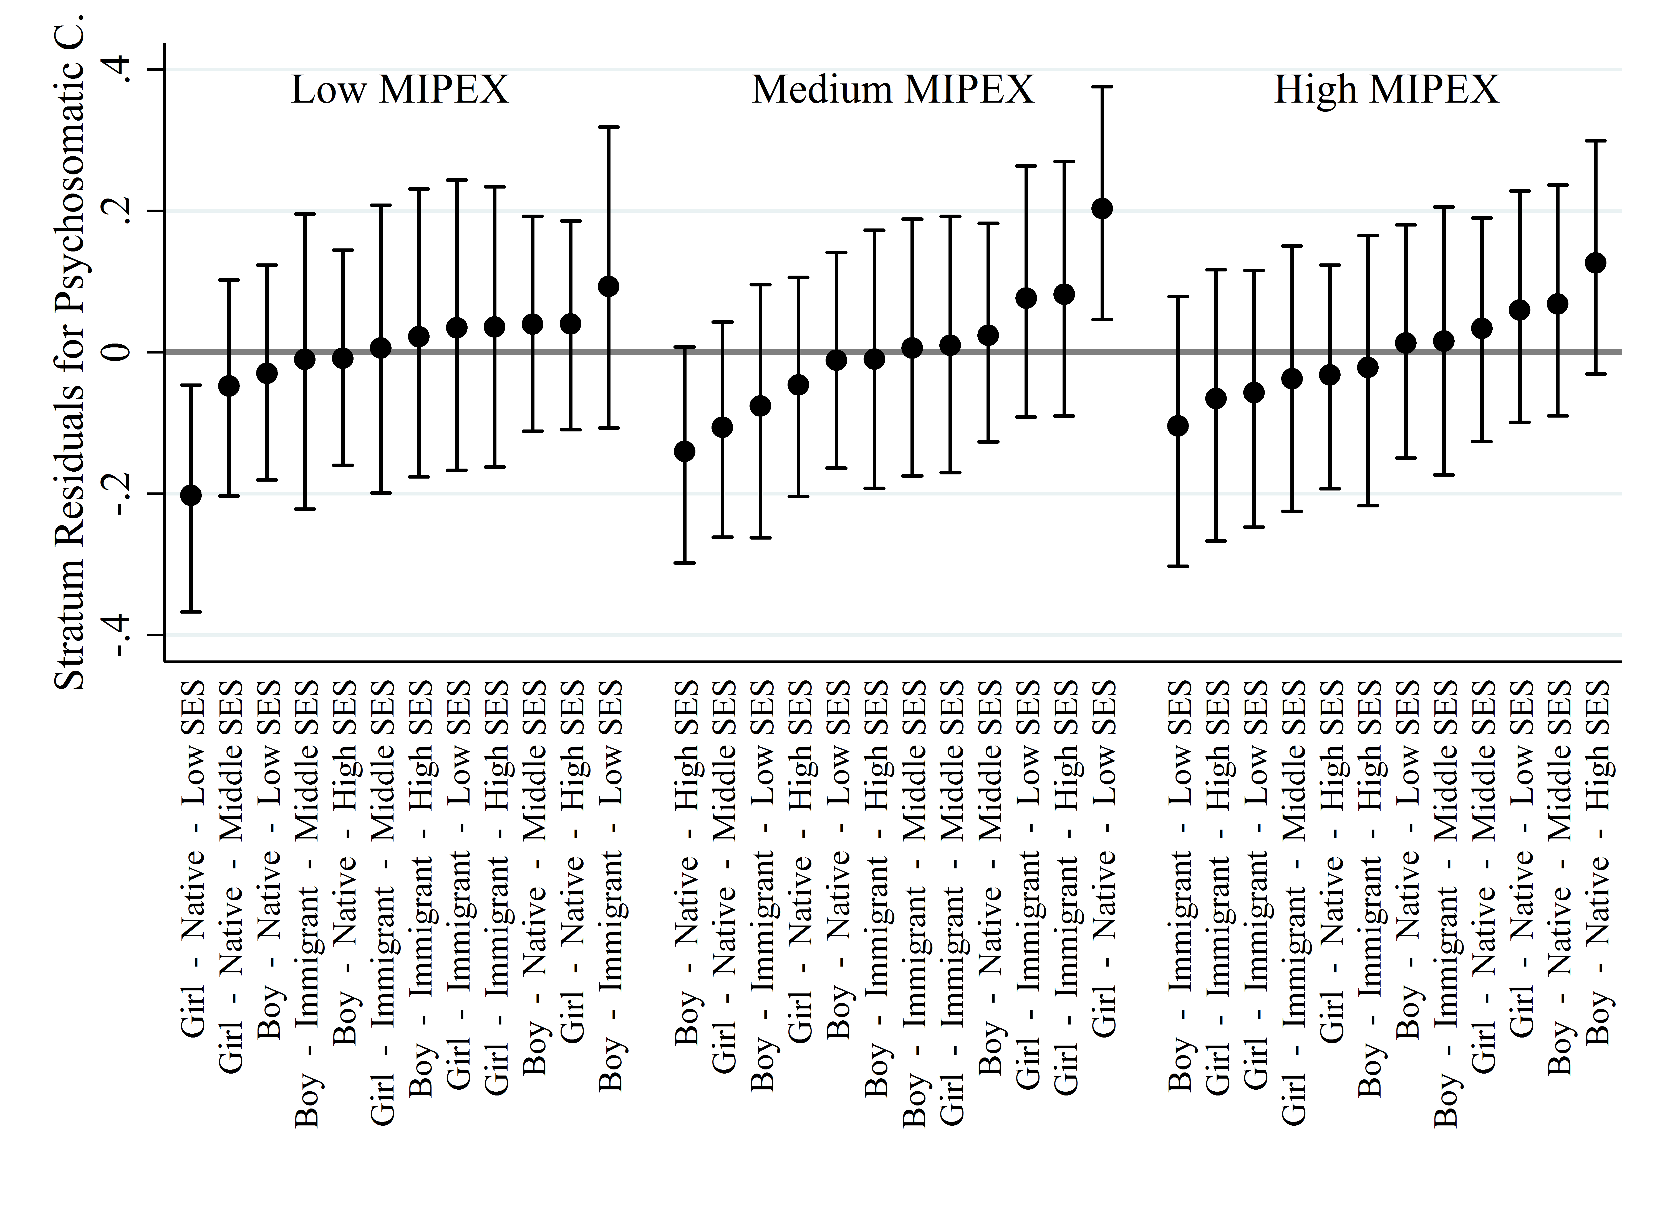
Figure 5 – Stratum-level residuals with Bayesian 95% credible intervals for life dissatisfaction with individuals nested in strata according to individual characteristics and national level of income equality
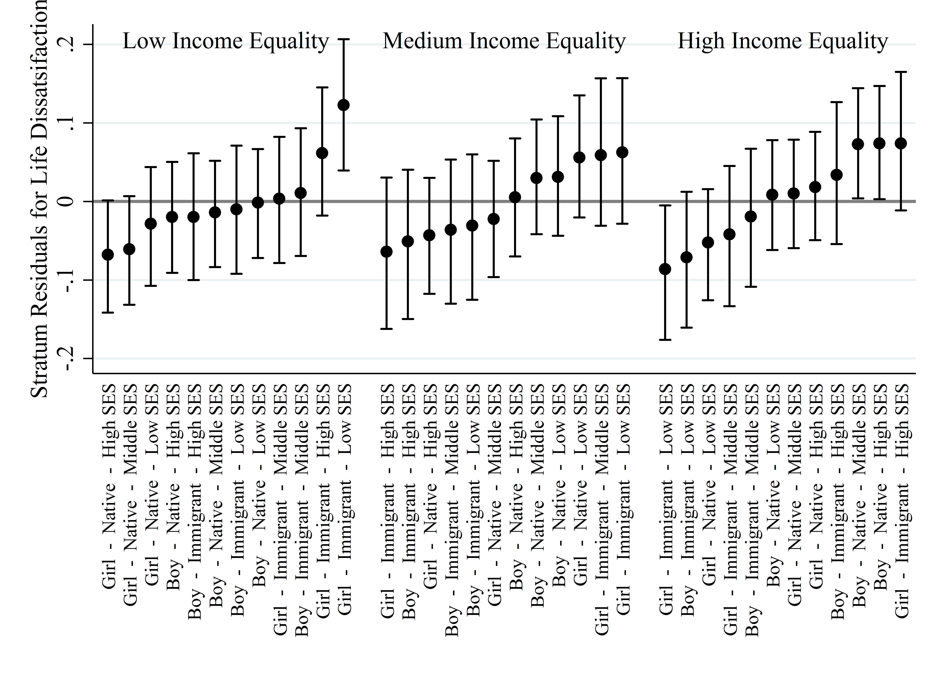
Figure 6 – Stratum-level residuals with Bayesian 95% credible intervals for psychosomatic complaints with individuals nested in strata according to individual characteristics and national level of income equality
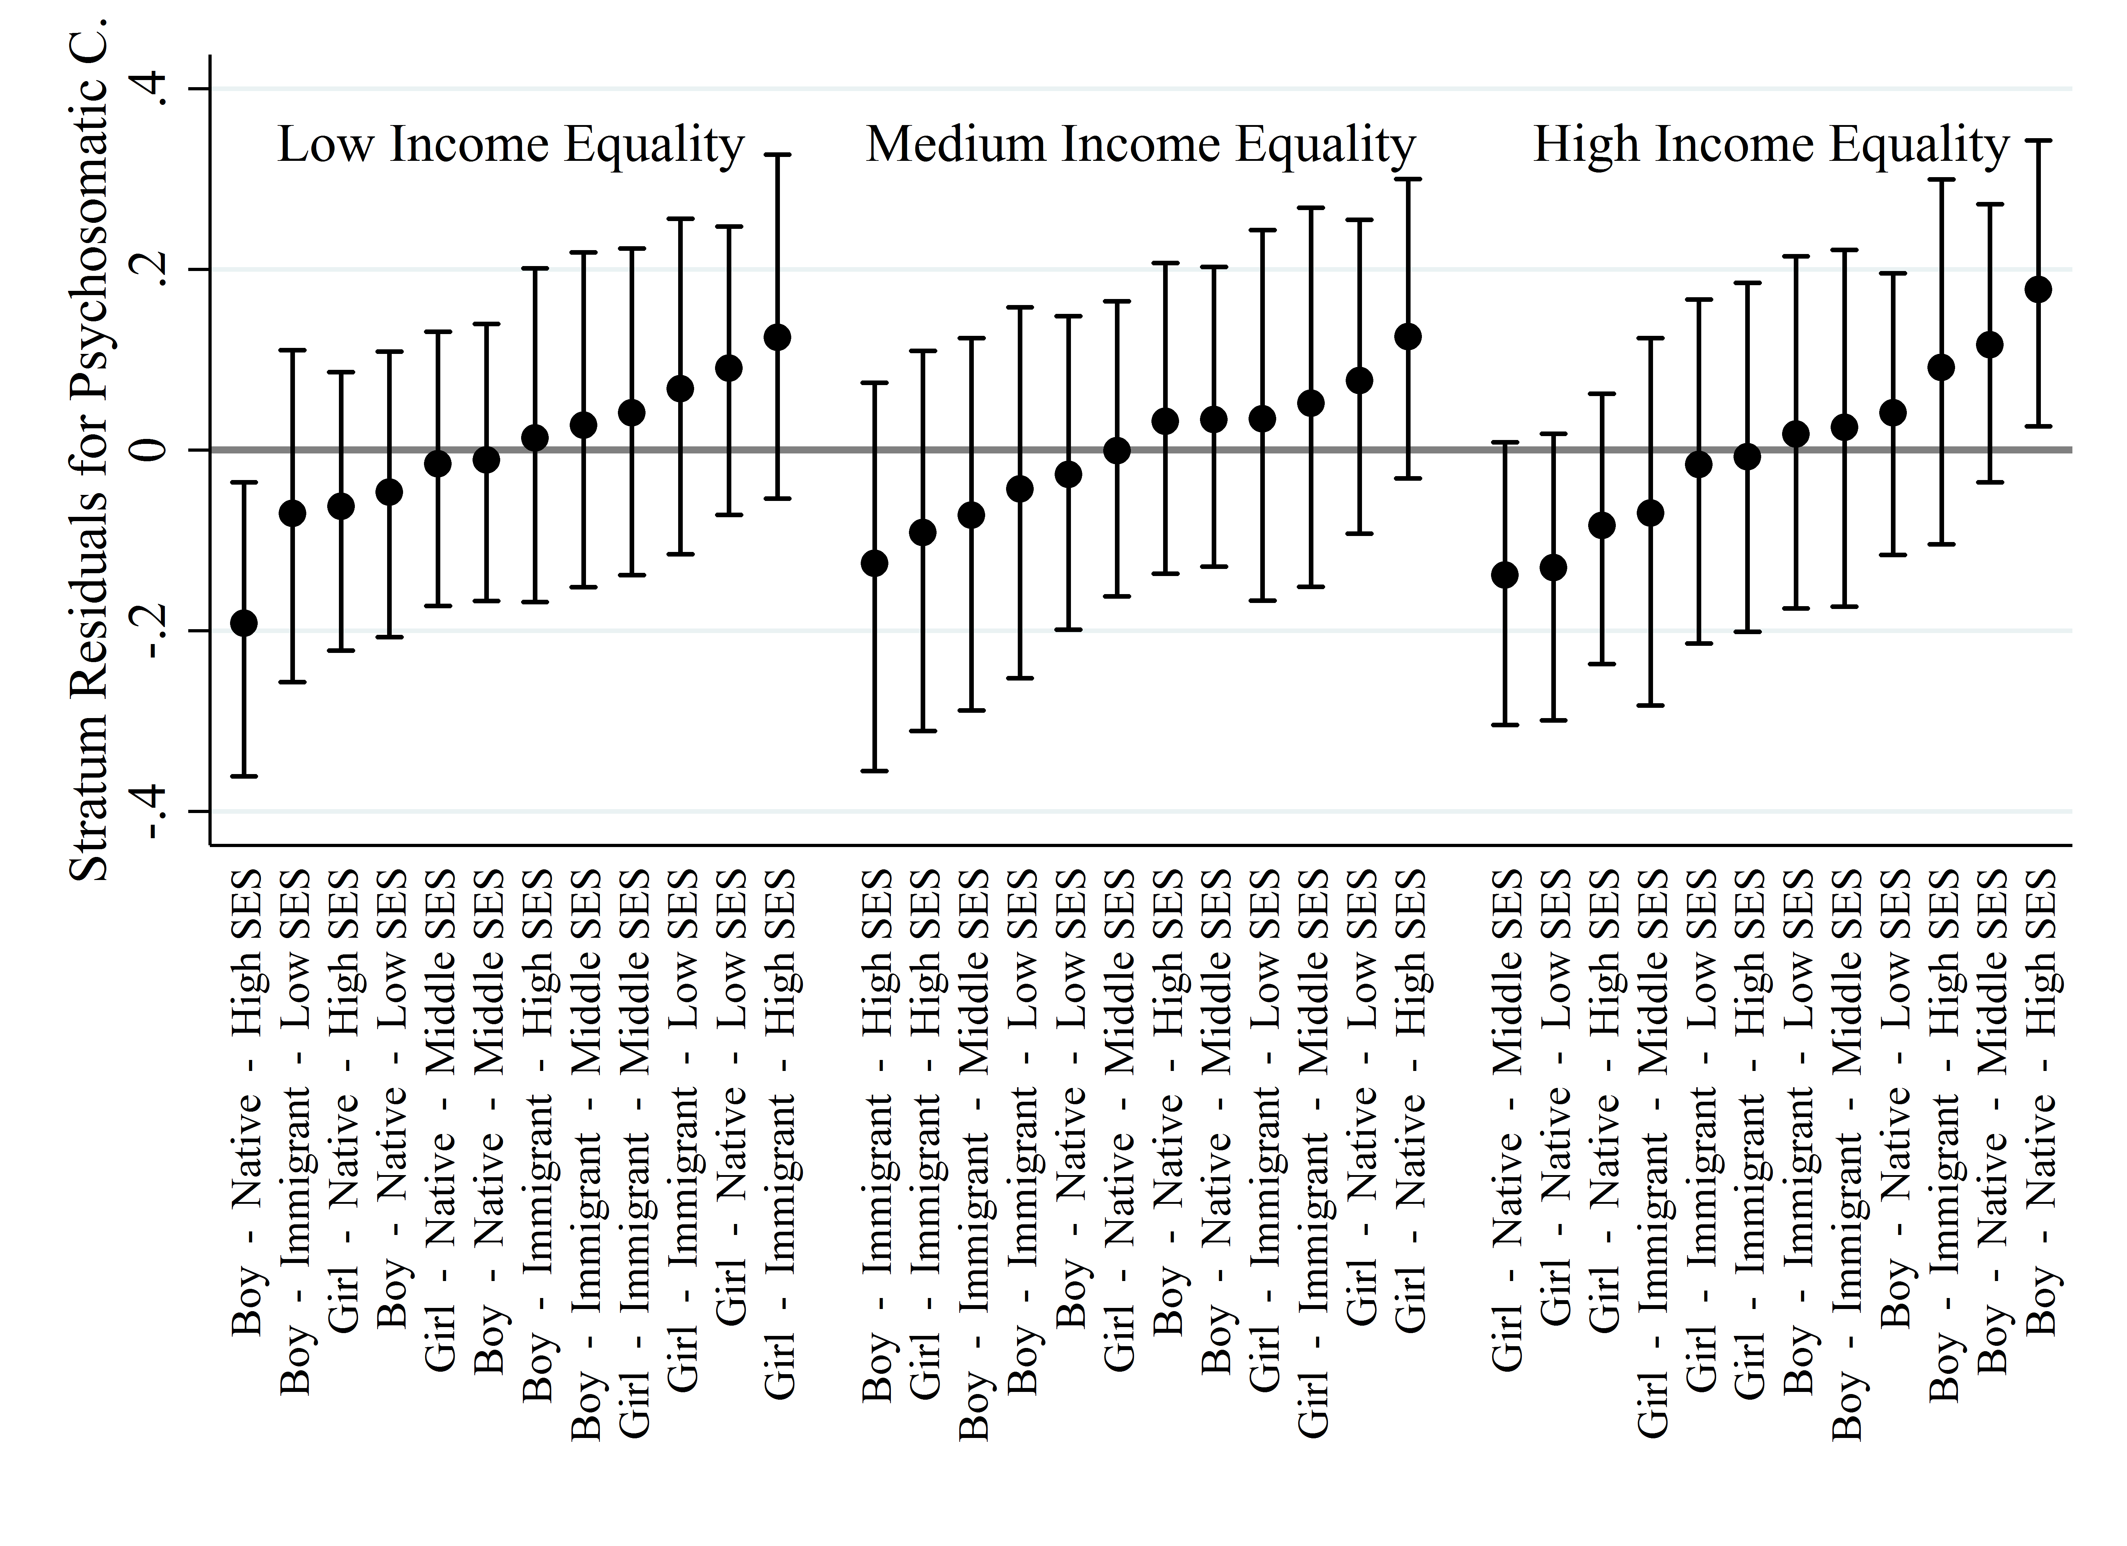
Figure 7 – Stratum-level residuals with Bayesian 95% credible intervals for life dissatisfaction with individuals nested in strata according to individual characteristics and national level of gender equality
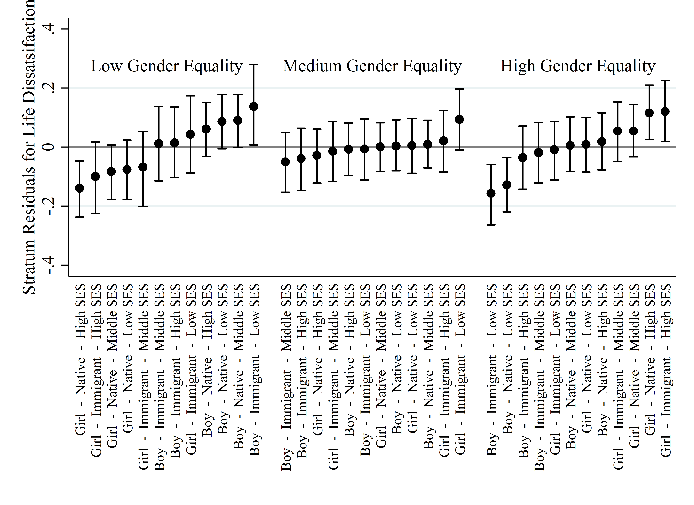
Figure 8 – Stratum-level residuals with Bayesian 95% credible intervals for psychosomatic complaints with individuals nested in strata according to individual characteristics and national level of gender equality
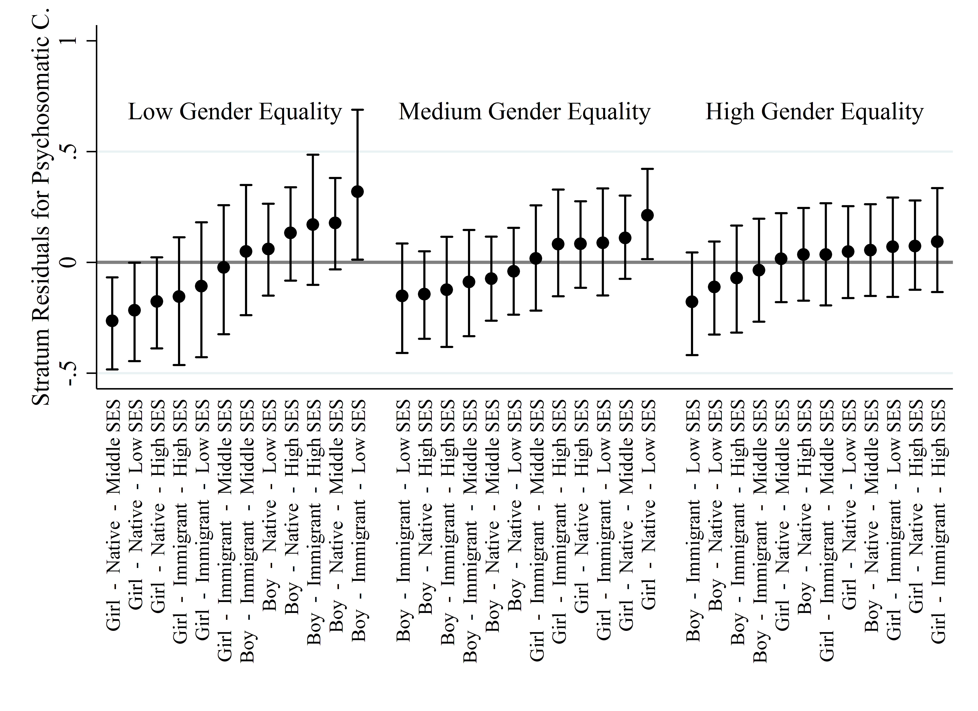
References (Appendix)

[1] Evans CR, Erickson N. Intersectionality and depression in adolescence and early adulthood: A MAIHDA analysis of the national longitudinal study of adolescent to adult health, 1995-2008. Soc Sci Med 2019;220:1-11. DOI: 10.1016/j.socscimed.2018.10.019.
[2] Evans CR, Williams DR, Onnela J-P, et al. A multilevel approach to modeling health inequalities at the intersection of multiple social identities. Soc Sci Med 2018;203:64-73. DOI: 10.1016/j.socscimed.2017.11.011.
[3] Bell A, Holman D, Jones K. Using shrinkage in multilevel models to understand intersectionality a simulation study and a guide for best practice. Methodology 2019;15:88-96. DOI: 10.1027/1614-2241/a000167.
[4] Fisk SA, Mulinari S, Wemrell M, et al. Chronic Obstructive Pulmonary Disease in Sweden: An intersectional multilevel analysis of individual heterogeneity and discriminatory accuracy. SSM Popul Health 2018;4:334-346. DOI: 10.1016/j.ssmph.2018.03.005.
[5] Browne WJ. MCMC estimation in MLwiN. Bristol (UK): Centre for Multilevel Modelling, University of Bristol, 2017.

