Oral History as a multimedia and multidimensional presentation challenge

Douglas C. Lambert

Centre for Digital and Contemporary History, University of Luxembourg, Luxembourg, douglas.lambert@uni.lu

ABSTRACT: Oral History is a multidisciplinary, multinational field based on a format of recorded, usually sit-down interviews, where the past is documented through personal narratives of life experience. In the early 2000’s, a new approach to processing and managing oral histories was introduced based on timecode indexing made possible by software environments. This work can be referred to as Oral History Digital Indexing (OHDI), and it represents a suite of activities, tools, methods, and interfaces that have made oral histories more accessible both with and without transcripts, whilst reconnecting navigable text to original recordings for listening and watching. OHDI allows for oral history to be represented in visual, dynamic forms far more palatable to users than the previous default--a collection of transcripts.
Pioneering OHDI work was done by Michael Frisch and The Randforce Associates, with whom the author worked with on a number of consulting projects between 2002 and 2018. The focus of these projects was distinctly on comprehensive timecode indexing, the use of annotation as an alternative to word-for-word transcription, and deployment of custom controlled vocabularies (CVs) organized visually as a spatially-meaningful content map. These CVs function like back-of-the-book term indexes providing better “front end” user access, but they have they also been adapted for research applications to organize sets of qualitative analysis codes. Through a post-doctoral research position at the University of Luxembourg, the author is introducing and integrating these OHDI methods into oral history development plans in Luxembourg. Several representative tools, interfaces, and CVs used to make oral histories more multimedia and multidimensional will be presented, all of which will be influential to the in-development “Luxembourgish Oral History Initiative.”

oral history digital indexing, presentation, and mapping
Oral History is a multidisciplinary, multinational field based on a format of recorded, usually sit-down interviews, where the past is documented through personal narratives of life experience. The medium for processing and management of oral histories has frequently been via transcripts, which often become the primary representative documentation of an oral history collection. Still today, transcription is often assumed to be the inevitable first and sometimes only medium for processing, representing, and using oral history. From a user interface perspective, transcripts are dense and flat, they only contain the literal words spoken in the interview, they rarely maintain any connection to the source media, and they miss layers of meaning that exist in a collection.

In the early 2000’s, a new approach to processing and managing oral histories was introduced based on timecode indexing made possible by software environments [1]. This worked paved the way for oral history to exist as whole collections, accessible within and across interviews at the timecode level, with fluid connection between text and audio/video media, and allowing innovative new forms of metadata representation and visualization. This general area of knowledge and work can be referred to as Oral History Digital Indexing (OHDI), and it represents a suite of activities, tools, methods, and interfaces that have made oral histories more accessible both with and without transcripts, whilst reconnecting navigable text to original recordings for listening. Figure 1 depicts the metadata building blocks of OHDI, which is based on timecode indexing that links descriptive text to a media player. The example shown in Figure 1 has discreet in/out timecode passages, whereas the timecode indexing in other systems may be based on singular “in” points.

An OHDI system increasingly used in the United States is “OHMS,” the Oral History Metadata Synchronizer [2]. It features capabilities for media linked by timecodes, either to transcriptions, abbreviated indexing text, or both. OHMS has allowed to University of Kentucky and other adopters to advance their oral history digital infrastructure, making it much cheaper and faster for archives to get material up online, making collections more accessible for users, and representing oral history in visual forms far more palatable to the average user than a collection of transcript files alone [3]. OHMS was built with digital libraries in mind and uses Dublin Core fields where possible, and it is meant to be integrated seamlessly with a library content management system (CMS). OHMS has controlled vocabulary (thesaurus) capabilities for adding subjects and keywords at the timecode level that are findable in searches, though users are mostly blind to the structure of those CVs. The OHMS interface will be shown, including its backend and frontend user interfaces for timecode-linked transcripts and indexes, as well as some of its metadata architecture.

Pioneering OHDI work was done by Michael Frisch and The Randforce Associates, with whom the author worked with on a number of consulting projects between 2002 and 2018. These projects were in collaboration with a variety of collection stewards, where the focus was distinctly on comprehensive timecode indexing, the use of annotation as an alternative to word-for-word transcription, and deployment of custom controlled vocabularies (CVs) organized visually for better cross-referencing power and user access. These CVs function like back-of-the-book style indexes for enhanced front-end user access, but they also can be easily function as qualitative analysis codes suited for research applications, as is exemplified in Figure 2. This higher order CV indexing work, predicated on timecode indexing, emphasizes a “mapping” aesthetic where new users have a visual menu offered to them of the content available. Through a post-doctoral research position at the University of Luxembourg, the author is introducing and integrating these OHDI methods into oral history development plans in Luxembourg.

Several representative tools, interfaces, and CVs used to make oral histories more multimedia and multidimensional will be presented, all of which will be influential to the in-development Luxembourgish Oral History Initiative. Other similar code structures from indexed oral history sites and research projects will also be shown.

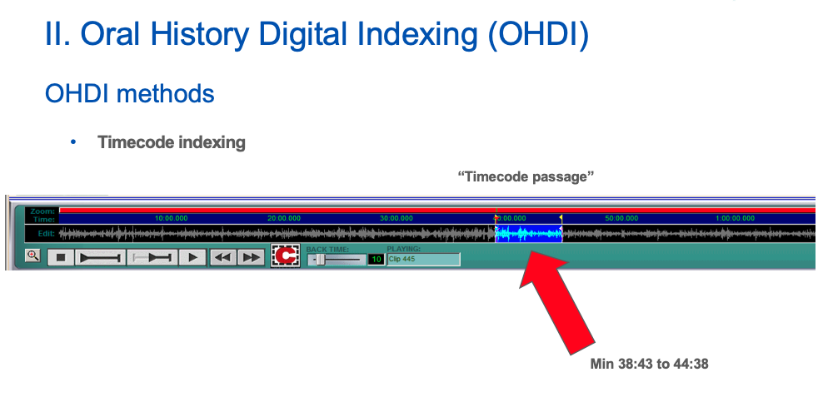
Figure 1: Oral History Digital Indexing (OHDI) is predicated on the establishment of discreet timecode passages within and across interviews. Annotations, keywords, or partial transcriptions can then be cross-referenced by theme, creating navigability through non-linear collections.

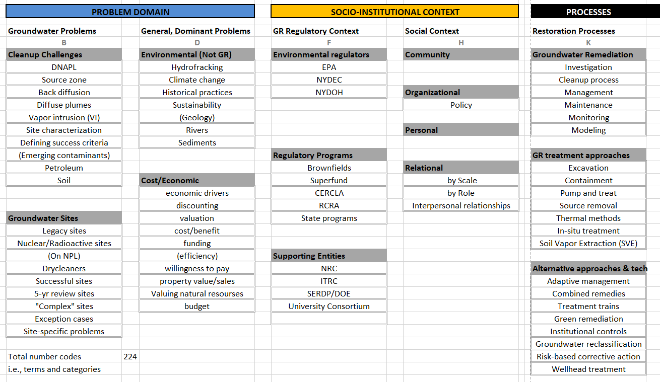
Figure 2: An OHDI code frame, this example shows a set of codes used for an environmental research project. Primarily a controlled vocabulary, terms are organized meaningfully to the benefit of the project researchers, the indexer, and long-term users of the collection.

References
- Frisch, Michael, ‘Oral History and the Digital Revolution: Towards a Post-Documentary Sensibility’, in Robert Perks and Alistair Thomson (eds.), The Oral History Reader, second edn., Routledge, London and New York, 2006, Ch.8.

- OHMS: Oral History Metadata Synchronizer (2019): OHMS, Oral History Metadata Synchronizer, enhance access for free, Available from: http://www.oralhistoryonline.org (retrieved October 2019).

- Boyd, Douglas: OHMS: Enhancing Access to Oral History for Free. The Oral History Review 40, no. 1, pp. 95-106, Winter/Spring 2013.

