DH Text Submission Guidelines
This is the template for abstract submissions to the annual Digital Humanities conference of ADHO. Please read and observe these guidelines closely in order to facilitate the file conversion for the edition of the Conference Proceedings. The guidelines included here are a subset of more complete instructions you can find online at: https://dh2018.adho.org/.

The template consists of sections with light grey background that cannot be edited and will be processed automatically during the TEI-conversion. The other sections are where you insert the content of your submission.

Below, you will find the three editable main sections of this document:

- Subtitle: section for an optional subtitle
- Body: section for the chapters of your paper
- References: section for the bibliographic references.

Please avoid pasting richly-formatted text into these sections and only use the paragraph styles provided by this template named „DH-[Stylename]“:

- DH-Default
- DH-Subtitle
- DH-Heading1
- DH-Heading2
- DH-Heading3
- DH-Quotation

Also supported are links, lists and tables. Please avoid wide tables with lots of cell content. In addition, we support the following character level styles:

- Bold (to be used, sparingly, for emphasis)
- Italics (to be used for titles)

Please observe the following additional indications:

Images: Accepted image file formats are PNG, JPEG and SVG. For PNG and JPEG images the minimum image width is 1000 pixels.

Quotations of 5 or more lines should be in the "DH-Quotation" block quote format. For short quotations within the text, single quotation marks should be used.

Program code or mathematical formulae should appear as images.

Notes should be used only for comments, not for bibliographic citations.

Bibliographic references should be made inline using the author's name and year of publication, e.g. (Bloggs, 1990; Bloggs et al., 1991).

References section: The works cited should be listed in the "References" section at the end of the article. The list should be in alphabetical order by author. Where an author has more than one publication, they should be arranged in chronological order.

Citation style: Please follow the citation style of the DSH journal at:
http://dsh.oxfordjournals.org/for_authors/index.html. We provide a CSL file for use with reference managers such as Zotero. See the file and instructions here:
https://github.com/computationalstylistics/DHAbstracts_biblio_style.
Some examples are given below.

Biber, D. (1988). Variation Across Speech and Writing. Cambridge: Cambridge University Press.
Calzolari, N. (1989). A typology of English text. In Batori, I. S., Lenders, W. and Putschke, W. (eds), Computational Linguistics. New York: ACM Press, pp. 510-19.
Oostdijk, N. (1988). A corpus linguistic approach to linguistic variation. Literary and Linguistic Computing, 3: 12-25.
Richardson, S. D. and Braden-Harder, L. (1988). The experience of developing a large-scale natural language text processing system: CRITIQUE. Proceedings of the Second Conference on Applied Natural Language Processing, Austin, TX, February 1988.
Garfinkel, M. S. and Weiss, S. C. (1999). In the court of history, Ehlers v. Bush. Recent Science Newsletter, 1(1): 6-7, http://web.archive.org/web/20030604160332/recentscience.gwu.edu/RSN/ (accessed 27 February 2004).

The main title of your contribution – this field cannot be edited
Building Bridges Across Heritage Silos
Add a subtitle (optional):

Kalliopi Kontiza (Kalliopi.Kontiza@ng-london.org.uk), The National Gallery, United Kingdom
Catherine Jones (Catherine.jones@uni.lu), University of Luxembourg, Luxembοurg
Joseph Padfield (Joseph.Padfield@ng-london.org.uk), The National Gallery, United Kingdom
Ioanna Lykourentzou (ioanna.lykourentzou@list.lu), Luxembourg Institute of Science and Technology, Luxembοurg
Author information – this field cannot be edited

Main body – enter your text and images here:
Building Bridges aCROSS CULTural Heritage Silos.
This research considers how best to cross the divides that exist between: (1) disparate practices between research fields (2) disparate interpretations of shared cultural heritage by the public and (3) disparate cultural heritage objects.
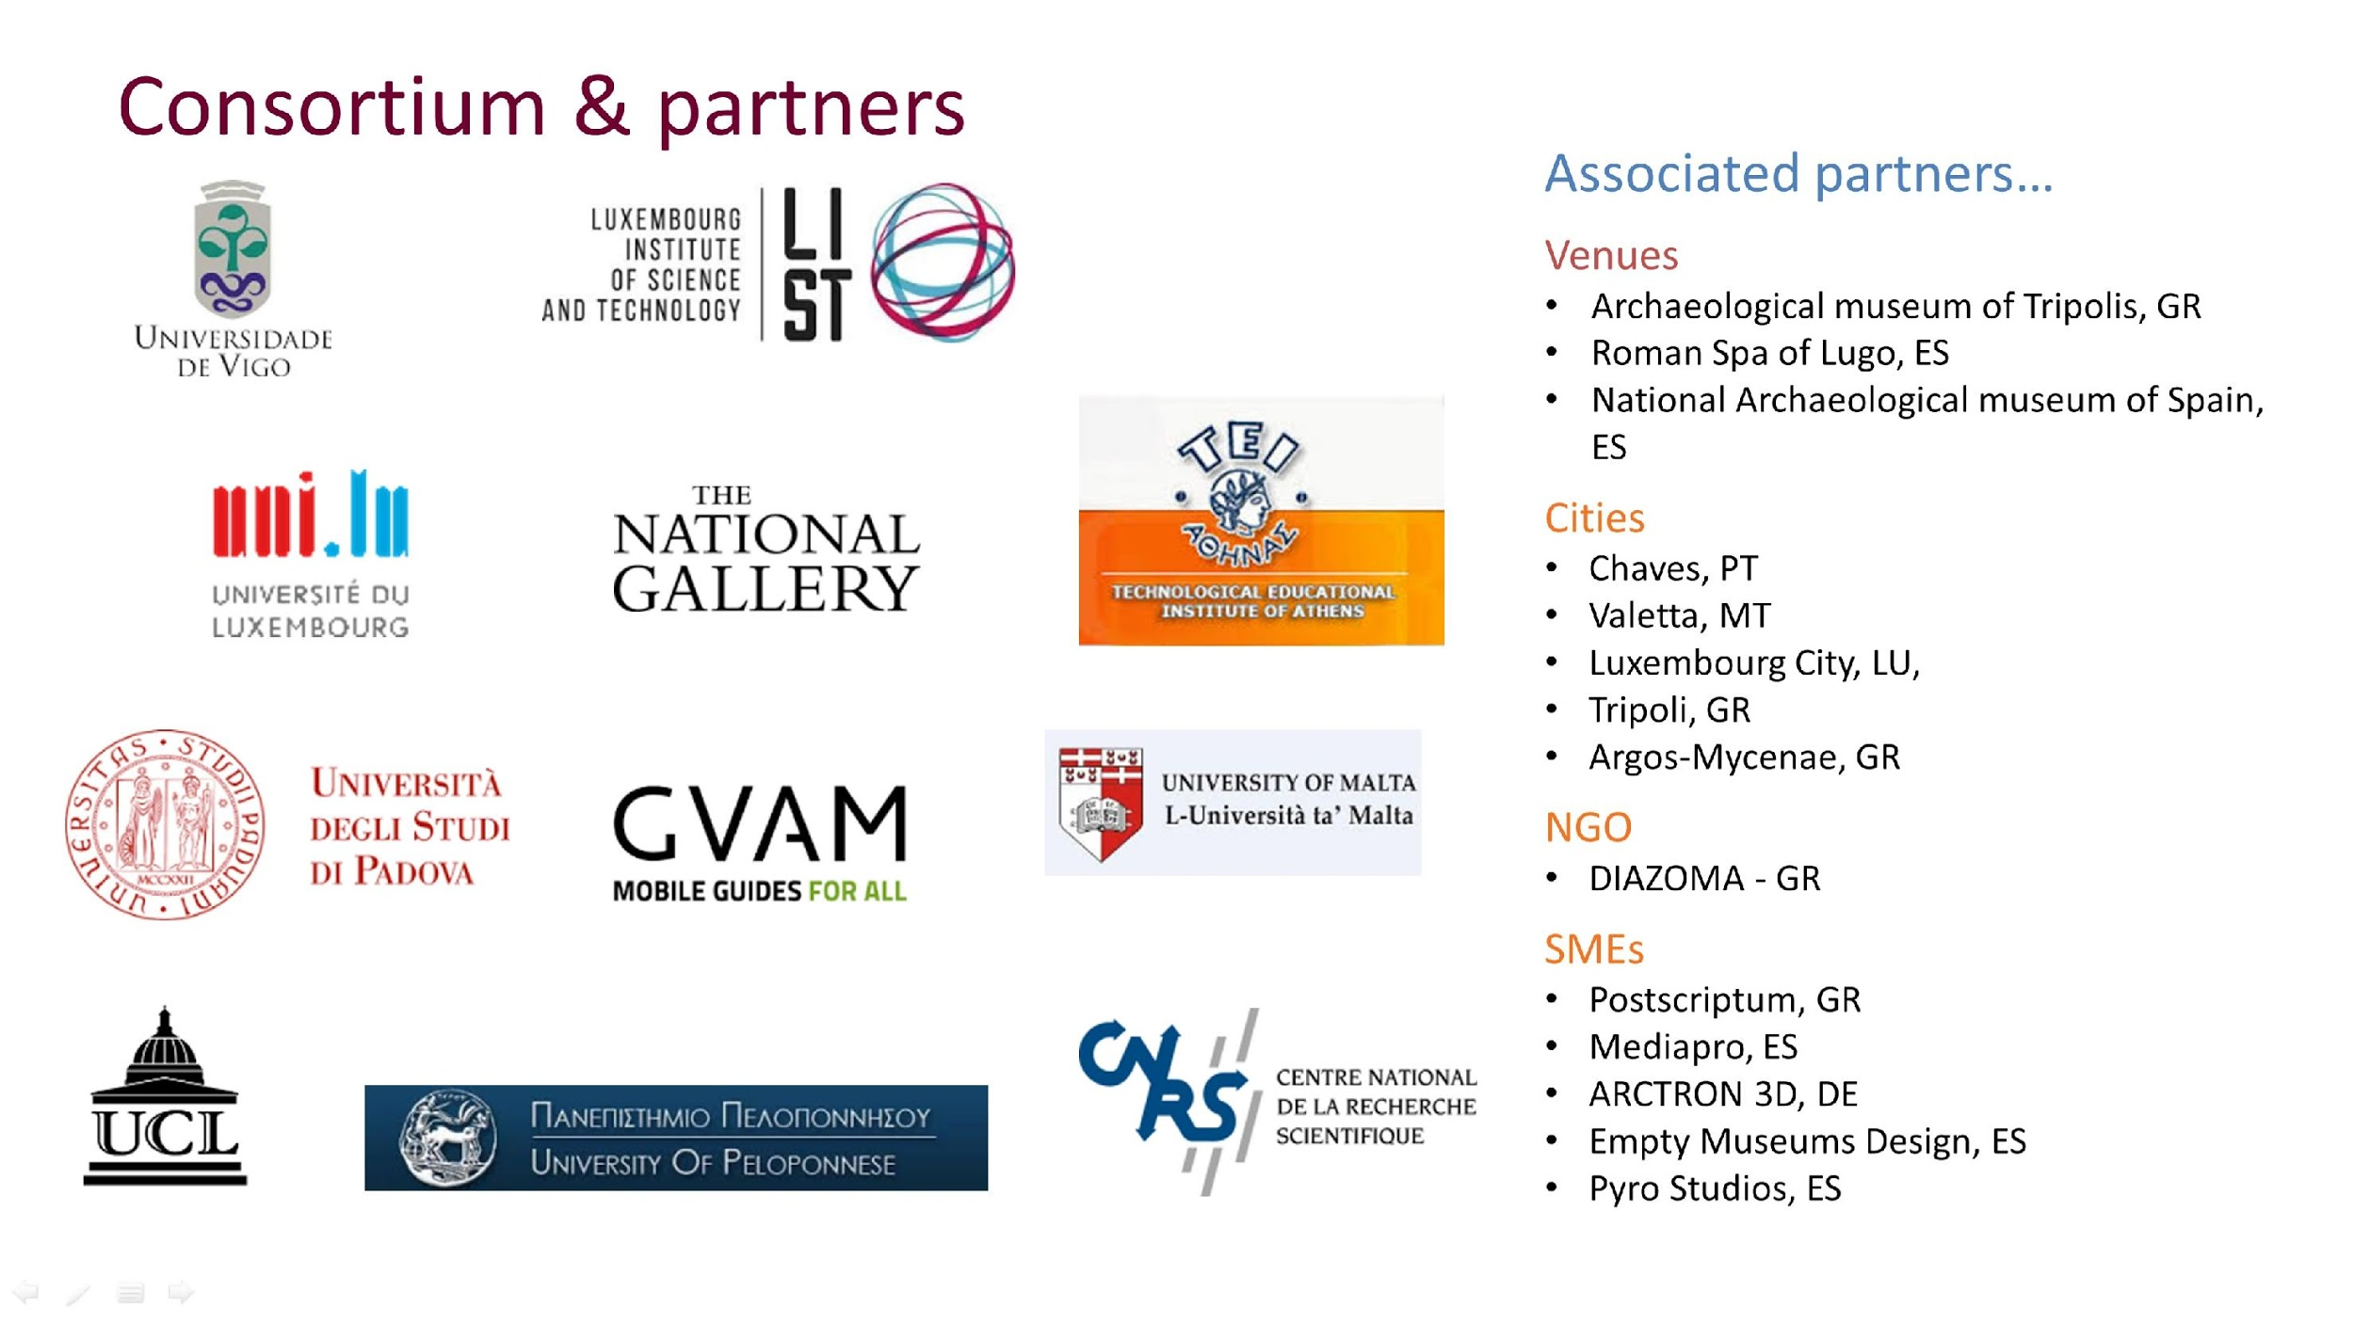
Figure 1The CrossCult Consortium and Partners
Building bridges across disciplines.
Within the field of heritage research there still remain, to this day, many silos between researchers in sciences or the humanities, professionals, practitioners and information technologists. In this poster we consider how best to bridge these gaps between the disciplines. We present, as a demonstrator, an H2020 project named CrossCult (http://www.crosscult.eu). The project brings together inter-disciplinary researchers including: Social scientists, Data and Information scientists, Heritage and Digital Heritage Scientists, Engineering, Humanities and Digital Humanities (Archaeologists and Digital Archaeologists, Linguists, Museum Professionals), Practitioners (Conservators, Curators), and Information Technologies (Backend and Front end and app Developers, Programmers, Semantic Web specialists, Gamers). We achieve collaboration and discussion through shared common goals and research objectives, and we support dialogue through tools. When possible, we use open source technology to support us for Communication, Programming, Data Structuring/Editing, Visualisation, Conceptual Mapping. We follow standards to be compatible with other people's work, produce reusable research outputs and collaborate with other European projects towards the same goal.
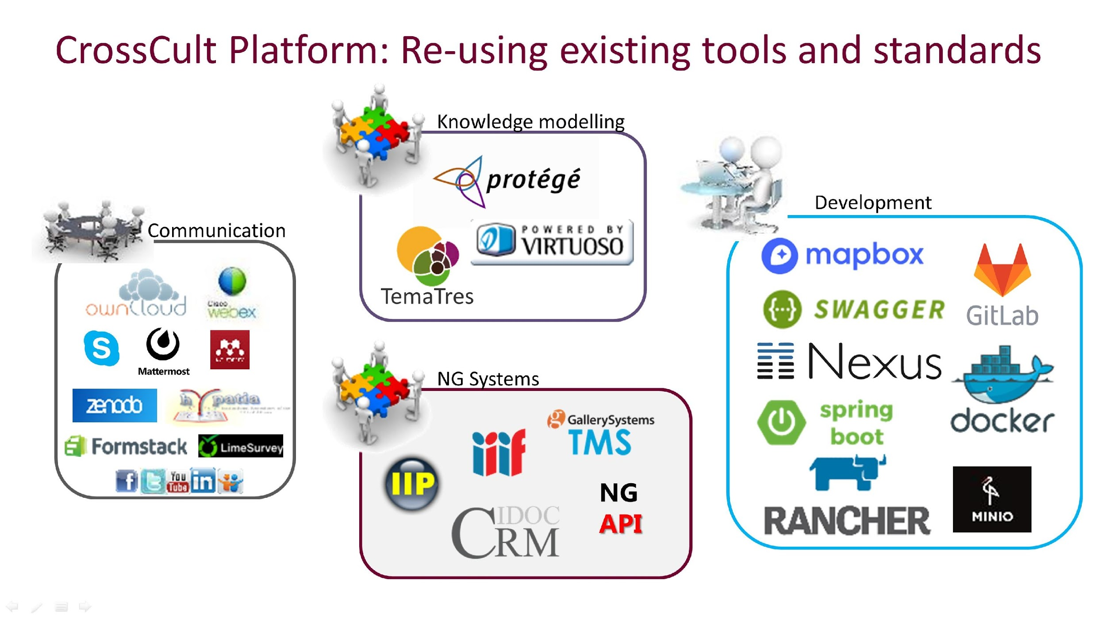
Figure 2 Reusing existing tools and Standards
Building bridges across members of the public.
The challenge also extends beyond researchers and continues into the lived experience of our shared Heritage. It raises the challenge of how CROSSCultures can challenge siloed opinions and interpretations of Cultural Heritage (Lykourentzou et al., 2016). At the heart of this project is the desire to build bridges between disciplines to explore innovative practices that can present historic knowledge to non-specialist audiences in an engaging way. European history is an exciting mesh of interrelated facts and events, interpretations and narratives that cross countries and cultures. However, public history is a challenging practice that must be mindful of the audiences, their interests and goals; in this research we are concerned with the museum or the city visitor (Vasilakis et al., 2016).
Building bridges across cultural objects.
The final challenge we explore is how to build bridges between disparate objects of our common Heritage. We use heritage objects and historical resources to trigger reflection, individually and collectively, on European history and to showcase the importance to bridge the past and its connection to the present (ERCIM News, 2017).
Using the CROSSCULT project we demonstrate how we are can address the three challenges by developing around four use cases: from large museums to small ones, and from indoors to outdoors. In this presentation, we discuss two of the project’s four pilots (Pilot 1 and Pilot 4), which highlight the comparison between the Indoor and Outdoor Exhibition; in the first case with the museum/gallery and its paintings and in the second case with the city and its geo-located Places of Interest (POIs). The exhibits (both POIs and paintings) are represented as semantically structured data, linked through our Knowledge Base (Vlachidis et al., 2017). They are our stepping stones to create stories that connect one item to the other, and invite the user (gallery visitor or city traveller) to discover them. The POIs are either discovered outside (in Pilot 4) and can lead to the museum/gallery or vice versa (Pilot 1), eventually bridging the outdoors with the indoors and creating a seamless cultural discovery experience.
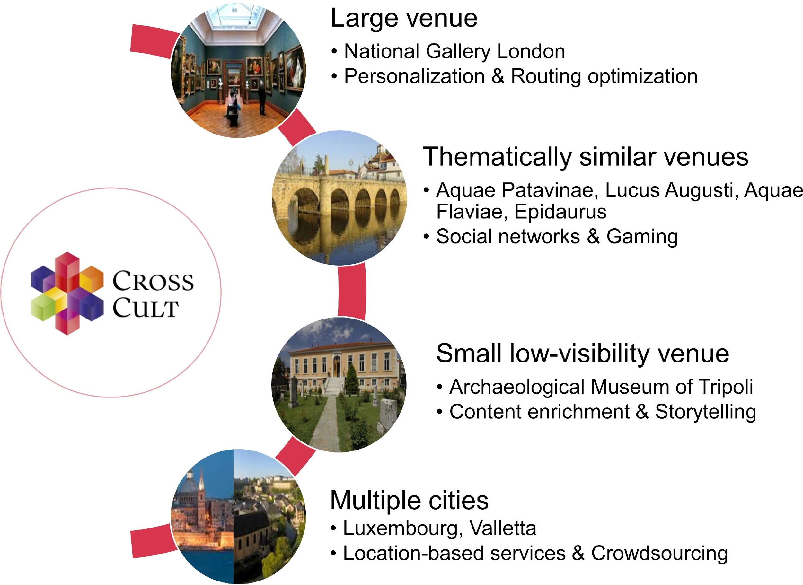
Figure 3 CrossCult H2020 project – Overview of the four pilots and their supporting technologies
Pilot 1: Large multi-thematic venue - The National Gallery London- Building narratives through personalisation.
We use the gallery’s large collection to offer the visitors personalised stories that highlight the connections among people, places and events across European history, through art. Semantic reasoning, recommender systems and path routing optimisation are employed to ensure that each visitor will be navigated through the conceptually linked exhibits that interest them the most, while avoiding congested spaces as much as possible. The experience combines technologies, balancing in a unique way individual visitor needs with museum-wide objectives, can be extended and customised to serve the needs of various other large venues across Europe.
Pilot 4: Multiple cities - City of Valletta in Malta and City of Luxembourg. Building narratives through location based gaming and crowdsourcing.
Pilot 4 takes place outdoors in the two cities to trigger reflection through urban discovery. Focusing on the topic of migration, past for Malta and present for Luxembourg, and using the technologies of location-based services, urban informatics and crowdsourcing, it invites people to walk the two cities, discover and share stories. Visitors and residents engage in comparative reflection that challenges their perception on topics touched by migration such as identity, quality of life, traditions, integration and sense of belonging (Jones et al., 2017).
Acknowledgements:
The work described in this presentation has received funding support from European Union's Horizon 2020 research and innovation programme under grant agreement no 693150.

References
Enter your references here:
ERCIM News. (2017, October) Reinterpreting European History Through Technology: The CrossCult Project. Retrieved from https://ercim-news.ercim.eu/en111/special/reinterpreting-european-history-through-technology-the-crosscult-project (accessed 02 May 2018)
Jones, C. E., Liapis, A., Lykourentzou, I., Guido, D. (2017). Board Game Prototyping to Co-Design a Better Location-Based Digital Game. Proceedings of the 2017 CHI Conference Extended Abstracts on Human Factors in Computing Systems. ACM Press, New York, USA, pp. 1055-64. Available from: https://doi.org/10.1145/3027063.3053348
Lykourentzou, I., Naudet Y., Vandenabeele, L. (2016). Reflecting on European History with the Help of Technology: The CrossCult Project. Proceedings of the Eurographics Workshop on Graphics and Cultural Heritage. The Eurographics Association, pp. 67-70. Available from: https://doi.org/10.2312/gch.20161384
Vassilakis, C., Antoniou, A., Lepouras, G., Wallace, M., Lykourentzou, I., Naudet, Y., 2016. Interconnecting Objects, Visitors, Sites and (Hi)Stories Across Cultural and Historical Concepts: The CrossCult Project, in: Ioannides, M., Fink, E., Moropoulou, A., Hagedorn-Saupe, M., Fresa, A., Liestøl, G., Rajcic, V., Grussenmeyer, P. (eds.), Digital Heritage. Progress in Cultural Heritage: Documentation, Preservation, and Protection. Springer International Publishing, Cham, pp. 501–10. Available from: https://doi.org/10.1007/978-3-319-48496-9_39
Vlachidis, A., Bikakis, A., Kyriaki-Manessi, D., Triantafyllou, I., Padfield, J., Kontiza, K. (2017). Semantic Representation and Enrichment of Cultural Heritage Information for Fostering Reinterpretation and Reflection on the European History. Paper presented to the final Conference of the Marie Skodowska-Curie Initial Training Network for Digital Cultural Heritage, ITN-DCH 2017. Olimje, Slovenia, 23–25 May.

Finished editing your document?
- MAKE SURE TO SAVE THIS FILE UNDER A NEW FILE NAME!
- Go back to the DHConValidator to upload & convert your file and check the output.

Click HERE to return to the DH ConValidator.

