When the exception becomes the rule …
When the margins become the center …

Valérie Schafer

« Theodore Roszak, whose 1969 book, “The Making of a Counter Culture,” popularized that era’s doctrines, later asserted that computer hackers — “whose origins can be discerned in the old Whole Earth Catalog” — invented the personal computer as a means of “fostering dissent and questioning authority.” Timothy Leary, the psychedelic maestro of that period, declared that “the PC is the LSD of the 1990’s.” »
Rothsrein E., « A Crunchy-Granola Path From Macramé and LSD to Wikipedia and Google », New York Times, September 25, 2006
http://www.nytimes.com/2006/09/25/arts/25conn.html

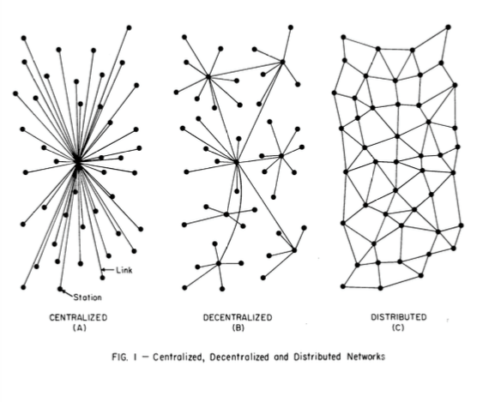In a 2012 presentation at SIGCIS, historian Andrew Russell built upon Paul Baran’s seminal schema of network architectures to put forward a new vision of Internet history: he suggested to call into question the American-centric, triumphalist and teleological narrative of linear success and to replace it with a decentralized, if not distributed approach.

This invites us to critically reflect upon centers and peripheries in Internet history, not only from a geographical perspective, but also from a narrative standpoint. However, unlike other approaches in media history, the history of the Internet has been written, since its very early days, by looking at the margins. Actually, they have likely been over-valued sometimes, echoing a libertarian and counter-cultural vision strongly supported by Internet actors.

In this contribution, I wish to adopt the standpoint of this division between margins/mainstream/center, and to observe its consequences on the writing of Internet history. This presentation will address three major paths in Internet history: the redistribution of powers on and thanks to the Internet; the criticism or devaluation of the “center”, whether it is political, informational or economic; and finally the exploration of “backstage” elements such as shadows, outsiders, etc. I will investigate in particular:
- the place of figures such as innovators, mediators and go-betweens, maintainers, users
- the oppositions of David vs Goliath, DIY and high vs low barrier to entry, niche communities vs giant companies, etc., all of which feed a nostalgia of the 90s and a strong criticism of the current evolutions of the Web and the Internet
- the access to archives to document the margins and the “empires” of the Internet.
Based on previous research (Cyclades, Renater, digital cultures in the 90s, the history of ISPs) but also on broader historiographical aspects, this presentation aims at analysing the relationship between centers and margins in Internet history and historiography. In doing so, we will raise the following question: is Internet history especially suited and open to margins? And to go further, being somewhat provocative: if yes, is it a positive quality, or one that carries some pitfalls and risks?

http://www.sigcis.org/workshop12/Russell
https://www.rand.org/content/dam/rand/pubs/research_memoranda/2006/RM3420.pdf
In fact this issue is already well established and recognized in Internet history. See for example Goggin and McLelland’s book The Routledge Companion to Internet History (2017), which covers a lot of countries and levels, from a national but also regional and transnational perspective.
Do It Yourself.

