Supplementary Figure 1:
- Experimental workflow of the relative quantification of AngII-dependent changes of the cellular phosphoproteome by Stable Isotope Labeling of Amino acids in Cell culture (SILAC) coupled with phosphopeptide enrichment and LC-MS/MS.
- Western Blot confirming the phosphorylation of ERK as a positive control for effective AngII signaling in our model of AB8 3F-AT1R podocytes treated with AngII (100 nM; 15 min)
- Venn diagram overview depicting the peptide identifications of four biological replicates with each three technical replicates

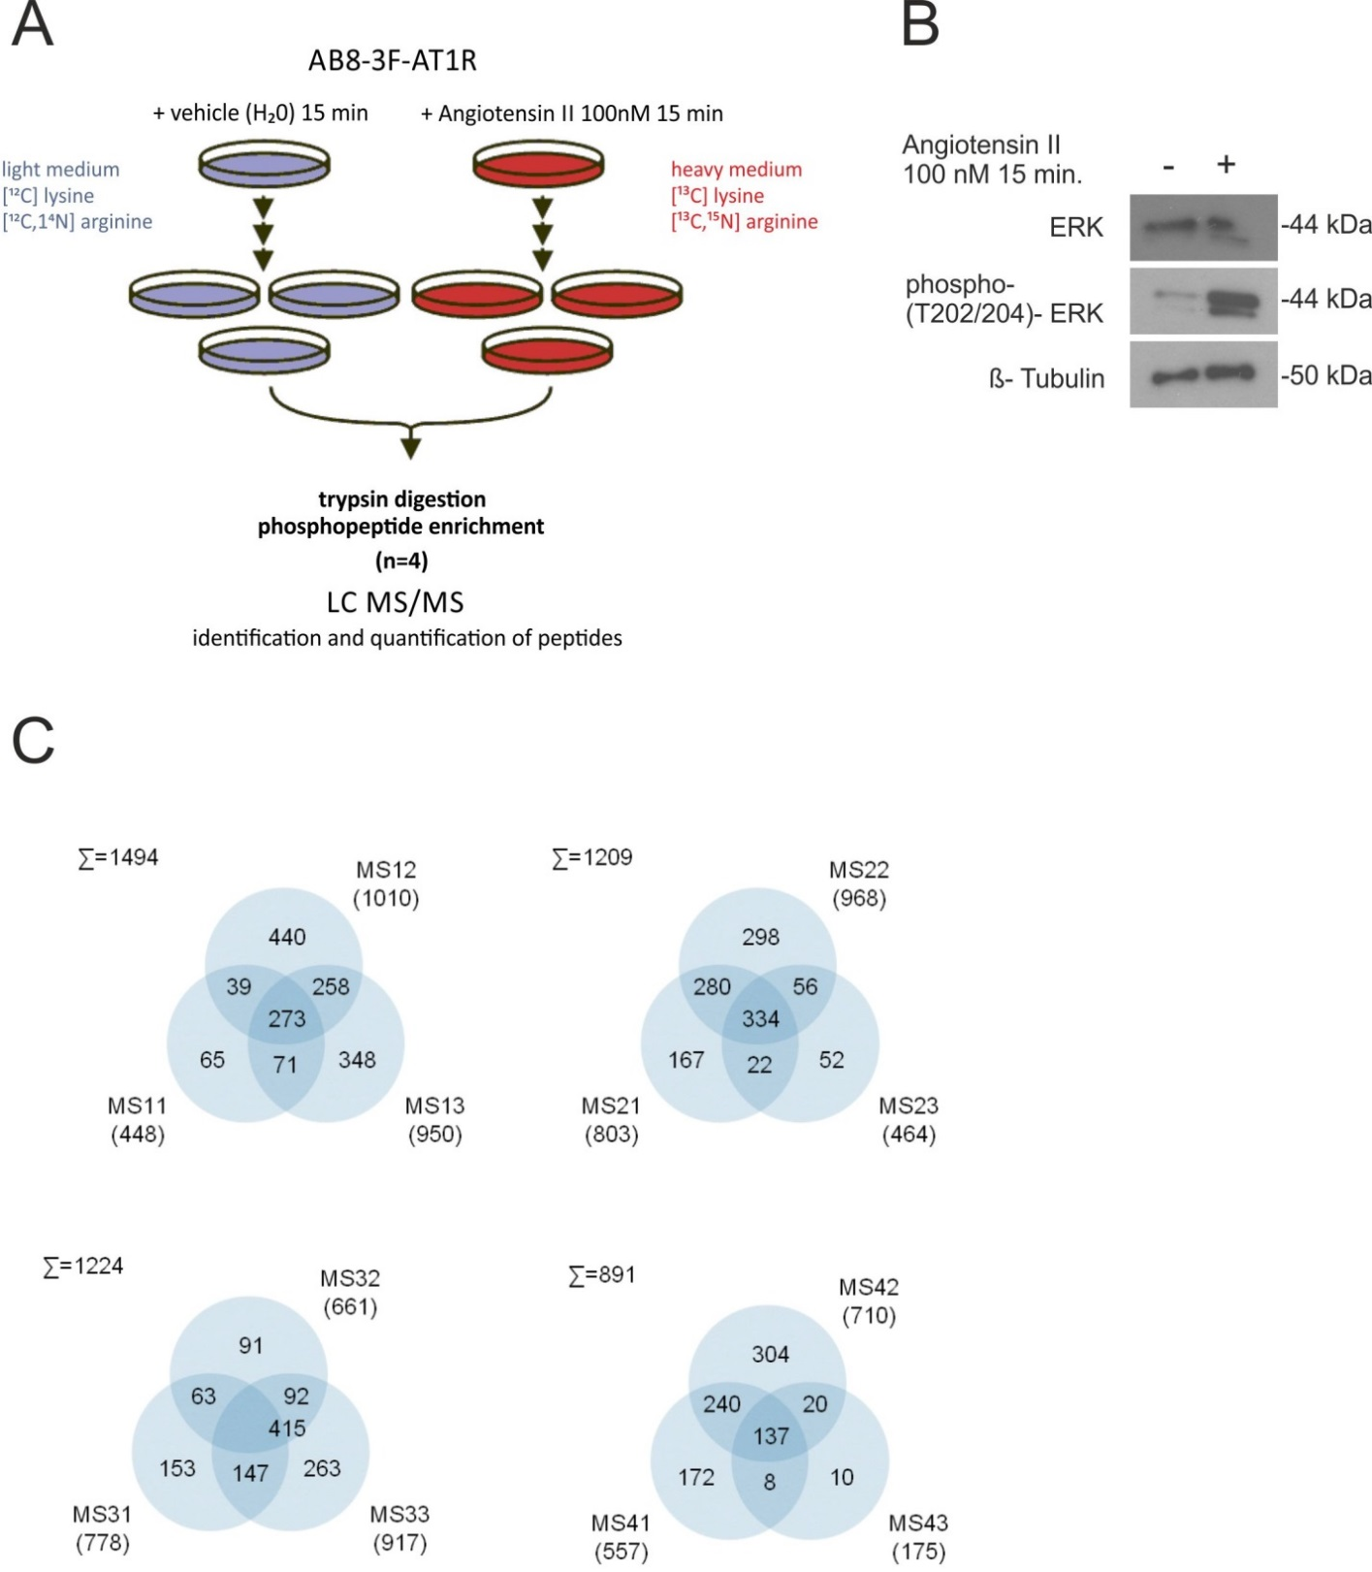
Supplementary Figure 2:
- Summary of KEGG pathways that were overrepresented among the increased phosphopeptides
- Gene Ontology functional classification/Biological processes that were overrepresented among the increased phosphopeptides
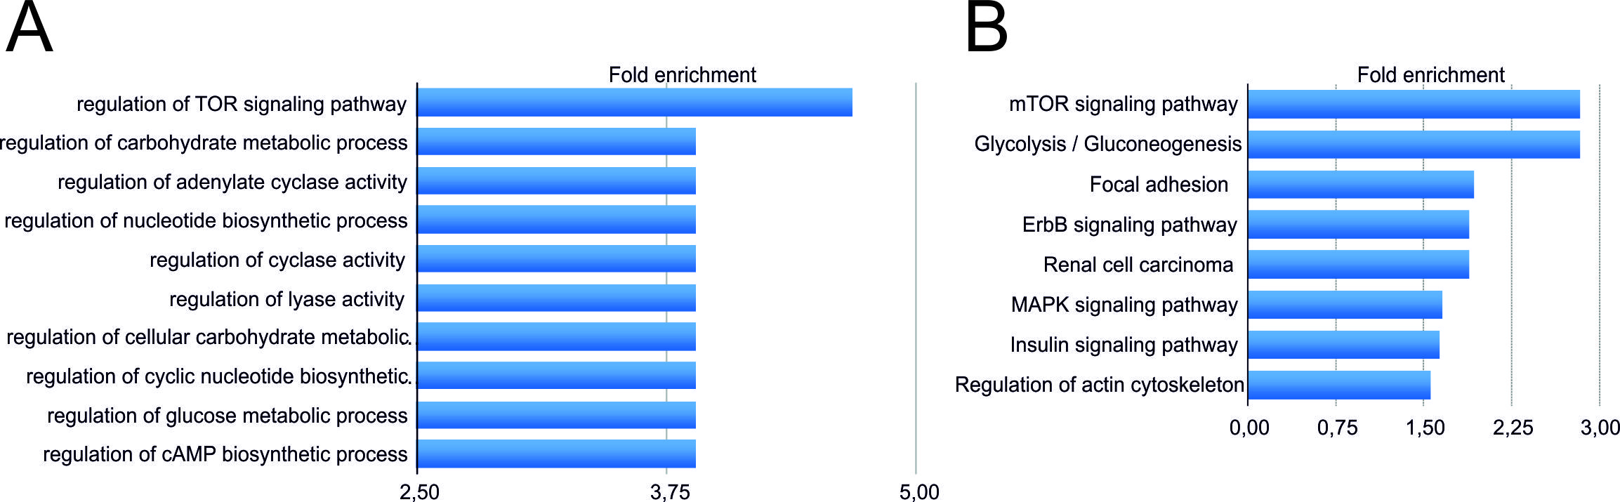

Supplementary Figure 3:
Left: Representative Western Blot results from podocytes after AngII treatment (100 nM) for 15 min versus unstimulated cells shows AngII dependent phosphorylation of LCP1. The FLAG staining confirms the expression of the AT1R, actin serves as loading control and phosphorylation of ERK proves the effective stimulation with AngII. Right: Ratio between phosphorylated and total amount of LCP1 and ERK after densitometric quantification from three independent experiments (mean ± S.D., t-test, *P<0.05).

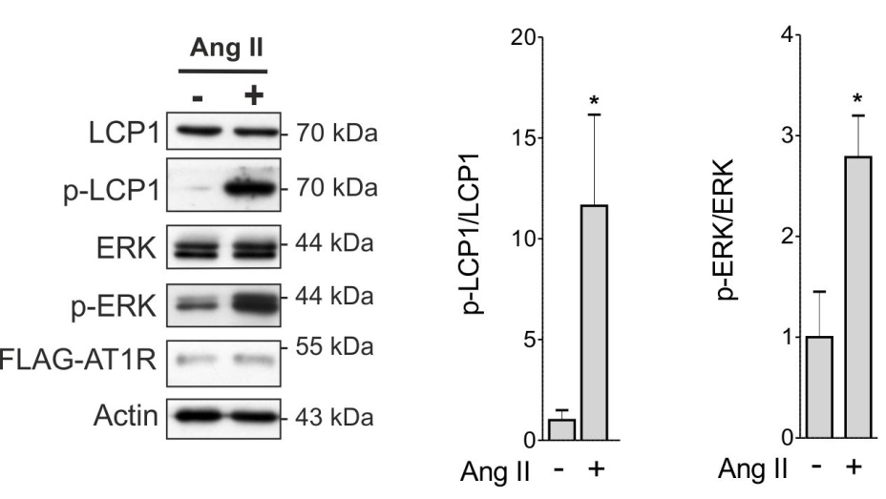

Supplementary Figure 4:
Immunofluorescence staining of endogenous phosphorylated LCP1 (phospho-LCP1 (Ser5)-Ab, red) and actin (Phalloidin, green) before and 15 min after stimulation with Ang II (100 nM) shows that Ser5 phosphorylated LCP1 is predominantly localized at the cell margins and at the thin cell-cell connections in podocytes. DAPI (blue) marks the nuclei. However the increase LCP1 phosphorylation could not be shown in this immunofluorescence experiment. Scale bar 20 µM.

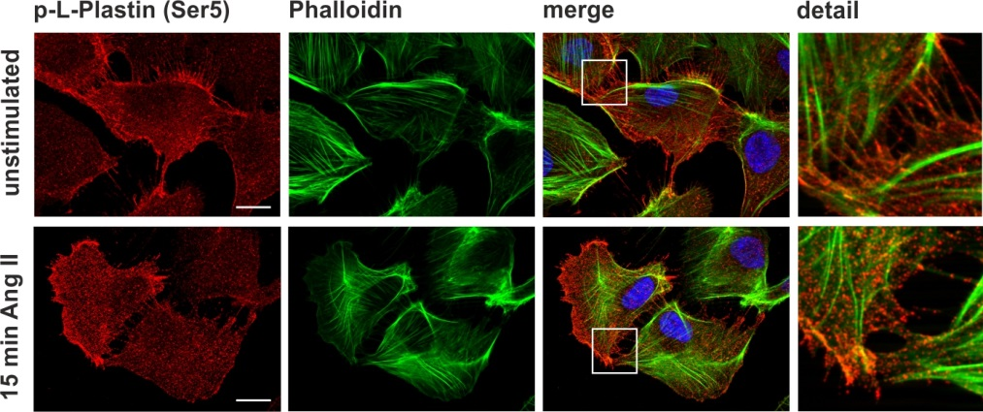

Supplementary Figure 5:
Validation of RFP-LCP1 variants expression and Ang II-induced phosphorylation of RFP-LCP1 in transiently transfected HEK293T cells.
Protein extracts of untransfected, RFP-LCP1-WT, RFP-LCP1-S5A and RFP-LCP1-S5E transfected HEK293T cells stimulated with Ang II (100 nM, 15 min) or unstimulated were analyzed in a Western Blot experiment. Transient transfection occurred by calcium phosphate method (Duning et al., 2008), cells were lyzed 24 h after transfection. HEK293T cells do not endogenously express LCP1. All RFP-tagged LCP1 variants are expressed in transfected cells, LCP1-WT can be phosphorylated by AngII stimulation. The phosphorylation of ERK proves the effectiveness of AngII stimulation.

Duning K, Schurek EM, Schluter M, Bayer M, Reinhardt HC, Schwab A et al. KIBRAmodulates directional migration of podocytes. J Am Soc Nephrol 2008; 19: 1891–1903.

Supplementary Figure 6
To analyze whether AngII treatment also leads to lamellipodia formation and cell area growth in cells overexpressing T-plastin we cloned a RFP-T-plastin-WT construct. Furthermore, to confirm that calcium binding is the major factor for AngII induced plastin redistribution, we additionally cloned a T-plastin deletion mutant excluding the EF hand motif (T-plastin_minus EF) (Suppl. Figure 6B).
Live cell imaging studies of podocytes transiently transfected with RFP-tagged T-plastin-WT showed AngII induced lamellipodia formation and cell enlargement (Suppl. Figure 6C). In contrast, AngII stimulation in cells expressing the deletion mutant led to T-plastin redistribution and membrane ruffling but not to cell area enlargement. The same effect was reached by reduction of the intra- and extracellular Ca²⁺ concentration. The quantification of cell enlargement after AngII stimulation in the various experiments is shown in Suppl. Figure 6D. In conclusion, our experiments with T-plastin confirm our previous observation that the AngII induced plastin redistribution and lamellipodia formation predominantly depends on the calcium binding capacity at the EF hand motifs and is independent of phosphorylation.

Effects of AngII stimulation on T-plastin localization resemble that of LCP1
A.: Immunofluorescence staining of endogenous T-plastin (red) and actin (Phalloidin, green) before and 15 min after stimulation with AngII (100 nM) shows an AngII-dependent redistribution of T-plastin to the cell margins in podocytes. B.: Schematic overview of the T-plastin deletion mutant without EF-binding sites (ABD=actin binding domain). C.: Representative live cell imaging experiments of podocytes transiently transfected with fluorescent RFP-T-plastin-WT (line 1 and 3) or the deletion mutant (line 2). For the experiment in line 3 the intracellular and extracellular Ca²⁺-concentration was reduced using BAPTA-AM and calcium-free Ringer solution. Stimulation of the cells occurred by addition of AngII (100 nM). The image labelled “0 min” was taken before stimulation; the other pictures were taken at the indicated time points after stimulation. D.: Quantification of cell area enlargement after stimulation from live cell experiments. RFP stained cell areas at time point “0 min” were determined as unstimulated values and at time point “15 min” as stimulated values. The ratio of cell areas is shown (n ≥ 3 independent experiments, mean ± S.D., t-test, *P<0.05; **P<0.01; ***P<0.001).

