A new methodology for designing laser-based additive manufactured motorcycles frame based on combination of topology optimization and lattice implementation

Thanh Binh Cao^{a,}, Slawomir Kedziora^{b}
ªResearch Unit in Engineering Sciences, University of Luxembourg, Luxembourg
E-mail address: Thanh-binh.cao@uni.lu

^{b}Research Unit in Engineering Sciences, University of Luxembourg, Luxembourg
E-mail address: Slawomir.kedziora@uni.lu

Keywords: CAD/CAE, FEA, additive manufacturing, topology/lattice optimization

Abstract
The use of laser-based additive manufacturing (AM) has been becoming more attractive recently since it offers a promising tool in rapidly fabricating complex components. Particularly, the technique is seen more powerful when it is combined with computer-aid design and computational optimization. In spite of knowledge increment in the above areas presently, design method for sophisticate structures towards laser-based AM is still far from being fully exploited. Therefore, this paper was issued aimed at investigating a novel methodology of design, developed by combining topology optimization and lattice beams implementation, for a blend-solid-lattice frame of a motorcycle. From the obtained results, it was recognized that the as-built tubular hybrid structure demonstrated comparable values of first resonant frequency and mass with respected to those of the original. Additionally, it was found that stiffness of the generated structures depended strongly on locations where lattice was substituted. In particular, less stressed frame’s components were evidenced as appropriate regions for the substitution. The achieved results also revealed estimated buckling load factors, being circa 17 times higher than applied bumping loads acted on the tubular-lattice structure. Finally, equivalent stress intensities predicted in static modes confirmed all designs working safely in nominated conditions. Based on these achievements, it is believed that the new method worked quite acceptable in designing laser-based AM motorcycle frame, and it is very promisingly to further develop the method as well as extend it into different complex AM objects for future applications.
1. Introduction
Environmental pollution and Global Warming have become serious problems in the recent decades due to an increment of Carbon emission into the air. One of the main reasons was originated from an enhancement of the number of personal vehicles each year, including motorcycle. As a consequence, not only our environment and mankind health, but also economy system was negatively influenced. The aforementioned circumstance placed great inquiries for researchers and engineers on how to further develop eco-friendly methods of designing transportation vehicles, so that, on the one hand, it helps to increase reliability of the vehicles. On the other hand, it may contribute to a reduction of energy/fuel consumption during fabrication stage or during their working life.
To solve the above problems, developing new design method should initially be concentrated. Currently, the uses of computer-aid design and computational optimization are becoming more attractive in design areas since they offer powerful tools to design complex components efficiently and significantly speed up the process. Concerning these aspects, there have been several studies focused on optimization of motorcycle frame recently. For instance, Ballo et al., 2014 has attempted to develop a frame structure of a high performance motorcycle. By Modelica, they have constructed a multi-body model of the motorcycle for simulation of braking. Subsequently, Optistruct was employed to generate an optimized concept, of which total mass and structural compliance was minimized. With a similar design approach, Katawa (2015) concentrated his work on developing a frame of a racing motorcycle, showing high longitudinal stiffness but low side stiffness to be able to withstand high decelerating forces. In more recent days, APWorks (Airbus Group, 2016) have applied successfully a bio-inspired method on designing a frame of an E-motorcycle. By utilizing structural optimization during design step and Selective Laser Melting in manufacturing phase, the APWorks has built up an organic-exoskeleton-frame-like structure, demonstrating an adequate strength and a 30% reduction in weight with respect to those frames traditionally fabricated.
In terms of manufacturing tool, there has been increasing interest in applying laser-based Additive Manufacturing (AM) in mechanical industry presently. This is due to its promising ability of producing sophisticate components through a single fabrication step (Santos et al., 2006). Based on diminution of tooling, the AM demonstrates advantages of lessening Carbon emission into the air and saving a considerable amount of fabricated materials. In view of these benefits, the AM could be considered as one of promising techniques for eco-friendly manufacturing mechanical components, among which motorcycle frame is a suitable candidate.
Although motorcycle frame design has been developed for a certain long time, to the best of authors’ knowledge, there is quite limited number of studies placed on designing motorcycle frame that can be produced by laser-based AM. There is also very little research focused on performing implementation of lattice beams into the structure as well as on evaluation of how feasible the process is. Hence, this paper was issued to partly filling the “gaps” by investigating an innovative method of design applied on a motorcycle frame, based on topology optimization and meso-scaled lattice implementation. In the investigation, the “additive-manufactured” frame was modeled, analyzed, topology optimized, re-designed, and size optimized for a hybrid product development. A main objective of the proposed process was to generate a new blend solid-lattice structure, representing comparable stiffness and mass with respected to those of a realistic one, also taking into account aspects of aesthetic design and environmental protection.
2. Methodology
  - Original frame design and analyses
CAD geometry of the original frame
CAD geometry of the original design was reconstructed based on real frame structure of an Enduro sport motorcycle (KTM LC4 640 cc). To start with, the frame was firstly evaluated all realistic features to point out unimportant characters that were less influenced by stress. These characters were then eliminated during reconstructing for simplification. In the next step, manual measurements of main sizes were taken place for the frame. Subsequently, Inventor was used to build up a concerned CAD frame, taking into account all possible feature eliminations as well as measured sizes. It should be noted that within the reconstructed frame, welding was not essentially utilized to bond different components (e.g. upper brackets and upper tubes). Instead, method of filleting common edges between these components was applied to create a homogenous solid structure. The aim of this modification was to create an appropriate geometrical reference for new frame designs, all of which were expected to be manufactured by laser-based AM. The issued geometry was finally exported into a CAD file for constructing FE models and conducting FEM structural analyses.
Table 1: Important dimensions represented in the motorcycle’s layouts
Denote | b | e | f | g | i | j | k | n | p | α
Corresponding value | 1510 (mm) | 300  (mm) | 750  (mm) | 750  (mm) | 400 (mm) | 1050 (mm) | 950  (mm) | 290  (mm) | 662  (mm) | 21º
FE model of the original frame
In order to build up an appropriate FE model for structural analyses, it was important to determine initially all factors that had high influences on the frame during working stages of the motorcycle. However, the higher number of factors was taken into account when developed the model, the more complicate construction process was. Therefore, to make the process simpler, different components of the motorcycle as well as a rider were substituted and merely represented by four concentrated masses in the generated model. The replacements were demonstrated in Fig. 1, while significant dimensions of the issued sketch were defined and reported in table 1.
In the following step, load-cases acting on the motorcycle were determined. Practically, there has been a lot of working stages of a motorcycle which are essential to be considered when designing its frame. So far, to study all of these, huge efforts and time are required. Within the scope of this paper, only typical working scenarios of the motorcycle, including acceleration, braking, bumping, and cornering, were proposed and analyzed. These mentioned scenarios were simply represented in Fig. 2.
Concerning acceleration (Fig. 2-A), an accelerating factor (a) was determined by applying criteria of “Wheel-limited acceleration”, suggested by Cossalter (2002). According to the criteria, maximum acceleration might reach a value at which an absence of road reaction on the front wheel was detected. Equation (1) was used to calculate the acceleration. Other concerned parameters were referred to those stated in Fig. 1 and table 1.
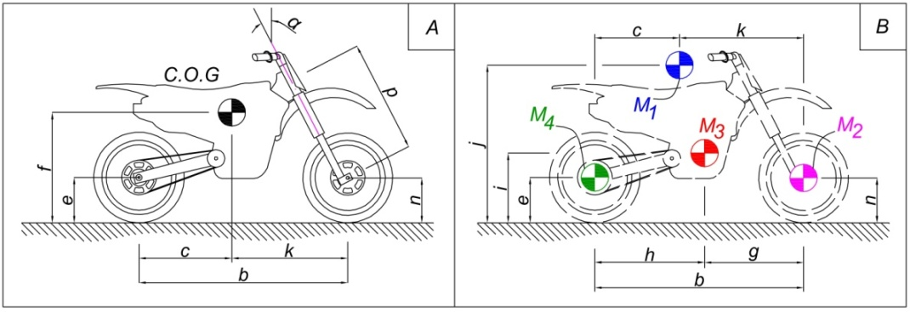
Fig. 1: Motorcyle’s layouts
A: Motorcycle with its centre of gravity (C.O.G), B: Substituted masses of motorcycle
$$a=\frac{c}{f}∙g$$ | (1)
With a similar approach, deceleration (d), arising during braking (Fig. 2-B), was identified by considering criteria of “Forward Flip Over” (Cossalter, 2002). In this state, the deceleration was upper limited by a value at which there had not existed a road reaction placed on the rear wheel. Equation (2) was used for this calculation.
$$d=\frac{k}{f}∙g$$ | (2)

In terms of bumping (Fig. 2-C), the scenario was supposed to occur instantaneously when the motorcycle hit, and tried to run through, a small obstacle on road. Once bumping, reactions originated from the obstacle theoretically made the motorcycle to decelerate in horizontal direction, and accelerate vertically. To critically consider the bumping state, horizontal deceleration was supposed to be the maximal allowable d shown in braking process, while vertical acceleration was assigned to a magnitude of 4g.
Regarding the last load-case shown in Fig. 2.2-D, the motorcycle was inspected when it was turning at a proposed constant velocity (V) of 80km/h. In this consideration, radius of curvature road (R) was assumed to be 100m; whereas, centrifugal acceleration (a_{centrifugal}) was determined following equation (3).
$$a_{centrifugal}=\frac{V^{2}}{R}$$ | (3)
Based on the determined parameters, a FE frame model was then constructed by employing Altair Hypermesh. During the construction, structural steel (without specific label) properties were assigned to the 3D tetrahedral elements (TETRA10) of the model. Other essential setups of the model were carried out following a normal procedure of FE model construction for static analyses.
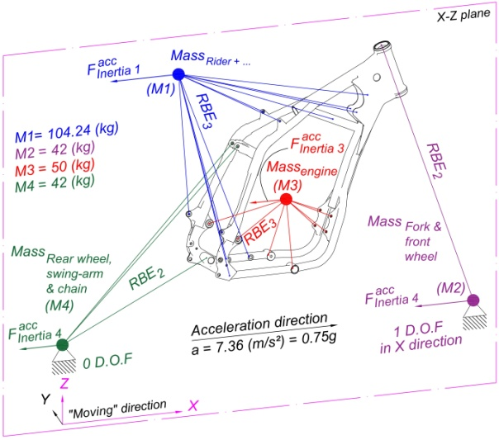  A | 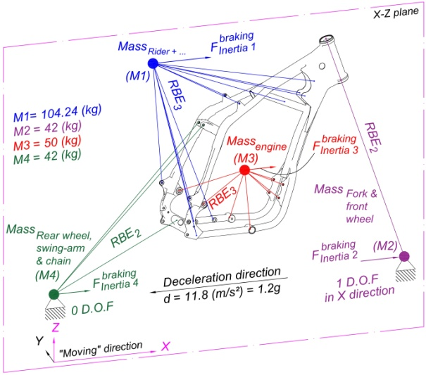  B
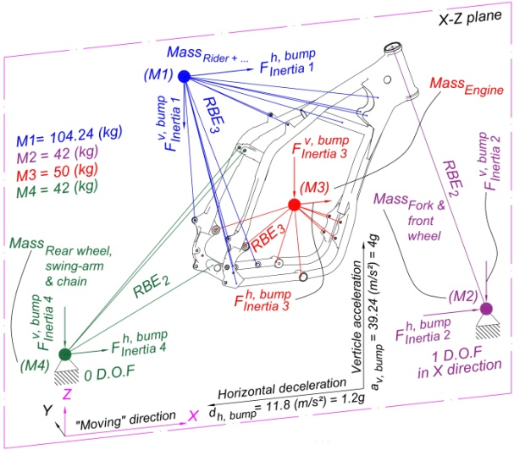  C | 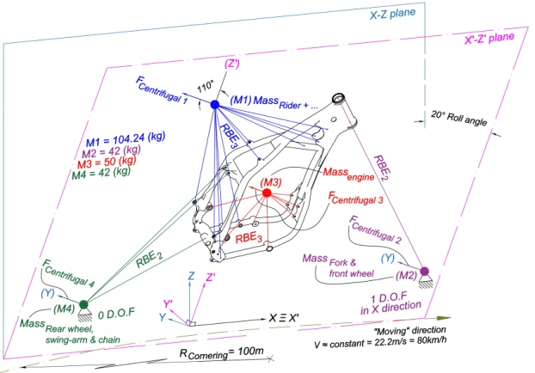  D
Fig. 2: Four proposed working scenarios of the motorcycle
A: acceleration, B: braking, C: bumping, and D: cornering
FEM structural analyses
To evaluate the issued FE model, modal and linear static analyses were essential to be carried out. Concerning the former, aims of the job were to estimate resonant frequencies of the frame at which it might vibrate resonantly, leading to detrimental damages, and to achieve as well predicted deformed shapes. In such analysis type, an applied solver, Optistruct, was used to solve equilibrium equation (4)
$$\left[K-λ.M\right]x=0$$ | (4)
where, K, M, and x were stiffness matrix, mass matrix and displacement vector, respectively for eigenvalues (λ) calculation. Upon receiving the estimated eigenvalues, resonant frequencies (f) were computed based on equation (5) (Altair University, 2015).
$$f=\frac{\sqrt{λ}}{2π}$$ | (5)
The three first frequencies of the analyses were subsequently extracted for further evaluations. In terms of the latter, Optistruct was also employed to figure out static problems concerning the four determined load-cases. This task was handled by solving the well-known equation (6)
$$K.x=f$$ | (6)
where, K was stiffness matrix, x was displacement vector, and f was external force vector. Finally, the predicted results of both analyses were saved into H3D files, which could be then visualized by Hyper-view to evaluate.
2.2 New frames design and analyses
New geometry concept for reference
To develop new design concept, a modern input geometry was firstly proposed and imported into “Inspire” for subsequent setups. The input must include constraint features as those of the original one, which had to be kept during the developing phase so that a frame, created based on the output, could be used interchangeably. Moreover, the inputted geometry should have enough design volume to provide high flexibility for the concept issuance. In principle, Inspire will generate a novel concept of design by solving topology optimization problem (Altair, 2015). Dealing with this, a density method called Solid Isotropic Material with Penalization (SIMP) is applied to transform topology optimization into material density optimization. Actually, material density tends to vary in a range of [0, 1], demonstrating free volume state or fully dense material. During this optimization, however, the material density of elements has to be selected either as 0 or 1. Hence, a “Power law representation of elastic properties” algorithm, represented by equation (7), is subsequently employed to impose a penalty on intermediate density as well as assign mandatorily 0 or 1 as the density of each element.
$$\underline{K}\left(ρ\right)=ρ^{p}K$$ | (7)
Where, $\underline{K}$ and K are penalized stiffness matrix and real stiffness matrix of element, ρ is the density, and p is the factor of penalization.
In the next step, pre-optimized model was established similar to that of the original frame, taking into account all necessary modifications, to synchronize the model with the proposed design volume. To control the optimization, boundary conditions, such as objectives, frequency and thickness constraints were essentially determined. In details, maximizing stiffness of output geometry was set as an objective of the optimization. The frequency was estimated towards maximizing its value; whereas, thickness constraints of the frame were restricted at 25mm. It should be also noticed that design space must be identified before the optimization. Upon completion of running, a novel concept of design was obtained, which would be used as an updated reference for redesigning frame geometry.
CAD geometry of new design frames
Similar to process of reconstructing the original frame, redesigning solid and tubular CAD frames were also handled by employment of Inventor as a developing tool. It was noticed that these redesigns should imitate as many as possible the features developed in the new design concept. Furthermore, additional elements were implemented into the redesigns as essential modifications aimed at reaching the preset targets. Those concerned CAD files, eventually, were exported for FE models construction as well as FEM structural analyses.
FE model of redesigned frame and FEM structural analyses
Issuances of new FE models, describing the redesigned frames working under different proposed conditions, were taken place similar to the process presented in 2.1. However, since there was presence of some modifications shown in the redesigned geometries, one should pay attention to differences in way of connecting four substituted masses and the redesigned frames. Concerning FEM structural analyses, procedure used to analyze the new FE models was the same as that described in 2.1.
2.3 Frames with lattice structure, design and analyses
Implementation of lattice structure into the redesigned frames
Basically, process of (meso-scaled) lattice implementation was handled following the first stage of lattice optimization. In such step, lower density bound (LB) and upper density bound (UP) must be firstly defined to help Optistruct identifying intermediate density elements. Subsequently, elements of which densities were lower than the LB will be eliminated while those with their densities higher than the UP would be assigned to solid elements. The remaining elements, therefore, possessed intermediate densities, which will be then transformed into beam structure. In addition, porosity of the FE models also has to be determined. This could be done via controlling the amount of intermediate density elements in the model (Altair, 2015). Since our main aim was to create structure, showing as high stiffness as possible, an output structure should be generated with low number of intermediate density elements, implying low porosity structure with minimal compliance. Stiffness of the obtained intermediate density elements would be approximately calculated following equation (8)
$$E=ρ^{1.8}E_{o}$$ | (8)
where, E was homogenized Young’s modulus of intermediate-dense material, E₀ was Young’s modulus of fully dense material, ρ was the density, and 1.8 was the natural penalty selected when low porosity was set.
It should be pointed out that to keep outer shapes of the redesigned frames for the aesthetic purpose the LB should be selected as zero. Besides, it is also necessary to notice that after running the lattice implementations, diameters of the issued lattice beams were directly proportion to density of the intermediate-dense elements (Altair, 2015). Since there were considerable amounts of tiny beams existed in the two FE models, which seemed unfeasible to be practically fabricated by laser-based AM, an additional design step, which proposed by authors, was further added to substitute all lattice beams by those of which radii were set equally and fell in a feasible fabricated range. In this paper, these values were initially assumed to be 0.8mm for beams of both solid-lattice frame and tubular-lattice frame.
Size optimization for the issued lattice structures and FEM structural analyses
Size optimizations were also handled by Optistruct to optimize cross-sections of the issued lattice beams. In our consideration, radii of beams’ cross-section were set as design variables which could vary in pre-defined millimeter ranges of [0.3-1.3] and [0.2-1.3] for solid-lattice and tubular-lattice frames, respectively. Whereas, properties of lattice beams were considered as functions of the mentioned radii, principally described by equation (9), and could be modified to figure out problem of minimizing the lattice volume (Altair, 2015).
$$p=C_{0}+Σ{DV}_{i}.C_{i}$$ | (9)
Where, p was the property, C_{i} were linear factors, and DV_{i} were design variables. In addition to the above parameters, optimization’s constraints were also necessary to be defined to guarantee that distributions of equivalent stress predicted in lattice structures of these frames would not exceed a value of 201MPa (n_{safety}=1.045) during different working scenarios of the motorcycle. It should be further noted that after the process, it was unnecessary to set up again the FE models. Once the size optimizations were completed, FEM structural analyses were then handled similar to the process shown in 2.1.
Linear-buckling analysis
In linear buckling analysis, the four proposed load-cases, used as references, were firstly analyzed in linear static mode, of which estimated stresses were applied to issue geometric stiffness matrix (K_{G}) (Altair, 2015). Buckling loads were subsequently predicted via Lanczos method by solving equation (10).
$$\left(K-λK_{G}\right)x=0$$ | (10)
Where, K was stiffness matrix of the frame containing lattice structure, λ was buckling load factor, and x was the related buckling displacement. It is essential to emphasize that the lowest calculated eigenvalue was mainly dealt with the buckling. Additionally, the analyses provided information of buckling load factors, showing those estimated critical loads under which buckling would occur.
3. Results and discussions
3.1 Original design, new concept, and redesigned CAD geometries of the frame
In this section, original design, new design concept of the motorcycle frame, as well as those developed CAD geometries based on the optimized concept were represented. As can be seen from Fig. 3-A, the original geometry was re-constructed towards a homogenous solid structure to adapt with laser-based AM technique. In Fig.3-B, a new concept of design obtained after topology optimization was represented. From the figure, it is seen that the proposed design volume was demonstrated by wire elements; whereas, a blue component indicated the achieved concept having constraint features that would not be modified through all designing stages. By referring to this concept, an initial redesigned geometry has been created and shown in Fig.3-C. It can be realized from Fig.3-C that the created geometry imitated almost all characters of the received conception, except for some disconnected elements which were necessary to be adjusted for generating well interconnected structure. In fact, this first developed frame was completely a dense object, showing almost two times heavier than the original (table 2). Taking this point into consideration, final designs would, therefore, be further innovated by implementations of hollow structure (in tubular form), lattice beams, or a combination of the two to lessen weight while being able to maintain reasonable stiffness of these frames. Fig.3-D showed one of examples of the generated frames, in which lattice beams were implemented into tubular structure.
3.2 Linear static, modal, and linear buckling analyses
This section briefly demonstrated all concerned results of linear static, modal, and linear buckling analyses. The obtained results were firstly summarized in table 2. From the table, it can be recognized that the highest equivalent stress values were estimated in bumping for all considered structures. This is probably due to the highest proposed gravity loads placed on the motorcycle system during this working condition. In particular, the most critical value of 2.046E+02MPa which nearly reached strength of structural steel (2.100E+02MPa) was detected in lattice beams of the redesigned solid-lattice structure. This value is believed to result from transmissions of the aforementioned gravity loads to groups of tiny beams possessed quite small circular cross-section (0.5mm in radius). Whereas, maximal stress intensity predicted in dense portion of the frame stood bit far below strength of the constituted material at 1.793E+02MPa. Based on what we achieved, it is suggested that bumping was the most critical working condition, which was necessary to be paid more attention during designing process.
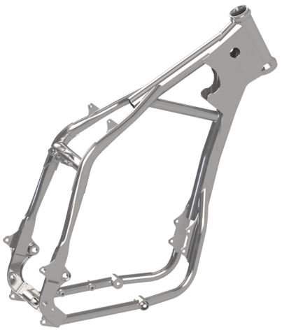  A | 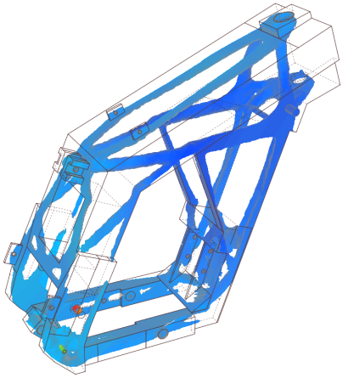  B | 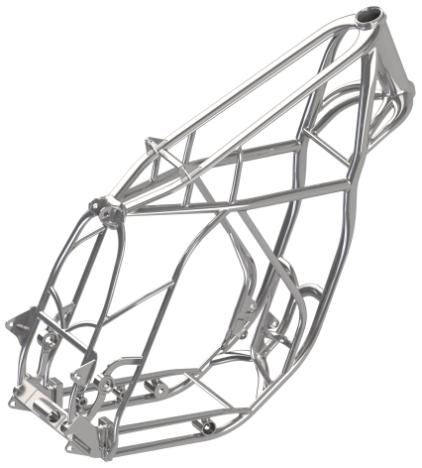  C
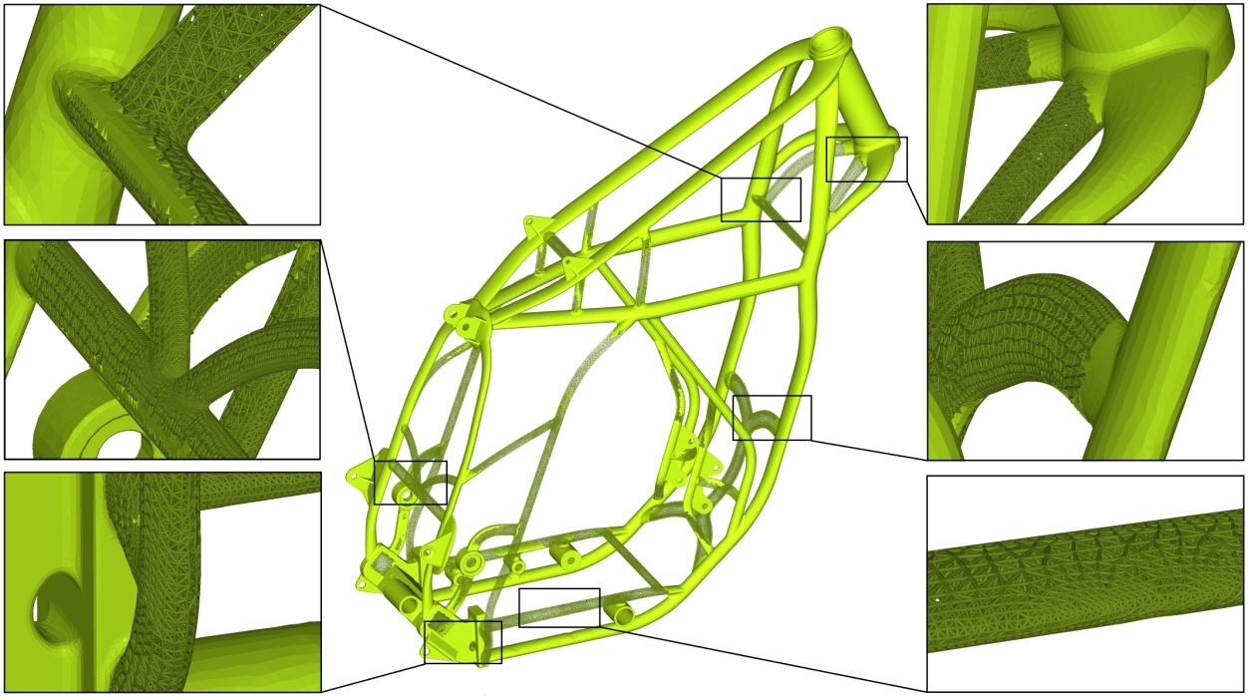
D
Fig. 3: Frame design development
A: “original” frame, B: concept of new frame, C: redesigned frame, D: tubular lattice frame
In order to have clearer views of how stress distributed in original design as well as in the developed frames during bumping, estimated static stress results found in these structures were selectively collected and represented in Fig.4. According to the figure, it is clear that high stress intensities tended to distribute at locations where significant changes in cross-section of the frames were detected. For example, in the original design, the highest intensity of stress (around 168MPa) was found at joined areas between the two upper brackets and the two upper tubes, as well as at vicinity of the rear suspension hole. On the one hand, occurrence of these high stress concentrations was derived from the above reason. On the other hand, high transmitted loads either from the heaviest mass M1 to the upper brackets (via RBE3) or from the upper portion of the motorcycle to the “anchored” rear mass M2 (via RBE2) might also result in the observed features. It should be explained further that the use of RBE2 in the FE models may lead to body rigid motion and lack of absorption of transmitted forces into intermediate components for which RBR2 were substituted. Nevertheless, an application of this 1-D element could provide an enough stable structure for linear static analyses as well as enable us to consider the frame under higher load interaction, meaning more safety consideration. Hence, to this extend the application of RBE2 could be accepted. In addition to the mentioned features of stress, it can also be realized from Fig.4 that there was a slight difference of stress distribution between left and right parts of the frame. The reason might be originated from asymmetric design of the original frame, particularly at pedal positions where only one connection area was arranged on the right side of the frame; while there were two connecting holes set up on the opposed direction. As a consequence, the predicted stress would slightly distribute in an asymmetrical way within the frame. Dealing with the redesigned tubular-lattice frame shown in Fig.4-C, D, it is necessary to mention that since only less stressed solid components of this structure were exclusively substituted by lattice beams, the upper limit of stress found in these beams (8.347E+01MPa) was reduced to circa one-third of that predicted in beam elements constituting the other lattice frame. Whereas, the dense portion of the frame had a maximal predicted stress equaled to 1.701E+02MPa, demonstrating a small deviation with respected to the highest stress (1.793E+02MPa) estimated in solid part of the redesigned solid-lattice frame structure.
Table 2: Summary of linear static, modal, and linear buckling analyses’ results
 |  |  | Original frame | Redesigned solid frame | Redesigned tubular frame |  | Redesigned solid-lattice frame |  | Redesigned tubular lattice frame
 |  |  |  |  |  |  | Solid | Lattice | Solid | Lattice
Mass (kg) |  |  | 13.06 | 25.21 | 16.45 |  | 5.691 | 15.19 | 12.72 | 2.424
Element quantity |  |  | 1058908 | 1191879 | 1738218 |  | 432614 | 998632 | 1334541 | 549414
Optimized R* (mm) |  |  |  |  |  |  | 0.5 |  | 0.3
Max  static stress (MPa) | Acceleration |  | 5.186E+01 | 5.133E+01 | 5.543E+01 |  | 7.731E+01 | 7.286E+01 | 6.356E+01 | 4.303E+01
 | Braking |  | 1.189E+02 | 6.906E+01 | 1.049E+02 |  | 1.085E+02 | 1.725E+02 | 1.076E+02 | 9.744E+01
 | Bumping |  | 1.679E+02 | 1.208E+02 | 1.407E+02 |  | 1.793E+02 | 2.046E+02 | 1.701E+02 | 8.347E+01
 | Cornering |  | 8.375E+01 | 3.532E+01 | 6.297E+01 |  | 6.819E+01 | 7.480E+01 | 7.758E+01 | 3.823E+01
Modal analysis | Mode  1 | F* | 1.295549E+02 | 1.334041E+02 | 1.462926E+02 |  | 7.102859E+01 |  | 1.198853E+02
 |  | T* | Torsion | Torsion | Torsion |  | Torsion |  | Torsion
 | Mode  2 | F* | 1.939753E+02 | 1.626859E+02 | 1.776109E+02 |  | 8.623605E+01 |  | 1.551867E+02
 |  | T* | Lateral | LT* | LC* |  | LT* |  | LC*
 | Mode  3 | F* | 2.196647E+02 | 2.289392E+02 | 2.311567E+02 |  | 1.180079E+02 |  | 1.712857E+02
 |  | T* | LT*³ | Lateral | Torsion |  | Torsion |  | Torsion
BLF* | Acceleration |  |  |  |  |  | 1.438852E+01 |  | 1.799555E+01
 | Braking |  |  |  |  |  | 1.438979E+01 |  | 1.799954E+01
 | Bumping |  |  |  |  |  | 1.437738E+01 |  | 1.798309E+01
 | Cornering |  |  |  |  |  | 1.439003E+01 |  | 1.799818E+01
*F denotes resonant frequency (Hz)  *T denotes type of resonant deformation  *R denotes radius of lattice beam after size optimization |  |  |  |  |  | *LT denotes longitudinal tension  *LC denotes longitudinal compression  *BLF denotes buckling load factor for lattice beams

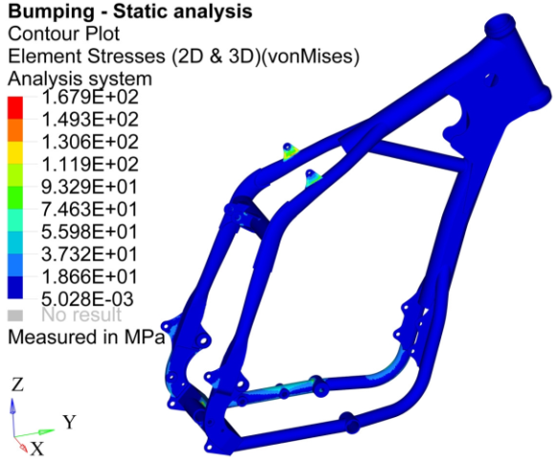  A | 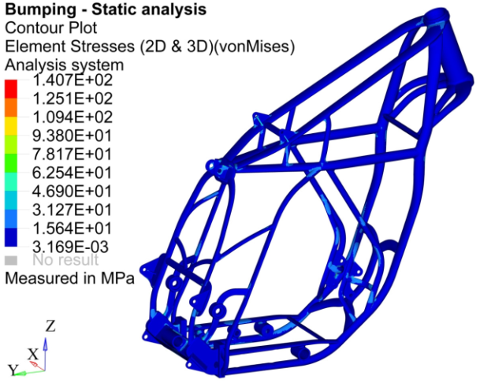  B
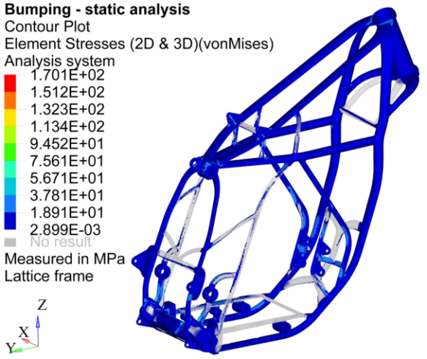  C | 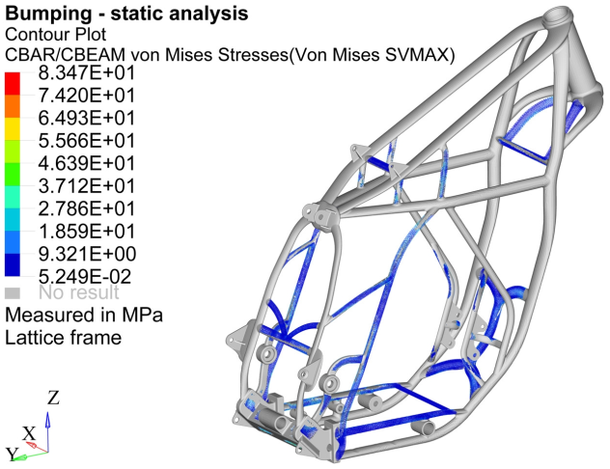  D
Fig.4: Equivalent stress distribution predicted in
A: original design, B: redesigned tubular frame, C and D: redesigned tubular frame with lattice

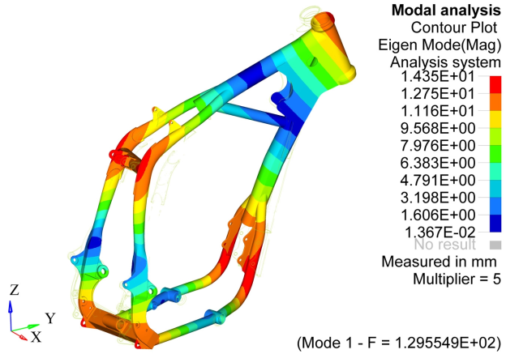  A | 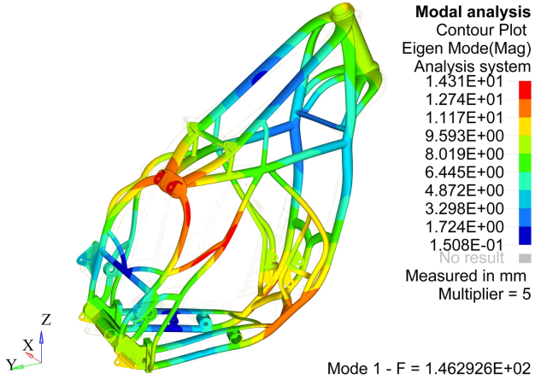  B
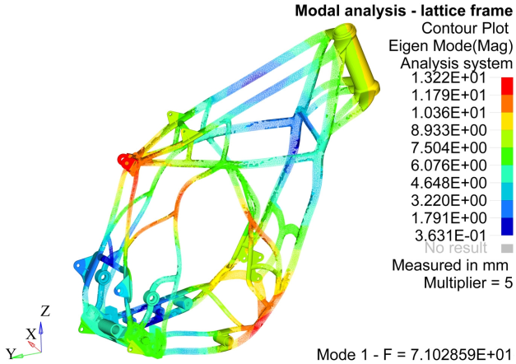  C | 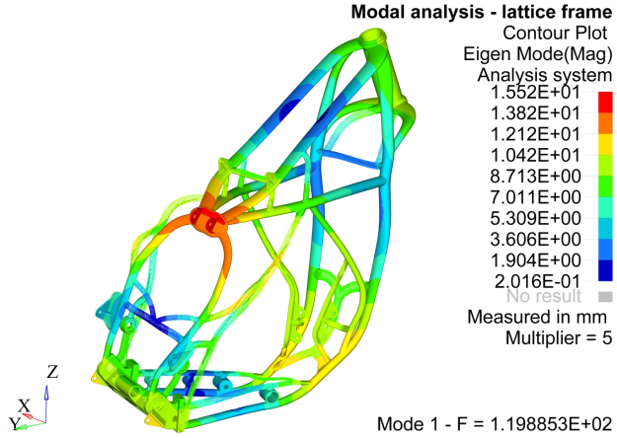  D
Fig.5: Mode 1 results of modal analysis in A: original design, B: redesigned tubular frame,
C: redesigned solid-lattice frame, and D: redesigned tubular-lattice frame
In order to give evaluations of how stiff these frames were, FEM modal analyses were additionally handled to obtain important information regarding natural frequencies and sorts of resonant deformation. From those achieved results listed in table 2 and Fig.5, it can be recognized that the redesigned tubular frame was probably the stiffest structure since it possessed the highest first resonant frequency of 1.462926E+02Hz, which was around 17Hz higher than that of the original one. However, the stiffest frame also represented its mass exceeding 3.39kg to that of the original. Therefore, in our proposed method of design, lattice implementation was introduced into the frame structures to lessen as much as possible their masses while being able to maintain their stiffness at reasonable values for safety reasons. In more details, results of the tubular-lattice frame indicated its first resonant frequency and mass being 1.198853E+02Hz and 15.144kg respectively, which were seen as comparable values with those of the original frame designed by traditional methods. These results may be used to evidence that our proposed method of designing laser-based AM frame worked quite acceptable and it is very promising to further develop and selectively extend this method to state-of-the-art AM structures for future applications. Nevertheless, it is necessary to emphasize that since the main aim of lattice implementation was to reduce mass and to attempt holding frame stiffness at reasonable values, it is recommended to implement this porous component only into less stressed structures. Otherwise, despite of obtaining a mass reduction purpose, the designed structure would experience a significant drop in stiffness, as similar to that shown in the redesigned solid-lattice frame (Fig.5-C) of which a majority of solid components were substituted by lattice beams. It is also necessary to note here that during mass estimation in Optistruct there might be an existence of overlapped material at junction areas between beams; hence, a value of calculated mass was probably over-estimated. In spite of this estimation, the results might imply that an enhancement of frame stiffness is closely associated with an increment of mass, as a result of “penalization”
In view of buckling, the linear buckling analyses were only carried out for the two lattice frames since their tiny beams (slender components) might be really sensitive to buckling under influences of compressive stresses. The concerned results were listed in table 2, giving information of buckling load factors (BLF) which used to demonstrate safety factor in buckling mode. As can be observed from the table, minimum estimated BLF of 1.437738E+01 was found in the redesigned solid-lattice frame, implying that the frame could be loaded (at minimum) more than 14 times of the bumping gravity loads until buckling happens. While in case of the tubular-lattice frame, its minimal estimated value of BLF was 1.798309E+01. Nevertheless, it should be recognized that in practice due to presences of structural/material imperfections, the fabricated frame may be buckled at a load being lower than the predicted values.
4. Conclusions
This article represented a new method of designing laser-based additive manufactured frame of a motorcycle. Principle of the method was based on combination between topology and lattice optimizations. In details, an initial design volume was firstly proposed for running the topology optimization towards maximizing frame stiffness. Upon completion of redesigning frames based on the optimized concept, lattice beams were implemented into these structures aimed at lessening their mass while maintaining their stiffness at reasonable values. Our results showed that stiffness of the new lattice frames were strongly depended on components where lattice structure was used to substitute. For example, if the porous structure was implemented into high stressed parts, the obtained frame would experience a signification diminution of stiffness with respected to that of the original solid form. This finding seems to be contrary to what stated in a study of Rosen, saying that solid sections of a structure replaced by cellular component could be stiffened. Despite of a certain stiffness reduction, our final design of tubular-lattice frame demonstrated comparable values of first resonant frequency and mass with respected to those of the original designed traditionally. In addition to these results, buckling analyses revealed estimated buckling loads being approximately 17 times higher than the proposed gravity loads applied on the same frame structure. Finally, those equivalent stress estimation of the considered frames suggested that all of these frames worked in safety conditions.
5. Future works
In future, our works would focus on further developing the design method to optimize AM structures in terms of stiffness, mass, fatigue, and shape. Additionally, it would also be interesting to extend the method to different mechanical components which are promising to be applied laser-based-AM technique. Last but not least, integrations between the design method and the relative fabrication process should be further investigated as well to be able to determine effective procedures of manufacturing high-quality-AM components for future applications.
6. References
F. Ballo, M. Gobbi, M. Massera, G. Mastinu (2014). A race motorcycle Frame: advance design. 16th International Conference in on Advance Vehicle Technologies, USA
K. Kawata (2015). Development of a motorcycle frame with low stiffness in the side direction for racing. JSAE/SAE Small Engine Technologies Conference & Exhibition
“Design inspired by nature” URL
www.airbusgroup.com, 20 May 2016
E.C. Santos, M. Shiomi, K. Osakada, T. Laoui (2006). Rapid manufacturing of metal components by laser forming. International journal of Machine Tools and Manufacture, Vol.46, page 1459-1468
V. Cossalter (2002). Text book of motorcycle dynamics
Altair University (2015). Practical aspects of finite element simulation, 3rd edition
Altair University (2015). Practical aspects of structural optimization, 2nd edition
D.W. Rosen. Design for additive manufacturing: a method to explore unexplored regions of the design space

Corresponding author. Tel: +352 46 66 44 5940.

