Design of Automotive Road Racing Rim with Aid of Topology Optimization
Laurent MARINI (laurent.marini.001@student.uni.lu),
Slawomir KEDZIORA (slawomir.kedziora@uni.lu)
Faculty of Science, Technology and Communication
University of Luxembourg, Campus Kirchberg, 6 rue Coudenhove-Kalergi
L-1359 Luxembourg, Luxembourg

Keywords: racing rim; finite element method; topology optimisation

Abstract
A goal of the project was done to develop a new good-looking racing rim of a sports car which would be lighter than existing ones. To achieve the goal, lightweight magnesium alloy Mg ZK60-T5 was applied for the rim, and its preliminary shape was developed employing topology optimisation. The rim was designed for forging technology; this means that it had to have all manufacturing features required by that production process.
Based on a literature review, loads, boundary conditions and structural requirements were established, which are crucial for a further development process.
The initial design was created using the topology optimisation, and then a parametric model was developed using a CAD system. As a next step, the first part of validation was done employing FEA in order to meet strength and stiffness targets; some modifications of the CAD model were imposed. As the last step, the final validation was done employing simply fatigue assessment. The optimisation and FEA were completed using Hyperworks 14/ Inspire 2015 software and the CAD model employing Autodesk Inventor 2015.
The results show that the rim design meets theoretically all structural requirements and a good-looking shape was reached. The total mass of 7.9 kg of the designed rim is obtained, which means a reduction about 1.8 kg with the comparison with a reference rim. The 3D model and a technical drawing are completed; this means that the rim can be sent to a production phase.
The results of the project also show that the topology optimisation technology provided by Hyperworks and the advanced CAD system can be used to generate competitive designs with any design offices without difficulties.

INTRODUCTION
Today’s industry seeks to produce parts using less material while keeping the same functional characteristics. Concretely, these are parts that can be designed by an optimisation process resulting in Lightweight Design. The design lightness is important, as a part mass is one of the most important factors influencing a dynamic system such as a complete vehicle. Indeed, the lighter a vehicle becomes, the more significant the impact will be on its acceleration, deceleration, fuel consumption, emissions and handling. In the main, car performance improves as its mass is reduced. This is important, especially for a racing application. However, some vehicle components have a particularly significant effect on performance. For instance, a little mass reduction on some rotating parts such as wheels will considerably effect on the overall performance of the car. Therefore, the main goal of this study is to optimise an automotive rim by using a developed design process in order to reduce the mass. The wheels are considered a part of the unsprung masses, which are parts that are not supported by the car suspension. While the rims are assumed ones of the most important components, there are other unsprung masses such as tyres, brakes and drive shafts. All these unsprung masses have an impact on the driving characteristics, as by reducing them, the suspension will more easily keep contact between the tyres and the road surface. Hence, the simplest way of improving handling is to replace the unsprung components by lighter ones. As the rims are assumed to have the highest impact, it is important to focus on them, principally in the road-racing environment. Indeed, using the full vehicle potential is of utmost importance in the racings, where a small technological advantage can affect scores considerably.
To achieve the mass reduction and to increase product performance of the road racing rim, in this study, Topology Optimisation was applied. Analyses on the road-racing rim is an excellent task for applying this innovative technology. As the resulting components are optimized for defined load cases, the material use is considerably reduced, making the lighter component. Simultaneously, the component functional features are maintained. Furthermore, it allows cost-effective development of new components due to fewer design iterations and therefore, less design effort. All these aspects contribute to supporting Topology Optimisation as an auspicious tool for mass improvement and thus explains the motivations of this study.
As the first step, sets of boundary conditions were defined using existing specified calculation formulas to simulate loads (forces, moments and pressure) acting on the rim under different driving conditions. Then, assumptions on the neighbouring parts of the rim (e.g. a tyre model) were made.
After the second development step using Topology Optimization, an adapted 3D-Model to current manufacturing technologies has been created. To analyse the rim behaviour in a realistic environment, a detailed CAD model was subsequently created using Computer Aided Design software Autodesk Inventor 2015. The obtained results were validated then using finite element analysis method. Subsequently, a final 3D-model was created, taking into account all manufacturing aspects, and then a detailed manufacturing drawing is issued for further processing. As a final point, a scaled down physical model of the wheel was produced using rapid prototyping techniques for presentation purposes.

Observed Failure Modes of Wheel
The car rims are loaded by cycling loads determined mainly by road conditions and a driving style of a driver. These parameters are particularly important for the road racing vehicle where the loads reach maximum values. Taking into account those facts, it should be expected that fatigue failure of the rims could be observed in sports cars. Actually, in racing applications, it can be seen that fatigue failure occurs commonly. This fact can be easily observed on user forums published on the Internet in different countries. Some interesting failure modes are presented below in Fig. 1.1 and Fig. 1.2. It can be easily predicted that all failures are common fatigue fractures caused by the cycling loading.
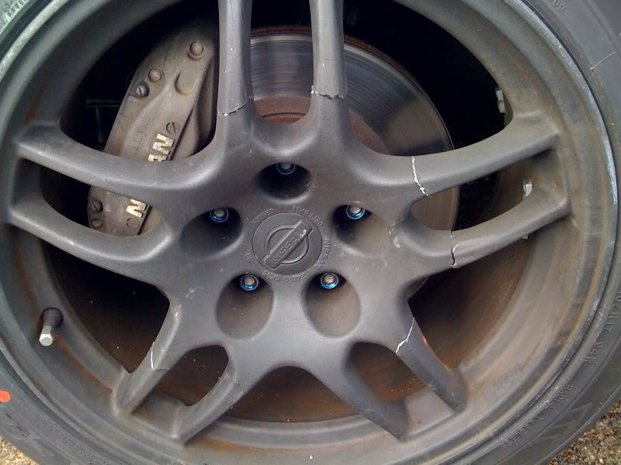
Fig. 1.1 Failure of wheel occurs during cornering; source: http://www.freshalloy.com/showthread.php/163887-R33-GT-R-OEM-wheels-cracked-!
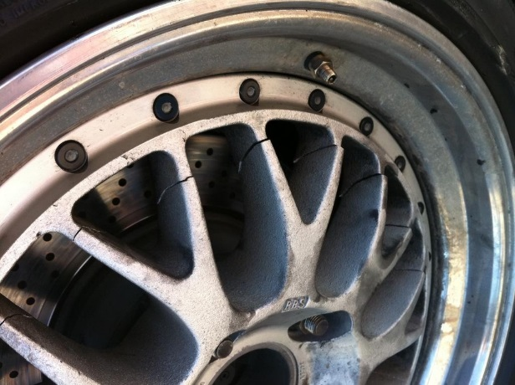
Fig. 1.2 Failure of wheel; source: http://rennlist.com/forums/racing-and-drivers-education-forum/631060-bbs-mag-wheel-failure.html
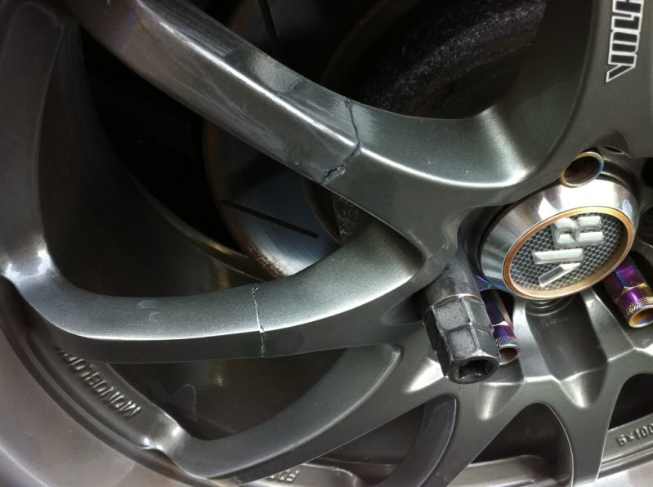
Fig. 1.3 Failure of wheel; source: http://www.evolutionm.net/forums/evo-tieres-wheels-brakes-suspension-sponsored-tire-rack/583697-those-running-xxr-s-becareful-2.html
The failure modes caused by static loading do not occur, and it is unquestionably easy to explain by stress analyses of the static loads using a finite element calculation method.
Fatigue analyses usually required extra data of material properties and in-depth knowledge of duty cycles of the particular car. The developed duty cycles should take into account all possible scenario of the loading and all driving styles.
The presented work is concentrated on the design of a robust road-racing rim; therefore, fatigue analysis is one of the main points of conducted validation analyses. A goal for the product validation is to check everything feasible by theoretical methods like FEA and the fatigue analyses as a real prototype, and track tests will not be achievable due to lack of funding for this project.

Literature Review
In the literature review, the general topics of Topology Optimization and Automotive Wheel/Rim Design will be addressed through the analysis of a selection of several research papers. In general, the analysed papers assess the impact of an optimisation process on the mass reduction of components.
The concepts raised in the papers had a positive influence on the different steps, followed by this study. Definitely, during the reviewing of literature, several main areas of study and good practices were highlighted, and they are grouped in the next following subsections. They have organised in the following order: Forces Applied on Components, Material Selection and Topology Optimisation and they contain literature review for those particular topics.

Forces Applied on Components
As was shown in the previous chapter, the loading is the most critical parameter for design and analysis on the rim. The selected load cases are essential for finite element analyses as well as for the topology optimisation, and this is highlighted by (Meyer-Pruessner, 2007). – “It is essential to select the loading carefully on components as they have a high impact on the topology optimisation's results.”
Since the field tests were not conducted, it is crucial to develop the load cases, which are realistic for the racing rims. Therefore, calculation formulas proposed by (Trzesniowski, 2008) were used to determine the loads acting on a racing wheel. Additionally, fatigue load cases are defined to simulate fatigue test conditions defined by SAE recommendations (SAE, J328 JUN 1994). The test conditions provided by this document are simplified and concern two load cases for normal highway conditions the first one called dynamic radial load and the other one - dynamic cornering load. The test conditions are presented in details in the next chapters of this work. Both cases are not describing the real conditions of the racing cars; therefore, the minimum fatigue safety factor of 1.5 is required regarding the material endurance limit. The safety factor is arbitrary, defined based on the authors’ experiences. It should be emphasized, that detail measurements of loads should determine the real racing conditions during the test. Unfortunately, this is outside the scope of the project due to the time and funding limitations of the project.

Material Selection
Spontaneously, one could think of using an aluminium alloy for the rim construction as this material is widely used in lightweight designs. However, the reading of (Saran Theja & Vamsi Krishna, 2013) revealed interest and superior characteristics of magnesium alloys. The same findings were highlighted by (Pekguleryuz, Kainer, & Kaya, 2013) and insisting on a possible application to the road-racing rims. Furthermore, (Dong, Liu, Ding, & Zou, 2011) pointed out methods for heat and surface (shot peened) treatments to further improvement of the magnesium alloy - Mg ZK60-T5 relative to ZK60). Therefore, the magnesium alloy ZK60-T5 was selected for the alloy from which the rim is designed. The following authors (Liu, et al., 2009) and (Dong, Liu, Ding, & Zou, 2011) published the properties of the selected alloy, unfortunately only as extruded. The current wheel is designed in order to be forged; therefore, the strength properties of this alloy should be slightly better than for extruded ones.
However, as shown by (Chaitanya & Ramana, 2015) magnesium has to be handled with special care, particularly in powder form or shavings because of a risk of fire. This can be very important during the manufacturing process like machining, where a large amount of chips is produced.
The next difficult for the magnesium alloy, which can be seen, is corrosion of the magnesium rim. It could be a problem, but currently, there are technologies, which allow us to protect the rims from corrosion. At least two technologies currently available to protect the rims which can be mentioned, these are namely:
- An electrochemical treatment, which does not cause any weight increase.
- Traditional painting carried out on the road wheels, but which increases the weight slightly.
Summarising, the corrosion issue is no longer a concern for the magnesium rims nowadays. Consequently, usage of the magnesium rims more commonly does have any obstacles, especially for the road racing application where the cost of the rim is not so important, and vehicle performance is a driving parameter.

Topology Optimization of Wheel
The topology optimisation was done using Inspire software, and the finite element analyses were conducted using Optistruct solver, Hypermesh as a pre-processor and HyperView as a postprocessor. All software is coming from Altair Corporation, a leader on the market for simulations and structural optimisation and finite element analyses. The selection of the tools was successful, and they were helpful to achieve targets of the projects smoothly, and as an example, the same software package was used by (Das, 2014).
In recent years, topology optimisation methods have been exploited for a great variety of mechanical components showing excellent results. (Norberg & Lövgren, 2012) have highlighted such encouraging results on the development of a vehicle body structure. (Nagatani & Niwa, 2005) Showed this on the development of a bearing hub and (Zhou, et al., 2011) presented this also on various components such as an automotive bracket and a Formula 1 roll structure. Furthermore, (Fritsch, 2012) proposed a very inspiring case study where a mounting plate was optimised using a Topology Optimization process. Furthermore, (Xiao, Zhang, Liu, He, & Shan, 2014) showed a process of the multi-objective topology optimisation methodology for a steel rim presenting an analysis process in the form of a flow chart.
These results in various domains give the expectation that topology optimisation method yields promising results in the development process of automotive road racing rims. Essentially, math models of the wheel based on two particular works: (Zuo, Xie, & Huang, 2011) and (Das, 2014). These papers were an inspiration for this article.

Validation with Finite Element Analysis
As Topology Optimization is a relatively new branch, it can give designers only an initial shape, and the final design can be still done conventionally. It is essential to validate the final design using precise structural analyses. The verification can be done employing the finite element analysis and the fatigue assessment. Having the finite element model of the rim, it is straightforward to conduct stress and modal analyses so to ensure that stress and stiffness requirements are met. Those analyses can reduce significantly time-consuming tests. Therefore, it benefits directly shortening development time and therefore, reducing the cost of the final product.
Unfortunately, the finite element analysis and the fatigue assessment could be encumbered with some errors, which are coming typically from the proper application and material properties knowledge. Besides, neglecting manufacturing process defaults can bring an unexpected difference between the simulation and test results. Therefore, it is crucial that the final validation of the rim should be completed by the tests of the wheel/ rim in the real application. This should always be a final exam for any designed parts.
Consequently, the detail and realistic model of the rim is crucial for excellent quality results. Thus the elaborated model is complex. Many modelling advice came from the literature review.
It can be seen that some works are focusing on building the finite element model of the wheel/rim. First, as shown by (Stearns J. , Srivatsan, Gao, & Lam, 2005) tyre pressure has an influence on stresses in the rim, and therefore, it should be included during calculations. As well, a simplified tyre model, as discussed by (Li, et al., 2014), would be advantageous to improve the accuracy of the results, as the forces would be distributed more equally over the contact surfaces between the tyre and the rim. Taking into account these comments, the elaborated model includes the internal pressure and the tyre model. To verify the accuracy of the FEA tyre model, the concept of remotely applied forces over a tyre contact surface defined as an arc section of the wheel are employed, this solution was proposed by (Stearns J. , Srivatsan, Prakash, & Lam, 2014) and (Ballo, Gobbi, Mastinu, & Previati, 2015).
(Akbulut, 2003) Established a new hypothesis that a critical zone of maximum stresses can be identified on a boundary zone between the spokes and the rim flange. Unfortunately, it looks that this can be true only for a particular design of the rim. Nevertheless, these regions should be modelled with great care – using a small size of elements so to get good quality stress results.
According to (Satya Prasad & Anil Kumar, 2013) a target safety factor of 1.5 (minimum 1.0) should be achieved for cornering and radial fatigue tests. In the presented work, the target safety factor was set-up to 1.5 as the developed design is for the road-racing application but not for a standard road application.
As a final point, the first resonance frequency should be of a minimum of 350 Hz in order to reduce noise inside the vehicle, as was proposed by (Yaman & Yegin, 2013). The limit value of the frequency comes for maximum speed, which the vehicle can achieve on a smooth road. For the road racing application, the noise is not very important as for the standard rim. For that reason, there is additional space for mass reduction of the rim, allowing the lower first resonance frequency. This must be confirmed by testing and further investigation. For the presented project, the recommended value of the first frequency is used criteria for the stiffness assessment.
An interesting observation was made (Siva Prasad, Krishnaiah, Iliyas, & Jayapal Reddy, 2014) that a hump on the rim is an important feature to prevent the tyre from slipping under the action of lateral forces at high speed and consequently it can cause air outflow from the rim. The hump is implemented in the elaborated design of the rim.

GOALS
All the previous readings have highlighted many areas of interest and have been very helpful for the development of this study. However, there has not been sufficient evidence, from all collected information, whether the results of the structural topology optimisation could be easily adapted to current manufacturing technologies. This new particular aspect of considering manufacturing requirements in the design process using the structural topology optimisation is of major interest in this study.
The main goal of the work is to design a lightweight magnesium wheel/ rim with specific dimensions using the topology optimisation for the road racing application, which is ready for the production using an existing manufacturing technology.
Additionally, an appealing rim design is a critical parameter in the presented work– the rim should have attractive appearance since targeted customers of this product are tuning cars’ groups.

ANALYSIS METHOD
In this chapter, methods that were used to conduct the study will be explained in details. Staring for a measurement of the reference wheel and finishing with the final 3D design ready for the production.
First, the measurement work was done where overall dimensions of the wheel have been defined basing on the reference design of the rim.
Then, different load cases and boundary conditions have been defined using the proposed formulas from literature (Trzesniowski, 2008) for the road racing application. The forces acting on the car rim under different road driving conditions are represented by several loading cases.
Furthermore, the rim material has been selected as a magnesium alloy ZK60-T5, and the selection was made as was said, based on the literature review.
Following, topology optimisation software Inspire was used to create the first rim design using the defined boundary, and the load conditions, the selected material and the required dimension constraints. With the help of Computer Aided Design (CAD) software Autodesk Inventor, a three dimensional model of the rim was designed and adapted to the current manufacturing technologies
Then, an interactive process was employed consisting of the finite element analyses and the CAD modifications; as results of this process, the rim design was created and verified. As a final point, the CAD-model of the rim that includes manufacturing aspects has been created.
Lastly, a scaled-down prototype of the rim was produced using rapid prototyping techniques for presentation and visualisation purposes only.

Reference Rim
In this first step, an existing road racing wheel has been chosen as a reference (see Fig. 3.1) for a sectional profile measurement.
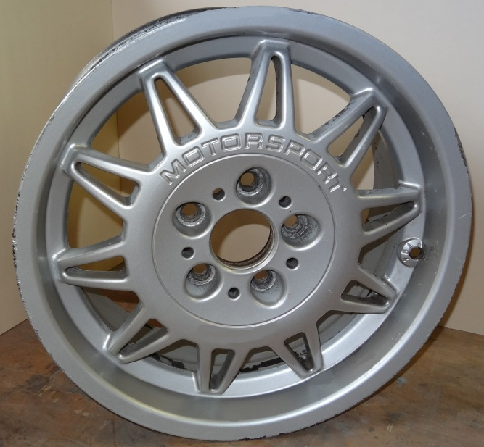
Fig. 3.1 Existing motorsport aluminium rim – reference rim
All the principal dimensions (see Fig. 3.2) of the existing rim have been measured so to create the based model, as it can be seen in Table 3.1. Furthermore, the mass of the reference rim has been measured for a reference purpose only.
Fig. 3.2 Main rim dimensions
Table 3.1 General dimensions of reference rim
Parameter | values
Diameter D | 17“
Width W | 7.5”
Offset ET, mm | 41
Pitch centre diameter PCD, mm | 5 x 120
Hub centre diameter CD, mm | 72.4
Mass of reference wheel, kg | 9.7
Consequently, to finalise the dimensional measurement of the reference rim, the shape of the rim has been measured using a profile gauge (see Fig. 3.3).
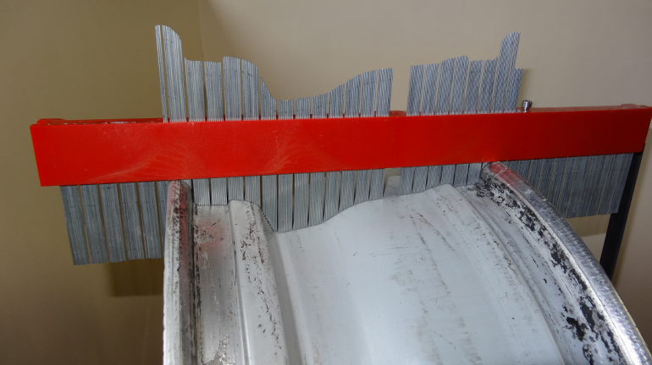
Fig. 3.3 Profile gauge
The existing wheel should be taken only as a reference for the dimensional constraints. Indeed, data concerning material properties of the rim are not known, and boundary conditions and loads are chosen by a manufacturer to design this rim are unknown. Thus, a direct comparison between masses of the reference rim and the newly developed rim should be made with special care because it could lead to incorrect conclusions.
In the presented work, the minimum mass is not the only target; besides, the robustness and appearance of the design are equally important. Therefore the reduction of the mass of the proposed design is lower than one estimated only based on a change of the material from aluminium to magnesium.

Load Cases Definition
In this step, the different forces, which act on a wheel during the driving of the vehicle in the different road conditions, have been estimated. The different driving conditions have been divided into 6 load cases that are detailed in the following section.
The calculations of the load cases are basing on the formulas from literature (Trzesniowski, 2008). A summary of the results is shown in Table 3.5 Discrete tyre model - parameters.
To perform the calculations, a reference vehicle - BMW 323ti was selected for which the reference rim is suitable. The mass of this vehicle according to the user manual (BMW, AG, 1998) is of 1330 kg, including a driver and a full tank.
Denotation, according to (Trzesniowski, 2008):
$F_{W,Z}$ - Vertical force at the centre of tyre contact
$F_{W,Z,0}$ - Static vertical force at the centre of tyre contact; with driver and full tank
$F_{W,Y}$ - Lateral force at wheel
$µ_{W,Y}$ - Coefficient of friction in lateral direction
$F_{W,Z,f}$ - Vertical force at the centre of front tyre contact
$F_{W,Z,f,0}$ - Static vertical force at the centre of front tyre contact; with driver and full tank
$F_{W,X,b,f}$ - Brake reaction force on the front axle
$µ_{W,X}$ - Coefficient of friction in longitudinal direction
$F_{W,Z,r}$ - Vertical force at the centre of rear tyre contact
$F_{W,Z,r,0}$ - Vertical force at the centre of rear tyre contact; with driver and full tank
$F_{W,X,b,r}$ - Brake reaction force on the rear axle
$F_{W,X,a}$ - Acceleration force in the centre of tyre contact of one wheel
Vertical impact
The vertical impact assesses the force acting radially on the vehicle wheel when driving over a road hole or a bump. The force acts in the vertical plane perpendicular to the wheel axis (see Fig. 3.4).
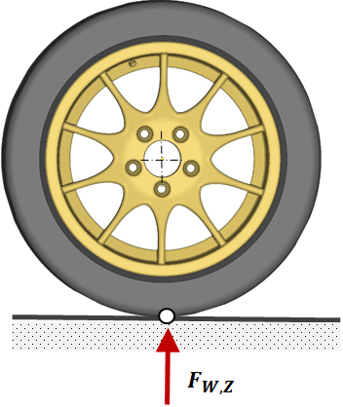
Fig. 3.4 Load case - “Vertical impact”
 | $$F_{W,Z,0}=\frac{1330 kg ∙ 9.81 \frac{m}{s^{2}}}{4}=3261.83N$$ | (1)
 | $$F_{W,Z}={3∙F}_{W,Z,0}=9785.59N$$ | (2)

Cornering outside wheel
The cornering forces on the outside wheel (e.g. left wheel in a right-hand turn) are divided into two components. The first force vector $F_{W,Z}$ acts radially towards the centre of the wheel in the vertical plane perpendicular to the wheel axis. The second force vector $F_{W,Y}$ acts parallel to the wheel axis towards the centre of the turn as se,en in Fig. 3.5. The forces can be calculated as follows:
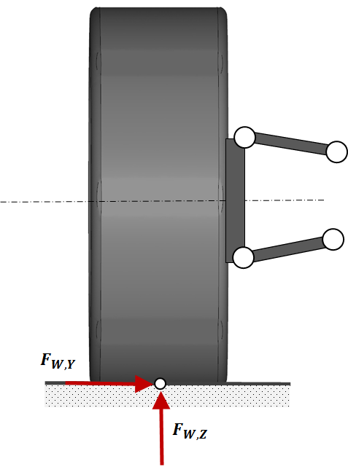
Fig. 3.5 Load case - “Cornering”
 | $$F_{W,Z}=2*F_{W,Z,0}={2∙F}_{W,Z,0}=6523.65 N$$ | (3)
 | $$F_{W,Y}=2*µ_{W,Y}*F_{W,Z,0}=2∙1 {∙F}_{W,Z,0}=6523.65 N$$ | (4)
Cornering inside wheel
The cornering forces on the inside wheel (e.g. right wheel in a right-hand turn) are divided into two components. The first force vector acts radially towards the centre of the wheel in the vertical plane perpendicular to the wheel axis. The second force vector acts parallel to the wheel axis towards the outside of the turn (opposite to the force depicted in Fig. 3.5 ).
 | $$F_{W,Z}=F_{W,Z,0}=3261.83 N$$ | (5)
 | $$F_{W,Y}=-µ_{W,Y}∙F_{W,Z,0}=-1∙ 3261.83N=-3261.83 N$$ | (6)
Braking front wheel
Two components represent the braking forces on the front wheels. As the first force vector $F_{W,X,b,f}$ acts tangentially on the wheel opposite to the driving direction, the second force vector $F_{W,Z,f}$acts radially towards the centre of the wheel in the vertical plane perpendicular to the wheel axis, as shown in Fig. 3.6.
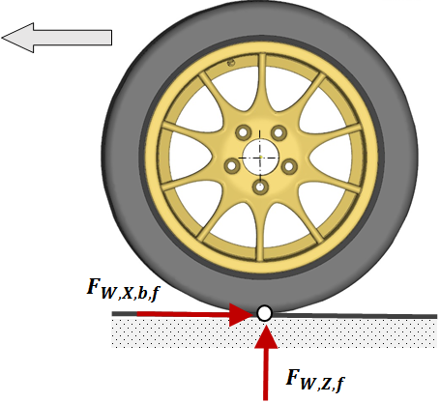
Fig. 3.6 Load case - “Braking”
 | $$F_{W,Z,f}=2 {∙F}_{W,Z,f,0}=2∙ 3261.83N= 6523.65 N$$ | (7)
 | $F_{W,X,b,f}=1.5∙µ_{W,X}∙F_{W,Z,f,0}$ = $1.5∙1∙ 3261.83N=4892.74 N$ | (8)
Braking rear wheel
The braking forces on the rear wheels are divided into two components. As the first force vector $F_{W,X,b,r}$ acts tangentially on the wheel opposite to the driving direction, the second force vector $F_{W,Z,r}$ acts radially towards the centre of the wheel in the vertical plane perpendicular to the wheel axis as shown in Fig. 3.6.
 | $$F_{W,Z,r}=F_{W,Z,r,0}=3261.83N=3261.83 N$$ | (9)
 | $$F_{W,X,b,r}=0.8∙µ_{W,X}∙F_{W,Z,r,0}=0.8∙1∙3261.83N=2609.46 N$$ | (10)
Acceleration rear wheel
In this load case, a rear wheel driven car is considered as the reference vehicle. Therefore, only the forces on the rear wheels due to acceleration are considered.
The acceleration forces on the rear wheels are divided into two components. As the first force vector $F_{W,X,a}$acts tangentially on the wheel in the driving direction, the second force vector $F_{W,Z,r}$ acts radially towards the centre of the wheel in the vertical plane perpendicular to the wheel axis as shown in Fig. 3.7.
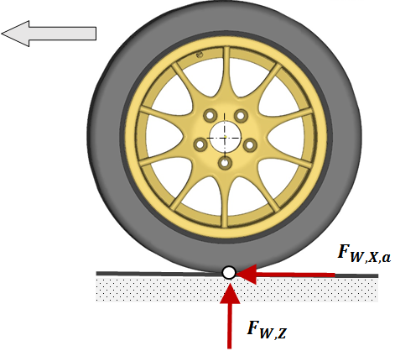
Fig. 3.7 Load case - “Acceleration”
 | $$F_{W,Z,r}= 1.8*F_{W,Z,r,0}=1.8∙3261.83N=5871.29 N$$ | (11)
 | $$F_{W,X,a}=1.5*µ_{W,X}*F_{W,Z,r,0}=1.5∙1∙3261.83N=4892.74 N$$ | (12)
Table 3.2 contains a summary of the results of the forces acting on the wheels under different load cases. The defined loads are used to design using the topology optimisation the rim in Inspire software.
Table 3.2 Load case – defined load cases
Load case | Forces | Figure
Vertical impact | $F_{W,Z}$ $=9785.48 N$ | Fig. 3.4
Cornering outside wheel | $F_{W,Z}=$ $6523.65 N$  $$F_{W,Y}=6523.65 N$$ | Fig. 3.5
Cornering inside wheel | $$F_{W,Y}=-3261.83 N$$  $$F_{W,Z }=3261.83 N$$ | Fig. 3.5
Braking front wheel | $$F_{W,Z,f}=6523.65 N$$  $$F_{W,X,b,f}=4892.74 N$$ | Fig. 3.6
Braking rear wheel | $$F_{W,Z,r}=3261.83 N$$  $$F_{W,X,b,r}=2609.46 N$$ | Fig. 3.6
Acceleration rear wheel | $$F_{W,Z,r}= 5871.29 N$$  $$F_{W,X,a}=4892.74 N$$ | Fig. 3.7

Material Properties
According to (Pekguleryuz, Kainer, & Kaya, 2013) ZK60 alloy was specially designed for the road racing rims. The mechanical properties of the material are excellent, especially with a temper condition -T5 (see Table 3.3). This material has superior mechanical properties in comparison with the aluminium alloy that is usually used for the rim designs.
Table 3.3 Mechanical properties of ZK60-T5 magnesium alloy and aluminium alloy EN AC 462000-T6
Properties | EN AC 462000-T6 (aluMATTER)  (Aluminium alloy) | Mg ZK60-T5  (Liu, et al., 2009)  (Magnesium alloy)
Elastic Modulus, MPa | 71000 | 45000
Poisson’s Ration | 0.33 | 0.35
Mass Density, kg/m³ | 2800 | 1700
Tensile Strength, MPa | 260 | 329
Yield Strength, MPa | 220 | 273
Fatigue Strength, MPa, at 1e7 cycles (R=-1, rotating beam loading in air ) | 80-100 | 150
SN- curve coefficients C, b |  | 458.36 MPa, -0.0679
To improve the fatigue strength of Mg ZK60, (Dong, Liu, Ding, & Zou, 2011) assessed the impacts of heat and surface treatments on the alloys in high cycle fatigue. They found out that the fatigue strength was increased from 140 to 195 MPa (using shot peening surface treatment + T5 ageing 24h@150°C.) Taking into account these facts, Magnesium ZK60-T5 has been chosen as the material for the designed rim. However, it should be noted that the material characteristics are taken from literature, where tests may have been performed under laboratory conditions. Detail fatigue testing of the magnesium alloy exceeds the scope of this study. Therefore, the adequate fatigue safety factor of 1.5 is required for the design to compensate for the lack of own fatigue data.

Topology Optimization
A topology optimisation process was done using the software Inspire 2015 from Altair Hyperworks 13.0. The tool makes it possible to determine an initial shape of the rim taking into account all defined load cases. The optimisation process was started from a basic 3D CAD parametric model done in Autodesk Invention 2015, which has then been imported to Inspire solidThinking for further processing. The load cases defined in Table 3.2 were applied during the optimisation; applied boundary conditions are shown in Fig. 3.9. Also, a minimum frequency for the first mode has been set to 350 Hz as a stiffness requirement. The natural frequencies under the 350 Hz could generate unwanted effects like vibration and nose in the vehicle, which is supported by (Yaman & Yegin, 2013) This problem can occur in high-speed applications. As the analysed application is the racing rim, this criterion must be fulfilled.
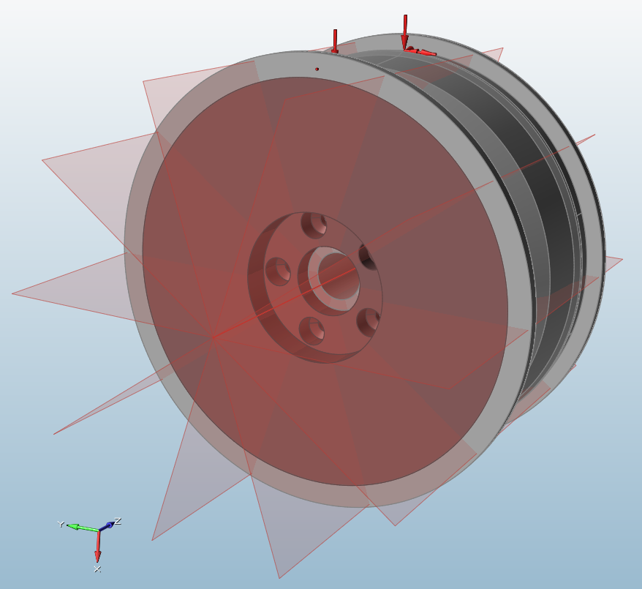
Fig. 3.8 Optimization model with manufacturing constraints (Brown solid means design space in which the optimisation process will take place)
The six load cases defined in the previous chapter, Table 3.2 were taken into account in the optimisation process, and the employed boundary conditions are shown in Fig. 3.9. They were applied on the selected surfaces of the body, which is not the design space so to distribute the load uniformly on the rim.
The model of the rim consisted of three solids, and only the brown one is a design space, the region where the software remove the unneeded material. The other parts are not changed because they define connection interfaces with other parts like tyres and a rim hub. The connection between those solids was modelled as a bounded contact – no sliding and no separation.
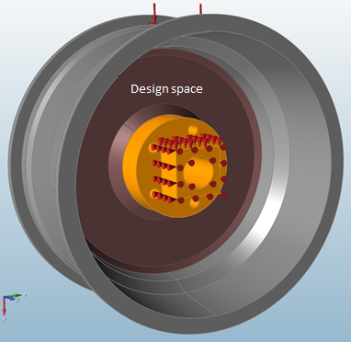
Fig. 3.9 Optimization model loads and boundary conditions
To conclude, the objective of the optimization was to maximize the stiffness of the rim with the total volume of the design space reduction to 30%. Additionally, the stiffness constraint of the rim imposed as the frequency limit of 350 Hz for the first nature resonance frequency. In addition, manufacturing constraints were imposed as: a minimum cross-section of the spoke should be 20 mm, and the rim should have 10 symmetry planes what enforces to create ten spokes. Table 3.4 shows the all-important parameter used in the optimisation process.
Table 3.4 Topology optimization parameters employed during the calculations:
Input Data | Value | Remarks
Define load cases | See Table 3.2 | Fixed value
Frequency constraints:  First resonance frequency, Hz | >350 | Standard boundary conditions see Fig. 3.17
Manufacturing constraints | 10 spokes | See Fig. 3.8
Objective | Maximize stiffness | No value
Thickness constrains minimum, mm | 20 mm | Fixed value
Total design space volume reduction | 30%
Contacts | bounded | No separation and no sliding
Applied gravity | yes
As it can be seen in Fig. 3.10, the material is distributed in an optimum way, creating very complex geometry. However, the rim should be manufacturable by current technologies; therefore, the achieved complex shape should be adapted to existing technology. Targeted technologies for the rim are forging and milling; therefore, as a next step, the CAD model of the rim was created with simplified geometry dedicated to the forging process.
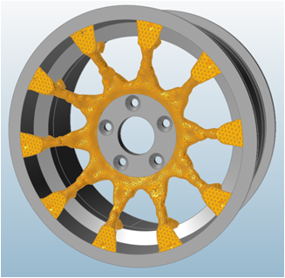
Fig. 3.10 Shape of rim spokes as results of shape optimisation

Manufacturing Adaptation Process
While the obtained geometry of the rim from the topology optimisation is very material efficient and at the same time very complex (Fig. 3.11), the design needs some reworking so that to be manufactured using the forging and milling processes. The design of the new rim based on the obtained shape that was created in Autodesk Inventor. The modified geometry is shown in Fig. 3.12 and Fig. 3.13; it fulfils all manufacturing requirements required by the selected technology processes.
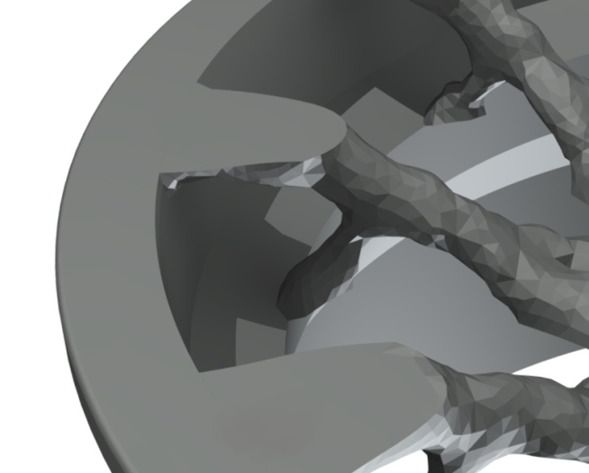
Fig. 3.11 Obtained shape of the rim for topology optimization
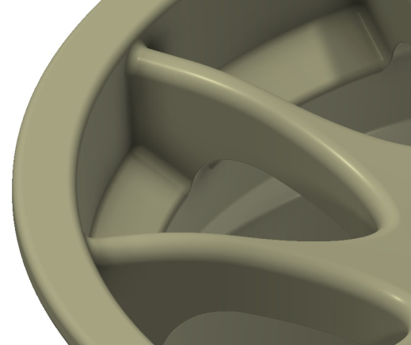
Fig. 3.12 Initial shape of rime built basing on topology optimisation
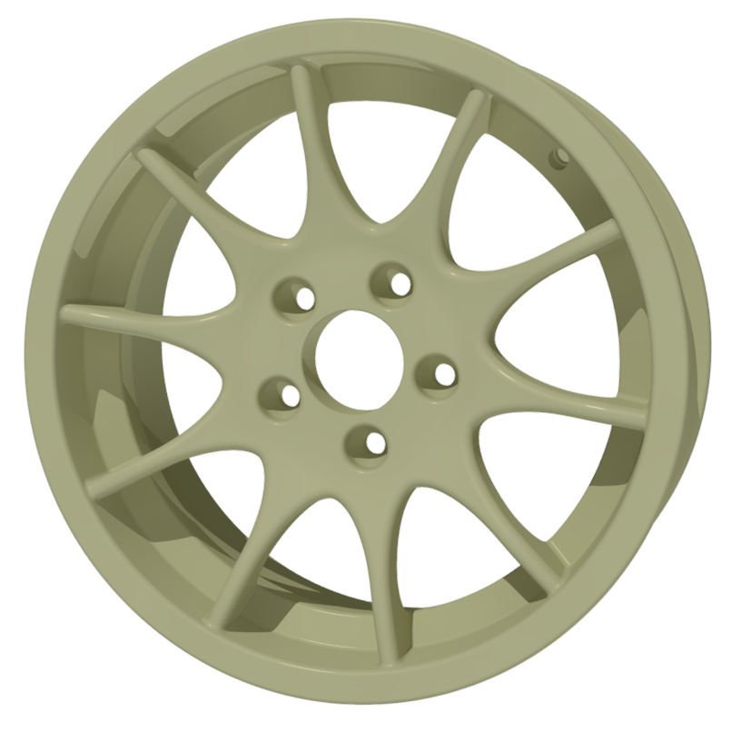
Fig. 3.13 Final shape of rim built basing on topology optimisation results – whole rim
The designed model was built with the help of a parameter shown in Fig. 3.14 so to control a spoke width. This parameter facilitated to determine the minimum spoke thickness of 14 mm using an interactive process of the FEA calculations and the CAD modifications.
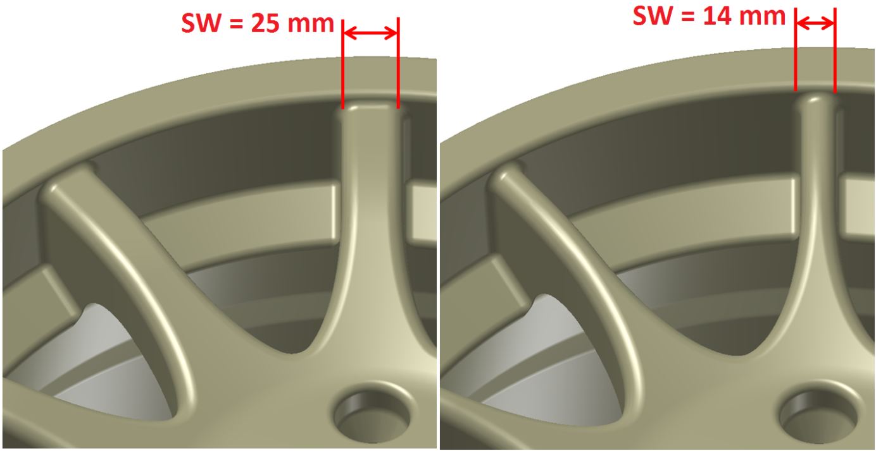
Fig. 3.14 Adaptation process - CAD-model parameter (minimum spoke thickness of 14 mm)

FEA Models Details

Model of Tyre
To achieve realistic stress distributions, a simplified model of the tyre was implemented into the finite element model (FEA) see Fig. 3.15. Inspiration for a discrete tyre model was found in the work of (Li, et al., 2014). The method was adjusted to the current rim of the presented study. The model of the tyre was made using the parameters shown in Table 3.1. A different part of the tyre was modelled using a linear elastic material model with different Young’s modulus, and with the same Poisson’s ratio. Thanks to this, the real behaviour of the tyre can be estimated during a loading phase.
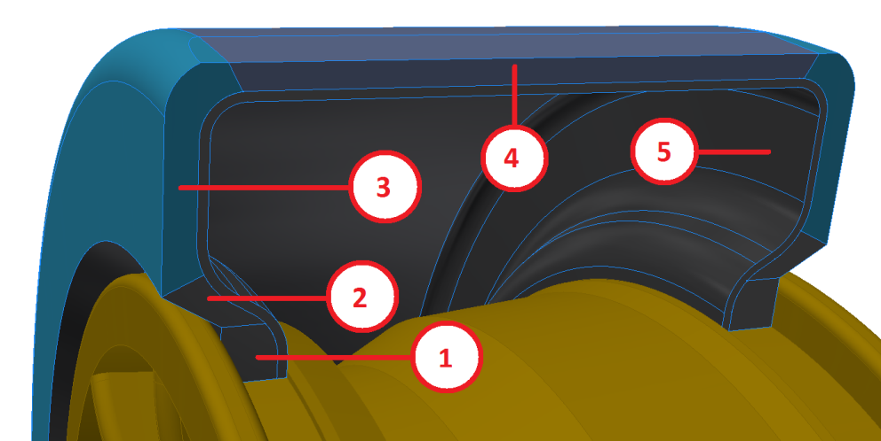
Fig. 3.15 Discrete model of tyre
Table 3.5 Discrete tyre model - parameters
Tyre part | Part name | Young’s modulus, MPa | Poisson’s Ratio
1 | Tyre bead | 1000 | 0.49
2 | Tyre apex | 100 | 0.49
3 | Tyre sidewall | 15 | 0.49
4 | Tyre thread | 40 | 0.49
5 | Tyre liner | 210 | 0.49

Mesh
The FEA model was built using second order elements - Tetra 10, mainly because of the complexity of geometry. The fine mesh was used in regions where the stress concentration was expected. A final configuration of the FEA model is shown in Table 3.6 and in Fig. 3.16.
Table 3.6 Analysed components, assigned materials, and FEA element type
Materials | Material | Element Type | Number of Elements
Rim | ZK60-T5 | Tetra 10 | 685111
Tyre | Pseudo rubber with reinforcements | Tetra 10 | 993044
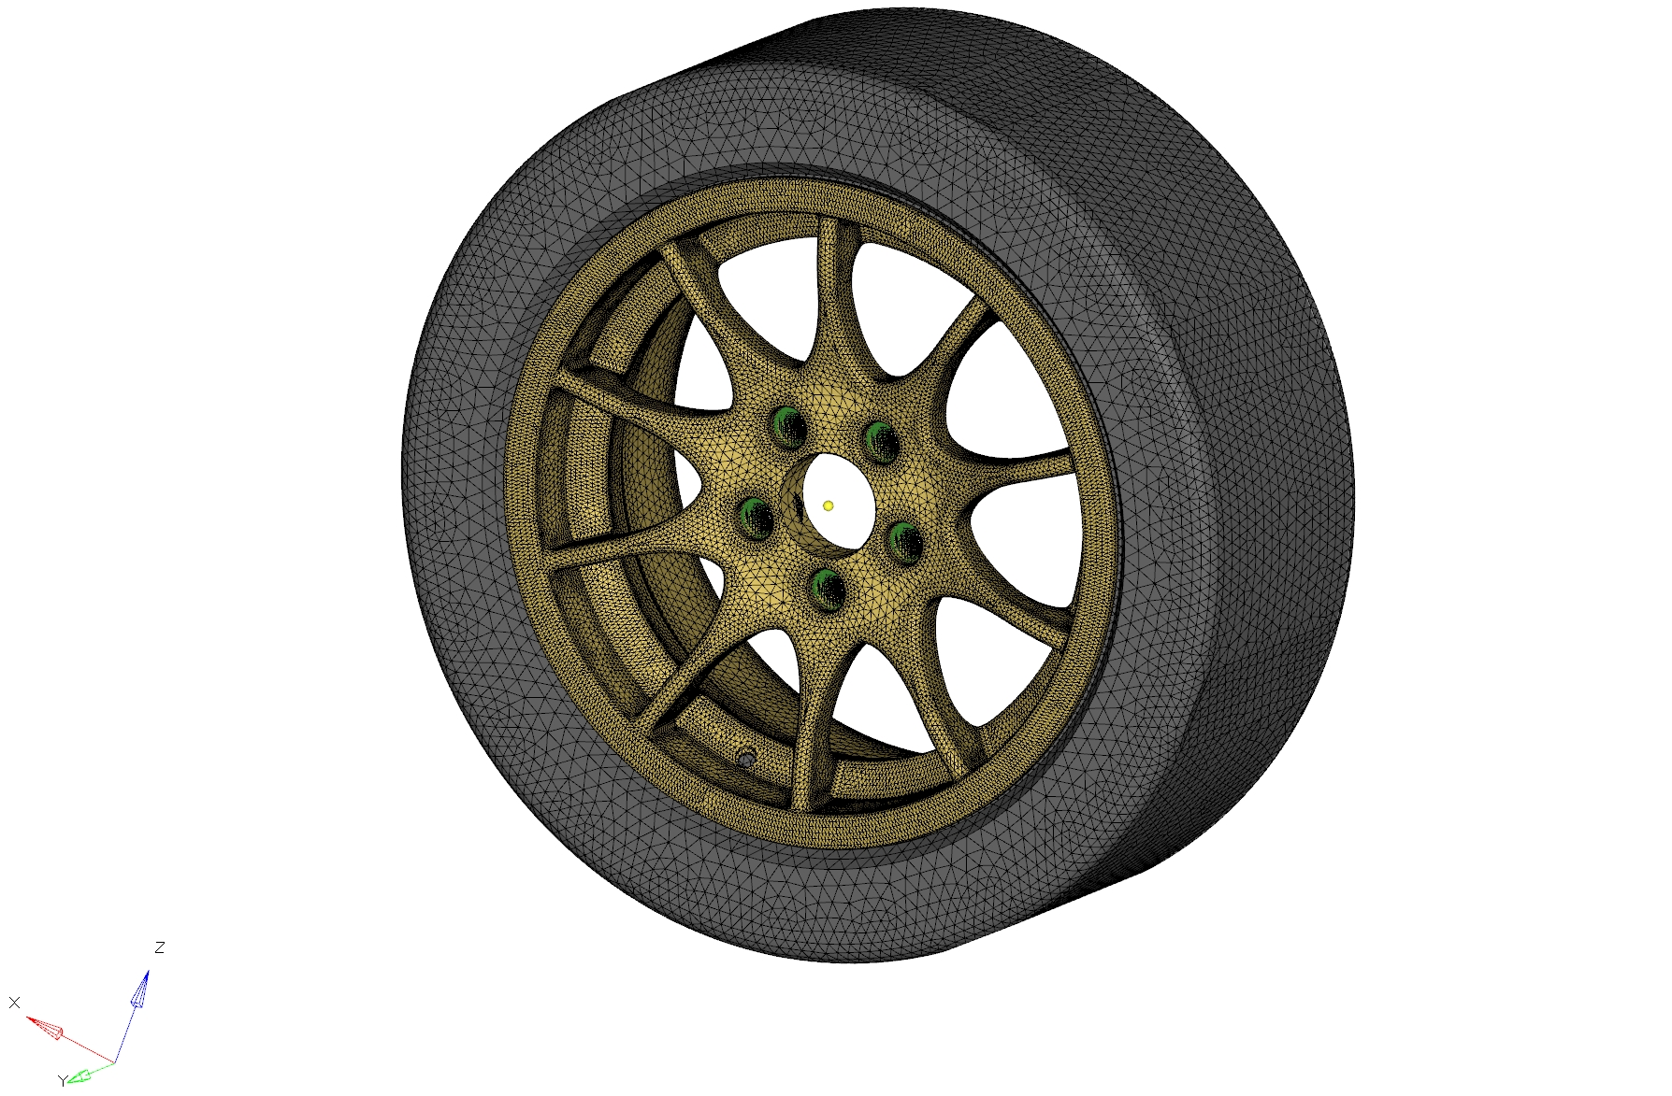
Fig. 3.16 Finite element model of wheel

Load Cases and Boundary Conditions for Stress Analysis
Fig. 3.17 shows the FEA model with the boundary conditions and with the load corresponding the load case - cornering outside wheel. The load is distributed using the RBE3 connection on some surfaces of the tyre; these surfaces represent a real contact region between a road and a tyre. Thanks to this, unwanted and unrealistic stress concertation is eliminated.
Furthermore, the internal pressure of 0.22 MPa was applied for all load cases so to represent the real tyre pressure.
In total, 9 load cases were analysed in order to make structural integrity assessment of the rim. The analysed load cases are shown in Table 3.7. It should be noticed, that some of them were analyses directly and another achieved using a superposition method, as the FEA model is linear.
Table 3.7 Define load cases for rim validation
No | Load Case Name | No | Load Case Name
1 | Vertical impact  +internal pressure | 6 | Braking rear wheel  + internal pressure
2 | Cornering outside wheel  + internal pressure | 7 | Acceleration rear wheel  + internal pressure
3 | Cornering inside wheel  + internal pressure | 8 | Cornering outside wheel + Acceleration rear wheel + internal pressure
4 | Braking front wheel | 9 | Cornering inside wheel + acceleration rear wheel + internal pressure
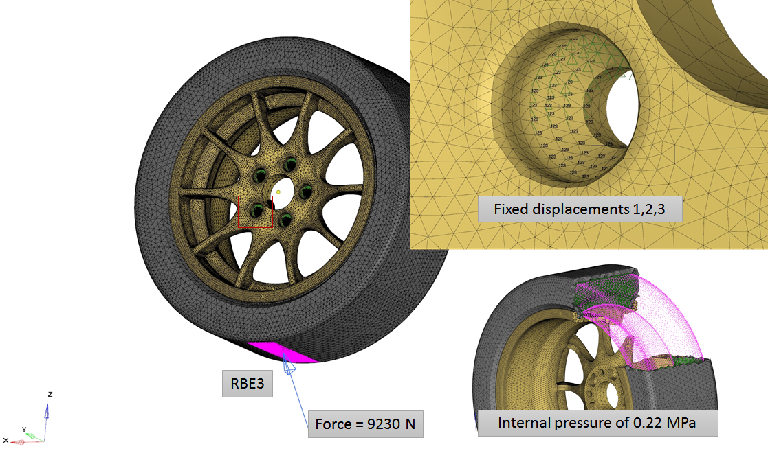
Fig. 3.17 Load and boundary conditions - cornering outside wheel

Fatigue Analysis
As it was said, to make a fatigue estimation, appropriate duty cycles are required. In the presented work, the duty cycles are created by the selected fatigue tests in lab conditions; there are not any real tests of the vehicles. Therefore some risk of fatigue failure may occur. Moreover, the material properties come from the literature, and they could be vitiated by errors. This leads to conclusions that a significant safety factor for fatigue load cases is needed. Tanking this into consideration this fact, the minimum safety factor of 1.5 for the alternating stresses is required in reference to the material fatigue strength.

Fatigue Tests of Wheel
The fatigue analyses were done to simulate the fatigue tests defined by the standard (SAE, J328 JUN 1994). Two tests are required for a typical high way service: first one – the dynamic cornering test and the other one - the dynamic radial fatigue. The tests are developed for the wheels of passenger vehicles and for the typical high way application only. Since the analysed application is the road racing application and uncertainty of the material fatigue properties exists, the adequate safety factor is demanded. The standard requested a minimum number of load cycles to failure for both tests. This must be fulfilled by more stringent requirements defined through the safety factor.
Dynamic cornering fatigue
In Fig. 3.18, the test stand is shown where a rotating constant bending moment is applied to a stationary rim through the long arm of 762 mm. The rim must withstand minimum 25000 cycles of the load.
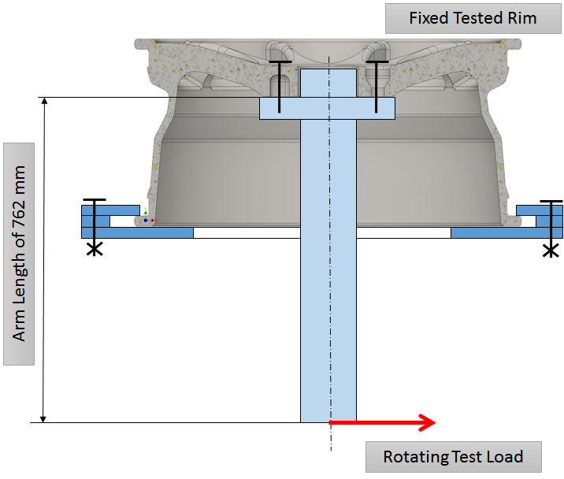
Fig. 3.18 Dynamic cornering fatigue test (typical set-up)
The rotating load of the dynamic cornering fatigue test $M_{max}$ is calculated as follows according to the standard:
 | $$M_{front}=F_{W,Z,0}∙\left(R∙u+d\right)∙S_{front}$$ | (13)
 | $$M_{rear}=F_{W,Z,0}∙\left(R∙u+d\right)∙S_{front}$$ | (14)
 | $$M_{max}=max\left[M_{front},M_{rear}\right]$$ | (15)
Where:
d – inset or outset of wheel m; use positive sign for inset and negative sign for outset.
R - static-loaded radius of largest tyre specified by vehicle manufacturer, m
S - load factor; $S_{front}=2.0, S_{rear}=1.75$
u - coefficient of friction developed between tyre and road: use u = 0.7.
 | $$M_{max}=max\left[3.11, 2.72\right] kNm=3.11 kNm$$ | (16)
Radial fatigue test
In Fig. 3.19, the sketch of the test stand is shown. A constant radial force loads the rotating wheel, and the wheel must withstand minimum 600000 cycles.
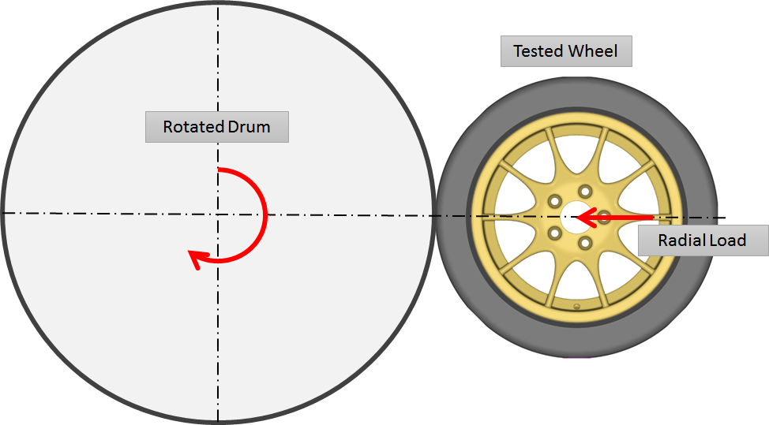
Fig. 3.19 Radial fatigue test (typical set-up)
The radial force $F_{max}$ for the radial fatigue test is calculated as follows according to the standard:
 | $$F_{front}={2.5∙F}_{W,Z,0}=8.15kN$$ | (17)
 | $$F_{rear}=2.25{∙F}_{W,Z,0}=7.34kN$$ | (18)
 | $$F_{max}=max\left[F_{front},F_{rear}\right]$$ | (19)
 | $$F_{max}=8.15kN$$ | (20)

Load Cases and Boundary Conditions for Fatigue Analysis
The boundary conditions used during the calculations of the load case of the dynamic cornering are shown in Fig. 3.20; the rims were fixed on one selected edge of the flange. This represents the real fixation during the test. The load was applied to employ the RBE3 connection so to create a remote constant force. The force rotates, as shown in Fig. 3.21; therefore, the calculations were done for a different position of the force defined by its clockwise rotation about 45 deg. Thus, eight load cases were analysed defined by the eight force directions with the intention of the simulation of one load cycle.
The boundary conditions and loads for the radial fatigue case are shown in Fig. 3.22, the fixation of the tyre as well as the radial force is rotating; therefore, 8 different load cases are analysed in order to simulate one load cycle. The radial force was applied to employ the RBE3 so to simulate the standard fixation of the wheel in the test stand.
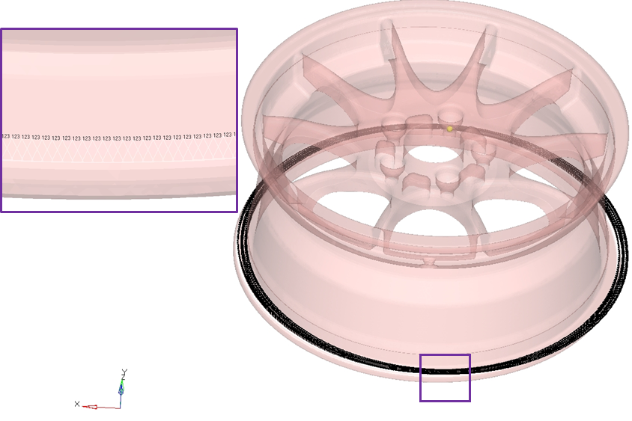
Fig. 3.20 Boundary conditions for load case of dynamic cornering
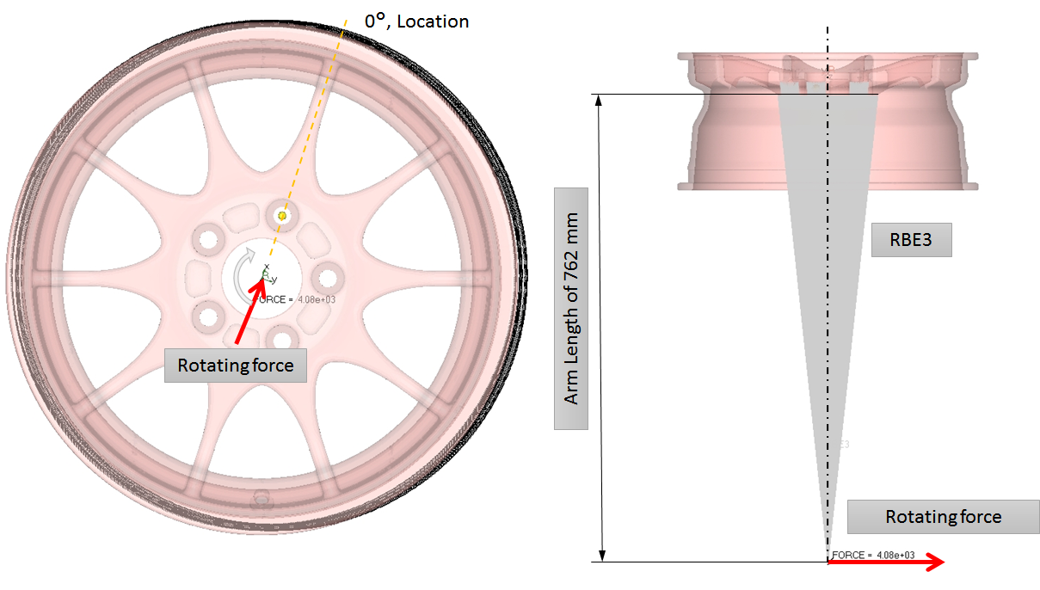
Fig. 3.21 Rotating force applied in load case of dynamic cornering
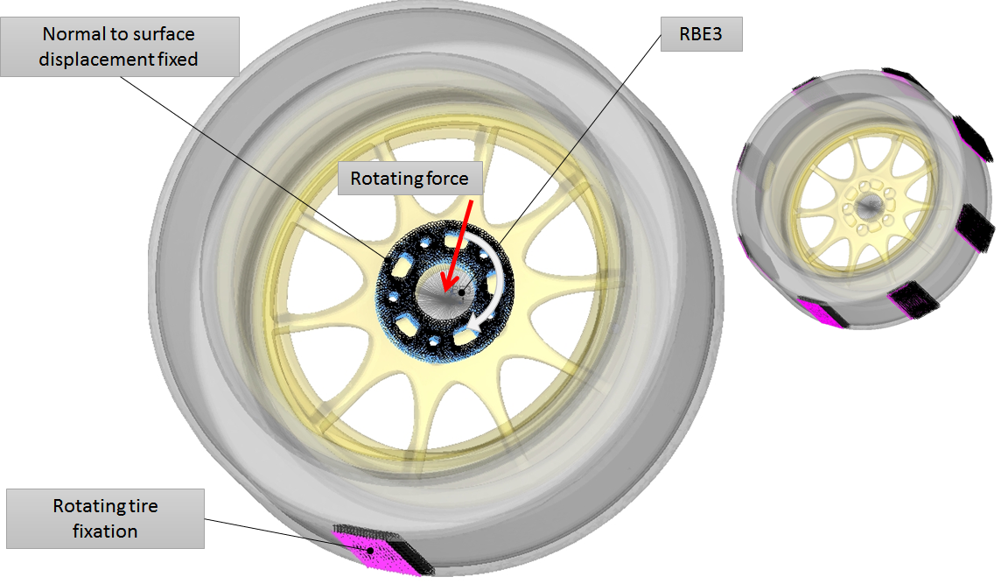
Fig. 3.22 Load boundary conditions load case of radial fatigue case

Solution
The problem is numerically solved using the finite element method, and the calculations are made using the commercial solver Optistruct, Hyperworks 13.
The material model is linear since the acceptable stress level is below the yield strength, which unambiguously means that the linear material model is sufficient. Moreover, it was assumed that the deformations are small; therefore, the conducted analyses can be linear. As results of this, a superposition method could be employed so to conduct the calculations of some of the load cases.

RESULTS

Stress Analyses
The stress analyses show (see Table 4.1) that the equivalent stresses are below 83 MPa for all analysed load case. The worst load case is the superposition of two cases: Cornering inside wheel and acceleration rear wheel. Fig. 4.1 show the map of the equivalent stresses for this superposition; the most considerable stress is located on the connection between the spoke and the ring flange.
Table 4.1 Results of stress calculations
(*)Load Case Name | Maximum Von Mises Stress, MPa | Location
Vertical impact | 35.7 | External flange
Cornering outside wheel | 61.8 | Spoke-Flange connection
Cornering inside wheel | 40.2 | Bolt hole
Braking front wheel | 41.9 | Spoke-Flange connection
Braking rear wheel | 22.0 | Spoke
Acceleration rear wheel | 41.0 | Spoke-Flange connection
Cornering outside wheel  + Acceleration rear wheel | 82.6 | Spoke-Flange connection
Cornering inside wheel  + Acceleration rear wheel | 69.7 | Spoke-Flange connection
(*) The internal pressure of 0.22 MPa was applied for all load cases.
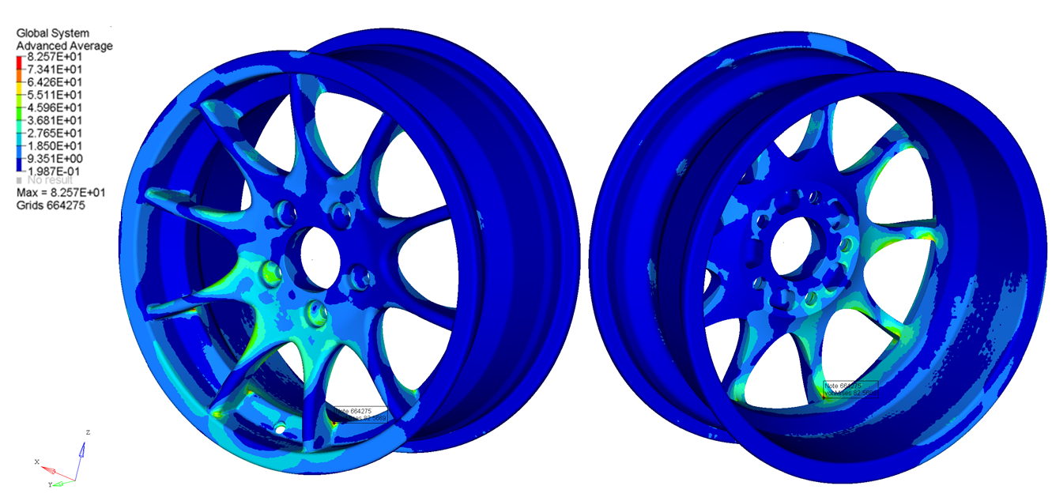
Fig. 4.1 Von Mises stresses for load case - Cornering outside wheel + Acceleration rear wheel

Modal Analysis
The modal analysis shows that the minimum obtained natural frequency is 358.6 Hz see Table 4.1. Mode shape of the first natural frequency is also shown in this table. It represents oval deformation of the cylindrical part of the rim. The second resonance mode with a frequency of 358.8 Hz has a similar shape as the first one. The two following modes have frequency adequately: 391.3 Hz and 391.5 and they can be characterised as out of plane bending of all spokes. The fifth mode shape with the frequency of 418.8 Hz represents an in-plane bending of all spokes. Only the first five modes are presented because greater modes can have an only negligible influence on the performance of the rim.
Table 4.2 Results of modal analysis
(*)Load Case Name | Frequency, Hz | Mode Shape
First mode | 358.6 | 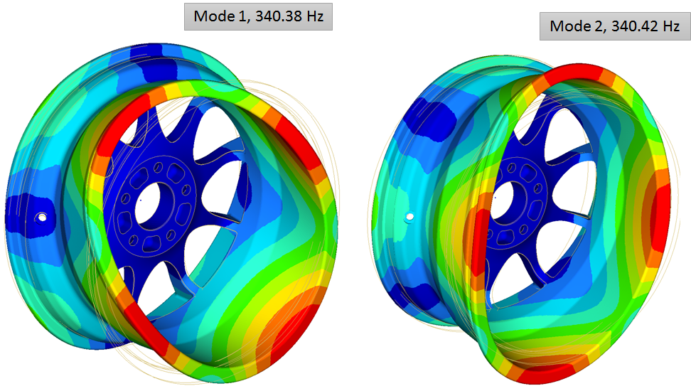
Second mode | 358.8
Third mode | 391.3 | 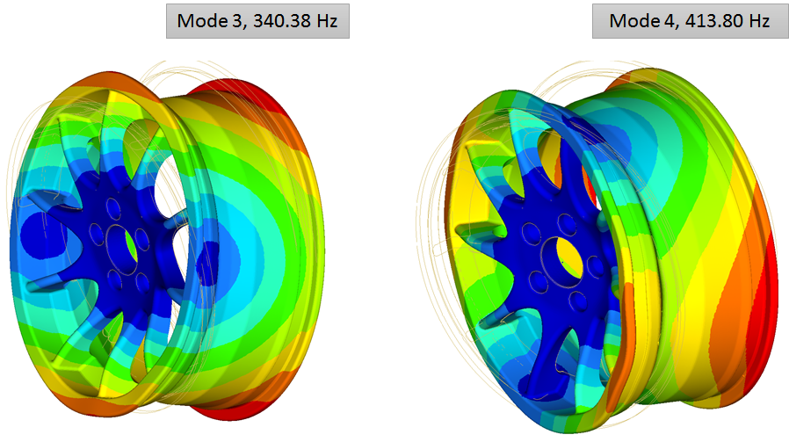
Fourth mode | 391.5
Fifth mode | 418.8 | 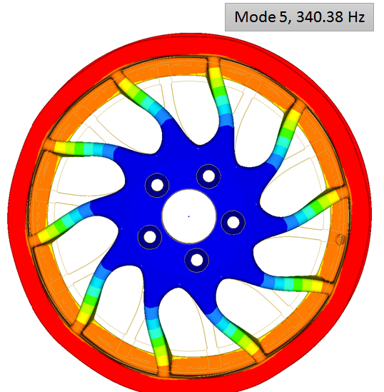

Fatigue Analysis
As the first step of the fatigue assessment was checked, the fatigue safety factor calculated simply as a ratio of maximum von Mises stress and the fatigue endurance. The calculations were repeated for the 8 load cases. The results of these analyses are shown in Table 4.3 and Table 4.4. The safety factors are greater than 1.5; the minimum values are recorded adequately 1.75 and 2.5 for the fatigue dynamic and the radial fatigue test case.
Table 4.3 shows maximum von Mises stress in rim during simulation of dynamic cornering test
Load Case Name\Position | 0 | 45 | 90 | 135 | 180 | 225 | 270 | 315
Von Mises Stress | 85.5 | 84.9 | 85.1 | 84.2 | 85.5 | 84.9 | 85.1 | 84.2
Fatigue safety factor | 1.75 | 1.77 | 1.76 | 1.78 | 1.75 | 1.77 | 1.76 | 1.78
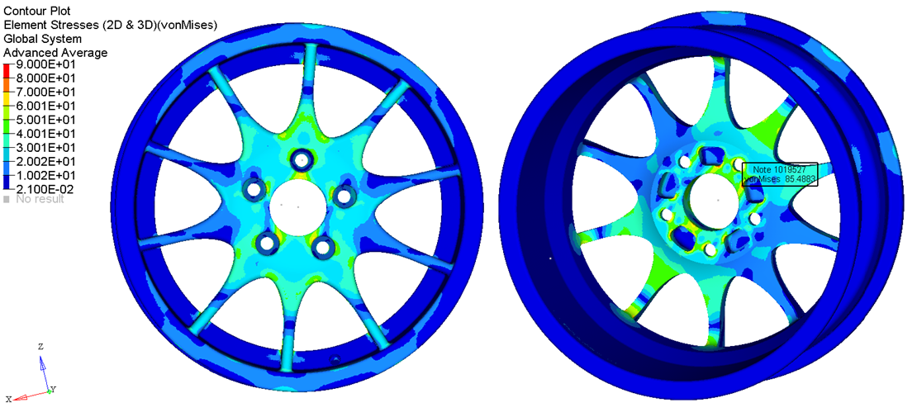
Fig. 4.2 Von Mises stresses for load case – dynamic cornering test, 180 deg
Table 4.4 shows maximum von Mises stress in rim during simulation of radial fatigue test
Load Case Name\Position | 0 | 45 | 90 | 135 | 180 | 225 | 270 | 315
Von Mises Stress | 25.9 | 51.6 | 58.3 | 37.4 | 34.0 | 31.5 | 31.5 | 60.1
Fatigue safety factor | 5.8 | 2.9 | 2.6 | 4.0 | 4.4 | 4.8 | 4.8 | 2.5
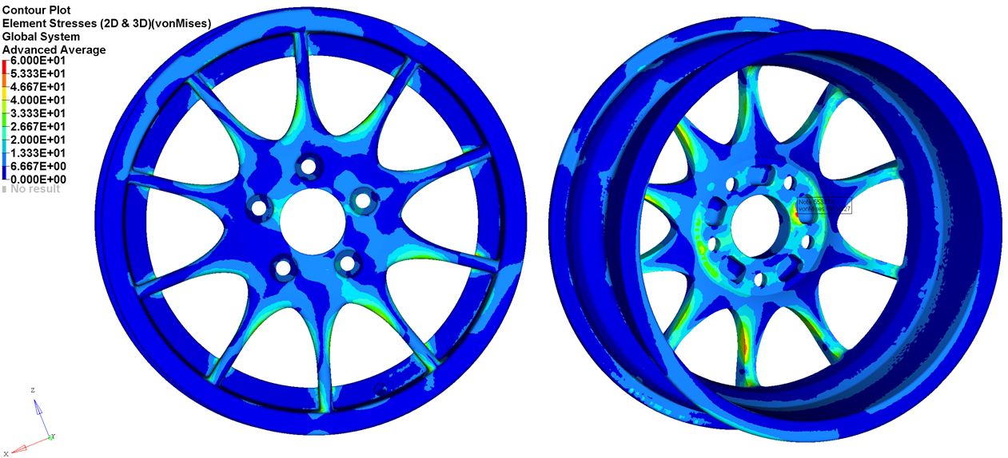
Fig. 4.3 Von Mises stresses for load case – radial fatigue test, 315 Deg
The figures: Fig. 4.2, and Fig. 4.3 show the equivalent stress for those worst-case conditions. For the dynamic cornering case, the maximum stress is located on the interference flange, and similarly, for the radial fatigue case, the stress concentration is also located on the interference flange.

DISCUSSION

Final 3D-Model
The final design of the rim has an eye-catching look, which was one of the goals of the presented projects see Fig. 5.1. The final model has all manufacturing details, which can be seen on the 2D drawing see Fig. 5.3, consequently, the design is ready for manufacturing.
Unfortunately, a current limitation of a project budget did not allow to create a prototype, and as an alternative of this, a 3D print-scaled part was created made of plastic. The details of this mock-up part are presented further in this paper.
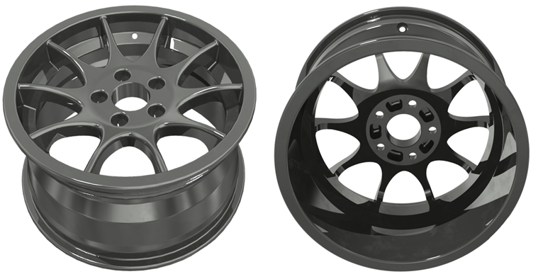
Fig. 5.1 Result – final 3D design of rim
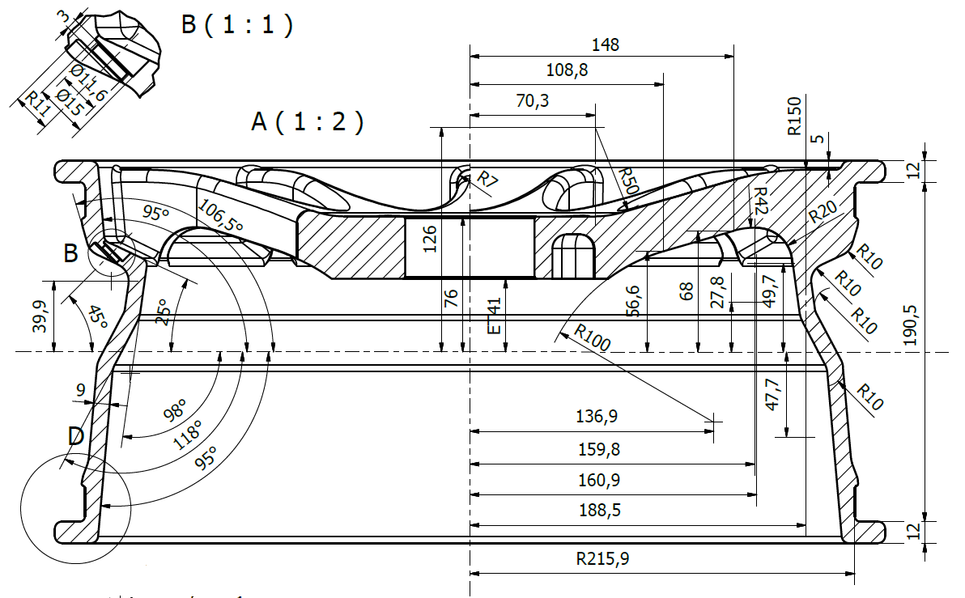
Fig. 5.2 Result – final drawing of rim
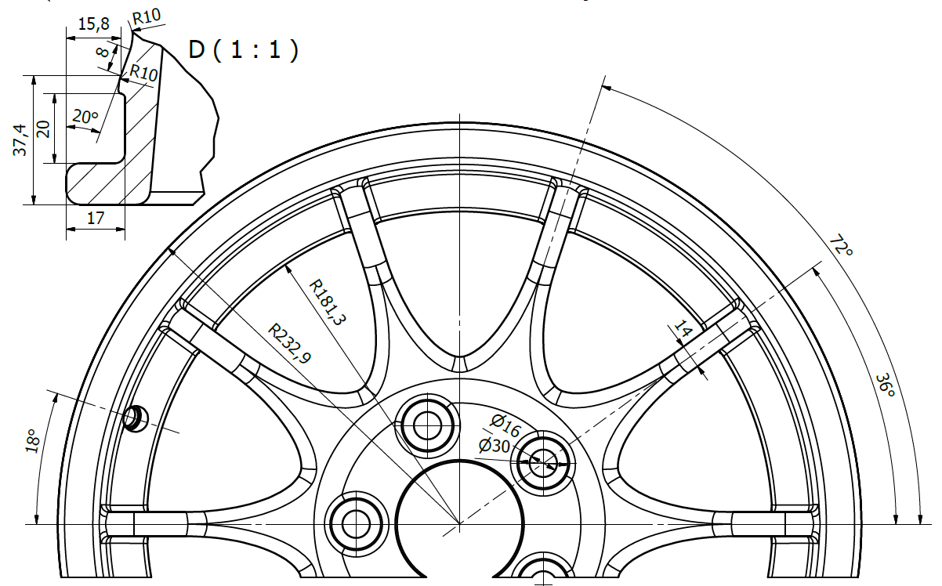
Fig. 5.3 Result – final drawing of rim

Scaled 3D Printed Rim
The scaled down prototype of the rim is presented in Fig. 5.4. It has been manufactured using rapid prototyping (powder bed printing technology) for visual and presenting purposes only.
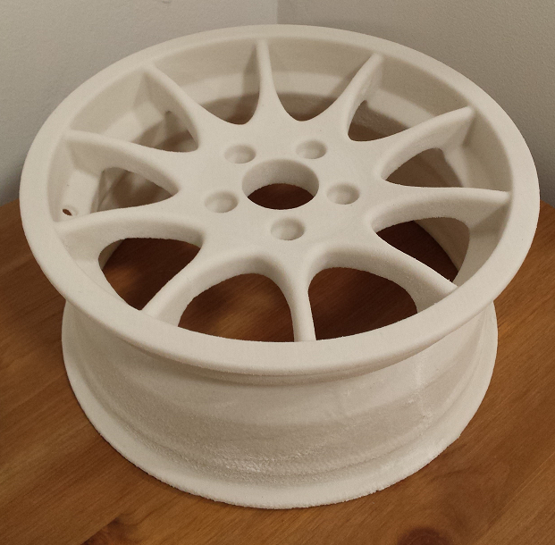
Fig. 5.4 Result – final 3D printed rim

Summary
The project has been completed, and the goals are achieved. The design for a road-racing rim has been created using the topology optimisation. Through the design for manufacturing adaptation process, the final design ready to be manufactured using the existing forging and milling technology has been put into practice.
Furthermore, with the help of FEA, the complete model has been validated concerning the structural integrity, stiffness and fatigue requirements. The minimum safety fatigue factor of 1.75 is achieved for the dynamic fatigue case, which is entirely acceptable, taking into account the defined limit of 1.5. The first natural resonance frequency is 358.6 Hz, which is greater than the set-up limit of 350 Hz.
The required lifetime for both fatigue load tests achieved the infinity lifetime theoretically, and the obtained safety factors are large. However, the influence of the manufacturing process on fatigue endurance strength is unknown; therefore, there is a minimal risk that the rim will fail during the tests.
It is decided that any further fatigue assessment is not conducted since there is not sufficient input data to achieve satisfactory results. Only real tests can answer a question of whether the manufacturing inaccuracies could lead to a drastic decrease in fatigue properties. As it is shown, the safety margin is significant. Thus it is supposed that there will be not any problems during a regular service of the rim. The real tests are mandatory before any release for a production of the developed design.
The next aspects of the fatigue analysis are the application, which in our case is road racing. The same as for the manufacturing defaults also a duty cycle of the vehicle is unknown. Moreover, the existing fatigue tests are suitable only for the highway application. Therefore, the large enough safety factors are needed in order to take into account existing uncertainty. The duty cycle can be determined only based on real racing test conditions. Unfortunately, this is out of the scope of the project.
Summarising fatigue assessment is based only on the presented simple approach with the calculations of the minimum safety factors and comparing with the defined limit, because of the insufficiency of the data concerning the material properties and the vehicle application. Consequently, the elaborated design has a significant safety margin as the rim design is dedicated to the road racing application where very high loads are expected.
The achieved shape of the rim is very eye-catching as it is pointed out. This was one of the goals of the presented work. This feature of the design is essential in the project since the targeted application is the road racing, where the appearance of the rim is just as important as the strength and the weight.
During the optimization and design process, the objective was to maximise the stiffness with the minimum mass of the rim taking into account other important parameters like strength, stiffness and appearance as the constraints. It needs to be highlighted that, the mass of the wheel has an extremely high influence on the vehicle performance. For instance, a mass reduction of 1 kg on an unsprung mass like the wheels is perceived as the mass reduction of 5 kg on the complete vehicle. Therefore, in the presented project, magnesium alloy ZK60-T5 is selected for the material of the rim, which is very low-density material with satisfactory strength. In the case of this study, 1.8 kg per wheel was reduced in comparison with the reference rim so that the total perceived mass reduction would be of$4∙1.8∙5=36 kg$ for the whole vehicle. Thus, the reference car of this study would be perceived 2.7% lighter, which nearly corresponds to driving with a full versus an empty fuel tank. Summarizing, the ideal rim should have minimum mass and maximum possible stiffness and it should meet the requirements of the minimum resonance frequency of 350 Hz.
As it can be seen in the presented work, the topology optimisation is an effective tool as it helps to construct the design of the rim using very few design iterations. The iterations are mostly needed due to the design adaptation for the manufacturing technology – forging and milling. It can be concluded, that the topology optimisation process is very promising for a future design development focusing on new designs. This is true, especially when design shapes can be very complex, and mass and stiffness requirements are very much demanded. For instance, a new manufacturing technology as metal 3D printing requires the topology optimisation naturally as the design tool so to create nature-type designs with very complex geometry.

CONCLUSIONS
The elaborated design of the rim meets all the set goals of the project:
- The lightweight design of the rim is developed with the first natural frequency greater than 350 Hz.
- The equivalent stress levels for all analyses load cases are lower than 83 MPa, which is significantly lower than the yield strength of the rim material.
- The adequate minimum safety factor of 1.75 of the rim design is achieved for the fatigue load cases.
- The eye-catching shape of the rim is achieved.
- The rim design is completed, and it is ready for prototyping.
- The rim has been developed using the optimisation method in order to reduce the design iteration process.
- The rim designed is ready for manufacturing.
Additionally, it has been shown that the implementation of the topology optimisation method in the design process is easy and it can be implemented in almost all design processes, which requires developing a new shape of designed elements.

References
Akbulut, H. (2003). On optimization of a car rim using finite element method, Finite Elements in Analysis and Design. Finite Elements in Analysis and Design, 39, 433-443.
aluMATTER. (n.d.). http://aluminium.matter.org.uk/aluselect/11_castmech_browse.asp”.
Ballo, F., Gobbi, M., Mastinu, G., & Previati, G. (2015). Topology Optimization of a Motorcycle Wheel. 44 Convegno Nazionale - Associazione Italiana per l’Analisi delle Sollecitazioni. Messina.
BMW, AG. (1998). BMW 323ti User Manual, BMW AG. Deutschland.
Chaitanya, S., & Ramana, M. B. (2015). Mass Optimization of Automobile Wheel Rim. International Journal of Engineering Trends and Technology, 26(3), 169-173.
Das, S. (2014). Design and Weight Optimization of Aluminium Alloy Wheel. International Journal of Scientific and Research Publications, 4( 4), 1-12.
Dong, J., Liu, W., Ding, W., & Zou, J. (2011). Surface Characteristics and High Cycle Fatigue Performance of Shot Peened Magnesium Alloy ZK60. Journal of Metallurgy, 2011, 1-9.
Fritsch, M. (2012). An Integrated Optimization System for ANSYS Workbench Based on ACT. Automotive Simulation World Congress. Detroit, Michigan, USA.
Li, Z., DiCecco, S., Altenhof, W., Thomas, M., Banting, R., & Hu, H. (2014). Stress and fatigue life analyses of a five-piece rim and the proposed optimization with a two-piece rim. Journal of Terramechanics, 52, 31-45.
Liu, W. C., Dong, J., Zhang, P., Yao, Z. Y., Q., Z. C., & Ding, W. J. (2009). High cycle fatigue behaviour of as-extruded ZK60 magnesium alloy. J Mater Sci, 44, 2916–2924.
Meyer-Pruessner, R. (2007). Significant Weight Reduction by Using Topology Optimization in Volkswagen Design Development with emphasis on engine design Part 2. 1st European Hyperworks Technology Conference. Berlin, Germany.
Nagatani, H., & Niwa, T. (2005). Application of Topology Optimization and Shape Optimization for Development of Hub-Bearing Lightening. NTN Technical Review, 73, 14-19.
Norberg, E., & Lövgren, S. (2012). Topology Optimization of Vehicle Body Structure for improved Ride & Handling. Linköping University.
Pekguleryuz, M. O., Kainer, K. U., & Kaya, A. A. (2013). Fundamentals of Magnesium Alloy Metallurgy. Oxford: Woodhead Publishing.
SAE. (J328 JUN 1994). SAE J328 standard, Wheels - Passenger Car and Light Truck Performance Requirements and Test Procedures. SAE. SAE.
Saran Theja, M., & Vamsi Krishna, M. (2013). Structural and Fatigue Analysis of Two Wheeler Lighter Weight Alloy Wheel. IOSR Journal of Mechanical and Civil Engineering, 8(2), 35-45.
Satya Prasad, B. G., & Anil Kumar, M. (2013). Topology Optimization of Alloy Wheel. Altair Technology Conference. Pune.
Siva Prasad, T., Krishnaiah, T., Iliyas, J. M., & Jayapal Reddy, M. (2014). A Review on Modeling and Analysis of Car Wheel Rim using CATIA & ANSYS. International Journal of Innovative Science and Modern Engineering, 2(6), 1-5.
Stearns, J., Srivatsan, T. S., Prakash, A., & Lam, P. (2014). Modelling the mechanical response of an aluminium alloy automotive rim. Materials Science and Engineering, A366, 262-268.
Stearns, J., Srivatsan, T., Gao, X., & Lam, P. C. (2005). Understanding the Influence of Pressure and Radial Loads on Stress and Displacement Response of a Rotating Body: The Automobile Wheel. International Journal of Rotating Machinery, International Journal of Rotating Machinery, 1.
Trzesniowski, M. (2008). Rennwagentechnik: Grundlagen, Konstruktion, Komponenten, Systeme, Vieweg+Teubner. Vieweg+Teubner.
Xiao, D., Zhang, H., Liu, X., He, T., & Shan, Y. (2014). Novel steel wheel design based on multi-objective topology optimization. Journal of Mechanical Science and Technology, 28(3), 1007-1016.
Yaman, M., & Yegin, B. (2013). A Light Commercial Vehicle Wheel Design Optimization for Weight, NVH and Durability Considerations. 5th ANSA & μETA International Conference,. Thessaloniki.
Zhou, M., Fleury, R., Patten, S., Stannard, N., Mylett, D., & Gardner, S. (2011). Topology Optimization - Practical Aspects for Industrial Applications. 9th World Congress on Structural and Multidisciplinary Optimization, Shizuoka. Shizuoka.
Zuo, Z. H., Xie, Y. M., & Huang, X. (2011). Reinventing the Wheel. Reinventing the Wheel, Journal of Mechanical Design, 133(2).

