[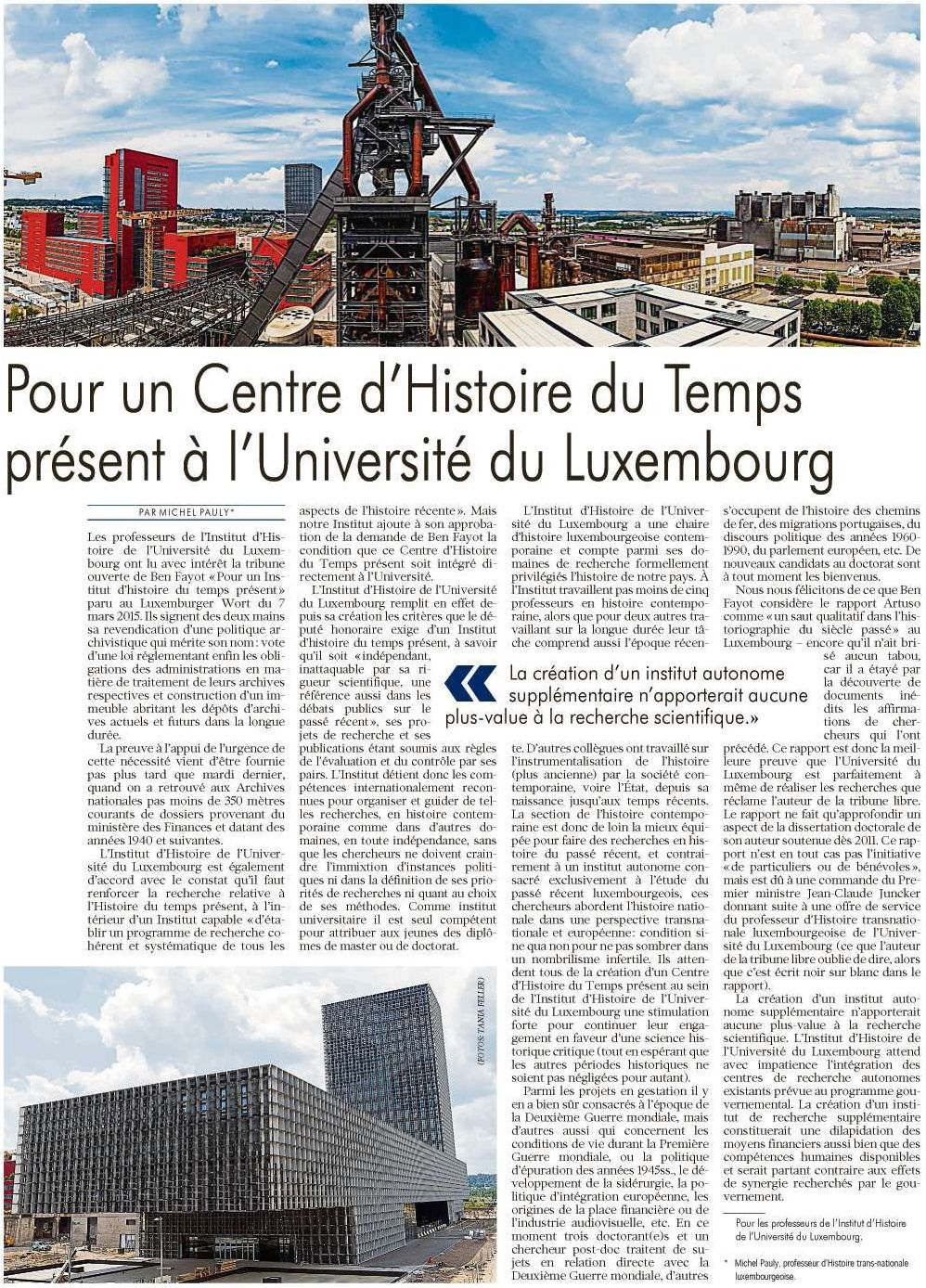](https://e-paper.wort.lu/eweb/media/spl/2015/03/14/elements/6b0e13fd3a5ce0c6.jpg)